1. Open Insta360 Studio
- Download and install the software from the official website and launch it on your computer.
www.insta360.com/download/insta360-x4

2. Record Video
- Prepare Your Camera
Ensure your camera (e.g., Insta360) is fully charged and ready to record.
- Set Up Recording Settings
Adjust the video resolution, frame rate, and any other settings on the camera as needed for your project (e.g., 8K, 30 FPS, 360-degree mode).
- Start Recording
Press the record button on your camera to begin capturing video.
- Stop Recording
When you're finished, press the stop button to end the recording.

3. Transfer Video from Camera to Computer
- Connect the Camera to the Computer
  - Use the provided USB cable or a card reader (if you use a memory card) to connect the camera to your computer. Alternatively, some cameras allow you to transfer files wirelessly via Bluetooth or Wi-Fi.
- Open File Explorer (Windows)
  - Once the camera is connected, open File Explorer on Windows to locate the camera or memory card.
- Find the Recorded Video Files
  - Navigate to the folder where the videos are stored. This may be in a folder labeled "DCIM" or "Videos" on the device.
- Copy the Files to Your Computer
Select the video files you want to transfer and copy them
Paste them into a folder on your computer
- Eject the Camera Safely
After the transfer is complete, safely eject the camera or memory card to avoid any file corruption.

4. Import Your Video
- Drag and drop your Insta360 video file into the software or use the "Import" option.

5. Turn Off Stabilization
- Switch "FlowState Stabilization" to OFF.
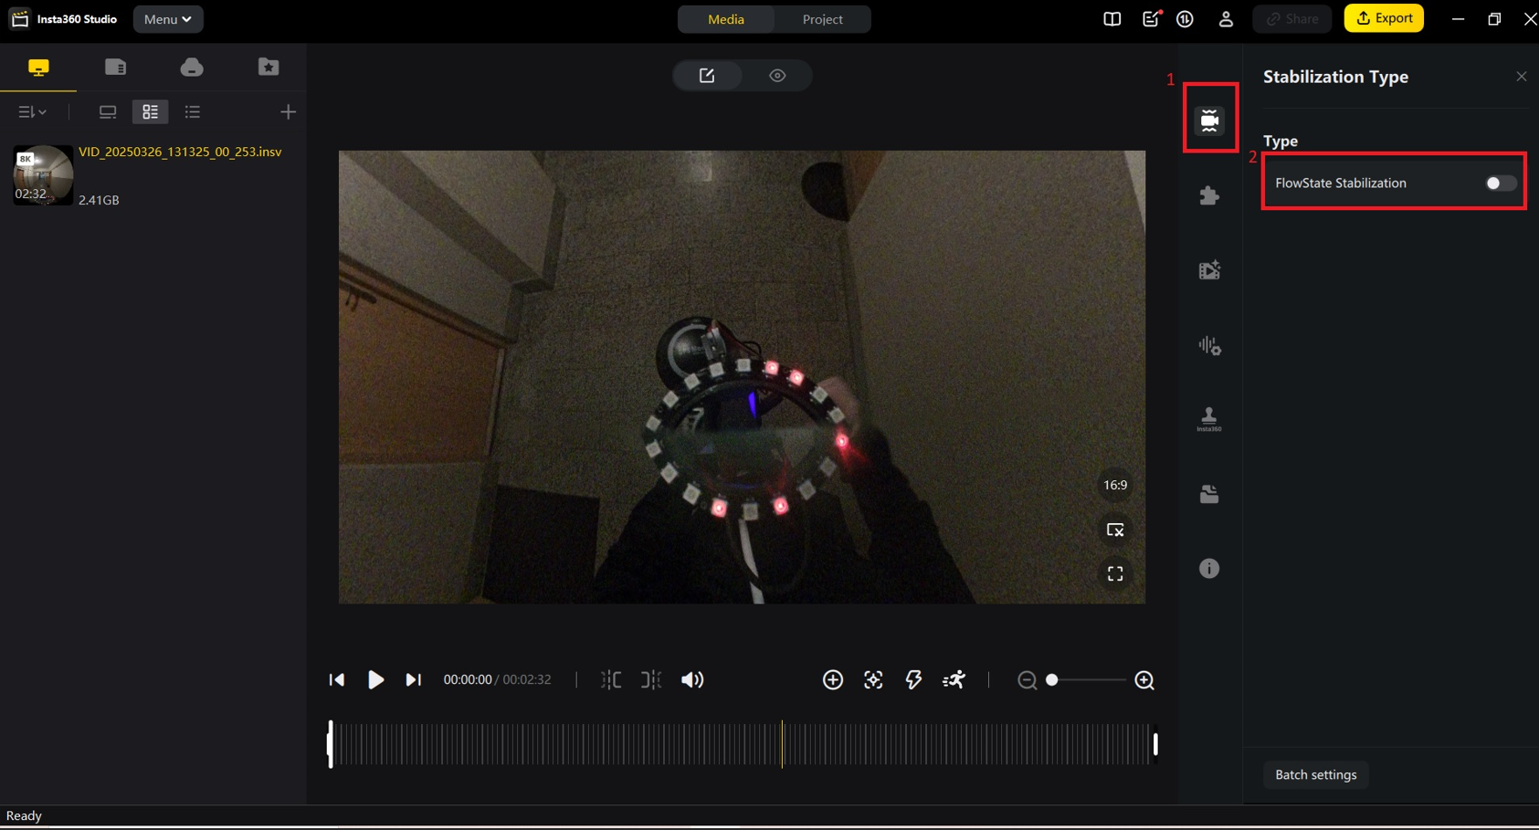

6. Export the Video

- Click the "Export" Button
After editing your video in Insta360 Studio, click the "Export”

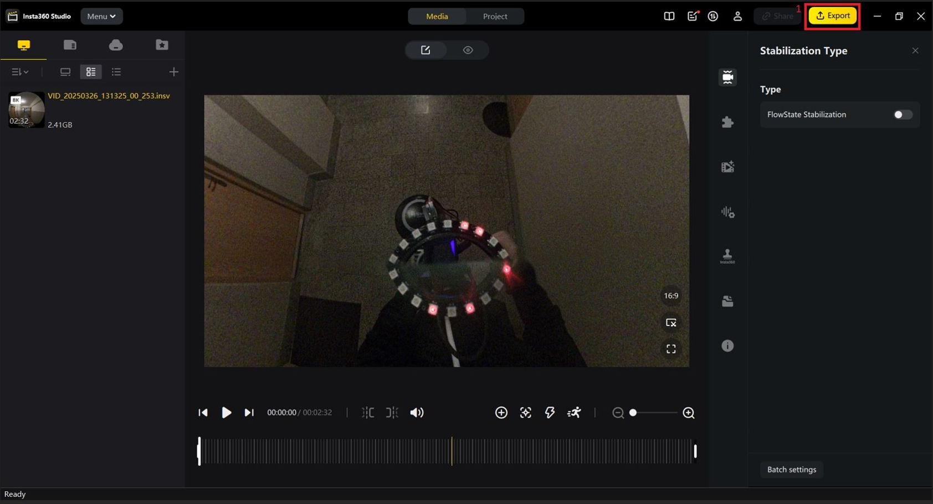

- Set 360 Video Options
In the export window, ensure that the 360 Video option is selected.
- Choose File Path
Select the destination folder where you want to save the exported video. You can do this by clicking on the file path.
- Click "Start Export"
Once everything is set up, click the "Start Export" button to begin the process.
The export time will depend on the size of the video and your computer's performance.
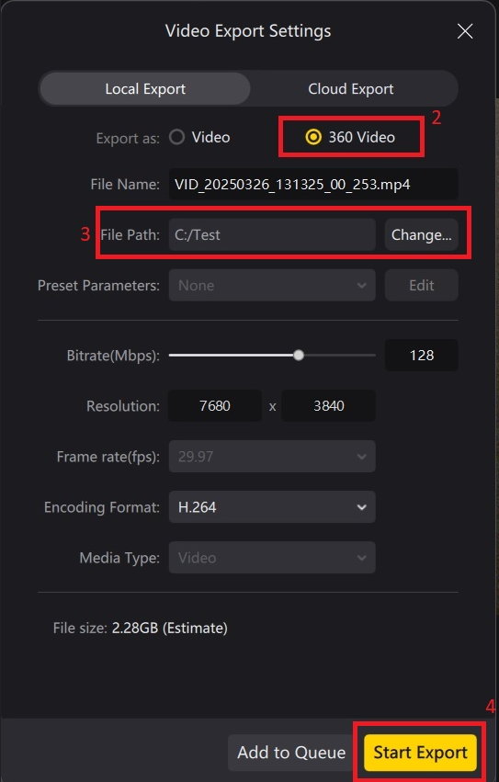

7. Download Ffmpeg
https://ffmpeg.org/download.html

Navigate to the FFmpeg Folder

- Open File Explorer (Windows)
- Go to the location where FFmpeg is installed.
- Open the bin Folder
- Inside the FFmpeg folder, find and open the bin folder. This folder contains the FFmpeg executable files.
- Open Terminal (Windows).
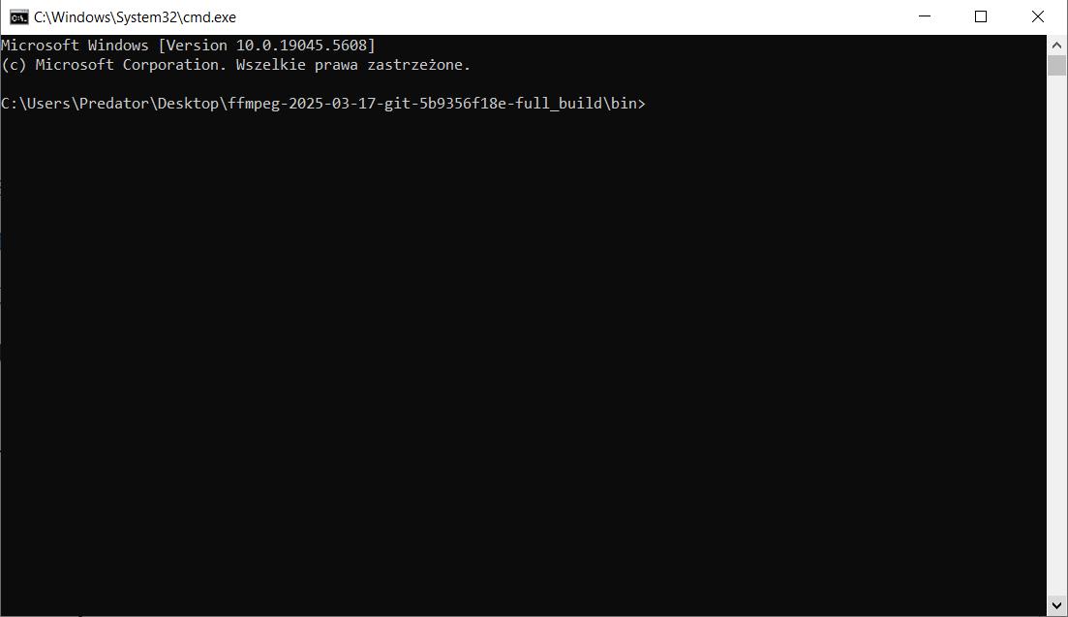

8. Run the FFmpeg Command

ffmpeg -i {path}.mp4 -vf "fps=30" -vsync vfr "frame_name%03d.jpg"

This FFmpeg command performs the following operations:
- -i {path}.mp4
Specifies the input file: {path}.mp4
(Replace {path} with the actual location of your video file.)
- -vf "fps=30"
Applies a video filter (-vf) that sets the frame rate to 30 frames per second (FPS).
This means that the extracted frames will be generated at 30 FPS.
- -vsync vfr
Maintains variable frame rate (VFR) based on the original video timestamps.
Preserves the original timestamps of the frames without modifying them
Drops frames if there are issues (e.g., two frames having the same timestamp) to ensure proper synchronization.
- "frame_name%03d.jpg"
Defines the naming pattern for the output files:
frame_name_ → Prefix for the output file names.
%03d → Frame number in a 3-digit format (e.g., 001, 002, 003...).
.jpg → Saves each extracted frame as a JPEG image.

