**Fig. 1**

**Prediction before recomputing Vi, Ve, and Vm:**

* **Vi (intracellular potential):** Expected to stay the same unless material properties or boundary conditions are changed.
* **Ve (extracellular potential):** Will remain unchanged as well unless the bath or boundary setup is modified.
* **Vm (transmembrane potential = Vi - Ve):** Will not change either unless there’s a change in geometry, membrane properties (like resistance or capacitance), or source strength.

The figure shows the **electric potential (Vi)** distribution in the intracellular domain of a passive cell, along with current density vector streamlines. The potential is highest at the center (the point source of current at the cell center) and decreases radially outward, forming a smooth, symmetric gradient. The arrows represent current flow direction, moving radially out from the source, consistent with a monopolar current injection.

**Fig. 2**

* **Vi is constant** around 40 mV across all angles (θ), indicating radial symmetry in the intracellular domain and a uniform distribution at the radius being measured.
* **Ve is nearly zero** and constant for all angles, which makes sense if the extracellular space is large and grounded or has a very low potential compared to Vi.
* **Vm remains constant** at ~40 mV, consistent with Vi – Ve, reinforcing the uniform spherical symmetry and no angular variation in potential.

**Fig. 3**

.

**Fig. 4**

**Fig. 5 A**

* The applied field is **distorted** around the cell, due to the discontinuity in electrical properties (cell membrane vs. bath).
* The **electric field norm** is enhanced at the poles (aligned with the field direction) and weakened at the equator, consistent with **field focusing** effects.
* Compared to the uniform applied field, the **field near the membrane is amplified** — this is especially important for triggering transmembrane effects like electroporation.

**Fig. 5 B**

**Fig. 6 A**

**Fig. 6 B**

**Fig. 6 C**

**Fig. 6 D**

**Fig. 6 E**

**Fig. 6 F**

**Fig. 7 A**

**Fig. 7 B**

**a)**

* Increasing membrane resistance **slows down the Vm response** to the applied field.
* The **steady-state Vm amplitude is unaffected**, but the **rise time increases**.
* This behavior is consistent with **capacitive charging theory,** By increasing R_m 10-fold, tau also increases 10-fold. This results in a **slower charging rate**, so Vm takes **longer to reach its steady-state value**

**Fig. 8 A**

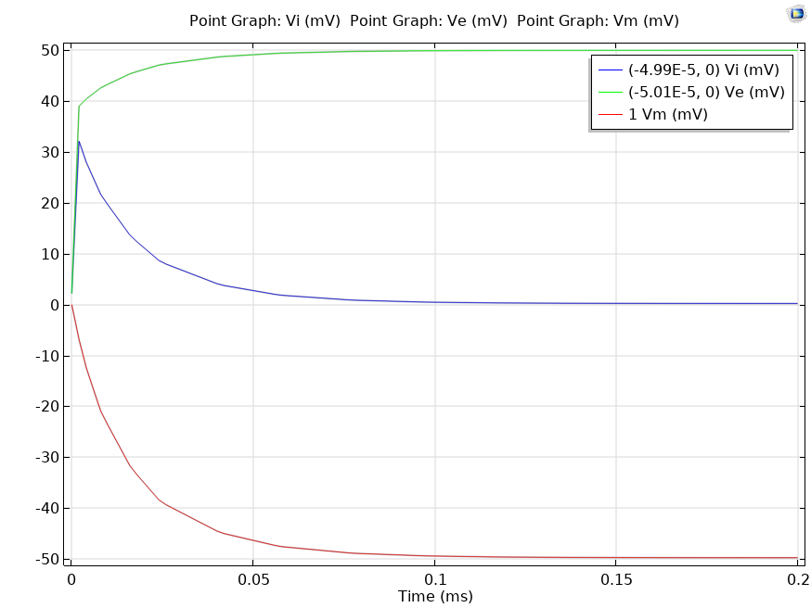

**Fig. 8 B**

**b) Vm stabilizes more slowly** with increased resistivity, but reaches the **same final amplitude**.

* The **dynamic response is slowed**, not the steady-state value — which is governed by the applied field and geometry.
* This matches theoretical expectations for **RC systems** with higher series resistance.

**Fig. 9 A**

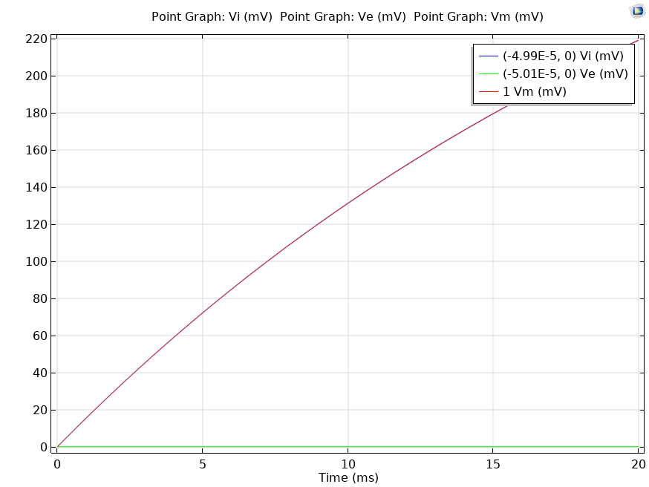

**Fig. 9 B**

**c)** With higher membrane resistance, **Vm rises more sharply and to a higher value**.

* This is because **less current escapes**, and the same injection results in **larger potential buildup**.
* The system becomes **less “leaky”**, leading to **greater polarization** for the same input.

**Fig. 10 A**

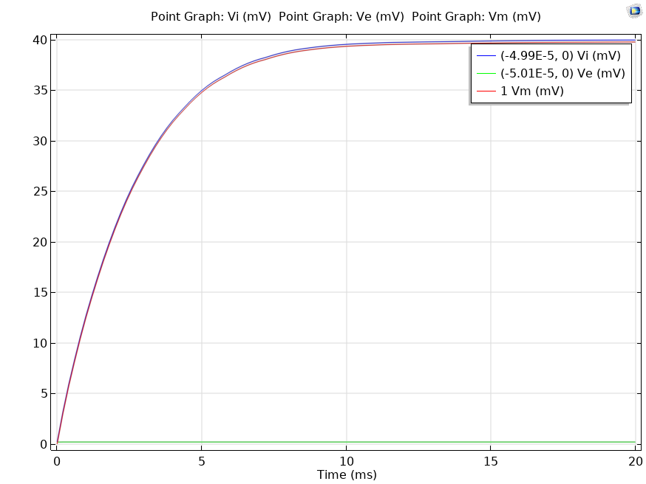

**Fig. 10 B**

**d) Increased resistivity of saline and cytoplasm has little to no effect** on the Vm time course during direct current injection.

* This is because the **internal and external media resistances** are **not the limiting factors** in this configuration.
* **Membrane dynamics dominate** the response.

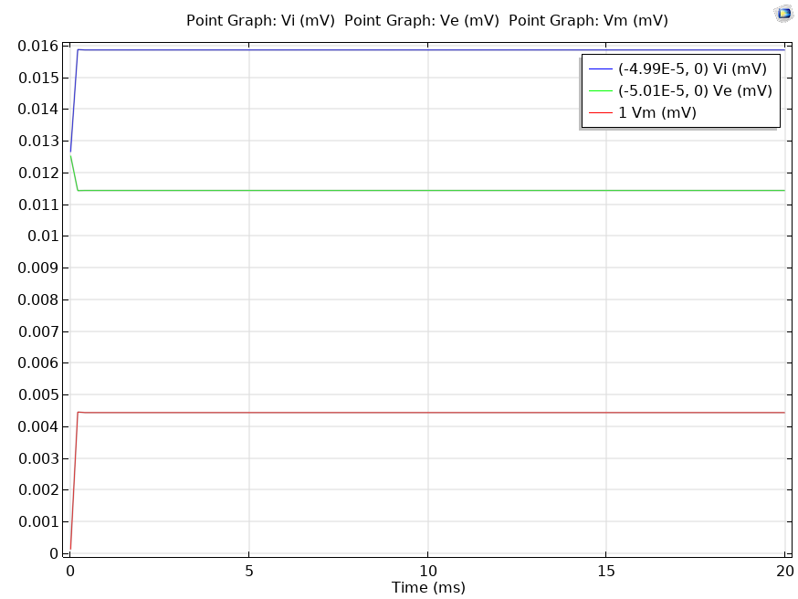

**Fig. 11 A**

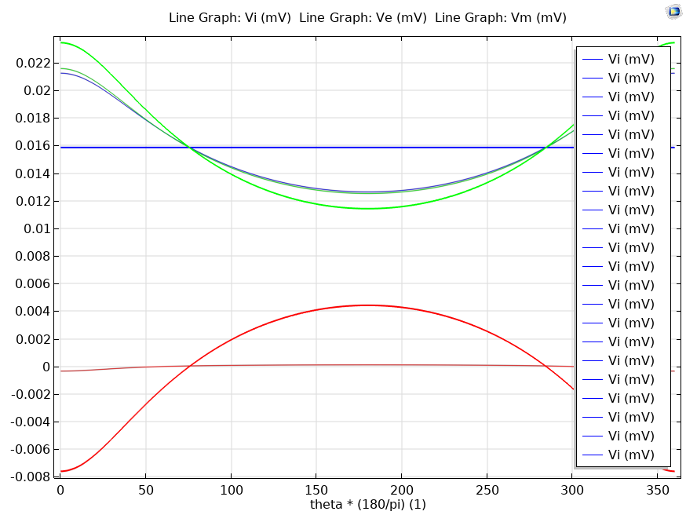

**Fig. 11 B**