**Supplement**

**Part 1:**

|  |  |
| --- | --- |
| A |  |
| B |  |
| C |  |

Fig1.

|  |  |  |  |  |  |  |
| --- | --- | --- | --- | --- | --- | --- |
| Ground | RA (mV) | LA (mV) | LL (mV) | VI (mV) | VII (mV) | VIII (mV) |
| Point at origin | -0.48141 | 1.1704 | 0.34449 | 1.6518 | 0.82590 | -0.82592 |
| Electrode at  (+10,0) | 0.12665 | 1.7785 | 0.95257 | 1.6518 | 0.82592 | -0.82592 |
| Electrode at  (-10,0) | -1.7785 | -0.12664 | -0.95256 | 1.6518 | 0.82590 | -0.82592 |

Table 1.

(i) Even though the electrodes are only used to measure, the **electric potential** around them is still influenced by the surrounding geometry. The current lines (streamlines) in the model naturally follow the path of least resistance. If there are **sharp potential gradients** near the electrode, the current flow will tend to converge toward the electrode, appearing as though the streamlines merge into it.

(j)

|  |  |
| --- | --- |
| **Expression** | **Descriptive Name** |
| aveop1(V) | **Right Arm Voltage (RA)** |
| aveop2(V) | **Left Arm Voltage (LA)** |
| aveop3(V) | **Left Leg Voltage (LL)** |
| aveop2(V) - aveop1(V) | **Lead I Voltage (VI)** |
| aveop3(V) - aveop1(V) | **Lead II Voltage (VII)** |
| aveop3(V) – aveop2(V) | **Lead III Voltage (VIII)** |

(n, o)When the ground reference is moved from (0,0) to (-10,0) or (+10,0), the electrode voltages shift. Specifically, the **RA voltage** becomes negative at (-10,0) and positive at (+10,0), with **LA** and **LL** showing corresponding changes. However, the **bipolar lead voltages (VI, VII, and VIII)** remain largely consistent, with **VI** staying constant as the relative difference between RA and LL doesn’t change. **VII** and **VIII** vary more significantly with the reference shift.

**Part 2:**

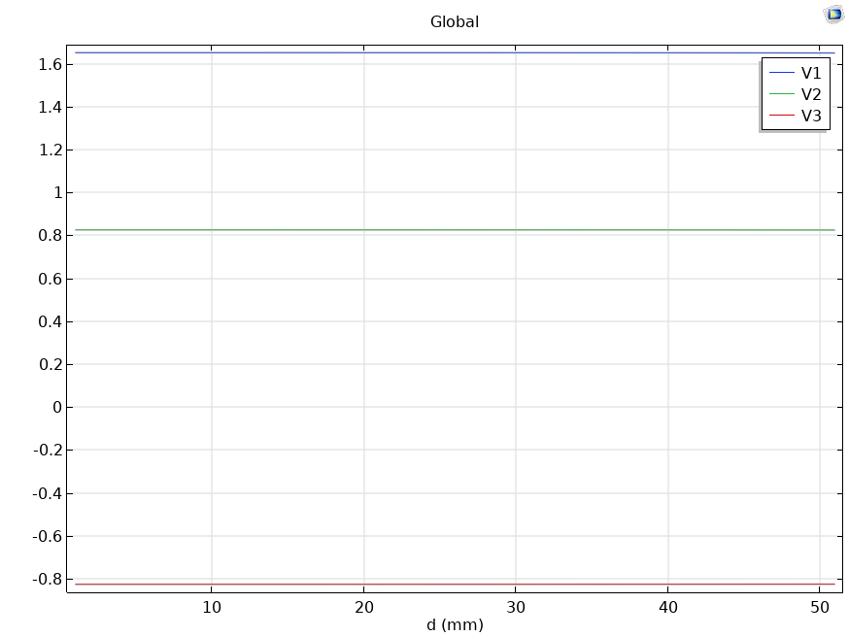

Fig. 2

* As **dipole separation (d)** increases, **VI (Lead I)**, **VII (Lead II)**, and **VIII (Lead III)** will likely show extremely slight decreasing trends in magnitude. This is because, as the dipole moves apart, the electric potential differences between the electrodes decrease.

**Part 3:**

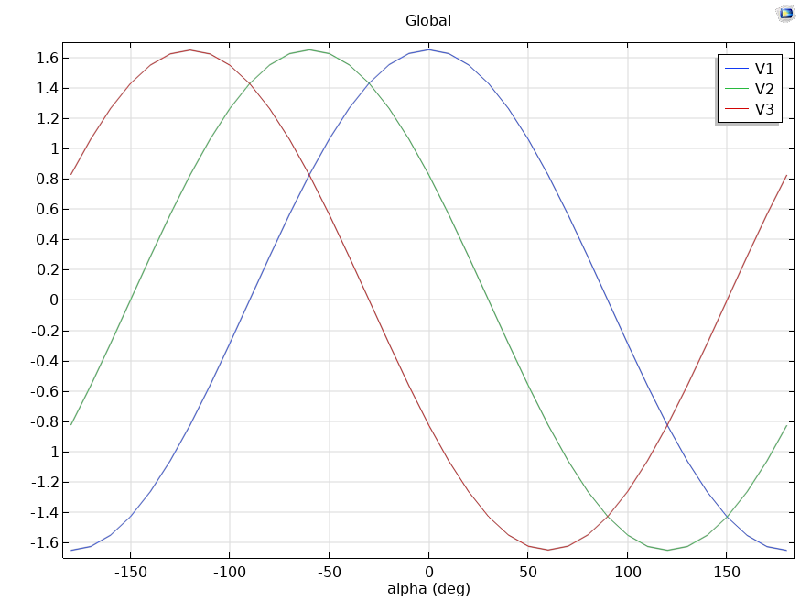

Fig. 3

* **As the dipole angle increases**, the voltages across the electrodes will change due to the **orientation of the dipole** relative to the electrode placement. When the dipole is aligned along the **x-axis (0°)**, **VI (Lead I)** will be the largest because it measures the voltage between the right arm and left arm, which are most aligned with the dipole.
* As the angle changes, **Lead II (VII)** and **Lead III (VIII)** will show different voltage magnitudes, and the voltages for **Lead I** will decrease, reflecting the change in the angle and the corresponding changes in the electric potential distribution.

**Part 4:**

|  |  |  |  |  |  |  |  |  |  |
| --- | --- | --- | --- | --- | --- | --- | --- | --- | --- |
| Time Point | p(uA) | d(mm) | alpha(deg) | RA (mV) | LA (mV) | LL (mV) | VI (mV) | VII (mV) | VIII (mV) |
| 1 | 2.74 | 4 | 173.4 | 0.16634 | 0.016454 | 0.07640 | -0.149890 | -0.08994 | 0.05995 |
| 2 | 2.40 | 4 | 113.2 | 0.09094 | 0.038722 | -0.04021 | -0.052220 | -0.13115 | -0.07893 |
| 3 | 3.72 | 4 | 81.9 | 0.02720 | 0.055795 | -0.13388 | 0.028587 | -0.16109 | -0.18967 |
| 4 | 20.00 | 4 | 54.0 | -0.44067 | 0.205404 | -0.88817 | 0.646079 | -0.44750 | -1.09358 |
| 5 | 15.80 | 4 | 29.5 | -0.69197 | 0.06462 | -0.68419 | 0.756604 | 0.00778 | -0.74881 |
| 6 | 13.22 | 4 | 12.4 | -0.72045 | -0.009744 | -0.50029 | 0.71071 | 0.22015 | -0.49055 |
| 7 | 3.84 | 4 | -9.5 | -0.23455 | -0.025977 | -0.10008 | 0.20858 | 0.13446 | -0.074111 |
| 8 | 2.68 | 4 | -48.2 | -0.13750 | -0.039000 | 0.00688 | 0.09850 | 0.14439 | 0.045888 |

Fig. 4

**Part 5:**

|  |  |  |  |  |  |  |  |  |  |
| --- | --- | --- | --- | --- | --- | --- | --- | --- | --- |
| Time Point | p(uA) | d(mm) | alpha(deg) | RA (mV) | LA (mV) | LL (mV) | VI (mV) | VII (mV) | VIII (mV) |
| 1 | 2.74 | 4 | 173.4 | 0.11423 | 0.011277 | 0.052457 | -0.10295 | -0.061771 | 0.04118 |
| 2 | 2.40 | 4 | 113.2 | 0.062442 | 0.026558 | -0.027631 | -0.035884 | -0.090073 | -0.054189 |
| 3 | 3.72 | 4 | 81.9 | 0.018665 | 0.038273 | -0.091956 | 0.019607 | -0.11062 | -0.13023 |
| 4 | 20.00 | 4 | 54.0 | -0.3027 | 0.14092 | -0.60997 | 0.44362 | -0.30727 | -0.75089 |
| 5 | 15.80 | 4 | 29.5 | -0.47522 | 0.044373 | -0.46984 | 0.5196 | 0.0053819 | -0.51421 |
| 6 | 13.22 | 4 | 12.4 | -0.49477 | -0.006657 | -0.34355 | 0.48812 | 0.15123 | -0.33689 |
| 7 | 3.84 | 4 | -9.5 | -0.16107 | -0.017805 | -0.068716 | 0.14326 | 0.092353 | -0.050911 |
| 8 | 2.68 | 4 | -48.2 | -0.094411 | -0.026743 | 0.0047517 | 0.067668 | 0.099163 | 0.031495 |

Fig. 5

* After the **re-meshing and recomputing**, we would see **different values for the lead voltages (VI, VII, VIII)** because the new boundary conditions (the introduction of water) alter the **electric field** and **current distribution**.
* **VI, VII, and VIII** will show a **smoother and more attenuated waveform** due to the changes in the medium (now involving water).
* **Lead voltages will be more uniform** across the torso since water typically has higher conductivity than air and would cause more uniform current flow.