Hazel Mapuranga

Assignment1 Documentation

## Task1

Users are successfully created, and passwords were only printed for testing purposes.

Execution of the cat /etc/passwd command

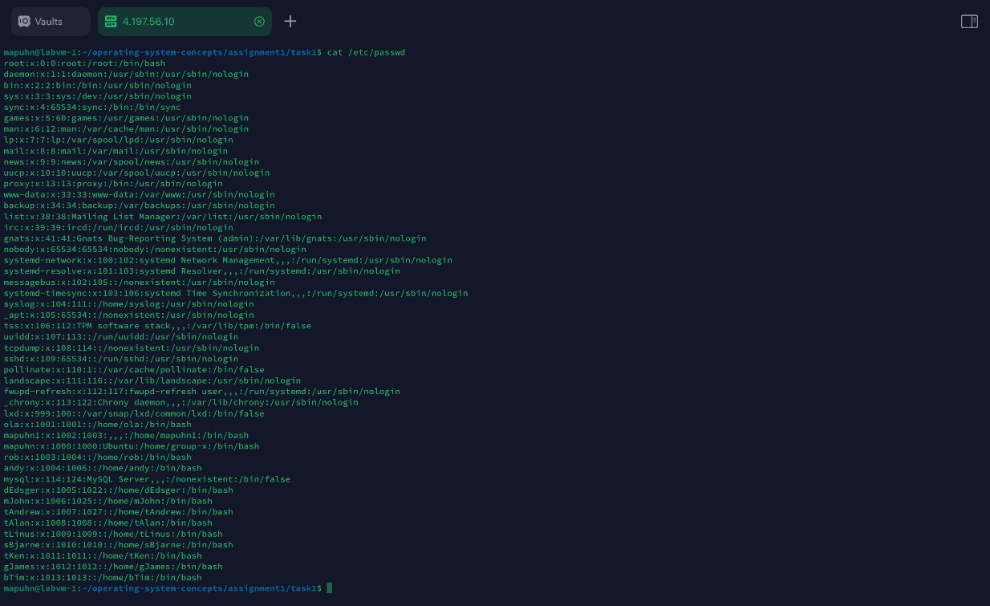

Execution of the cat /etc/group command

## Task2

Execution of the SCP command

Successful execution of the command

