8/1/2025

Hazel Mapuranga (1000125469)

Checkpoint 1 Operating system concepts

## Task 1 : Connecting to Azure Virtual machine using Putty

1. Logged in – successful .
2. Connected using Putty - successful.
3. Changing the account username

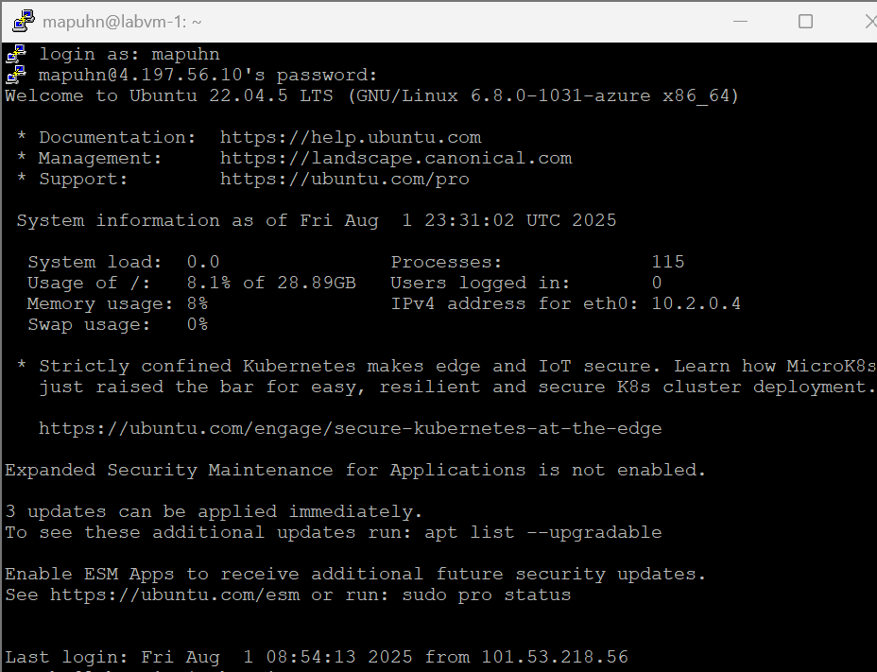

I did this by creating a password for the root user as the group-x user by using the

* sudo passwd root command
* sudo mkdir -p /home/mapuhn
* sudo cp -r "/home/group-x"/* /home/mapuhn/
* sudo cp -r "/home/group-x"/.* /home/mapuhn/ 2>/dev/null (to copy hidden files)
* sudo chown -R mapuhn:group-x /home/mapuhn (to set proper ownership)

## Task 2 : User On-Boarding Automation

Terminal output from running the onboard_users.sh script that processes the users.csv file :

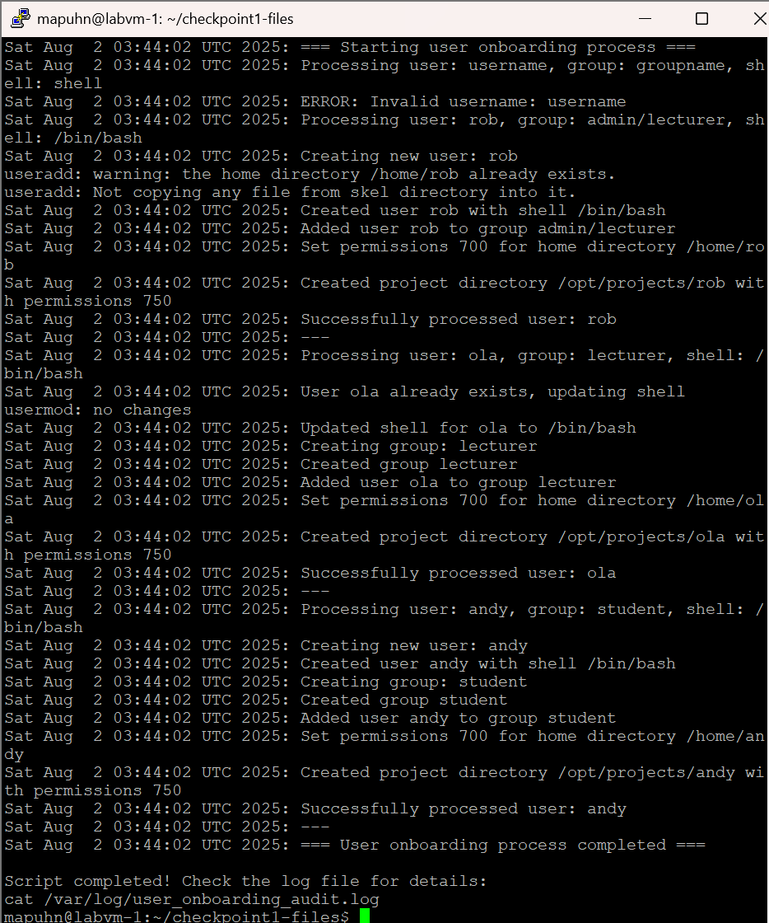

### Onboard script explained

**How it works:** The script reads the CSV file line by line, extracts username/group/shell info that we got from the users.csv file, then creates user accounts and sets up their folders with the right permissions.

**Design choices**: I used a logging function which is the (log_action) to record everything with timestamps, made the script keep going even if one user fails, and handles both creating new users and updating existing ones.

**Error handling**: Checks if usernames are valid, makes sure the shell exists, skips bad entries, and continues processing other users. Won't crash if files are missing or users already exist.

**What the output means:** Shows when users or groups are created, when permissions are set and logs any issues like existing folders or unchanged settings. Every action gets timestamped for tracking.

The contents of /var/log/user_onboarding_audit.log :

This output shows the following:

It is looping through each line from the users.csv file and doing username validation as well. It then creates a user in the current while loop iteration, and sets the user shell, adds the user to a certain group then sets their permissions and lastly creates a project directory for the user. After all this is done, it echoes back to the user that the script completed. And to check the log details it prints to the screen a cat command (cat /var/log/user_onboarding_audit.log) to where the output text file also lives.

### Task 3 : Critical log analysis

Terminal output of the results of the top 10 tokens

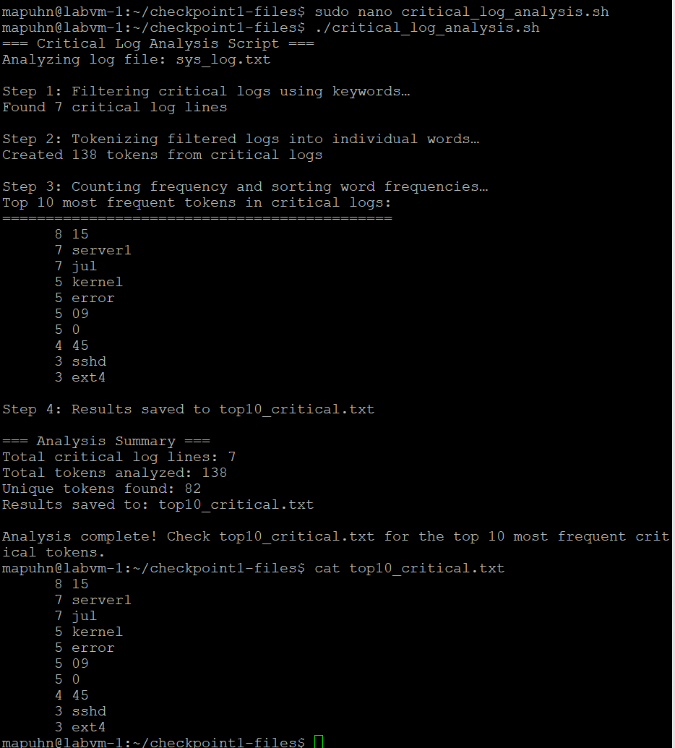

The output shows how many critical log lines were found which are ERROR, CRITCAL and FATAL and in total they are 7. Then prints back to the screen that the filtered logs are being tokenized into individual word. Then it shows the 10 most frequent tokens from the critical logs. After this it prints back where the output was saved in this case the top10_critical.txt file and then I by used the cat command to show the results saved into that file