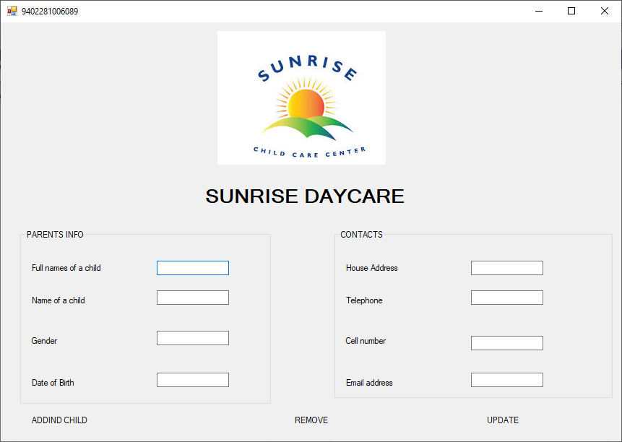

Public Class MATHOBELA MT

9402281006089

Public IDKey As Long

Private Sub Form1_Load(ByVal sender As System.Object, ByVal e As System.EventArgs) Handles MyBase.Load

'TODO: This line of code loads data into the 'CHEFDataDataSet.CHEF_TABLE' table. You can move, or remove it, as needed.

Me.CHEF_TABLETableAdapter.Fill(Me.CHEFDataDataSet.CHEF_TABLE)

Try

'My Connection Object

Dim dbconnect As New OleDb.OleDbConnection

'My Command Object

Dim command As New OleDb.OleDbCommand

'table object to hold the selected data for the grid

Dim CHEF_TABLE As New Data.DataTable

'My connection string

dbconnect.ConnectionString = "Provider=Microsoft.ACE.OLEDB.12.0;Data Source=C:\Users\SAVAGE\Desktop\KABELO\CHEFData.accdb"

dbconnect.Open()

command.Connection = dbconnect

command.CommandText = "SELECT * FROM CHEF_TABLE"

CHEF_TABLE.Load(command.ExecuteReader())

dbconnect.Close()

grvCHEF.DataSource = CHEF_TABLE

Catch ex As Exception

MsgBox(ex.ToString)

End Try

End Sub

Private Sub BtnInsert_Click(ByVal sender As System.Object, ByVal e As System.EventArgs) Handles BtnInsert.Click

Try

Dim dbconnect As New OleDb.OleDbConnection

Dim command As New OleDb.OleDbCommand

Dim CHEF_TABLE As New Data.DataTable

dbconnect.ConnectionString = "Provider=Microsoft.ACE.OLEDB.12.0;Data Source=C:\Users\SAVAGE\Desktop\KABELO\CHEFData.accdb"

dbconnect.Open()

command.Connection = dbconnect

command.CommandText = "INSERT INTO CHEF_TABLE (CHF_ID, CHF_Name ,CHF_Telephone , CHF_Speciality,) VALUES (@CHF_ID, @CHF_Name, @CHF_Telephone, @CHF_Speciality,)"

'Seting the parameters with the contents of the textboxes

Dim parCHEF_ID = New OleDb.OleDbParameter("@CHF_ID", txtCHF_ID.Text)

Dim parCHEF_Name = New OleDb.OleDbParameter("@CHF_Name", txtCHF_Name.Text)

Dim parCHEF_Telephone = New OleDb.OleDbParameter("@CHF_Telephone", txtCHF_Tel.Text)

Dim parCHEF_Speciality = New OleDb.OleDbParameter("@CHF_Speciality", txtchf_Spec.Text)

'Adding the parameters to the list

command.Parameters.Add(parCHEF_ID)

command.Parameters.Add(parCHEF_Name)

command.Parameters.Add(parCHEF_Telephone)

command.Parameters.Add(parCHEF_Speciality)

command.ExecuteNonQuery()

dbconnect.Close()

Catch ex As Exception

MessageBox.Show(ex.ToString())

End Try

End Sub

Private Sub BtnUpdate_Click(ByVal sender As System.Object, ByVal e As System.EventArgs) Handles BtnUpdate.Click

Try

Dim dbconnect As New OleDb.OleDbConnection

Dim command As New OleDb.OleDbCommand

Dim DOCTORS_TABLE As New Data.DataTable

dbconnect.ConnectionString = "Provider=Microsoft.ACE.OLEDB.12.0;Data Source=C:\Users\SAVAGE\Desktop\KABELO\CHEFData.accdb"

dbconnect.Open()

command.Connection = dbconnect

command.CommandText = "UPDATE DOCTORS_TABLE (CHF_ID, CHF_Name ,CHF_Telephone , CHF_Speciality,)VALUES (@CHF_ID, @CHF_Name, @CHF_Telephone, @CHF_Speciality,)"

'Seting the parameters with the contents of the textboxes

Dim parCHEF_ID = New OleDb.OleDbParameter("@cHF_ID", txtCHF_ID.Text)

Dim parCHEF_Name = New OleDb.OleDbParameter("@CHF_Name", txtCHF_Name.Text)

Dim parCHEF_Telephone = New OleDb.OleDbParameter("@CHF_Telephone", txtCHF_Tel.Text)

Dim parDoctor_Speciality = New OleDb.OleDbParameter("@CHEF_Speciality", txtCHF_Spec.Text)

'Adding the parameters to the list

command.Parameters.Add(parCHEF_ID)

command.Parameters.Add(parCHEF_Name)

command.Parameters.Add(parCHEF_Telephone)

command.Parameters.Add(parCHEF _Speciality)

command.ExecuteNonQuery()

dbconnect.Close()

Catch ex As Exception

MessageBox.Show(ex.ToString())

End Try

End Sub

Private Sub BtnSearch_Click(ByVal sender As System.Object, ByVal e As System.EventArgs) Handles BtnSearch.Click

Try

Dim dbconnect As New OleDb.OleDbConnection

Dim command As New OleDb.OleDbCommand

Dim DOCTORS_TABLE As New Data.DataTable

dbconnect.ConnectionString = "Provider=Microsoft.ACE.OLEDB.12.0;Data Source=C:\Users\SAVAGE\Desktop\KABELO\CHEFData.accdb"

dbconnect.Open()

command.Connection = dbconnect

command.CommandText = "SELECT * FROM CHEF_TABLE WHERE CHF_Name = @CHF_Name"

Dim paramName = New OleDb.OleDbParameter("@CHF_Name", txtCHF_Name.Text)

command.Parameters.Add(paramName)

CHEADF_TABLE.Load(command.ExecuteReader())

dbconnect.Close()

If DOCTORS_TABLE.Rows.Count = 0 Then

MessageBox.Show("No Contact found, Re-enter")

ElseIf DOCTORS_TABLE.Rows.Count = 1 Then

txtCHS_ID.Text = CHEF_TABLE.Rows(0)("CHEF_ID")

txtCHF_Name.Text = CHEF_TABLE.Rows(0)("CHEF_Name")

txtCHF_Tel.Text = DOCTORS_TABLE.Rows(0)("CHEF_Telephone")

txtCHF_Spec.Text = DOCTORS_TABLE.Rows(0)("CHEF_Speciality")

End If

Catch ex As Exception

MsgBox(ex.ToString())

End Try

End Sub

Private Sub BtnDelete_Click(ByVal sender As System.Object, ByVal e As System.EventArgs) Handles BtnDelete.Click

Try

Dim dbconnect As New OleDb.OleDbConnection

Dim command As New OleDb.OleDbCommand

Dim DOCTORS_TABLE As New Data.DataTable

dbconnect.ConnectionString = "Provider=Microsoft.ACE.OLEDB.12.0;Data Source= C:\Users\Black-k-Savage\Desktop\KABELO\CHEFData.accdb"

dbconnect.Open()

command.Connection = dbconnect

command.CommandText = "DELETE FROM FROM CHEF_TABLE WHERE (CHF_ID, CHF_Name ,CHF_Telephone , CHF_Speciality,) VALUES (@CHF_ID, @CHF_Name, @CHF_Telephone, @CHF_Speciality,)"

Dim paramName = New OleDb.OleDbParameter("@CHF_Name", grvHealth.CurrentRow.Cells("Doc_Name").Value)

command.Parameters.Add(paramName)

command.ExecuteNonQuery()

dbconnect.Close()

Catch ex As Exception

MsgBox(ex.ToString)

End Try

End Sub

Private Sub updGrid()

Try

Dim dbconnect As New OleDb.OleDbConnection

Dim command As New OleDb.OleDbCommand

Dim DOCTORS_TABLE As New Data.DataTable

dbconnect.ConnectionString = "Provider=Microsoft.ACE.OLEDB.12.0;Data Source=C:\Users\SAVAGE\Desktop\KABELO\CHEFhData.accdb"

dbconnect.Open()

command.Connection = dbconnect

command.CommandText = "SELECT * FROM CHEF_TABLE"

DOCTORS_TABLE.Load(command.ExecuteReader())

dbconnect.Close()

grvCHEF.DataSource = CHEF_TABLE

Catch ex As Exception

MsgBox(ex.ToString)

End Try

End Sub

Private Sub BtnNext_Click(ByVal sender As System.Object, ByVal e As System.EventArgs) Handles BtnNext.Click

'Moving to the Next Row

CHEFTABLEBindingSource.MoveNext()

End Sub

Private Sub BtnPreviouse_Click(ByVal sender As System.Object, ByVal e As System.EventArgs) Handles BtnPreviouse.Click

'Moving to the Previous Row

CHEFTABLEBindingSource.MovePrevious()

End Sub

Private Sub BtnClear_Click(ByVal sender As System.Object, ByVal e As System.EventArgs) Handles BtnClear.Click

'Clearing all My Text Boxes

txtCHF_ID.Clear()

txtCHF_Name.Clear()

txtCHF_Tel.Clear()

txtCHF_Spec.Clear()

End Sub

Private Sub BtnSave_Click(ByVal sender As System.Object, ByVal e As System.EventArgs) Handles BtnSave.Click

'Saving the File

On Error GoTo SaveErr

CHEFTABLEBindingSource.EndEdit()

CHEF_TABLETableAdapter.Update(HealthDataDataSet)

MessageBox.Show("EVERYTHING IS SAVED")

SaveErr:

Exit Sub

End Sub

End Class





EVERYTHING IS SAVED

