**42178**

Transport system analysis – demand and planning

Portfolio 4



**s212156 -** Irene Gómez Sánchez

**s212904 -** Zoltán György Varga

**s213470 -** Jakob Ryttergaard Poulsen

Content

Table list 1

Exercise 1 3

Task 1: Implement the model 3

Task 2: Calculate OD matrices and calibrate the model 5

Task 3: Analyse model sensitivity 6

Exercise 2 7

Task 1: Apply the model from Exercise 1 for policy analysis 7

Task 2: Cost-benefit analysis of the PT price reduction policy 7

Section 3: Cost-benefit analysis with feedback 9

# Table list

Table 1. Exercise 1.2. Comparison observed and obtained market shares 5

Table 2. Exercise 1.2. Results from ASC iterative procedure 6

Table 3. Exercise 1.2. ASC constants calibrated values 6

Table 4. Exercise 1.3. Elasticities 6

Table 5. Exercise 2.1. Point pivoting technique results 7

Table 6. Exercise 2.3. New market shares 9

# Figure list

Figure 1. Exercise 1.1. Structure of nested logit model 3

Figure 2. Exercise 1.1. Market shares of transport modes 4

Figure 3. Exercise 1.2. OD matrices from GAs 5

Figure 4. Exercise 2.2. Total Added consumer surplus and total lost ticket revenues 9

# Exercise 1

## Task 1: Implement the model

**Based on the application data, the model structure, and the parameters you are asked to implement the model. Open the application data in Excel and calculate the following;**

* **The mode choice utility function.**
* **The conditional mode choice probabilities P𝑖(𝑚|𝑑) for each representative person (indexed by the zone 𝑖) and each destination *d* for all modes 𝑚.**
* **The destination choice utility function.**
* **Destination choice probabilities 𝑃𝑖(𝑑) for each representative person 𝑖𝑖and each destination 𝑑.**
* **The joint probability 𝑃𝑖(𝑚,𝑑) of mode and destination for each person 𝑖𝑖.**

**Hint: Refer to the formulas for the Nested Logit Model Section 8.2. Now, based on the implemented model you are supposed to calculate the**

**- Average mode shares for the population.**

We are asked to implement a nested logit model, designed to predict the probability of person from origin going to destination and choosing between 5 modes of transport; *walking, biking, car, carpooling* and *public transport.* We have 20 origin zones and the same 20 zones as possible destinations. Destination choice is given at the “upper” level of the nested logit model, and mode choice is given at the “lower” level, giving us the nested logit structure shown below in Figure 1.

Figure 1. Exercise 1.1. Structure of nested logit model

The principle behind nested logit models is Random Utility Maximization (RUM). We assume that a choice of destination and mode can be associated with a latent amount of utility. The more utility a certain choice provides, the more likely that person is to make said choice. While the given utility for a specific person is latent, we can estimate systematic utility for a population. We split the utility into systematic utility and a stochastic error-term .

For a nested logit model, we can further partition the systematic utility into systematic utility for a given mode-choice and systematic utility across options within the nest .

We are given the following utility functions and coefficients:

We have no shared systematic utility terms within the nests, so becomes for all utility functions.

We note that the signs of the coefficients are as we would expect; negative coefficients for all traveltimes, highest for walking and biking and lowest for public transport. Owning a car increases the utility and probability of driving, while car cost and public transport cost will decrease the utility and probability of driving and taking public transport respectively. Any access-egress time will also decrease the utility of taking public transport.

From the systematic utility functions, we can assign a probability of a representative individual choosing a specific mode of transport by the following equation

It is given from the assignment that the nest-coefficients has already been multiplied onto the alternative-specific constants in the utility functions. So we can simplify the probabilities into

The probability of choosing a destination is given as

And the joint probabilities are given by

As we are dealing with latent variables in the utility function, the joint probabilities for any given individual may be more or less accurate, but when we aggregate the probabilities over the population of tours, we should approximate an accurate description of the number of tours for the whole population. In this case, we are told that we can assume that 50% of the population takes on a tour every day, so if we multiply the joint probabilities stemming from every origin, for all destinations and modes, with 50% of the population from said origin, we get an estimation of number of tours for all modes, stemming from this origin. The market shares can be seen below

The market shares are given below:

|  |  |  |  |  |
| --- | --- | --- | --- | --- |
| MS-walk | MS-bike | MS-car | MS-carp | MS-pub |
| 4% | 14.1% | 62.7% | 10.6% | 8.5% |

And when we multiply with the 50% of the populations, we get the following demand:

Figure 2. Exercise 1.1. Market shares of transport modes

## Task 2: Calculate OD matrices and calibrate the model

**Based on the model, which is tour based, calculate the corresponding OD matrices for all modes. Since we do the exercise in Excel it is difficult to calculate OD(i,j)=GA(i,j)+GA(j,i). But you are welcome to do it, e.g. using VLOOKUP. Otherwise, it is OK just to approximate this by OD(i,j)=2*GA(i,j). If you do it the easy way you should explain in your report why this is not correct.**

Firstly, based on GAij matrix, the function VLOOKUP was used to build GAji as **(1)** shows in Figure 3, both GAij and GAji were added to get OD matrix as **(2)** shows in the same figure. In order to show it, some cells have been hidden.

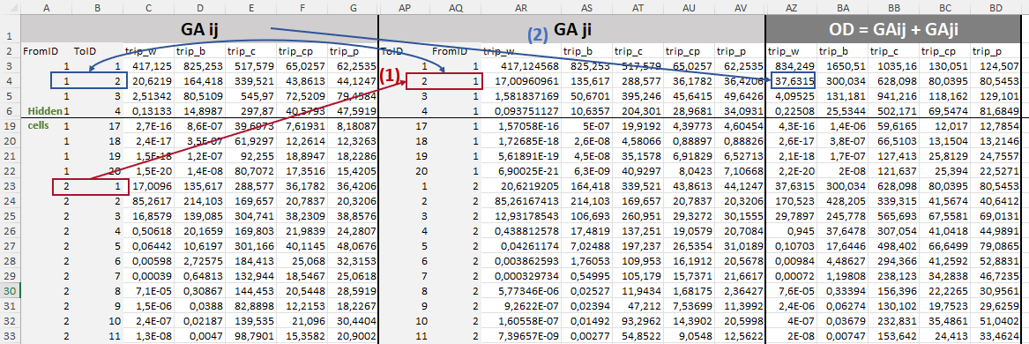

Figure 3. Exercise 1.2. OD matrices from GAs

**Based on the observed OD matrix, you are now asked to evaluate whether the model replicates the market shares of the observed OD matrix. If not, you are asked to calibrate the model so that the mode-choice shares are identical to the market shares of the OD matrix. The observed market shares can be found in the appendix. A few iterations should be enough. You should report how well your model replicates the observed OD mode shares.**

***Hint: Apply algorithm 15.1.***

In the Table 1 are collected both the observed market shares and the ones got through the model in the previous task. As can be noted, they are not the same. Thus, a calibration of ASC constants needs to be carried out.

|  |  |  |  |  |  |
| --- | --- | --- | --- | --- | --- |
|  | MSw | MSb | MSc | MScp | MSpubt |
| Observed | 4% | 14.2% | 62.3% | 8.8% | 10.6% |
| Model | 4% | 14.1% | 62.7% | 10.6% | 8.5% |

Table 1. Exercise 1.2. Comparison observed and obtained market shares

We use an iterative calibration algorithm of the form

Where is the observed market shares we wish to calibrate for, and is the market shares calculated by the model using . When has approximated the algorithm converges.

Only one iteration are needed to calibrate the constants ASC up to the fifth decimal figure, which indicates that the model initially replicated very well the observed market shares.

The results from the iterative process are shown in Table 2.

|  |  |  |  |  |
| --- | --- | --- | --- | --- |
| kw | kb | kc | kcp | kpubt |
| 1,492 | 2,009 | 0,493 | -0,688 | 0,217 |

Table 3. Exercise 1.2. ASC constants calibrated values

## Task 3: Analyse model sensitivity

**Evaluate the model sensitivity with respect to cost and time attributes for trips. Hence, calculate elasticities based on a 10% increase of the main variable in each simulation. This can be done using either your modelled GA matrices or OD matrices. You decide what you prefer. Report the elasticities in a table similar to the one below. Please comment on the elasticities. Do you find them realistic relative to each other?**

The calculated elasticities are included in Table 4. If we increase the car travel cost the car travel is decreasing. If we increase the car travel time, everything which is related to car is decreasing. If we increase the public travel cost or time the number of public transport users are decreasing. We can say that all elasticities make sense.

|  |  |  |  |  |
| --- | --- | --- | --- | --- |
|  | CC | CT | PC | PT |
| Walk | 0,195 | 0,262 | 0,071 | 0,037 |
| Bike | 0,202 | 0,271 | 0,074 | 0,038 |
| Car | -0,151 | -0,087 | 0,091 | 0,055 |
| Car passenger | 0,293 | -0,432 | 0,093 | 0,057 |
| Public Transport | 0,299 | 0,405 | -0,739 | -0,434 |

Table 4. Exercise 1.3. Elasticities

# Exercise 2

## Task 1: Apply the model from Exercise 1 for policy analysis

**It is considered whether to introduce a new pricing policy for public transport in Labtown. This policy involves that every public transport tour, irrespectively of the length will be priced 10 DKK, i.e the one-way ticket is 10 DKK so pubcost (pc) should be changed to 10 DKK. Apply pivoting to predict the effects of this policy in terms of demand changes.**

**Hint: refer to Section 15.4.**

The pivoting technique involves four matrices (Rich J. & Mabit, 2018):

* **Base OD matrix** (OB matrix), which is the one observed from data. These values are taken from *“labtown_od”* Excel file.
* **Model Base OD matrix** (MB matrix), which is the one obtained through the model when running a simulation with a “do-nothing” setting. The model with calibrated constants has been used.
* **Model Scenario OD matrix** (MS matrix), which is the one obtained through the model when running a simulation with a “do-something” setting. In this case, pc is 10DKK.
* **Final Scenario OD matrix** (SC matrix), which is the final OD scenario matrix after pivot pointing.

To use the pivot pointing technique, “*Table 15.3: Pivot pointing scheme”* in the book was consulted. Since all of them OB, MB and MS matrices are positive (>0), then we can select the normal growth prediction, which is as follows:

Applying this formula to the OD matrices, the results obtained are as in Table 5.

|  |  |  |  |  |  |
| --- | --- | --- | --- | --- | --- |
|  | MSw | MSb | MSc | MScp | MSpubt |
| OB matrix | 0,0403 | 0,1419 | 0,6232 | 0,0883 | 0,1063 |
| MB matrix | 0,0403 | 0,1419 | 0,6232 | 0,0883 | 0,1063 |
| MS matrix | 0,0387 | 0,1363 | 0,5919 | 0,0837 | 0,1493 |
| SC matrix | 0,0387 | 0,1361 | 0,5909 | 0,0840 | 0,1504 |

Table 5. Exercise 2.1. Point pivoting technique results

## Task 2: Cost-benefit analysis of the PT price reduction policy

**The transport organisation in Labtown would like to know whether the PT price reduction in task 1 is valuable to the society. As input for a cost-benefit analysis, they therefore ask you to calculate the user benefit of this policy and compare the user benefit to the loss in ticket revenues. To calculate the user benefit, you may use rule of a half, see 17.3 in the book.**

**You may assume that the social value of travel time (SVTT) for all modes is equal to 70 DKK/hr and the social value of access egress time to be 1.5*SVTT.**

**NB. In task 2, it is OK not to consider the feedback of the travel time change due to fewer cars on the mode choice.**

For this task, we need to calculate two values and compare them, the *consumer surplus* and the *lost ticket revenues*.

To calculate the change in consumer surplus, first we need to define the generalized travel cost for all public transport trips in the OD matrix. We are given the following information, the social value of travel time (SVTT) is 70 DKK/hr, and the social value of access egress time is 1.5*SVTT (105 DKK/hr). The generalized travel cost equations then becomes

Where

*TC = Travel Cost (DKK)*

*SVTT = Social Value of Travel Time (DKK/hr)*

*TT = Travel Time (Minutes)*

*AE = Access Egress (Minutes)*

We are interested in the change in consumer surplus from before the price change for public transport to after the price change. Therefore we are also interested in the change in generalized travel cost. We define it as the sum of all generalized travel cost given origin and destinations for all origins and destinations before the price change, subtracted with the generalized travel costs from the scenario where the price has changed.

Where is given before the price change as

And is given after the price change as

Applying the “rule-of-a-half”, we can approximate the surplus that is realized at the existing and added consumers after a change in generalized travel cost as

Where

*= number of travellers before the price change*

*= number of travellers after the price change*

and are calculated by pivoting in task 1 above. So we can plug in the numbers, sum the GTC’s and we get a total added consumer surplus of 352,081.3 DKK.

Now we would like to know the losses in ticket revenue. This is given as

And we get a total loss of ticket revenue of 114.668,8 DKK. Both values are shown graphically below in Figure 4.

Figure 4. Exercise 2.2. Total Added consumer surplus and total lost ticket revenues

It seems there is an overall benefit to be gained for society of **237.412,5 DKK.**

## Task 3: Cost-benefit analysis with feedback

**In the transport organisation of Labtown, a traffic engineer argues that given current commute traffic in Labtown, the car travel time has an elasticity wrt. car demand of 0.5. Discuss how such an effect would affect your results in Task 2 and try to implement a solution that considers this elasticity.**

To implement the effect of the car demand first we calculated the different in percentage between the old and new car market share row wise.

This means the decreasing were 5.9%

We multiplied the calculated percentage by 0.5 because this is the elasticity value.

This way we got the percentage which we could use to get the new car travel time. We multiplied the old car travel time data row wise with 1 - this above-mentioned new percentage.

And using the new ct (car travel time) data we calculated the new market shares. After the implementation we got the new market shares comparing with the old market share. The new and old market shares are included in Table 6. As we expected because the travel time has decreased the number of car user have increased. The described method can be seen in Figure 5.

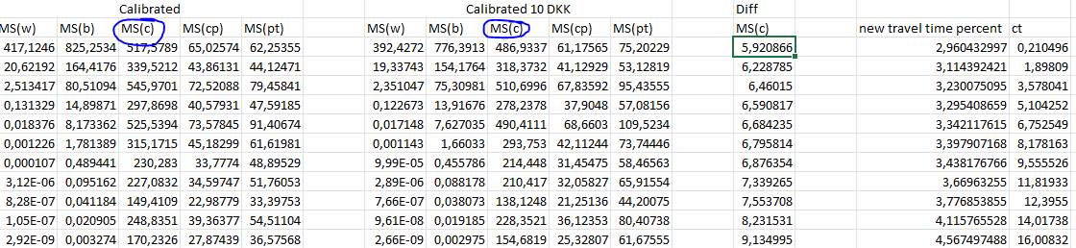

Figure 5 The head of the calculation table

|  |  |  |  |  |
| --- | --- | --- | --- | --- |
| MS(w) | MS(b) | MS(c) | MS(cp) | MS(pt) |
| 11,09 | 39,02 | 169,41 | 23,96 | 42,74 |
| 11,43 | 40,26 | 178,82 | 25,67 | 30,03 |

Table 6. Exercise 2.3. New market shares

When we recalculate the consumer surplus and ticket los revenue we get the following figures

Consumer Surplus: 401.458,8 DKK

Loss in ticket revenue: 119.563,8 DKK

A net gain for society of **281.895 DKK**