Knowledge Graph — System Architecture Proposal
An AI cross-source synthesis instrument · open-core (Community self-host · Premium hosted)
Stack: Next.js / Vercel · FastAPI + Dramatiq on Fly.io · Managed Postgres 16 + pgvector · Anthropic / Voyage / Ollama

1. Overview
Knowledge Graph is an AI cross-source synthesis instrument — not a notes app — for researchers, analysts, and writers. Users write their own notes and import their existing reading library; the product surfaces genuinely non-obvious, true, cross-domain connections between notes: links that topical or embedding similarity cannot find because the notes are far apart in subject matter.
Core principle. A deterministic six-stage pipeline decides what surfaces; the LLM reasons and renders but never selects or invents a connection it cannot ground. A separate verifier model — with no access to the reasoner's rationale — scores validity and non-obviousness independently (decorrelated judgment). Only q = min(validity, non-obviousness) ≥ 3 surfaces; an empty result is the correct result. No LLM or embedding call ever runs on an HTTP request path — all engine work is asynchronous, idempotent, and keyed by (content_hash, model_version).
One codebase, two editions. Community (open-source, self-host, bring-your-own Ollama, on-demand only, fully private) and Premium (hosted, managed Claude, background scan + weekly digest) are the same code behind env seams — the engine API is identical; only the trigger and the model_router targets differ.
Open for review: the async substrate default (Postgres-queue vs Redis+Dramatiq for Premium), the embedder choice (eval-gated, not pre-committed), the feedback re-ranker, and the bulk-import cost controls — each is called out under its section.

Scope of this document
- On-demand Find connections / Scan — the user-facing path: a user triggers the engine over the open note or the whole library and gets surfaced connections, a local graph, and clusters.
- Ingestion — authored notes and imports (file-drop + managed connectors) flow through one normalize → enqueue → engine path.
- Premium background path — a scheduler fans out incremental scans and a weekly digest.

2. System context
The system in scope is the Knowledge Graph platform. Users write and import notes and trigger connection-finding; the platform depends on model and embedding providers, an object store, import connectors, and (Premium) auth and email. Community swaps managed providers for local Ollama and runs without Clerk/email.
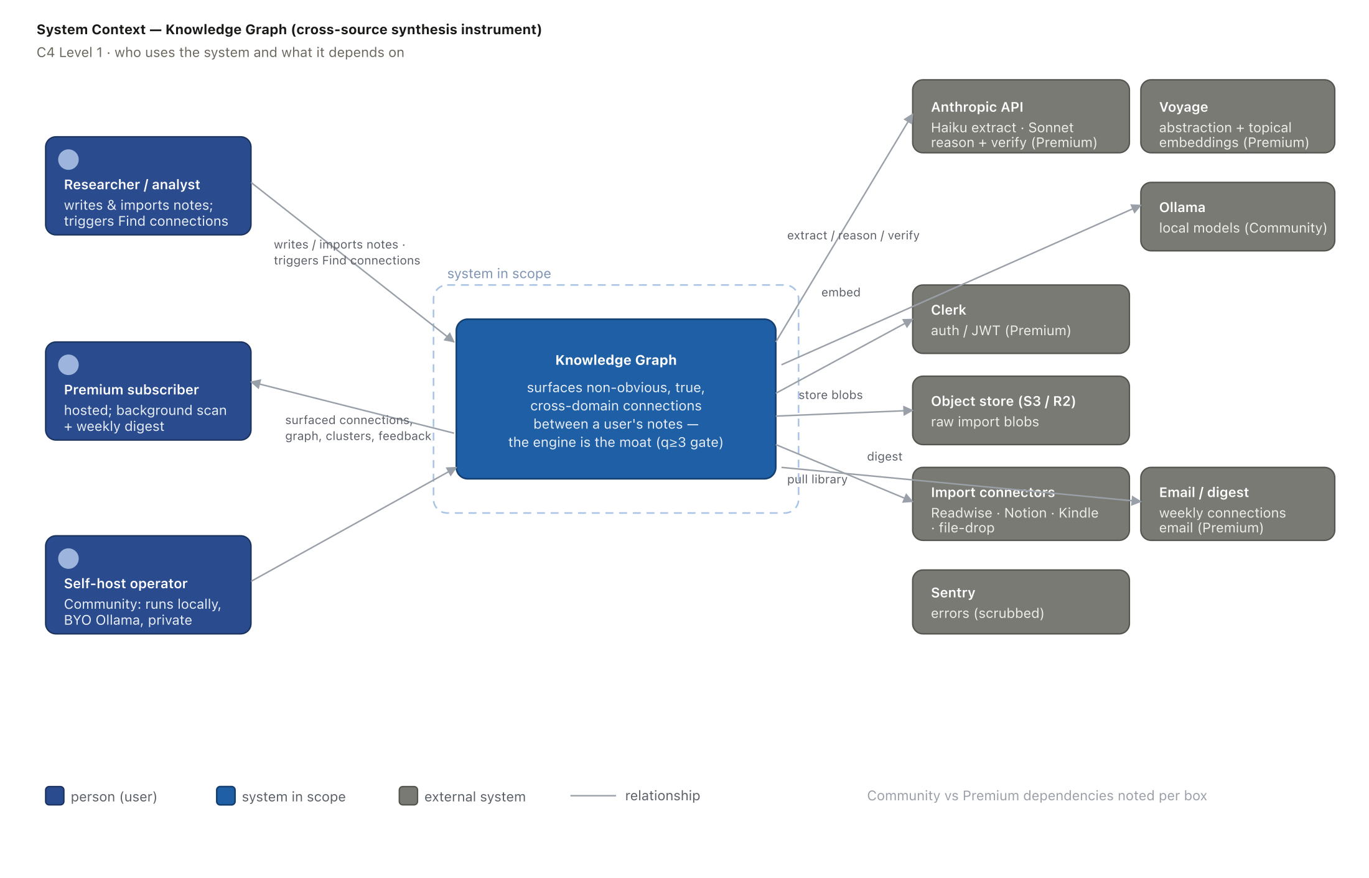
Figure 1 — System context (C4 Level 1). Dependencies are labelled Community vs Premium.

3. Architecture — containers & data flow
The platform is a modular monolith plus workers: a thin Next.js BFF, a FastAPI edge that only authenticates and enqueues, a queue seam over a durable Postgres outbox, and a worker that runs the engine off the request path. Postgres + pgvector is the single system of record.
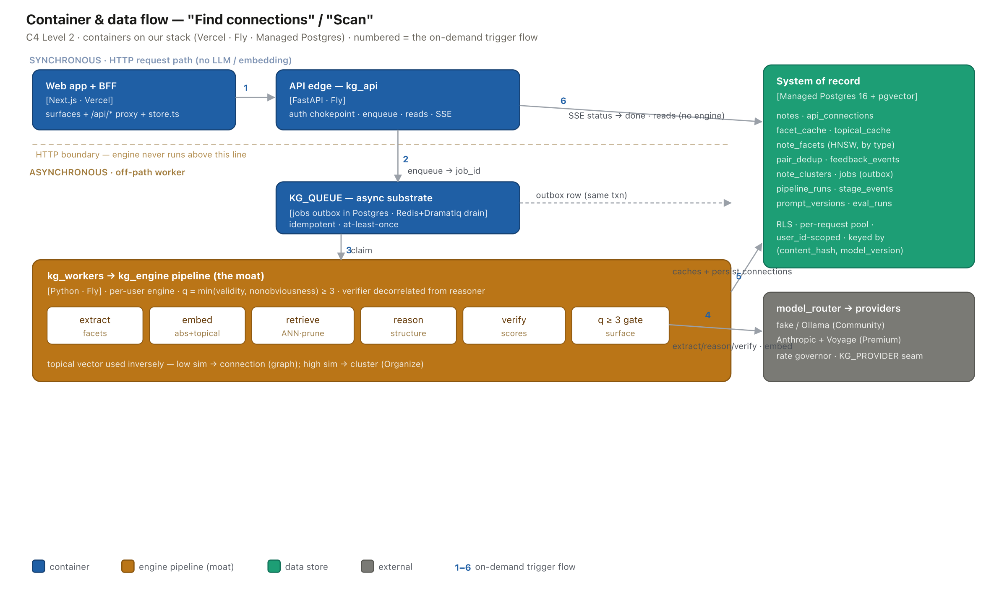
Figure 2 — Container & data-flow (C4 Level 2). Numbers 1–6 trace the on-demand “Find connections” flow; the engine never runs above the HTTP boundary.

4. Flows

4.1 Find connections / Scan (the on-demand trigger)
A user opens a note and clicks Find connections (or Scan library). The edge authenticates, enqueues a job, and returns a job id; the client streams progress over SSE. A worker drains the job and runs the pipeline, persisting only q≥3 connections. Reads serve persisted rows — no model call on any request.
Component | Service (our stack) | Role
Web app + reads | Next.js · Vercel | SPA surfaces (Notes · Graph · Organize); thin BFF proxy; consumes the SSE progress stream
API entry | kg_api — FastAPI · Fly | Auth chokepoint (sole user_id source); validate; enqueue; return job_id — no LLM/embedding
Async substrate | KG_QUEUE — Postgres jobs outbox (Community) / Redis + Dramatiq (Premium) | Durable, idempotent, at-least-once; double-click collapses to one job
Engine worker | kg_workers — Python · Fly | Drains queue off-path; runs extract → embed → retrieve → reason → verify → q-gate
Extraction | Anthropic Haiku (Premium) / Ollama (Community) | 0–5 typed structural facets per note; cached forever by content_hash
Reasoning + verifier | Anthropic Sonnet (Premium) / Ollama (Community) | Reason the shared structure, then an independent decorrelated verify — two calls, never merged
Embeddings | Voyage (Premium) / nomic · bge-m3 (Community) | Abstraction-space + topical vectors; topical cached by (content_hash, embed_version)
Vector search | Postgres + pgvector (HNSW) | Type-partitioned ANN; topical-reject + generic-skeleton prune before any LLM call
System of record | Managed Postgres 16 | Notes, connections, caches, dedup, jobs, clusters, feedback, eval — RLS, user-scoped
Progress | SSE via kg_api | Live job status (queued → done) to the client
Observability | stage_events table + Sentry | Per-stage latency/status/retries; errors scrubbed of note text
Points for discussion
- Async substrate default: Postgres SKIP-LOCKED (zero extra infra, the Community default) vs Redis+Dramatiq for the Premium digest/scan fan-out. We default Premium to Redis for backpressure/priority/abort; PG-queue would contend with pgvector on the same database.
- Verifier model: Sonnet vs a cheaper model — the floor experiment shows local verifiers cap recall, so the moat (reason+verify) is the place to spend.
- topical_reject threshold: the floor experiment moved it 0.82 → 0.92 after it wrongly rejected metaphor-sharing cross-domain analogies (genuine recall 0/4 → 1/4, garbage flat).

4.2 Ingestion — authored notes & import
Every path terminates in one normalize → enqueue entrypoint, so adding a source never touches the engine. An authored note is just another ingestion source. Idempotency by content_hash means an overlapping highlight (the same passage in Kindle and Readwise) deduplicates and never double-bills extraction.
Component | Service (our stack) | Role
File-drop import | Next.js client parser | Markdown / .txt / Obsidian / Kindle clippings / Notion export → notes → POST /notes
Managed connectors | Readwise / Notion API (Premium) | OAuth pull → normalize (priority order = breadth is the moat)
Normalize + dedup | kg_api + content_hash | One entrypoint; idempotent; same content never re-extracted or double-billed
Blobs | S3 / Cloudflare R2 | Raw import artifacts + extraction audit trail
Engine path | enqueue → kg_workers | Imported and authored notes share the exact same async pipeline
Points for discussion
- Bulk import lane (KG_BULK_LANE=sync|batch): ship the rate-governed sync fast-lane + per-import spend ceiling + adaptive-K now; the Anthropic Batches API (50% off, ~1h) is deferred until import spend is measured. Invariant: the ceiling throttles backfill over time, never silently dropping corpus coverage.
- Connector health is execution risk: Apple Notes / OneNote / Evernote export paths rot — file-drop first keeps everyone unblocked.

4.3 Background scan & weekly digest (Premium only)
The retention lever. A single external scheduler fans out incremental scans across active users and assembles a weekly “connections found in your library” email. Community is on-demand only (no scheduler, battery-friendly).
Component | Service (our stack) | Role
Scheduler | External Fly cron → tick actor | Leader-safe (no per-replica double-fire); enqueues incremental scans + the weekly digest
Digest | Email provider | Proactive re-engagement loop — the #1 retention lever and the justification for the hosted tier
Points for discussion
- Fan-out cost/latency across ~1000 users is modeled, not measured — this is what pins Premium to Redis+Dramatiq rather than a shared Postgres queue.

4.4 Feedback capture (the moat)
The defensible asset is accumulating per-user feedback, captured the moment a connection is shown. It is an append-only event log anchored to the stable note-pair + facet abstraction (not a foreign key to the version-bound connection row), with an immutable provenance snapshot — so a threshold change never orphans a label.
Component | Service (our stack) | Role
Capture | feedback_events (Postgres, append-only) | Two axes: wrong → validity, obvious → non-obviousness, plus a surface-match signal
Read-back | materialized view | Per-cohort / per-facet downvote-rate decay alarm; threshold tuning; a personalized re-ranker (v2)
Points for discussion
- The data is un-backfillable — the capture schema must be right on day one.
- The day-1 UI must force the wrong/obvious/surface reason, or the two-axis signal collapses to one-axis noise regardless of schema correctness.

5. Deployment topology
Two stateless Fly deployables (kg_api, kg_workers) share Managed Postgres and the queue substrate; Vercel serves the frontend; S3/R2 holds blobs; one external cron owns scheduling. Community collapses to a single process against a local Postgres with no Redis/Clerk/cron.
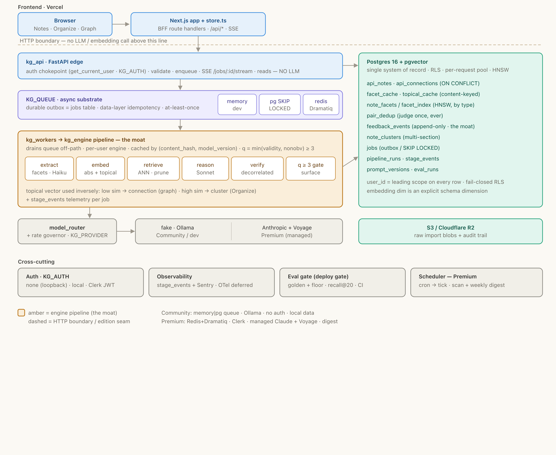
Figure 3 — Deployment & components. Amber = the engine pipeline (the moat); the dashed line is the HTTP boundary; the legend lists the Community vs Premium env seams.

6. Cross-cutting properties (Well-Architected lens)

Reliability
- At-least-once delivery made safe by data-layer idempotency: UNIQUE(content_hash, model_version) + ON CONFLICT, and a lifetime per-pair dedup table — every actor re-checks the cache before any paid call.
- Transactional outbox: the note write and the job enqueue commit in one Postgres transaction; Redis only distributes a drain signal, so durability never depends on the broker.
- DLQ → Postgres with a depth alarm; per-actor TimeLimit unpins a hung model call; Managed Postgres with PITR.

Security & multi-tenancy
- Connections are strictly intra-user. get_current_user is the sole source of user_id; it is the leading column of every index and a filter on every query.
- Defense in depth: fail-closed Row-Level Security keyed on a per-request GUC, plus a mandatory cross-tenant leak test as a CI merge gate (fake-provider tests can never catch a tenancy leak).
- PII: decided before telemetry goes live — Sentry before_send scrubbing, no note text in logs/spans. A bring-your-own-key strict-privacy tier is the v2 wedge for the researcher persona.

Performance & scaling
- The N² all-pairs matrix is never materialized: per-tenant isolation, ANN top-K, five facet-type partitions, and generic-skeleton suppression before any LLM token.
- HNSW is tuned recall-biased (the moat is topically-distant-but-structural matches) with iterative scan so filter+ANN do not under-return; an ANN recall@20-vs-brute-force metric guards it.
- Connection pools are small (LLM latency dominates, not driver QPS); reason/verify fan out per candidate.

Cost
Extraction cached once per unique note; prompt-caching on the frozen system blocks; tiered routing (Haiku extract, Sonnet reason+verify, Opus as the offline eval judge only — never per-pair); embed short abstractions, not full notes; per-import/per-user spend ceilings with adaptive-K.
Target @ 1,000 users | ~$1.30–1.90 / user / month all-in (>85% gross margin against a $/seat price)
Biggest driver | One-time large imports — bounded by the content-hash cache, spend ceilings, and the Opus-free verifier path

Observability & the eval gate
- Day-1 observability is SQL over rows we already write: pipeline_runs / stage_events + per-pair cost/tokens, plus Sentry. OTel/Logfire export is deferred behind a seam until multi-worker scale demands cross-process p99.
- The eval harness is a deploy gate, not optional tooling: two independent thresholds (recall floor AND garbage ceiling) + ANN recall@20 + precision ≥ 75%, gated in CI on any prompt/model/threshold/K change, with shadow mode before promotion.

7. Editions — env seams
Models | Community: Ollama (BYO) · Premium: Anthropic Haiku/Sonnet
Embeddings | Community: nomic / bge-m3 (768-d) · Premium: Voyage (1024-d), eval-gated
Queue (KG_QUEUE) | Community: Postgres SKIP-LOCKED · Premium: Redis + Dramatiq + outbox
Auth (KG_AUTH) | Community: none (loopback) / local token · Premium: Clerk JWT
Triggers | Community: on-demand only · Premium: + background scan + weekly digest
Data | Community: 100% local / private · Premium: hosted (or BYO-key privacy tier, v2)
Price | Community: free · Premium: $ / seat

8. Open risks (not solved by architecture)
- Gate 2 — does genuine insight recur weekly on a real, un-curated corpus at scale? The make-or-break product risk; needs real user data.
- Local-model quality cap: the floor experiment on a messy corpus recovered only 1/4 genuine pairs after threshold tuning — retrieval is exact (recall@20 = 100%), so the gap is the local verifier. Real recall needs managed Claude.
- Generic-skeleton precision decay at 50k+ notes/user is mitigated, not proven; the live downvote-rate canary is the only true alarm and it lags.
- Feedback-flywheel fracture across embedding dimensions (768 vs 1024): a provenance-aware re-embed/reattribution migration must exist before multi-dimension data accumulates.

