# Using Quarto to Generate Documents in APA Style (7th Edition)

Ana Fulano1, Blanca Zutano1, Carina Mengano2,3, and Dolorita C. Perengano4

1Clinical Psychology Program, Department of Psychology, Ana and Blanca’s University

2Carina’s Primary Affiliation

3Carina’s Secondary Affiliation

4Buffalo, NY

# Author Note

Ana Fulano  <https://orcid.org/0000-0000-0000-0001>

Blanca Zutano  <https://orcid.org/0000-0000-0000-0002>

Carina Mengano  <https://orcid.org/0000-0000-0000-0003>

Dolorita C. Perengano  <https://orcid.org/0000-0000-0000-0004>

Carina Mengano is now at Generic University.

The authors have no conflicts of interest to disclose.

Author roles were classified using the Contributor Role Taxonomy (CRediT; [credit.niso.org](https://credit.niso.org)) as follows: *Ana Fulano***:** conceptualization and writing – original draft. *Blanca Zutano***:** project administration and formal analysis. *Carina Mengano***:** formal analysis and writing – original draft. *Dolorita C. Perengano***:** writing – original draft, methodology, and formal analysis

Correspondence concerning this article should be addressed to Ana Fulano, Clinical Psychology Program, Department of Psychology, Ana and Blanca’s University, 1234 Capital St., Albany, NY 12084-1234, USA, Email: [sm@example.org](mailto:sm@example.org)

# Abstract

This document is a template demonstrating the apaquarto format.

*Keywords*: keyword1, keyword2, keyword3

# Using Quarto to Generate Documents in APA Style (7th Edition)

This is my introductory paragraph. The title will be placed above it automatically. *Do not start with an introductory heading* (e.g., “Introduction”). The title acts as your Level 1 heading for the introduction.

Details about writing headings with markdown in APA style are [here](https://wjschne.github.io/apaquarto/writing.html#headings-in-apa-style). In general, level 1 headings should be reserved for the Method, Results, Discussion, References, and Appendices sections.

## Citations

See [here](https://quarto.org/docs/authoring/footnotes-and-citations.html) for instructions on setting up citations and references.

A parenthetical citation requires square brackets (Cameron & Trivedi, 2013). This reference was in my bibliography file. An in-text citation is done like so:

Cameron and Trivedi (2013) make some important points …

See [here](https://wjschne.github.io/apaquarto/writing.html#references) for explanations, examples, and citation features exclusive to apaquarto. For example, apaquarto can automatically handle possessive citations:

Schneider and McGrew’s (2012) position was …

## Masking Author Identity for Peer Review

Setting mask to true will remove author names, affiliations, and correspondence from the title page. Any references listed in the masked-citations field will be masked as well. See [here](https://wjschne.github.io/apaquarto/writing.html#masked-citations-for-anonymous-peer-review) for more information.

## Block Quotes

Sometimes you want to give a longer quote that needs to go in its own paragraph. Block quotes are on their own line starting with the > character. For example, Austen’s (1814/1990) *Mansfield Park* has some memorable insights about the mind:

If any one faculty of our nature may be called more wonderful than the rest, I do think it is memory. There seems something more speakingly incomprehensible in the powers, the failures, the inequalities of memory, than in any other of our intelligences. The memory is sometimes so retentive, so serviceable, so obedient; at others, so bewildered and so weak; and at others again, so tyrannic, so beyond control! We are, to be sure, a miracle every way; but our powers of recollecting and of forgetting do seem peculiarly past finding out. (p. 163)

## Math and Equations

Inline math uses LaTeX syntax with single dollar signs. For example, the reliability coefficient of my measure is $r_{XX}=.95$.

If you want to display and refer to a specific formula, enclose the formula in two dollar signs. After the second pair of dollar signs, place the label in curly braces. The label should have an #eq- prefix. To refer to the formula, use the same label but with the @ symbol. For example, Equation 1 is Euler’s Identity, which is much admired for its elegance.

$$e^{iπ}+1=0 \left(1\right)$$

A more practical example is the z-score equation seen in Equation 2.

$$z=\frac{X−μ}{σ} \left(2\right)$$

If no identifier label is given, a centered equation in display mode will have no identifying number:

$$σ_{e}=σ_{y}\sqrt{1−r_{xy}^{2}}$$

## Displaying Figures

Do you want the tables and figures to be at the end of the document? You can set the floatsintext option to false. The reference labels will work no matter where they are in the text.

A reference label for a figure must have the prefix fig-, and in a code chunk, the caption must be set with fig-cap. Captions are in [title case](https://apastyle.apa.org/style-grammar-guidelines/capitalization/title-case).

Figure 1

The Figure Caption

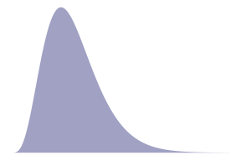

*Note*. This is the note below the figure.

To refer to any figure or table, use the @ symbol followed by the reference label (e.g., Figure 1).

## Displaying Tables

We can make a table the same way as a figure. Generating a table that conforms to APA format in all document formats can be tricky. When the table is simple, the kable function from knitr works well. Feel free to experiment with different methods, but I have found that David Gohel’s [flextable](https://davidgohel.github.io/flextable/) to be the best option when I need something more complex.

Table 1

The Table Caption.

| Numbers | Letters |
| --- | --- |
| 1 | A |
| 2 | B |
| 3 | C |
| 4 | D |

*Note*. The note below the table.

To refer to this table in text, use the @ symbol followed by the reference label like so: As seen in Table 1, the first few numbers and letters of the alphabet are displayed.

## Tables and Figures Spanning Two Columns in Journal Mode

When creating tables and figures in journal mode, care must be taken not to make figures and tables wider than the columns, otherwise LaTeX sometimes makes them disappear.

As demonstrated in Figure 2, you can make figures tables span the two columns by setting the apa-twocolumn chunk option to true.

Figure 2

A Figure Spanning Two Columns When in Journal Mode

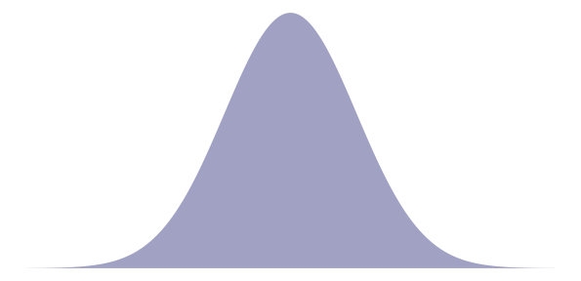

*Note*. Figures in two-column mode are only different for jou mode in .pdf documents

## Using Footnotes

A footnote is usually displayed at the bottom of the page on which the footnote occurs. A short note can be specified with the ^[My note here] syntax.[1] A longer note can be specified with the [^id] syntax with the text specified on a separate line like so [^id]: Text here.[2]

A regular paragraph without any indentation is not part of the footnote and will be part of the main body of the document.

## Hypotheses, Aims, and Objectives

The last paragraph of the introduction usually states the specific hypotheses of the study, often in a way that links them to the research design.

# Method

General remarks on method. This paragraph is optional.

Not all papers require each of these sections. Edit them as needed. Consult the [Journal Article Reporting Standards](https://apastyle.apa.org/jars) for what is needed for your type of article.

## Participants

Who are they? How were they recruited? Report criteria for participant inclusion and exclusion. Perhaps some basic demographic stats are in order. A table is a great way to avoid repetition in statistical reporting.

## Measures

This section can also be titled **Materials** or **Apparatus**. Whatever tools, equipment, or measurement devices used in the study should be described.

### Measure A

Describe Measure A.

### Measure B

Describe Measure B.

#### Subscale B1.

A paragraph after a 4th-level header will appear on the same line as the header.

#### Subscale B2.

A paragraph after a 4th-level header will appear on the same line as the header.

##### Subscale B2a.

A paragraph after a 5th-level header will appear on the same line as the header.

##### Subscale B2b.

A paragraph after a 5th-level header will appear on the same line as the header.

## Procedure

What did participants do? How are the data going to be analyzed?

# Results

## Descriptive Statistics

Describe the basic characteristics of the primary variables. My ideal is to describe the variables well enough that someone conducting a meta-analysis can include the study without needing to ask for additional information.

Table 2 is an example of a plain markdown table. Note the that the caption begins with a colon.

Table 2

My Caption.

| Letters | Numbers |
| --- | --- |
| A | 1 |
| B | 2 |
| C | 3 |

*Note*. My note

# Discussion

Describe results in non-statistical terms.

## Limitations and Future Directions

Every study has limitations. Based on this study, some additional steps might include…

## Conclusion

Describe the main point of the paper.

# References

Austen, J. (1990). *Mansfield Park*. Oxford University Press. (Original work published 1814)

Cameron, A. C., & Trivedi, P. K. (2013). *Regression analysis of count data* (2nd ed.). Cambridge University Press. <https://doi.org/10.1017/CBO9781139013567>

Schneider, W. J., & McGrew, K. S. (2012). The Cattell-Horn-Carroll model of intelligence. In D. P. Flanagan & P. L. Harrison (Eds.), *Contemporary intellectual assessment: Theories, tests, and issues* (3rd ed., pp. 99–144). Guilford Press. <https://psycnet.apa.org/record/2012-09043-004>

# Appendix A

# My Appendix Title

Appendices are created as level 1 headings with an identifier with an #apx- prefix. Appendix titles should be in title case and should describe the content of the appendix.

If there is only one appendix, the label automatically inserted above the the appendix title will be **Appendix**. If there are multiple appendices, the labels **Appendix A**, **Appendix B**, **Appendix C** and so forth will be inserted above the titles.

To cite an appendix as a whole, reference it with the @apx- prefix. For example, see Appendix A and Appendix B.

This is an appendix with a table using markdown (see Table A1).

Table A1

My Caption

| Col 1 | Col 2 | Col 3 |
| --- | --- | --- |
| A | B | C |
| E | F | G |
| A | G | G |

*Note*. These are letters.

# Appendix B

# Another Appendix

See Figure B1, an example of an imported graphic using markdown syntax.

Figure B1

Appendix Figure

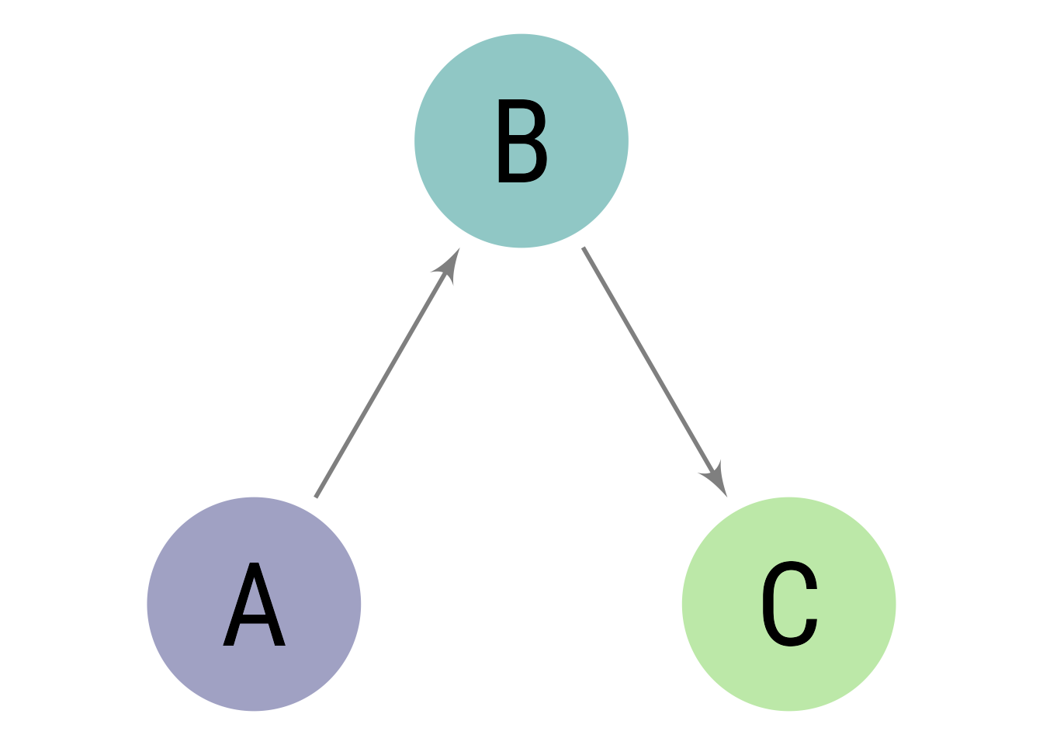

*Note*. A *note* below the figure

1. Here is my short footnote!
2. This is a longer footnote. If it has multiple paragraphs, subsequent paragraphs need to be indented with two tabs.

   This paragraph is still part of the footnote because it is indented with two tabs.