**SOCIAL COMPLAINER WEB FORM**



**DEPARTMENT OF COMPUTER SCIENCE AND ENGINEERING**

**BANGLADESH UNIVERSITY OF BUSINESS AND TECHNOLOGY (BUBT)**

**DHAKA-1216**

**MARCH, 2018**

**SOCIAL COMPLAINER WEB FORM**

**BY**

**Md. Abdur Rahman (ID: 14153103048) Intake: 30th**

**Md. Touhidul Islam (ID: 14153103082) Intake: 30th**

**Oyshorjo Nur Oyshi (ID: 14153103090) Intake: 30th**

**Suborna Nondi (ID: 14153103055) Intake: 30th**

A project

*Submitted to the Department of Computer Science and Engineering*

*Bangladesh University of Business and Technology (BUBT), Dhaka*

*In partial fulfillment of the requirements*

*For the degree*

*Of*

**BACHELOR OF SCIENCE**

**IN**

**COMPUTER SCIENCE AND ENGINEERING**

**SEMESTER: Summer, 2018**

**APPROVED BY:**

**___________**

**Chairman**

**Dr. M. Ameer Ali**

Professor

Department of CSE, BUBT.

**Supervisor**

**Md. Mizanur Rahman**

Assistant Professor

Department of CSE, BUBT.

**DEDICATION**

We dedicate this project to God Almighty our creator, our strong pillar, our source of inspiration, wisdom, knowledge and understanding. He has been the source of my strength throughout this program and on His wings only we have soared. We also dedicate this work to our parents who has encouraged us all the way and whose encouragement has made sure that we give it all it takes to finish that which we have started. We dedicate my dissertation work to my family and many friends. A special feeling of gratitude to our loving parents, whose words of encouragement and push for tenacity ring in my ears. We also dedicate this dissertation to my many friends who have supported me throughout the process.

**ABSTRACT**

Social Complainer Web Form (SCWF), provides a simple interface for complaining against any social issues and occurrence. It can be used for the platform where complaining against any illegal occurrence, and maintaining complains, taking steps from complains and make the society corruption free.

Throughout the project the focus has been on creating a web form that takes complains from the mass people without any registration and deliver it to the admin. Admins are the security moderator, who controls the security system in the society.

The project provides facilities of online complaining and profile creation of security moderators thus reducing paperwork and automating the record generation process in an online security center. It is faster process than traditional system of complaining.

This document will discuss each of the underlying technologies to create and implement Social Complainer Web Form.

**ACKNOWLEDGEMENTS**

Praise to Allah, the most magnificent and the most merciful, without whose patronage and blessing this project would not have been successfully completed. He gave us zeal, confidence, power of determination and courage and vanquished all the stumbling hardness that we faced on the way.

It is an auspicious occasion for us as students of Department of Computer Science and Engineering, one of the prestigious academic centers of the Bangladesh University of Business and Technology(BUBT), to express our deep feelings of gratitude to the department and especially to our supervisor, Head of the department, all the teachers and also to the departmental staff. We are immensely indebted to our supervisor, Md. Mizanur Rahman , Assistant Professor, Department of Computer Science and Technology, for his wonderful guidance, inspiration, encouragement and also for through review and correction of this dissertation work that could not be finalized without his astute supervision.

We would also thank to our honorable Prof. Dr. M. Ameer Ali, **chairman** Department of CSE for his support and giving us permission to use the computer labs whenever we needed.

We pay profound regard to all of our teachers of the department for their very valuable directives and special attention. Our parents are very much keen and hopeful in the best performance of the dissertation we are going to submit. We wish we could fulfill their aspiration. We also pay regards to our friends in the department who, through their interest and work, are our contestant source of inspiration.

With Best Regards,

Md. Touhidul Islam (ID: 14153103082)

Oyshorjo Nur Oyshi (ID: 14153103090)

Md. Abdur Rahman (ID: 14153103048)

Suborna Nondi (ID: 14153103055)

**DECLARATION**

We hereby declare that the project entitled Social Complainer Web Form(SCWF) submitted in partial fulfillment of the requirements for the degree of Bachelor of Science in Computer Science and Engineering in the Faculty of Computer Science and Engineering of Bangladesh University of Business and Technology (BUBT) is our own work and that it contains no material which has been accepted for the award to the candidate(s) of any other degree or diploma, except where due reference is made in the text of the project. To the best of our knowledge, it contains no materials previously published or written by any other person except where due reference is made in the project.

Md. Abdur Rahman(ID-14153103048)

**Md. Abdur Rahman**

**ID: 12133103082**

**ID: 14153103048**

**Suborna Nandi**

**ID: 14153103055**

**Md. Touhidul Islam**

**Oyshorjo Nur Oyshi**

**ID: 14153103090**

**CERTIFICATE**

TO WHOM IT MAY CONCERN

This is to certify that Md. Abdur Rahman(ID-14153103048) , Md. Touhidul Islam (ID-14153103082), Oyshorjo Nur Oyshi(ID-14153103090), and Suborna Nandi(ID- 14153103055) Students of B.Sc. in CSE has completed their project work titled “Social Complainer Web form” satisfactorily in partial fulfillment for the Requirement of B.Sc. In CSE. Bangladesh University of Business and Technology in the year 2018.

**___________**

**Chairman**

**Dr. M. Ameer Ali**

Professor

Department of CSE, BUBT.

**Supervisor**

**Md. Mizanur Rahman**

Assistant Professor

Department of CSE, BUBT.

**TABLE OF CONTENTS**

|  |  |
| --- | --- |
|  |  |
|  |  |
| **DEDICATION** | **………………………………………………….... i** |
| **ABSTRACT** | **…………………………………………………....ii** |
| **ACKNOWLEDGEMENTS** | **………………………………………………….. iii** |
| **DECLARATION** | **………………………………………………..….vi** |
| **CERTIFICATE** | **……………………………………………….…...v** |

|  |  |  |
| --- | --- | --- |
|  |  | **Page No.** |

**Table of Content**

1. Introduction 1

2. Technological Background 1

3. System Analysis & Design 2

**3.1**  **Use Cases** 2

**3.1.1** **Customer Interface** 3

**3.1.2** **Admin Interface** 5

**3.2**  **Sequence Diagrams** 7

**3.2.1** **Customer Interface** 7

**3.2.2** **Admin Interface** 8

**3.3**  **Webpage Diagrams** 9

**3.3.1** **A general diagram of the Customer Side** 9

**3.3.2** **A general diagram of the Admin Side** 11

Web page 11

4. Implementation Detail 11

**4.1**  **Admin side** 12

**4.1.1** **Create Username & Password** 12

**4.1.2** **Login** 12

**4.1.3** **Delete items** 12

**4.1.4** **Modify items** 12

**4.1.5** **Query Sale** 12

**4.1.6** **Query Information** 12

**4.1.7** **Logout** 13

**4.2**  **Customer side** 13

**4.2.1** **Categories are selected** 13

**4.2.2** **Search Products** 13

**4.2.3** **Buy Items** 13

**4.2.4** **Continue Shopping** 13

**4.2.5** **View Cart** 13

**4.2.6** **Change Quantity (in View Cart page)** 13

**4.2.7** **Remove Items** 13

**4.2.8** **Checkout** 13

**4.2.10** **Sign-in** 13

**4.2.11** **Billing/Shipping Information** 13

**4.2.12** **Change (in Bill/Ship Information page)** 14

**4.2.13** **Submit (in Bill/Ship Information page)** 14

**4.2.14** **Delete Order (in Confirm page)** 14

**4.2.15** **Send Order (in Confirm page)** 14

5. Conclusion 14

7. Future Work 15

Works Cited 16

Appendix A 17

Appendix B 19

**CHAPTER 1**

**INTRODUCTION**

**1.1 Introduction**

In today’s world corruption, illegal-unethical activity, inhumanity is increasing day by day. There is security agents to ensure security and make the system ethical and legal. But there is few one who have the courage to complain in police station. Many occurrence is happening in our country. There is no one to complain because of own safety. For this we thought a lot and design this website.

Social Complainer Web Form (SCWF) is complaining web form site for any social issues or occurrence. It is site where mass people can complain their complains without providing personal information.

It is highly profitable for security sector of our country because many people cannot come to police station for complain against any criminal or criminal groups or any illegal activity. Many peoples are afraid of their safety . There is many issues because of why complaining in police station is difficult for a person.

For the remedy of this problem, our website is best to use. Because it is a website that will be moderating by an admin who is security provider to mass people. While complaining complainer need not give his/her any personal information, jst the complain including information on crime location, and description.

A security admin checks the complains and check for validity . If the complain is valid, he/she orders forces to take action immediately.

**2. Project Objectives**

1) To provide an internet medium of receiving complaint from mass people.

2) To make it easy for them complaint without using forms and giving identity.

3) To gather information of complaints and means of settlement.

4) To build the complaint management systematic and effective.

5) To provide immediate action.

# **3. Technological Background**

The tools used to develop ‘Social Complainer Web Form’ include:

- HTML

- PHP scripting language

- MySQL database server

- Apache server

- Text Editor

PHP is a server side scripting language designed especially for the Web. Within an HTML page, PHP code can be embedded and it will be executed each time the page is visited. PHP is an Open Source product. PHP source code can be accessed, used, altered, and redistributed without any charges.

MySQL is a very fast, robust, relational database management system (RDBMS). A database enables the users to efficiently store, search, sort, and retrieve data.

Apache server interprets the PHP code at the Web server and generates HTML or other output that the visitor will see.

Text editor such as Text pad is used to write the coding in plain text that the Web server can recognize and translate into binary code.

There are advantages of using these tools to develop and run the software. Apache server, MySQL server, and PHP are free to download from the internet if one does not have any tools.

# 4. System Analysis & Design

The system was analyzed and designed before implementation began. In this section, use cases, sequence diagrams, and webpage diagrams are described in details.

## 

## 3.1 Use Cases

The following use cases outline the requirements for the online shopping.

They have been revised during the course of the project to more accurately reflect the

system.

**3.2 User Interface:**

**USER**

**User Complain Process:**

User complaining providing personal information:

* This interface is created when user provide his personal phone number address location and complain in details with providing picture of related complains, providing personal information, which is Social complainer web form.
* Here needs no SIGN UP/ LOGIN complication for complaining.
* It’s easy and simple and of course time saving.

User complaining without providing personal information:

* This user interface does not need any personal information to make a complaint for any illegal social issues.
* User can hide his all personal information, post complain anonymously.

**3.3 ADMIN INTERFACE:**

**ADMIN**

1. Admin Login:

Number of security officers are the admins of this complainer site. An admin logins to monitor the complains and take immediate action against it. Admin reads complains and others information from the database.

2. ADMIN DISMISS COMPLAIN:

Admin can dismiss any complain if it is invalid or action has been taken. Dismissing a complain does not delete the complaint from database, simply make it invisible to admins. Making checked complains invisible to admins, it becomes less complicated and easy to

3. ADMIN VIEW COMPLAIN DETAILS:

In admin interface page, there shows list of complains with time and crime location. When admin click on view details, it shows the full complain details with map, picture according to crime location.

Facilities to be provided to the admin

* Administrators will have user-friendly asynchronous GUI (Graphical User Interface) system.
* Data will be shown in Data List view for easy understanding.
* Easy to access. Can be accessed from website.
* Admin can easily monitor all thing in this webpage.

Facilities to be provided to the user

Basically,

* Mass people can complain easily.
* Can complain anonymously.

## 

## 3.2 Sequence Diagrams

The next step is to develop scenarios through sequence diagrams. The sequence diagram below outlines the requirements for online shopping

### **3.2.1 USER Interface**

**Front End:** web browser**; Back End**: web server**; DB** : database server

DA

WEB SERVER

DATABASE

WEB BROWSER

Provide info+complain

Successfully done

Check validity

Only Complain

Successful store complains

**3.2.3 Admin Interface**

**Front End:** web browser**; Back End**: web server**; DB** : database server

DA

WEB SERVER

DATABASE

WEB BROWSER

LOGIN ADMIN

Valid

Check validity

Display complains

List view

Action on complains view/dismiss complains

success

Logout

## 

## 3.3 Webpage Diagrams

### **3.3.1 A general diagram of the user Side:**

Homepage.html

Phone number:

Crime Location

Complain Details

Image insert:

Complain.php

**Valid info.**

SUBMIT

**Check for validity**

ADMIN LOGIN

**Send To DATABASE**

**Link:**

# Web page:

………

**Fig**: Diagram shows the general interface from user side.

**3.3.2 A general diagram of the Admin Side:**

Login.html

Homepage.html

Phone number:

Crime Location

Complain Details

Image insert:

# 4. Implementation Detail

Admin.php

(Complain list)

SUBMIT

ADMIN LOGIN

Dismiss

View Details

dismissed.php

(dismiss the complain)

view.php

(Full Complain Details)

In the Admin and user side, for each feature (e.g. feature Create Username & Password in Admin side), there are classes’ function(s) or PHP codes in web pages involving to process the requests from users or display the results on the web pages

## 4.1 Admin side

### 

### **4.1.1 Login**

* validate the username and password (in login.php)

### **4.1.2 Monitors complain**

* The PHP codes in the admin_page.php page are used show the complains time and crime location from database in a list view.

### **4.1.3 Complains In Details**

* The PHP codes in the view.php page are used to display the selected item to be view on the web page in details with phone no,mail, image, crime location, time and other information.
* If action is taken for the complain, an admin dismiss the complain using dismiss button.

### **4.1.4 Dismiss Complains**

* After taking action on complains, admin usually dismiss the complain, which does not delete the complain from database. But make it invisible in webpage for admin/
* While pressing on dismiss button dismiss.php codes are implemented make the tag 0 to 1.
* Which is logically shows the complains in admin pages in a list view.

### **4.1.5 Logout**

* The PHP codes in the logout.php page is used to unset the username and password session variables.

## 

## 4.2 User side (Complainer)

From user side, it makes very easy to implement, because user needs not to register/login complication.

Simply write your complains and submit it. Here is input box for personal phone no, crime location which can leave as blank.

User can complain here anonymously .

**4.4 Database**

**Tables:**

1. Admins

-user name

-passwords

2. complains

-phone no

-crime location

-mail

-complain

-id

-tag

-name

-time

# 

# 5. Conclusion

The web form is working well so far, and it is easy to use. However, all the features in the Admin side is working friendly. More designs and decorations should be added to the web pages to make them more attractive.

**CHAPTER 5**

**PROJECT DESIGN**

**5.1 Introduction**

Software design sits at the technical kernel of the software engineering process and is applied regardless of the development paradigm and area of application. Design is the first step in the development phase for any engineered product or system. The designer’s goal is to produce a model or representation of an entity that will later be built. Beginning, once system requirement have been specified and analyzed, system design is the first of the three technical activities -design, code and test that is required to build and verify software.

* 1. **Database Design Model**

In this section of this report, we describe the database design method for the development of student information system.

* + 1. **Relational DBMS (RDBMS)**

The RDBMS (Relational Database Management System) is a system complying to the relational model developed by IBM’s E F Cod. It allows the user to construct, modify and administer a relational database. Most of the databases that exist today are an extension of this age-old model. The data is structured in database tables, fields and records.

The stored data is allowed to be manipulated using relational operators in **Relational Database Management System**. SQL is used as the data query language in this system.

### **Features of RDBMS**

The system caters to a wide variety of applications and quite a few of its stand out features enable its worldwide use. The features include:

1. First, its number one feature is the ability to store data in tables. The fact that the very storage of data is in a structured form can significantly reduce iteration time.
2. Data persists in the form of rows and columns and allows a facility primary key to define unique identification of rows.
3. It creates indexes for quicker data retrieval.
4. Allows for various types of data integrity like (i) Entity Integrity; wherein no duplicate rows in a table exist, (ii)Domain Integrity; that enforces valid entries for a given column by filtering the type, the format, or the wide use of values, (iii)Referential Integrity; which disables the deletion of rows that are in use by other records and (iv)User Defined Integrity providing some specific business rules that do not fall into the above three.
5. Also allows for the virtual table creation which provides a safe means to store and secure sensitive content.
6. Common column implementation and also multi user accessibility is included in the RDBMS features.

### **We used RDBMS because it has following advantages:**

1. Data is stored only once and hence multiple record changes are not required. Also deletion and modification of data becomes simpler and storage efficiency is very high.
2. Complex queries can be carried out using the Structure Query Language. Terms like ‘Insert’, ‘Update’, ‘Delete’, ‘Create’ and ‘Drop’ are keywords in SQL that help in accessing a particular data of choice.
3. Better security is offered by the creation of tables. Certain tables can be protected by this system. Users can set access barriers to limit access to the available content. It is very useful in companies where a manager can decide which data is provided to the employees and customers. Thus a customized level of data protection can be enabled.
4. Provision for future requirements as new data can easily be added and appended to the existing tables and can be made consistent with the previously available content. This is a feature that no flat file database has.

**5.2.2 ENTITY RELATIONSHIP DIAGRAM (E-R DIAGRAM)**

An entity relationship diagram (ERD) shows the relationships of entity sets stored in a database. An entity in this context is a component of data. In other words, ER diagrams illustrate the logical structure of databases.

**5.2.2.1 General Overview:**

An entity relationship diagram consists of several components. Components those are frequently used to represent an e-r diagram are__

1. Entity
2. Weak entity
3. Attribute
4. Multi valued attribute
5. Derived attribute
6. Relationship
7. **Entity:**

An entity can be a person, place, event, or object that is relevant to a given system. For example, a school system may include students, teachers, major courses, subjects, fees, and other items. Entities are represented in ER diagrams by a rectangle and named using singular nouns. It is represented by rectangle.



1. **Weak entity:**

A weak entity is an entity that depends on the existence of another entity. In more technical terms it can defined as an entity that cannot be identified by its own attributes. It uses a foreign key combined with its attributed to form the primary key. An entity like order item is a good example for this. The order item will be meaningless without an order so it depends on the existence of order. It is represented by double rectangle.



1. **Attribute:**

An attribute is a property, trait, or characteristic of an entity, relationship, or another attribute. It is represented by an ellipse.

1. **Multi valued attribute:**

If an attribute can have more than one value it is called an multi valued attribute. It is important to note that this is different to an attribute having its own attributes. For example a teacher entity can have multiple subject values. It is represented by adouble ellipse.

**5.2.2.2Mapping Cardinality:**

Cardinality refers to the number of entity objects on each side of the relationship. In e-r diagram there are four types of mapping cardinalities. For example: a customer can order products one after another.

* One-to-One
* One-to-Many or Many-to-One (dependent on the direction)
* Many-to-One
* Many-to-Many

**One to One:**

A one-to-one relationship is the simplest relationship between two beans. One entity bean relates only to one other entity bean. For example: a customer can be kept only in one word/cell at a time.



**One-to-many**:

In a one-to-many relationship, one object can reference several instances of another.



**Many –to-one:**

In a many-to-one relationship, many objects can reference one instance of another.



**Many-to-many:**

A many-to-many relationship is complex. In a many-to-many relationship, many objects can reference many objects. This cardinality is the most difficult to manage.

**5.3.1 Entity Relationship Diagram for Our database**

ADMIN

USER(Complainer)

DOES

CHECKS

COMPLAINS

**Figure 5.14** Main ER Diagram

**5.4 Context Diagram or 0 label DFD**

can login our system. And they can use some feature of our software those are: add student, manage accounts, exam, result etc. All those data are store in SQL database.

COMPLAIN

USER

Complainer

Social Complainer

Complain Admin dismiss

Personal info

Admin view

COMPLAIN

LOGIN

ADMIN

Figure 5.15: Context Diagram

## 5.5 Comparison of Primary Keys to Foreign Keys

Databases are the storehouses of data used in the software systems. The data is stored in tables inside the database. Several tables are created for the manipulation of the data for the system. Two essential settings for a database are

* Primary Key - the field that is unique for all the record occurrences.
* Foreign Key - the field used to set relation between tables.

Normalization is a technique to avoid redundancy in the tables.

In this section, the basic structure of the tables composing the database for the project are shown along with information .about primary and foreign keys.

|  |  |  |
| --- | --- | --- |
| **Item** | **Primary Key** | **Foreign Key** |
| Consist of One or More columns | Yes | Yes |
| Duplicate Values Allowed | No | Yes |
| Null Values Allowed | No | Yes |
| Unique Identify Rows in a Table | Yes | Maybe |
| Number allowed per table | One | One or More |
| Indexed | Automatically Indexed | No Index Automatically created |

Table 5.1: Comparison of Primary Keys to Foreign Keys

**5..6.1 Admin Table**

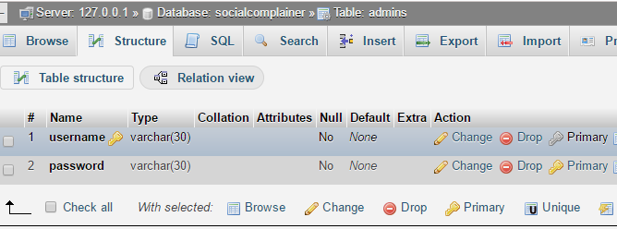

Table 5.2: Admin Information Table

**5.6.2 Complain Table**

In this section, the basic structure of the tables composing the database for the project are shown along with information. about primary and foreign keys.

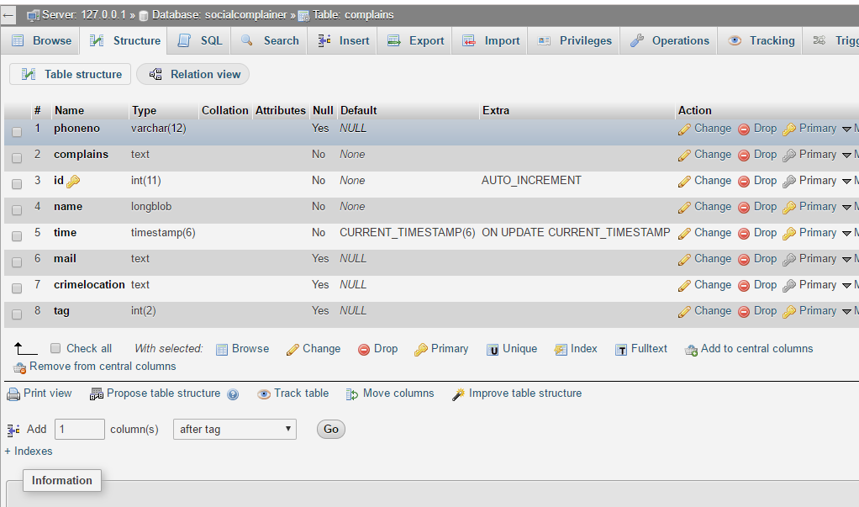

Figure : Complain Table Structure

**Inserted Datas:**

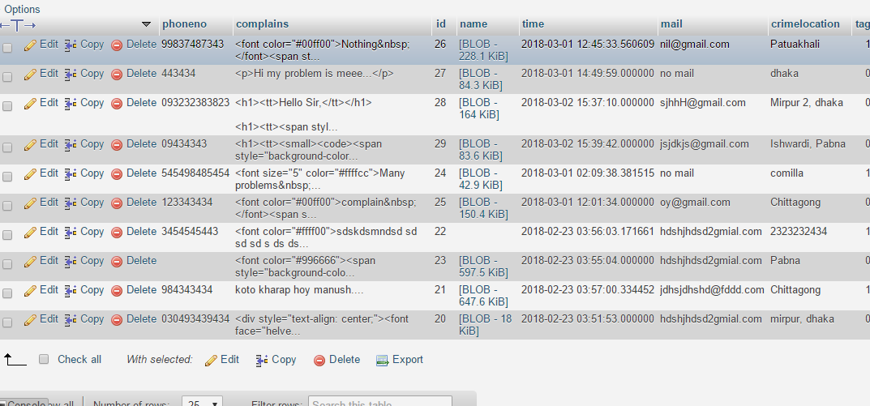

**5.7 Conclusion**

Project design is an early phase of the project where a project's key features, structure, criteria for success, and major deliverables are all planned out. The point is to develop one or more designs which can be used to achieve the desired project goals, in this chapter we try to design Easy Rent system properly.

**CHAPCTER 6**

**USER MANUAL**

**6.1 Introduction**

This chapter will show the Graphical User Interface (GUI) of the system through screenshots and user guides that how will they operate the system. A complete direction for a use social complainer web form .

**6.2 Hardware requirements**

To be used efficiently, all [computer software](https://en.wikipedia.org/wiki/Computer_software) needs certain [hardware](https://en.wikipedia.org/wiki/Computer_hardware) components or other resources to be present on a [computer](https://en.wikipedia.org/wiki/Computer). These prerequisites are known as (computer) system requirements and are often used as a guideline as opposed to an absolute rule. Most software defines two sets of system requirements: minimum and recommended. With increasing demand for higher processing power and resources in newer versions of software, system requirements tend to increase over time. Industry analysts suggest that this trend plays a bigger part in driving upgrades to existing computer systems than technological advancements. A second meaning of the term of System requirements is a generalization of this first definition, giving the requirements to be met in the design of a system or sub-system. Typically an organization starts with a set of Business requirements and then derives the System requirements from there. So the most important hardware requirements are-

1. Computer
2. Server

**6.2.1 Computer**

A computer is a device that can be [instructed](https://en.wikipedia.org/wiki/Computer_programming) to carry out arbitrary sequences of [arithmetic](https://en.wikipedia.org/wiki/Arithmetic) or [logical](https://en.wikipedia.org/wiki/Boolean_algebra) operations automatically. The ability of computers to follow generalized sets of operations, called [program*s*](https://en.wikipedia.org/wiki/Computer_program), enables them to perform an extremely wide Range of tasks.

The system need:

1. Pentium IV 1 GHz
2. Minimum of 512 MB RAM (Recommended).
3. 40GB Hard disk for storage

**6.2.2 Server**

In [computing](https://en.wikipedia.org/wiki/Computing), a server is a [computer program](https://en.wikipedia.org/wiki/Computer_program) or a [device](https://en.wikipedia.org/wiki/Computer) that provides functionality for other programs or devices, called "[clients](https://en.wikipedia.org/wiki/Client_(computing))". This [architecture](https://en.wikipedia.org/wiki/Systems_architecture) is called the [client–server model](https://en.wikipedia.org/wiki/Client%E2%80%93server_model), and a single overall computation is distributed across multiple processes or devices. Servers can provide various functionalities, often called "services", such as sharing data or [resources](https://en.wikipedia.org/wiki/System_resource) among multiple clients, or performing computation for a client.

**6.3 Software requirements**

As said before for this type of project we need coding and various types of programming languages, we mainly used web based programming languages. There is some third party software so there are two categories of software. They are –

**6.3.1 Language based**

* PHP
* HTML, CSS
* MYSQLI

**6.3.2 System based**

* Notepad+
* SQL Server 2012

**6.4 System Layout**

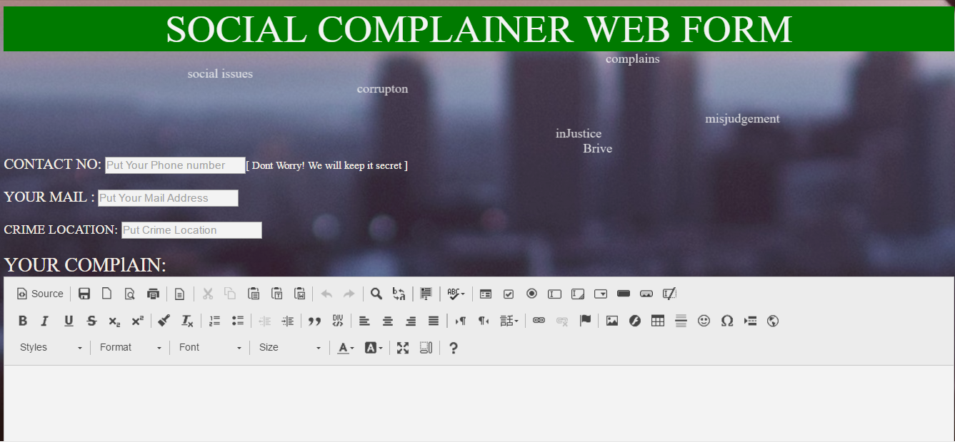

Fig: 6.1 homepage for both users and admins

The above form contains four text boxes for entering phone no. mail, crime location and complains in detail. The person has to enter appropriate answer. The person’s complain will not be stored in database unless he fills up complain text box. He can keep other box empty if he wants. After the person enters answers, he has to press ‘submit Button in order to post the complaint.

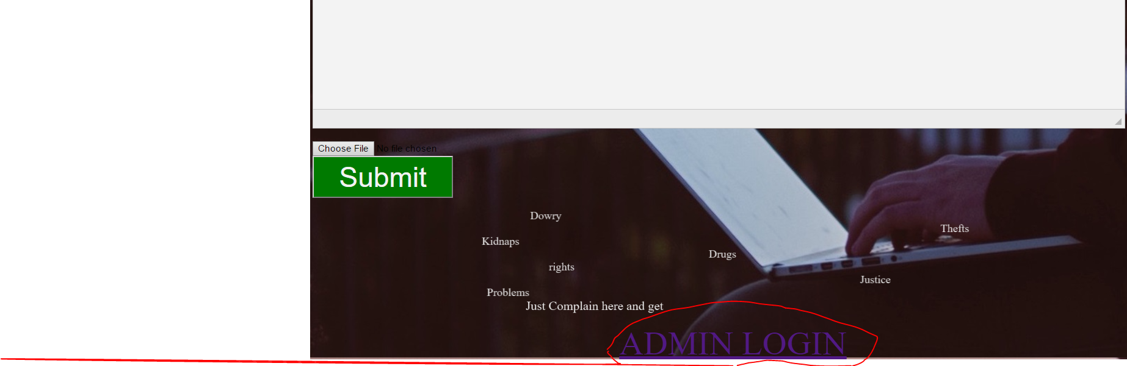

Above the SUBMIT button, there is option to insert picture as attachments while complaining.

And in the bottom of homepage there is option for admin to LOGIN into the system to manage.

**Admin:**

This is Administration System.

**Username:**

This is identification used by a person with access to a computer network.

**Password:**

This is a secret code that must be entered into a computer to enable access to his software/webpages. It is made up of numbers, letters, specials characters or a combination of any of the above categories.

**6.5 Login for admin**

New users can login from this page. Just type user name and password.

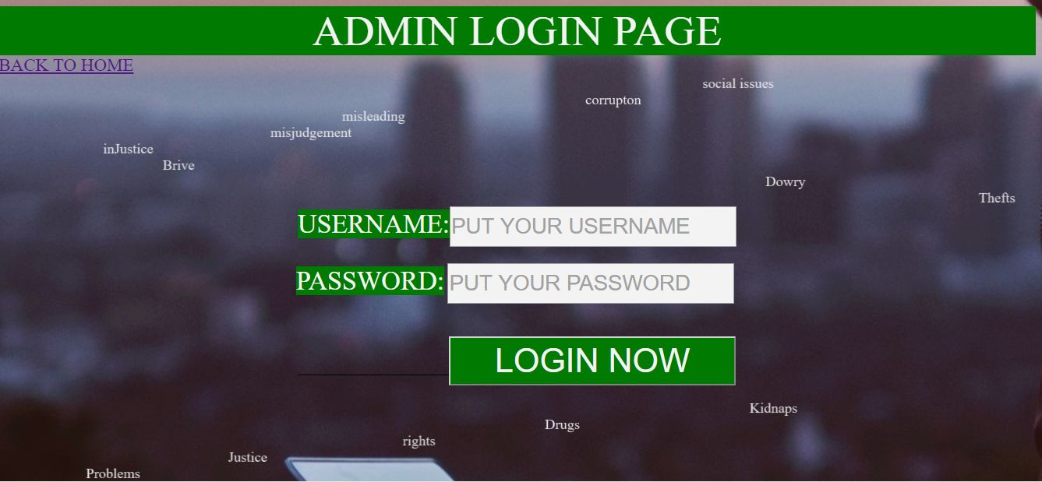

Fig: 6.2 LOGIN Form for admin

**6.6 Admin Action Page**

When admin login the system then opens this main page.

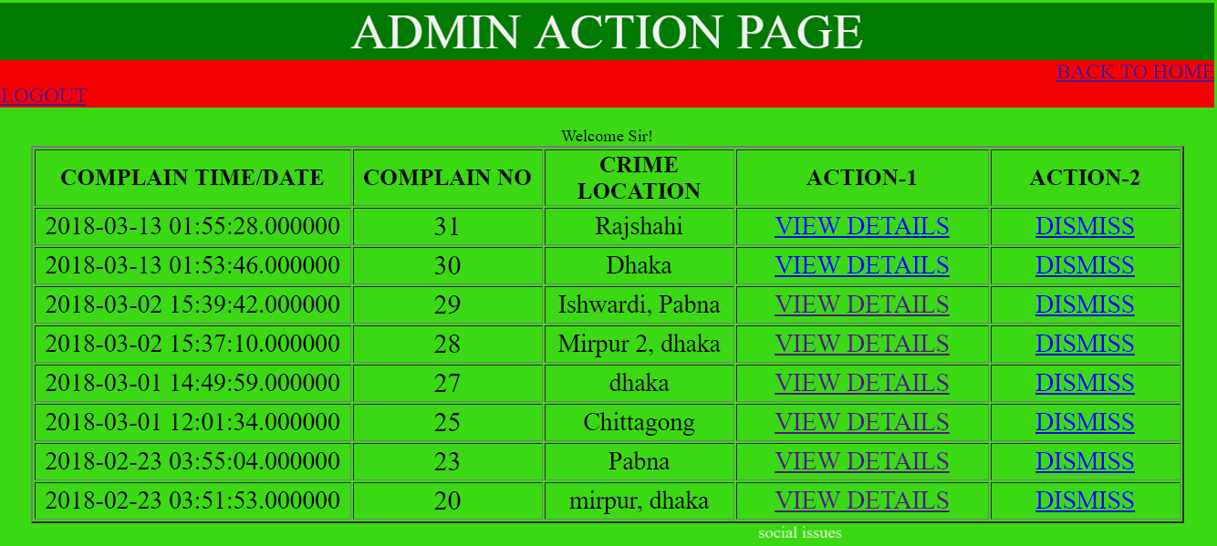

Fig: 6.3 this is the Admin interface of the webpage complains.

Here is the list view of complains of complainers. There is VIEW DETAILS and DISMISS button.

**6.7 View Details Page**

When admin wants to view details a complaint. Just click the view details button.

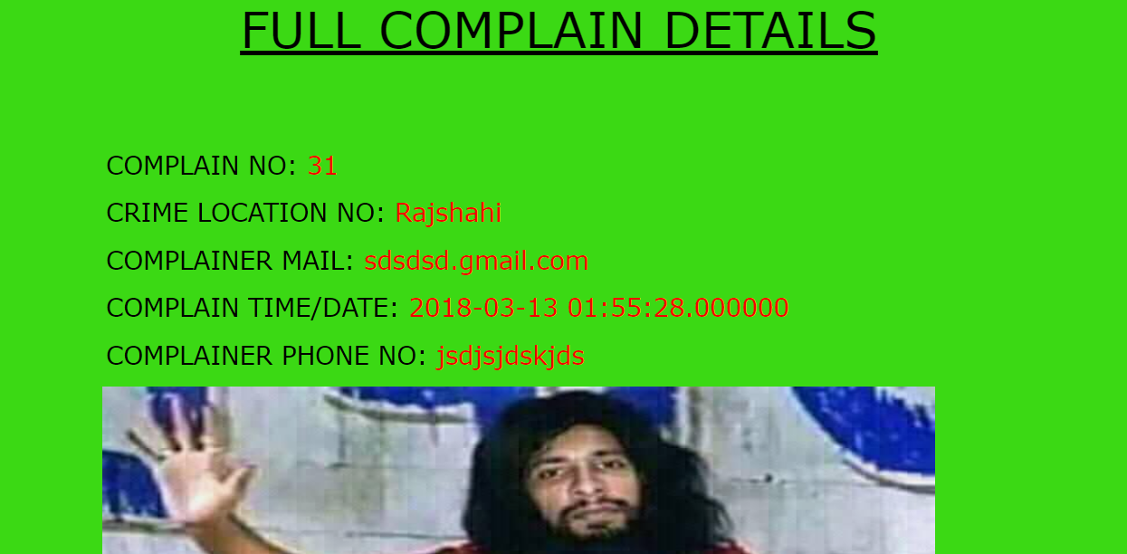

Figure : View Details complain 1

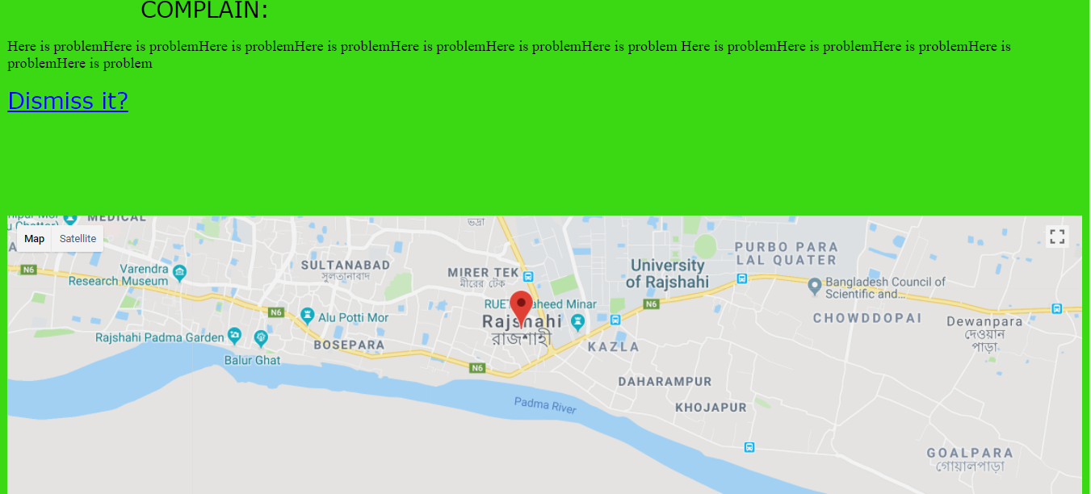

Figure : View Details complains 2

In view details page , all the information of complainer and complains shows, and shows the location of crime in Google Map.

**6.8 Dismiss Action**

This is an action button that makes the complaint invisible to admin if it is clicked once. This is used when the case is solved.

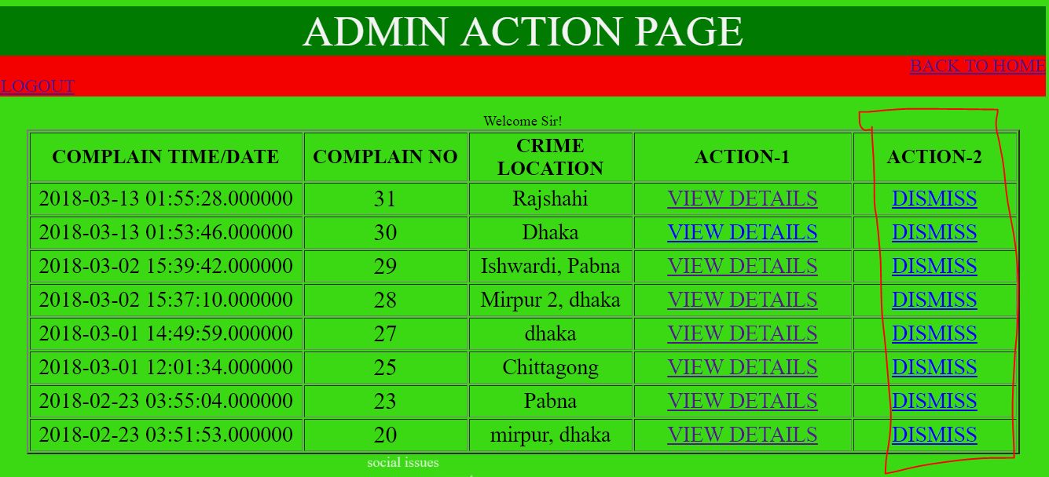

Fig: Dismiss Button action

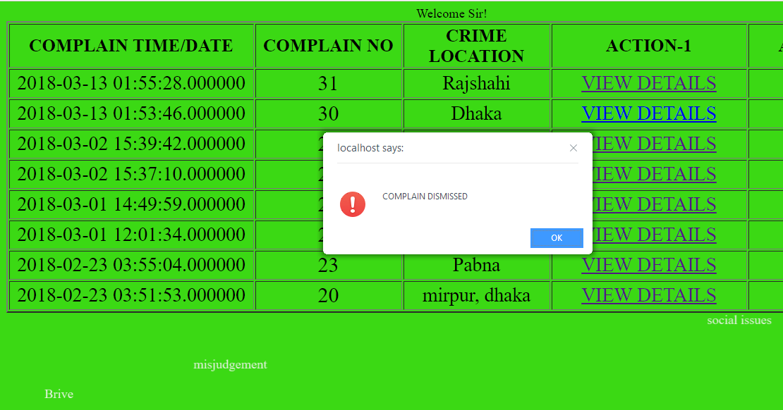

Figure : A complain dismissed

**6.13 Conclusion**

If anybody want to rent a car from Easy Rent system suppose he/she do not know about this system then he/she just flow this chapter properly now he/she can easily rent car from this website, update and cancel car from here.

**CHAPTER 7**

**CONCLUSIONS**

**7.1 Conclusions**

In this project we made the social complainer web form more user friendly, more helpful, money and time saving, and more secured. We have tried our best to build a web form website, which is helpful, secure, extendable and reusable. The purpose of this web form is to make the system easier to make a complain against corruption and illegal activity of society , we hope it will satisfy the demand of our users and make better improvement in near future. We believe that, it will remove the monotony/bindings/risk of the mass people to complain in police station. It will help the admin/security officer to about the crime and can take steps. Where he will manage his activities, he can also find his benefit. Social complainer web form will be helpful to perform paperless work and manage all data. This provides easy, accurate, unambiguous and faster data access. Lesser learning curve - Consistent user interface, customized for the group of users, statistical information in various graphical and tabular forms. There are numerous advantages of Social complainer web form. Admin who make a decision to manage information he can easily do. Moreover, with an online booking system, you can require user to prepay for activities and rentals. This puts money into your pocket faster and helps make sure that on the day of the event you don't have to worry about payment giving you and your customers more time to have fun.

Social complainer web form is a very efficient system for the society and its people. Most of all the task can be easily done with this system. This can be used by any organization.

**7.2 Future Works**

Social complainer web form has been developed with a main aim of making work easier and timesaving for the human capital. The whole system is bi-lingual at present and can be extended to other languages too with minor changes.

The coding pattern is kept as dynamic as possible with minimum amount of static values to make it easier for future extensions. As the current system is expected to add more functionality and dependency according to requirement changes and technology, proper coding standards and working platform have been kept in mind to produce a quality product.

One enhancement is that we can make this application in more than 1 language as well. Adding attendance management is also one option for enhancement.

* This is a desktop web based software. So anyone cannot access from anywhere. First of all we will make it web based.
* We will also develop a mobile application that is why anyone can use it anytime anywhere for complaining and servicing.

**REFERENCES**

[1]Complaint_Management_System_Wan_Nor_Munirah_Binti_Wan_Yusof_QA76.9.D3.W56_2009_-_24_Pages

[2] Project Vinotemp Online Store Author: Ken Hoang CS491B

[3] Wikipedia