day9

screenshot



Html

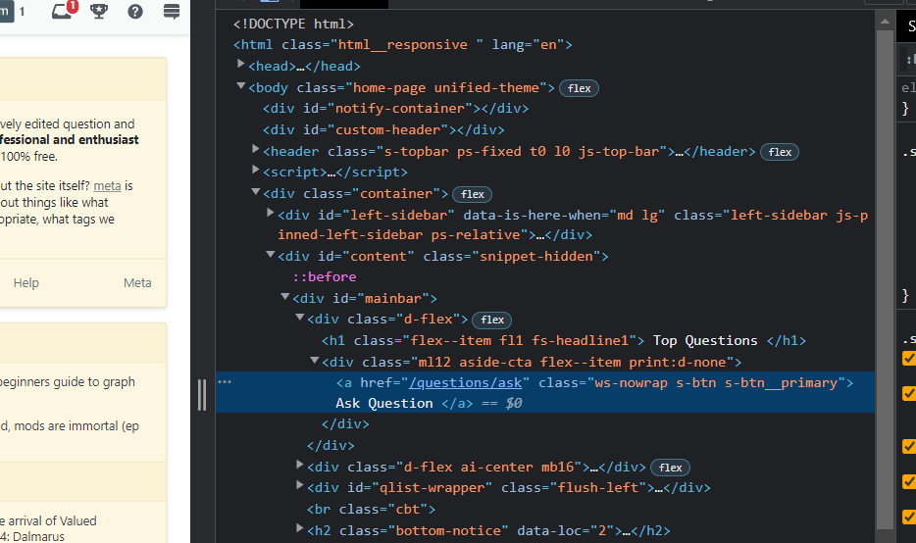

Dom locator

document.getElementById("mainbar").children[0].children[1].children[0]

css locator

#mainbar > div.d-flex > div > a

xPath locator

/html/body/div[3]/div[2]/div[1]/div[1]/div/a

screenshot

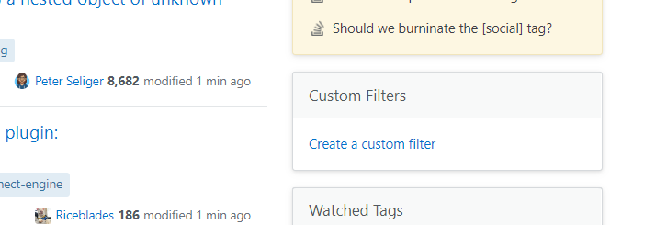

Html

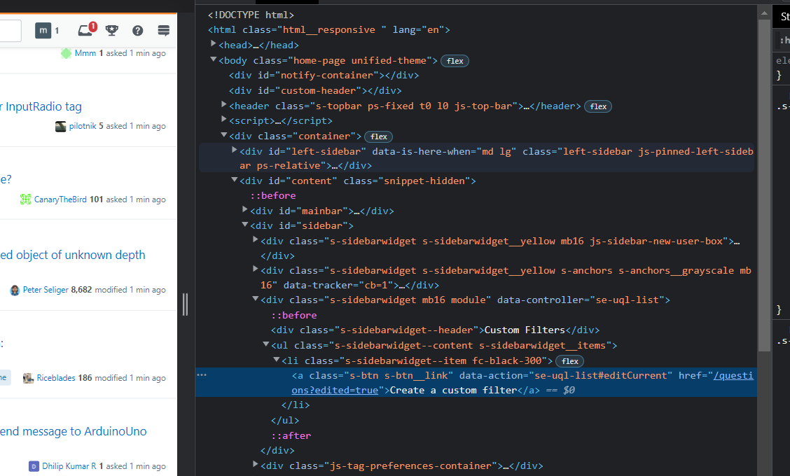

Dom locator

document.getElementById("sidebar").children[2].children[1].children[0] .children[0]

css locator

# sidebar > div.module > ul > li > a

xPath locator

/html/body/div[3]/div[2]/div[2]/div[3]/ul/li/a

screenshot

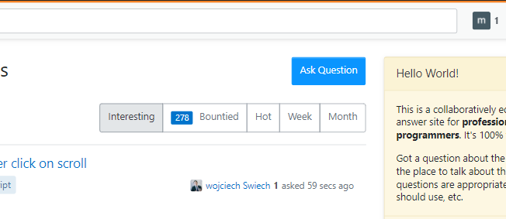

Html

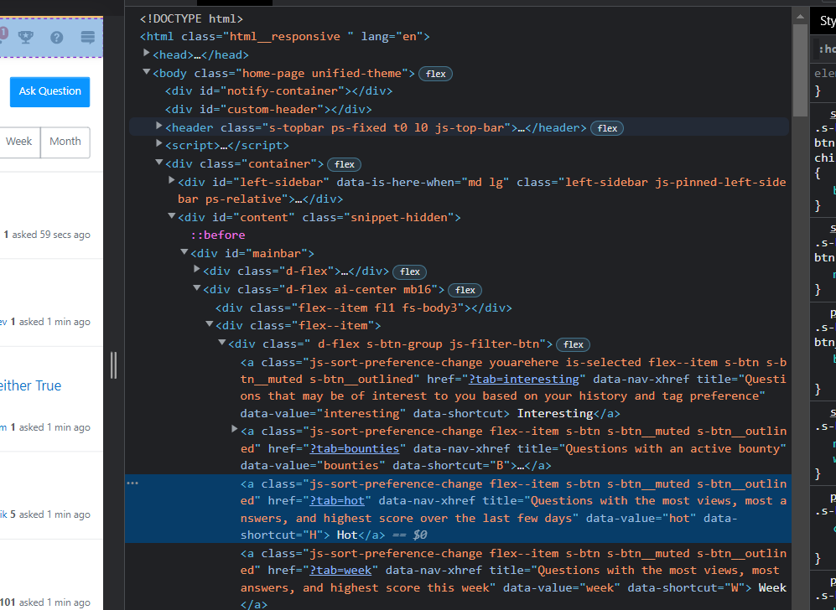

Dom locator

document.getElementById("mainbar").children[1].children[1].children[0].children[1]

css locator

#mainbar > div.d-flex > div.flex--item > div >a

xPath locator

/html/body/div[3]/div[2]/div[1]/div[1]/div/div/a

screenshot



Html

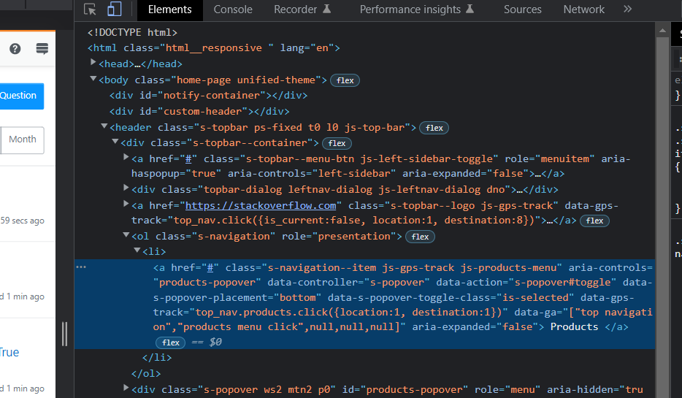

Dom locator

document.getElementsByTagName(“header”) .children[0].children[1].children[3] .children[0] .children[0]

css locator

header > div.s-topbar--container > ol > li >a

xPath locator

/html/body/header/div/ol/li/a