**TASK: 4**

* Use the mtcars data set to plot different graphs in order to convince a buyer which is the best car to buy. Assume some kind of criteria that the car is interested in e.g. Young buyer with interest in speed, or an executive thinking of buying a luxury sedan etc.

**SOLUTION:**

**SCATTER PLOT b/w MILAGE PER GEAR(Speed) & WEIGHT:**

**Command:**

plot(x = mtcars$wt, y = mtcars$mpg)

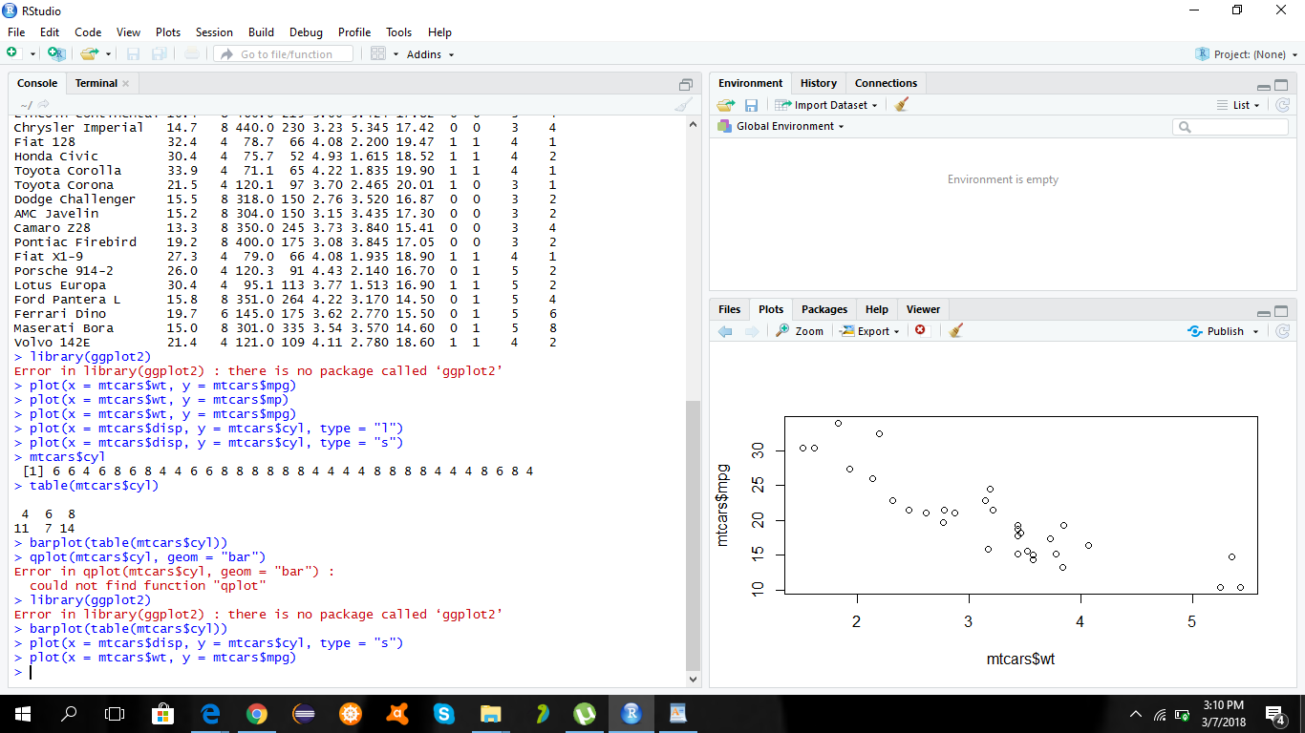

**BAR CHART of no of gears in types of cars:**

**Command:**

barplot(table(mtcars$gear),col='blue',main='gears')

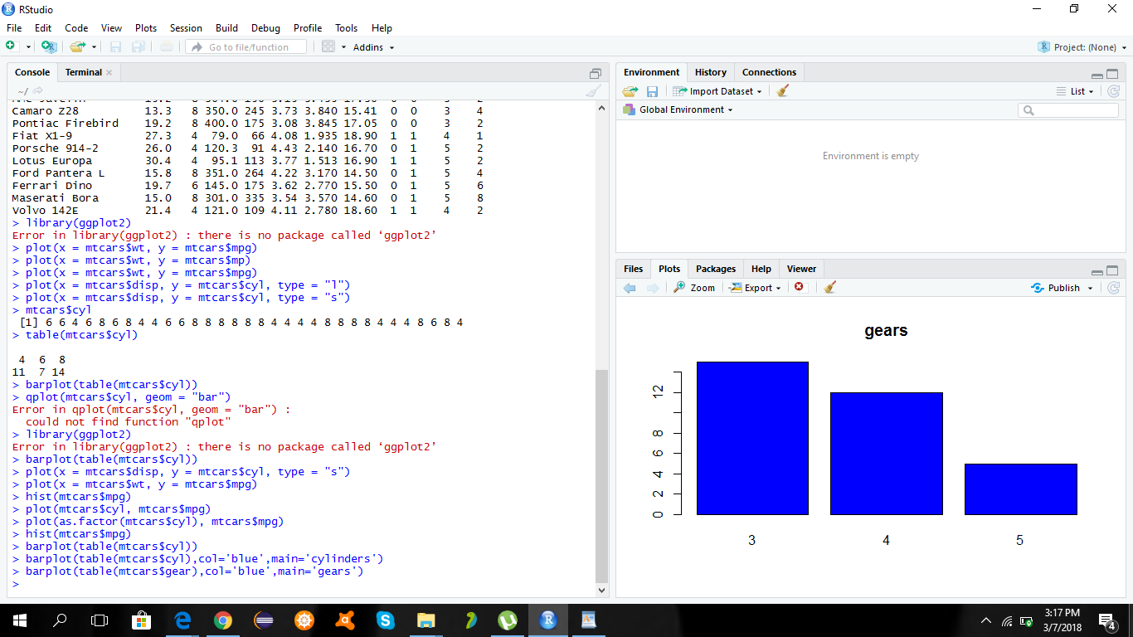

**BAR CHART of no of cylinders in types of cars:**

**Command:**

barplot(table(mtcars$cyl),col='blue',main='cylinders')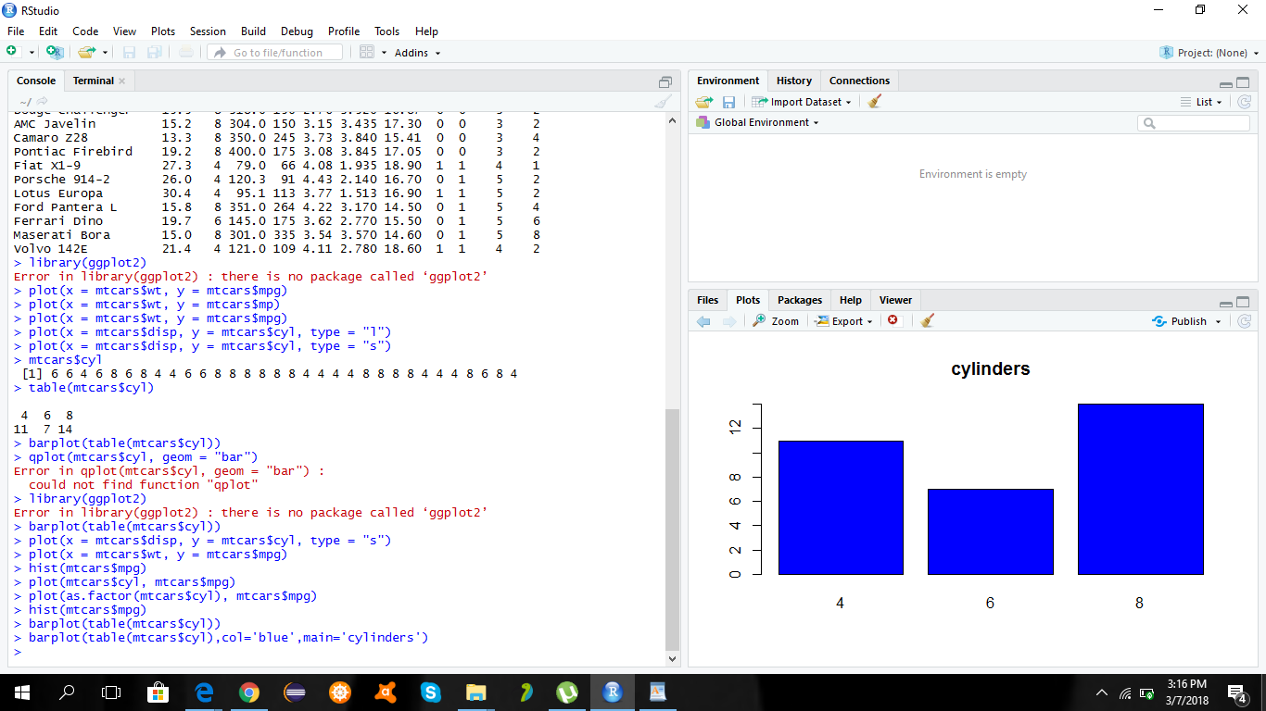

**Histogram for frequency of speed in different cars:**

**Command:**

hist(mtcars$mpg)