

**National University of Sciences and Technology**

**School of Electrical Engineering and Computer Sciences**

**Formal Methods**

**Assignment No. 3**

**Submitted By:**

Maryam Adnan

**Class:**

BESE-6B

**Registration No.:**

134252

**Q1.**

**Take the example of Jobshop from Uppaal demos.**

1. **Add more jobbers and accommodate the changes**

To accommodate more jobbers 4 instances of the jobber template were created in the System declaration file

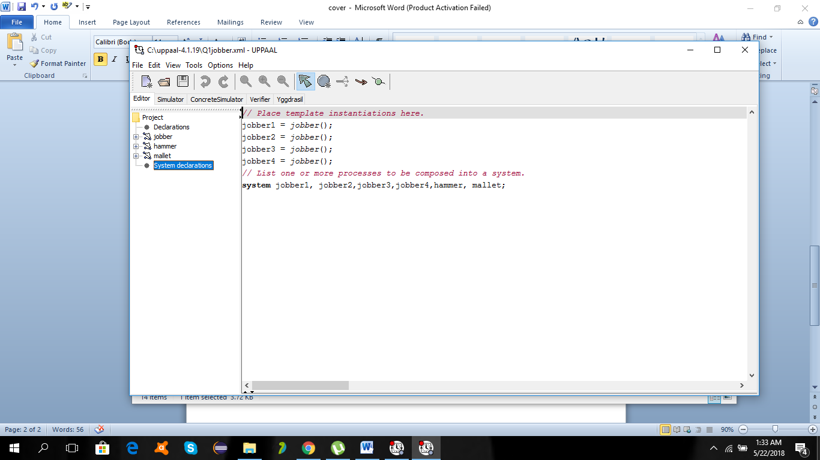

This is the snapshot of one of the instances during execution of the system in simulator.

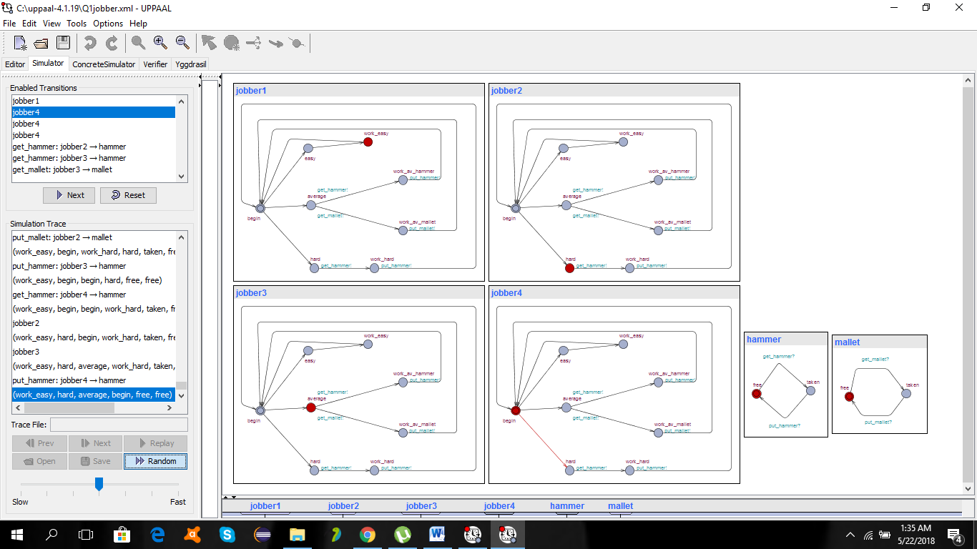

1. **Add and check at least two properties in Uppaal verifier**

|  |  |  |
| --- | --- | --- |
| **Properties No** | **Property** | **Verification** |
| Property 1: | A<>(hammer.free && mallet.free) | Property satisfied |
| Property 2 | E<>(jobber1.work_hard || jobber2.work_hard || jobber3.work_av_hammer) | Property satisfied |
| Property 3 | E<>(jobber1.work_av_mallet && jobber2.work_av_hammer&&jobber3.work_easy && jobber4.work_easy) | Property satisfied |
| Property 4 | E<>(jobber1.work_hard && jobber2.work_av_hammer&&jobber3.work_av_hammer&& jobber4.work_hard) | Property unsatisfied |

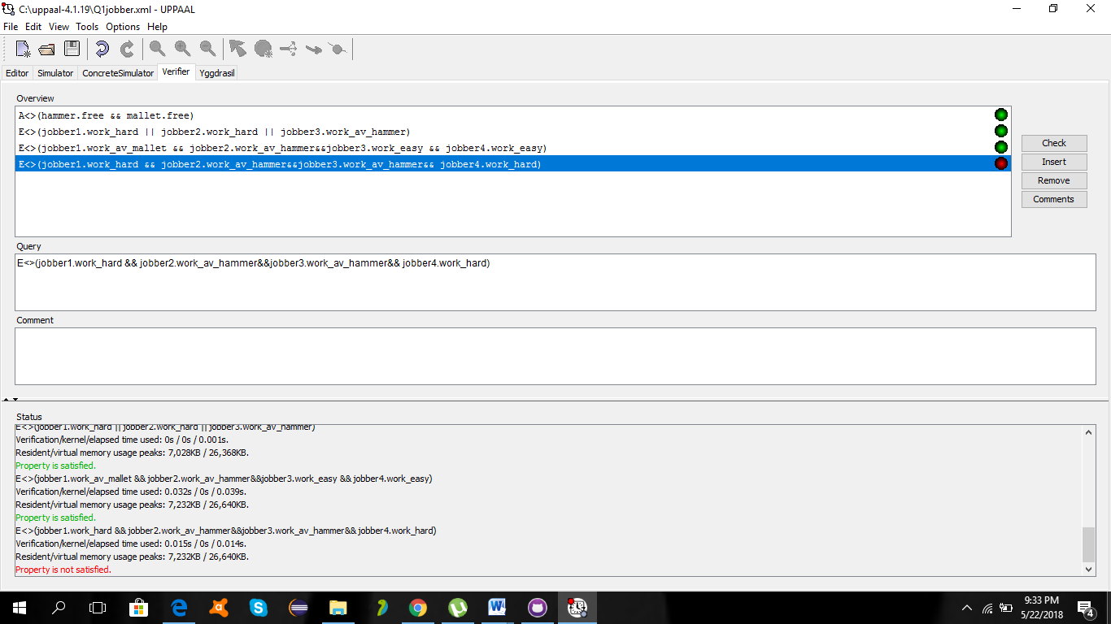

**Q2.**

**The New Islamabad International Airport is operational from May 3, 2018. Traffic on Shahrah-e-Kashmir (major road) is 8 times as compared to the traffic on the minor road at the G-11 signal crossing. CDA wants NUST’s software engineers to provide a complete Uppaal diagram of traffic flow diagram with directions and proposed timings for optimal traffic flow. Diagram of all the important objects for the system is mandatory for execution in simulator. In the verifier must check the following three properties:**

1. **Mutex Property**
2. **Bounded liveness**
3. **Deadlock avoidance**

**Proposed Solution:**

Traffic Controlled System is a real time controlled system. Therefore the state diagram or the automaton of this system will be a time controlled automaton. As there are 4 traffic signals present at the intersection of Nust Chowk. So at one instance of time only one of the signals can be green and others have to be red to avoid collision. Here Nust Chowk Pass is considered as the resource through which the cars need to pass. So considering the above scenario my solutions consists of two state diagrams

**Traffic Signal:**

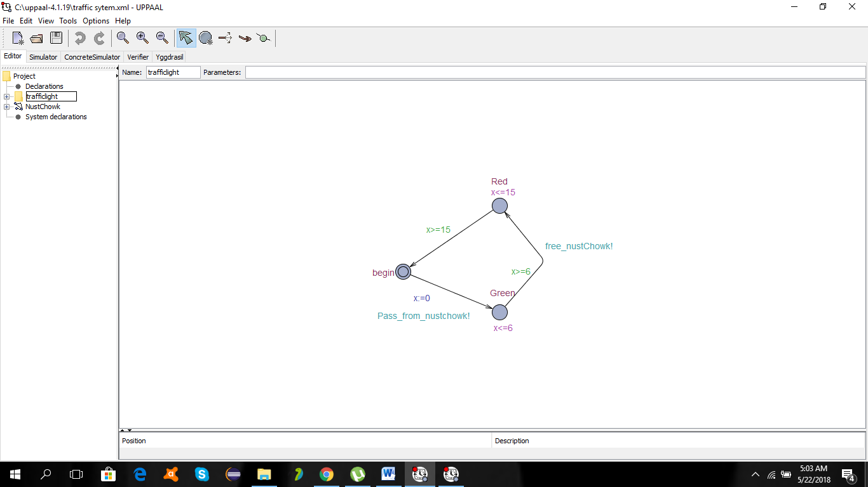

**Resource Allocation:**

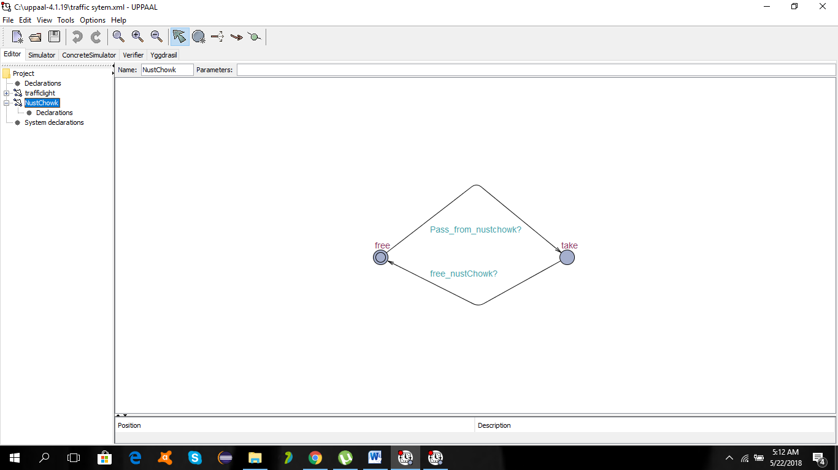

**Explanation:**

**Initialization:**

The first one is theTraffic signal template which consist of three states of traffic light begin,red and green. Yellow state is avoided for the sake of simplicity.The second one is representation of the resource that is Nust Chowk.Total four instances of these traffic signals are created to represent 4 signals in the problem and the clock or timer is also declared to consider time as its atimed automaton.Moreover the sync channels that relates both the automatons are also declared that are free_nustChowk and Pass_from_nustChowk.

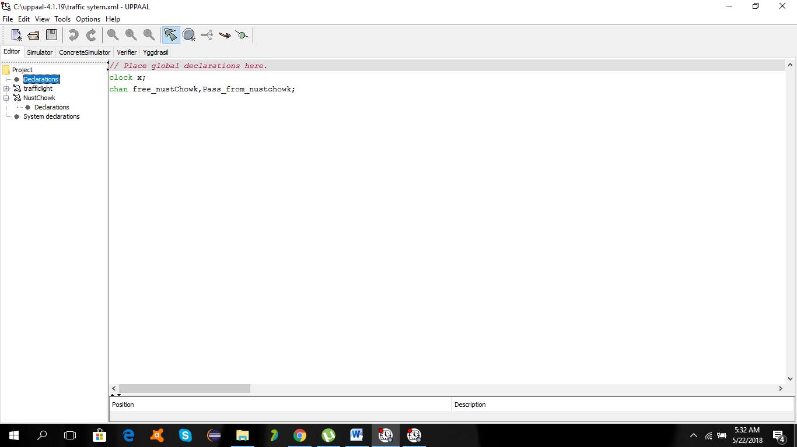

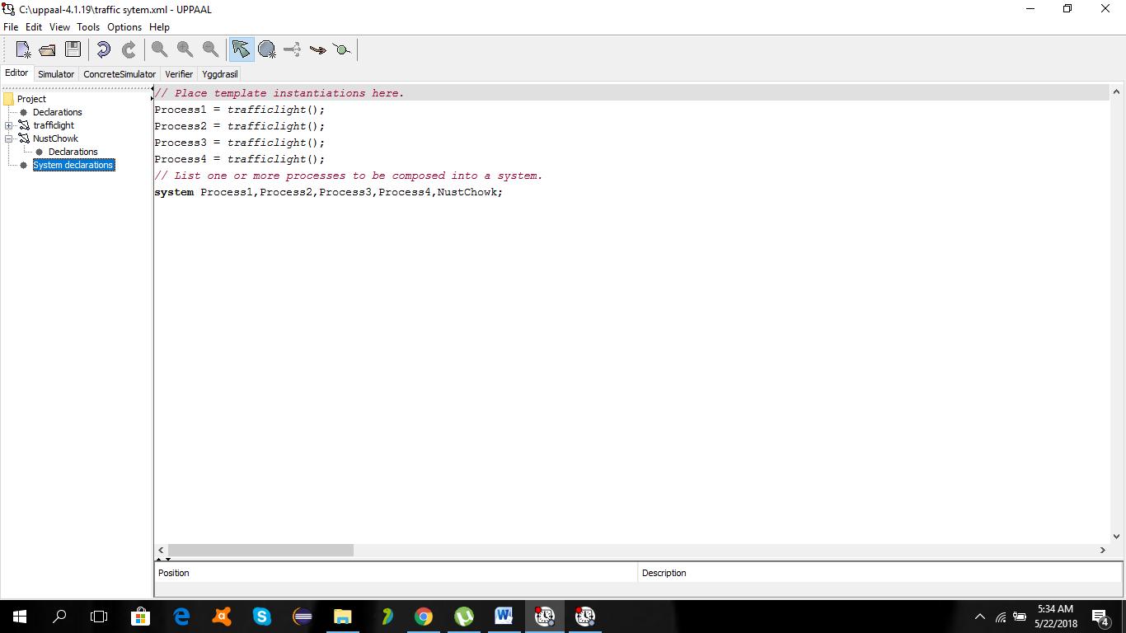

**Execution:**

At the beginning state the clock variable i.e x is initialized to zero .After that the signal will turn to green and will execute the commnad of pass nust chowk through the Sync channel of Pass_nustChowk that is the call for the resource.Now at the initial statethe resource is also free.Due to synchonization of channel Pass_nustChowk transition will occur and the resource will be taken.Meanwhile the other three instances of the traffic signal can not perform transition of Pass nust chowk as the resource will not be available.So no dead lock will occur.After The clock will tick to 6 seconds the the first traffic signal will change its stae from green to red through the channel of free_nust_Chowk! Due to which the resource will transit to free.Therefore any other traffic signal at that point can attain the resource and turn green.The first traffic signal will wait for 8 secs at the red signal and then come the begin state to start again.Its timer will be initialized to zero.Similarly after a delay of 6 secs all signal instances will change their state.

**System execution diagram:**

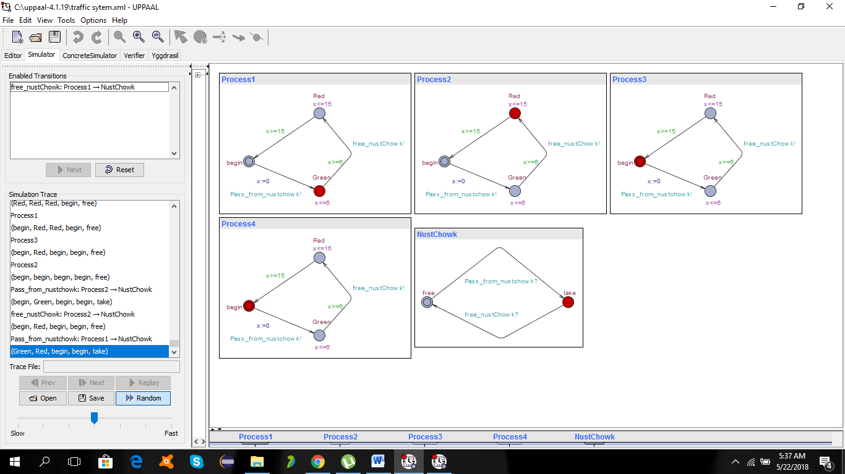

**Properties:**

Following properties were written and verified for the system:

* **Mutex Property**

There will be no case when the two traffic signals will become green at one time

**A<>!(Process1.Green && Process2.Green)**

* **Bounded liveness**

During the execution all the traffic signals will once attain the green state.

**E<>(Process1.Green||Process2.Green||Process3.Green||Process4.Green)**

* **Deadlock avoidance**

There will be no case when the traffic light will become green and the resource will not be available.

**A<>!(Process1.Green && NustChowk.take)**

Three of the properties were verified

