**Problem 3.2:**

**Every Monday at 08:30** = 30 8 * * 1 /home/date-script.sh

**Every workday, every 30 minutes, from 8:15 to 17:45** = 15-45/30 8-17 * * 1-5 /home/date-script.sh

**Last day of every month** **at 17:30** = 59 23 28-31 * * [ "$(date +\%d -d tomorrow)" == "01" ] && /home/date-script.sh

\

**Problem 4.1:**

I firstly initialize a mutex

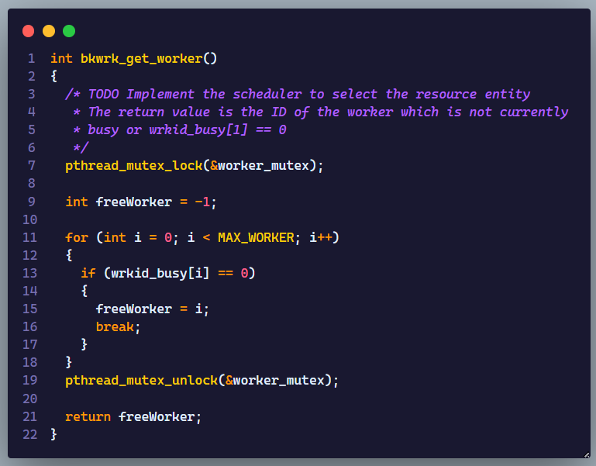Lock and unlock adding will keep the program from running without waiting the process

And here is the result :

**Problem 4.2 :**

I won’t mention the code in here.