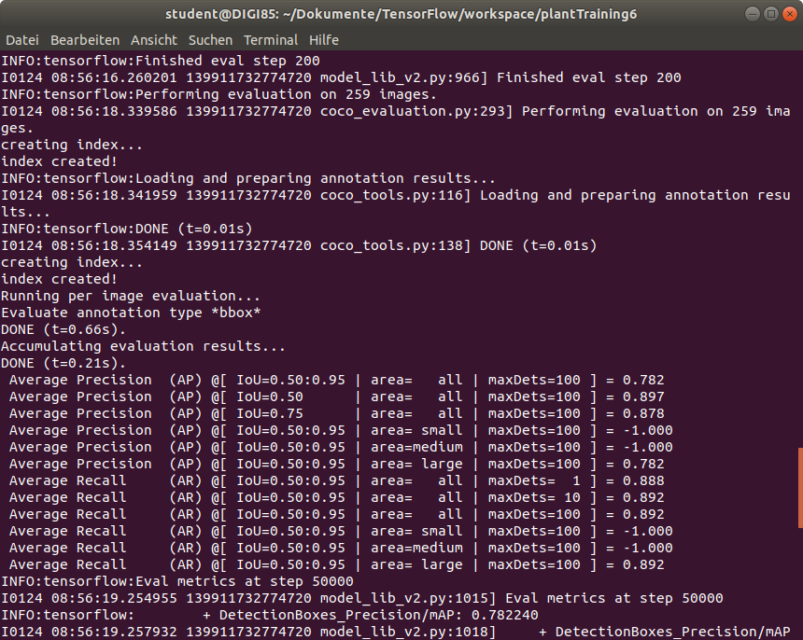
model {
ssd {
num_classes: 9
image_resizer {
fixed_shape_resizer {
height: 320
width: 320
}
}
feature_extractor {
type: "ssd_mobilenet_v2_fpn_keras"
depth_multiplier: 1.0
min_depth: 16
conv_hyperparams {
regularizer {
l2_regularizer {
weight: 3.9999998989515007e-05
}
}
initializer {
random_normal_initializer {
mean: 0.0
stddev: 0.009999999776482582
}
}
activation: RELU_6
batch_norm {
decay: 0.996999979019165
scale: true
epsilon: 0.0010000000474974513
}
}
use_depthwise: true
override_base_feature_extractor_hyperparams: true
fpn {
min_level: 3
max_level: 7
additional_layer_depth: 128
}
}
box_coder {
faster_rcnn_box_coder {
y_scale: 10.0
x_scale: 10.0
height_scale: 5.0
width_scale: 5.0
}
}
matcher {
argmax_matcher {
matched_threshold: 0.5
unmatched_threshold: 0.5
ignore_thresholds: false
negatives_lower_than_unmatched: true
force_match_for_each_row: true
use_matmul_gather: true
}
}
similarity_calculator {
iou_similarity {
}
}
box_predictor {
weight_shared_convolutional_box_predictor {
conv_hyperparams {
regularizer {
l2_regularizer {
weight: 3.9999998989515007e-05
}
}
initializer {
random_normal_initializer {
mean: 0.0
stddev: 0.009999999776482582
}
}
activation: RELU_6
batch_norm {
decay: 0.996999979019165
scale: true
epsilon: 0.0010000000474974513
}
}
depth: 128
num_layers_before_predictor: 4
kernel_size: 3
class_prediction_bias_init: -4.599999904632568
share_prediction_tower: true
use_depthwise: true
}
}
anchor_generator {
multiscale_anchor_generator {
min_level: 3
max_level: 7
anchor_scale: 4.0
aspect_ratios: 1.0
aspect_ratios: 2.0
aspect_ratios: 0.5
scales_per_octave: 2
}
}
post_processing {
batch_non_max_suppression {
score_threshold: 9.99999993922529e-09
iou_threshold: 0.6000000238418579
max_detections_per_class: 100
max_total_detections: 100
use_static_shapes: false
}
score_converter: SIGMOID
}
normalize_loss_by_num_matches: true
loss {
localization_loss {
weighted_smooth_l1 {
}
}
classification_loss {
weighted_sigmoid_focal {
gamma: 2.0
alpha: 0.25
}
}
classification_weight: 1.0
localization_weight: 1.0
}
encode_background_as_zeros: true
normalize_loc_loss_by_codesize: true
inplace_batchnorm_update: true
freeze_batchnorm: false
}
}
train_config {
batch_size: 4
data_augmentation_options {
random_horizontal_flip {
}
}
data_augmentation_options {
random_crop_image {
min_object_covered: 0.0
min_aspect_ratio: 0.75
max_aspect_ratio: 3.0
min_area: 0.75
max_area: 1.0
overlap_thresh: 0.0
}
}
sync_replicas: true
optimizer {
momentum_optimizer {
learning_rate {
cosine_decay_learning_rate {
learning_rate_base: 0.07999999821186066
total_steps: 50000
warmup_learning_rate: 0.026666000485420227
warmup_steps: 1000
}
}
momentum_optimizer_value: 0.8999999761581421
}
use_moving_average: false
}
fine_tune_checkpoint: "/home/student/Dokumente/TensorFlow/workspace/plantTraining6/pre-trained-models/ssd_mobilenet_v2_fpnlite_320x320/checkpoint/ckpt-0"
num_steps: 50000
startup_delay_steps: 0.0
replicas_to_aggregate: 8
max_number_of_boxes: 100
unpad_groundtruth_tensors: false
fine_tune_checkpoint_type: "detection"
fine_tune_checkpoint_version: V2
}
train_input_reader {
label_map_path: "/home/student/Dokumente/TensorFlow/workspace/plantTraining6/annotations/label_map.pbtxt"
tf_record_input_reader {
input_path: "/home/student/Dokumente/TensorFlow/workspace/plantTraining6/annotations/train.record"
}
}
eval_config {
metrics_set: "coco_detection_metrics"
use_moving_averages: false
}
eval_input_reader {
label_map_path: "/home/student/Dokumente/TensorFlow/workspace/plantTraining6/annotations/label_map.pbtxt"
shuffle: false
num_epochs: 1
tf_record_input_reader {
input_path: "/home/student/Dokumente/TensorFlow/workspace/plantTraining6/annotations/test.record"
}
}

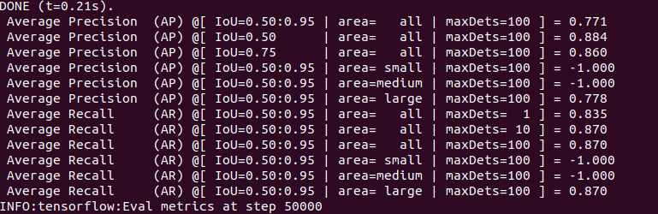
model {
ssd {
num_classes: 9
image_resizer {
fixed_shape_resizer {
height: 640
width: 640
}
}
feature_extractor {
type: "ssd_mobilenet_v2_fpn_keras"
depth_multiplier: 1.0
min_depth: 16
conv_hyperparams {
regularizer {
l2_regularizer {
weight: 3.9999998989515007e-05
}
}
initializer {
random_normal_initializer {
mean: 0.0
stddev: 0.009999999776482582
}
}
activation: RELU_6
batch_norm {
decay: 0.996999979019165
scale: true
epsilon: 0.0010000000474974513
}
}
use_depthwise: true
override_base_feature_extractor_hyperparams: true
fpn {
min_level: 3
max_level: 7
additional_layer_depth: 128
}
}
box_coder {
faster_rcnn_box_coder {
y_scale: 10.0
x_scale: 10.0
height_scale: 5.0
width_scale: 5.0
}
}
matcher {
argmax_matcher {
matched_threshold: 0.5
unmatched_threshold: 0.5
ignore_thresholds: false
negatives_lower_than_unmatched: true
force_match_for_each_row: true
use_matmul_gather: true
}
}
similarity_calculator {
iou_similarity {
}
}
box_predictor {
weight_shared_convolutional_box_predictor {
conv_hyperparams {
regularizer {
l2_regularizer {
weight: 3.9999998989515007e-05
}
}
initializer {
random_normal_initializer {
mean: 0.0
stddev: 0.009999999776482582
}
}
activation: RELU_6
batch_norm {
decay: 0.996999979019165
scale: true
epsilon: 0.0010000000474974513
}
}
depth: 128
num_layers_before_predictor: 4
kernel_size: 3
class_prediction_bias_init: -4.599999904632568
share_prediction_tower: true
use_depthwise: true
}
}
anchor_generator {
multiscale_anchor_generator {
min_level: 3
max_level: 7
anchor_scale: 4.0
aspect_ratios: 1.0
aspect_ratios: 2.0
aspect_ratios: 0.5
scales_per_octave: 2
}
}
post_processing {
batch_non_max_suppression {
score_threshold: 9.99999993922529e-09
iou_threshold: 0.6000000238418579
max_detections_per_class: 100
max_total_detections: 100
use_static_shapes: false
}
score_converter: SIGMOID
}
normalize_loss_by_num_matches: true
loss {
localization_loss {
weighted_smooth_l1 {
}
}
classification_loss {
weighted_sigmoid_focal {
gamma: 2.0
alpha: 0.25
}
}
classification_weight: 1.0
localization_weight: 1.0
}
encode_background_as_zeros: true
normalize_loc_loss_by_codesize: true
inplace_batchnorm_update: true
freeze_batchnorm: false
}
}
train_config {
batch_size: 8
data_augmentation_options {
random_horizontal_flip {
}
}
data_augmentation_options {
random_crop_image {
min_object_covered: 0.0
min_aspect_ratio: 0.75
max_aspect_ratio: 3.0
min_area: 0.75
max_area: 1.0
overlap_thresh: 0.0
}
}
sync_replicas: true
optimizer {
momentum_optimizer {
learning_rate {
cosine_decay_learning_rate {
learning_rate_base: 0.07999999821186066
total_steps: 50000
warmup_learning_rate: 0.026666000485420227
warmup_steps: 1000
}
}
momentum_optimizer_value: 0.8999999761581421
}
use_moving_average: false
}
fine_tune_checkpoint: "/home/student/Dokumente/TensorFlow/workspace/plantTraining2/pre-trained-models/ssd_mobilenet_v2_fpnlite_640x640/checkpoint/ckpt-0"
num_steps: 50000
startup_delay_steps: 0.0
replicas_to_aggregate: 8
max_number_of_boxes: 100
unpad_groundtruth_tensors: false
fine_tune_checkpoint_type: "detection"
fine_tune_checkpoint_version: V2
}
train_input_reader {
label_map_path: "/home/student/Dokumente/TensorFlow/workspace/plantTraining2/annotations/label_map.pbtxt"
tf_record_input_reader {
input_path: "/home/student/Dokumente/TensorFlow/workspace/plantTraining2/annotations/train.record"
}
}
eval_config {
metrics_set: "coco_detection_metrics"
use_moving_averages: false
}
eval_input_reader {
label_map_path: "/home/student/Dokumente/TensorFlow/workspace/plantTraining2/annotations/label_map.pbtxt"
shuffle: false
num_epochs: 1
tf_record_input_reader {
input_path: "/home/student/Dokumente/TensorFlow/workspace/plantTraining2/annotations/test.record"
}
}
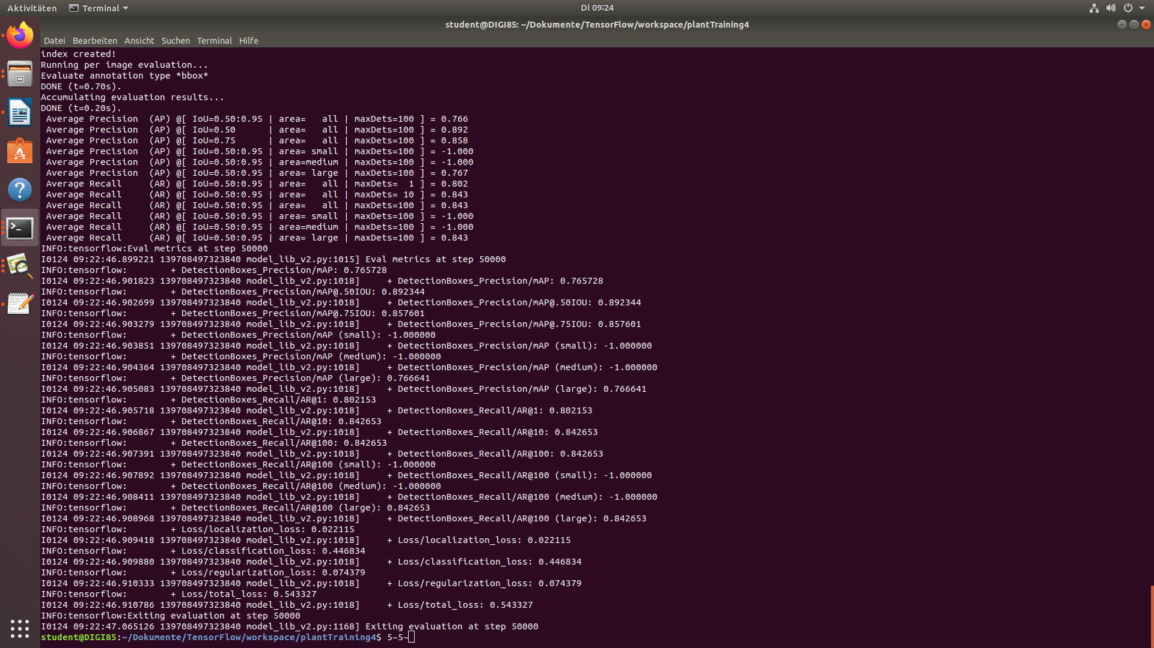
model {
ssd {
num_classes: 9
image_resizer {
fixed_shape_resizer {
height: 640
width: 640
}
}
feature_extractor {
type: "ssd_mobilenet_v2_fpn_keras"
depth_multiplier: 1.0
min_depth: 16
conv_hyperparams {
regularizer {
l2_regularizer {
weight: 3.9999998989515007e-05
}
}
initializer {
random_normal_initializer {
mean: 0.0
stddev: 0.009999999776482582
}
}
activation: RELU_6
batch_norm {
decay: 0.996999979019165
scale: true
epsilon: 0.0010000000474974513
}
}
use_depthwise: true
override_base_feature_extractor_hyperparams: true
fpn {
min_level: 3
max_level: 7
additional_layer_depth: 128
}
}
box_coder {
faster_rcnn_box_coder {
y_scale: 10.0
x_scale: 10.0
height_scale: 5.0
width_scale: 5.0
}
}
matcher {
argmax_matcher {
matched_threshold: 0.5
unmatched_threshold: 0.5
ignore_thresholds: false
negatives_lower_than_unmatched: true
force_match_for_each_row: true
use_matmul_gather: true
}
}
similarity_calculator {
iou_similarity {
}
}
box_predictor {
weight_shared_convolutional_box_predictor {
conv_hyperparams {
regularizer {
l2_regularizer {
weight: 3.9999998989515007e-05
}
}
initializer {
random_normal_initializer {
mean: 0.0
stddev: 0.009999999776482582
}
}
activation: RELU_6
batch_norm {
decay: 0.996999979019165
scale: true
epsilon: 0.0010000000474974513
}
}
depth: 128
num_layers_before_predictor: 4
kernel_size: 3
class_prediction_bias_init: -4.599999904632568
share_prediction_tower: true
use_depthwise: true
}
}
anchor_generator {
multiscale_anchor_generator {
min_level: 3
max_level: 7
anchor_scale: 4.0
aspect_ratios: 1.0
aspect_ratios: 2.0
aspect_ratios: 0.5
scales_per_octave: 2
}
}
post_processing {
batch_non_max_suppression {
score_threshold: 9.99999993922529e-09
iou_threshold: 0.6000000238418579
max_detections_per_class: 100
max_total_detections: 100
use_static_shapes: false
}
score_converter: SIGMOID
}
normalize_loss_by_num_matches: true
loss {
localization_loss {
weighted_smooth_l1 {
}
}
classification_loss {
weighted_sigmoid_focal {
gamma: 2.0
alpha: 0.25
}
}
classification_weight: 1.0
localization_weight: 1.0
}
encode_background_as_zeros: true
normalize_loc_loss_by_codesize: true
inplace_batchnorm_update: true
freeze_batchnorm: false
}
}
train_config {
batch_size: 8
data_augmentation_options {
random_horizontal_flip {
}
}
data_augmentation_options {
random_crop_image {
min_object_covered: 0.0
min_aspect_ratio: 0.75
max_aspect_ratio: 3.0
min_area: 0.75
max_area: 1.0
overlap_thresh: 0.0
}
}
sync_replicas: true
optimizer {
momentum_optimizer {
learning_rate {
cosine_decay_learning_rate {
learning_rate_base: 0.07999999821186066
total_steps: 30000
warmup_learning_rate: 0.026666000485420227
warmup_steps: 1000
}
}
momentum_optimizer_value: 0.8999999761581421
}
use_moving_average: false
}
fine_tune_checkpoint: "/home/student/Dokumente/TensorFlow/workspace/plantTraining4/pre-trained-models/ssd_mobilenet_v2_fpnlite_640x640/checkpoint/ckpt-0"
num_steps: 50000
startup_delay_steps: 0.0
replicas_to_aggregate: 8
max_number_of_boxes: 100
unpad_groundtruth_tensors: false
fine_tune_checkpoint_type: "detection"
fine_tune_checkpoint_version: V2
}
train_input_reader {
label_map_path: "/home/student/Dokumente/TensorFlow/workspace/plantTraining4/annotations/label_map.pbtxt"
tf_record_input_reader {
input_path: "/home/student/Dokumente/TensorFlow/workspace/plantTraining4/annotations/train.record"
}
}
eval_config {
metrics_set: "coco_detection_metrics"
use_moving_averages: false
}
eval_input_reader {
label_map_path: "/home/student/Dokumente/TensorFlow/workspace/plantTraining4/annotations/label_map.pbtxt"
shuffle: false
num_epochs: 1
tf_record_input_reader {
input_path: "/home/student/Dokumente/TensorFlow/workspace/plantTraining4/annotations/test.record"
}
}

