ByRA Pre-Processor

# Installation

1. Make sure QGIS 3 is installed (plugin not backwards compatible with earlier versions).
2. Download folder *byra*.
3. Copy *byra* to your QGIS plugin folder.   
   **On a Mac,** the default path is /Users/[username]/Library/Application Support/QGIS/QGIS3/profiles/default/python/plugins.  
    **In Windows**, the default path is C:\Users\[username]\AppData\Roaming\QGIS\QGIS3\profiles\default\python\plugins.   
   Note: Folders under AppData may be hidden by Windows. For instructions to show hidden folders, see:   
   <https://support.microsoft.com/en-us/help/14201/windows-show-hidden-files>
4. Start QGIS and open the Plugins dialog (Plugins > Manage and Install Plugins). Bycatch Risk Assessment Toolbox should be the first item under Installed. Check the box next to the toolbox name to make the icon appear (file:///var/folders/l6/rwht_wwd09ndyxtgzckw4ygc0000gn/T/com.microsoft.Word/screenshot.png) in the QGIS toolbar.

# Usage

1. Click on the tool icon to launch the dialog.  
   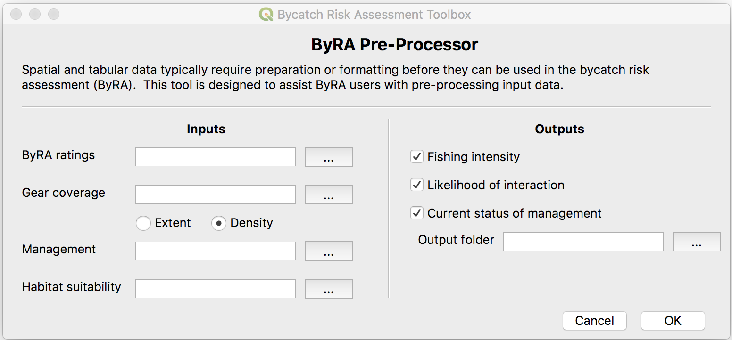
2. The inputs on the left are paths to the folders/shapefiles with the necessary data.
   1. ByRA ratings: folder containing habitat risk assessment files

sample_data/sample_KUCG

* 1. Gear coverage: folder containing shapefiles of gear coverage.  
     sample_data/sample_KUCG/Gear_KUCG_Dry
  2. Extent/Density: radio buttons indicating if gear coverage defines extent of gear use (i.e. no Rating) or density of gear use (i.e. categorized into Rating 1-3).  
     binary variable: Extent –or- Density
  3. Management: a shapefile of management areas.  
     sample_data/sample_KUCG/KUCG_Management_prj.shp
  4. Habitat suitability: a folder containing shapefiles of habitat suitability for each species. sample_data/sample_KUCG/HabSuit_KUCG_Dry   
     Each shapefile inside the folder must have a field called ‘Rating’ with values 1 to 3. If not, an error message similar to the one below will appear.  
     

1. The inputs on the right determine which outputs will be produced. The three checkboxes indicate which spatially explicit criteria (SECs) should be generated. The output shapefiles will go in…   
   [Output folder]/Spatially_Explicit_Criteria/Exposure
2. Click OK to run.
3. The tool runs in two phases. First is validation, which ensures that all paths are valid, the species and gear shapefiles indicated by the ByRA ratings files exist and have a column called Rating, and the output SECs are possible based on the inputs. After successful validation, a green message bar appears at the top of the workspace.  
     
   The second phase, preprocessing, runs the geoprocessing tools necessary to produce the SECs. After an unsuccessful preprocessing (e.g. input files with invalid geometries), a red message bar appears at the top of the workspace, referring the user to CSV checklist with more details.  
   