**ERD Digram**

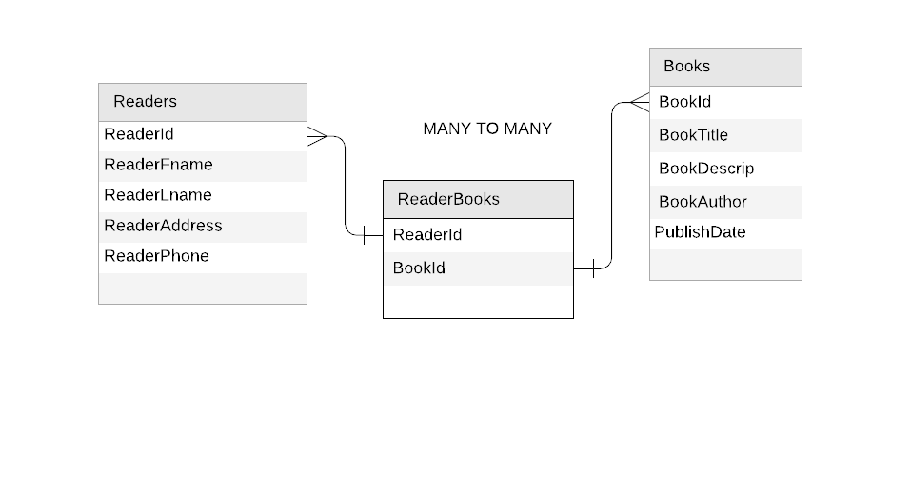

THE Relationship is a Reader can have many books to read and the Books can have many readers. This relationship is a many to many relationship cause A person can actually read a lot of books while the books can have multiple person that can read the specific book.