**ERD Diagram**

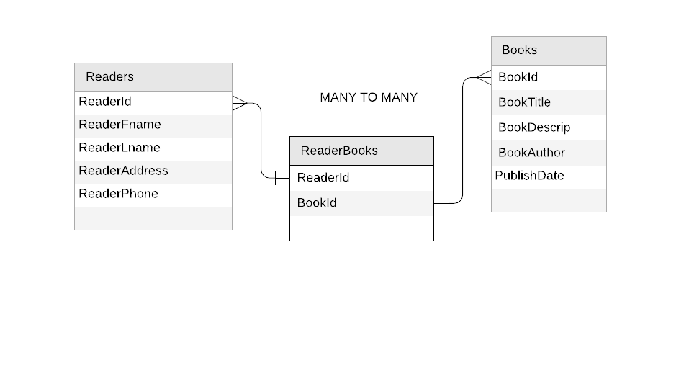

The Relationship is a Reader can have many books to read and the Books can have many readers. This relationship is a many to many relationship cause A person can actually read a lot of books while the books can have multiple person that can read the specific book. An example would be Harry like to read books, he actually read hundreds of books such as Harry Potter Series, Twilight Saga, and many more. This shows that a reader can have many books (one to many). On the other hand, a Science book which is use for teaching has been read by the students in a class. This shows a book can have many readers (one to many). This concludes that the relationship between books and readers is many to many relationship.