# Ford Mustang GT Fastback

## Source

Figure 1: 3D Model of Ford Mustang

## Material and textures

### Task

* Map the 3D geometry of your 3D model (the result of Task 1) to 2D texture space (UV mapping) (3 points)
* Create textures (base color, metallic, specular, roughness, etc.) for your 3D model (5 points)
* Use the created textures together with the Principled BSDF node to create material for your 3D model (2 points)
* Use light probe to light your 3D model (2 points)

### 3D modeling process

*3D modeling tool: Blender 2.81.16*

*Time: 10 hours*

### Materials

The first step I needed to do was to create materials for the car. To do that I switched to the materials tab. I created different materials for the car using only “Base color”, “Metallic”, “Specular” and “Roughness” values to bake them into textures later easily.

The main used materials were:

* Paint – red metallic material used for car paint.
* Black – black metallic material used for dark parts of the car.
* Light – red, low roughness material used for lights.
* White metal – low roughness, metallic material used for reflective surfaces.
* Tire – black, high roughness material used as rubber for wheels.

And some other materials for smaller parts.

After putting all materials where they belong using edit mode and the “assign” button, the output looked like this:

Figure 2: 3D Car model with materials

### UV Map

The next step of texturing was to create a UV map for the car. This process took some time since we needed to create one UV map for both the car and the wheels. Since the wheel was quite high detailer and circular, the automatic UV unwrap didn’t give realistic results, since the wheel took a huge part of the UV map. To counter that, I added seams using “Edge->Add Seam” to the edges of the wheel, which I wanted to be split in a UV map. Then I used the smart UV project with an angle limit of 20 and an island margin of 0.15 to create a UV map with spaces between the faces for better baking of the materials. The resulting UV map then looked like this:

Figure 3: UV map of the model

### Textures

With a working UV map, I could continue working on texture baking. For baking, I used the “BakeLab” plugin. In there, after selecting both wheels and the car, I set up the plugin to bake “Albedo”, “Glossy”, “Roughness”, “Metallic and “Normal” into 4k texture each. Afterward, I duplicated the car and set a single texture for all of its parts. This texture had the image texture I baked as all inputs.

For some reason, which I couldn’t figure out, the baked normal looked very weird, so I set the value of the normal map to zero to ignore them. The baked normal for everything after this looked good, but I kept it this way.

Figure 4: Material from image textures

Figure 5: Car with baked textures.

After baking the textures, I still needed to add the Mustang logo as well as the icons representing the car (5.0 and GT on the back). Unfortunately, I couldn’t use the plugin since it wasn’t able to bake texture into the existing texture.

For that, I used the cycles renderer baking method. After switching to cycles, the bake tab appeared. There I could set that I wanted to bake “selected to active” and in output unset “clear image”, so that the texture I’m writing into won’t be reset but written onto. There I could bake the same values as before (for metallic I needed to set the value to some other channel and bake it into the metallic texture). To bake, I needed to select the object I wanted to bake from and then the object to bake into. Then in the shading tab I selected the texture I wanted to bake into.

Since the baking had some issues, such as baking outside of the area I wanted it to bake, every time I needed to bake something, I first separated it from the car model, baked it, and merged it back together.

Last thing I added HDR and some lights as light probes around the model.

### Output

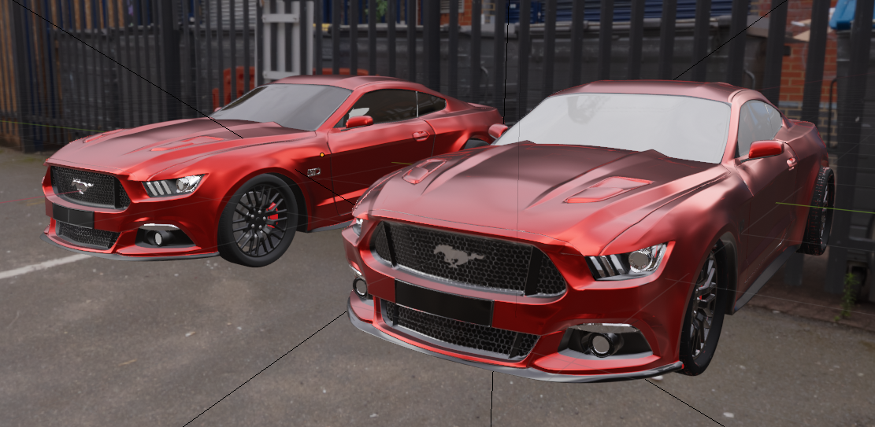

Figure 6: Left - materials, right – textures.

Figure 7: Left - materials, right – textures.