to nail this down properly — it's the foundation everything else in Flint rests on. Let me build this out systematically.
The core insight from your PDF and Image 16 is the one most traders miss: a CHoCH is only valid if it breaks the swing that produced the last BOS. Everything else — internal highs, wicks, random pullbacks — is noise. Let's work through the full hierarchy.

The three things a market can do
Before BOS/CHoCH even matter, you classify the regime. Uptrend = HH + HL. Downtrend = LH + LL. Consolidation = neither expanding. Every BOS and CHoCH event is just a transition between or within these states.

External vs internal structure — the most overlooked split
Every timeframe contains two layers of swing points simultaneously. External highs/lows are the major structural pivots that institutions actually respect — they define the trend. Internal highs/lows are the sub-swings living inside those bigger legs, the noise retail traders get trapped by.
The rule from Image 16 is blunt about this: a CHoCH must come from an HTF supply or demand zone, otherwise it's invalid. That's the same thing restated — if the break happens at an internal swing, it's just a retracement, not a character change.
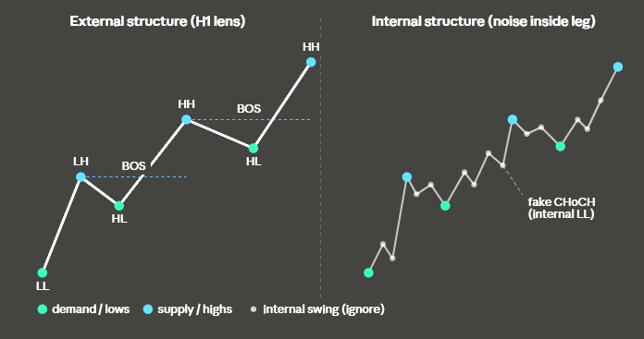
BOS — break of structure (trend continuation)
A BOS is price closing a candle body beyond the previous external swing in the direction of the current trend. In a downtrend, price closes below the last external LL — sellers confirmed, downtrend continues. In an uptrend, price closes above the last external HH — buyers confirmed, uptrend continues. Image 14 (Lambda Trading) shows this cleanly: red BOS labels mark every continuation break during the bearish phase, green BOS labels mark every continuation break once the bullish flip happens.
Two hard rules from your PDF: wicks don't count, and the close must be on whatever timeframe you're analyzing. An H1 BOS needs an H1 candle body close.
CHoCH — change of character (potential reversal)
A CHoCH is the first time price breaks the swing that created the last BOS in the opposite direction. It doesn't confirm reversal — it signals one. As Image 6 shows, in a downtrend the sequence is: LL → LH → LL → BOS breaks previous LL → price reverses → CHoCH breaks the LH that preceded that BOS. That specific LH is the only valid CHoCH level. Anything earlier is internal noise.
The critical thing Image 2 adds is the internal vs external dimension applied to BOS/CHoCH itself. An iBOS (internal break of structure) happens at sub-swing levels and just means the move is retracing before continuing. An eBoS (external break of structure) is the one that matters for structural classification. An iCHoCH is a warning; an eCHoCH is the actual flip.
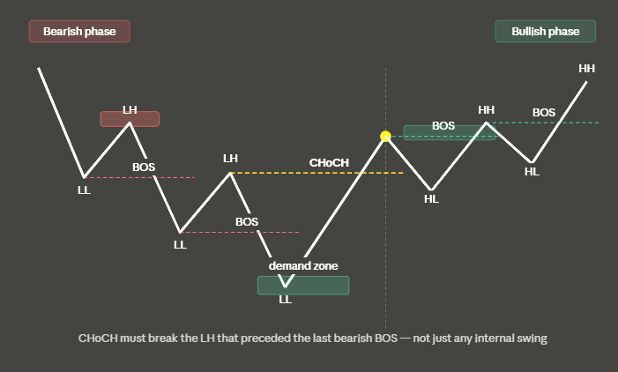
Why the "last BOS" rule is everything
Your PDF nails this: pick the wrong swing and you misread structure every time. In the bearish phase above, each LH is a candidate — but only the LH that directly preceded the most recent bearish BOS is the valid CHoCH level. The earlier LHs are already consumed structure. A price close above the wrong one just looks like a corrective bounce.
Image 16 adds the HTF context layer: even if price breaks the correct LH, if it doesn't come from an HTF supply zone, it's still invalid. This is the SMC version of "don't trade against the higher timeframe." In Flint terms: your H1 CHoCH requires alignment with H4 structure, and your H4 CHoCH requires the D1 macro context to support the flip.

Breaker and mitigation blocks — what BOS/CHoCH leave behind
Images 3, 4, 7, and 13 all show the same mechanic from different angles. When an order block (supply or demand zone) gets broken — meaning price BOS through it — that zone flips polarity. A broken bullish order block becomes a bearish breaker block. The old demand (buyers defending it) is now supply (those trapped buyers exiting when price returns).
Image 4 distinguishes them cleanly: a breaker block occurs when price makes a HH, then breaks all the way down past the previous LL (full trend reversal). A mitigation block occurs when price makes a lower high but doesn't break to a new low — it's a failure swing, not a full reversal. The mitigation block is at the last significant high before the failed attempt. When price returns to it, it acts as resistance because the traders who entered there on the impulse are still trapped.
In Spring Leaf terms: your H1 demand zones that get broken by a bearish BOS become the breaker blocks you'd short into on retest. The zone flipped. Same zone, opposite polarity.
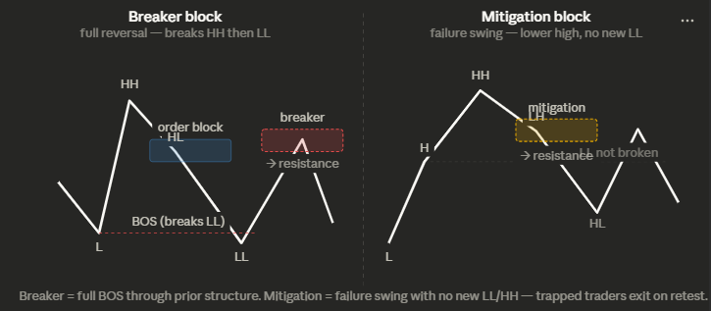
How this maps to Flint's layer stack
Putting it all together in your D→H4→H1 cascade:
The D1 layer only cares about eBOS and eCHoCH at the daily timeframe. The two zones you described in your trace — D1 supply and D1 demand — are the external boundaries. When D1 demand breaks with a daily candle body close, that's a bearish D1 BOS. The broken zone becomes a mitigation/breaker zone. The macro state flips only on a D1 eCHoCH: price must close above the D1 LH that preceded the last bearish D1 BOS.
The H4 layer runs the same algorithm one level down. H4 eBOS = trend continuation within the D1 macro. H4 eCHoCH = structural flip at the meso level — but it only has weight if it's happening inside a D1 supply or demand zone (the HTF context rule from Image 16). An H4 CHoCH inside dead space between D1 zones is much weaker.
The H1 layer is where your Spring Leaf zone counting lives. Each H1 eBOS extends the chain count. Each H1 eCHoCH is what the sweep-scalp-growth chain tracks as the entry trigger — the M1 CHoCH at an H1 zone. The H1 BOS being a liquidity sweep (as your SWEEP_SCALP_GROWTH_CHAIN doc formalizes) is just naming the same thing: the H1 BOS sweeps the retail stop cluster sitting just beyond the prior swing, which is exactly where the trapped traders' orders are.
The validation hierarchy is therefore: D1 macro direction → H4 zone context → H1 structural count → M1/M5 entry confirmation. A CHoCH at any level is only valid if the level above is aligned or at minimum neutral. That's the whole filter stack, from first principles.

