these two docs sharpen things considerably. Let me pull out what's actually new versus what confirms what we covered.

Zone Classification doc — the cleanest thing here
The BOS/CHoCH distinction just became mechanical rather than conceptual. From the previous discussion it was "CHoCH breaks the swing that created the last BOS." Your classification doc reduces it further:
HH or LL zone breaks → BOS. LH or HL zone breaks → CHoCH.
That's it. You never have to ask "which swing was the last BOS swing?" You just classify the zone being broken. If the zone being violated is a LH (supply top below previous supply top) or HL (demand bot above previous demand bot) — that's already a corrective zone, so breaking it is a character change. If it's a HH or LL zone, breaking it extends the trend.
The cross-TF propagation table is the other genuinely new piece — the threshold comparison that makes the cascade precise. An H1 HH only creates an H4 HH if the H1 supply top exceeds the previous H4 supply top. Without that comparison, you'd flag every H1 HH as structurally significant at H4, which is wrong. The cross-TF threshold is the filter.
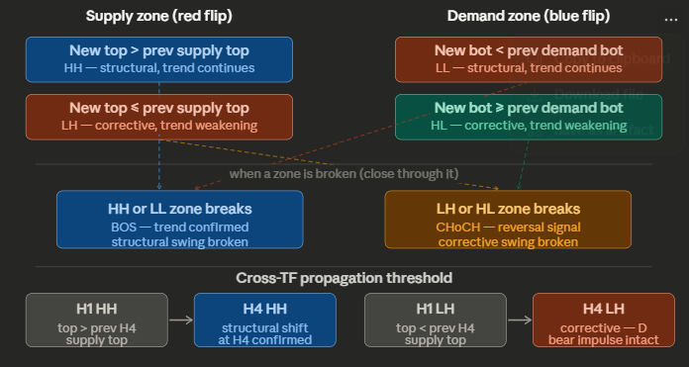
Early Confirmation Cascade — what's genuinely new
The previous discussion established the hierarchy conceptually: D1 macro → H4 meso → H1 zone count → M1 entry. This doc inverts the reading direction and that's the key shift. Instead of "wait for the HTF event then drop down for entry," you read upward: the M1 CHoCH is already telling you the H4 event is mechanically inevitable before the H4 candle has finished forming.
The sharpest sentence in the whole doc: "You don't wait for the H4 HH to appear on the chart. You detect it earlier through the H1 CHoCH that builds that H4 HH."
That reframes the entire timing question. The H4 HH is a lagging description of something that the H1 CHoCH already confirmed. The cascade direction is always bottom-up for execution and top-down for context.
The other piece that's new is the boundary zone as a gate rather than just a zone. Section 6 makes this explicit: a close above the bearish boundary supply top doesn't just break a zone — it confirms the H4 HH. You're not waiting for two separate events (zone break + H4 confirmation), they're the same event. That collapse has real implications for how context_mode transitions should be coded in Flint.
One thing worth resolving: the cascade doc describes M1 CHoCH as "always the final execution trigger," but your current Flint rules use growth_entry gated at H1 zone count. The M1 CHoCH entry (Path E) is an add-on, not the primary trigger in the current implementation. That's not a contradiction — Mode A/B entries fire at M5/M15 supply zones which are just the M5/M15 expression of the same cascade — but it's worth being explicit in the spec that Path E (M1 CHoCH) is the earliest possible entry, not the default.
The cascade table in Section 7 is the most immediately useful thing for Flint's implementation — each row is essentially a rule condition: what state variable to check, what comparison threshold triggers it, what the earliest tradeable signal is. That maps almost directly to the rule engine's condition format.

