Oh the things you can knit to!

Mara Alexeev

Last Updated 2021-08-05

## R Markdown

This is an R Markdown document. Markdown is a simple formatting syntax for authoring HTML, PDF, and MS Word documents (and more!) For more details on using R Markdown see <http://rmarkdown.rstudio.com>.

summary(cars)

## speed dist   
## Min. : 4.0 Min. : 2.00   
## 1st Qu.:12.0 1st Qu.: 26.00   
## Median :15.0 Median : 36.00   
## Mean :15.4 Mean : 42.98   
## 3rd Qu.:19.0 3rd Qu.: 56.00   
## Max. :25.0 Max. :120.00

## HTML only section

You can have code that is only evaluated when the output is HTML to allow interactive outputs.

test_plot <- ggplot(cars, aes(x = speed, y = dist)) +  
 geom_point()  
ggplotly(p = test_plot)

## Word only section

Or parts that render only for word documents.

if (format == "word_document"){  
test_plot <- ggplot(cars, aes(x = speed, y = dist)) +  
 geom_point()  
test_plot  
}

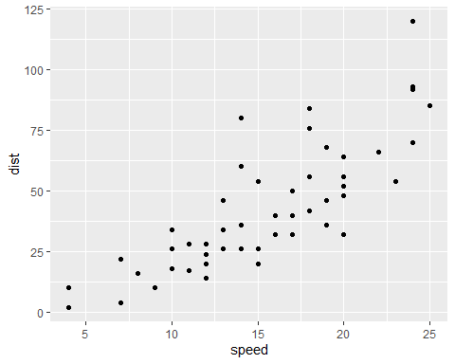

A plot about cars

## PDF only section

Or you can have code that is only evaluated when the output is latex for a PDF.

test_plot <- ggplot(cars, aes(x = speed, y = dist)) +  
 geom_point()  
test_plot