# Unit 7: Creating Your e-Portfolio (Part 1)

## Overview

In this unit, you will learn about what an e-Portfolio is and why you will be creating one for your final Leadership Integration Project. You will also learn how to create an e-Portfolio and create a structure including: setting up pages, menus, and posts. Last, you will spend some time reflecting on the learning activities by creating your first blog post on your e-Portfolio.

## Topics

This unit is divided into the following topics:

1. What is an e-Portfolio?
2. Creating an e-Portfolio
3. Selecting a Theme for Your e-Portfolio
4. What Are Pages?
5. What Are Posts?

## Learning Outcomes

When you have completed this unit, you should be able to:

* Explain what an e-portfolio is.
* Describe the purpose of an e-Portfolio as part of the MA Lead Capstone.
* Create an e-portfolio site.
* Create pages and format pages in the e-portfolio site.
* Create your first blog post.

## Activity Checklist

Here is a checklist of learning activities you will benefit from in completing this unit. You may find it useful for planning your work.

**Activity 7.1:** Read and Reflect

**Activity 7.2:** Watch a tutorial and sign up for a website.

**Activity 7.3:** Watch two tutorials and select a theme for your website.

**Activity 7.**4: Watch a tutorial and create pages for your site.

**Activity 7.**5: Watch a tutorial and create a post on your site.

**Assessment:** Complete the Discussion Post.

## Resources

Online resources will be provided in the unit.

## Topic 1: What is an e-Portfolio?

## A personal ePortfolio is both a product (a digital collection of artifacts) and a process (of reflecting on those artifacts and what they represent). In other words, your e-portfolio will be a website that you create where you will be able to share important assignments, projects, and reflections about your journey in the MA Leadership program and how you plan to apply your learnings as a transformational servant leader in your vocational context.

## ePortfolios generate learning because they provide a virtual space for you to critically assess your academic work, reflect on that work, and make connections among different courses, assignments, and other activities, such as work experience, extracurricular pursuits, volunteering opportunities, and more.  Making and then sharing an ePortfolio with others is somewhat like telling a story: *the story of your learning journey*.

Effective leaders are aware of the power of stories and use them naturally and authentically in a variety of ways and for many purposes. The best way to develop a great leadership story is to tell it. As you tell your story, you will undoubtedly discover new depths to it, clarify the deeper meanings of it, and discover how your story might help you better connect with the people you lead now or in the future.

In the MA Leadership program, the e-Portfolio is the platform you use to share the artifacts (digital collection) of your **Leadership Integration Project** (LDRS 697/698). This project will take the form of two activities:

1) Your action research project.

2) Your leadership journey.

Specifically, your e-Portfolio will include the following:

* A clear documentation of your leadership philosophy.
* Artifacts that help you tell your leadership story.
* Your Action Research Report.
* A final reflection on how Transformational Servant Leadership will impact your future as you influence the various contexts into which you are called.

The information covered in Units 7-9 will walk you through the steps you need to take to create an e-portfolio. These three units will give you the time you need to reflect, prepare, practice, troubleshoot, and ultimately create the e-portfolio so that when you begin LDRS 698 you can move right into data collection and analysis for your action research project and have your e-portfolio already set up to share your findings. In this unit, you will create the “skeleton” of your e-Portfolio by creating a WordPress site, deciding on a theme, and creating menus and pages.

## Learning Activity 7.1: Read and Reflect

To begin this learning activity, start by looking at a few examples of e-Portfolios that other students have created [here](https://uwaterloo.ca/centre-for-teaching-excellence/resources/integrative-learning/eportfolios/examples-student-eportfolios) and [here](https://digitalcurations.trubox.ca/). These examples are from the University of Waterloo and cover a range of programs from the arts, business, drama, pharmacy, and leadership.

Respond to the following questions in your reflective learning journal:

* What portfolios did you look at? Why?
* What did you like about the portfolios that you looked at? What did you not like?
* What would you do differently?

*The learning activities in this course are ungraded, unless specified. They are designed to help you succeed in your assignments in this course, so you are strongly encouraged to complete them.*

## Topic 2: Create a Website

**The following content is from** [**the Beginner’s Guide to WordPress**](https://www.wpbeginner.com/guides/)**:**

Your e-Portfolio site is built in WordPress and hosted for you by Trinity Western University. If you have never used this platform before, or if you have no experience with it, the information provided in these next three units will provide you with a step by step guide to help you create your website in order to get it ready for your e-Portfolio.

WordPress is an open source **Content Management System (CMS),** which allows users to build websites and blogs. WordPress is the most popular blogging system on the web and allows you to customize and easily manage your e-Portfolio. If you already have your own website or you have previous experience using WordPress, you may set up your e-Portfolio on it and skip the set-up steps in these units, but you still need to complete the learning activities.

Because WordPress is hosted by Trinity Western University, it is free for any TWU student to use. However, you must create and use your own domain name. A domain name is your website’s address on the Internet. This is what your users will type in their browsers to reach your site. For example, my site is: <https://create.twu.ca/drheatherstrong>.

If you have not created a WordPress site, you will need to go to <https://create.twu.ca/> and click on the following link to sign-up for a new site if you don’t have one already (see image below):

[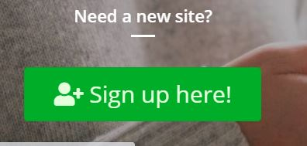](https://create.twu.ca/)

Be sure to read the Privacy Statement carefully before clicking “I Agree.” The information provided gives you excellent guidance regarding digital citizenship, privacy, and how to build a professional digital persona.

Make sure that you choose a domain name that is related to you, easy to pronounce and spell, and easy to remember. Once you have done that, we suggest you write all this information somewhere you can access it easily – just in case. If you need help choosing a domain name for your website you can read these tips and tools on [how to choose the best domain name](https://www.wpbeginner.com/beginners-guide/tips-and-tools-to-pick-the-best-domain-for-your-blog/).

Once you have created your domain name and you have a Uniform Resource Locator (URL, also known as a web address) you will need to sign in to your WordPress site to complete the following learning activities.

## Learning Activity 7.2: Watch a Tutorial and Sign up for a WordPress Site

To begin this learning activity, watch the following video tutorial on how to create a website using WordPress. This video provides you with an overview of all the necessary steps. Do not worry if you start to feel overwhelmed—we will break these steps down for you one by one in the following learning activities. You can watch the video tutorial here:

**Note to production: Insert Mel Laurie’s WP tutorial video.**

Next, go to <https://create.twu.ca> and sign up for your own WordPress site.

Finally, post a link to your e-Portfolio on the unit 7 discussion forum in Moodle.

## Topic 3: Select Your Theme

**The following content is from the** [**Beginner’s Guide to WordPress**](https://www.wpbeginner.com/guides/)**:**

The visual appearance of your WordPress site is controlled by a WordPress theme. WordPress themes are professionally designed templates that you can install on your website to change its appearance.

By default, each WordPress site comes with a basic theme. If you visit your website, then it will look something like this:

## 

This theme is not very appealing for most users. But don’t worry, there are thousands of free WordPress themes that you can install on your site. You can change your theme from the WordPress admin dashboard. Take a look at some WordPress templates [here](https://wordpresstemplates.trubox.ca/) for inspiration.

## Learning Activity 7.3: Watch a Tutorial and Choose a Theme for your site.

To understand the back end or dashboard of your WordPress site, watch the following two videos [Backend Tour #1](https://youtu.be/CUHlWbDwCo8) and [Backend Tour #2](https://youtu.be/XHBnKu3lewI) that will provide you with an orientation to the administrative end of your WordPress site.

Next, go to your dashboard on your WordPress site. You need to add the word “admin” at the end of your WordPress domain name, like this to access your dashboard:

[https://create.twu.ca/drheatherstrong/admin](https://create.twu.ca/yourdomainnamehere/admin)

Next, you will choose a theme for your WordPress site by clicking on **Appearance » Themes** page and then click on the ‘Add New’ button.

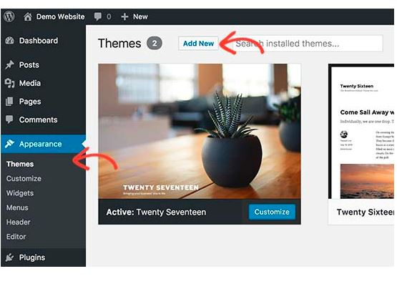

On the next screen, you can search from thousands of free WordPress themes that are available in the official WordPress.org themes directory. You can sort them by popular, latest, featured, as well as other feature filters (i.e industry, layout, etc).

WordPress will show you the theme in search results. You will need to take your mouse over to the theme and then click on the Install button.

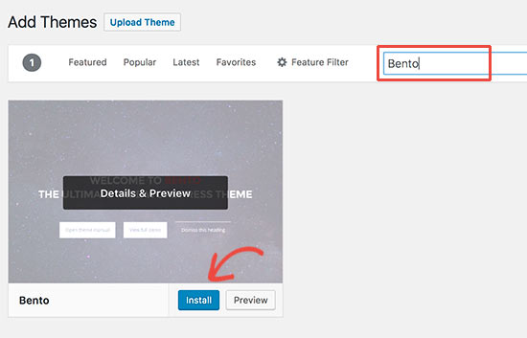

Once you have installed your theme, you can customize it by clicking on the Customize link under the Appearance menu.

This will launch the theme customizer where you will be able to change your theme settings with live preview of your website.

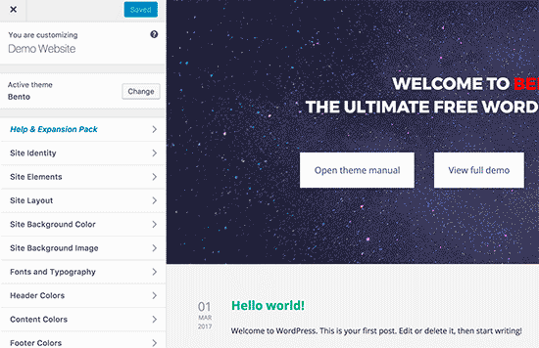

You don’t need to finalize all theme settings right away. You will be able to customize it much better once you have some content on your website.

## Topic 4: What are Pages?

**The following content is from the** [**Beginner’s Guide to WordPress**](https://www.wpbeginner.com/guides/)**:**

Next, let’s work on adding content to your WordPress site. WordPress comes with two default content types called **posts** and **pages**. Posts are part of a blog and appear in reverse-chronological order (newer items displayed first). On the other hand, pages are meant to be static “one-off” type content such as “About Me,” “Contact Page,” etc. Learning Activity 7.4 will help you set up the specific pages needed for your MA Lead Capstone project.

## Learning Activity 7.4: Watch a Tutorial and Adding Pages to Your Website

In this learning activity, you will start adding pages to your WordPress site, creating a static front page, changing your title and tag line, and creating a navigation menu. Don’t worry if you don’t have enough content for these pages now. You can always edit and update them later.

Begin by watching the following video “[Adding a Page](https://www.youtube.com/watch?v=1QdQ-QCio9A)”. This video will walk you through how to create pages on your WordPress Site.

Next, open the dashboard of your own WordPress site and head over to **Pages » Add New** page in WordPress admin area. This will bring you to the page editor screen, which looks like this:

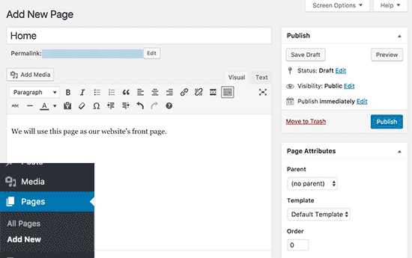

First you need to provide a title for your page, let’s call this first page ‘Home..

After that you can add content in the text editor below. You can add text, links, images, embed videos, audio, etc. After adding content to your page, you can click on the publish button to make it live on your website.

Repeat the process by adding more pages for different sections of your website. For your final e-Portfolio you will need to have the following pages created on your WordPress site. Here are some suggestions for labelling your pages. You do not have to follow these labels, you can create your own headings and labels, you just need to ensure that you have these sections available on your e-Portfolio:

* Home
* About Me
* My Leadership Story
* My Leadership Philosophy
* My Action Research Report
* Reflection on Transformational Servant Leadership
* Blog

### Setting up a Static Front Page

You need to visit the **Settings » Reading** page in your WordPress admin area. Under the ‘Front page displays’ option click on the static front page and then select ‘Pages’ you created earlier for your home and blog pages.

* 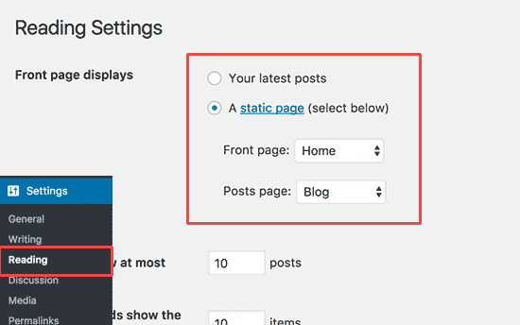

Don’t forget to click on the ‘Save Changes’ button at the bottom of the page to store your changes.

WordPress will now use the page titled ‘Home’ as your site’s front page and ‘Blog’ page to display your blog posts.

### Change Site Title and Tagline

During the installation you get to choose your site’s title. WordPress automatically adds a tag line to your site title that says ‘Just another WordPress site’.

You can change both your site’s title and tagline at any time by visiting **Settings » General** page.

* 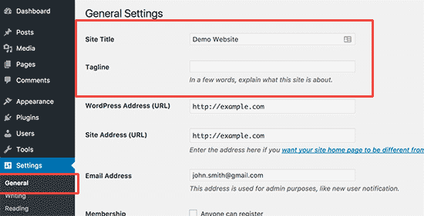

Your site title will be the name of your website like WPBeginner or Dr. Heather Strong. The tag line is usually a single line that describes your website. You can also leave the tag line field blank if you want. I have used one of my favorite quotes about leadership in my tag line.

Don’t forget to click on the save changes button to store your settings.

### Create Navigation Menus

Navigation menus allow your users to browse different pages or sections on your website. WordPress comes with a powerful navigation menu system, and your WordPress theme utilizes this system to display menus.

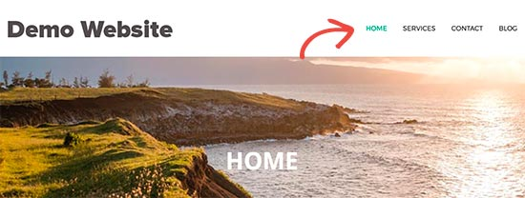

Let’s add a navigation menu to your website.

First, you need to visit **Appearance » Menus** page. Enter a name for your navigation menu and click on the create menu button.

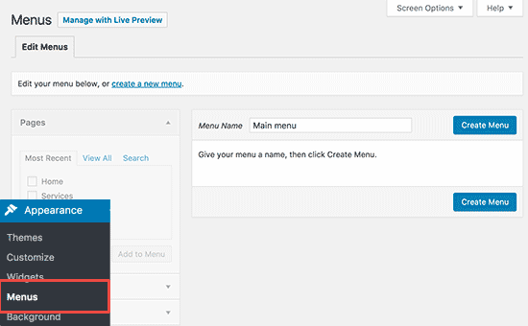

WordPress will now create your navigation menu. It will be empty at the moment.

Next, you need to select the pages you want to display in your menu and then click on add to menu button.

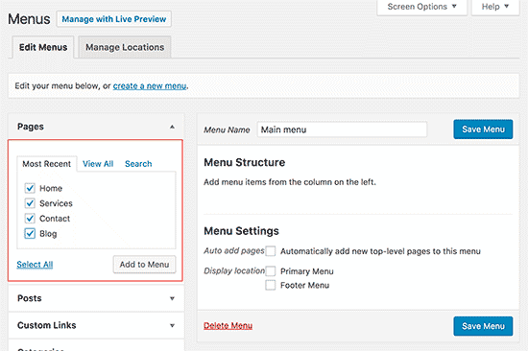

You will notice your selected pages filling the empty area of your navigation menu. You can move them up and down to rearrange their position in the menu.

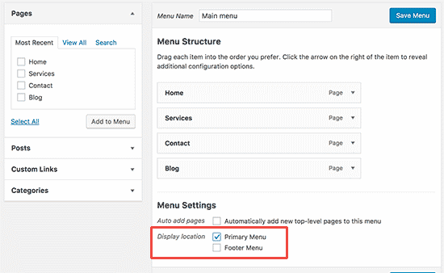

Now you need to select a display location. These locations are defined by your WordPress theme. Usually, most WordPress themes have a primary menu that appears on top.

Finally, click on the save menu button to store your navigation menu.

You can now visit your website to see the menu in action.

For more detailed instructions see the WPbeginner’s guide on [how to add navigation menu in WordPress](https://www.wpbeginner.com/beginners-guide/how-to-add-navigation-menu-in-wordpress-beginners-guide/).

## Topic 5: What are Posts?

**The following content is from the** [**Beginner’s Guide to WordPress**](https://www.wpbeginner.com/guides/)**:**

Posts are blog content listed in a reverse chronological order (newest content on top). You will see posts listed on your blog page. If you are using WordPress as a blog, then you will end up using posts for the majority of your website’s content. You can add and edit your WordPress posts from the ‘Posts’ menu in your dashboard.

Because WordPress posts are published with time and date in mind, they are syndicated through the RSS feeds. The acronym RSS stands for Really Simple Syndication or Rich Site Summary. It is a type of web feed that allows users and applications to receive regular updates from a website or blog of their choice. It is sometimes referred to as the **feed** or **RSS feed**.

In the early days of Internet, if you wanted to keep track of updates on your favorite website, then you had to bookmark it and then manually visit to see if there were any updates. RSS feed solved that problem by allowing users to keep track of their favorite websites without having to manually visit the website each time.

RSS allows bloggers and publishers to automatically syndicate their content, so that people can read it in their email, feed reader and other devices. This kind of sharing allows your readers to be notified of the most recent post update via RSS feeds.

The very timely nature of posts makes it extremely social and available for real-time feedback from an authentic audience. You can use one of the many social sharing plugins to allow your users to share your posts in social media networks like Facebook, Twitter, LinkedIn, or Pinterest.

Posts encourage conversation. They have a built-in comment feature that allows users to comment on a particular topic. By default, comments are enabled on all WordPress sites.

## Learning Activity 7.5: Watch a Tutorial and Add a Post to Your Website

In this learning activity, we will start adding a few posts on your WordPress Site. Begin by watching the following video “[How to Add a New Post in WordPress](https://www.youtube.com/watch?v=WdO_thpXBZ4)”.

Head over to **Posts » Add New** in your WordPress admin area.

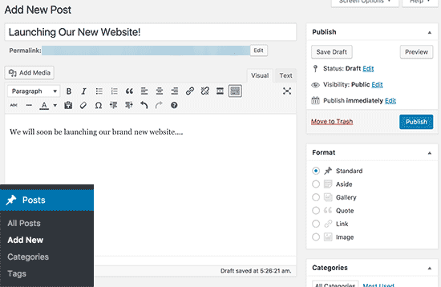

You will see a screen much like you saw earlier when adding pages.

You can add a post title and then add content in the post text editor. You’ll also notice some extra options like post formats, categories and tags.

You can click on the save button to store your post as a draft or click on the publish button to make it visible on your site.

For more detailed instructions on how to utilize all these options on post and page edit screens, please see the WPbeginners guide on [how to add a new post in WordPress](https://www.wpbeginner.com/beginners-guide/how-to-add-a-new-post-in-wordpress-and-utilize-all-the-features/).

### Set up Comments Settings

WordPress comes with a built-in comment system allowing your users to leave comments on your posts. This comment system is great for user engagement, but it can also be targeted by spammers as well.

To deal with this, you’ll need to enable comment moderation on your website.

Visit **Settings » Discussions** page and scroll down to ‘Before a comment appears’ section. Check the box next to ‘Comment must be manually approved’ option.

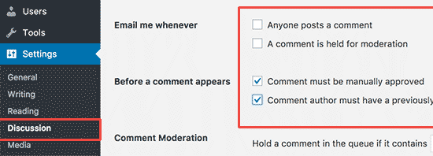

Don’t forget to click on the save changes button to store your settings.

Now, let’s create your first post. In your first post, create a reflection on your experience creating a Wordpress site, setting up your pages, and writing your first post:

* What happened when you created your site?
* What were you thinking or feeling as you were creating or designing your site?
* What was good and bad about these learning activities?
* What went well or not so well? What kind of feedback do you have about this activity?
* What conclusions can you draw? What specific (personal) conclusions do you have?
* What will you do the next time? What will you do differently, the same?

## Summary

In this unit, you have learned what an e-Portfolio is and why you will be creating one for your final Leadership Integration project. You have learned how to create a website and create a structure for that website including: setting up pages, menus, and posts. Finally, you spent time reflecting on the Summary learning activities by creating your first blog post on your new website. In the next unit, you will begin exploring how to protect your privacy and add images and documents to your website.

## Assessment

### Discussion Post and Response:

After completing this unit, including the learning activities, you are asked to share a link to your new website on the discussion forum and a link to your first reflection post.

In your discussion post, create a reflection on your experience creating a WordPress site, setting up your pages and writing your first post:

* **DESCRIBE:** What happened when you created your site?
* **FEEL:**What were you thinking or feeling as you were creating or designing your site?
* **EVALUATE:** What was good and bad about these learning activities?
* **ANALYZE:** What went well or not so well? What kind of feedback do you have about this activity?
* **CONCLUDE:** What conclusions can you draw? What specific (personal) conclusions do you have?
* **PLAN:** What will you do the next time? What will you do differently, the same?

## Checking your Learning

Before you move on to the next unit, you may want to check to make sure that you are able to:

* Explain what an e-portfolio is.
* Describe the purpose of an e-Portfolio as part of the MA Lead Capstone.
* Create an e-portfolio site.
* Create pages and format pages in the e-portfolio site.
* Create your first blog post.