Unit 8: Creating Your E-Portfolio (Part 2)

Overview
In this unit, you will learn how to control your privacy settings and access to your WordPress site. You will also learn how to add images, videos, and files on pages or posts. Next, you will spend some time adding an artifact from one of your courses in MA Lead to your website and reflecting on it. Finally, you will also spend some time sharing about your progress on your e-Portfolio and discuss how you think your e-Portfolio will be a useful resource for you moving forward.

Topics
This unit is divided into the following topics:
- How to Control Access to Your e-Portfolio
- Adding Images and Videos to Your e-Portfolio
- Inserting Files on Your e-Portfolio

Learning Outcomes
When you have completed this unit, you should be able to:
- Describe how to control access to your e-Portfolio.
- Create images and post documents that showcase important artifacts.
- Reflect on how you think your e-Portfolio will be a useful resource for you moving forward.

Activity Checklist
Here is a checklist of learning activities you will benefit from in completing this unit. You may find it useful for planning your work.
Activity 8.1: Watch a video and set up your privacy settings.
Activity 8.2: Watch a few videos and add images to your website.
Activity 8.3: Watch a video and practice adding a document to your website.
Activity 8.4: Upload an artifact and reflect on questions in your learning journal.
Assessment: Complete the Discussion Post.

Resources
Online resources will be provided in the unit.

Topic 1: How to Control Access to Your e-Portfolio
(Content adapted from: www.wpbeginners.com/beginners-guide)
Now that you have created your own e-Portfolio, you may be thinking, “This is really great, I now have my first website! But wait…. I don’t want anyone (outside of my classmates and instructors) to access or read what I am posting on the Internet.” There may be many reasons for your reluctance to share your work, so you should be reassured that using WordPress does not mean that your website is accessible to everyone on the Internet.

You can restrict access to a WordPress site for logged-in users only or for people with specific IP addresses. You can also choose to redirect users with no access to the site by sending them to the login page, redirect to another web address, show them a custom message, or even redirect them to a specific page (e.g. “Coming Soon”) that you have created on the same site. Restricting access to your site is useful for testing your site before a launch. It is also helpful if you are creating private blogs for friends, colleagues, and/or classmates only.

Learning Activity 8.1: Set Your Privacy Settings
To begin this learning activity, watch the following video on “Restricting Access to Your Website”. You may not want your site to be made public or you may not be ready to make it public yet. This video will show you how to restrict access to your WordPress site.
Next, follow these steps. There are several options for privacy.
Go to your site dashboard. Next select, Settings » Reading. Scroll down to the bottom and you will see options to configure restricted access.
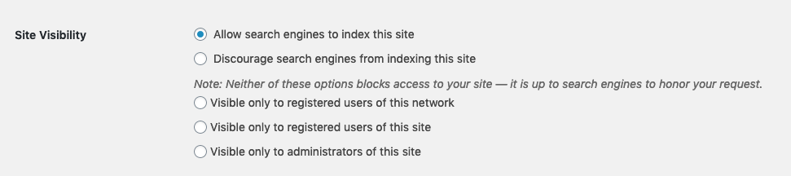
- The top two options are open on the web, but you can still protect your posts with a password.
- ‘Visible only to registered users of this network’ includes all students, staff and faculty at TWU who are logged in to a create.twu.ca site.
- ‘Visible only to registered users of this site’ means that the learner will have to add users from the class who they want to see the site.
- ‘Visible only to administrators of this site’ means that the site is private and only the learner and the network administrators can see it.
These settings apply regardless of where the user or potential site visitor might be.
- For a view of what a private site looks like, click here.
- For a view of what a password-protected post on a public site looks like, click here.

Topic 2: Adding Images and Videos to Your e-Portfolio
The following content is adapted from: https://wordpress.org/support/article/media-library-screen/
The Media Library on your WordPress site houses the media you upload to your site. WordPress supports a variety of media types such as images, audio, video, and documents. Media is typically uploaded and inserted into the content when writing a Post or writing a Page. Note that the Uploading Setting in the Settings Media Screen describes the location and structure of the upload directory (where your media files are stored). If you do need to upload Media, even if that Media is not related to a Post or Page, then you need to use the Media Add New Screen. We do suggest that you host your video files in your TWU Microsoft Stream account for optimal playability. Images and videos bring life to your WordPress posts and pages by making them more engaging. However, many beginners struggle with adding images just the way they like.

Learning Activity 8.2: Watch Videos and Add Images to Your Website
To begin this learning activity watch the following short tutorial videos:
- How to Add an Image to a Wordpress Site
- How to Add a Featured Image
- How to Add Menu Icons
- How to Embed Videos
Next, choose an image that represents your first blog post. Upload the image to your first post from Unit 7 by following the instructions below. Instructions for this learning activity are from: https://wordpress.org/support/article/inserting-images-into-posts-and-pages/
Note: You must adhere to the Canadian Copyright Act when choosing images for your site. Do not simply search for an image on Google and put it in your e-Portfolio. That is stealing someone else’s work. You can find open source photos by modifying the “Usage Rights” feature under “Tools” when searching on Google images, or use one of the following royalty free photo repositories:
- Unsplash
- Pixabay
- Burst
- Kaboompics
- Free Images
- And more here
Step 1: To add an image to your page or post, you must first insert your cursor in the place in the text where you want the image to appear. By placing your cursor within your text, you can add images in line with your content. You can also place your cursor on a blank line if you want the image to appear by itself instead.
Tip: It’s a good idea to place your cursor on the left margin of your text, even if you want the image to appear on the right. That’s because there is a special setting called Alignment that allows you to control whether the image appears on the right or the left side of the text. It even controls how text flows around the image automatically.
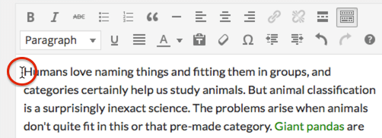

Step 2: Once you’ve placed your cursor on the line where you want your image to appear, click on the Add Media button to launch the media uploader interface, and then select the Insert Media option from the list of actions in the left side of the media uploader window.
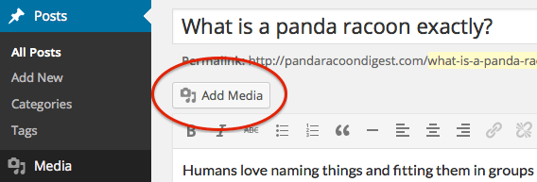
“Add Media” button above editor
You can add or select the image you want to add to your page or post by choosing from either of the following options in the center of the media uploader window:
- Upload Files: Upload the image you want to use from your computer by dragging it into the upload area. Be sure it is your own work or downloaded from an open source photo site.
- Media Library: Select from any previously uploaded images in the media library by clicking on the one you wish to add to your page or post.
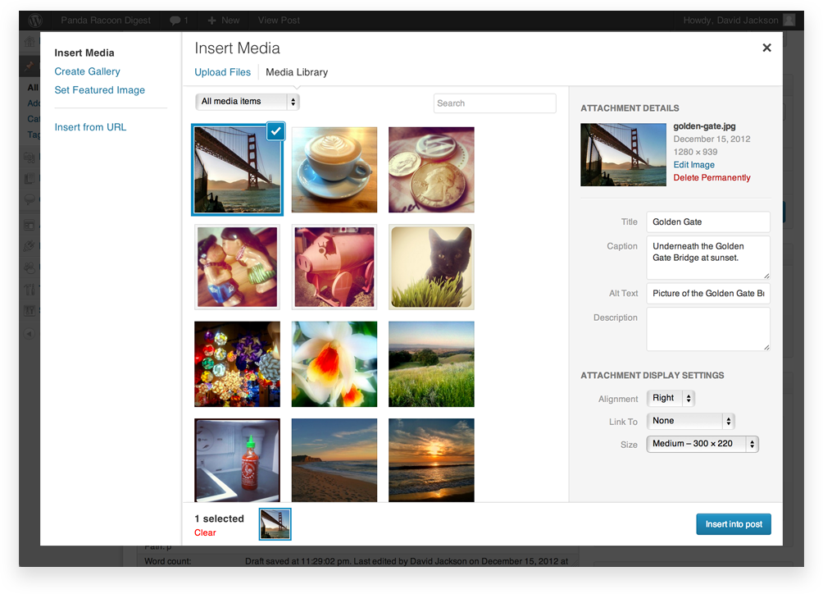
Step 3: Once you have selected or uploaded the image you want to add, you will see a checkbox next to the thumbnail confirming your selection, and see information about it displayed in the Attachment Details pane on the right hand side of the media uploader interface.
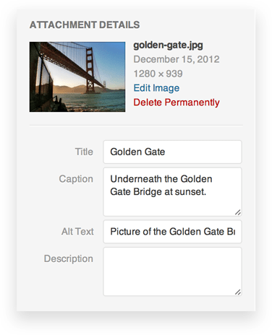
Step 4: The Attachment Details pane displays a small un-cropped thumbnail of the image, as well as important information such as the filename, date uploaded, and image dimensions in pixels.
There are also action links that allow you to Edit Image, which takes you to the page, or to Delete Permanently to remove the image from your site.
In addition, you can edit the following media information:
- Title: The title of this media.
- Caption: The caption for this image. The text you enter here will be displayed below the image.
- Alternate Text: Enter the Alt text for the image, e.g. “The Mona Lisa” to describe the media.
- Description: A description for this particular media.

Step 5: Attachment Display Settings
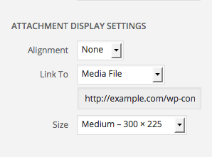
The Attachment Display Settings pane controls how the image is displayed when viewed on the site.
You have options to set how you would like the image aligned on the page (in relation to the text and margins) and what the link behavior of the image will be. In addition you can set what size image you would like to display on your page.

Image Alignment
The Alignment setting allows you to determine where you would like the image to appear in your content area and how it interacts with any text on the page. You have the following image alignment options to choose from:
- Left: Aligns the image on the left hand margin, and any text that is on the page wraps (or flows) around the image to the available space on the right.
- Right: Aligns the image on the right hand margin, and any text that is on the page wraps (or flows) around the image to the available space on the left.
- Center: Aligns the image to the center of the page, with no text displayed around it.
- None: Inserts the image in to the page with no alignment
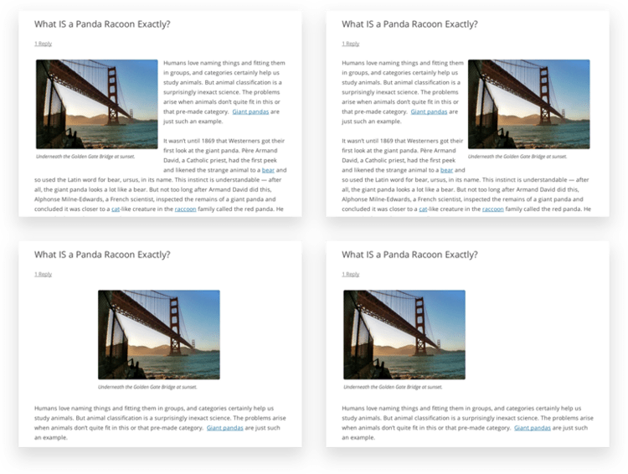

Image Size
The Size settings determine the size of the image you are adding to your site. By default WordPress creates four image sizes for you to choose from:
- Thumbnail: Displays a small thumbnail-sized version of your image on the page/post. Note, by default the Thumbnail size is a square, so some cropping of your original image may occur.
- Medium: Displays a medium-sized version of your image on the page/post. This is a good size to use with Left/Right alignments, as it leaves sufficient space for legible text to either side.
- Large: Displays a large-sized version of your image on the page/post. Note: WordPress will determine the width of the content column of your theme, and display the largest possible image for that space.
- Full Size: Displays a full-sized version of your image on the page/post. Note: WordPress will determine the width of the content column of your theme, and display the largest possible image for that space. If your original image is larger than this column width, the full size of the image may not be displayed. Here is an example of the image sizes:
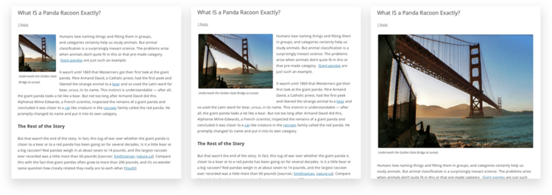

Step 6: Inserting the image
Once you have determined your image settings, click on the Insert into post or Insert into the page button, to add the image to your page or post. After the image uploader window closes, you will see the image in the text editor window, including a preview of the alignment of the image, if you have specified an image alignment.
At any time, you can edit the image settings by clicking on the Edit Image button in the upper left hand corner. You can remove the image from your page/post by clicking on the Remove Image button.

Topic 3: Inserting Files on Your e-Portfolio
(Content adapted from: https://wordpress.com/support/uploading-documents/)
WordPress allows you to easily upload files from your computer or a URL to make them available on your e-Portfolio. You can upload files like PDFs, Word documents, PowerPoint slides, or audio recordings to your WordPress site. You can link cloud-based documents (e.g. Google Docs, Google Slides, Google Drawings) and websites. It will be important for you to know how to add documents, presentation files, audio or video recordings on your WordPress site because this will be the primary way that you share significant artifacts from your learning journey in MA Lead and share your action research report.

Learning Activity 8.3: Watch a video and practice adding documents and files to your website.

To begin this learning activity, watch the following video [How to Upload a PDF file in your Media Library in WordPress](https://www.youtube.com/watch?v=E-Ja467CK_Q)

Next, follow the steps outlined below to help you practice uploading a document from your computer, and to also upload a file from a URL, and making them visible on your website.

Step 1: Uploading a Document from Your Computer
The following process describes uploading a document from your computer to your blog’s Media Library and inserting a download link into a post or page.
- Go to My Site(s) → Site → Media.
- Click on the Add New icon found in the top left corner:
- Choose a file (or multiple files) from your computer to upload.
- Once the file has finished uploading, click the Edit button.
- Click the ‘Copy’ button to copy the file URL to your clipboard:
Copy the file URL
Now that you have the URL, you can insert this as a link or a button on any post or page.

Step 2: Uploading a Document from a URL
The following process describes inserting a download link to a file that already exists on another web site. This method will not upload the document/file to your blog’s Media Library. This means that if the file is removed from its location, your link will appear broken. This is not recommended unless you know the file will always be available at the specified location.
- Go to My Site(s) → Site → Media
- Click on the chevron symbol next Add New and click Add via URL (found in the top left corner):
- Enter the URL and click Upload.
- Once the file has finished uploading, click the Edit button.
- Click the ‘Copy’ button to copy the file URL to your clipboard:
Copy the file URL
Now that you have the URL, you can insert this as a link or a button on any post or page.

Step 3: Uploading a Document from the WP Admin Media Library
Note: The instructions from this guide are referring to the WP Admin dashboard. You can get to this dashboard by adding /wp-admin to the end of your site’s url (e.g.: example.wordpress.com/wp-admin)
The following process describes inserting a download link to a file that already exists in your Media Library.
- In the WP Admin dashboard, go to Posts → Add New or Pages → Add New.
- Click on the Add Media icon found directly above your editor.
- Click on the Media Library tab.
- Locate the file you wish to add and click on it once.
- Select the Media File option under Attachment Display Settings (the type of link you choose will be saved for next time).
- Click the Insert into post button.
- You should now have a working download link to the file in your new post or page.

Learning Activity 8.4: Upload an Artifact and Reflect
To begin this learning activity, select one artifact from one of your courses in MA Lead. Your artifact can be a PowerPoint presentation, video, written assignment, audio recording, or visual that you created in any of your previous MA Lead courses. Add the artifact to a page on your WordPress site to fulfill the “Leadership Story” component of your e-Portfolio. For this artifact, create a reflection on each document that incorporates these components:
- DESCRIBE: What happened when you created that activity?
- FEEL: What were you thinking or feeling as you were creating or designing?
- EVALUATE: What was good and bad about that activity?
- ANALYZE: What went well or not so well? What kind of feedback do you have about this activity?
- CONCLUDE: What conclusions can you draw? What specific (personal) conclusions do you have?
- PLAN: What will you do the next time? What will you do differently, the same?

Summary
In this unit, you have learned about how to control your privacy settings on your WordPress site. You have also learned how to add images and videos to your website and insert files on pages or posts. Finally, you spent some time reflecting on the progress of your website and you discussed how you think your e-Portfolio will be a useful resource for you moving forward. Coming up in the next unit, you will continue adding important artifacts to your website and start writing your leadership philosophy.

Assessment

Discussion Post and Response:
After completing this unit, including the learning activities, you are asked to share how you plan to share your experience with others in a discussion post for your colleagues.
Here are some questions to consider in your post:
- What difficulties did you have as you were creating your e-Portfolio? Is there anything you still need help with? By sharing your learning needs, you have a better chance of receiving support from someone in the cohort who is skilled in solving some of the problems you face.
- What skills do you have that you would be willing to teach others?
- When you were building your e-Portfolio, what categories did you believe were the most important for you personally?
- How can you make your e-Portfolio a resource for yourself moving forward?
- How can you create an e-Portfolio that has the greatest possibility for contributing to the growth of others?
- What unique skills or insights do you have that you might share more fully with others?
- As it stands right now, how do you see your e-Portfolio growing throughout the MA Lead Capstone project?

Checking your Learning
Before you move on to the next unit, you may want to check to make sure that you are able to:
- Describe how to control access to your e-Portfolio.
- Create images and post documents that showcase important artifacts.
- Reflect on how you think your e-Portfolio will be a useful resource for you moving forward.

