***COMENZI CREARE TABELE***

create table client(

client_id number(3) PRIMARY KEY,

nume VARCHAR2(50) NOT NULL,

prenume VARCHAR2(50) NOT NULL,

tip_de_client VARCHAR2(20) NOT NULL,

firma_angajatoare VARCHAR2(50),

numar_de_telefon number(15) NOT NULL,

adresa_de_email VARCHAR2(50)

);

insert into client (client_id, nume, prenume, tip_de_client, firma_angajatoare, numar_de_telefon, adresa_de_email)

values (100, 'Ada', 'Popescu', 'persoana fizica', null, 070555395, 'anaposescu@yahoo.com');

insert into client (client_id, nume, prenume, tip_de_client, firma_angajatoare, numar_de_telefon, adresa_de_email)

values (101, 'Stoica', 'Mihai', 'persoana fizica', null, 0705557524, 'stoica.mihai@gmail.com');

insert into client (client_id, nume, prenume, tip_de_client, firma_angajatoare, numar_de_telefon, adresa_de_email)

values (102, 'Mosescu', 'Emil', 'persoana juridica','ABCtech', +40785554346, 'EmilMosescu@abctech.ro');

insert into client (client_id, nume, prenume, tip_de_client, firma_angajatoare, numar_de_telefon, adresa_de_email)

values (103, 'Moraru', 'Ana', 'persoana fizica',null, +407655520345 , 'ana_moraru@yahoo.com');

insert into client (client_id, nume, prenume, tip_de_client, firma_angajatoare, numar_de_telefon, adresa_de_email)

values (104, 'Rusu', 'Elena', 'persoana juridica', 'DataTech', +40711555046 , 'rusu.elena@DataTech.ro');

insert into client (client_id, nume, prenume, tip_de_client, firma_angajatoare, numar_de_telefon, adresa_de_email)

values (105, 'Fratila', 'Alina', 'persoana juridica', 'DataTech', +40711555272 , null);

insert into client (client_id, nume, prenume, tip_de_client, firma_angajatoare, numar_de_telefon, adresa_de_email)

values (106, 'Mocanu', 'Nicu', 'persoana fizica', null, +4070555115 , null);

insert into client (client_id, nume, prenume, tip_de_client, firma_angajatoare, numar_de_telefon, adresa_de_email)

values (107, 'Diaconescu', 'Maria', 'persoana fizica', null, +40711555487 , null);

commit;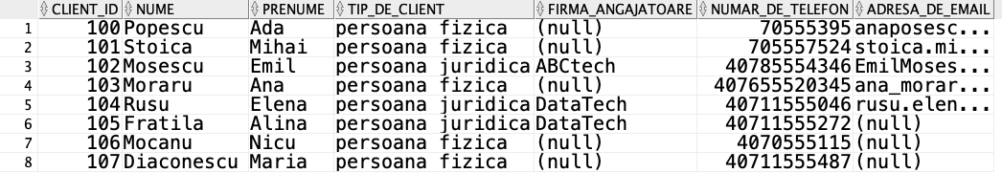

create table factura(

factura_id NUMBER(3) PRIMARY KEY,

client_id NUMBER(3) NOT NULL,

pret_total NUMBER(5, 2) NOT NULL,

data date NOT NULL

);

alter table factura modify(data date default sysdate);

insert into factura(factura_id, client_id, pret_total)

values (10, 104, 300);

insert into factura(factura_id, client_id, pret_total, data)

values (20, 101, 124, to_date('03-FEB-21'));

insert into factura(factura_id, client_id, pret_total, data)

values (30, 104, 753.59, to_date('15-DEC-20'));

insert into factura(factura_id, client_id, pret_total)

values (40, 100, 999.99);

insert into factura(factura_id, client_id, pret_total,data)

values (50, 102, 200, to_date('26-AUG-20'));

insert into factura(factura_id, client_id, pret_total)

values (60, 103, 500);

insert into factura(factura_id, client_id, pret_total,data)

values (70, 103, 130, to_date('10-MAR-20'));

insert into factura(factura_id, client_id, pret_total)

values (80, 102, 326);

insert into factura(factura_id, client_id, pret_total,data)

values (90, 100, 780, to_date('19-SEP-19'));

insert into factura(factura_id, client_id, pret_total,data)

values (100, 101, 450, to_date('13-OCT-20'));

commit;

alter table factura add FOREIGN KEY(client_id) references client(client_id);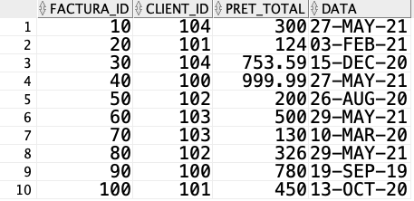

create table calculator(

calculator_id number(3) PRIMARY KEY,

client_id number(3) NOT NULL

);

alter table calculator add FOREIGN KEY(client_id) references client(client_id);

insert into calculator(calculator_id, client_id)

values (1, 101);

insert into calculator(calculator_id, client_id)

values (2, 104);

insert into calculator(calculator_id, client_id)

values (3, 100);

insert into calculator(calculator_id, client_id)

values (4, 101);

insert into calculator(calculator_id, client_id)

values (5, 102);

insert into calculator(calculator_id, client_id)

values (6, 104);

insert into calculator(calculator_id, client_id)

values (7, 102);

insert into calculator(calculator_id, client_id)

values (8, 100);

insert into calculator(calculator_id, client_id)

values (9, 103);

insert into calculator(calculator_id, client_id)

values (10, 104);

insert into calculator(calculator_id, client_id)

values (11, 106);

insert into calculator(calculator_id, client_id)

values (12, 107);

insert into calculator(calculator_id, client_id)

values (13, 105);

insert into calculator(calculator_id, client_id)

values (14, 107);

insert into calculator(calculator_id, client_id)

values (15, 106);

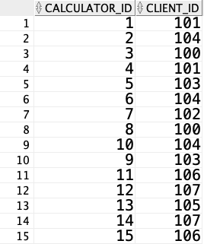

commit;

create table reparatie(

reparatie_id number(3) PRIMARY KEY,

angajat_id number(3) NOT NULL,

factura_id number(3) NOT NULL,

data_inceput date NOT NULL,

data_sfarsit date NOT NULL

);

alter table reparatie add foreign key(factura_id) REFERENCES factura(factura_id);

alter table reparatie add foreign key(angajat_id) REFERENCES tehnician_it(angajat_id);

alter table reparatie modify(data_inceput date default to_date(sysdate - 30));

alter table reparatie modify(data_sfarsit date default sysdate);

insert into reparatie(reparatie_id, angajat_id, factura_id)

values (110, 11, 10);

insert into reparatie(reparatie_id, angajat_id, factura_id, data_inceput , data_sfarsit)

values (120, 13, 30, to_date('10-OCT-20'), to_date('20-NOV-20'));

insert into reparatie(reparatie_id, angajat_id, factura_id)

values (130, 11, 40);

insert into reparatie(reparatie_id, angajat_id, factura_id, data_inceput, data_sfarsit)

values (140, 11, 20, to_date('28-JAN-21'), to_date('3-FEB-21'));

insert into reparatie(reparatie_id, angajat_id, factura_id)

values (150, 13, 50);

insert into reparatie(reparatie_id, angajat_id, factura_id)

values (160, 11, 70);

insert into reparatie(reparatie_id, angajat_id, factura_id)

values (170, 19, 90);

insert into reparatie(reparatie_id, angajat_id, factura_id)

values (180, 11, 60);

insert into reparatie(reparatie_id, angajat_id, factura_id)

values (190, 13, 100);

insert into reparatie(reparatie_id, angajat_id, factura_id)

values (200, 19, 80);

commit;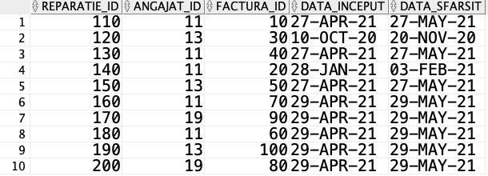

create table evidenta_reparatie(

calculator_id number(3),

reparatie_id number(3),

constraint pk_reparatie_ev primary key (calculator_id, reparatie_id)

);

alter table evidenta_reparatie add foreign key(calculator_id) REFERENCES calculator(calculator_id);

alter table evidenta_reparatie add foreign key(reparatie_id) REFERENCES reparatie(reparatie_id);

insert into evidenta_reparatie(calculator_id, reparatie_id)

values (2, 110);

insert into evidenta_reparatie(calculator_id, reparatie_id)

values (2, 120);

insert into evidenta_reparatie(calculator_id, reparatie_id)

values (3, 130);

insert into evidenta_reparatie(calculator_id, reparatie_id)

values (1, 140);

insert into evidenta_reparatie(calculator_id, reparatie_id)

values (5, 150);

insert into evidenta_reparatie(calculator_id, reparatie_id)

values (5, 160);

insert into evidenta_reparatie(calculator_id, reparatie_id)

values (8, 170);

insert into evidenta_reparatie(calculator_id, reparatie_id)

values (9, 180);

insert into evidenta_reparatie(calculator_id, reparatie_id)

values (4, 190);

insert into evidenta_reparatie(calculator_id, reparatie_id)

values (7, 200);

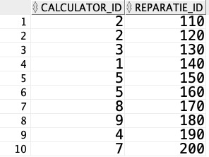

commit;

create table garantie(

garantie_id number(3) primary key,

reparatie_id number(3) not null,

perioada number(4) not null

);

alter table garantie add foreign key(reparatie_id) REFERENCES reparatie(reparatie_id);

alter table garantie modify (perioada number(4) default 6);

insert into garantie(garantie_id, reparatie_id, perioada)

values (200, 110, 10);

insert into garantie(garantie_id, reparatie_id)

values (210, 120);

insert into garantie(garantie_id, reparatie_id, perioada)

values (220, 130, 24);

insert into garantie(garantie_id, reparatie_id)

values (230, 140);

insert into garantie(garantie_id, reparatie_id, perioada)

values (240, 150, 10);

insert into garantie(garantie_id, reparatie_id)

values (250, 160);

insert into garantie(garantie_id, reparatie_id, perioada)

values (260, 170, 12);

insert into garantie(garantie_id, reparatie_id, perioada)

values (270, 180, 6);

insert into garantie(garantie_id, reparatie_id)

values (280, 190);

insert into garantie(garantie_id, reparatie_id, perioada)

values (290, 200, 24);

commit;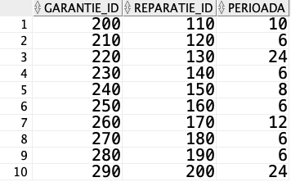

create table angajat(

angajat_id number(3) primary key,

nume varchar2(50) not null,

prenume VARCHAR2(50) not null,

salariu number(6, 2) not null

);

alter table angajat modify (salariu number(6));

insert into angajat(angajat_id, nume, prenume, salariu)

values(11, 'Albu' , 'Camelia' , 4000);

insert into angajat(angajat_id, nume, prenume, salariu)

values(12, 'Cristea' , 'Marius' , 2000);

insert into angajat(angajat_id, nume, prenume, salariu)

values(13, 'Sava' , 'Camil' , 6500);

insert into angajat(angajat_id, nume, prenume, salariu)

values(14, 'Georgescu' , 'Luca' , 1900);

insert into angajat(angajat_id, nume, prenume, salariu)

values(15, 'Dobre' , 'Mihnea' , 2300);

insert into angajat(angajat_id, nume, prenume, salariu)

values(16, 'Ifrim' , 'Nicoleta' , 2100);

insert into angajat(angajat_id, nume, prenume, salariu)

values(17, 'Mihail' , 'Ana' , 2200);

insert into angajat(angajat_id, nume, prenume, salariu)

values(18, 'Enache' , 'Bogdan' , 3450);

insert into angajat(angajat_id, nume, prenume, salariu)

values(19, 'Iancu' , 'Vlad' , 8000);

insert into angajat(angajat_id, nume, prenume, salariu)

values(20, 'Puscasu' , 'Miruna' , 2850);

insert into angajat(angajat_id, nume, prenume, salariu)

values(21, 'Barbu' , 'Mirela' , 7000);

insert into angajat(angajat_id, nume, prenume, salariu)

values(22, 'Dinu' , 'Ionel' , 7250);

insert into angajat(angajat_id, nume, prenume, salariu)

values(23, 'Dima' , 'Mihai' , 3000);

insert into angajat(angajat_id, nume, prenume, salariu)

values(24, 'Stan' , 'George' , 3050);

insert into angajat(angajat_id, nume, prenume, salariu)

values(25, 'Cristea' , 'Felix' , 2750);

commit;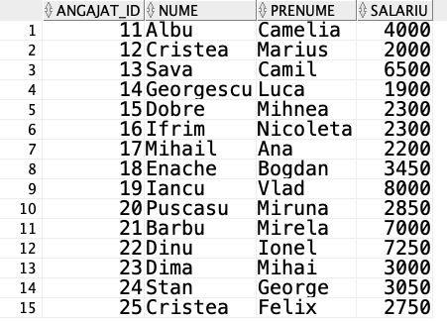

create table vanzator(

angajat_id number(3) primary key,

ore_de_lucru_zi number(2) not null

);

alter table vanzator add foreign key(angajat_id) REFERENCES angajat(angajat_id);

insert into vanzator (angajat_id, ore_de_lucru_zi)

values(12, 8);

insert into vanzator (angajat_id, ore_de_lucru_zi)

values(15, 12);

insert into vanzator(angajat_id, ore_de_lucru_zi)

values(17, 10);

insert into vanzator(angajat_id, ore_de_lucru_zi)

values(20, 12);

insert into vanzator(angajat_id, ore_de_lucru_zi)

values(23, 8);

commit;

create table tehnician_it(

angajat_id number(3) primary key,

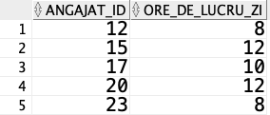 ani_de_experienta number(2, 1) not null

);

alter table tehnician_it add foreign key(angajat_id) REFERENCES angajat(angajat_id);

insert into tehnician_it(angajat_id, ani_de_experienta)

values (11, 3);

insert into tehnician_it(angajat_id, ani_de_experienta)

values (13, 5);

insert into tehnician_it(angajat_id, ani_de_experienta)

values(19, 6);

insert into tehnician_it(angajat_id, ani_de_experienta)

values(21, 6);

insert into tehnician_it(angajat_id, ani_de_experienta)

values(22, 5);

commit;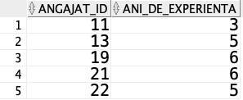

create table sofer(

angajat_id number(3) primary key,

modalitate_de_deplasare char(20) not null

);

alter table sofer add foreign key(angajat_id) REFERENCES angajat(angajat_id);

insert into sofer(angajat_id, modalitate_de_deplasare)

values(14, 'bicicleta');

insert into sofer(angajat_id, modalitate_de_deplasare)

values(16, 'masina');

insert into sofer(angajat_id, modalitate_de_deplasare)

values(18, 'masina electrica');

insert into sofer(angajat_id, modalitate_de_deplasare)

values(24, 'masina');

insert into sofer(angajat_id, modalitate_de_deplasare)

values(25, 'bicicleta');

commit;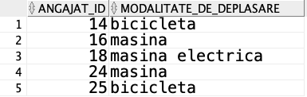

create table vanzare(

vanzare_id number(3) primary key,

angajat_id number(3) not null

);

alter table vanzare add foreign key(angajat_id) REFERENCES vanzator(angajat_id);

insert into vanzare(vanzare_id, angajat_id)

values(111, 12);

insert into vanzare(vanzare_id, angajat_id)

values(112, 15);

insert into vanzare(vanzare_id, angajat_id)

values(113, 15);

insert into vanzare(vanzare_id, angajat_id)

values(114, 17);

insert into vanzare(vanzare_id, angajat_id)

values(115, 20);

insert into vanzare(vanzare_id, angajat_id)

values(116, 17);

insert into vanzare(vanzare_id, angajat_id)

values(117, 23);

insert into vanzare(vanzare_id, angajat_id)

values(118, 20);

insert into vanzare(vanzare_id, angajat_id)

values(119, 15);

insert into vanzare(vanzare_id, angajat_id)

values(120, 20);

commit;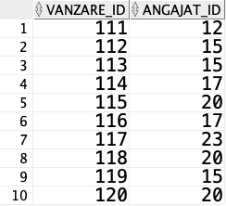

create table depozit(

depozit_id number(3) primary key,

oras char(50) not null,

numar_de_telefon number(15) not null

);

alter table depozit add foreign key(oras) REFERENCES oras(oras);

insert into depozit(depozit_id, oras, numar_de_telefon)

values (300, 'Bucuresti', 40725555178);

insert into depozit(depozit_id, oras, numar_de_telefon)

values (301, 'Budapesta', 36305554989);

insert into depozit(depozit_id, oras, numar_de_telefon)

values (302, 'Praga', 420775552205);

insert into depozit(depozit_id, oras, numar_de_telefon)

values (303, 'Munchen', 491635554629);

insert into depozit(depozit_id, oras, numar_de_telefon)

values (304, 'Milano', 393512555783);

commit;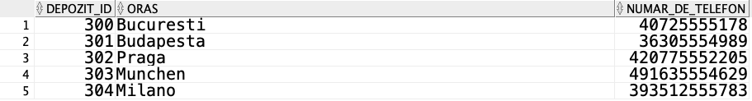

create table evidenta_vanzare(

calculator_id number(3),

vanzare_id number(3),

depozit_id number(3),

constraint calc_vanzare_dep primary key (calculator_id, vanzare_id, depozit_id)

);

alter table evidenta_vanzare add foreign key(calculator_id) REFERENCES calculator(calculator_id);

alter table evidenta_vanzare add foreign key(vanzare_id) REFERENCES vanzare(vanzare_id);

alter table evidenta_vanzare add foreign key(depozit_id) REFERENCES depozit(depozit_id);

insert into evidenta_vanzare(calculator_id, vanzare_id, depozit_id)

values(6,111,300);

insert into evidenta_vanzare(calculator_id, vanzare_id, depozit_id)

values(7,112,301);

insert into evidenta_vanzare(calculator_id, vanzare_id, depozit_id)

values(8,113,302);

insert into evidenta_vanzare(calculator_id, vanzare_id, depozit_id)

values(9,114,303);

insert into evidenta_vanzare(calculator_id, vanzare_id, depozit_id)

values(10,115,304);

insert into evidenta_vanzare(calculator_id, vanzare_id, depozit_id)

values(11,116,300);

insert into evidenta_vanzare(calculator_id, vanzare_id, depozit_id)

values(12,117,302);

insert into evidenta_vanzare(calculator_id, vanzare_id, depozit_id)

values(13,118,304);

insert into evidenta_vanzare(calculator_id, vanzare_id, depozit_id)

values(14,119,303);

insert into evidenta_vanzare(calculator_id, vanzare_id, depozit_id)

values(15,120,301);

commit;

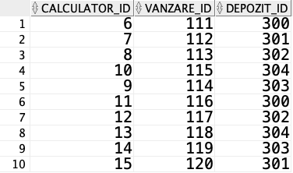

create table oras(

oras char(50) primary key,

tara char(50) not null

);

insert into oras(oras, tara)

values ('Bucuresti', 'Romania');

insert into oras(oras, tara)

values ('Budapesta','Ungaria');

insert into oras(oras, tara)

values ('Praga','Cehia');

insert into oras(oras, tara)

values ('Munchen','Germania');

insert into oras(oras, tara)

values ('Milano','Italia');

commit;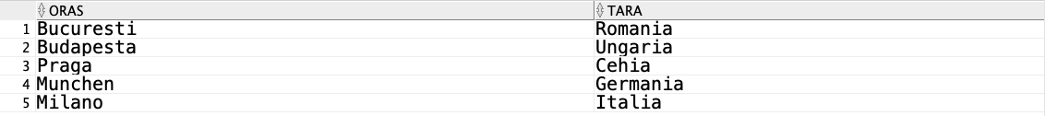

create table livrare(

livrare_id number(3) primary key,

angajat_id number(3) not null,

depozit_id number(3) not null,

calculator_id number(3) not null,

data_livrare date not null,

cost number(2) not null

);

create sequence liv_id

start with 400

increment by 10;

alter table livrare add foreign key(angajat_id) REFERENCES sofer(angajat_id);

alter table livrare add foreign key(depozit_id) REFERENCES depozit(depozit_id);

alter table livrare add foreign key(calculator_id) REFERENCES calculator(calculator_id);

insert into livrare(livrare_id, angajat_id, depozit_id, calculator_id, data_livrare, cost)

values(liv_id.nextval, 14, 300, 6, to_date('24-JUN-21'), 35);

insert into livrare(livrare_id, angajat_id, depozit_id, calculator_id, data_livrare, cost)

values(liv_id.nextval, 16, 300, 7, to_date('4-JUN-21'), 20);

insert into livrare(livrare_id, angajat_id, depozit_id, calculator_id, data_livrare, cost)

values(liv_id.nextval, 16, 302, 8, to_date('17-JUL-21'), 40);

insert into livrare(livrare_id, angajat_id, depozit_id, calculator_id, data_livrare, cost)

values(liv_id.nextval, 18, 304, 9, to_date('30-MAY-21'), 25);

insert into livrare(livrare_id, angajat_id, depozit_id, calculator_id, data_livrare, cost)

values(liv_id.nextval, 18, 303, 10, to_date('25-JUL-21'), 50);

commit;