Design, Development and Evaluation of Domain-Specific Topic Models and Classifiers for Public Health Using Big Social Data

- Problem Definition:

After the COVID-19 pandemic, people have faced unprecedented situation in their own life and started to share their thoughts as a post in various social media regarding their take on COVID-19 and COVID-19 Vaccinations. A recent study says that 72% of the internet users have looked for health information online. One of their findings reveal that there is a high amount of trust expressed by a subset of users and these users play a vital role in supporting other users of the online discussion forums about COVID-19 and its vaccinations. The major challenges we face currently are many contrasting information about COVID-19 and its vaccinations around the web with various perspective.

- Dataset:

We have many social media online forums where people can post their thoughts and feelings on how they feel about COVID-19 and its vaccination. I found Reddit as one of the influential players in the realm of social media.

I used my reddit account and scrapped the data for this project using the reddit API. There are many methods that reddit allows us to scrape the data. Below is the structure of Reddit posts.

Reddit → Subreddit → Post → Comments

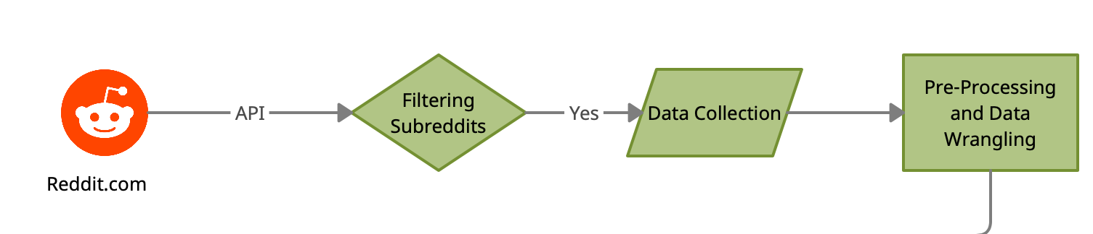
Since we are dealing only with the posted relating to COVID-19 Vaccinations. I have found 20+ relevant subreddits to scrape and retrieve the post and its relevant information. I am using “Search” and “Top” strategy to scrape the data while we have other methods as well.

Our clean and workable dataset consists of 14089(currently) posts with the following fields.

- Title
- Body
- Score
- Id
- URL
- No of comments
- Created date
- Author
- Upvote_ratio
- Permalink
- Subreddit_id

- Research Question:

What, if any, are they temporal and linguistic patterns on posts regarding COVID-19 Vaccination on relevant subreddits.?

Which insights can be derived from online forum conversations such as reddit about COVID-19 Vaccinations, and how can such insights be used to optimize public healthcare communication and services to benefit common people, pharmaceutical companies, and healthcare organisations?

The aim of the research project would be to work towards building a classifier that can classify the post with set of labelling which then will be trained and tested using domain specific modelling. We would like to propose the idea of identifying vaccination proponents and vaccination hesitant with various perspective such a Medical, Personal, Social and Conspiracy.

