**object-oriented programming (OOP)**

**-What is object-oriented programming?**

Object-oriented programming (OOP) is a computer programming model that organizes software design around data, or [objects](https://www.techtarget.com/searchapparchitecture/definition/object), rather than functions and logic. An object can be defined as a data field that has unique attributes and behavior.

Object-oriented programming (OOP) centers around the objects developers aim to work with, rather than the specific steps needed to process them. This makes it particularly effective for building and maintaining large, complex, and frequently updated software systems—such as design tools, manufacturing simulation software, and mobile apps.

It is a method for storing data and the operations required to process that data based on the mathematical field known as abstract data types. Programming could advance to a more abstract level thanks to OOP. Nearly all developers employ the core programming paradigm known as object-oriented programming at some point in their careers.

The structure of OOP also supports teamwork, as it allows projects to be split into smaller, manageable parts handled by different groups. Other advantages of this method include better code reusability, easier scalability, and greater overall development efficiency.

The first stage in OOP is to gather all the objects that a programmer wishes to work with and determine their relationships, a process known as data modeling. Data and functions are combined to create an object from the data structure. Programmers can also establish connections between several objects. Objects can, for instance, acquire traits from other objects. A human is a straightforward illustration of an object.

Once your objects are in place, you may use their interactions to achieve the desired outcome. Consider the possibility of a show where someone gets in a car and drives it from point A to point B. Beginning with the objects like a person or a vehicle is how you would describe them.

**-What is the structure of object-oriented programming?**

* **Classes:**are user-defined data types that act as the blueprint for individual objects, attributes and methods.
* **Objects:** are instances of a class created with specifically defined data. Objects can correspond to real-world objects or an abstract entity. When class is defined initially, the description is the only object that is defined.
* **Methods:** are functions that objects can perform. They are defined inside a class that describe the behaviors of an object. Each method contained in class definitions starts with a reference to an instance object. Additionally, the subroutines contained in an object are called *instance methods*. Programmers use methods for reusability or keeping functionality encapsulated inside one object at a time.
* **Attributes:** represent the state of an object. In other words, they are the characteristics that distinguish classes. Objects have data stored in the attributes field. Class attributes belong to the class itself and are defined in the class template.

**-What are the main principles of OOP?**

* **Encapsulation:** Encapsulation means keeping important data inside an object and only sharing what’s necessary. The details and state of the object stay private within its class, so other objects can’t change them directly. Instead, they use public methods to interact with the object. This helps protect data and keeps the program safe from errors.
* **Abstraction:** Objects only reveal internal mechanisms that are relevant for the use of other objects, hiding any unnecessary implementation code. The derived class can have its functionality extended. This concept can help developers more easily make additional changes or additions over time.
* **Inheritance:** Classes can share code and features by inheriting from other classes. This lets developers reuse common logic while keeping a clear structure. Inheritance also helps save time, improves accuracy, and encourages better data design.
* **Polymorphism:** Objects are designed to share behaviors, and they can take on more than one form. The program determines which meaning or usage is necessary for each execution of that object from a parent class, reducing the need to duplicate code. A child class is then created, which extends the functionality of the parent class. [Polymorphism](https://www.techtarget.com/whatis/definition/polymorphism) enables different types of objects to pass through the same interface.
* 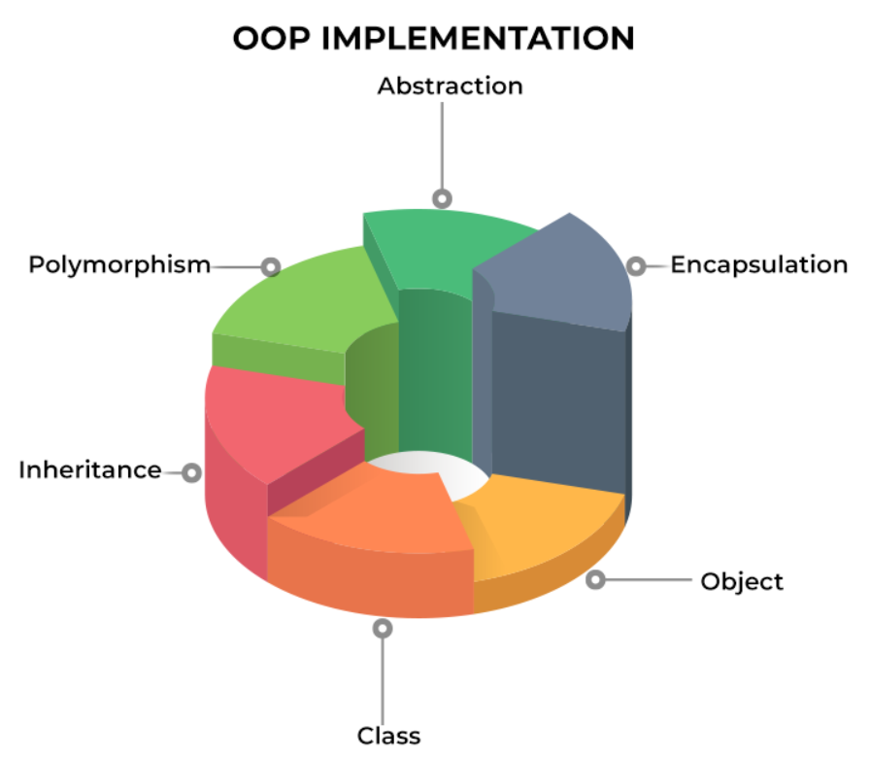**Syntax:** This is the set of rules that define how words and punctuation are organized in a programming language.

**-Advantages of OOP:**

Despite the rise of various programming models, OOP remains popular in [DevOps](https://www.spiceworks.com/tech/devops/articles/what-is-devops/). This is due to the following advantages it provides:

* **Enables code reusability:** The idea of inheritance is one of the critical concepts offered by object-oriented programming. A class’s attributes can be passed down through inheritance, eliminating the need for duplication of effort. Doing this prevents the problems associated with repeatedly writing the same code.
* **Increases productivity in software development:** We can create programs from pre-written, interconnected modules rather than having to start from scratch, which would save time and increase productivity. Thanks to the OOP language, we can break the software into manageable, discrete problems. Because it allows for the division of labor in the creation of object-based programs, object-oriented programming is modular.
* **Makes troubleshooting simpler:** When object-oriented programming is used, troubleshooting is made simpler since the user knows where to look in the code to find the source of the problem. Since the error will indicate where the issue is, there is no need to inspect additional code areas. All objects in object-oriented programming (OOP) are self-constrained, which is one benefit of employing encapsulation. [DevOps engineers](https://www.spiceworks.com/tech/devops/articles/devops-engineer/) and developers gain a lot of advantages from this multimodal behavior because they may now work on several projects at once with the benefit of avoiding code duplication.
* **Reinforces security:** To maintain [application security](https://www.spiceworks.com/it-security/application-security/articles/what-is-application-security-definition-best-practices/) and provide vital data for viewing, we are filtering out limited data through data hiding and abstraction mechanisms. The concept of data abstraction in OOPS allows only a small amount of data to be displayed to the user, which is one of OOP’s strong points.
* When only the necessary info is accessible, the rest is not. As a result, it makes security maintenance possible. Another set of OOP’s advantages in Java’s idea of abstraction is used to conceal complexity from other users and display the element’s information per the requirements.

**-References:**

* **TechTarget. (n.d.). *Object-oriented programming (OOP)*. Retrieved from** [**https://www.techtarget.com/searchapparchitecture/definition/object-oriented-programming-OOP**](https://www.techtarget.com/searchapparchitecture/definition/object-oriented-programming-OOP)
* [**https://www.spiceworks.com/tech/devops/articles/object-oriented-programming/**](https://www.spiceworks.com/tech/devops/articles/object-oriented-programming/)
* **Based on discussion with ChatGPT.**
* **Real Python. (2024, December 15). *Object‑Oriented Programming (OOP) in Python*. Real Python. Retrieved July 21, 2025, from** [**https://realpython.com/python3-object-oriented-programming/**](https://realpython.com/python3-object-oriented-programming/)