**Report**

• The average age of patients for each diagnosis:

• The department has the highest number of admitted patients:

• Patients have been discharged per month:

• The most common diagnosis among patients:

• The doctor who treated the most patients:

**Visualization:**

• Visualize the number of patients per department using a bar chart: 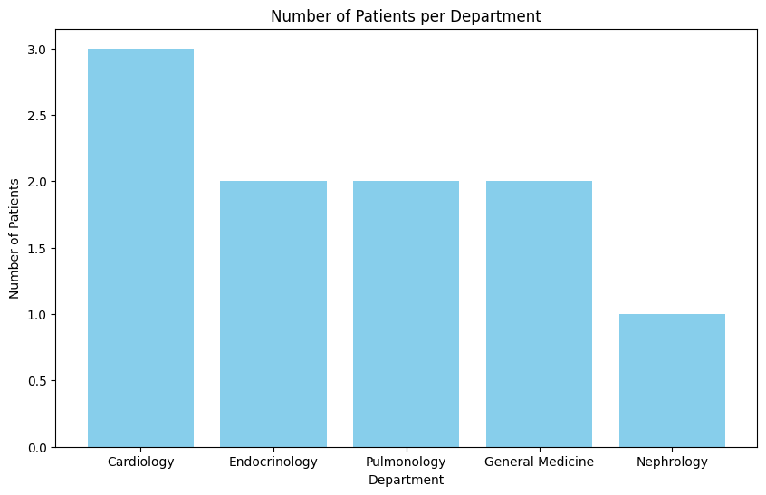

• Create a pie chart showing the distribution of patient statuses (Admitted, Discharged, Under Observation).

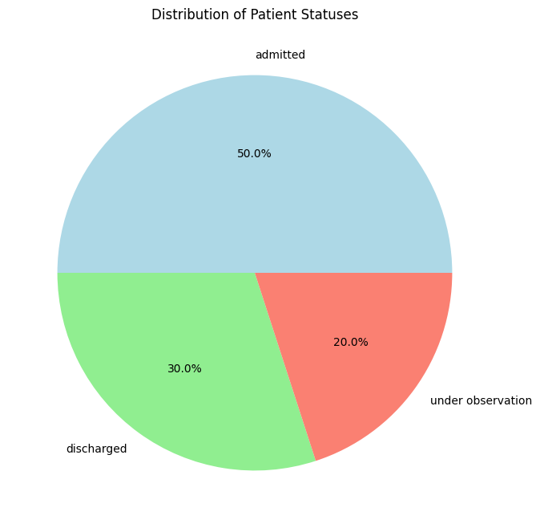

• Line chart showing monthly hospital admissions trends :