Sign Language Project  
Prerequisite:

1. Python should be installed in the laptop(Recommended version > 3.8 +)
2. Download **requirements.txt** file that is already shared.
3. Locate to the directory where requirements.txt file is exist and Open command prompt to that specific location (To open command prompt on specific location, locate to that folder and right click and select **open in terminal**)
4. Then type the highlighted command in command prompt.. This command line will install dependencies required for this projects and also some additional libraries which will be useful while executing some other projects too. **pip install -r requirements.txt**
5. 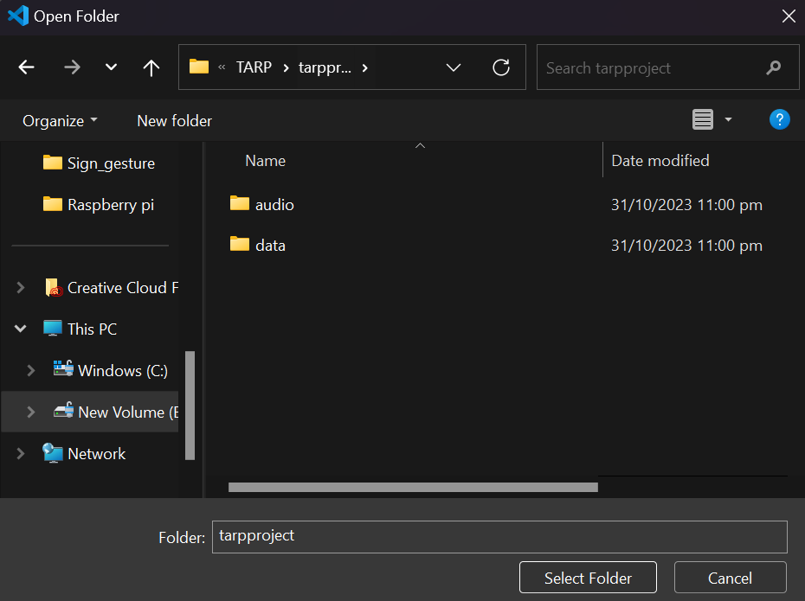Then open the entire project folder in vs code…file -> open folder ->locate to the folder as shown in image and click on select folder
6. Open run.py, right click on code and select **Run** **python file in terminal..** It will execute thecode and camera frame will open.

