

MyBox: Easy Tools Set
User Guide - Overview

Author: Mara
Version: 6.6.2
Date: 2022-11-30

Contents
1 Introduction 3
1.1 What's New 4
1.2 Cross Platforms 4
1.3 Personal 4
1.4 Data Compatible 4
1.5 Internationalized 4
2 Resources Addresses 6
3 Documents 7
4 Download and Execution 8
4.1 Source Codes 8
4.2 Self-contain packages 8
4.3 Jar 8
4.4 Other addresses to download 8
4.5 Limitation 9
4.6 Migration 9
4.7 Configuration 9
5 Implementation 10
6 Common Functions in Interfaces 12
6.1 Main Interface 12
6.2 Interface Layout 13
6.3 Set Font Size 13
6.4 Open New Stage 14
6.5 Restore Scene Size 14
6.6 Recent Visited Files/Directories 14
6.7 Data Table 15
6.8 Context Menu 16
6.9 Window “Examples” 17
6.10 Window “Histories” 18
6.11 Color Block and Palette 18
7 Settings 19
7.1 Interface 20
7.2 Base 21
7.3 Data 21
7.4 PDF 22
7.5 Image 22
7.6 Map 23
8 Window 24
9 Shortcuts 25

Introduction
This is desktop application based on JavaFx to provide simple and easy functions. It's free and open sources.
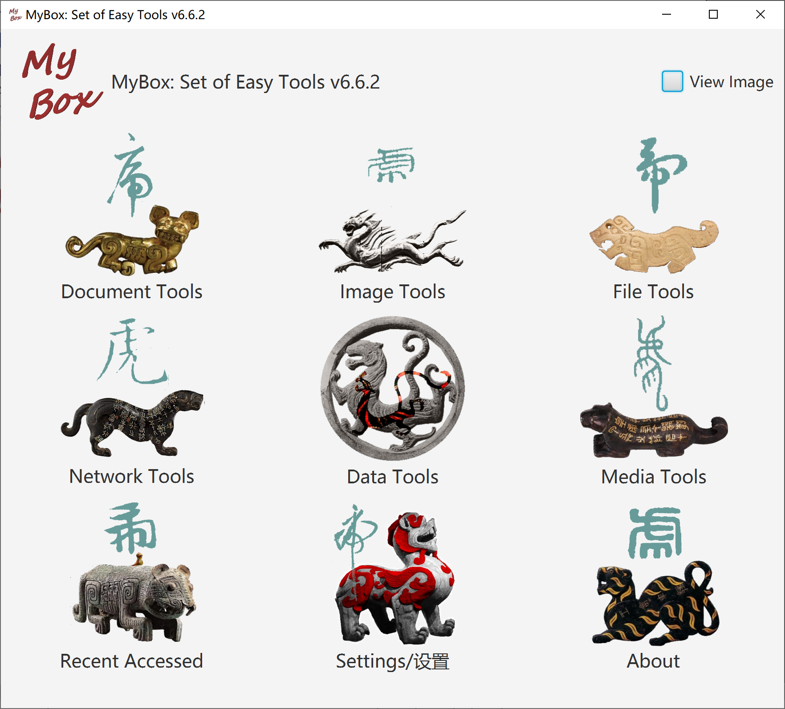

What's New
2022-11-30 v6.6.2
- Enhance:
  - Group by “Value range”:
    - To date/era, values are converted as milliseconds.
    - When split by size，time unit can be set for date/era type.
    - Add/Edit/Delete “start-end” list in table.
    - To “start-end”, set whether include “start”/“end”.
  - Results of data trim/calculation can be written into json/xml/html/pdf directly.
  - Data examples: My data. Personal data, like notes/contacts/properties/weight, can be record in tables.
- Improve:
  - Write strings into temporary tables to avoid data loss due to types conversion.
  - Only one resource file for each language.
- Solved: Modification of languages are not saved.
Closed requirements/bugs in this version

Cross Platforms
MyBox is implemented in pure Java and only based on open sources, and it can run on platforms which support Java 18.
Versions before v5.3 are based on Java 8.

Personal
- No register/login/DataCenter/Cloud.
- No network if unnecessary.
- Not read/write if unnecessary.

Data Compatible
- Exported data are in common text formats, like txt/csv/xml/json/html.
- Imported data are in common text format, like txt/csv。
- At least one exported format can be imported.
- Imported data are self-contain, that original data can be rebuilt without extra data.

Internationalized
- All codes of MyBox are internationalized. Language can be switched in time.
- Each langauge is defined in one resource files, like: "Messages_NAME.properties".
- Support adding new languages online. Table is provided with English as comparison. New langauges take effects at once.
Example, the new language is named as “aa”, and its resource files are Messages_aa.properties.
- Translated languages can be shared with others: Put the files under "mybox_languages" of data path and MyBox is aware of them immediately.
- Embed Chinese and English, whose files are under path MyBox/src/main/resources/bundles/.
Language | Resource file of interface
Chinese | Messages_zh_CN.properties
English | Messages_en.properties

Resources Addresses

Contents | Link
Project Main Page | https://github.com/Mararsh/MyBox/
Source Codes and Compiled Packages | https://github.com/Mararsh/MyBox/releases
Submit Software Requirements and  Problem Reports | https://github.com/Mararsh/MyBox/issues
Data | https://github.com/Mararsh/MyBox_data
Documents | https://github.com/Mararsh/MyBoxDoc
Mirror Site | https://sourceforge.net/projects/mara-mybox/files/
Cloud Storage | https://pan.baidu.com/s/1fWMRzym_jh075OCX0D8y8A#list/path=%2F



Documents
Name | Version | Time | English | Chinese
Development Logs | 6.6.2 | 2022-11-30 | html | html
Shortcuts | 6.5.6 | 2022-6-11 | html | html
Functions list | 6.6.2 | 2022-11-30 | html | html
Packing Steps | 6.3.3 | 2020-9-27 | html | html
Development Guide | 2.1 | 2020-8-27 | PDF | PDF
User Guide - Overview | 6.6.2 | 2022-11-30 | html PDF odt | html PDF odt
User Guide - Data Tools | 6.6.2 | 2022-11-30 | html PDF odt | html PDF odt
User Guide - Document Tools | 6.6 | 2022-9-28 | html PDF odt | html PDF odt
User Guide - Image Tools | 6.6 | 2022-9-28 | html PDF odt | html PDF odt
User Guide - File Tools | 6.6 | 2022-9-28 | html PDF odt | html PDF odt
User Guide - Network Tools | 6.6 | 2022-9-28 | html PDF odt | html PDF odt
User Guide - Media Tools | 6.6 | 2022-9-28 | html PDF odt | html PDF odt
User Guide - Development Tools | 6.6.2 | 2022-11-30 | html PDF odt | html PDF odt
Examples - Notes | 6.6.1 | 2022-11-16 | html | html
Examples - Information in Tree | 6.6.1 | 2022-11-16 | html | html
Examples - Favorite Address | 6.6.1 | 2022-11-16 | html | html
Examples - SQL | 6.6.1 | 2022-11-16 | html | html
Examples - JShell | 6.6.1 | 2022-11-16 | html | html
Examples - JEXL | 6.6.1 | 2022-11-16 | html | html
Examples - JavaScript | 6.6.1 | 2022-11-16 | html | html
Examples - Math Function | 6.6.1 | 2022-11-16 | html | html
Examples - Row Filter | 6.6.1 | 2022-11-16 | html | html
About - Color | 6.6.1 | 2022-11-16 | html | html
About - Coordinate System | 6.6.1 | 2022-11-16 | html | html
About - Media | 6.6.1 | 2022-11-16 | html | html
About - Data Analysis | 6.6.1 | 2022-11-16 | html | html
Palette - Common Web Colors | 6.6.1 | 2022-11-16 | html | html
Palette - Chinese Traditional Colors | 6.6.1 | 2022-11-16 | html | html
Palette - Japanese Traditional Colors | 6.6.1 | 2022-11-16 | html | html
Palette - Colors from colorhexa.com | 6.6.1 | 2022-11-16 | html | html
Palette - MyBox Colors | 6.6.1 | 2022-11-16 | html | html

Download and Execution
Packages of each version have been uploaded at Releases directory now. You can find them by clicking releases tab in main page of this project.

Source Codes
MyBox-6.6.2-src.zip 55M-
About structure, editing, and building of source codes, please refer to Developement Guide and Packing Steps

Self-contain packages
Self-contain packages include all files and need not java env nor installation.

Platform | Link | Size | Launcher
win10 x64 | MyBox-6.6.2-win-x64.zip | 260MB- | MyBox.exe
CentOS 7 x64 | MyBox-6.6.2-CentOS7-x64.tar.gz | 280MB- | bin/MyBox
mac | MyBox-6.6.2-mac.dmg | 280MB- | MyBox-6.6.2.app

User can double click the launcher to start MyBox or run it by command line. The default “Open Method” of image/text/PDF files can be associated to MyBox and a file can be opened directly by MyBox by double clicking the file’s name.

Jar
When JRE or JDK(Oracle jdk or open jdk) is installed, jar can run:
Platform | Link | Size | Requirements
win | MyBox-6.6.2-win-jar.zip | 190MB- | Java 18 or higher
linux | MyBox-6.6.2-linux-jar.zip | 200MB- | Java 18 or higher
mac | MyBox-6.6.2-mac-jar.zip | 200MB- | Java 18 or higher

Run following command to launch this program with Jar package:
java -jar MyBox-6.6.2.jar
A file path can follow the command as argument to be opened directly by MyBox. Example, following command will open the image:
java -jar MyBox-6.6.2.jar /tmp/a1.jpg

Other addresses to download
Download from cloud storage: https://pan.baidu.com/s/1fWMRzym_jh075OCX0D8y8A#list/path=%2F
Download from sourceforge: https://sourceforge.net/projects/mara-mybox/files/

Limitation
- Without enough testings, MyBox has low reliability. Data damage even happened in some versions.
- New functions being added and codes being improved continually, MyBox has bad stability. Unexpected function failures happened sometimes.
- MyBox windows may often be blocked when some Input Method is running. Workaround is to disable/uninstall this Input Method.

Migration
- Each version has itself’s configuration file. New version can copy parameters from existed versions.
- Data handled in each version are under “Data Directory” referred by it. Multiple versions can refer to same data directory.
- MyBox is backward compatibility: Later version can work on data of previous versions. While forward compatibility is not supported: Wrong may happen when old version handles data of new version.

Configuration
Configuration file is under “User Home”:
Platform | Path of MyBox Configuration File
win | C:\users\UserName\mybox\MyBox_v6.6.2.ini
linux | /home/UserName/mybox/MyBox_v6.6.2.ini
mac | /Users/UserName/mybox/MyBox_v6.6.2.ini

Add parameter “config="FilePath"” when run jar to change configuration file temporarily.
Function “Settings” can be used to change configuration values.

Implementation
MyBox is based on following open sources:
Name | Role | Link
JDK | Java | http://jdk.java.net/
 |  | https://www.oracle.com/technetwork/java/javase/downloads/index.html
 |  | https://docs.oracle.com/en/java/javase/18/docs/api/index.html
JavaFx | GUI | https://gluonhq.com/products/javafx/
 |  | https://docs.oracle.com/javafx/2/
 |  | https://gluonhq.com/products/scene-builder/
 |  | https://openjfx.io/javadoc/18/
NetBeans | IDE | https://netbeans.org/
jpackage | pack | https://docs.oracle.com/en/java/javase/18/docs/specs/man/jpackage.html
maven | build | https://maven.apache.org/
jai-imageio | Image manufacture | https://github.com/jai-imageio/jai-imageio-core
PDFBox | PDF manufacture | https://pdfbox.apache.org/
PDF2DOM | PDF to html | http://cssbox.sourceforge.net/pdf2dom/
javazoom | MP3 manufacture | https://sourceforge.net/projects/javalayer/
Derby | Database | http://db.apache.org/derby/
GifDecoder | Decode broken gif | https://github.com/DhyanB/Open-Imaging/
EncodingDetect | Determine encoding of text file | https://www.cnblogs.com/ChurchYim/p/8427373.html
Lindbloom | Color theory | https://icons8.com/icons/set/home
Free Icons | Icon | http://brucelindbloom.com/index.html
tess4j | OCR | https://github.com/nguyenq/tess4j
tesseract | OCR | https://github.com/tesseract-ocr/tesseract
barcode4j | Create barcodes | http://barcode4j.sourceforge.net
zxing | Create/Decode barcodes | https://github.com/zxing/zxing
flexmark-java | Convert Markdown | https://github.com/vsch/flexmark-java
commons-compress | archive/compress | https://commons.apache.org/proper/commons-compress
XZ for Java | archive/compress | https://tukaani.org/xz/java.html
jaffree | wrap ffmpeg | https://github.com/kokorin/Jaffree
ffmpeg | convert/create medias | http://ffmpeg.org
image4j | ico format | https://github.com/imcdonagh/image4j
AutoCommitCell | Submit updates | https://stackoverflow.com/questions/24694616 （Ogmios）
GaoDe | Map | https://lbs.amap.com/api/javascript-api/summary
GaoDe | Coordinate | https://lbs.amap.com/api/webservice/guide/api/georegeo
WeiBo | Image materials | https://weibo.com/3876734080/InmB1aPiL?type=comment#_rnd1582211299665
poi | Microsoft Documents | https://poi.apache.org
LabeledBarChart | Javafx charts | https://stackoverflow.com/questions/34286062/how-to-clear-text-added-in-a-javafx-barchart/41494789#41494789 (Roland)
commons-csv | CSV | https://commons.apache.org/proper/commons-csv/
geonames | Location data | https://www.geonames.org/countries/
world-area | Location data | https://github.com/wizardcode/world-area
China National Bureau of Statistics | Data | http://www.stats.gov.cn/tjsj/tjbz/tjyqhdmhcxhfdm/
JHU | COVID-19 data | https://github.com/CSSEGISandData/COVID-19
Website | Color data | https://tool.lanrentuku.com/color/china.html
Book | Materials | https://book.douban.com/subject/3894923/
National Geomatics Center of China | Map | http://lbs.tianditu.gov.cn/api/js4.0/guide.html
movebank | Location data | https://www.datarepository.movebank.org
CoordinateConverter | convert coordinates | https://www.jianshu.com/p/c39a2c72dc65?from=singlemessage
JavaMail | email | https://javaee.github.io/javamail/
Commons IO | File IO | https://commons.apache.org/proper/commons-io/
colorhexa | Color data | https://www.colorhexa.com/color-names
WQY | Font file | http://wenq.org/wqy2/
ttc2ttf | Extract ttf | https://github.com/fermi1981/TTC_TTF
sfds | Handwriting | https://book.douban.com/subject/10465940/
Book | Materials | http://www.sfds.cn/725B/
PaginatedPdfTable | PDF | https://github.com/eduardohl/Paginated-PDFBox-Table-Sample
jsoup | DOM | https://jsoup.org/
WeiBo | Materials | https://weibo.com/2328516855/LhFIHy26O
ZhiHu | Materials | https://www.zhihu.com/question/41580677/answer/1300242801
commons-math | Calculation | https://commons.apache.org/proper/commons-math/index.html
JEXL | Calculation | https://commons.apache.org/proper/commons-jexl
OpenOffice | Document | http://www.openoffice.org/
nashorn | JavaScript | https://openjdk.org/projects/nashorn/
echarts-gl | WebGL | https://github.com/ecomfe/echarts-gl

Common Functions in Interfaces

Main Interface
Main interface is shown after MyBox is launched. Move mouse over one icon to pop its menu. Then select a tool to start.

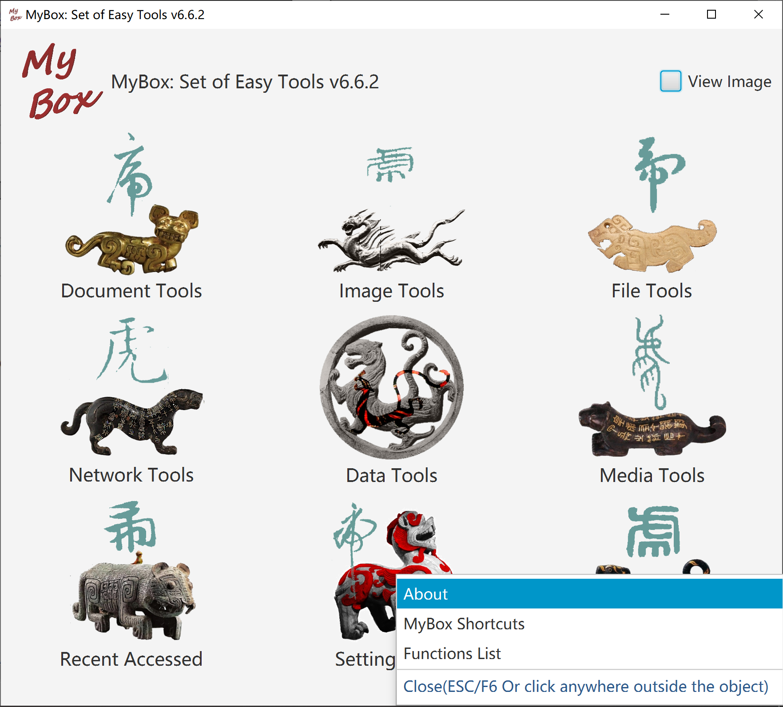

Interface Layout
- Window title includes the object name being handled.
- Main menu in top to open windows of functions.
- Some interfaces include pagination toolbar which is generally in bottom.
- Some interface include icon Fish. Hover mouse upon it to pop tips.
- Some interfaces include left pane or right pane. If icon Rosefinch is there, hover mouse upon it to hide/show the pane.
- To some buttons, checkbox, or icon, shortcut or tips will be popped when hover mouse upon them.
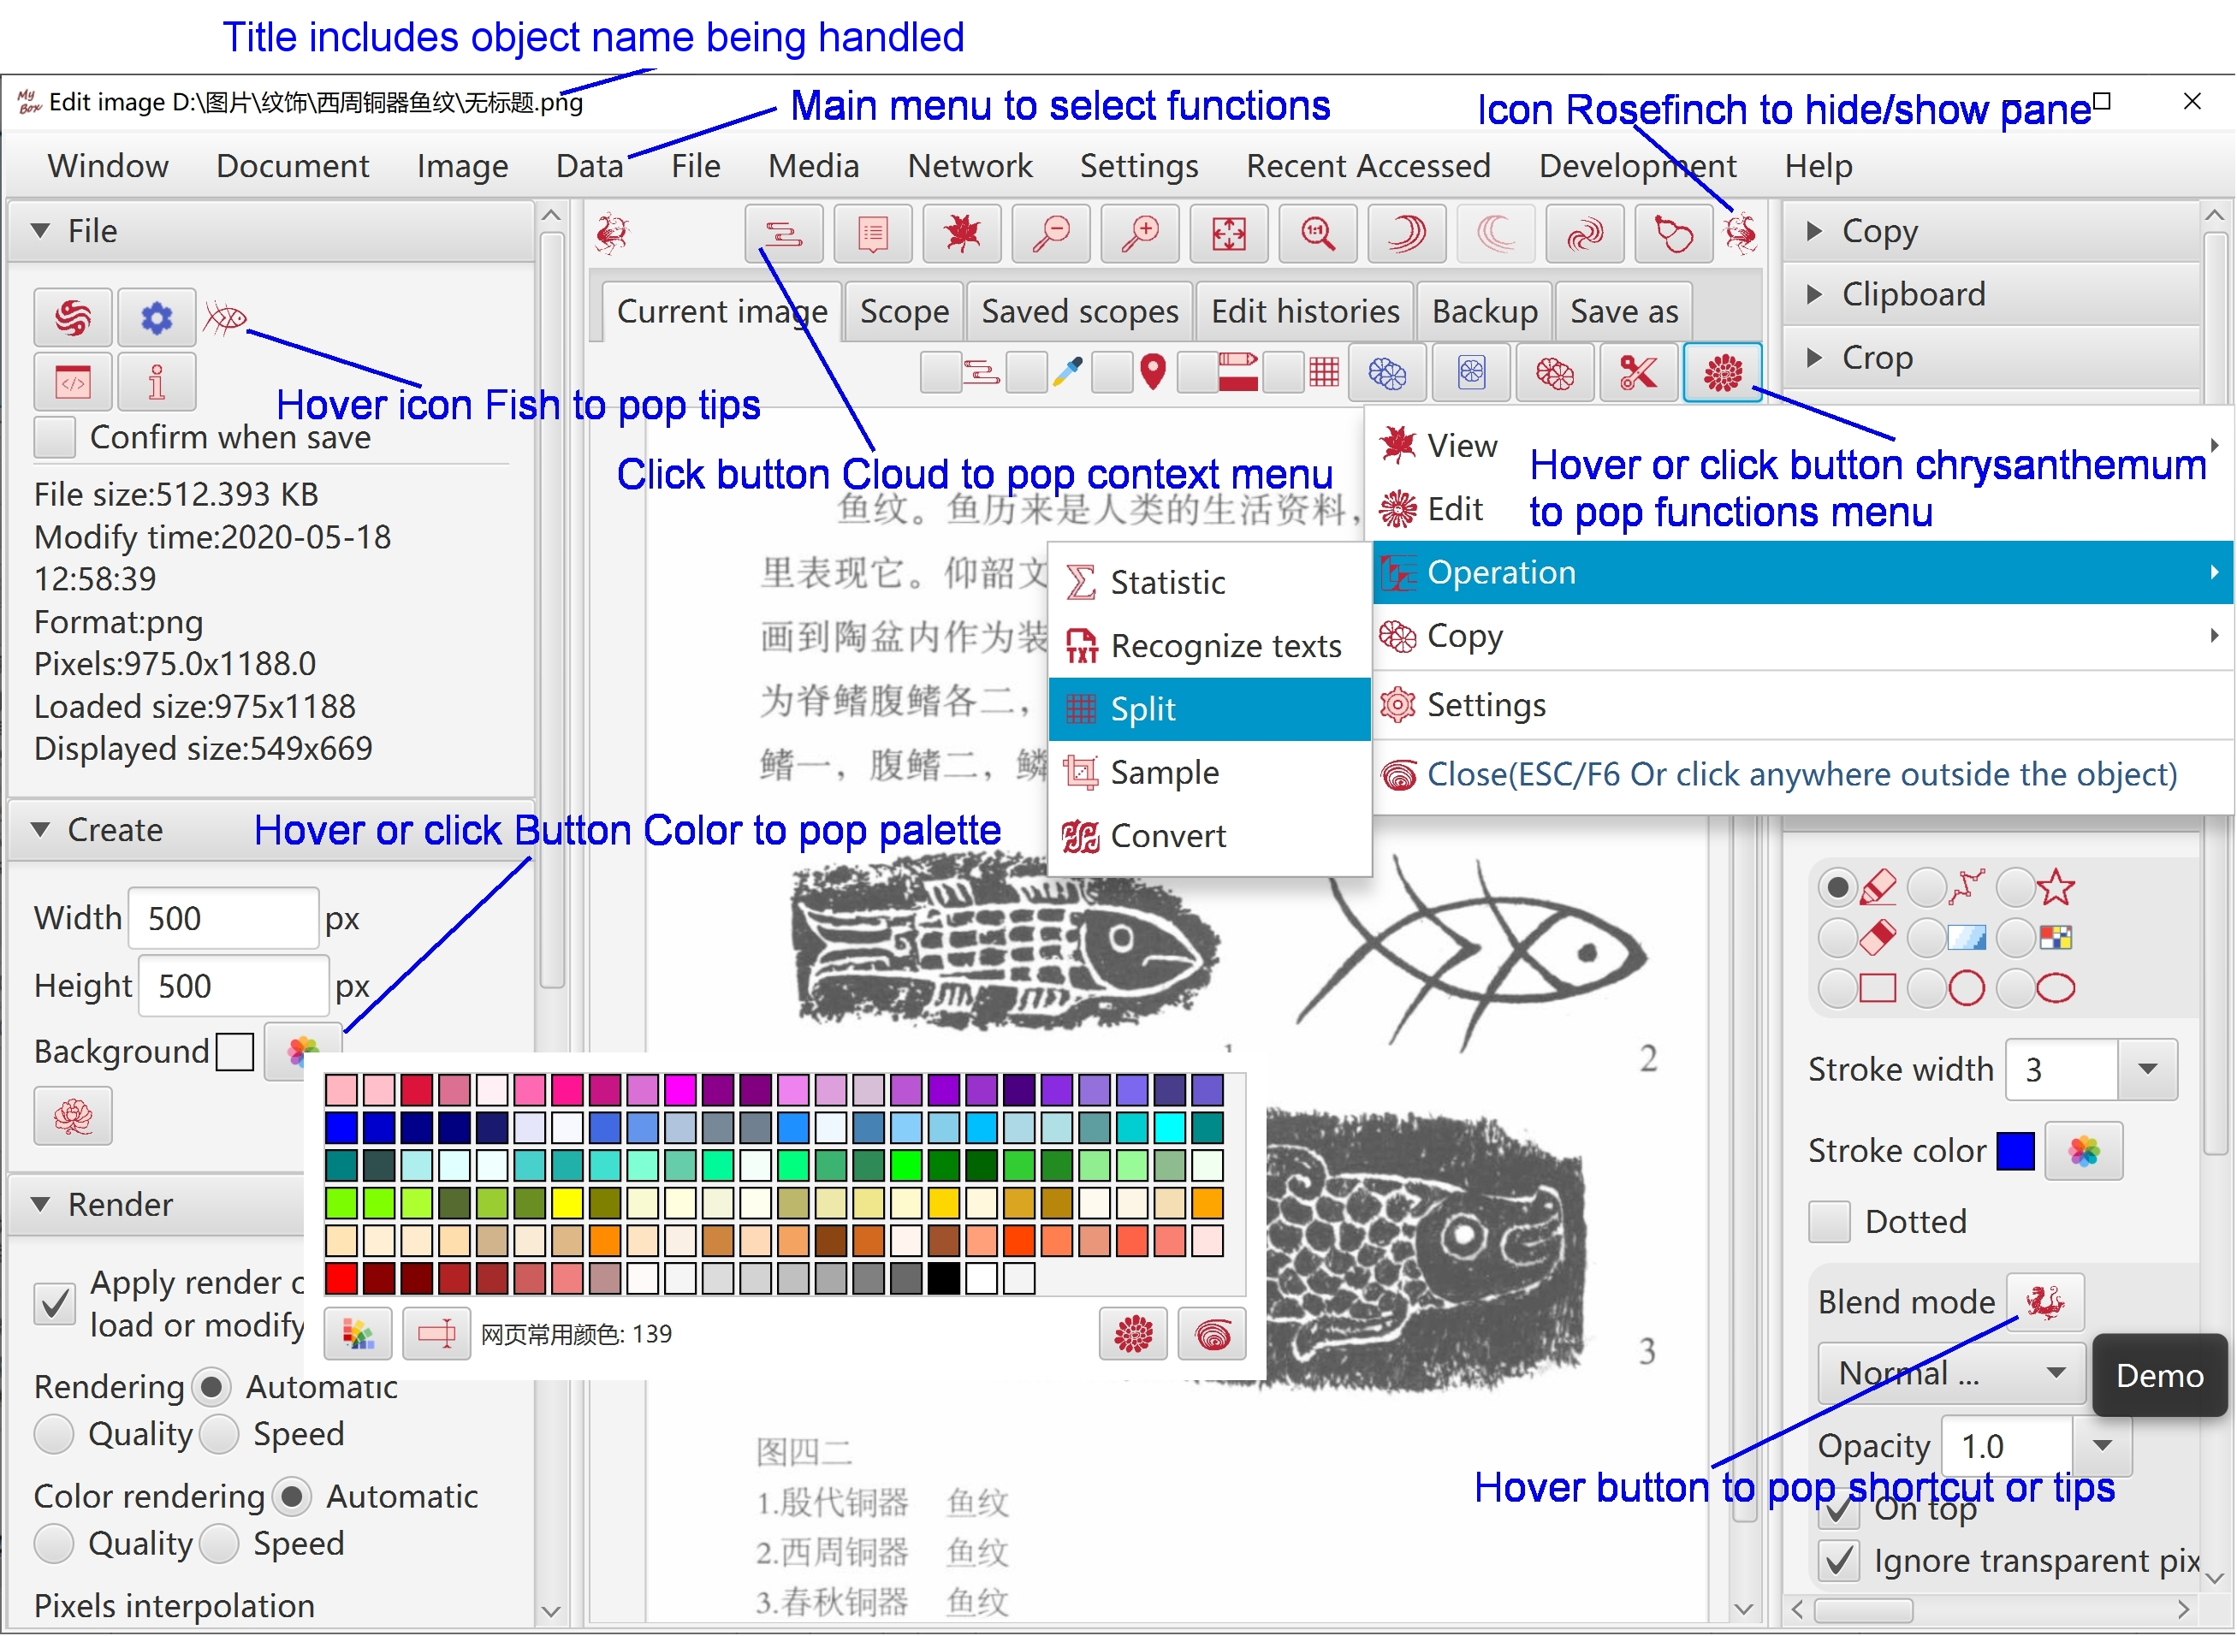

Set Font Size
- Decrease font size by press key “CTRL” and key “-” at same time.
- Increase font size by press key “CTRL” and key “=” at same time.
- Select one font size of 12px, 15px, and17px by click menu item directly.
- Set font size in Setting window.

Open New Stage
To open new window for new scene and keep current scene in current window, do not select menu item “Settings”-“Close current window when open new tool”.


Restore Scene Size
By selecting menu item “Settings”-“Record size and location of windows”, recent size and location of each stage will be saved and restored when it is opened again.

Recent Visited Files/Directories
When menu item “Settings”-“Pop recent visited files/directories” is selected, each access of files/directories will be record and list will be popped when mouse is moved upon the button of selection. Example:


Data Table

- To select rows:
  - Press key SHIFT and click rows to select multiple rows of a range.
  - Press key CTRL and click rows to select multiple rows one by one.
  - Click the checkboxs in head of rows.
- To edit data:
  - Header texts of editable columns are in blue (Editable primary keys are still in red).
  - Click the editable cell, then its input field will be shown.
  - When editable cell loses focus, its value will be checked and invalid data will be rejected.
- To display/hide columns, click button "+" in right side of table header.
This operation does not affect data.
- To adjust order of columns, click and drag column headers.
This operation does not affect data.
- - To order rows:
- Click column header for ascending order by this column.
- Click column header again for descending order by this column.
- Click column header for thrid time to cancel ordering of this column.
- Press SHIFT and click more column headers to order by multiple columns.
This operation only affect current data in table.
- Header texts of primary keys are in red and auto-increated keys are in orange.

Context Menu
- This menu is popped when right click object like text, image, or table.
- If interface includes button “Cloud”, context menu will be popped when click this button.
- If interface includes checkbox “Cloud”:
  - If this checkbox is not selected, the context menu is not popped when right click object.
  - If this checkbox is selected, the context menu is popped when right click object.
  - Checkbox “Cloud” does not affect button “Cloud”, which means context menu is always popped when click button “Cloud”.



Window “Examples”
Window “Examples” is popped when hover or click button “Examples”.



Window “Histories”
Hover or click button “Histories” to pop window “Histories”.


Color Block and Palette
- Hover “Color Block” to pop color's information.
- Hover or click button “Palette” to pop window Palette, and select or edit colors.



Settings
Select “Settings...”in main menu to open window Settings.



Interface
- Language, font size, icon size
- Control color, whether display control text, interface style
- Select hi-dpi icons(100x100) or common icons(40x40).
When screen resolution is not high than 120dpi, suggest to use common icons.
Hi-dpi icons may look blurred on low-resolution screen.
- Whether restore last size of each scene.
- Whether open new stage to display scene.
- Whether show/Hide splitted panes when mouse passing.
- Whether pop stage "Set Color" when mouse passing.
- Font size, color, duration of popped messages.



Base
- Maximum memory usage of JVM
- Network timeouts



Data
- Data path
- Derby driver mode
- Whether pop recent visited files/directories. And the number.
- Whether close alarm clocks when exit program.

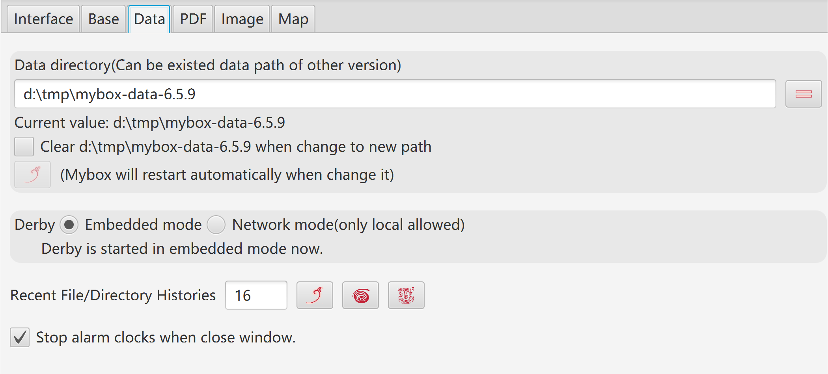

PDF
Maximum main memory of PDF handling.


Image
- Width and color of stroke and anchor. Whether anchors are solid.
- Color to replace Alpha when Alpha is not supported. (Suggest as White)
- Wdith of thumbnail
- Maximum width to display sampled images



Map
Data keys of map



Window
- Refresh/Reset/Full-screen/Top windows.
- Close other windows.
- Reboot MyBox.
- Recent visited tools.
- Snapshot of window/pane.



Shortcuts
Controls in interfaces, like buttons, checkboxs, images, may have their shortcuts:
- When focus is in "Text Input" control, following keys work for this control:
Delete/Home/End/PageUp/PageDown/Enter/Ctrl-c/v/z/y/x
Or else shortcuts work for the interface.
- When focus is not in "Text Input" control, Ctrl/Alt of combination keys can be omitted.
Example, if an image is currently foused, press "c" to copy and press "2" to set as pane size.
- Move mouse upon control, its tooltip(if has) including shortcut may be popped.

Function key | Action | Possible alternative
F1 | Start / OK / Synchronize / Set / Query | CTRL+e / ALT+e, CTRL+q / ALT+q
F2 | Save | CTRL+s / ALT+s
F3 | Recover / Export | CTRL+r / ALT+r, CTRL+e / ALT+e
F4 | Show/Hide left pane
F5 | Show/Hide right pane
F6 | Close Popup
F7 | Close Stage
F8 | Refresh Stage
F10 | Synchronize
F11 | Save as | CTRL+b / ALT+b
F12 | Menu
DELETE | Delete | CTRL+d / ALT+d
PAGE_UP | Previous | ALT+PAGE_UP
PAGE_DOWN | Next | ALT+PAGE_DOWN
HOME | First | ALT+HOME
END | Last | ALT+END
ESCAPE | Cancel / Withdraw | CTRL+w / ALT+w
CTRL+e | Start /OK / Set / Export | F1 / ALT+e
CTRL+c | Copy | ALT+c
CTRL+v | Paste | ALT+v
CTRL+z | Undo | ALT+z
CTRL+y | Redo | ALT+y
CTRL+d | Delete | DELETE / ALT+d
CTRL+x | Crop | ALT+x
CTRL+s | Save | F2 / ALT+s
CTRL+b | Save as | F11 / ALT+b
CTRL+f | Find | ALT+f
CTRL+h | Replace / Copy html | ALT+h
CTRL+r | Recover / Clear | ALT+r
CTRL+n | Create
CTRL+a | Select all | ALT+a
CTRL+o | Select none | ALT+o
CTRL+u | Select | ALT+u
CTRL+g | Clear | ALT+g
CTRL+w | Cancel / Withdraw / Replace all | ESCAPE
CTRL+p | Pop | ALT+p
CTRL+q | Query | ALT+q
CTRL+k | Pick color | ALT+k
CTRL+t | Select area / Copy text | ALT+t
CTRL+m | MyBox Clipboard | ALT+m
CTRL+j | System Clipboard | ALT+j
CTRL+1 | Original size / Previous
CTRL+2 | Pane size / Next
CTRL+3 | Zoom in
CTRL+4 | Zoom out
CTRL+- | Decrease font size
CTRL+= | Increase font size
ALT+1 | Set / Previous | F1
ALT+2 | Increase / Next
ALT+3 | Decrease
ALT+4 | Filter
ALT+5 | Invert
ALT+PAGE_UP | Previous | PAGE_UP
ALT+PAGE_DOWN | Next | PAGE_DOWN
ALT+HOME | First | HOME
ALT+END | Last | END
s / S | Play / Pause
q / Q | Stop
m / M | Mute / Sound
f / F | Full screen

<End of Document>

