

MyBox: Easy Tools Set
User Guide – Development Tools

Author: Mara
Version: 6.6
Date: 2022-9-28

Contents
1 Introduction 3
1.1 Main Interface 3
1.2 Resources Addresses 4
1.3 Documents 5
1.4 Menu of Tools 5
2 Monitor CPU/Memory 6
3 MyBox Properties 6
4 MyBox Logs 7
5 Run system commands 8
6 Start JConsole(Java Monitoring and Management Console) 9
7 Manage Languages 10
8 Make Icons 11
9 MyBox Internal Tables 12
10 Automatical Testing: Open Interfaces 13
11 Send Message To Author 14

Introduction
This is desktop application based on JavaFx to provide simple and easy functions. It's free and open sources.

Main Interface

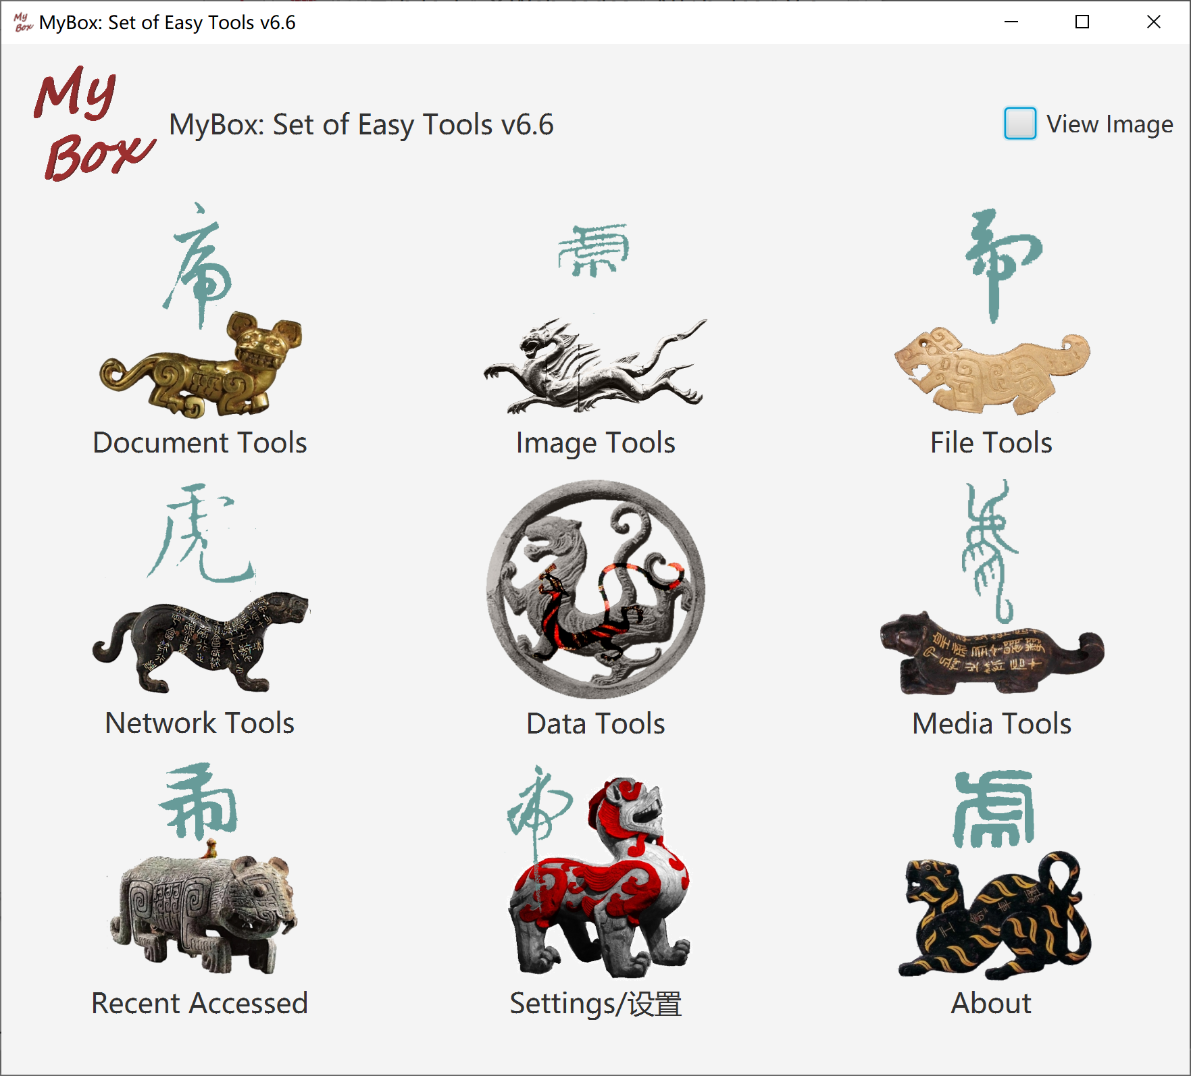

Resources Addresses

Contents | Link
Project Main Page | https://github.com/Mararsh/MyBox/
Source Codes and Compiled Packages | https://github.com/Mararsh/MyBox/releases
Submit Software Requirements and  Problem Reports | https://github.com/Mararsh/MyBox/issues
Data | https://github.com/Mararsh/MyBox_data
Documents | https://github.com/Mararsh/MyBoxDoc
Mirror Site | https://sourceforge.net/projects/mara-mybox/files/
Cloud Storage | https://pan.baidu.com/s/1fWMRzym_jh075OCX0D8y8A#list/path=%2F



Documents
Name | Version | Time | English | Chinese
Development Logs | 6.6 | 2022-9-28 | html | html
Shortcuts | 6.5.6 | 2022-6-11 | html | html
Packing Steps | 6.3.3 | 2020-9-27 | html | html
Development Guide | 2.1 | 2020-8-27 | PDF | PDF
User Guide - Overview | 6.6 | 2022-9-28 | html PDF odt | html PDF odt
User Guide - Document Tools | 6.6 | 2022-9-28 | html PDF odt | html PDF odt
User Guide - Image Tools | 6.6 | 2022-9-28 | html PDF odt | html PDF odt
User Guide - File Tools | 6.6 | 2022-9-28 | html PDF odt | html PDF odt
User Guide - Network Tools | 6.6 | 2022-9-28 | html PDF odt | html PDF odt
User Guide - Data Tools | 6.6 | 2022-9-28 | html PDF odt | html PDF odt
User Guide - Media Tools | 6.6 | 2022-9-28 | html PDF odt | html PDF odt
User Guide - Development Tools | 6.6 | 2022-9-28 | html PDF odt | html PDF odt

Menu of Tools
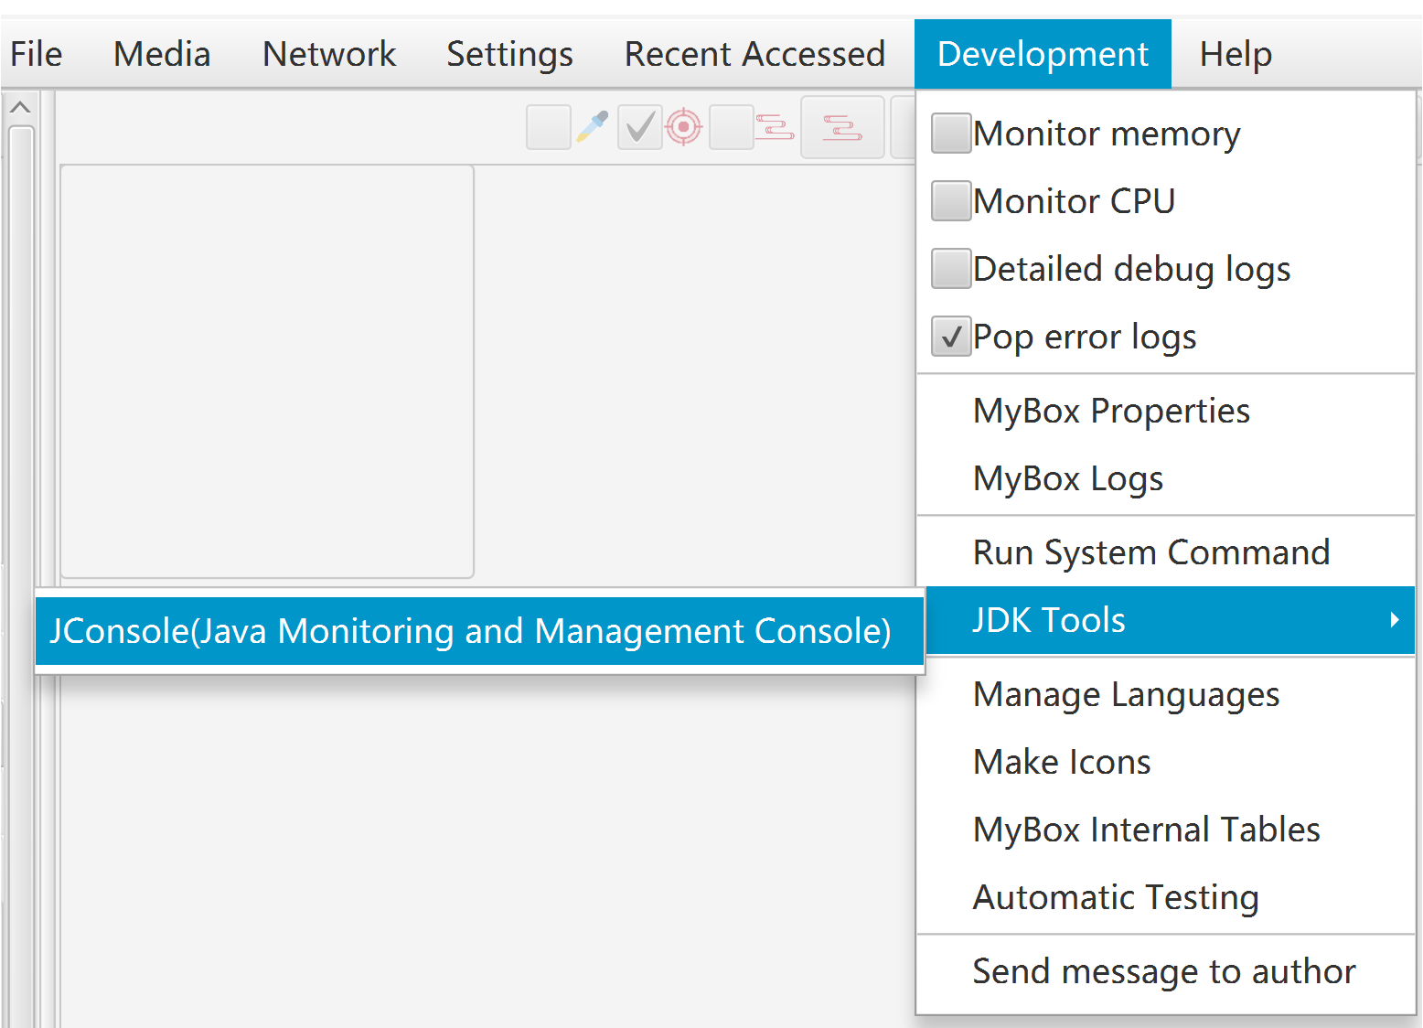

Monitor CPU/Memory
When monitor CPU/memory, status is updated in every second in top bar.

MyBox Properties

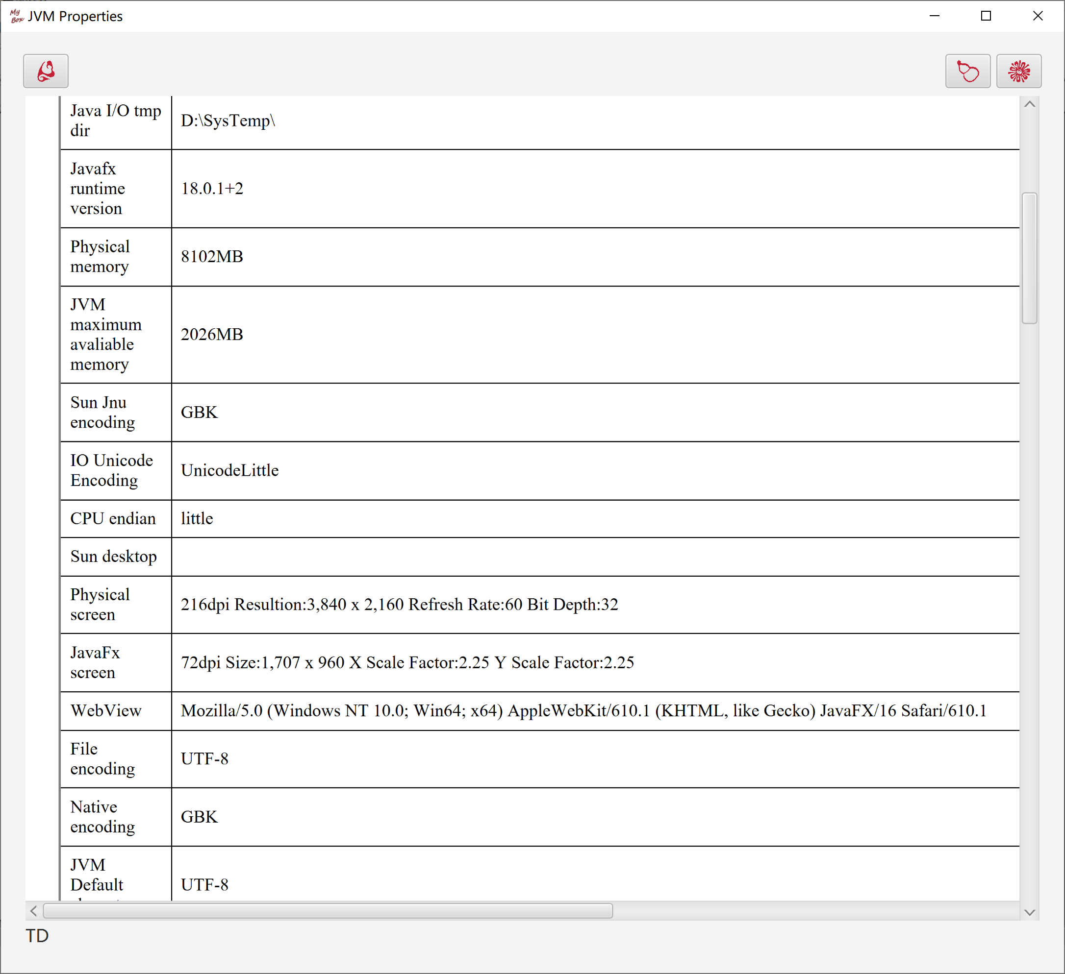

MyBox Logs
- Types of MyBox logs: Error, Info, Debug, Console.
- All logs will be displayed on console.
- "Error" and "Info" are always written in database.
- "Debug" are written in database only in Dev Mode.
- "Console" are never written in database.
- Fields: ID, time, type, file, class, method, line, callers, comments.
- "Callers" is the calling chain. Each line is one node and records: file, class, method, line. Calling chains only include methods of MyBox itself.
- "Error" will cause interface of MyBox Logs Viewer is popped.
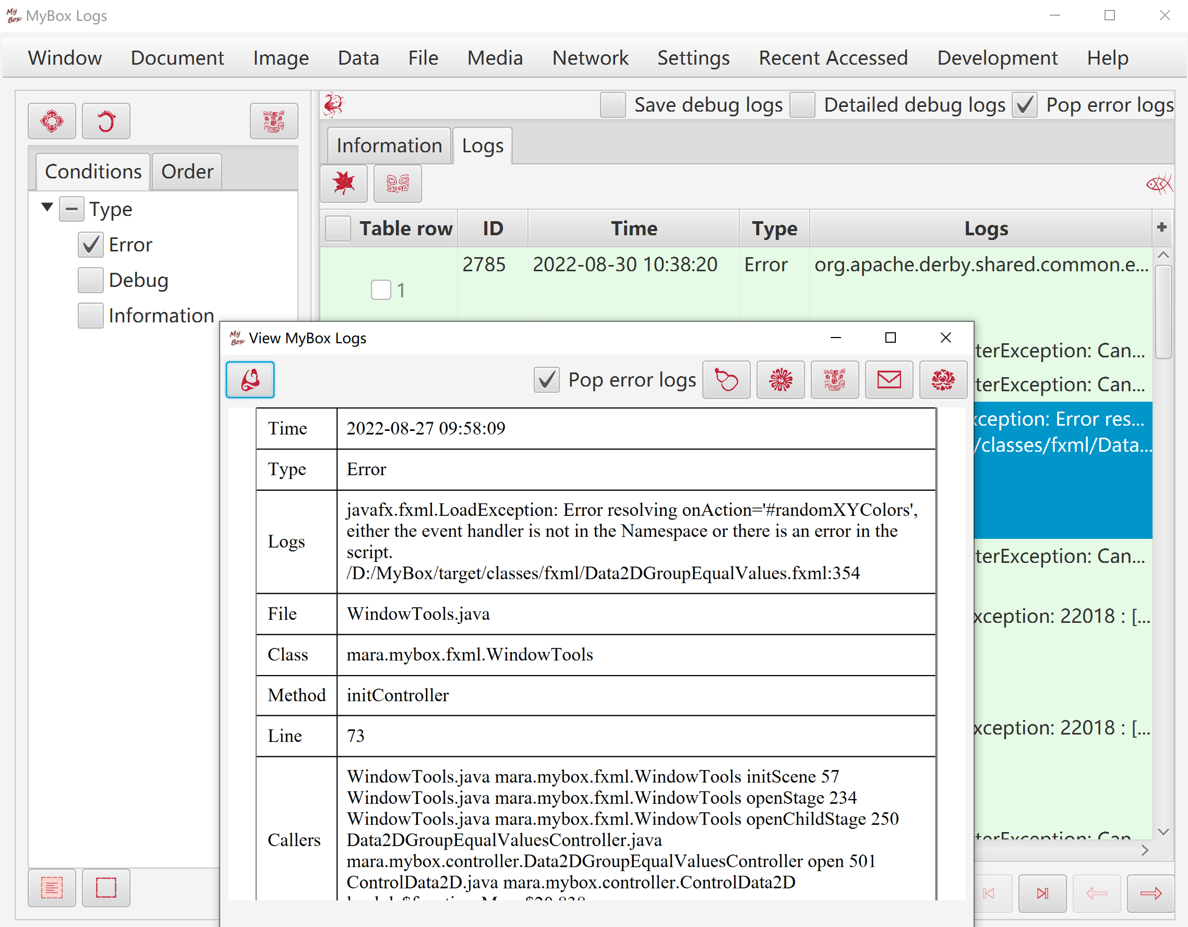

Run system commands

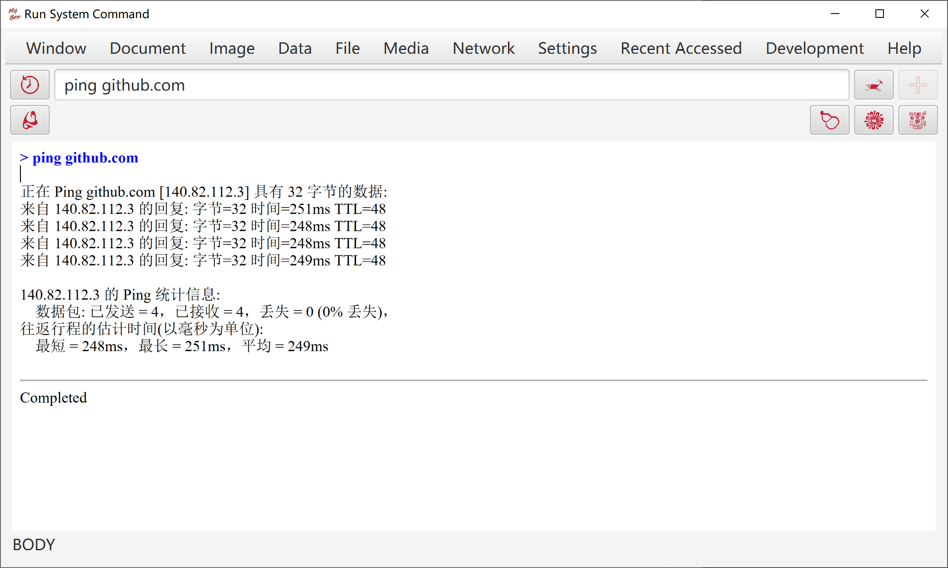

Start JConsole(Java Monitoring and Management Console)

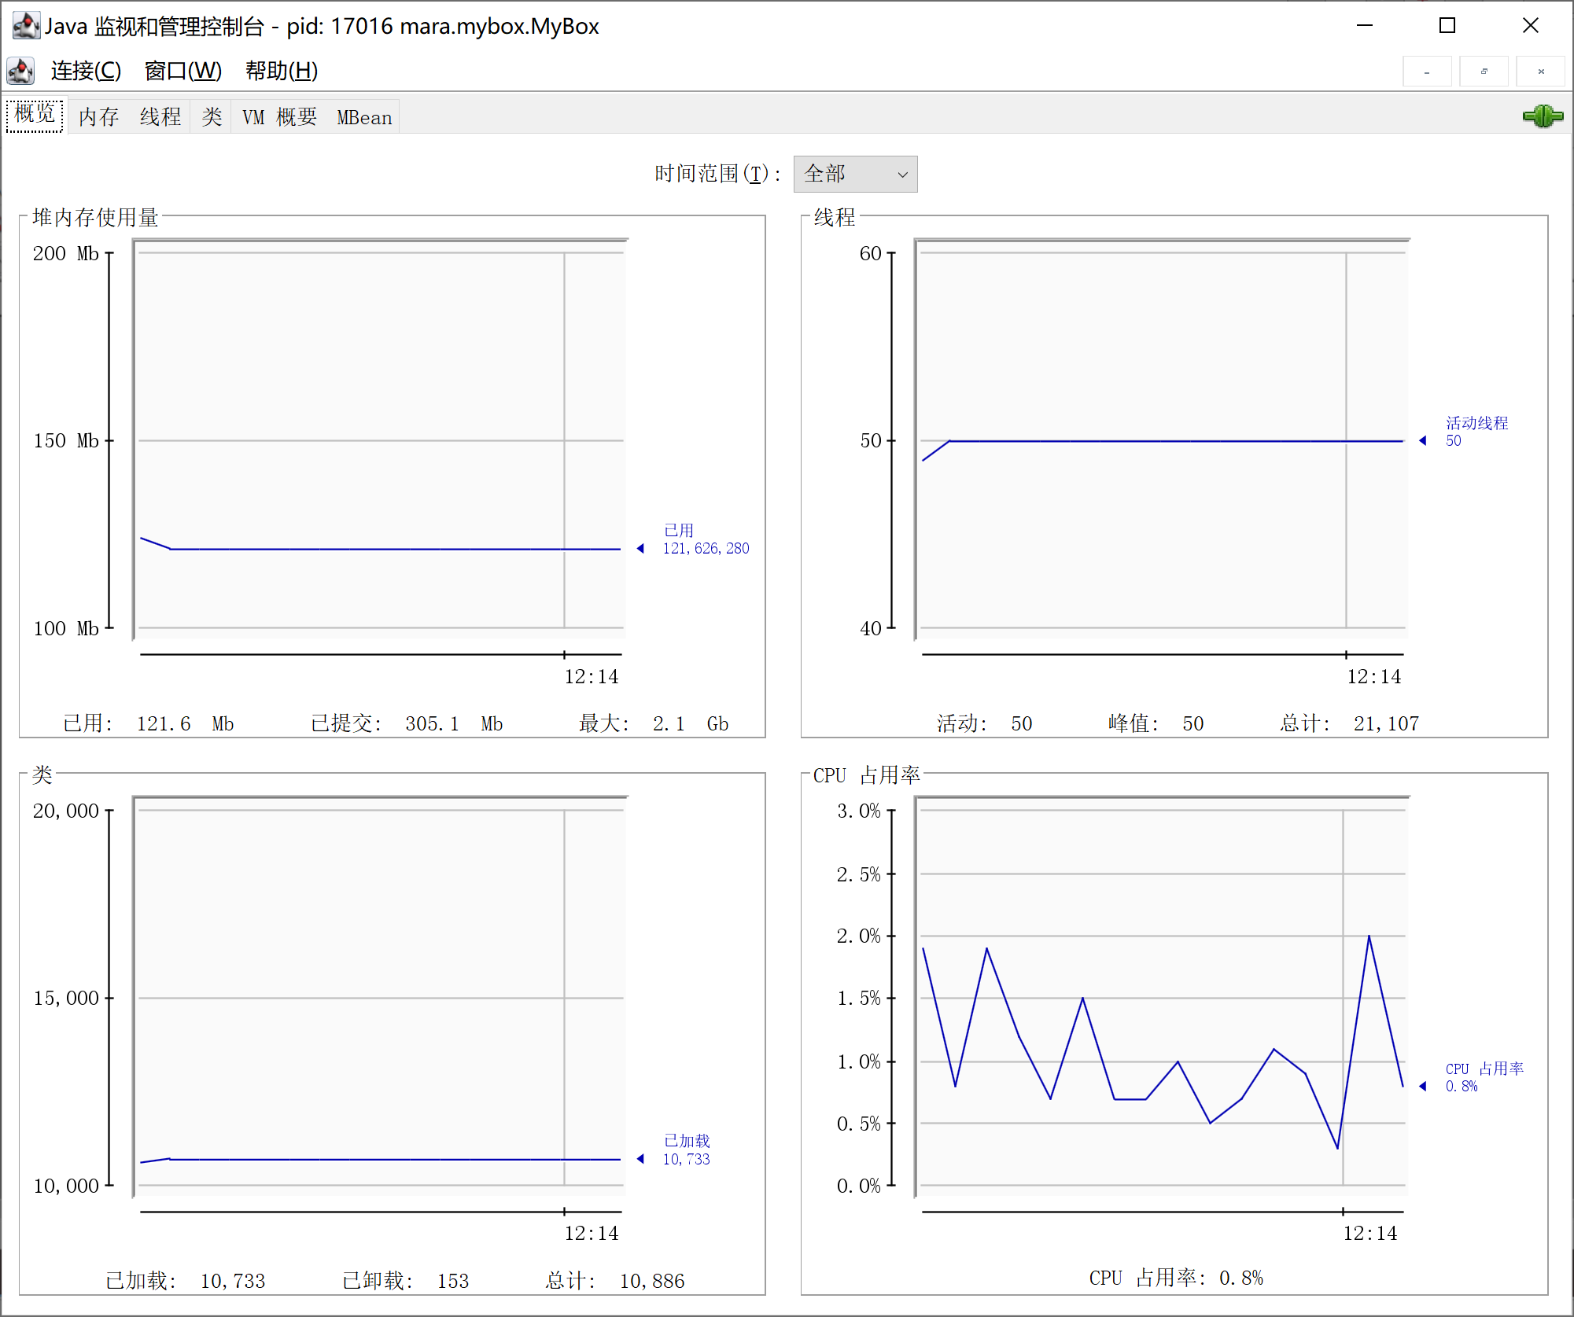

Manage Languages
This tool helps to manage customized languages of MyBox:
- Click button "Add" to create a new language.
- Edit translation of language items.
  - Select a row in the tables.
  - Click the cell in the row：
      - If its English contains line breaks, then pop text editor to help input multiple lines.
      - If its English is single line, then display a text field to help fill line directly.
  - Keep item empty to use English as default.
  - Right click the cell to select "Copy English" or "Copy Chinese".
- Click button "Save" to save modification.

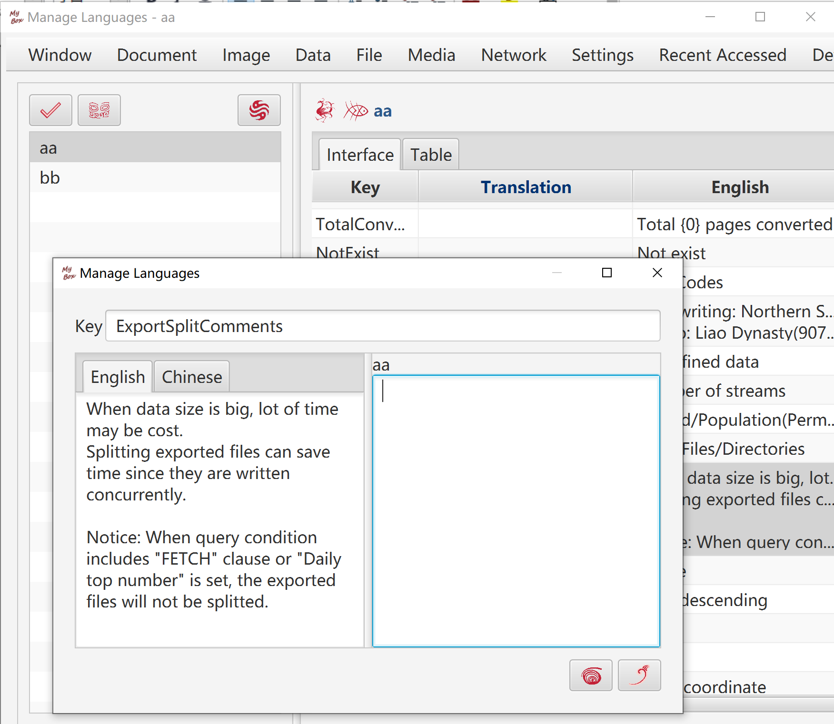

Make Icons
This tool helps to create MyBox icons in other colors from light-grey icons.

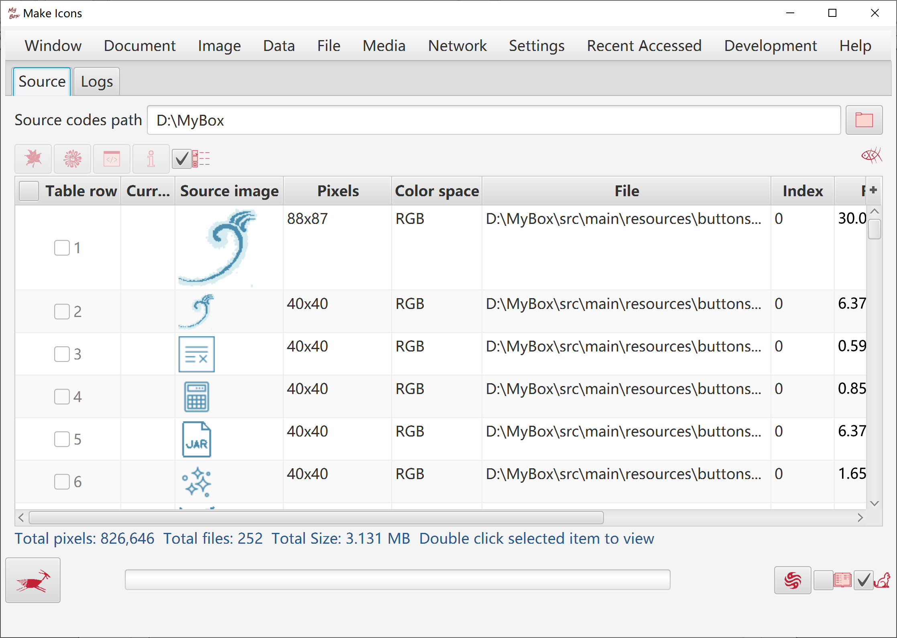

MyBox Internal Tables

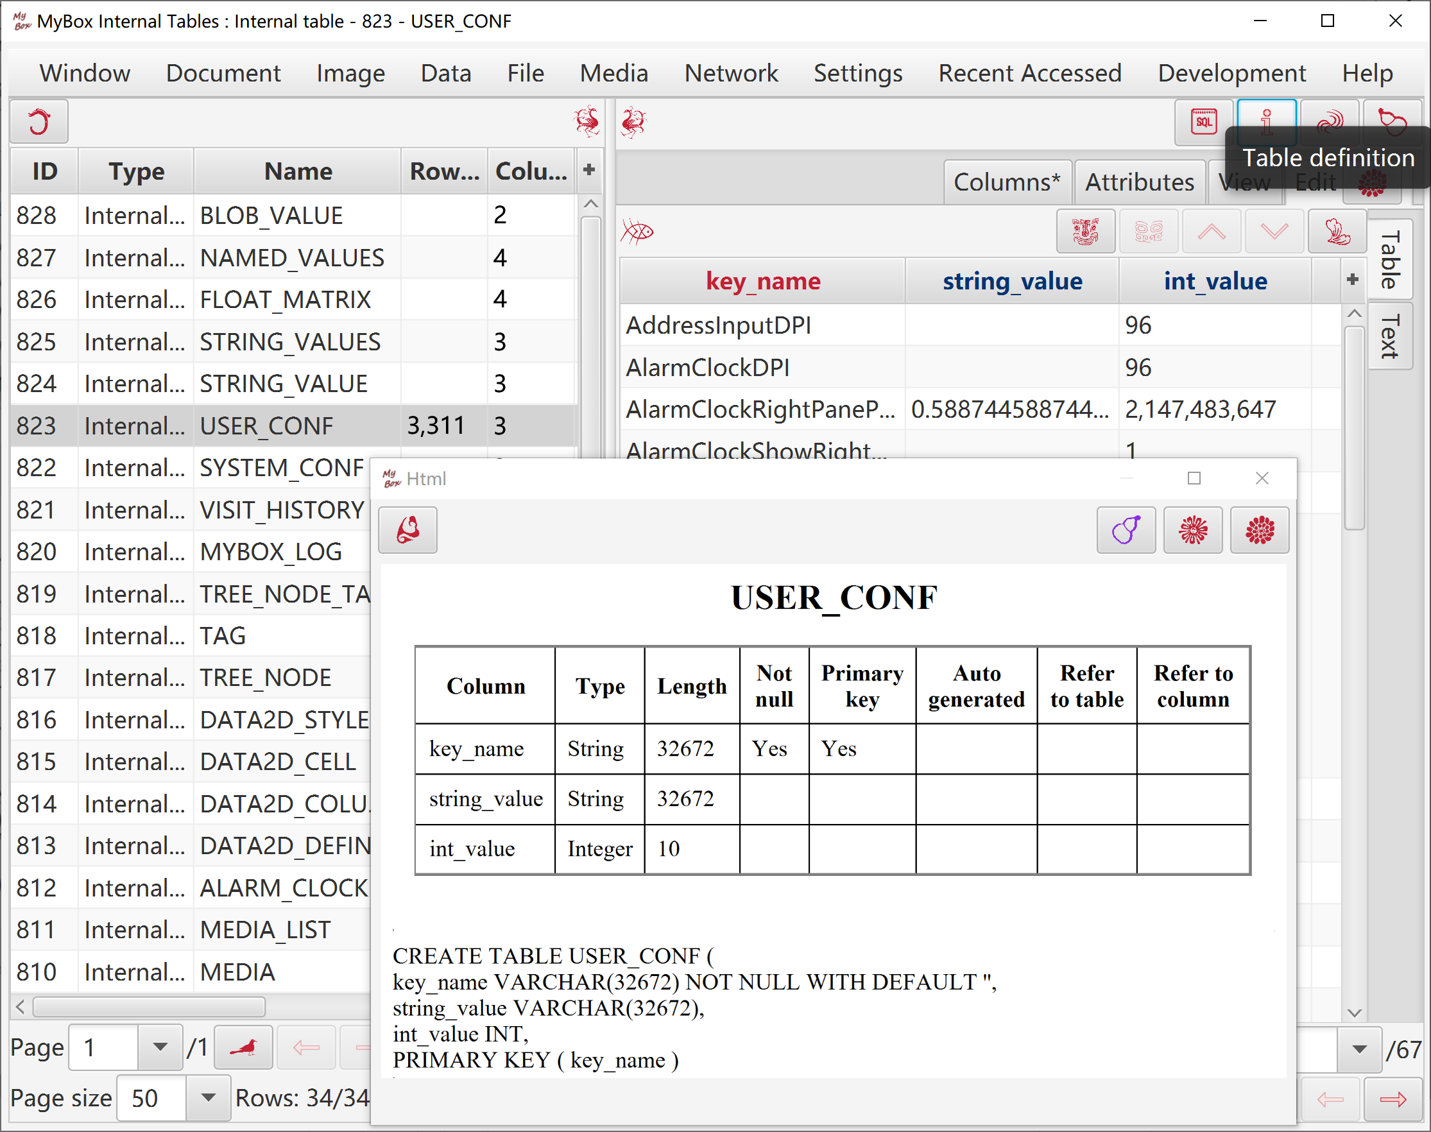

Automatical Testing: Open Interfaces

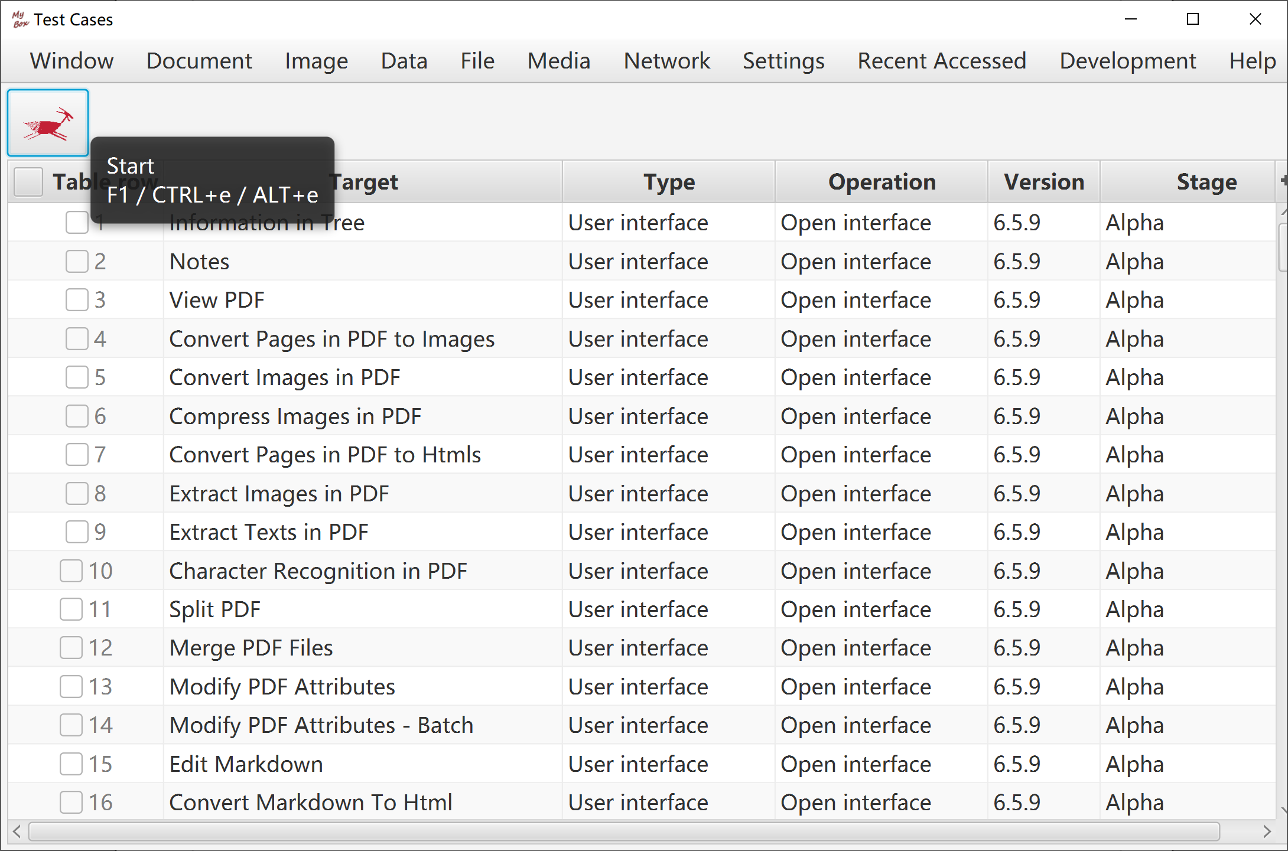

Send Message To Author
Welcome to submit problem reports and software requirements.

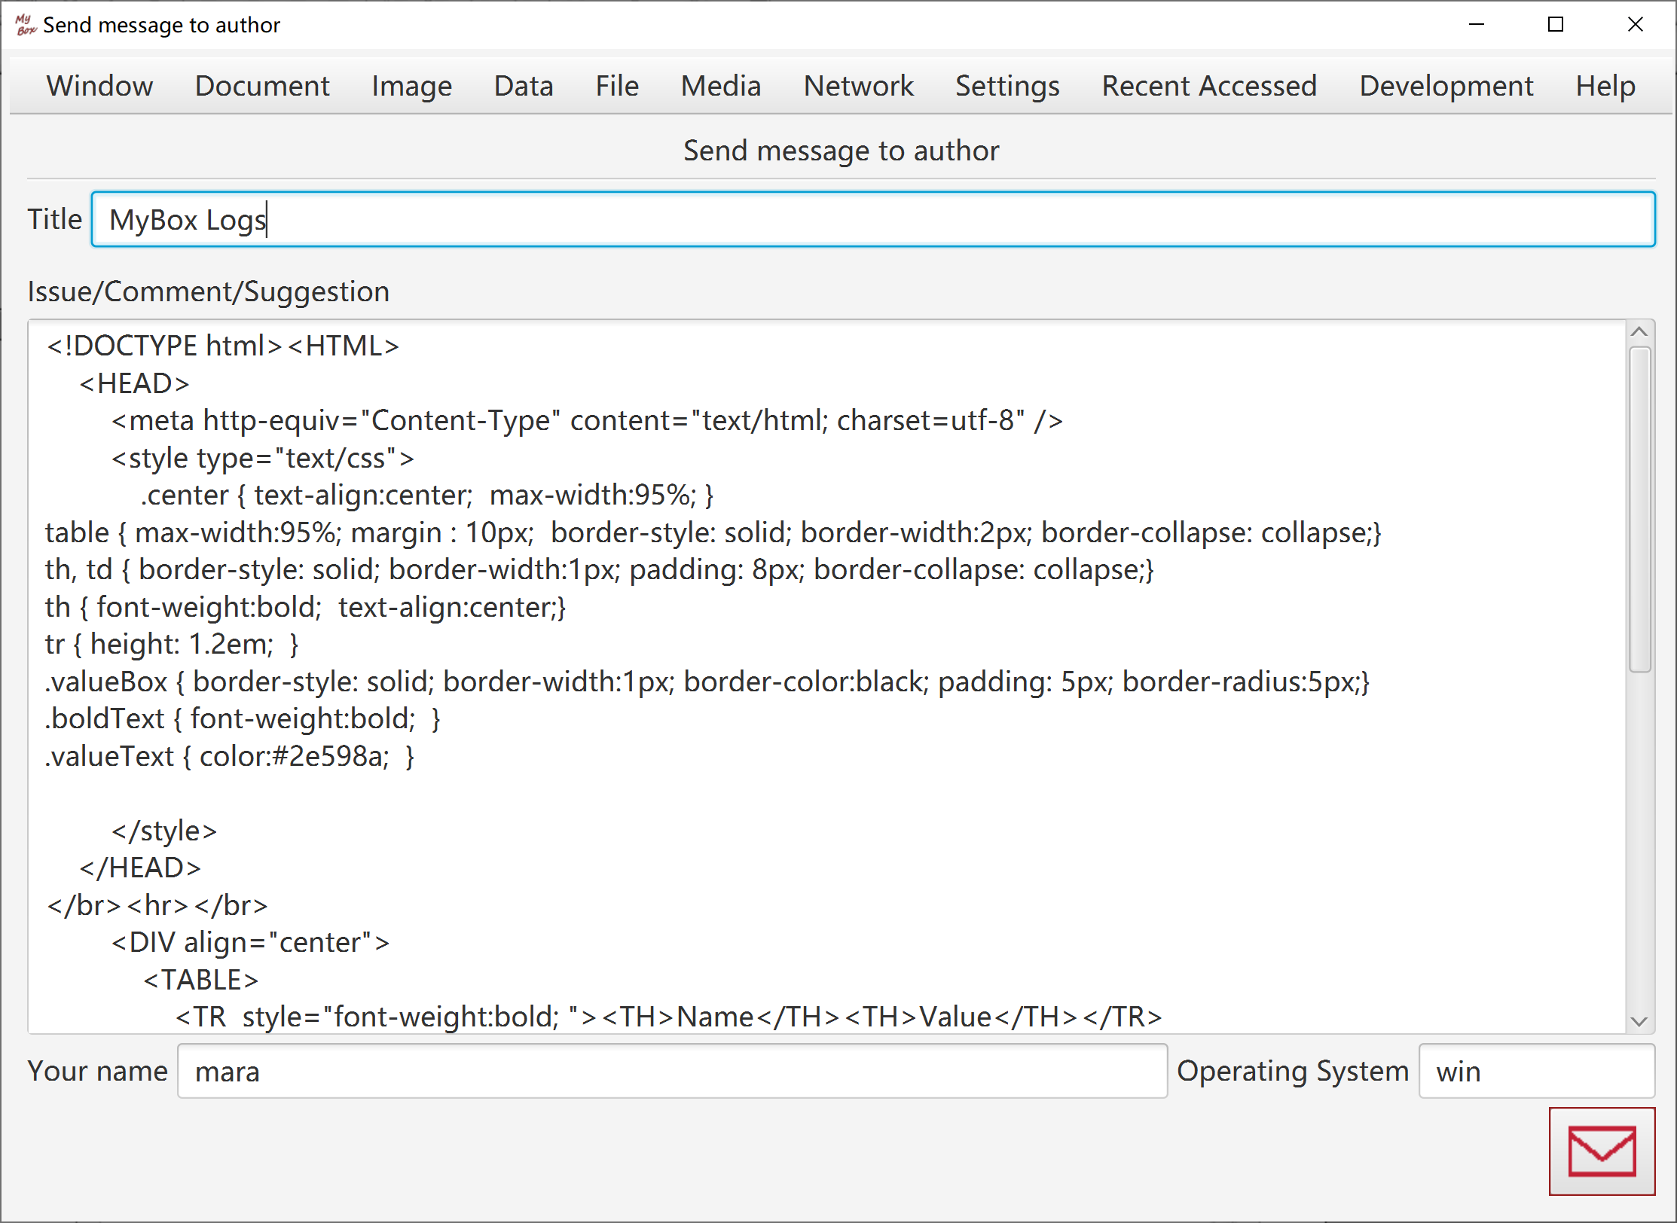

<End of Document>

