

MyBox: Easy Tools Set
User Guide – Media Tools

Author: Mara
Version: 6.6
Date: 2022-9-28

Contents
1 Introduction 3
1.1 Main Interface 3
1.2 Resources Addresses 4
1.3 Documents 5
1.4 Menu of Tools 5
2 Play Videos/Audios 6
3 Manage Playlist 7
4 Wrap Functions of ffmpeg 8
4.1 Base 8
4.2 Record Screen 10
4.3 Convert Videos/Audios in Batch 11
4.4 Combine Images And Audios As Video 11
4.5 Read Media Information with ffprobe 12
4.6 Read Information of ffmpeg 13
5 Game-Elimination 14
6 Game-Mine 15

Introduction
This is desktop application based on JavaFx to provide simple and easy functions. It's free and open sources.

Main Interface

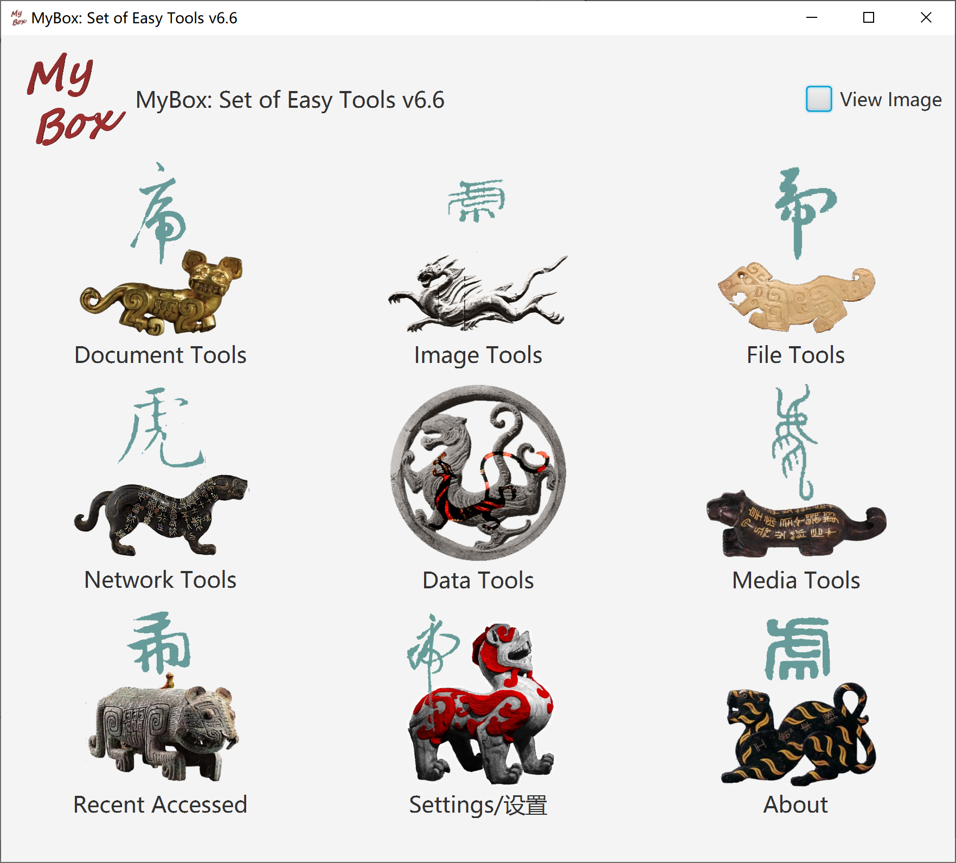

Resources Addresses

Contents | Link
Project Main Page | https://github.com/Mararsh/MyBox/
Source Codes and Compiled Packages | https://github.com/Mararsh/MyBox/releases
Submit Software Requirements and  Problem Reports | https://github.com/Mararsh/MyBox/issues
Data | https://github.com/Mararsh/MyBox_data
Documents | https://github.com/Mararsh/MyBoxDoc
Mirror Site | https://sourceforge.net/projects/mara-mybox/files/
Cloud Storage | https://pan.baidu.com/s/1fWMRzym_jh075OCX0D8y8A#list/path=%2F



Documents

Name | Version | Time | English | Chinese
Development Logs | 6.6 | 2022-9-28 | html | html
Shortcuts | 6.5.6 | 2022-6-11 | html | html
Packing Steps | 6.3.3 | 2020-9-27 | html | html
Development Guide | 2.1 | 2020-8-27 | PDF | PDF
User Guide - Overview | 6.6 | 2022-9-28 | html PDF odt | html PDF odt
User Guide - Document Tools | 6.6 | 2022-9-28 | html PDF odt | html PDF odt
User Guide - Image Tools | 6.6 | 2022-9-28 | html PDF odt | html PDF odt
User Guide - File Tools | 6.6 | 2022-9-28 | html PDF odt | html PDF odt
User Guide - Network Tools | 6.6 | 2022-9-28 | html PDF odt | html PDF odt
User Guide - Data Tools | 6.6 | 2022-9-28 | html PDF odt | html PDF odt
User Guide - Media Tools | 6.6 | 2022-9-28 | html PDF odt | html PDF odt
User Guide - Development Tools | 6.6 | 2022-9-28 | html PDF odt | html PDF odt

Menu of Tools
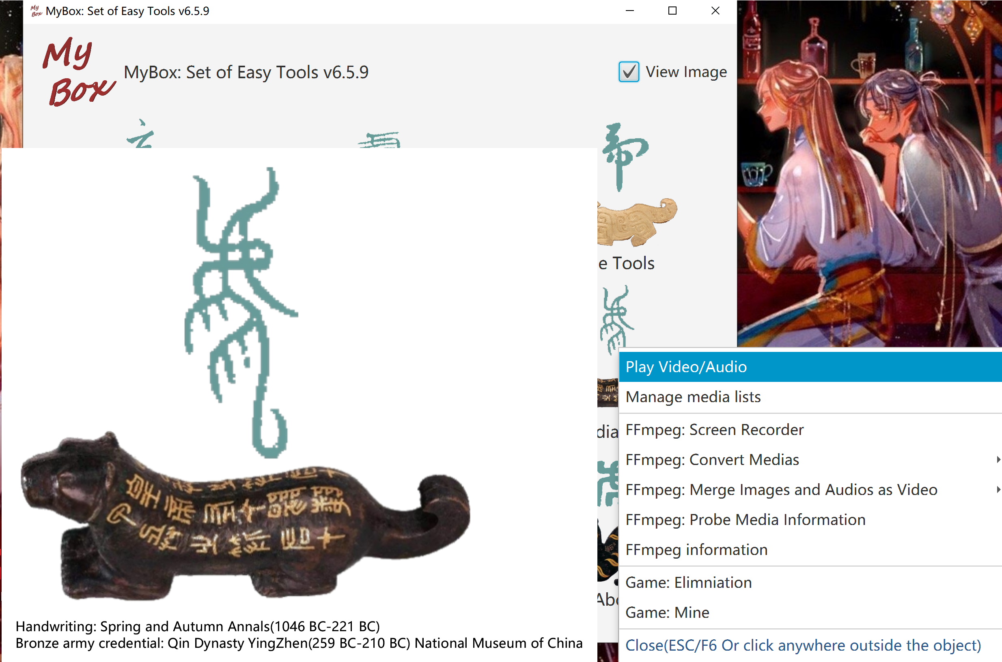

Play Videos/Audios
- Create/load playlist
- Options: auto-play, display milliseconds, loop number, random order
- Set: volumn, speed(0~8 times)
- Buttons: Play, Pause, Stop, Next, Previous, Media-info, Mute, Full-screen
- When full screen, display controls in short duration by clicking screen, and quit full-screen by ESC
- Support muxer format: aiff, mp3, mp4, wav, hls(m3u8), video codec: h.264/avc, audio codec: aac, mp3, pcm.
- If video does not sound, this is due to unsupported audio codec.
- Known issue: MyBox may quit when play some media stream.
- Sounds of GuaiGuai and BenBen
- This tool need not ffmpeg. But libavcodec and libavformat are required on Linux, and refer to:
https://www.oracle.com/technetwork/java/javafx/downloads/supportedconfigurations-1506746.html

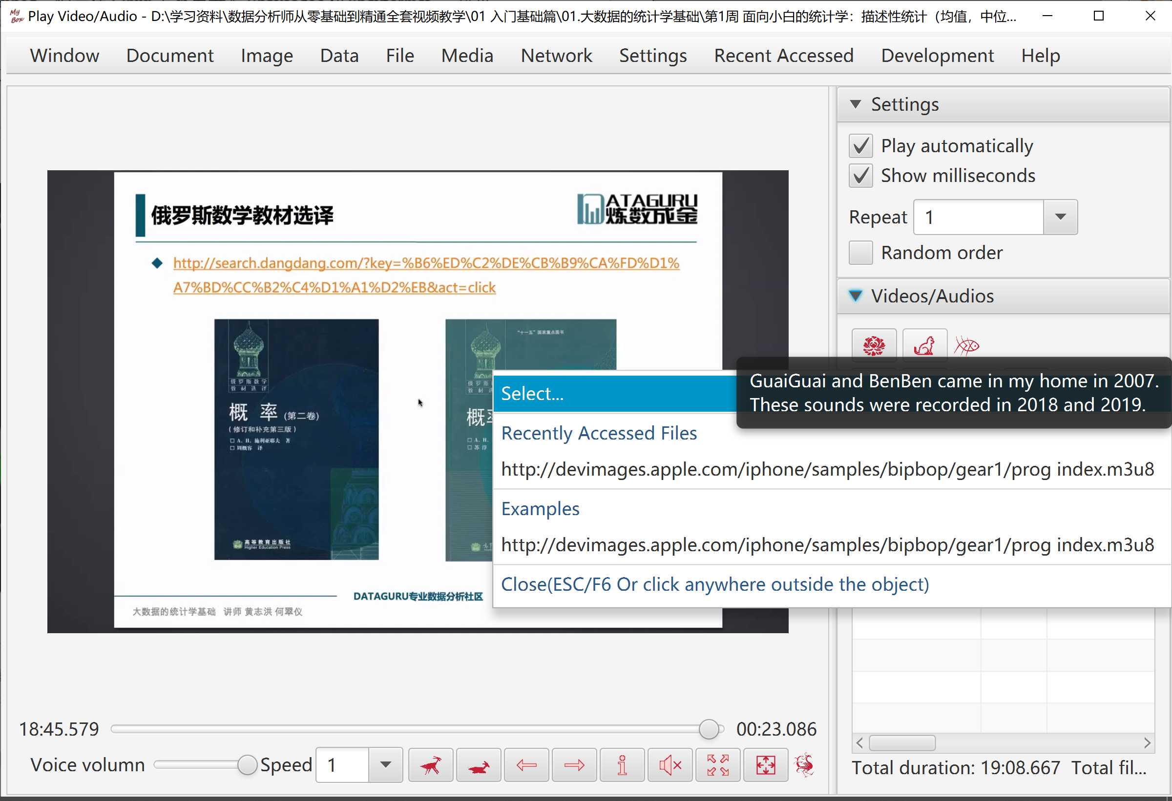

Manage Playlist
- Create/Delete/Update playlists.
- Add/Delete items in playlists.
- Read medias information, including duration, audio encoding, and video encoding.

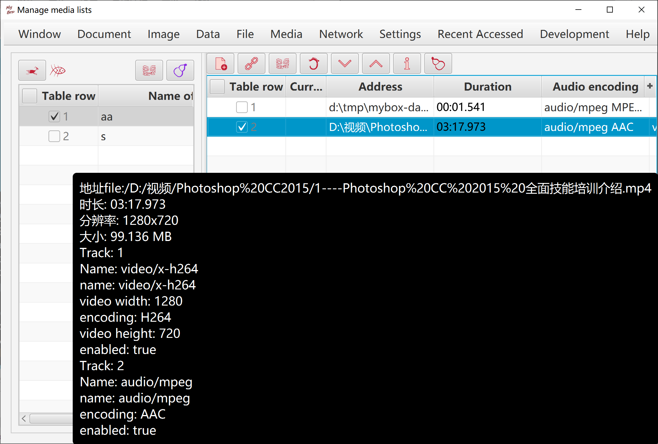

Wrap Functions of ffmpeg

Base
Notice: This set of functions is based on ffmpeg, and user need download ffmpeg by yourself. (Suggest to use static version)
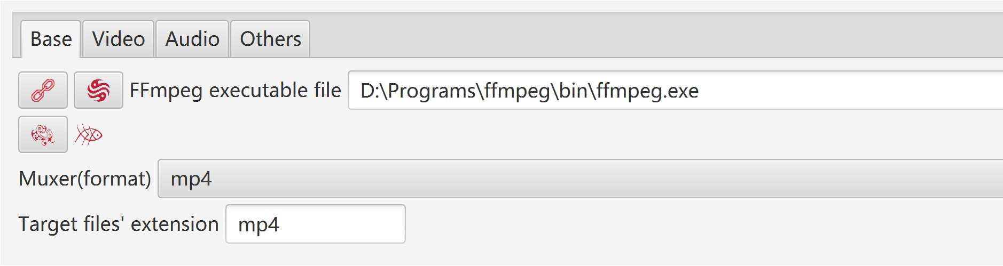
When handle media:
- All parameters can be selected/set, including format, codec, subtitle, frame rate, sample rate, change volumn, etc.
- Button "Default": When NVIDIA is available, chooce "h264_nvenc" as video encoder, to make use of hardware acceleartion.
- Most of players support: muxer "mp4", video codec "H.264", audio codec "AAC".
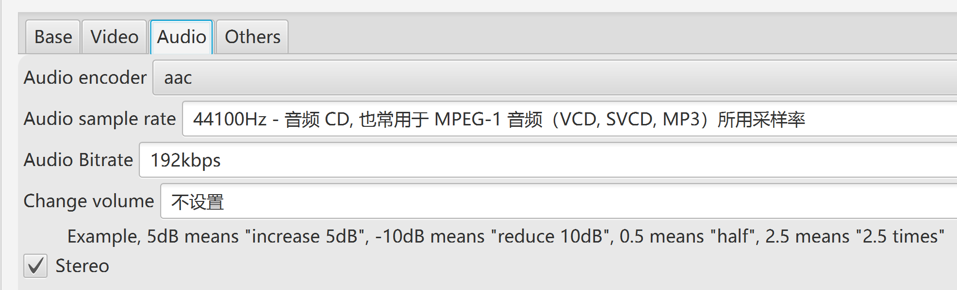
- Try different options of encoders, preset, and CRF, to get suitable settings of your computer, as following factors :
- The encoder should be fast enough to record without frames dropping.
- Consume limited system resources, and leave enough CPU and memory for other applications.
- Quality and size of the generated file are tolerable.

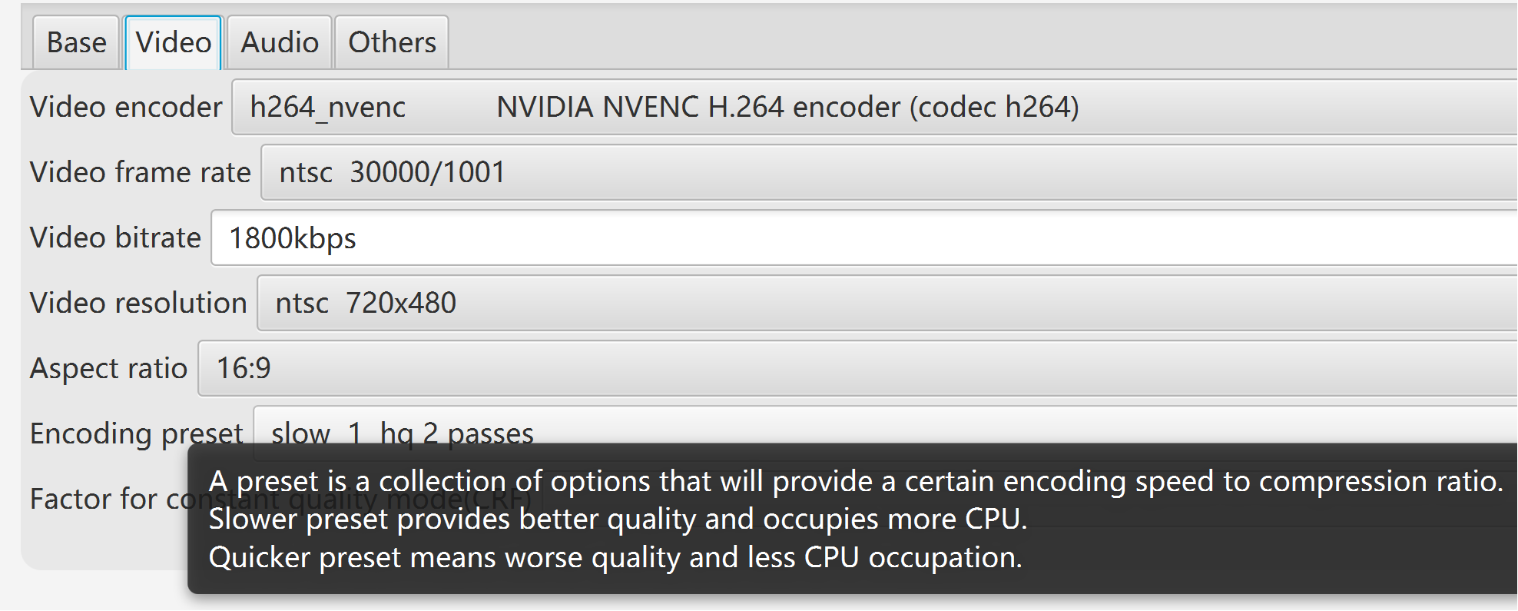
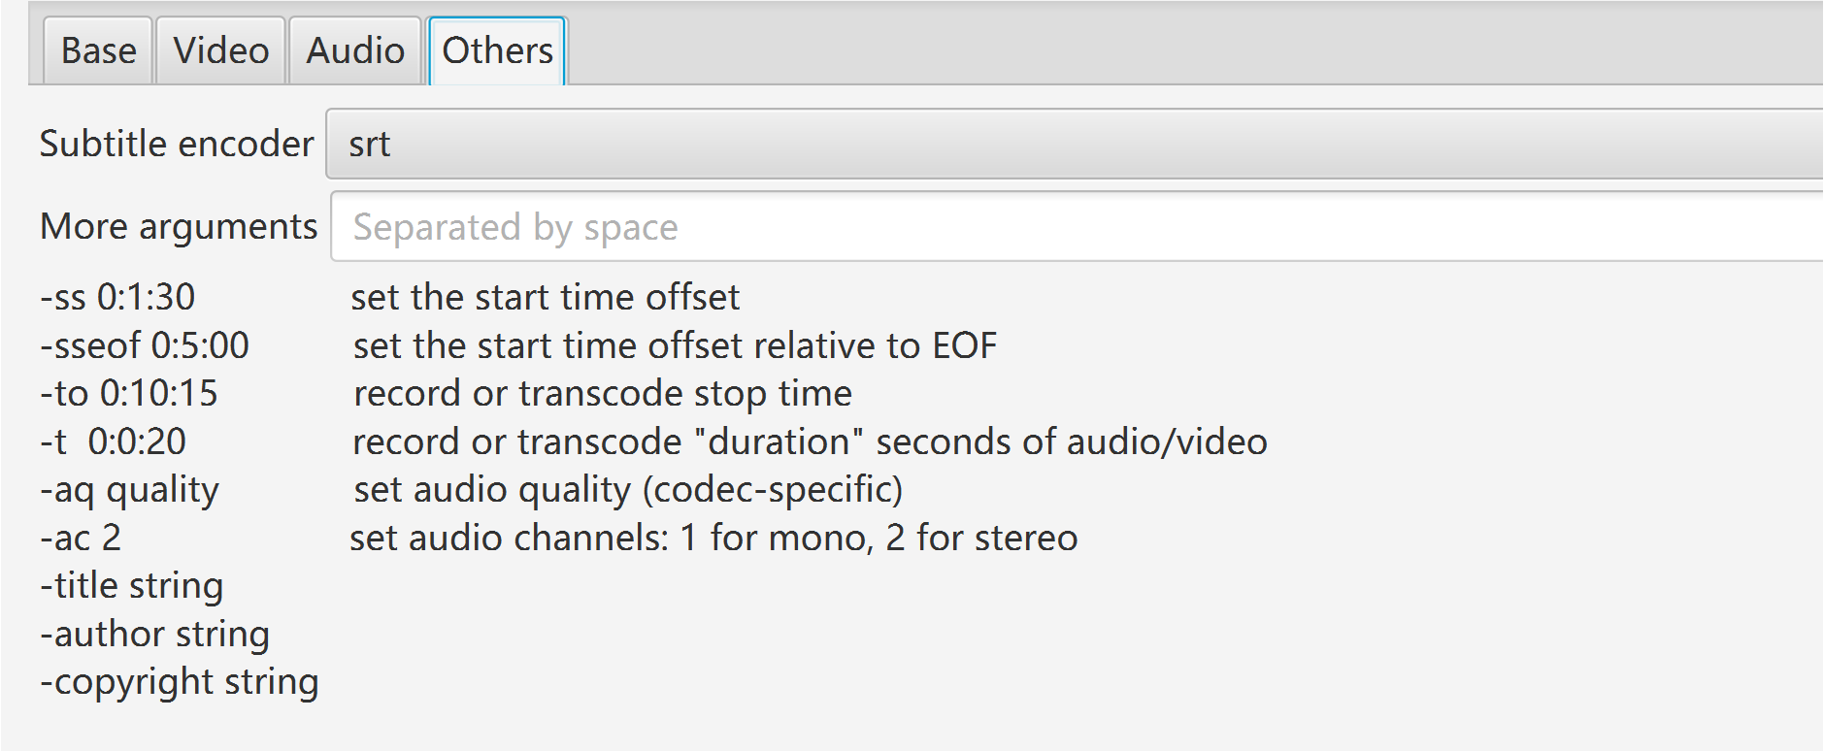

Record Screen
- When have not NVIDIA and CPU is not so powerful:
- Choose "libx264rgb" as video encoder, to bypass conversion from RGB to yuv444p.
- Select quicker encoding preset.
- After recording, use conversion tool to change generated video from RGB to yuv444p with encoder "libx264".
- Select whether record video：
- Set size of threads queue.
- Record area: full screen, window by title, rectangle.
- Select wether record audio:
- Detect audio cards automatically, and pick the first one as the audio device.
- Set size of threads queue.
- Set delay:
- If "unlimited", record at once when user click button "Start".
- If valid value, recording will start when this time is past.
- Set duration:
- If "unlimited", record untill user click button "Stop".
- If valid value, recording will end when duration completes. User can click button "Stop" to finish recording at any time.

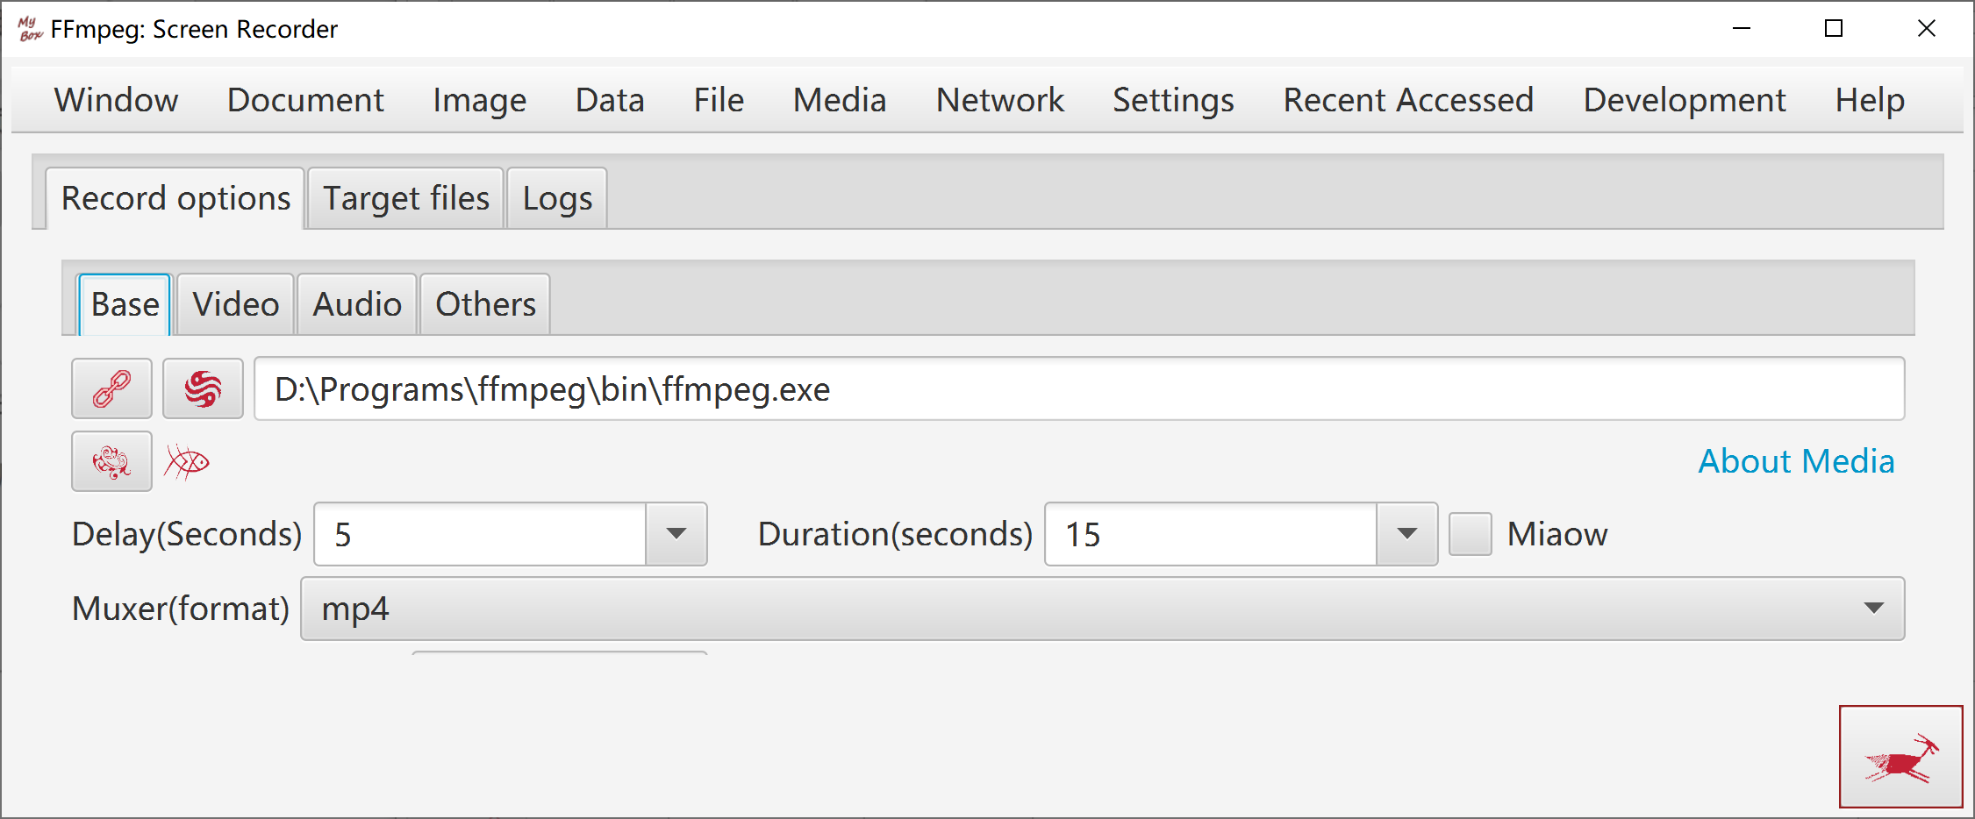

Convert Videos/Audios in Batch
- Source files are listed as files/directories.
- Source files are listed as streams and medias information.

Combine Images And Audios As Video
- Source files are listed as files/directories.
- Source files are listed as streams and medias information.
- Duration can be set for each image, or set for all images.
- Option: End video when audios finish.
- Images are adjusted automatically to fit for screen size meanwhile keep width-height ratio.

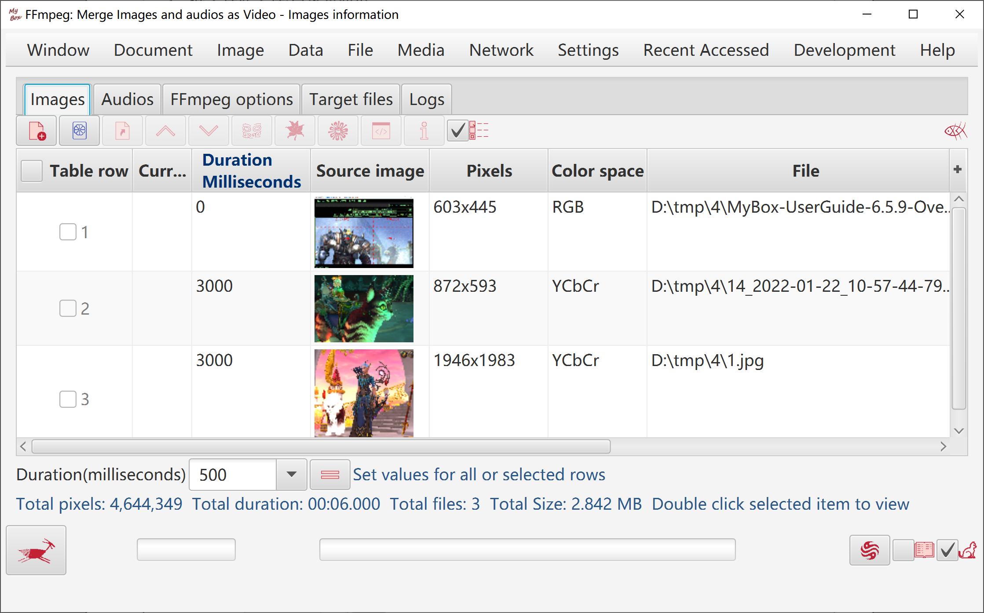

Read Media Information with ffprobe
Format, audio stream, video stream, frames, packets, pixel formats.

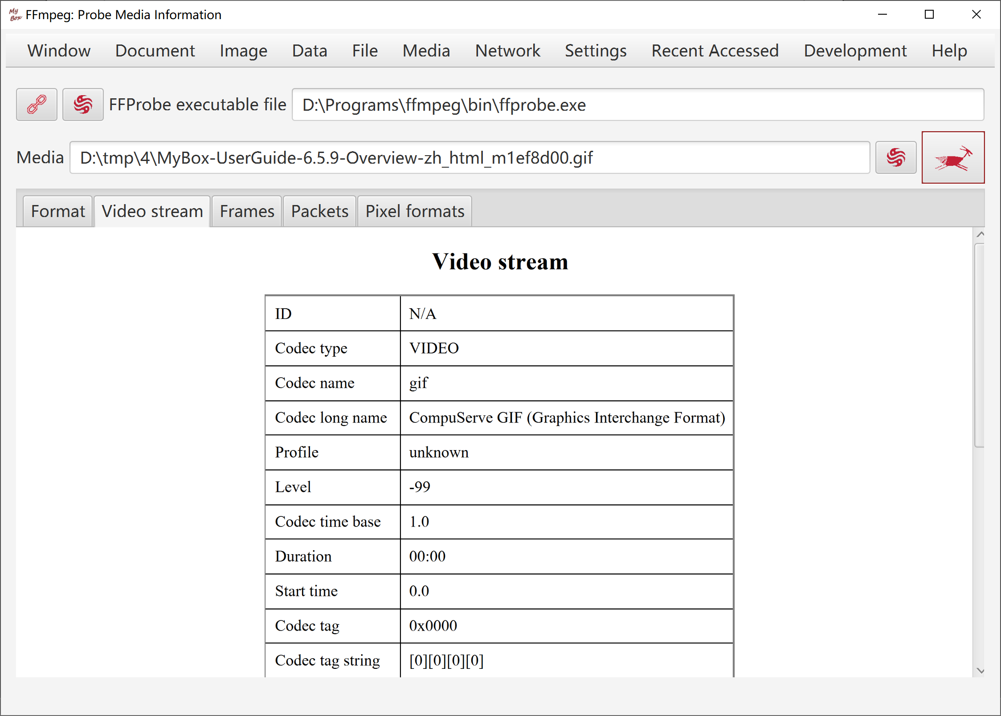

Read Information of ffmpeg
Version, supported formats/codecs/filters, and query with customized parameters.

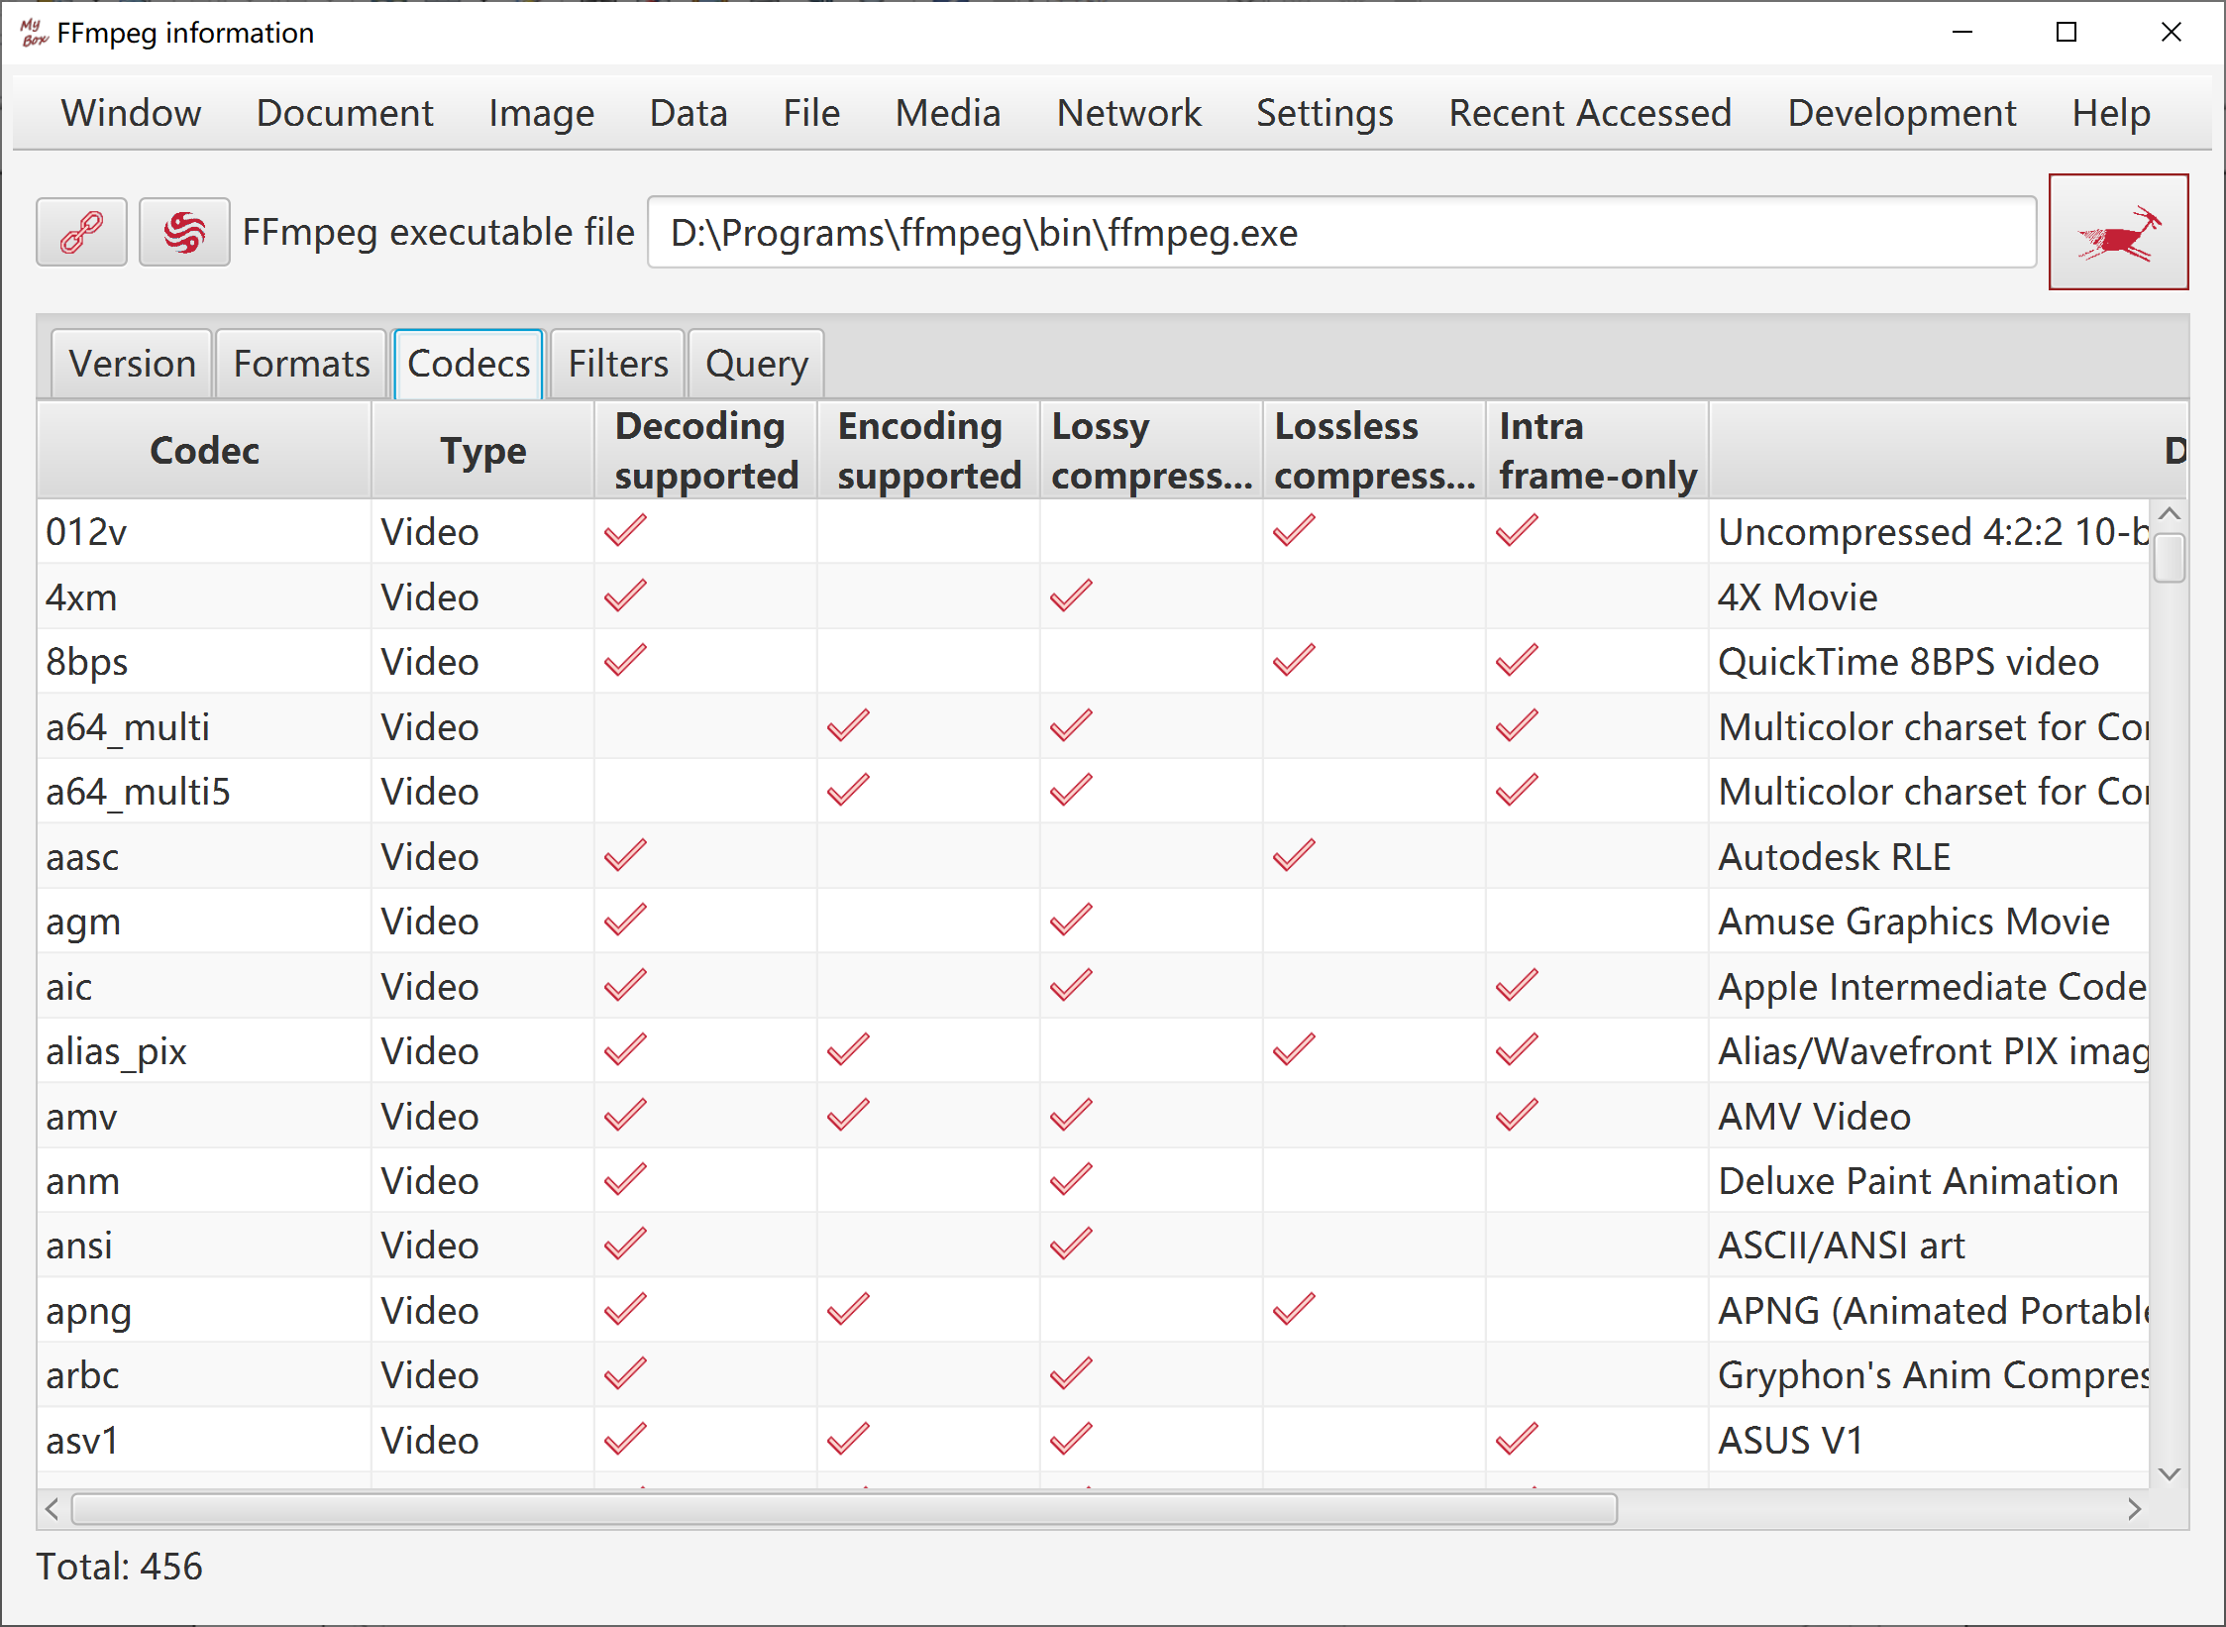

Game-Elimination
- Options about chesses images, number, size, effects like dropshadow or arc.
- Chesses can be predefined images, user defined images, or colors.
- Sound: praise from GuaiGuai, praise from BenBen, 3-conection from Ben and others from Guai, mute, or any mp3/wav file.
- Counted chesses: Make scores only when eliminate selected types of chesses.
- Customize rulers that how to give score when eliminate different type of connection.
- Set strategy when deadlock happens: keep score and renew game, make chance of elimination, or pop alert to have user chooce.
- Options: speed of automation, times of flush when eliminate, whether pop scores.
- Button "Help Me": prompt valid step.
- Button "Play Automatically": click to play by compute and click again to stop it.

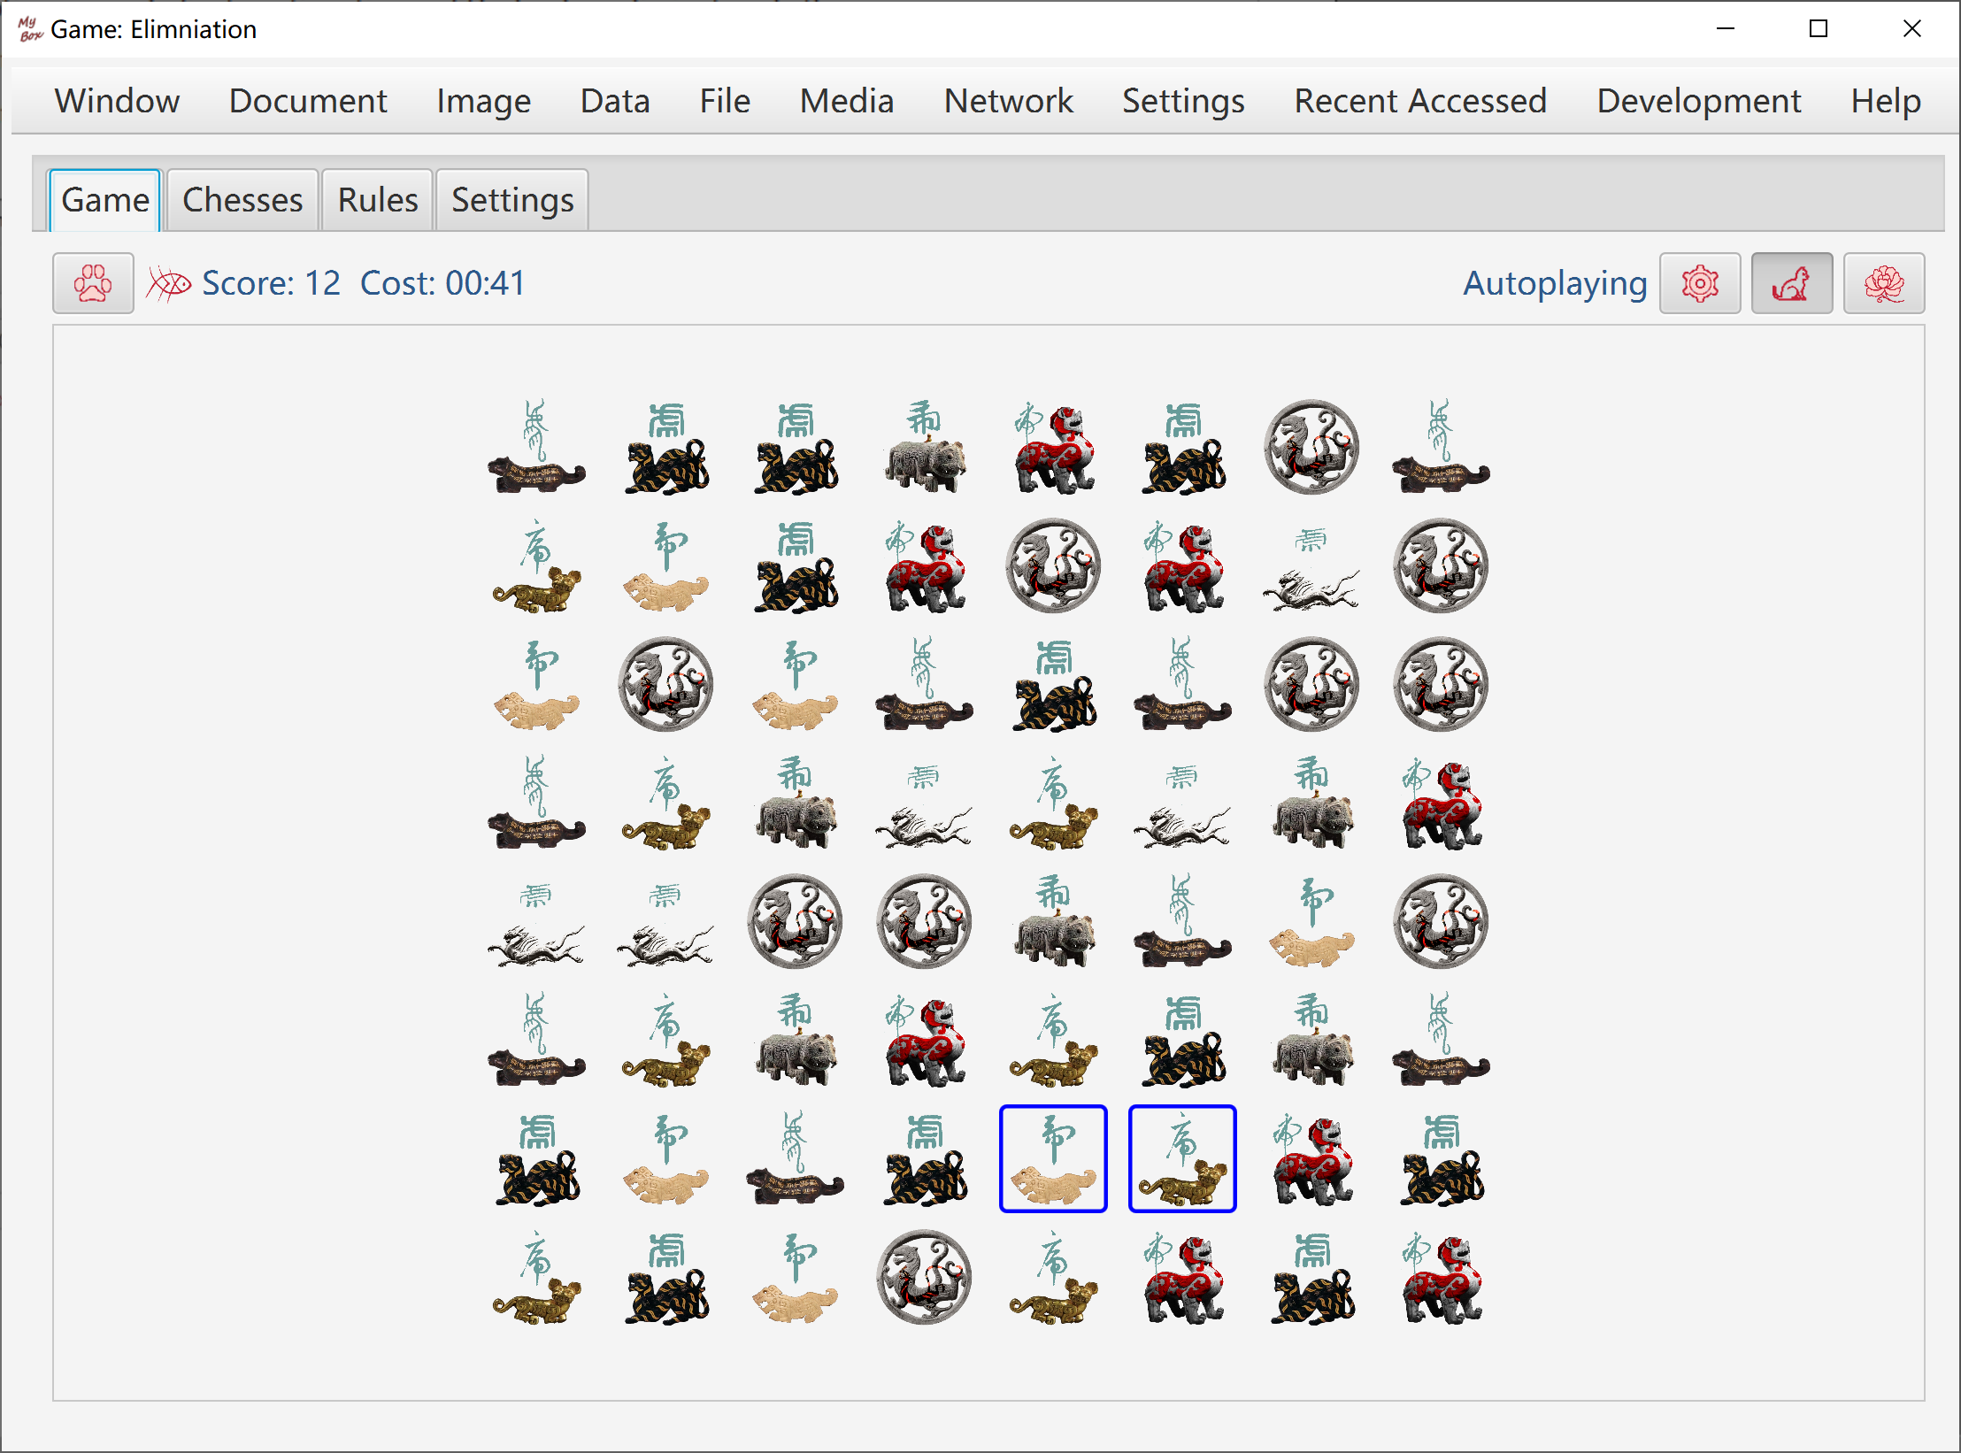

Game-Mine
Target: Disclose all cells which are not mines. Game fails once a mine is opened.
Rulers:
- When game is started, all cells are in status "closed".
- Start timing when click a cell at first time.
- Count: Opened cells number / Total number of cells which are not mines.
- When left-click a cell, nothing happens when it is "disclosed", or else:
- If it is a mine, then game fails.
- If it is not a mine, then it is opened and its status becomes "disclosed".
- If there are mines around this cell, then the number of mines around it is shown in the cell.
- If there is no mine around this cell, then it is shown as blank and all cells around it will be disclosed. Continue this process.
- When right-click a cell, nothing happens when it is "disclosed", or else:
- If this cell is not marked, then mark it as "Mine".
- If this cell is marked as "Mine", then change its mark as "Suspected".
- If this cell is marked as "Suspected", then remove its mark.
- Right-clicking only marks the cell, and will not trigger mine nor disclose the cell.
- When double-click a cell:
- If the cell is in status "closed", then disclose it.
- Disclose all cells which are not marked as "Mine" around this cell.
- Do this only when you are sure all mines are marked correctly around this cell.
- When you are unlucky to trigger a mine:
- Click button "Undo", to pretend that did not happen and continue the timing and counting.
- Click button "Replay", to restart the same game.
- Click button "New Game" to start a different game.
- Click button "Help me" to see all mines secretly, and click button "Undo" to continue playing.

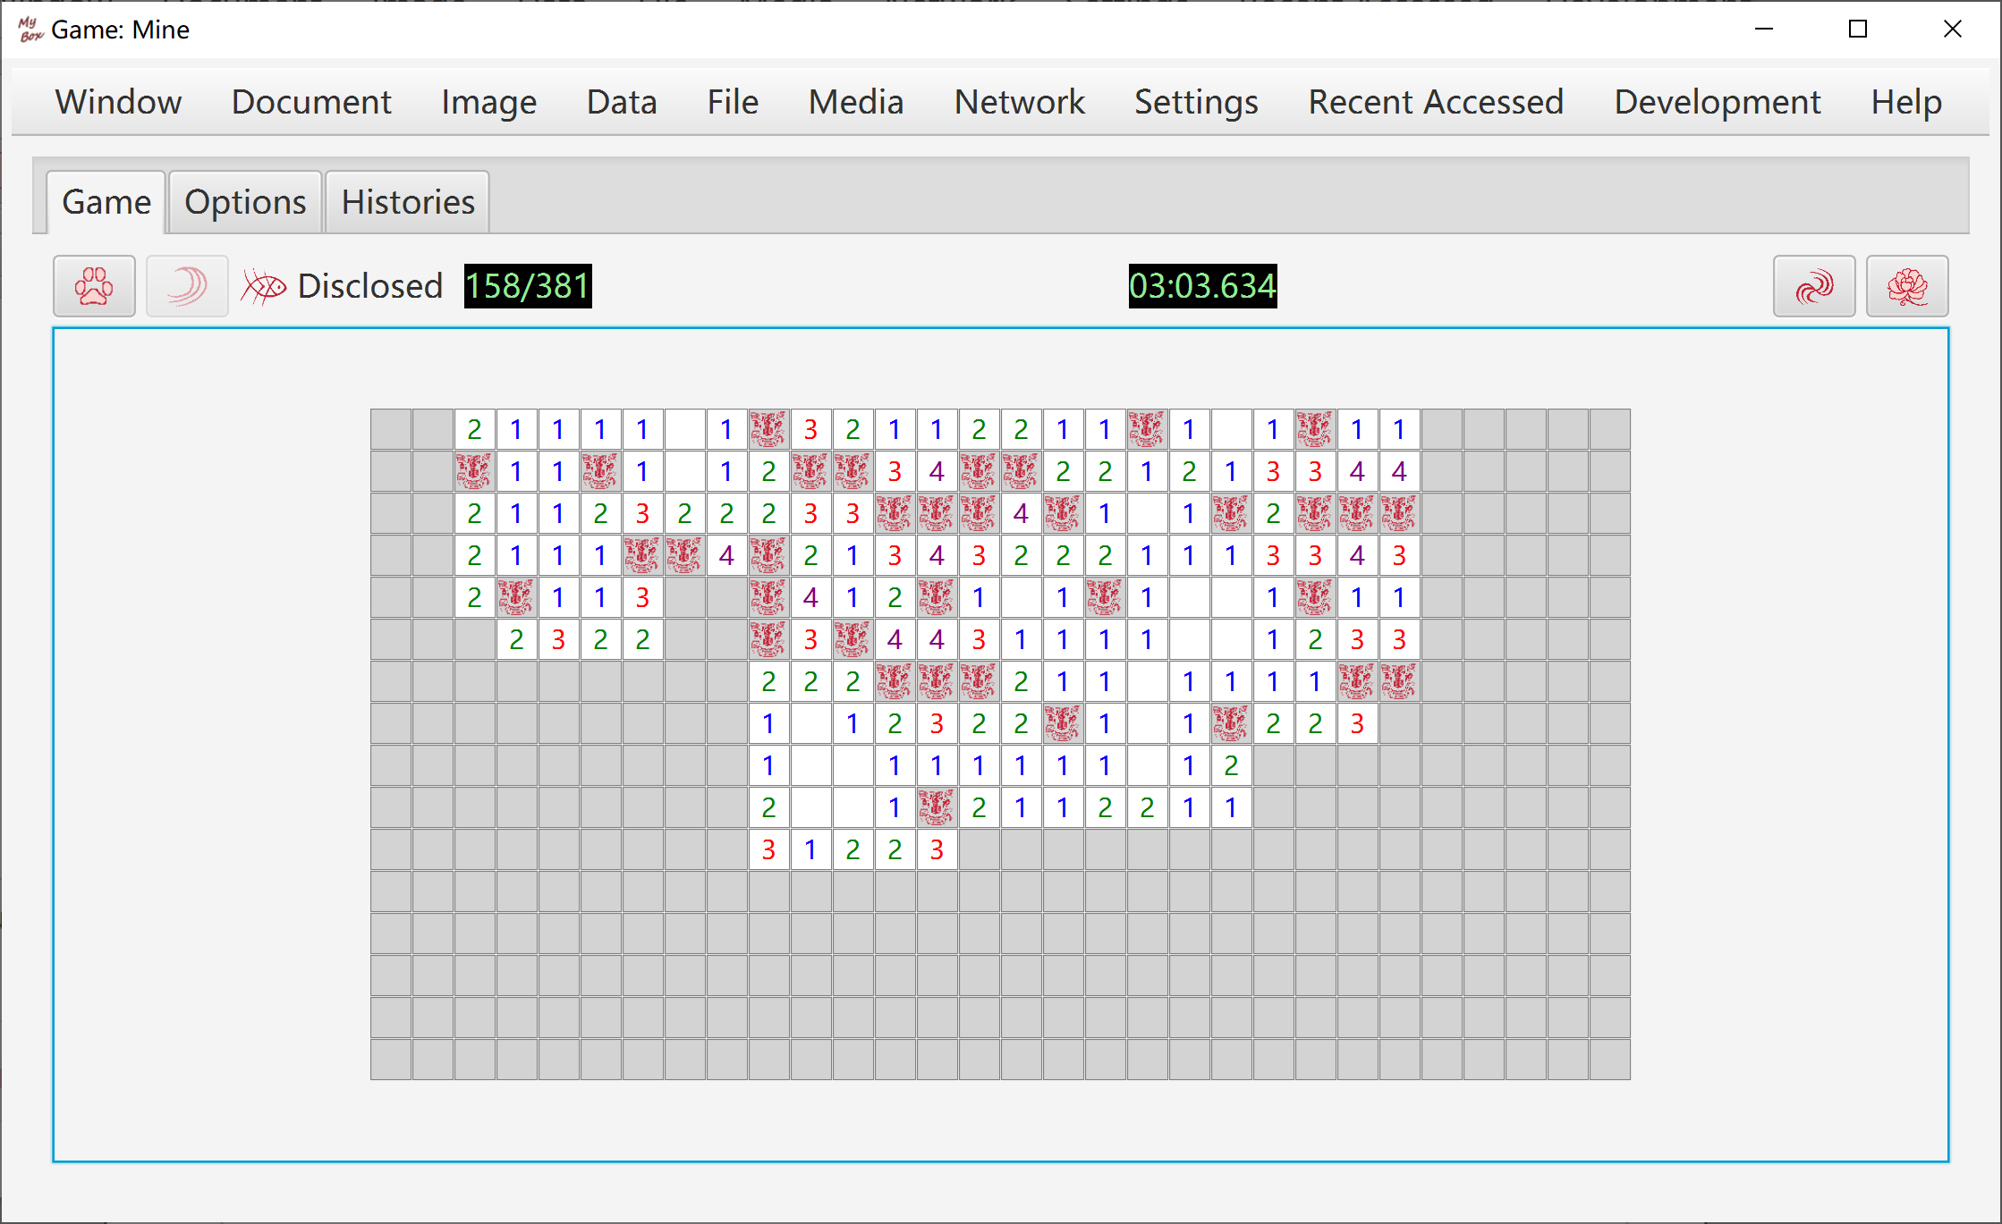

<End of Document>

