MyBox: Easy Tools Set
User Guide - Overview

Author: Mara
Version: 6.5.9
Date: 2022-8-29

Contents
1 Resource Addresses 3

Introduction
This is desktop application based on JavaFx to provide simple and easy functions. It's free and open sources.

Main Interface

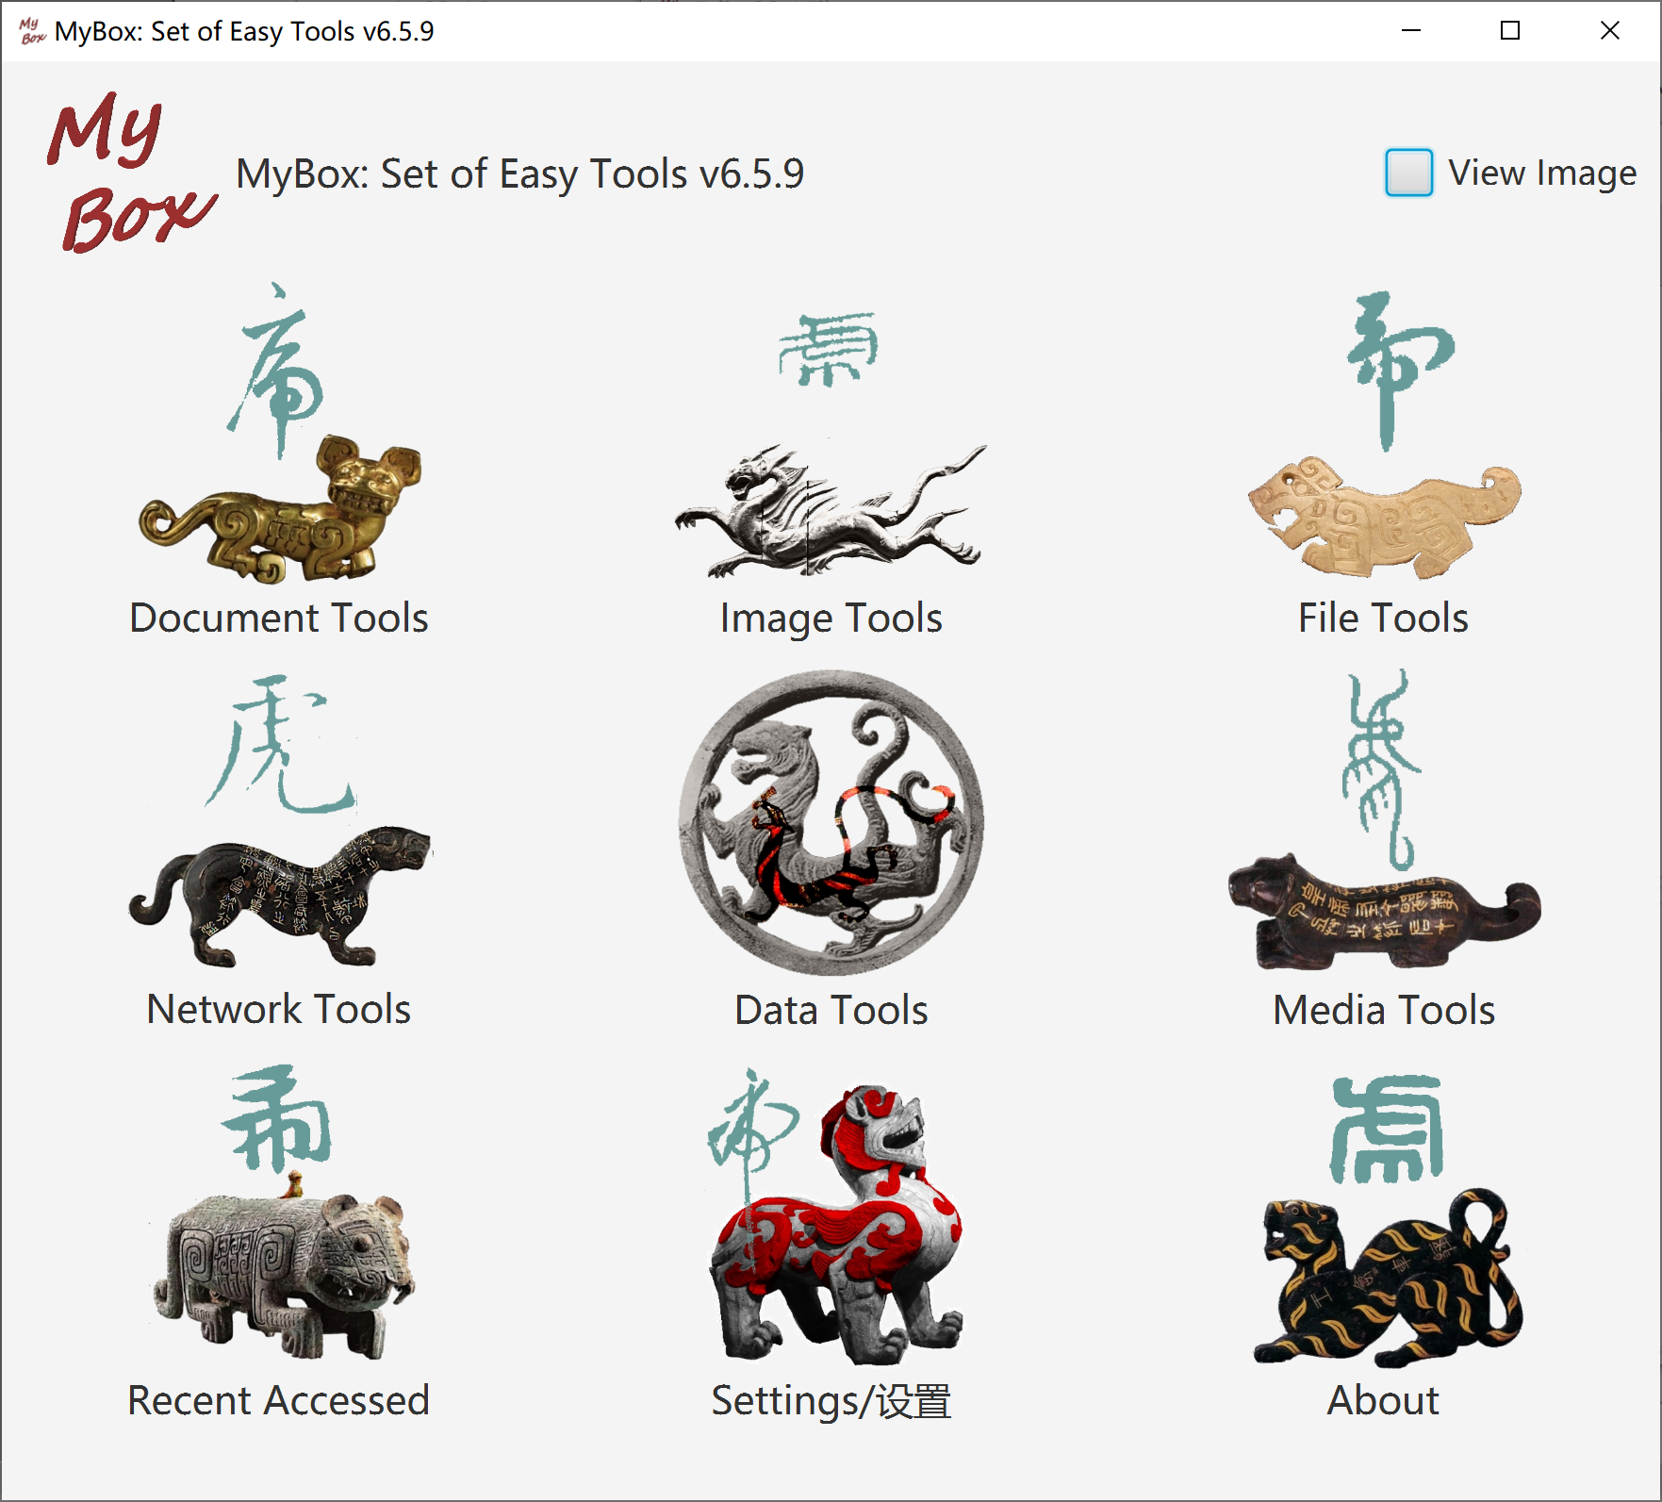

Resources Addresses

Contents | Link
Project Main Page | https://github.com/Mararsh/MyBox/
Source Codes and Compiled Packages | https://github.com/Mararsh/MyBox/releases
Submit Software Requirements and  Problem Reports | https://github.com/Mararsh/MyBox/issues
Data | https://github.com/Mararsh/MyBox_data
Documents | https://github.com/Mararsh/MyBox_documents
Mirror Site | https://sourceforge.net/projects/mara-mybox/files/
Cloud Storage | https://pan.baidu.com/s/1fWMRzym_jh075OCX0D8y8A#list/path=%2F

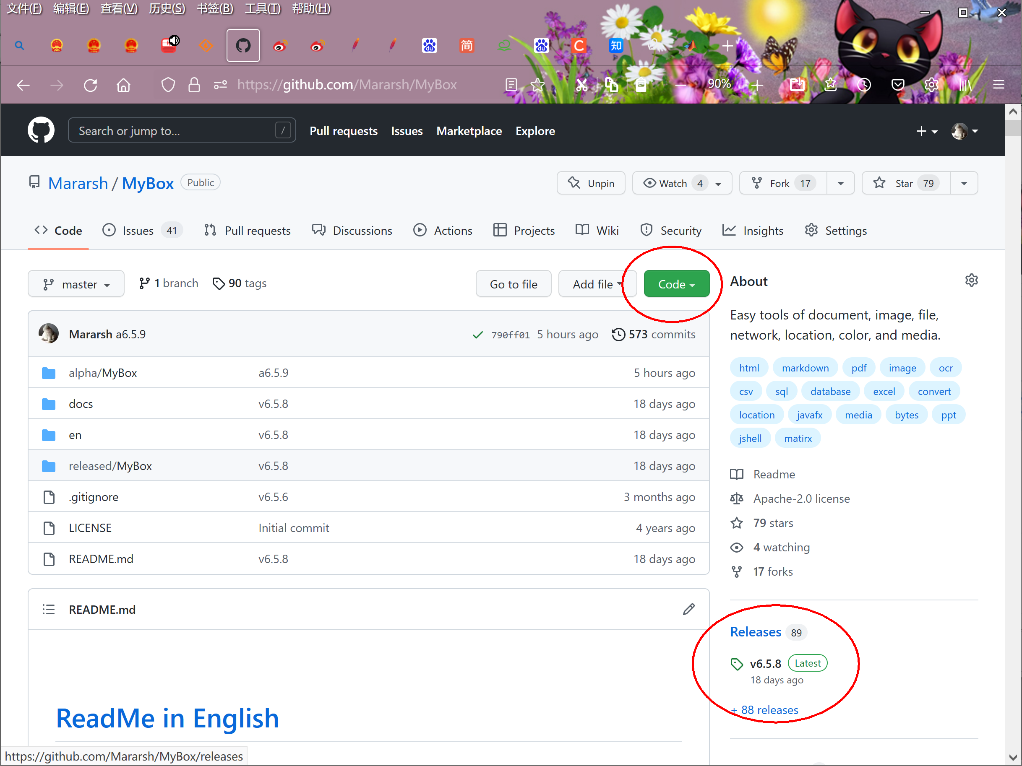

Documents

Name | Version | Time | Link
Development Logs | 6.5.9 | 2022-8-28 | html
Shortcuts | 6.5.6 | 2022-6-11 | html
Packing Steps | 6.3.3 | 2020-9-27 | html
Development Guide | 2.1 | 2022-8-28 | PDF
User Guide - Overview | 6.5.9 | 2022-8-29 | html PDF
User Guide – Document Tools | 6.5.9 | 2022-8-29 | html PDF
User Guide - Image Tools | 6.5.9 | 2022-8-29 | html PDF
User Guide - File Tools | 6.5.9 | 2022-8-29 | html PDF
User Guide - Network Tools | 6.5.9 | 2022-8-29 | html PDF
User Guide - Data Tools | 6.5.9 | 2022-8-29 | html PDF
User Guide - Media Tools | 6.5.9 | 2022-8-29 | html PDF
User Guide - Development Tools | 6.5.9 | 2022-8-29 | html PDF

Menu of Tools

<End of Document>

