

MyBox: Easy Tools Set
User Guide – File Tools

Author: Mara
Version: 6.5.9
Date: 2022-8-31

Contents
1 Introduction 3
1.1 Main Interface 3
1.2 Resources Addresses 4
1.3 Documents 5
1.4 Menu of Tools 5
2 Arrange Files 6
3 Sychronize Directories 7
4 Archive/Compress 8
5 Decompress/Unarchive 9
6 Cut File 10
7 Merge Files 10
8 Find Files 11
9 Check Redundant Files 12
10 Compare Files(bytes) 13
11 Rename Files 14
12 Copy Files/Directories 15
13 Move Files/Directories 15
14 Delete Files/Directories 16
15 Delete Empty Directories 16
16 Delete Files under Java IO Temporary Path 16
17 Delete Nested Directories 17

Introduction
This is desktop application based on JavaFx to provide simple and easy functions. It's free and open sources.

Main Interface



Resources Addresses

Contents | Link
Project Main Page | https://github.com/Mararsh/MyBox/
Source Codes and Compiled Packages | https://github.com/Mararsh/MyBox/releases
Submit Software Requirements and  Problem Reports | https://github.com/Mararsh/MyBox/issues
Data | https://github.com/Mararsh/MyBox_data
Documents | https://github.com/Mararsh/MyBox_documents
Mirror Site | https://sourceforge.net/projects/mara-mybox/files/
Cloud Storage | https://pan.baidu.com/s/1fWMRzym_jh075OCX0D8y8A#list/path=%2F



Documents

Name | Version | Time | English | Chinese
Development Logs | 6.5.9 | 2022-8-31 | html | html
Shortcuts | 6.5.6 | 2022-6-11 | html | html
Packing Steps | 6.3.3 | 2020-9-27 | html | html
Development Guide | 2.1 | 2020-8-27 | PDF | PDF
User Guide - Overview | 6.5.9 | 2022-8-31 | html PDF odt | html PDF odt
User Guide – Document Tools | 6.5.9 | 2022-8-31 | html PDF odt | html PDF odt
User Guide - Image Tools | 6.5.9 | 2022-8-31 | html PDF odt | html PDF odt
User Guide - File Tools | 6.5.9 | 2022-8-31 | html PDF odt | html PDF odt
User Guide - Network Tools | 6.5.9 | 2022-8-31 | html PDF odt | html PDF odt
User Guide - Data Tools | 6.5.9 | 2022-8-31 | html PDF odt | html PDF odt
User Guide - Media Tools | 6.5.9 | 2022-8-31 | html PDF odt | html PDF odt
User Guide - Development Tools | 6.5.9 | 2022-8-31 | html PDF odt | html PDF odt

Menu of Tools
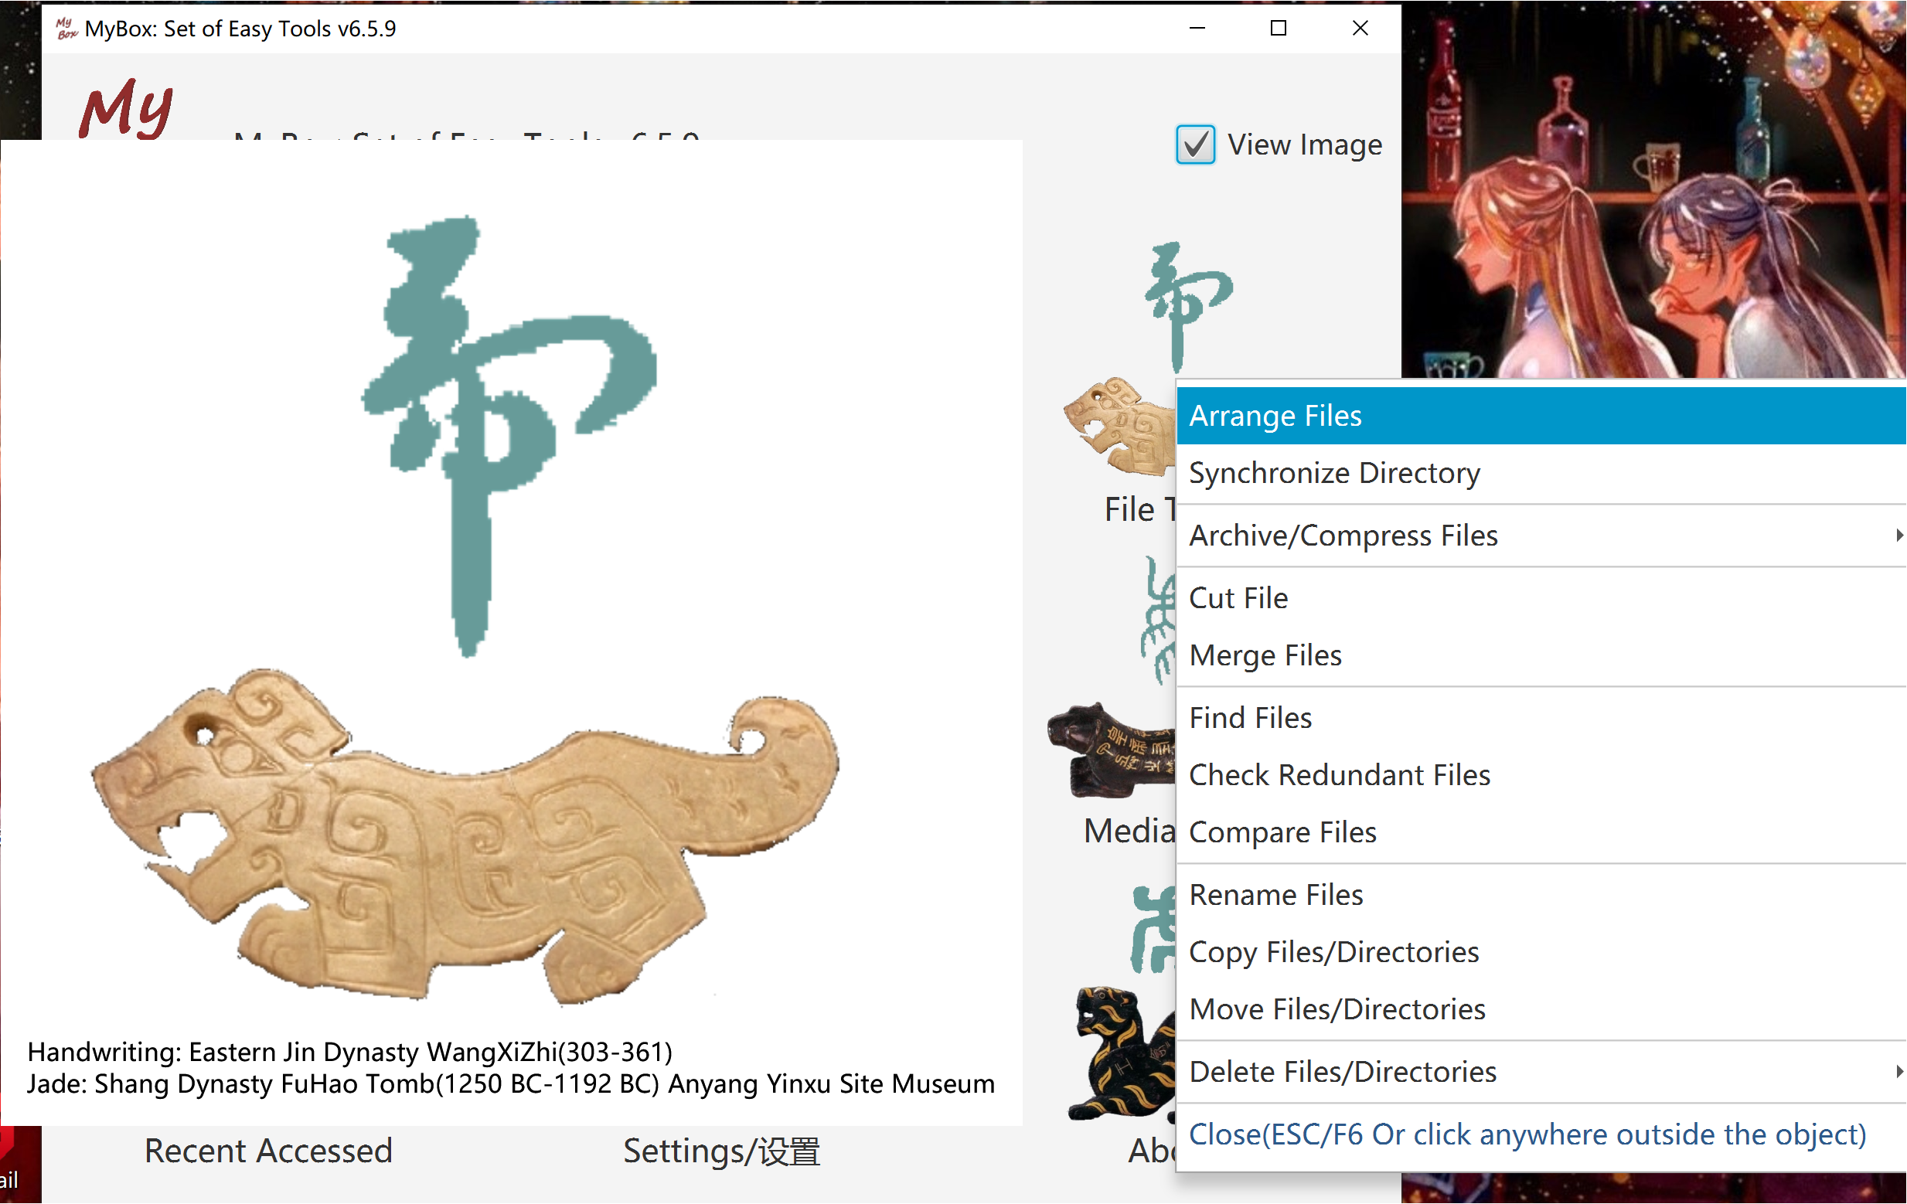

Arrange Files
Reorganize files under new directories by modifed time.
This tool can be used to handle lots of files which need be archived according to time, like photoes, screenshots of games, or system logs.

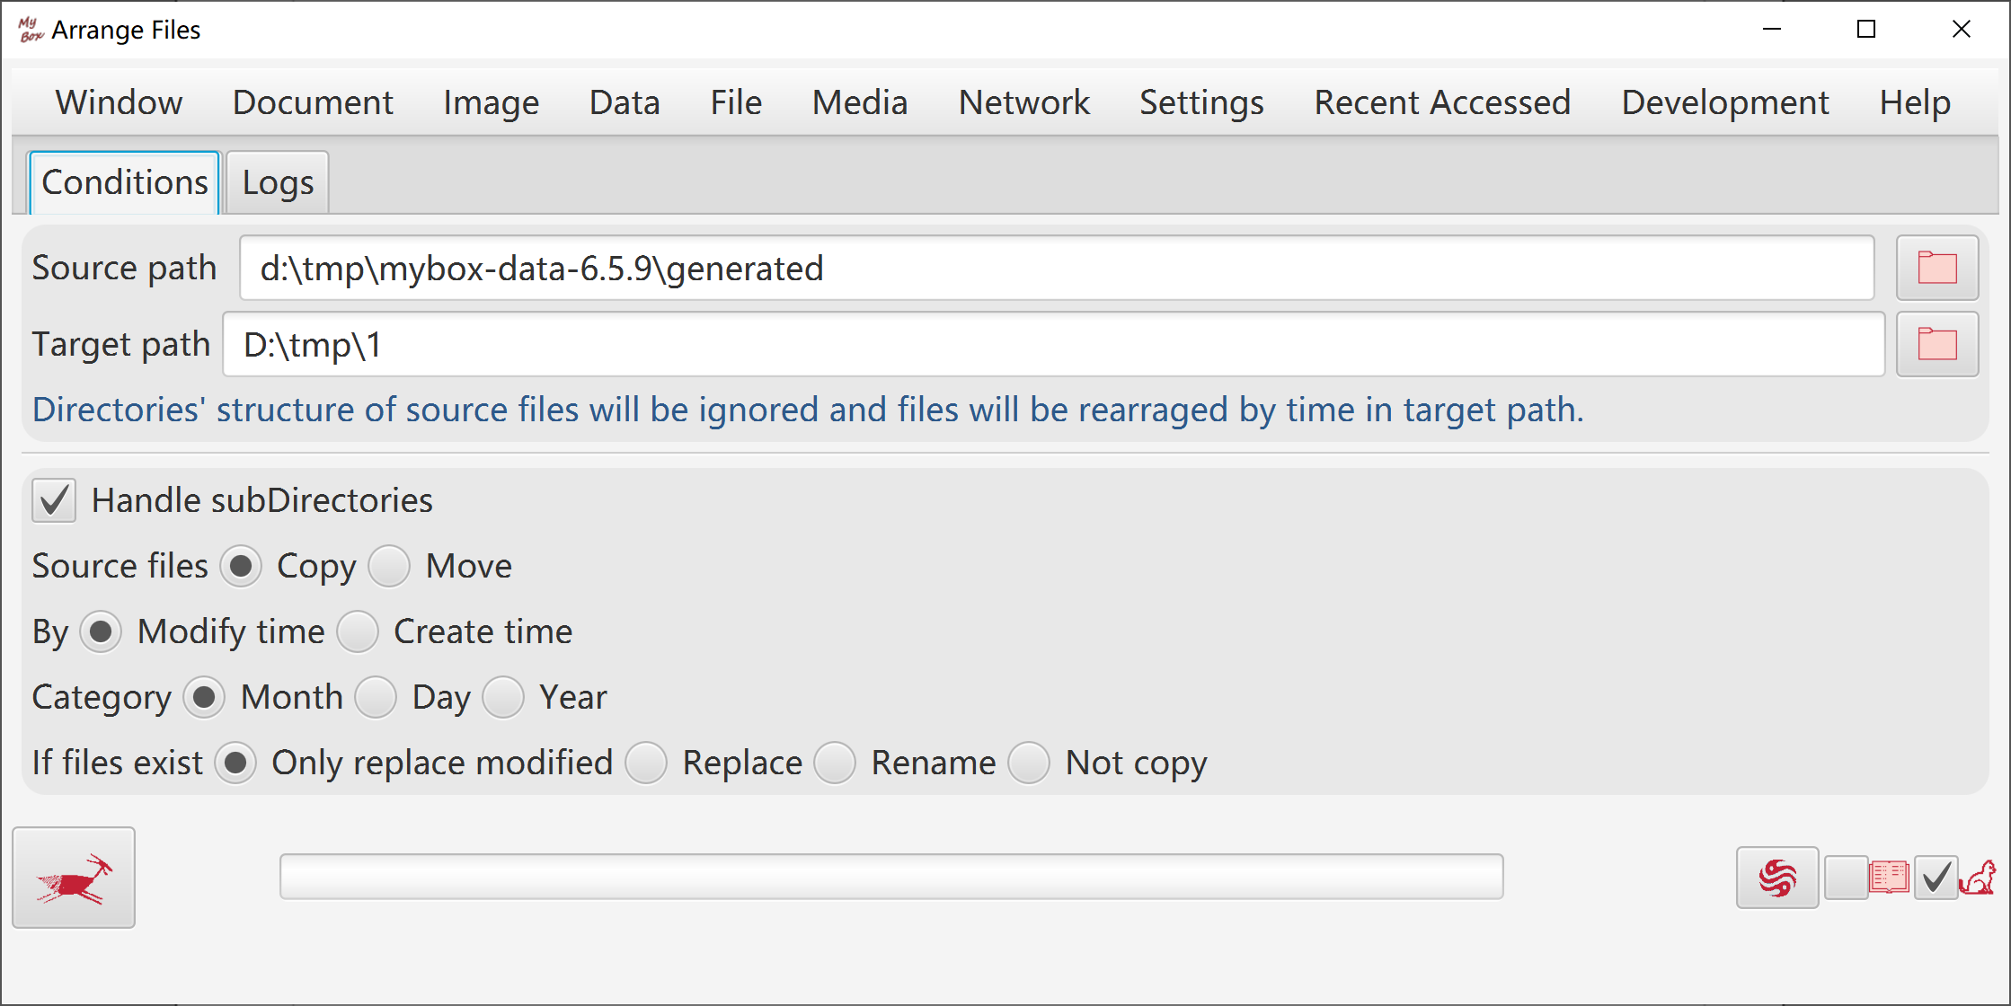

Sychronize Directories
Options like:
  - Whether copy sub-directories or new files.
  - Whether only copy modified files after specific date time.
  - Whether keep attributes of original files.
  - Whether delete non-existed files/directories under original directory.

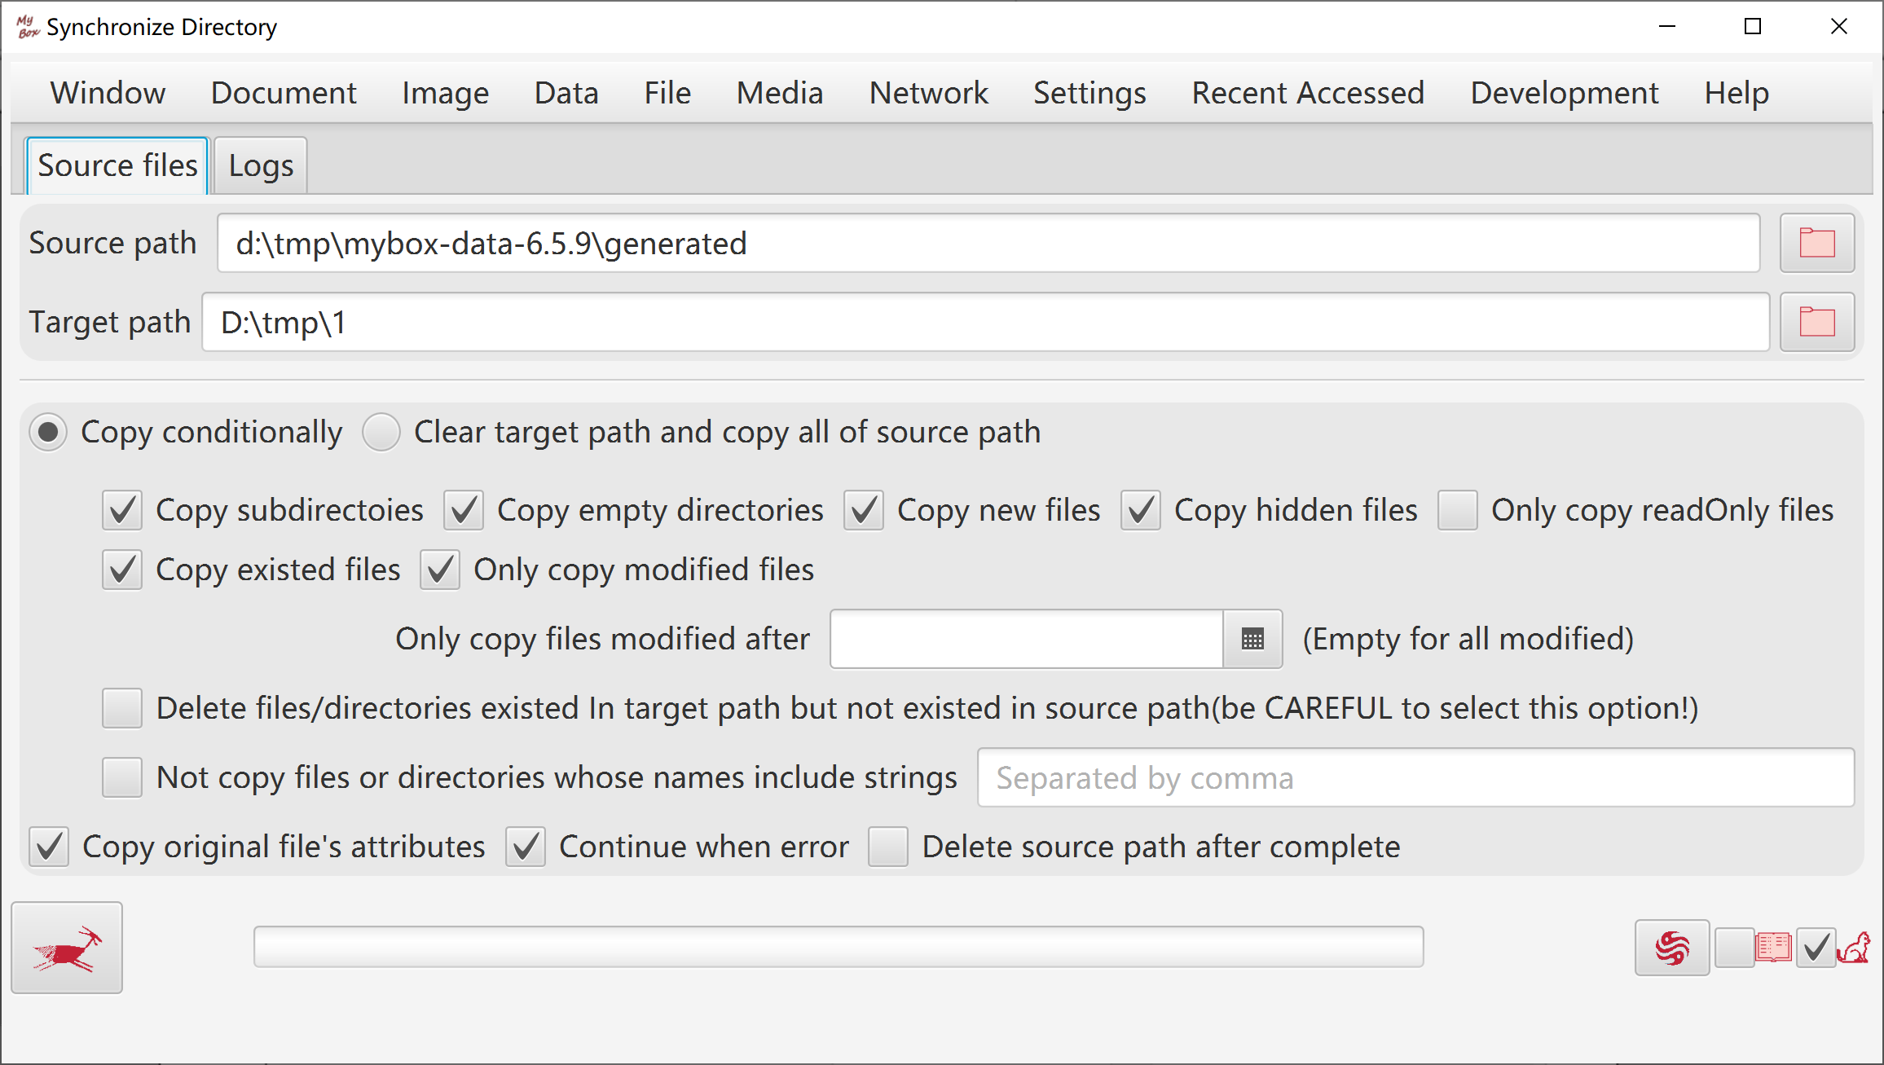

Archive/Compress
- Archiving is the process to collect multiple files/directories as single file. Some archive formats like zip and 7z implement compression too.
- Compressing is the process to reduce size of single file. Generally it happens after archiving.
- Supported archive formats include zip, tar, 7z(Only support some algorithms), ar, cpio.
- Supported compress formats include gzip, bzip2, xz, lzma, Pack200, DEFLATE, snappy-framed, lz4-block, lz4-framed.

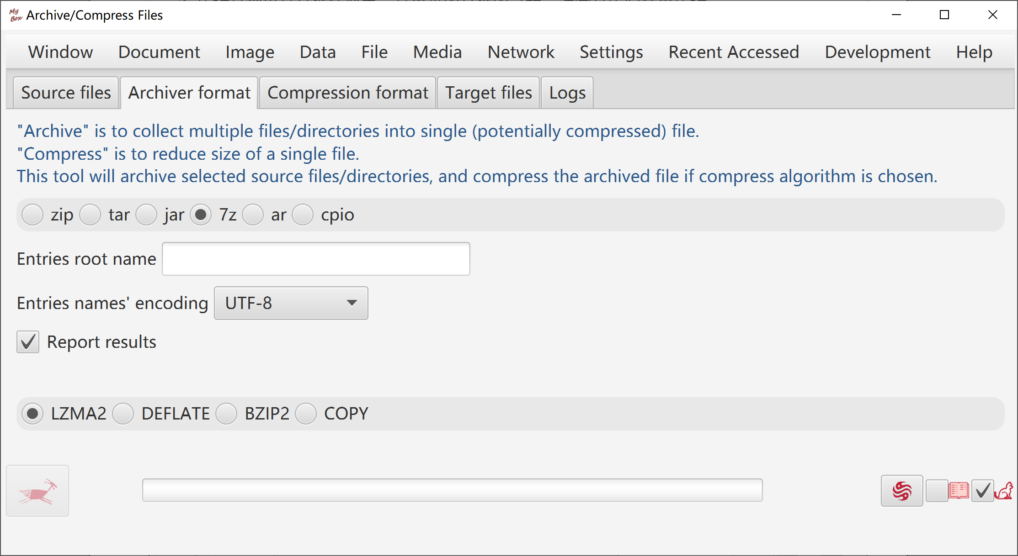
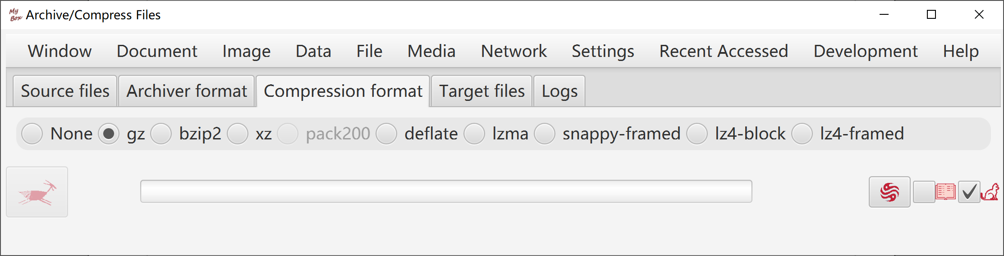

Decompress/Unarchive
- Unarchiving is the process to restore an archived file to original files and directories.
- Decompressing is the process to restore a compressed file to original file.
- Supported unarchive formats include zip, tar, 7z(Only support some algorithms), ar, cpio, arj, dump.
- Supported decompress formats include gzip, bzip2, xz, lzma, Pack200, DEFLATE, snappy-framed, lz4-block, lz4-framed, DEFLATE64, Z.
- When unarchive/decompress, the formats can be defected automatically meanwhile user can choice the formats since some formats can not be defected.
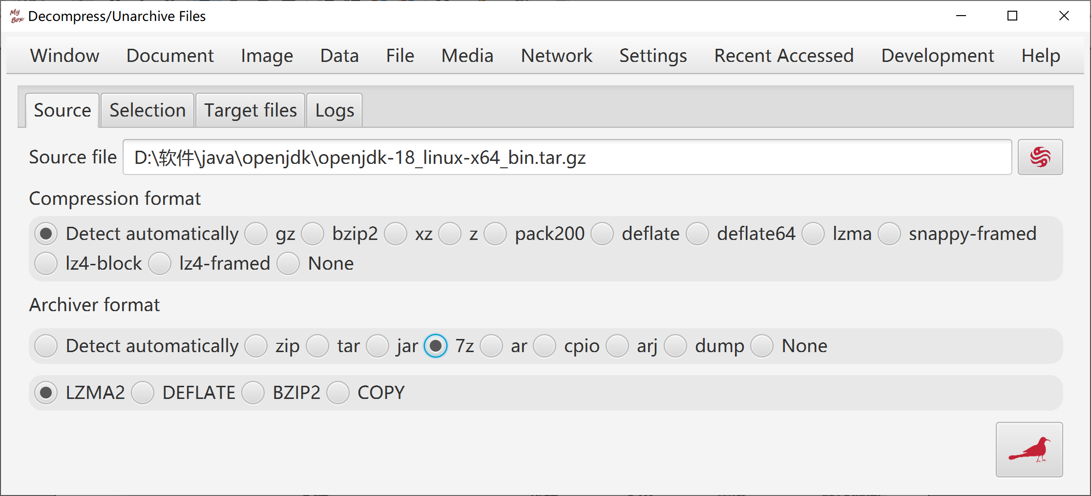
- When unarchive, files tree is displayed to help user select which to be extracted.

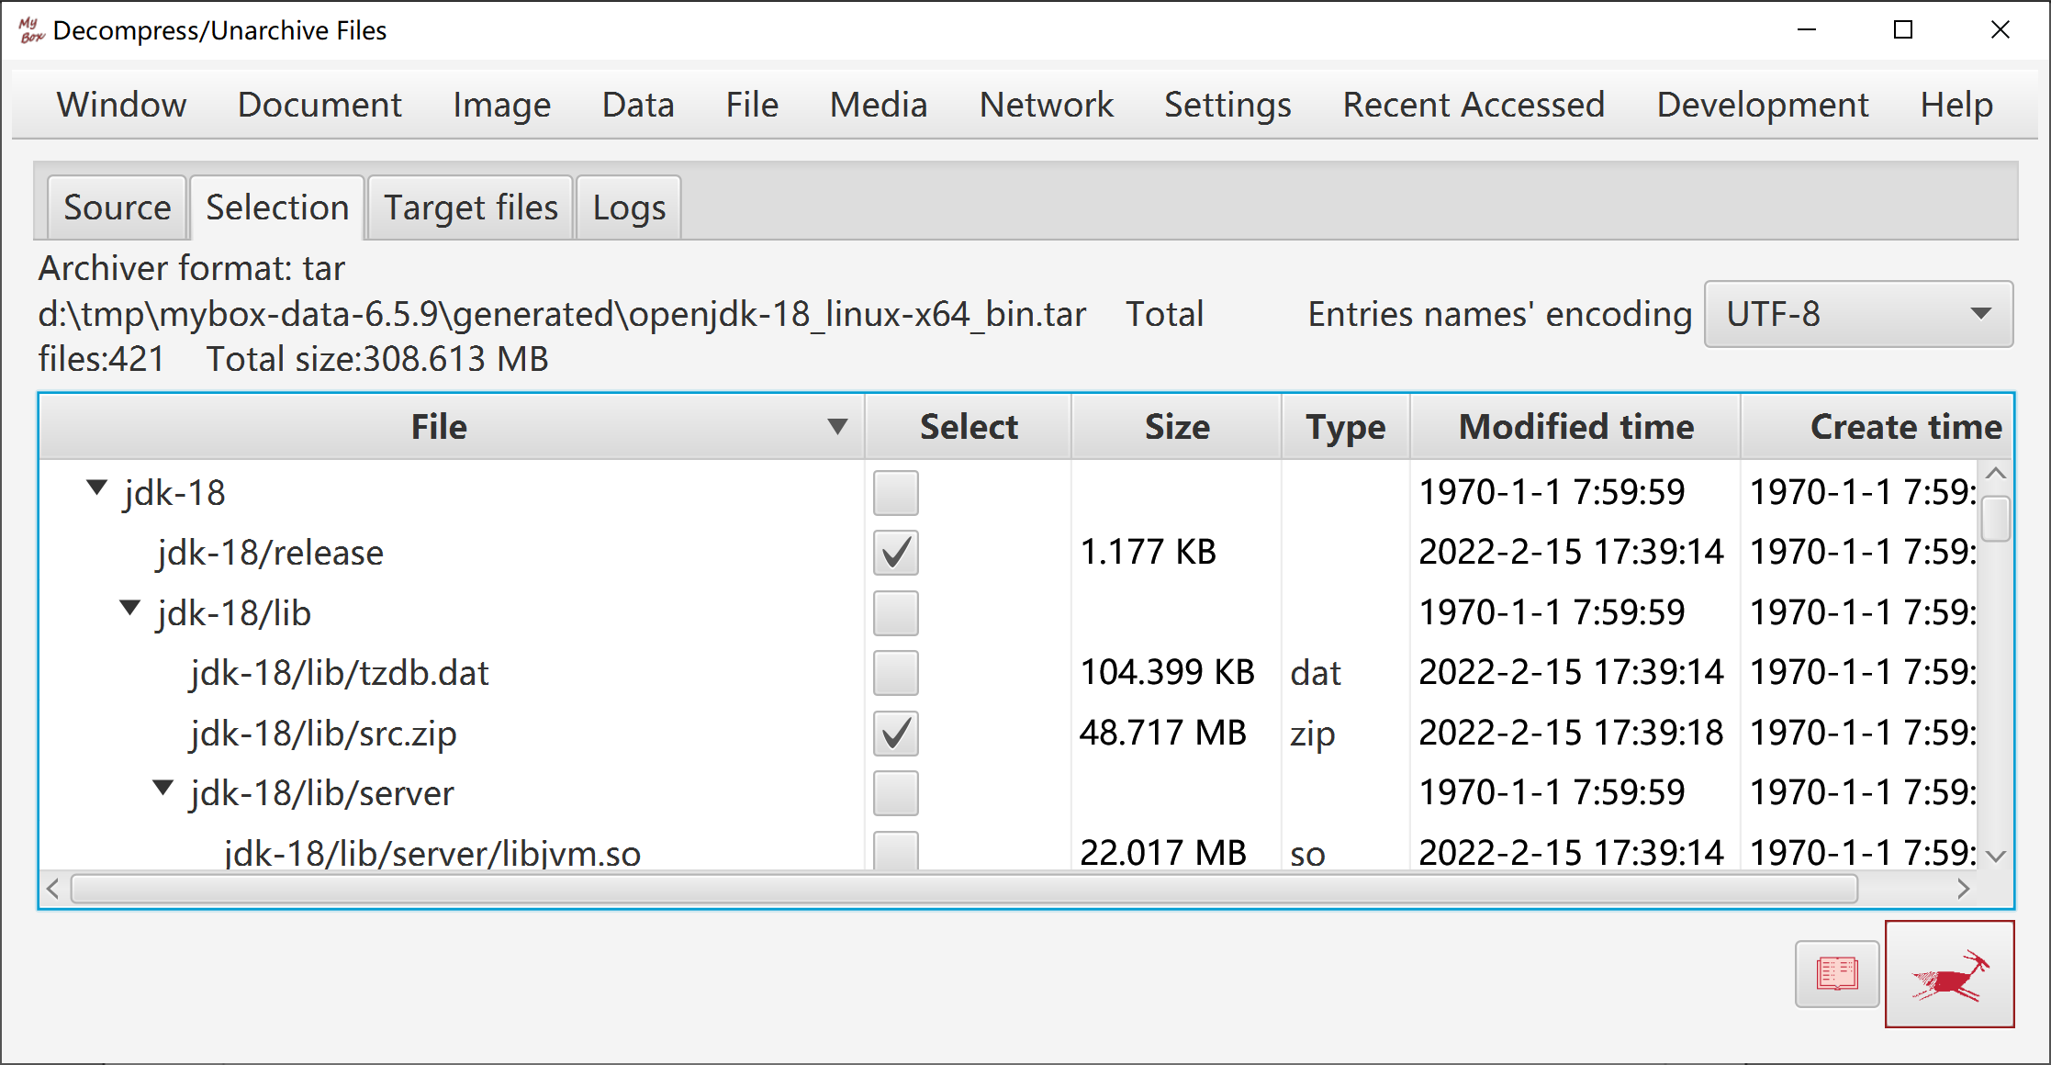

Cut File
- By files number
- By bytes number
- By start-end list

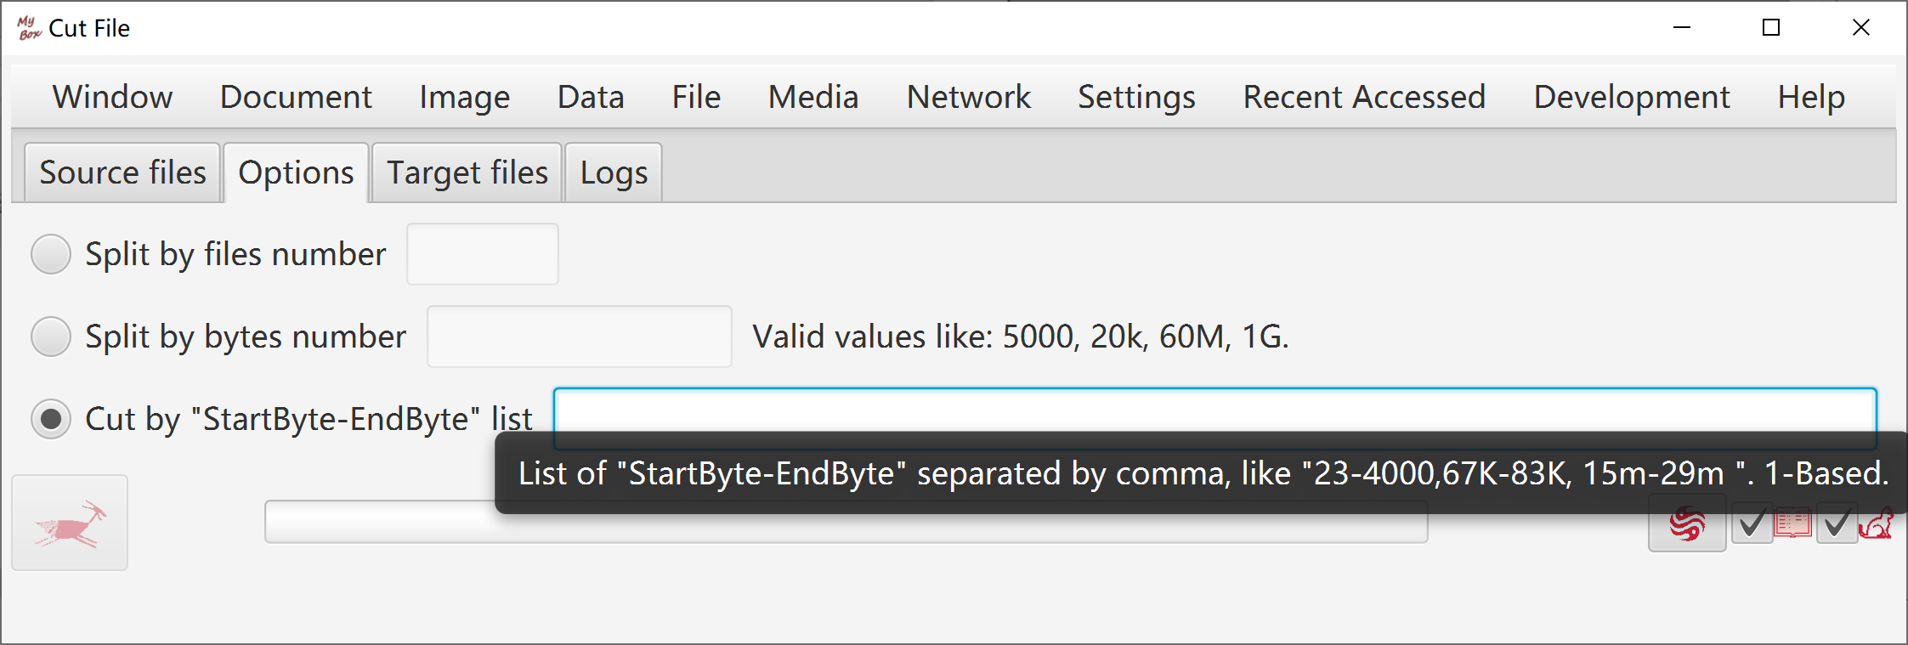

Merge Files
Combine bytes of multiple files into one file.

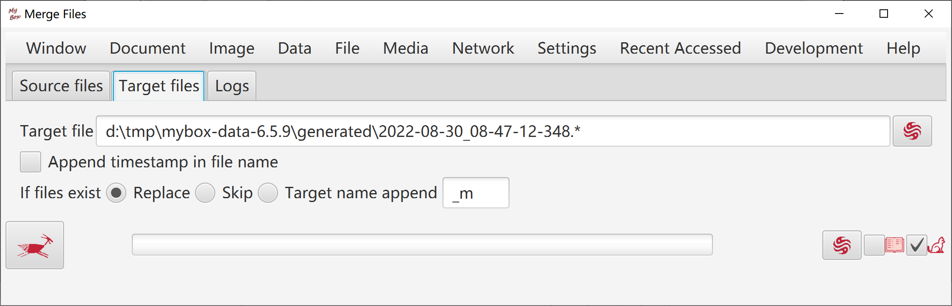

Find Files

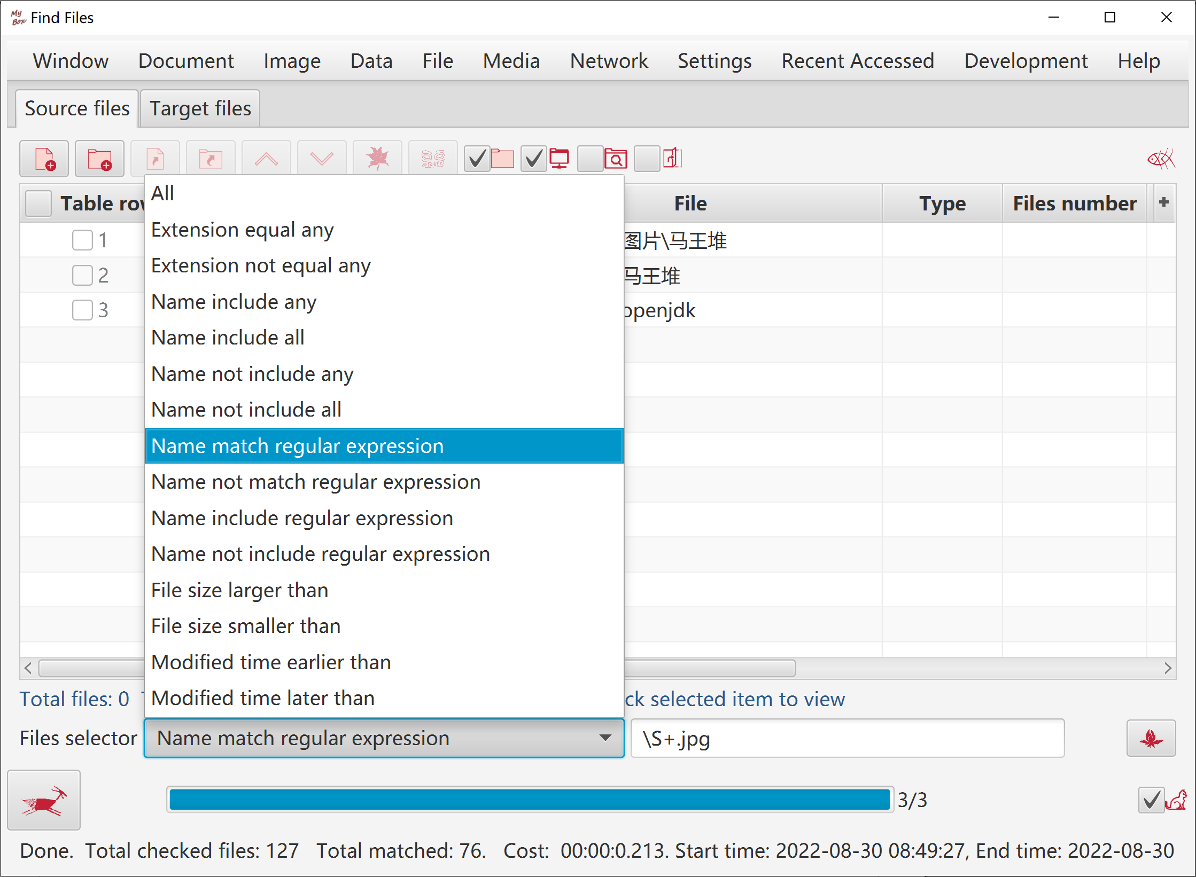

Check Redundant Files
- Find duplicated files according to MD5.
- Files tree is displayed to help user delete redundant files.
- Deletion can be executed while checking is running.

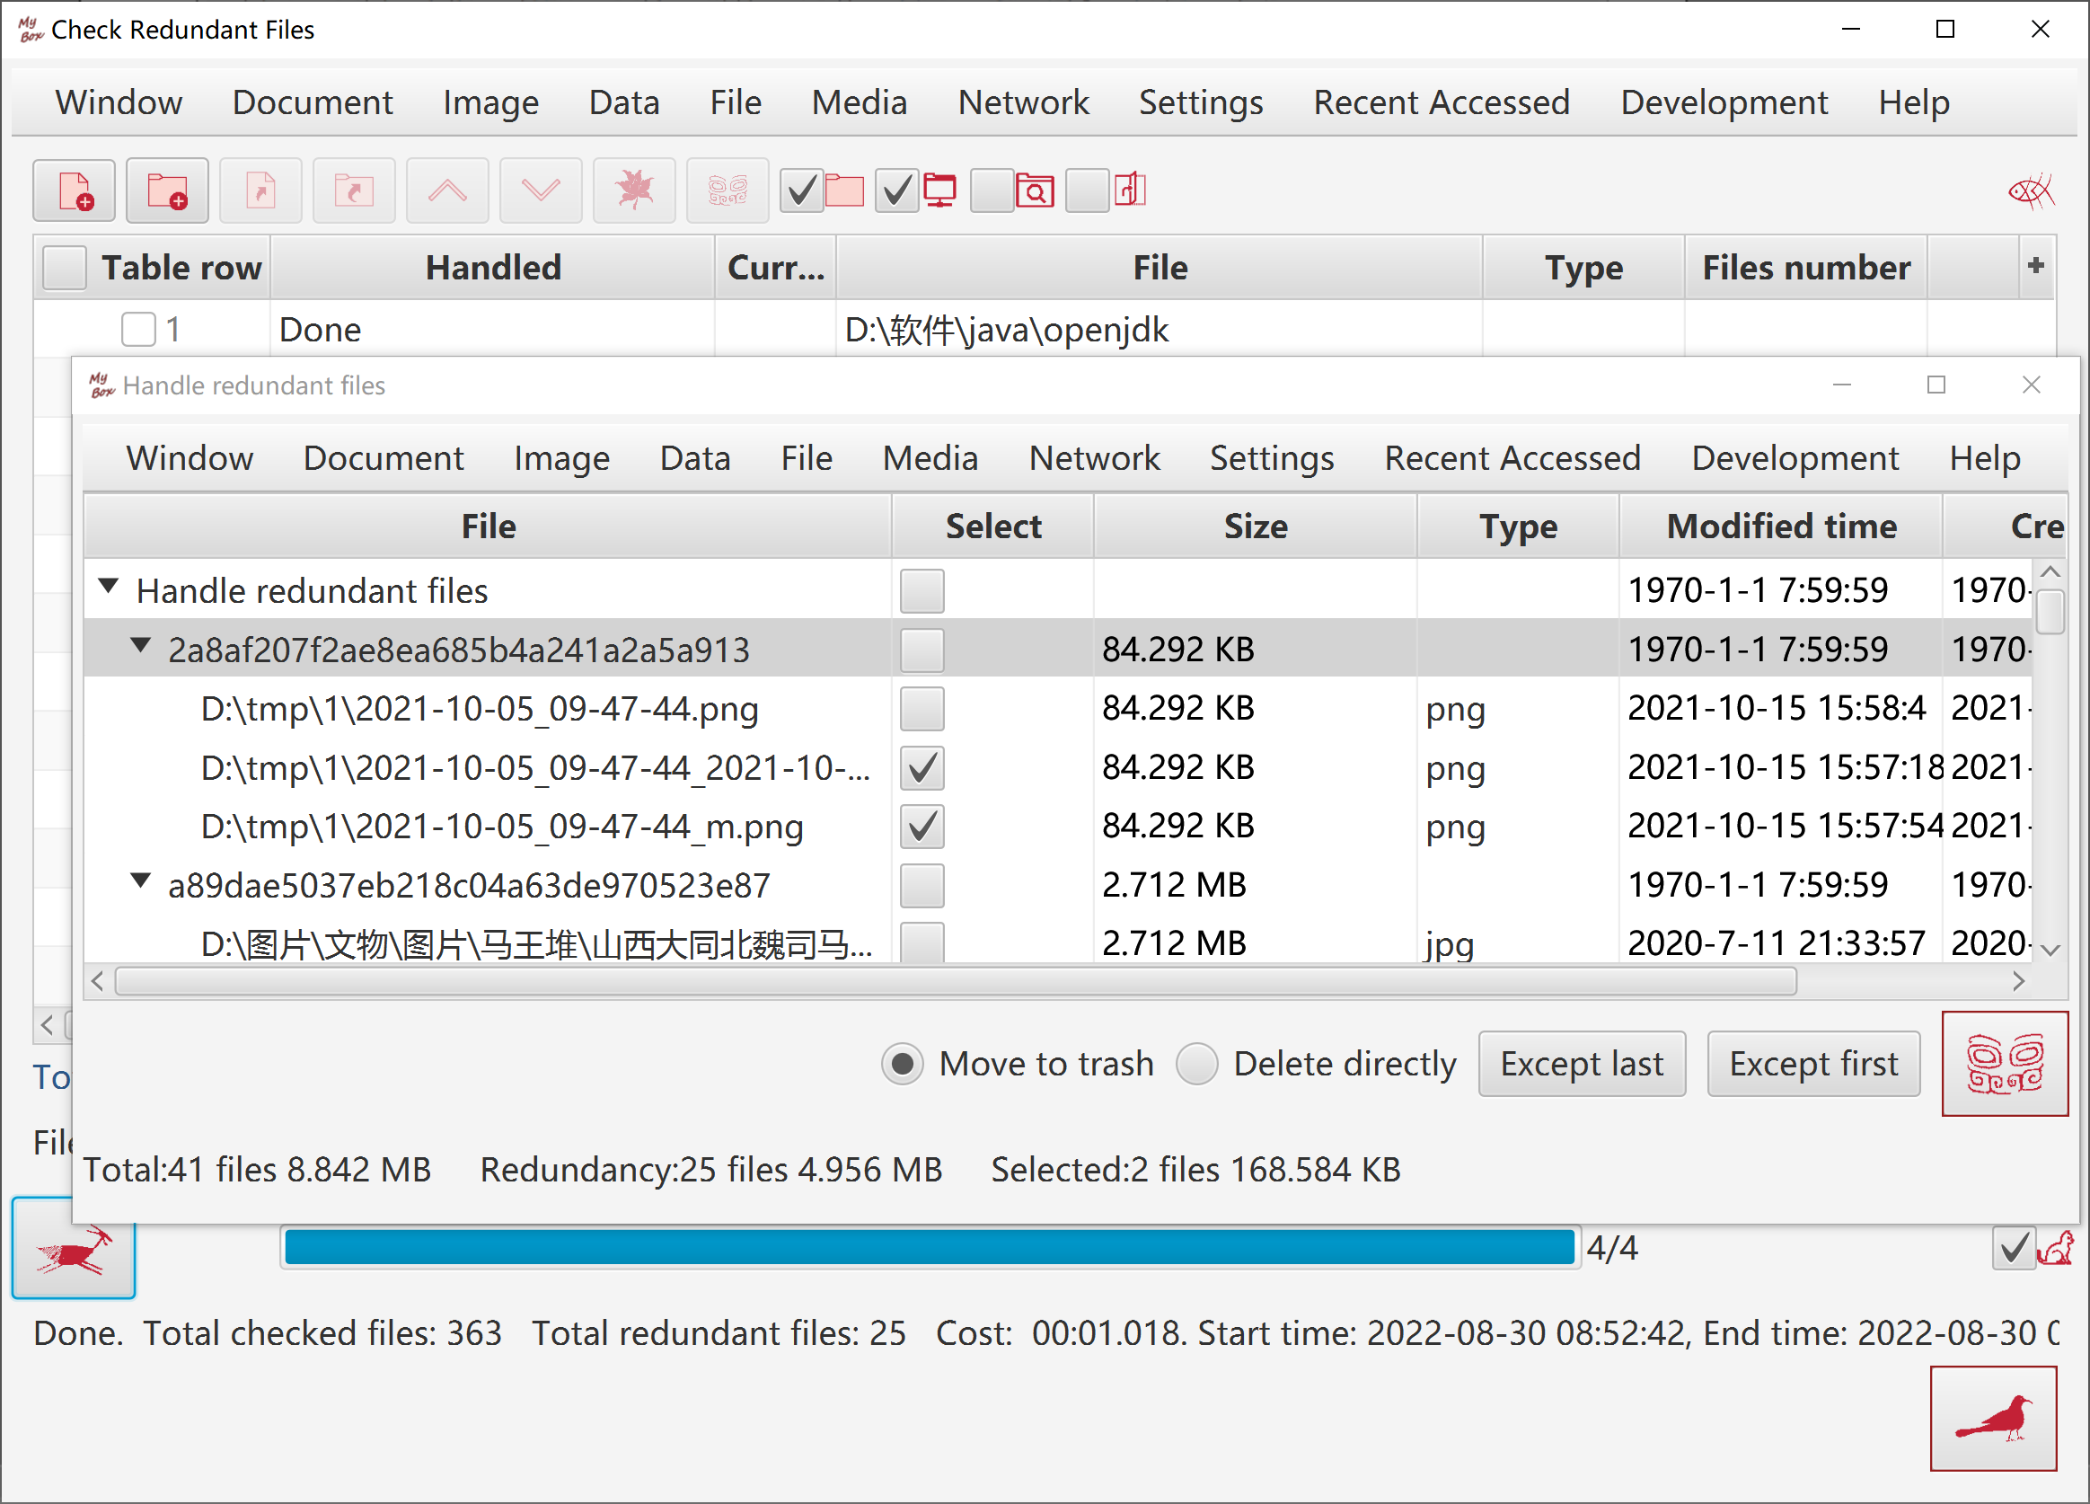

Compare Files(bytes)

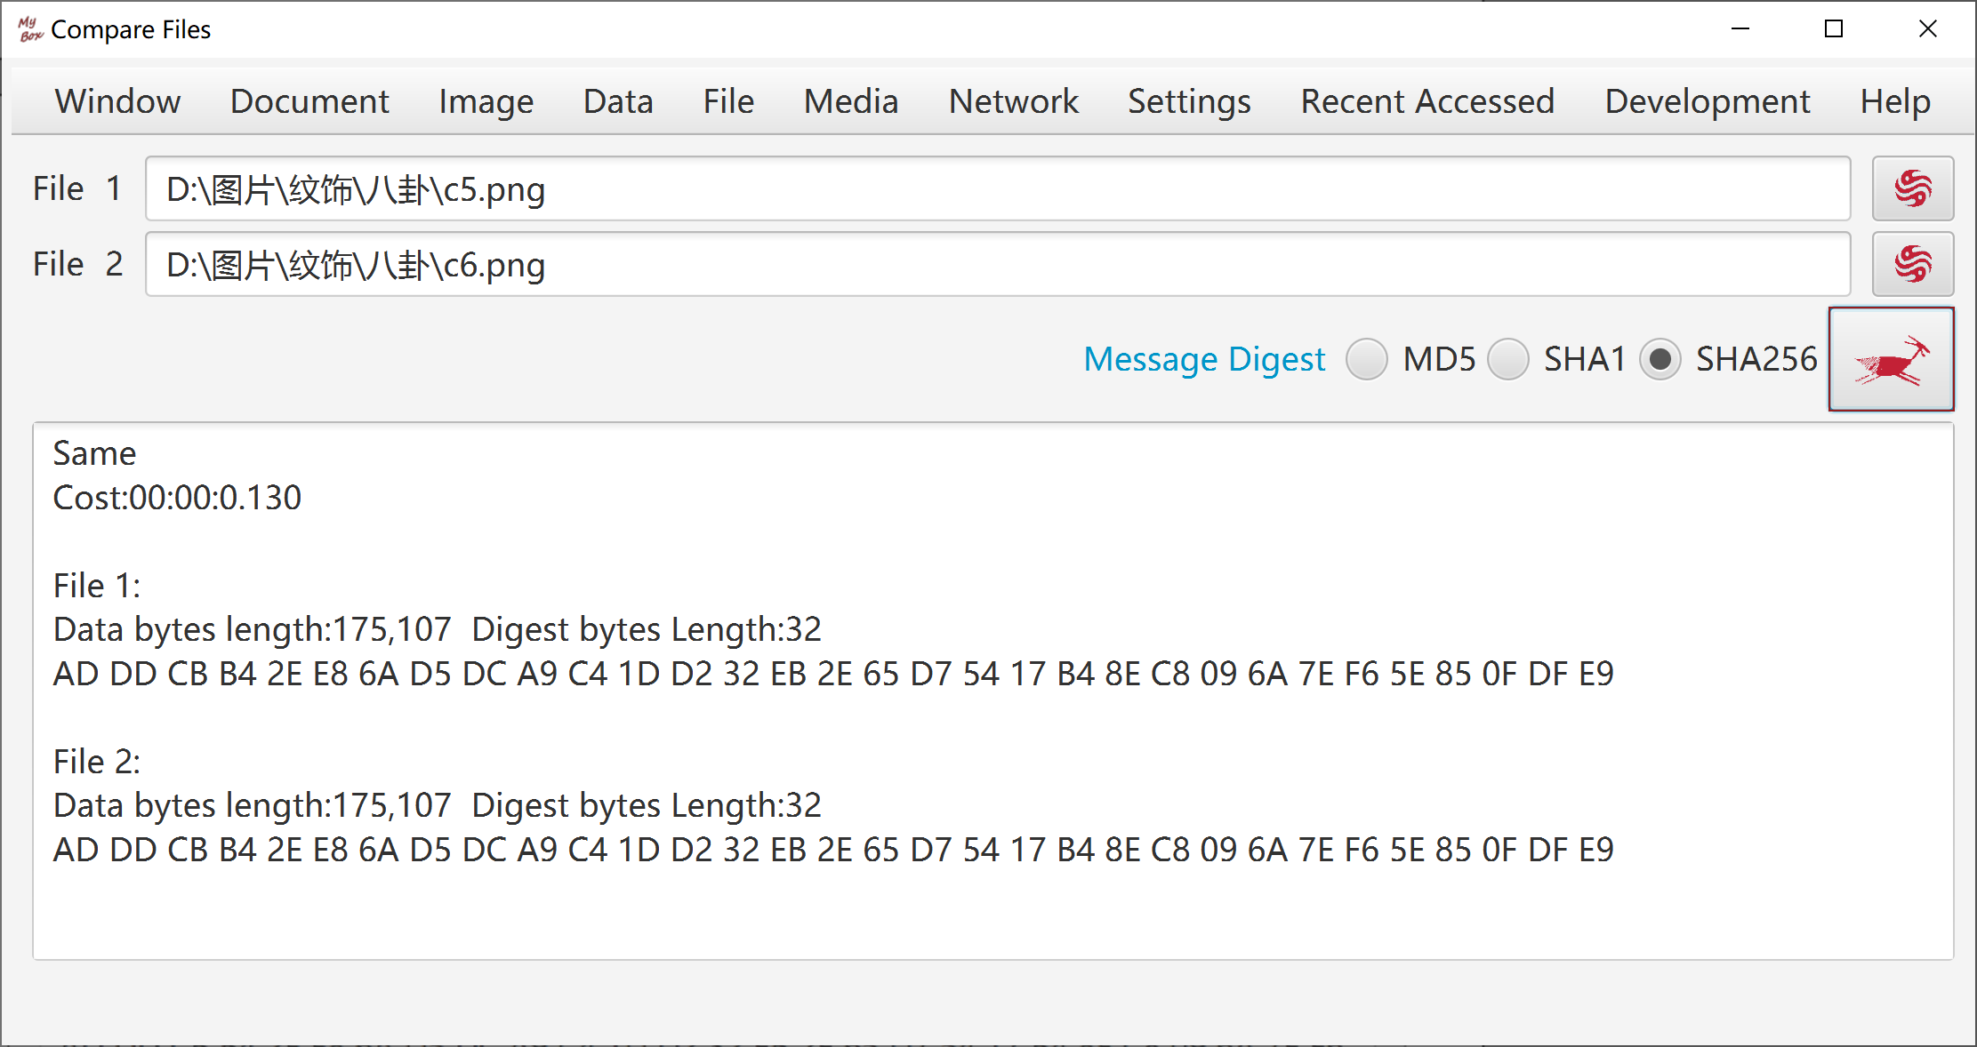

Rename Files

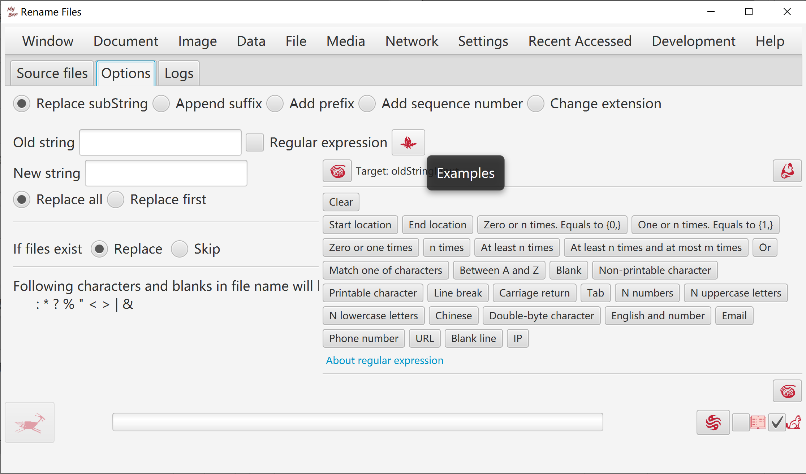
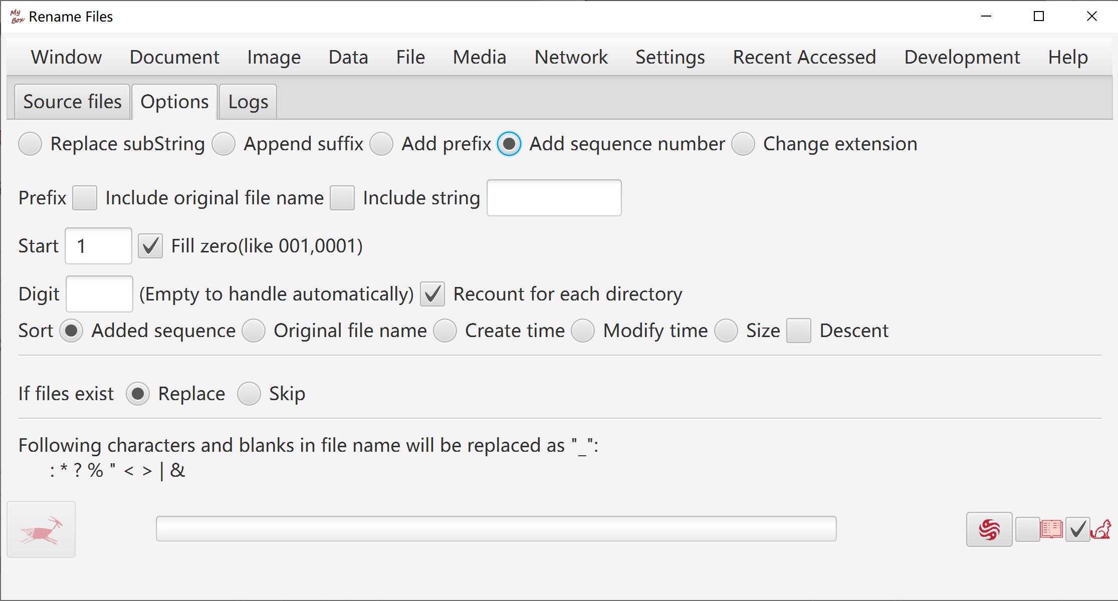

Copy Files/Directories

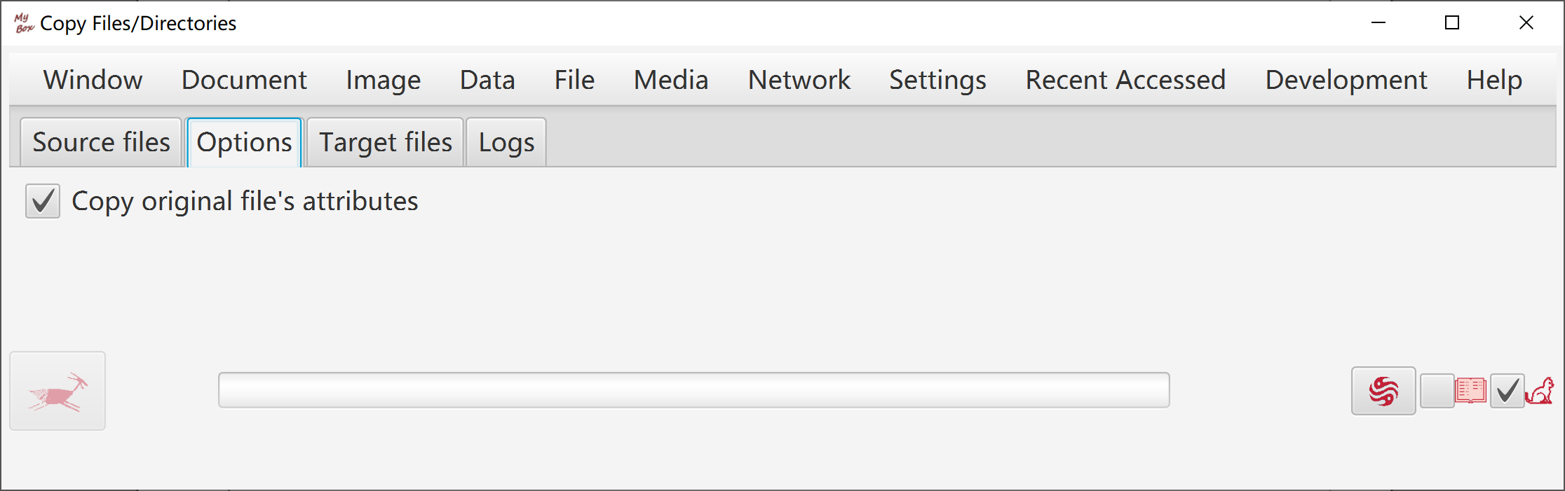

Move Files/Directories

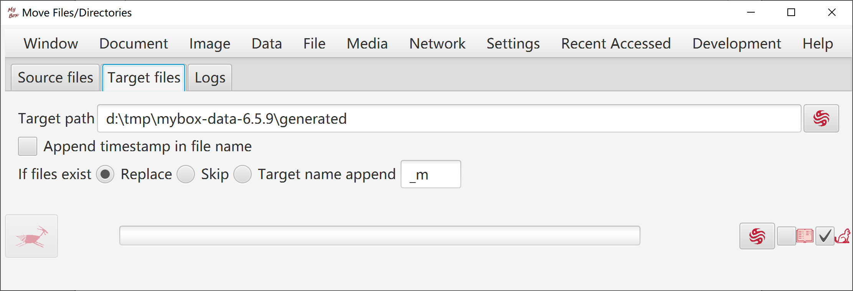

Delete Files/Directories

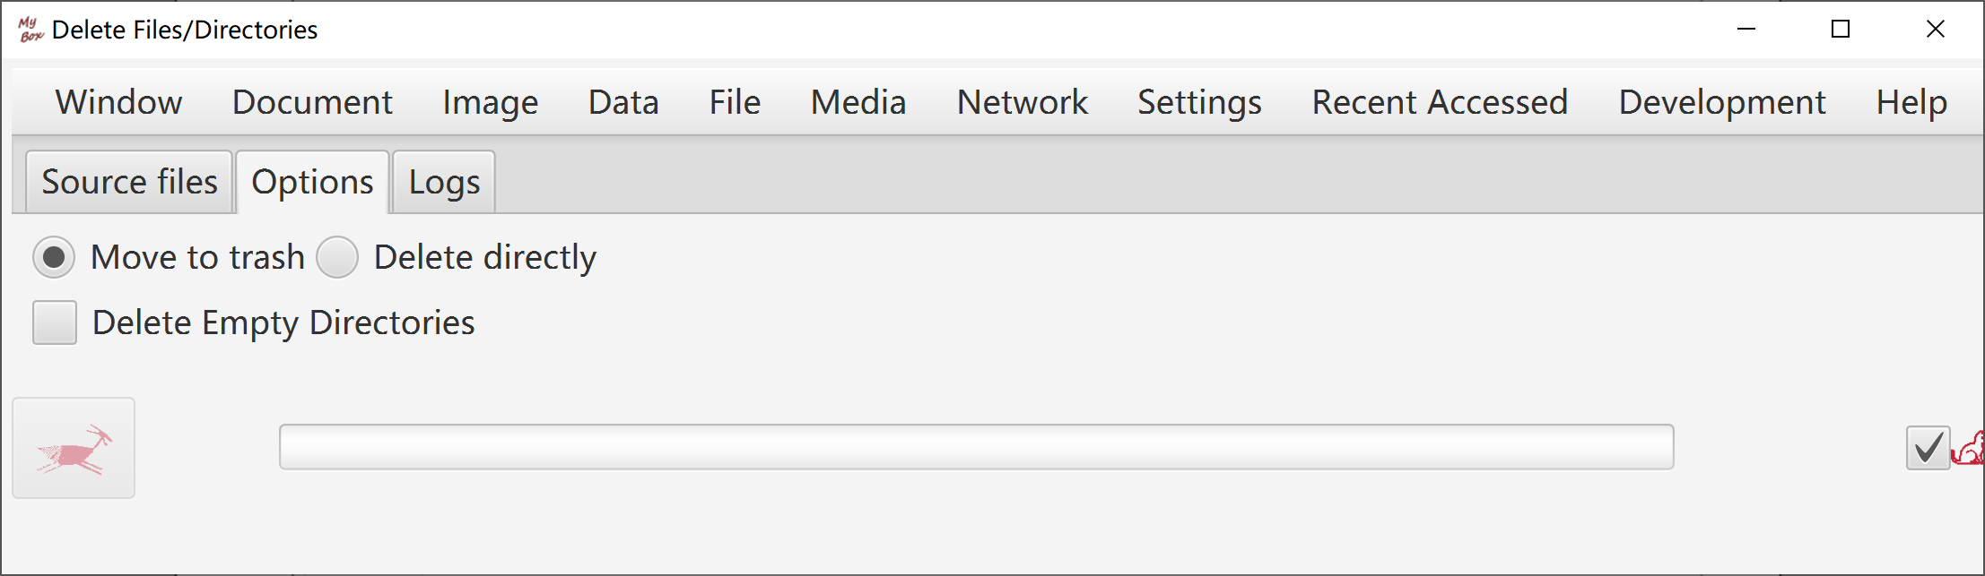

Delete Empty Directories

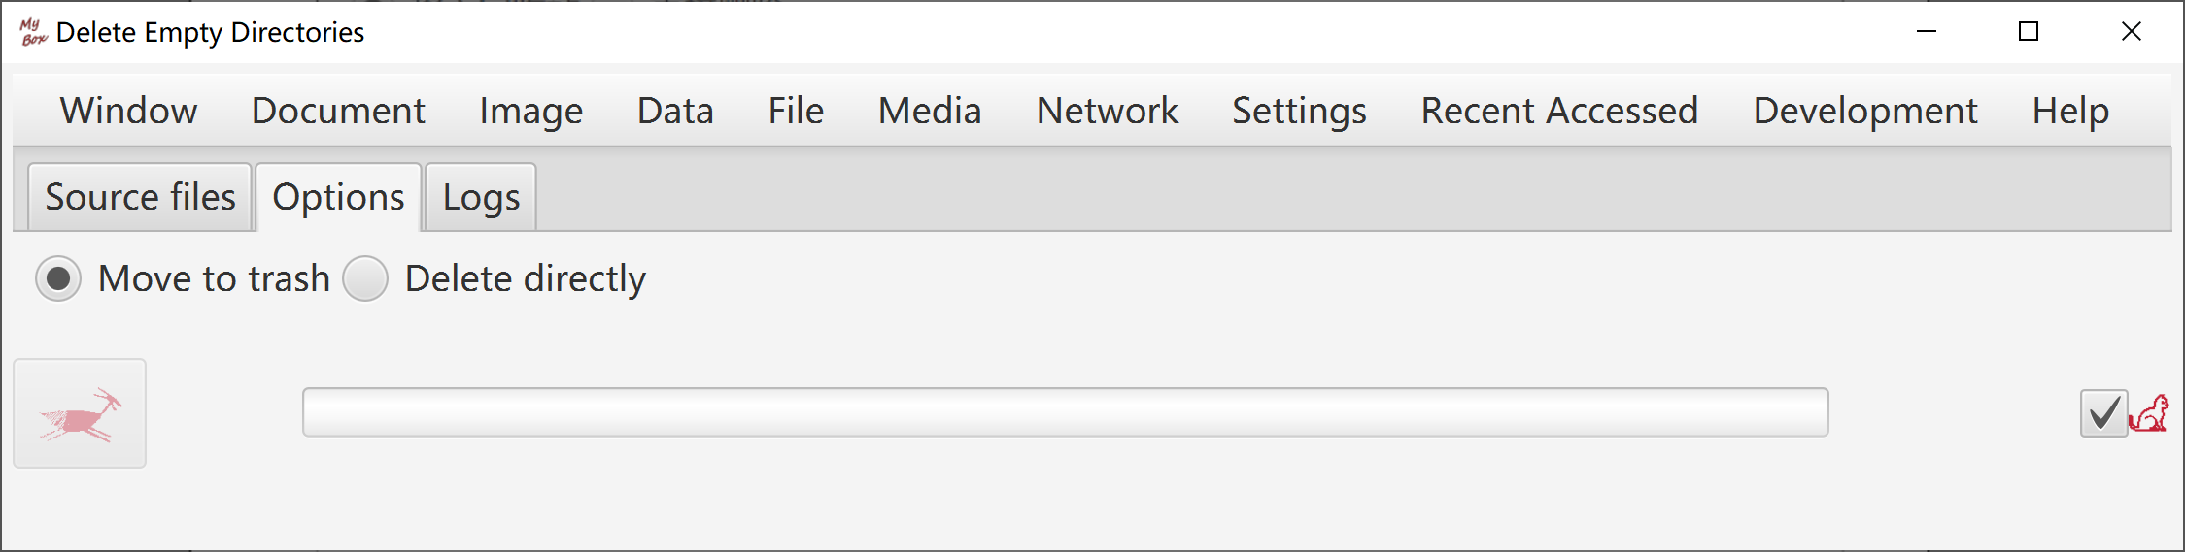

Delete Files under Java IO Temporary Path

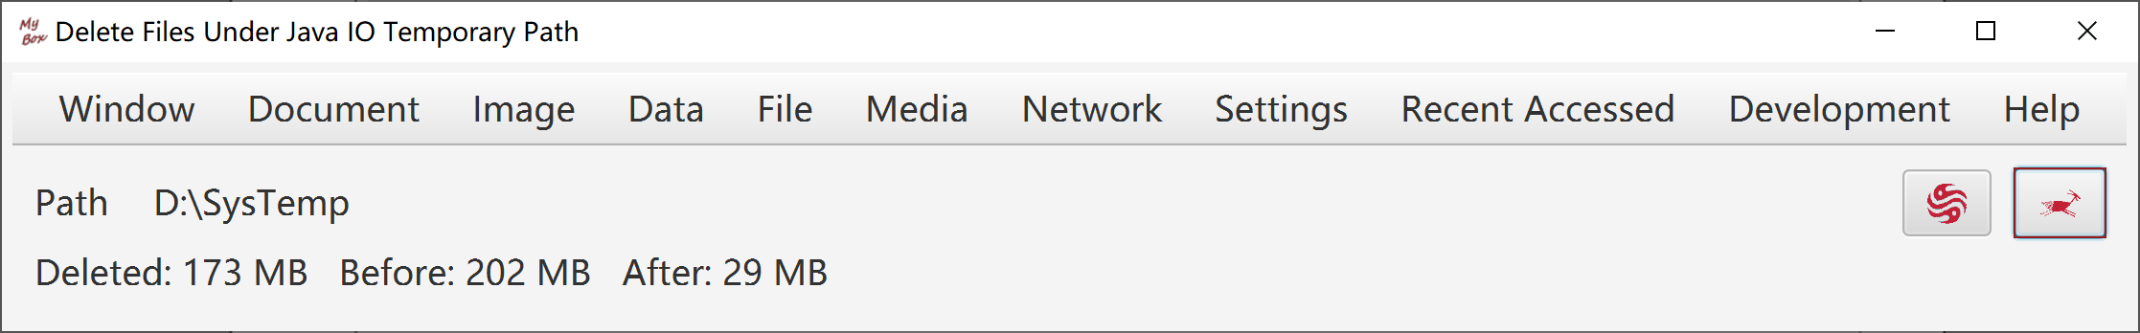

Delete Nested Directories

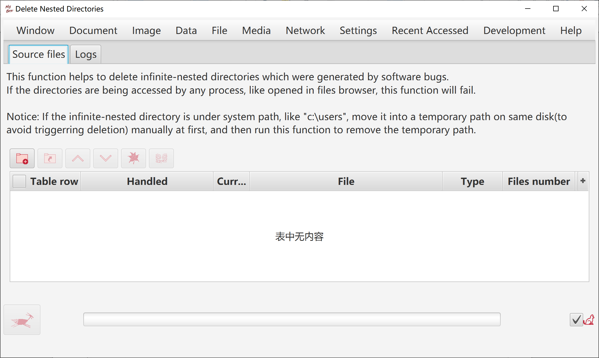

<End of Document>

