Novosibirsk State University  
  
  
Faculty of Information Technology **Technical specification**for the discipline “Digital Platforms”  
on the topic: **“2048”**

The work was performed by:  
students of the 1st year  
of the Faculty  
of Information Technologies  
of the group 24214  
Maksunova E. Е.  
Timofeev M. V.  
Peshkov A. M.

Novosibirsk, 2025

As part of this project, the following tasks were required:

1. Implementation of the game 2048
2. Implementation of a computer player for the game 2048

## Game Requirements

The game 2048 consists of a 4x4 game field, where each tile can contain a number that is a degree of two, but no greater than degree of 2048 (11).  
 Some tiles may be empty.

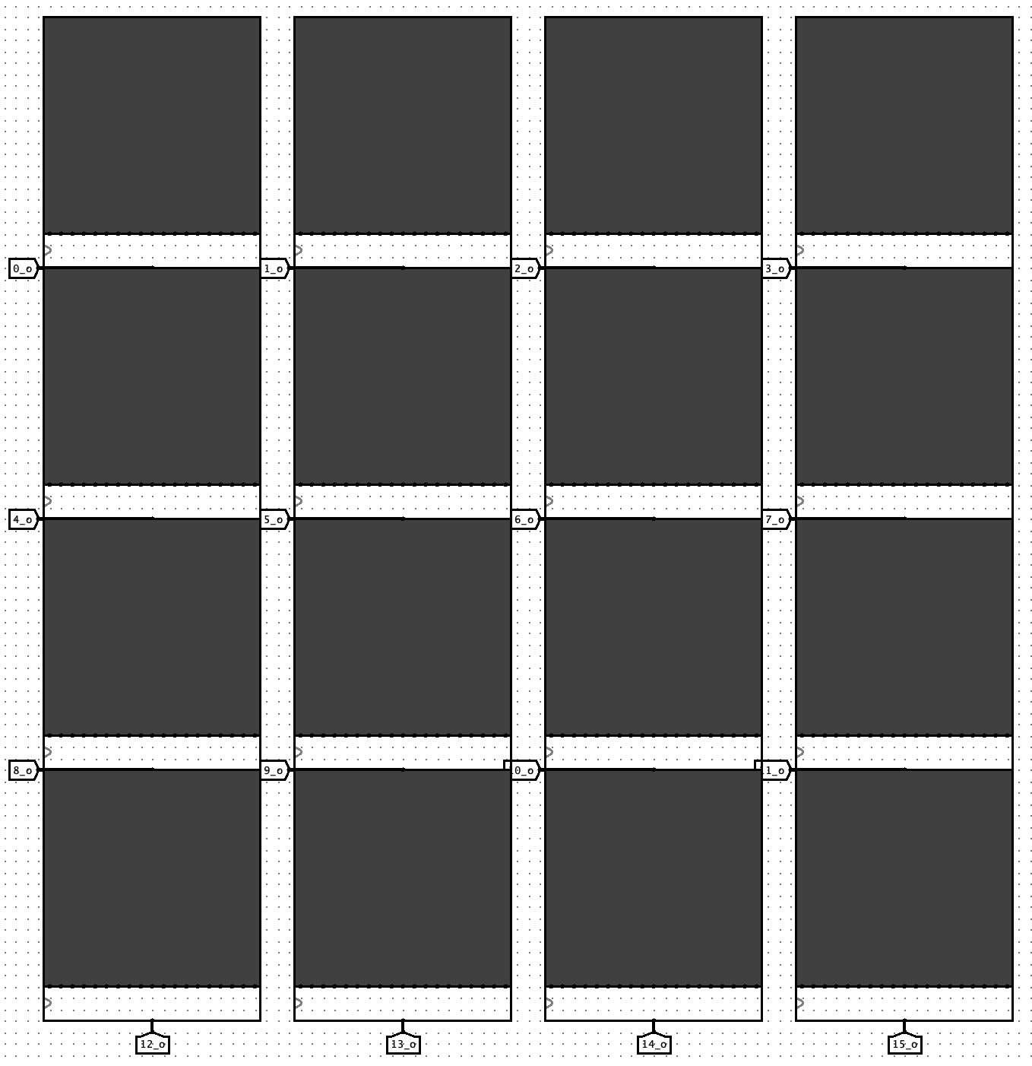

## Game Objective:

To create a tile with the value of 2048 from other tiles on the field.

## Game Start:

At the beginning of the game, two tiles appear on the field in random order. Each tile has a value of 2 or 4, the chance of a tile with the first value is 81.75%, the second is 18.75%.

## Move Rules:

The player has four possible moves:

* left
* right
* down
* up

Next to the main game grid there are 4 buttons responsible for selecting one of these directions. When a button is pressed, a move is considered as made and the grid is updated in the appropriate direction.

When a move is made, all tiles shift in the chosen direction. If two tiles with the same value come into contact as a result of the move, they merge into a single tile with a value equal to the sum of the merged tiles.

After each turn, a new tile with a value of 2 or 4 appears on a random empty place on the grid with the same chance as at the beginning of the game.

A move is considered invalid if it results in no tiles moving or merging.

Here we can see an example of a situation where move up is invalid, because no tile moves or merges will be done after it.

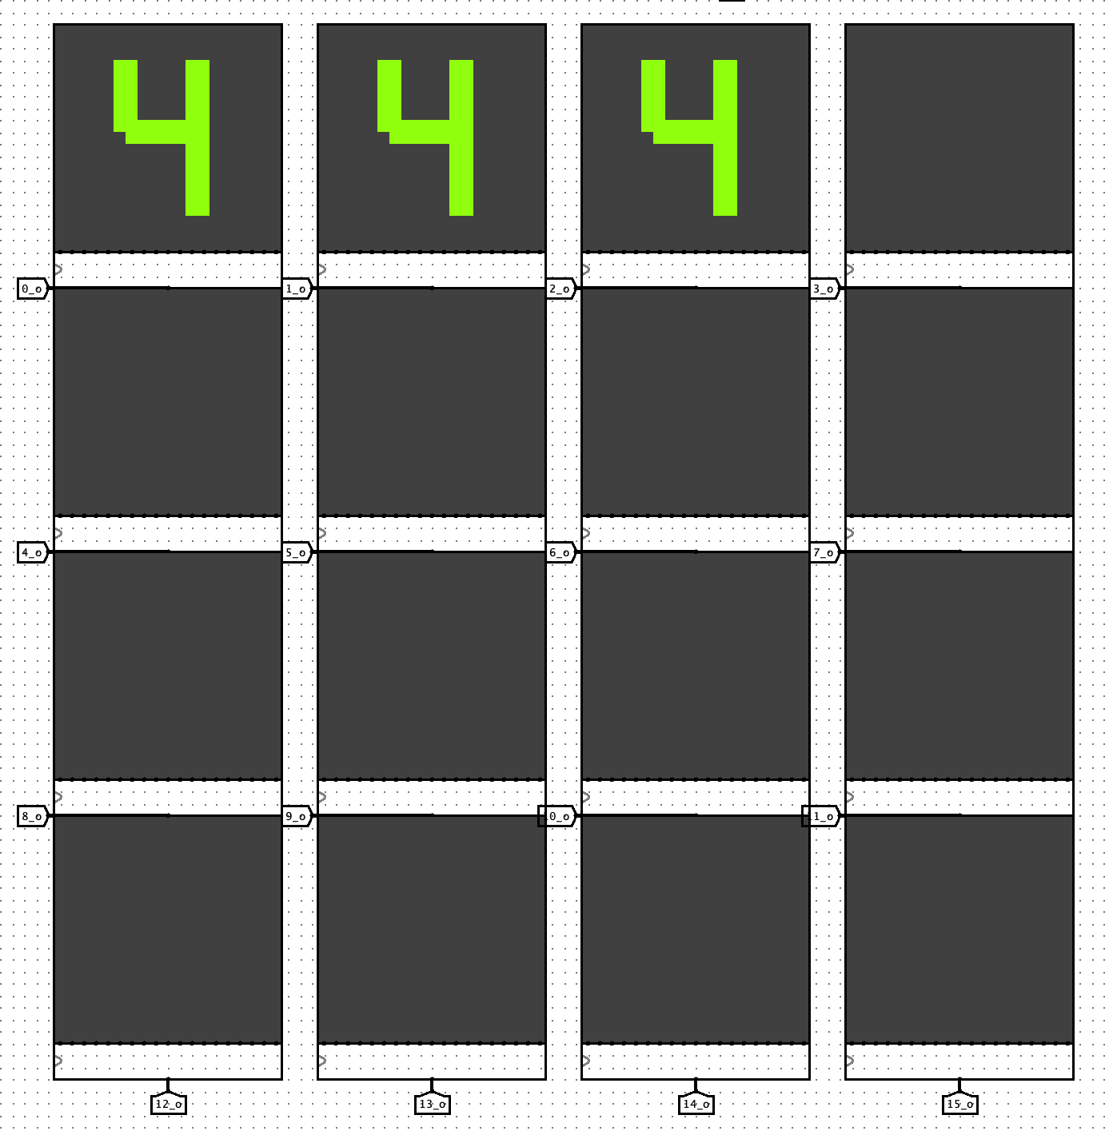

## Game Over:

The game ends either when a tile with the value 2048 inside is created (game ends with a win), or when there are no possible moves left (defeat).

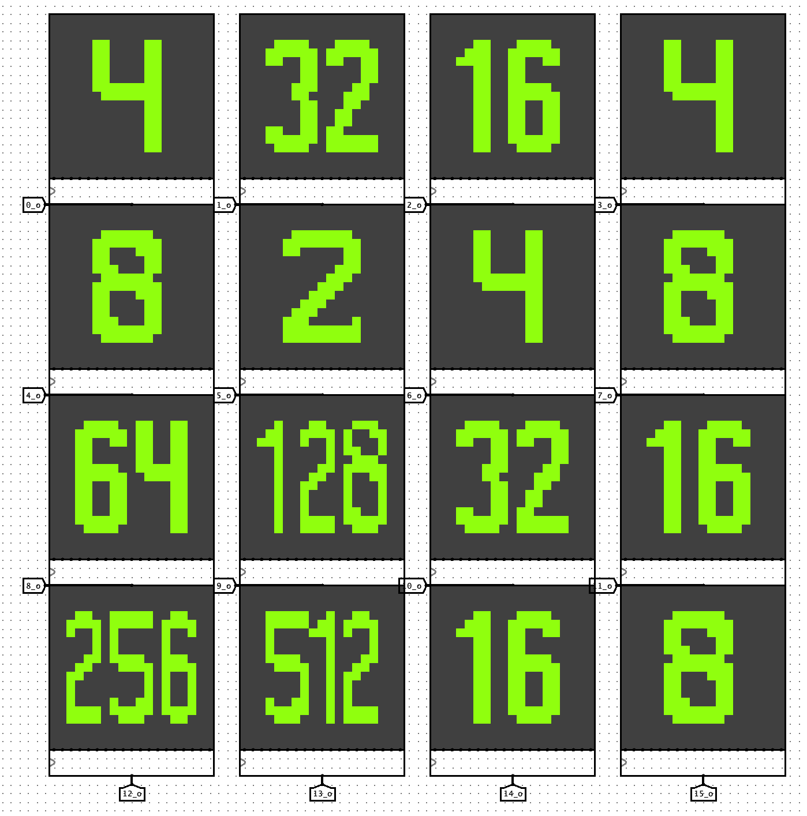

At this situation there are no possible moves, so game is considered as over

## Game mode selection:

It is necessary to realize the possibility of choosing 2 game modes: the first one is an independent game of the user in 2048, while the second one is a computer player mode, where the user observes the results of the game of artificial intelligence built on the basis of an algorithm. A user can switch the mode by button near the grid.

## Computer Player Requirements

The computer player should consistently achieve better results compared to a random strategy.

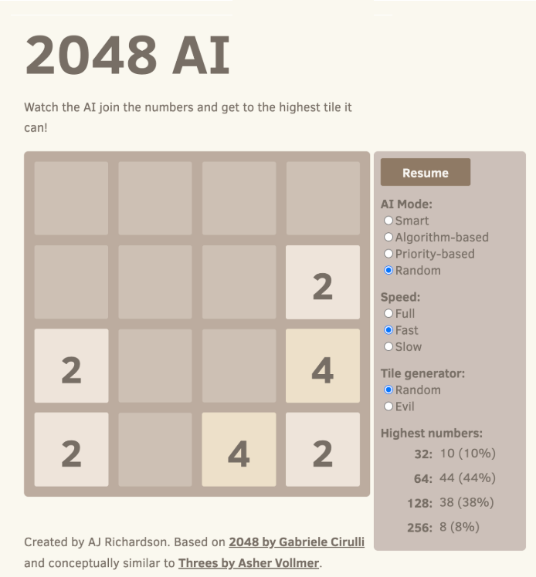

## Results of 100 games using random move selection:

Frequency of reaching different maximum tile values.  
As we can see, it is very hard for the random player to get 256, so the robotic player should get 256 quite often, and even be able to get 512, 1024 and 2048.

## Computer player

In one of the game modes, the user can watch the passage of a “computer player”. This is a specially written algorithm that calculates the best move. The evaluation is based on the current state of the field and each individual cell.

The following parameters are taken into account in the collective assessment:

* Smoothness

Determines how smoothly adjacent values will increase or decrease after a shift in a certain direction. The smaller the resulting difference, the better the stroke.

* Merge

Evaluates the ability to merge all pairs of identical cells into one. The more connections, the higher the final score.

* Monotonicity

Controls how many rows and columns are in ascending or descending order. With this parameter a system of numbers is formed on the field, where the highest in priority are moved to the corner and the others are arranged around them in descending order.

The parameters of the individual evaluation are:

* Free cells

The parameter defines the number of empty cells. More cells mean more possibilities to control the field state.

* The maximum number position

This parameter is responsible for controlling the location of the maximum number in the corner cells of the field. It is this location of the maximum that disposes to positive generation and convenient control of new numbers.

## Game field requirements

The field consists of 16 cells, each of which represents a cell and is responsible for representing the number located in it. The display size is 19x19, as this is the size that allows four-digit numbers to be presented in a readable and aesthetically pleasing way: each digit of such a number will have at least three pixels in width, which will allow the design of the whole number to be properly organized. Numbers with less than four digits are centered relative to the display, enlarged in size so that they remain visually balanced against its background.

## Font design

Based on the accepted concept of displays and their special way of displaying information, a font of all possible numbers in the cells was designed to reflect their current state:

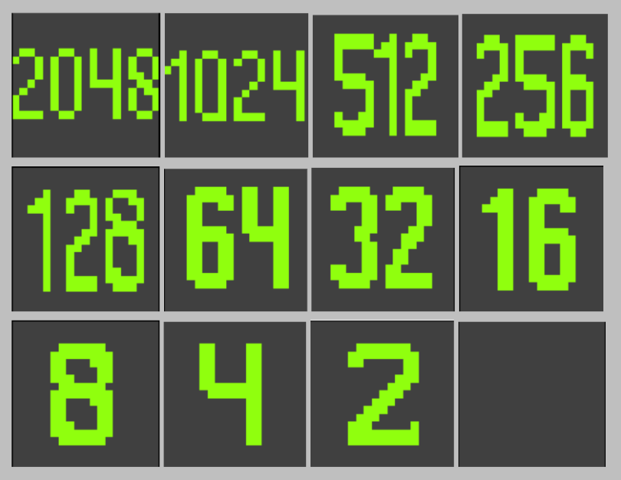

A total of 12 different cell states are possible:

* empty
* 2
* 4
* 8
* 16
* 32
* 64
* 128
* 256
* 512
* 1024
* 2048

Each number pattern is a sequence of nineteen 19-bit values that determine at which column position a pixel should light up.