Computer Science Department
Senior Project Requirements and Design document – Fall 2026

Title of the project: | Online Auction Service
Team Members: | Magzhan, Daniel, Sultanbek, Ayan, Zhibek  Responsibilities: feature comparison and front end (Daniel); front end (Magzhan); design (Zhibek); database and backend (Ayan, Sultanbek).
Project Advisor/Co-Advisors | Prof. Michel Lewis
Project Overview (20%)
1.1 Motivation and problem
Online auctions look simple but are hard to build correctly. Many people bid at the same moment, and the system must still pick one correct winner and one correct price, every time. Sellers also want different selling mechanisms for different goods: ascending bids for collectibles, a falling price for perishable goods, sealed bids for one-off deals. Most platforms offer one or two of these, and few explain how they stay correct under simultaneous bids.
Problem we solve: a single web platform where the seller chooses the auction format per listing (English, Dutch, sealed first-price, or sealed second-price/Vickrey), and where bidding stays correct and fast under concurrent load, with security that goes beyond a password (MFA at login and again when a purchase is finalized).
1.2 What we will develop
The Online Auction Service is a web application with four parts:
- Accounts and security: registration with email verification, three roles (buyer, seller, admin), TOTP multi-factor authentication, and a step-up MFA check when a transaction is finalized.
- Listings and auctions: sellers create listings and configure an auction; buyers browse and search.
- One auction engine, four formats: each format is a separate strategy module behind one interface; bidding is made safe with row-level locking in PostgreSQL; every watcher sees updates live.
- After the auction: automatic closing, one transaction per sale, simulated checkout, notifications, an admin dashboard and an audit log.
Out of scope: real payments, identity verification (KYC), advanced fraud and reputation scoring, native mobile apps. Stretch goals: a tamper-evident bid ledger (hash-chained log, or blockchain), reputation checks, large-scale load deployment.
1.3 Phasing
Phase | What is delivered
Fall 2026 (MVP) | Accounts, email verification and MFA; listings, browse and search; English auctions with sniping protection and live updates; automatic closing; transaction and checkout with step-up MFA; audit log; concurrency tests; usability test.
Spring 2027 | Dutch, sealed first-price and Vickrey strategies; notifications; admin dashboard and flagging; full evaluation (correctness per format, load, OWASP security tests, usability); optional ledger stretch goal.
1.4 Feature comparison with existing platforms (preliminary)
We compared what two reference systems do with what our service will do. This is a preliminary table; it will be extended and checked against more platforms during weeks 6 to 8. A dash means we did not find the feature in the sources we checked, not that it does not exist.
Feature | eBay (online marketplace) | Royal FloraHolland clock (flower trade) | Our service
Ascending (English) bidding | Yes. Automatic bidding raises your bid for you up to a maximum you set. | — | Yes. Minimum increment, sniping extension, all bids visible.
Falling-price (Dutch) auction | — (offers fixed-price "Buy It Now" instead) | Yes. The price falls on a clock; the first buyer to stop it buys. | Yes. Price is driven by the server; first valid acceptance wins.
Sealed-bid formats (first-price, Vickrey) | — | — | Yes. Hidden bids until close; Vickrey winner pays the second-highest bid.
Seller picks the format per listing | — | — (one mechanism) | Yes, four formats on one engine.
Extra check when finalizing a purchase | — | — | Yes. Step-up MFA (fresh TOTP code).
Owner of this comparison: Daniel. Sources: eBay Help, "Tips for winning auctions"; Thursd, "How the clocks of Royal FloraHolland work".

Requirements (30%)
Priority: M = MVP (fall 2026), S = spring 2027. Items marked "proposed" or [TBD] are defaults we chose where the kickoff document left a value open; they are listed in the open-issues table in the Conclusion.
2.1 Functional requirements
Accounts and access control
ID | Pri. | Requirement
FR-1 | M | The system shall let users register with email and password and require email verification before they can bid or sell.
FR-2 | M | The system shall support three roles (buyer, seller, admin) and enforce them on the server for every request.
FR-3 | M | The system shall enforce object-level permissions: a user can modify only their own listings and see only their own transactions. Bids are visible only as the format allows (FR-24, FR-28).
FR-4 | M | The system shall support TOTP-based MFA and require it at login for users who enabled it. MFA is mandatory for sellers and admins.
FR-5 | M | The system shall require a fresh MFA code to confirm and finalize a transaction, even in an authenticated session.
FR-6 | M | The system shall rate-limit login and bid endpoints and temporarily lock an account after repeated failed logins.
Listings
ID | Pri. | Requirement
FR-7 | M | A seller shall be able to create, edit and withdraw a listing with title, description, images, category, starting price and reserve price.
FR-8 | M | A listing shall not be editable in price or format once its auction has received a bid.
FR-9 | M | Buyers shall be able to browse and search listings by keyword, category, format and status.
FR-10 | S | Any user shall be able to flag a listing; admins shall be able to review, approve or remove flagged listings.
FR-39 | M | The reserve price shall not be shown to bidders. English auctions show only whether the reserve has been met (proposed).
Auction configuration
ID | Pri. | Requirement
FR-11 | M | A seller shall configure an auction with a format, a start time and an end time.
FR-12 | S | For a Dutch auction, the seller shall also set the starting price, the price-drop amount and the drop interval. The price shall never fall below the reserve price, which is the floor (proposed).
FR-13 | M | An auction shall have one of these statuses: scheduled, active, closed, no_sale, cancelled, changing only as the state machine in Section 3.4 allows.
Auction engine (all formats)
ID | Pri. | Requirement
FR-14 | M | The engine shall support all formats behind one interface with four operations: create listing, collect bids, determine winner and price, report result.
FR-15 | M | Each format shall be a separate strategy module. Adding a format shall require adding a strategy, not changing the engine or other modules.
FR-16 | M | The engine shall validate every bid against the current state of the auction at the moment the bid is processed.
FR-17 | M | The engine shall close each auction automatically at its end time.
FR-18 | M | If there are no bids, or the highest valid bid or accepted price is below the reserve, the auction shall end as no_sale.
FR-19 | M | Ties in the highest bid shall be resolved by the earliest timestamp, then the lowest bid id.
FR-20 | M | A bid arriving exactly at the end time shall be accepted only if the server timestamp is strictly before the end time. The server clock is the only authority.
FR-21 | M | Sniping protection (proposed): a valid bid in the last 2 minutes of an English auction extends the end time by 2 minutes. [TBD: confirm values.]
FR-22 | M | A seller shall not be able to bid on their own auction.
Format-specific rules
ID | Pri. | Format | Requirement
FR-23 | M | English | A bid shall be accepted only if it is at least the current price plus the minimum increment. [TBD: fixed amount or percentage.]
FR-24 | M | English | All bids and the current price are visible to everyone. The highest bidder wins at their bid.
FR-25 | S | Dutch | The price shall drop by the configured amount at each interval, driven by the server and not the client.
FR-26 | S | Dutch | The first valid acceptance wins at the server's price at that moment. Later acceptances are rejected cleanly.
FR-27 | S | Dutch | If the price reaches the floor with no acceptance, the auction ends as no_sale.
FR-28 | S | Sealed first-price | Each buyer submits one bid, hidden until close. [TBD: revision before close; proposed: no.]
FR-29 | S | Sealed first-price | The highest bidder wins and pays their own bid.
FR-30 | S | Vickrey | Bidding works as in the sealed first-price format.
FR-31 | S | Vickrey | The highest bidder wins and pays the higher of the second-highest bid and the reserve price (proposed). With only one bid, the winner pays the reserve. If the top two bids are equal, the winner is chosen by FR-19 and pays that amount.
Real-time, notifications, orders, administration
ID | Pri. | Requirement
FR-32 | M | Every watcher of an auction shall see new bids, current price, remaining time and status changes without refreshing the page.
FR-33 | S | The system shall notify users when they are outbid, shortly before an auction closes, and when a result is available. Notifications appear in the app and are stored. [TBD: email delivery.]
FR-34 | M | When an auction closes with a winner, the system shall create exactly one transaction linking buyer, seller and final price.
FR-35 | M | The winner shall complete the transaction through a checkout flow with simulated payment and step-up MFA.
FR-36 | S | A transaction not completed within a set period shall expire. [TBD: period, e.g. 48 hours.]
FR-37 | S | Admins shall have a dashboard to manage users, listings and flagged items.
FR-38 | M | The system shall write bids, authentication events and admin actions to an audit log that normal users cannot alter.
2.2 Non-functional requirements
ID | Quality | Requirement
NFR-1 | Concurrency correctness | Under simultaneous bids the system shall always produce one correct winner and final price. No bid is lost, accepted twice, or accepted against stale state. This is the core project requirement.
NFR-2 | Determinism | Every edge case (ties, no bids, reserve not met, bid at close, sniping) resolves the same way every time, per Section 2.1.
NFR-3 | Real-time latency | A bid or price change reaches 95% of watchers within 1 second. Basis: 1 second is the limit at which a user's flow of thought stays unbroken (Nielsen, 1993 [R1]), so a rival bid shows up before the user has lost the thread of the auction. Test load (team assumption): 200 concurrent watchers on one auction and 20 active auctions, sized for a university-scale deployment; this is not taken from a standard. [TBD: calibrate with load tests.]
NFR-4 | Bid throughput | A bid is validated and committed in under 300 ms at the 95th percentile under the NFR-3 load. Basis: a user-initiated action should give feedback within 100 ms and the whole path (network, commit, broadcast, render) must fit in the 1 second of NFR-3 (RAIL model [R2]). We give the server-side commit 300 ms, so about 700 ms remain for network, broadcast and rendering. The 300 ms value is our engineering budget derived from these two guidelines. [TBD: confirm after first load tests.]
NFR-5 | Security | The system meets OWASP Top Ten (2021) items A01, A02, A03, A05, A07 and A09: server-side role and object-level access control; hashed passwords (Argon2 or PBKDF2), TLS, no sensitive data in responses or logs; input validation and parameterized queries; DEBUG off in production, restricted CORS, secure headers; rate limiting, lockout, MFA and email verification; audit logging. Secrets live in environment variables, not code.
NFR-6 | Transaction protection | A stolen session alone shall not be enough to complete a purchase (step-up MFA, FR-5).
NFR-7 | Extensibility | A new auction format is added by writing one strategy module, with no change to the engine core, the API, or the schema beyond the strategy's own data.
NFR-8 | Usability | A first-time buyer can find an auction and place a bid without help. The interface is responsive on desktop and mobile browsers.
NFR-9 | Reliability and durability | Accepted bids and results are stored durably in PostgreSQL. After a server restart, active auctions resume and close at the correct time.
NFR-10 | Maintainability | Code is reviewed through pull requests with at least one reviewer, and every auction format has its own automated test suite.
NFR-11 | Portability | The system runs in Docker and can be deployed to more than one hosting provider, including free-tier hosts.
NFR-12 | Auditability | Audit log entries record who, what and when, and cannot be edited through the application.
References for performance targets. [R1] J. Nielsen, "Response Times: The 3 Important Limits", Nielsen Norman Group (1993): 0.1 s feels instantaneous, 1 s keeps the user's flow of thought, 10 s is the limit of attention. [R2] Google web.dev, "Measure performance with the RAIL model": respond to user input within 100 ms. Percentile targets (95th) follow common practice of judging latency by the tail rather than the average.
2.3 Domain requirements
Domain requirements come from how auctions work and from the setting of the project, not from what users ask for. They constrain every format.
ID | Domain rule or constraint
DR-1 | The server clock is the only time authority. Clients show countdowns but never decide whether a bid is on time.
DR-2 | A reserve price is the minimum at which the seller will sell. Below it the auction ends as no_sale and no transaction is created.
DR-3 | English auctions are ascending: each bid must beat the current price by the minimum increment. The winner pays their own bid.
DR-4 | Dutch auctions are descending: the price falls over time and the first buyer to accept wins at the current price. Only one acceptance can succeed.
DR-5 | In sealed auctions no bid, bidder or amount is visible to anyone, including the seller, until the auction closes.
DR-6 | In a Vickrey auction the winner pays the second-highest bid (not less than the reserve), which makes bidding one's true value the best strategy.
DR-7 | A seller may not bid on, or otherwise influence, their own auction (no shill bidding). Admin actions on auctions are logged.
DR-8 | A bid is a binding offer: once accepted it cannot be withdrawn. A closed auction with a winner produces exactly one transaction.
DR-9 | Money amounts are stored as exact decimals in one currency; no floating-point arithmetic is used for prices. [TBD: currency.]
DR-10 | Payments are simulated and no real money moves. The system stores only the personal data it needs (email, password hash, MFA secret), and never stores card data.

Preliminary Design (20%)
3.1 Stakeholders
Stakeholder | What they do | What they need from the system
Buyer | Browses, searches, watches auctions, bids or accepts a Dutch price, checks out after winning. | Fair, correct outcomes; live prices; clear rejection reasons; safe checkout.
Seller | Creates listings, chooses the format and prices, follows results. | Control over format and reserve; trust that the winner and price are correct.
Admin | Reviews flagged listings, removes listings, suspends users, reads the audit log. | Tools to moderate; a log that cannot be altered.
System (scheduler) | Opens and closes auctions, drops Dutch prices, sends notifications. | Reliable timing; safe repeated runs; recovery after a restart.
Advisor (Prof. Lewis) | Reviews and approves requirements and design. | Clear scope, justified decisions, a measurable evaluation plan.
Usability testers | Try the bidding flow near the end of the semester. | A flow they can finish without help.
3.2 Structured use cases
The overview lists all eleven use cases. The six that carry the core rules of the system are written out in a structured form below.
ID | Use case | Actor | Related requirements
UC-1 | Register and verify | Buyer, seller | FR-1, FR-2, FR-4, FR-6 (detailed below)
UC-2 | Create a listing | Seller | FR-7, FR-8, FR-39: title, description, images, category, starting and reserve price.
UC-3 | Configure an auction | Seller | FR-11, FR-12, FR-13: format, schedule; for Dutch, price drop and interval.
UC-4 | Bid in an English auction | Buyer | FR-16, 19 to 24, 32 (detailed below)
UC-5 | Accept a Dutch price | Buyer | FR-25 to FR-27 (detailed below)
UC-6 | Place a sealed bid | Buyer | FR-28 to FR-31 (detailed below)
UC-7 | Close an auction | System | FR-17 to FR-19, FR-34 (detailed below)
UC-8 | Check out | Winner | FR-5, FR-35, FR-36 (detailed below)
UC-9 | Receive notifications | Buyer, seller | FR-33: outbid, closing soon, result.
UC-10 | Flag and review a listing | Any user, admin | FR-10, FR-37: flag, review, remove.
UC-11 | Browse and search | Any user | FR-9: keyword, category, format, status.

ID and name | UC-1 Register and verify
Actors | Buyer or seller (new user); email service
Requirements | FR-1, FR-2, FR-4, FR-6
Preconditions | The user has an email address and is not logged in.
Trigger | The user opens the sign-up page.
Main flow | 1. The user enters email, password and role (buyer or seller).  2. The system validates the input, stores a password hash, and sends a verification link.  3. The user opens the link; the account becomes verified.  4. The system shows a TOTP secret (QR code); the user scans it and enters the first code.  5. The system enables MFA for the account.
Alternative flows | 2a. The email is already registered: the system rejects the sign-up.  3a. The link has expired: the user requests a new one.  5a. The code is wrong: the user retries; repeated failures are rate-limited (FR-6).
Postconditions | A verified account exists. MFA is enabled and is mandatory for sellers and admins. The event is written to the audit log.

ID and name | UC-4 Bid in an English auction
Actors | Buyer (primary); watchers; previous highest bidder (notified)
Requirements | FR-16, FR-19 to FR-24, FR-32, FR-33
Preconditions | The buyer is logged in and verified. The auction is active. The buyer is not the seller.
Trigger | The buyer submits a bid amount.
Main flow | 1. The buyer sees the current price and the smallest allowed next bid.  2. The buyer enters an amount and submits.  3. The system locks the auction row and re-reads its current state.  4. The system checks the bid against that state using server time.  5. The system stores the bid, updates price and leader, and extends the end time if the bid fell in the last 2 minutes.  6. The system commits, then pushes the update to all watchers and queues an outbid notification for the previous leader.  7. The buyer sees the confirmation and the new price.
Alternative flows | 4a. The auction is closed or not started: rejected, "auction closed".  4b. The amount is below current price plus increment: rejected, showing the minimum.  4c. Another bid committed first: this bid is checked against the new price and may now be too low.  4d. The bidder is the seller: rejected (FR-22).
Postconditions | The bid is stored and the price is updated, or the bid is rejected with a reason and nothing changed.

ID and name | UC-5 Accept a Dutch price
Actors | Buyer; competing buyers; watchers
Requirements | FR-25, FR-26, FR-27, FR-34
Preconditions | The buyer is logged in and verified. A Dutch auction is active. The buyer is not the seller.
Trigger | The buyer presses "Accept price".
Main flow | 1. The page shows the server-computed price and the time to the next drop.  2. The buyer presses Accept.  3. The system locks the auction row and recomputes the price at server time.  4. The system records the acceptance as the winning bid at that price and sets the status to closed.  5. The system commits, broadcasts "auction closed", and creates the transaction.
Alternative flows | 3a. Another buyer already won: rejected, "already sold".  3b. The price dropped between the click and processing: the buyer wins at the lower server price (FR-26).  3c. The price had reached the floor: the auction is no_sale and the acceptance is rejected.
Postconditions | At most one acceptance succeeds. The auction is closed with one winner, or it stays no_sale.

ID and name | UC-6 Place a sealed bid (first-price or Vickrey)
Actors | Buyer
Requirements | FR-28 to FR-31, DR-5
Preconditions | The buyer is logged in and verified. A sealed auction is active. The buyer has no bid on it yet.
Trigger | The buyer submits one bid amount.
Main flow | 1. The page states that bids are hidden until close.  2. The buyer enters an amount and submits.  3. The system locks the auction, checks status and time, and checks the amount against the starting price.  4. The system stores the bid as hidden and commits.  5. The buyer sees confirmation of their own bid only. Watchers see a bid count, never amounts.
Alternative flows | 3a. The buyer already has a bid: rejected (proposed: no revision, FR-28).  3b. The amount is below the starting price: rejected.  3c. The auction has closed: rejected.
Postconditions | One hidden bid per buyer is stored. No amount is visible to anyone until close.

ID and name | UC-7 Close an auction
Actors | System (scheduler); buyer and seller (notified)
Requirements | FR-17 to FR-20, FR-34, NFR-1, NFR-9
Preconditions | The auction is active and its end time has passed.
Trigger | The scheduler finds an active auction whose end time is at or before the current server time.
Main flow | 1. The scheduler opens a database transaction and locks the auction row.  2. It re-checks that the status is still active and the end time has passed.  3. The strategy determines the winner and final price (tie-break by FR-19).  4. The engine applies the reserve check (FR-18).  5. If sold: status closed, winner and final price stored, one transaction created as pending. Otherwise status no_sale.  6. The system commits, broadcasts the result and notifies buyer and seller.
Alternative flows | 2a. The status is already closed: skip. Running the job twice is safe.  2b. A sniping extension moved the end time: skip until the new end time.  4a. The best bid is below the reserve: no_sale and no transaction.
Postconditions | The auction is in exactly one final state. At most one transaction exists for it.

ID and name | UC-8 Check out
Actors | Winner; seller (notified)
Requirements | FR-5, FR-35, FR-36, NFR-6
Preconditions | A pending, non-expired transaction exists for the winner, who is logged in.
Trigger | The winner opens the transaction and chooses "Confirm purchase".
Main flow | 1. The winner reviews the item, price and seller.  2. The system asks for a fresh TOTP code (step-up MFA).  3. The winner enters the code.  4. The system verifies it; the code is valid once and only for this transaction.  5. The simulated payment runs and succeeds.  6. The transaction becomes completed; the seller is notified; the event is logged.
Alternative flows | 4a. The code is wrong or stale: rejected; attempts are limited.  5a. The simulated payment fails: the transaction stays pending.  1a. The expiry period has passed: the transaction is expired and cannot be confirmed.
Postconditions | The transaction is completed, or it is unchanged. A stolen session alone cannot complete it.

3.3 Sequence diagrams
The four diagrams cover the interactions where correctness matters most. Numbers on the arrows give the order of messages.
SD-1: Place a bid in an English auction (UC-4)
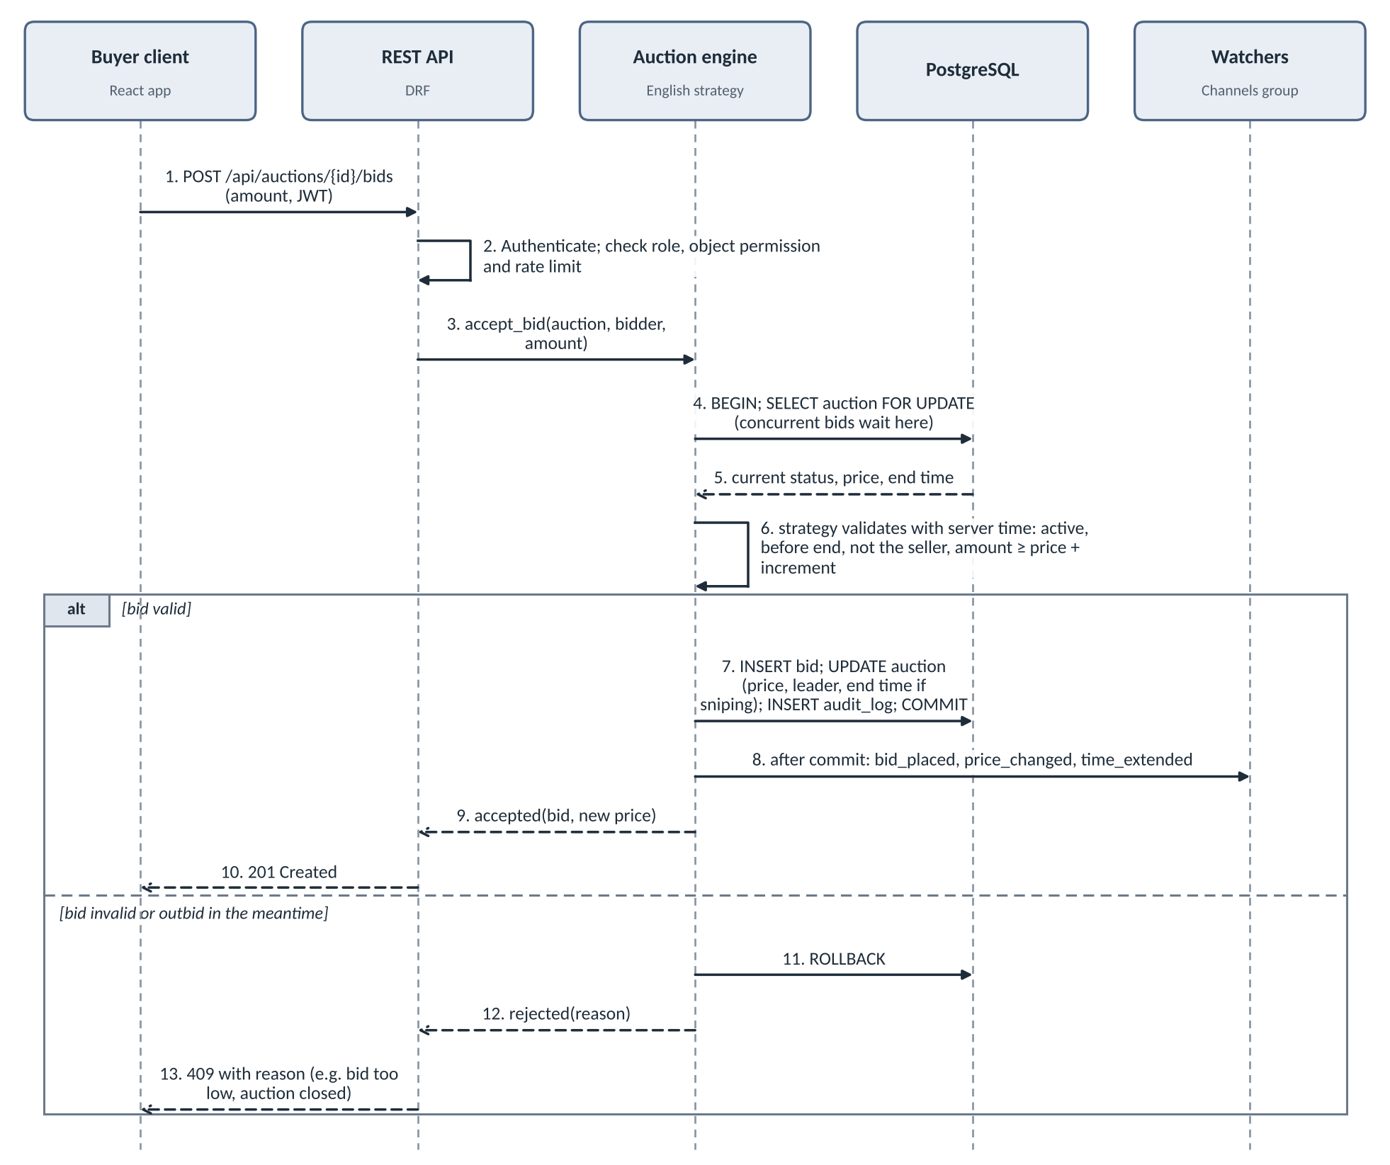
Figure 1. Placing a bid. The row lock serializes bids on one auction; the broadcast happens only after commit.
SD-2: Close an auction (UC-7)
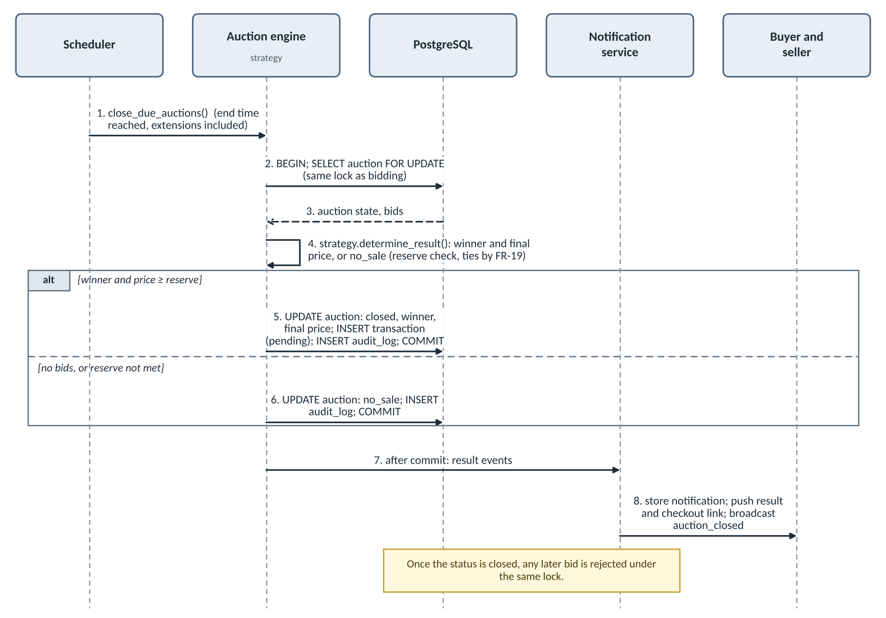
Figure 2. Closing an auction. The close job takes the same lock as bidding, so a bid and the close cannot interleave.
SD-3: Check out with step-up MFA (UC-8)
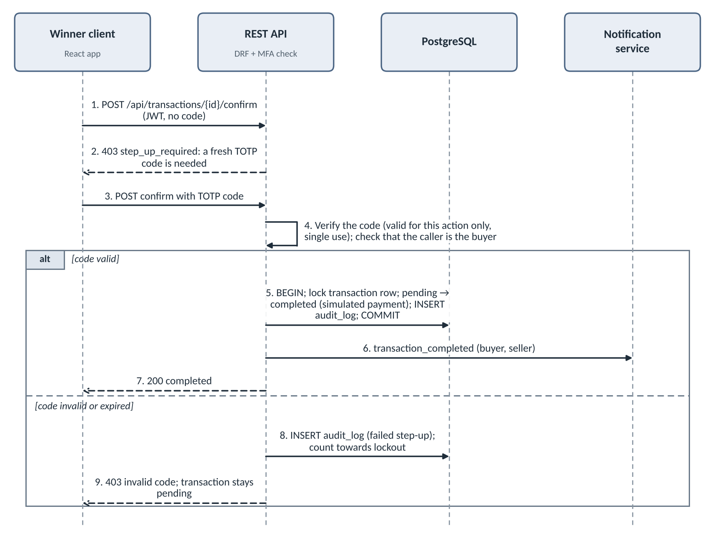
Figure 3. Checkout. A fresh TOTP code is required even in a logged-in session.
SD-4: Dutch acceptance race (UC-5)
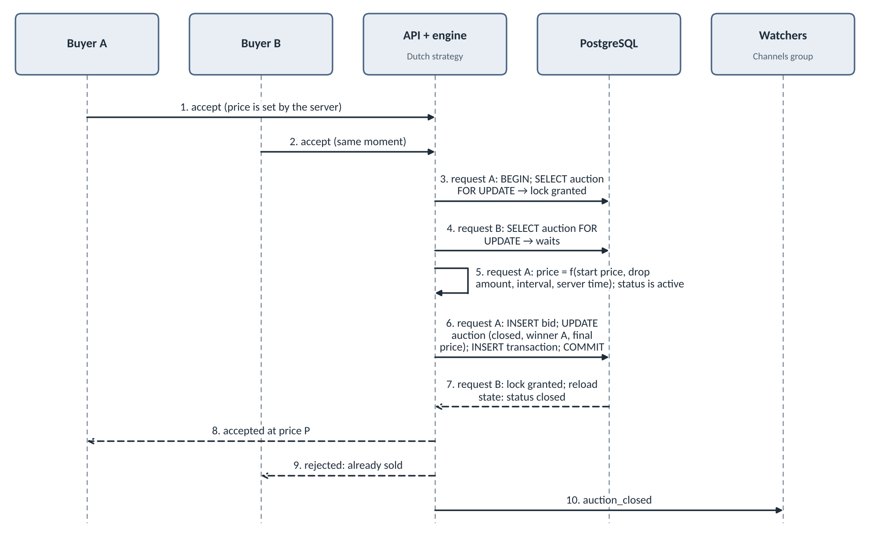
Figure 4. Two buyers accept at nearly the same moment. The lock lets exactly one win; the other is rejected cleanly.
3.4 Architectural models
Architecture
The system has four layers. The client calls REST for accounts, listings and orders, and keeps a WebSocket open while watching an auction. A bid passes authentication and permission checks, goes to the engine, which opens a database transaction, applies the format's rules and commits. Only after the commit is a message pushed to every watcher.
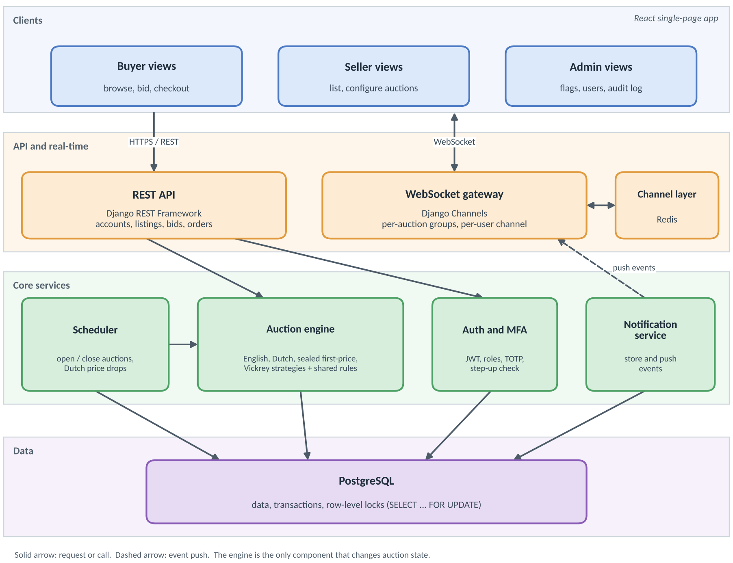
Figure 5. Layered architecture.
Auction engine: strategy pattern
The engine owns the rules shared by all formats (seller cannot bid, auction must be active, reserve check, tie-break, close-time check, transaction wrapper). Each format is a strategy with four operations: create, accept_bid, determine_result, report. The engine looks up the strategy from the auction's format and delegates to it. Adding a format means writing one class and registering it (FR-15, NFR-7).
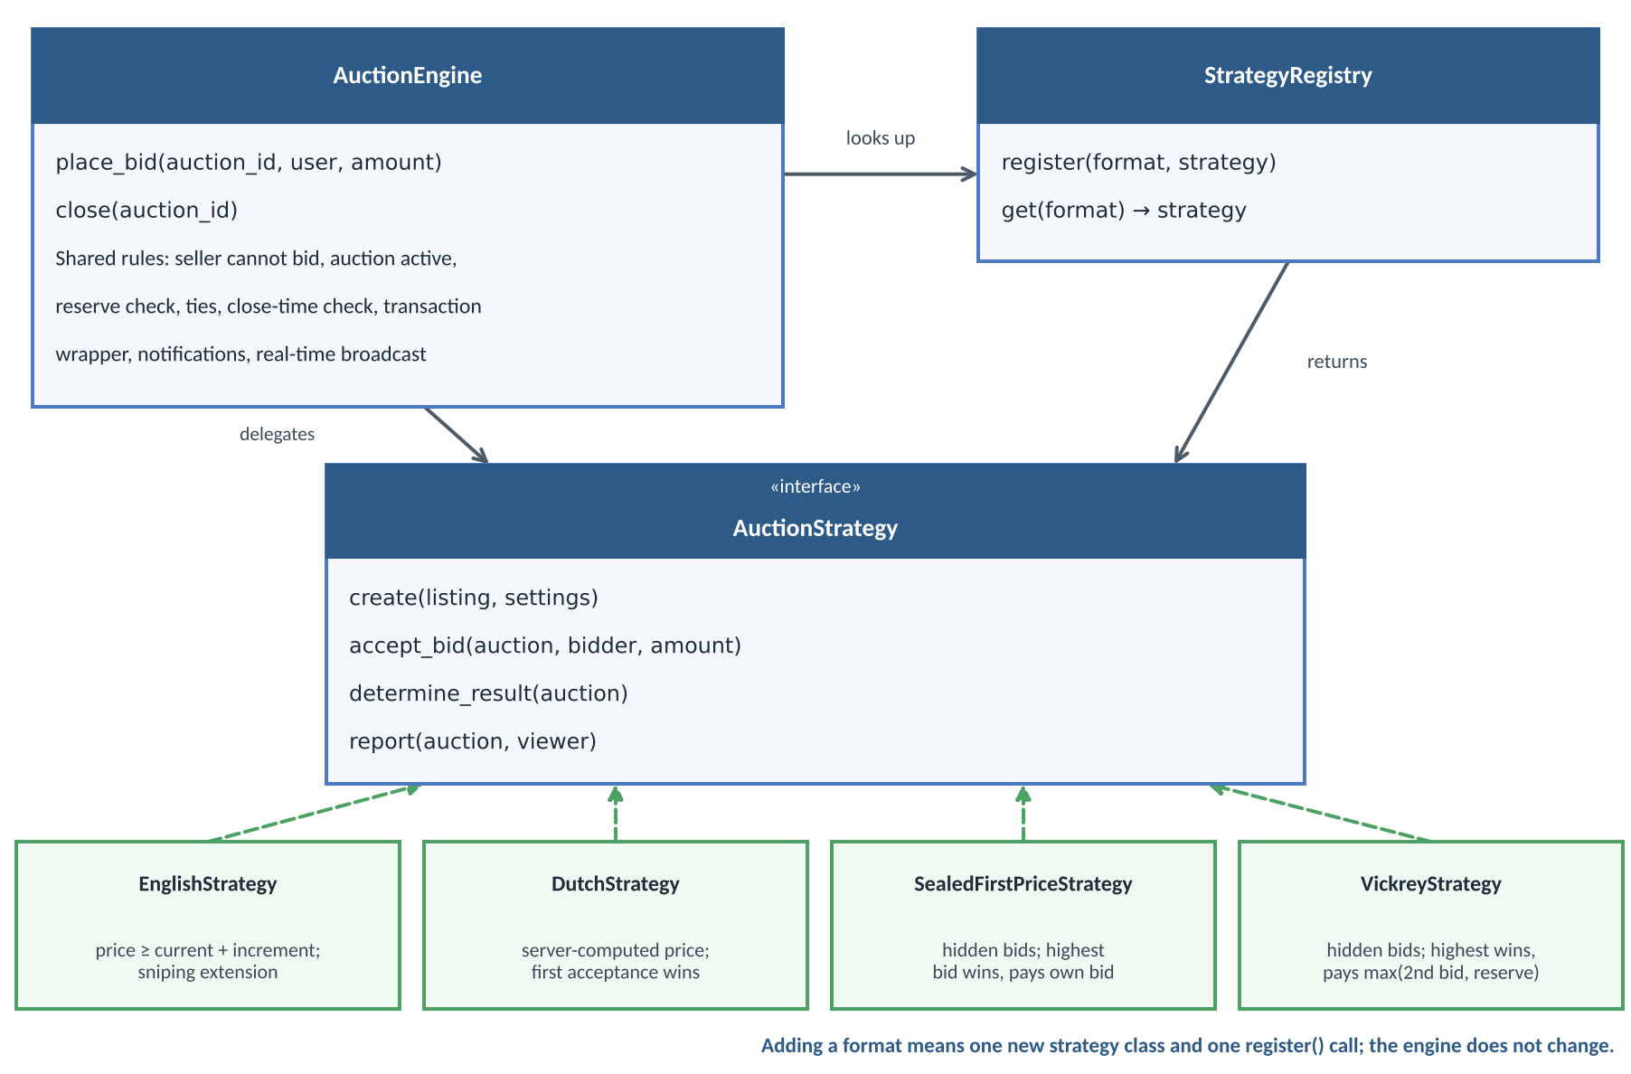
Figure 6. Engine and strategies.
Strategy | Behavior
English | Requires bid ≥ current price + increment. Updates price and leader. Applies the sniping extension. Winner pays their bid.
Dutch | Current price is computed from start time, drop amount and interval. The first acceptance wins; only one can succeed.
Sealed first-price | Stores one hidden bid per buyer. At close the highest wins and pays their own bid.
Vickrey | Stores hidden bids as above. At close the highest wins and pays the higher of the second-highest bid and the reserve.
Concurrency design
Requirement: one correct winner and price under simultaneous bids (NFR-1). Options: (a) pessimistic row-level locking, (b) optimistic locking with a version number and retry, (c) an application-level bid queue per auction. Decision: (a), because it is the simplest to reason about and to prove correct, and different auctions lock different rows so they do not block each other. Fallback: if load tests (Locust or k6) show contention, we evaluate (b) or (c); the test results drive that decision.
- Authenticate the user and check their role.
- Open a database transaction.
- Lock the auction row with SELECT ... FOR UPDATE. Concurrent bids on the same auction wait here, one at a time.
- Reload the current state (status, price, end time) inside the lock.
- Ask the strategy to validate the bid against that state, using server time.
- If valid, insert the bid and update the auction (price, leader, possible extension). If not, roll back and return the reason.
- Commit.
- After commit, broadcast to watchers and queue notifications.
A bid that was highest when submitted cannot overwrite a newer, higher bid, because validation always uses the true current state. The close job takes the same lock, so a bid and the close cannot interleave.
Auction state machine
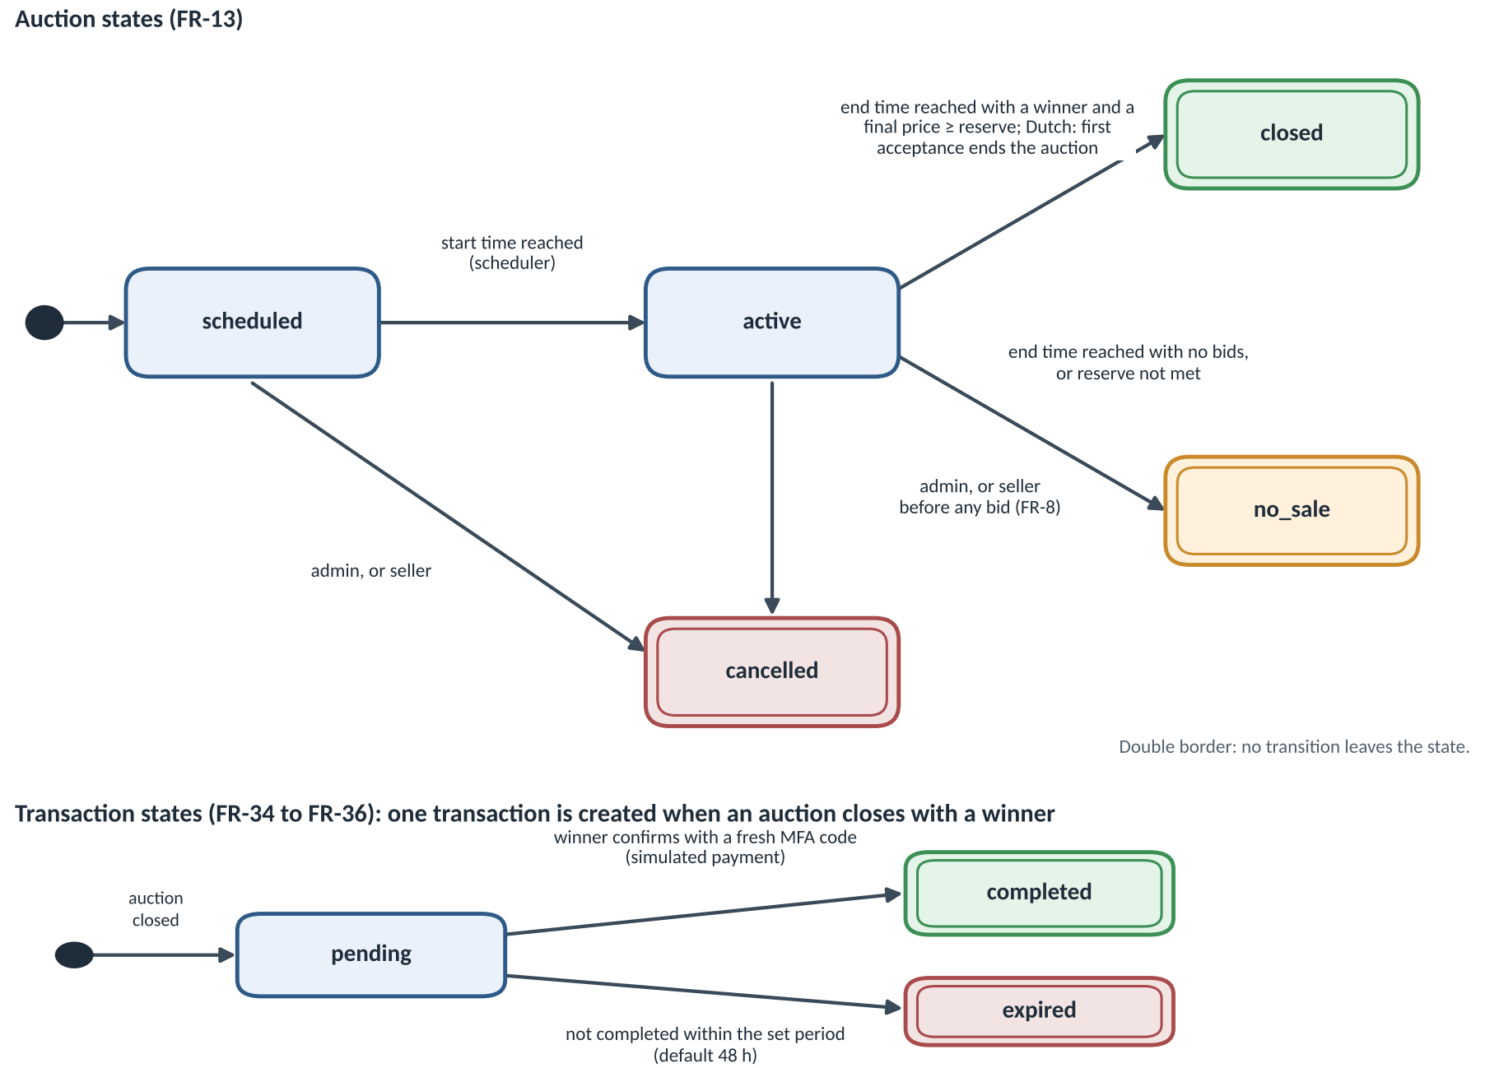
Figure 7. Auction states (top) and transaction states. No transitions leave closed, no_sale or cancelled.
Data model
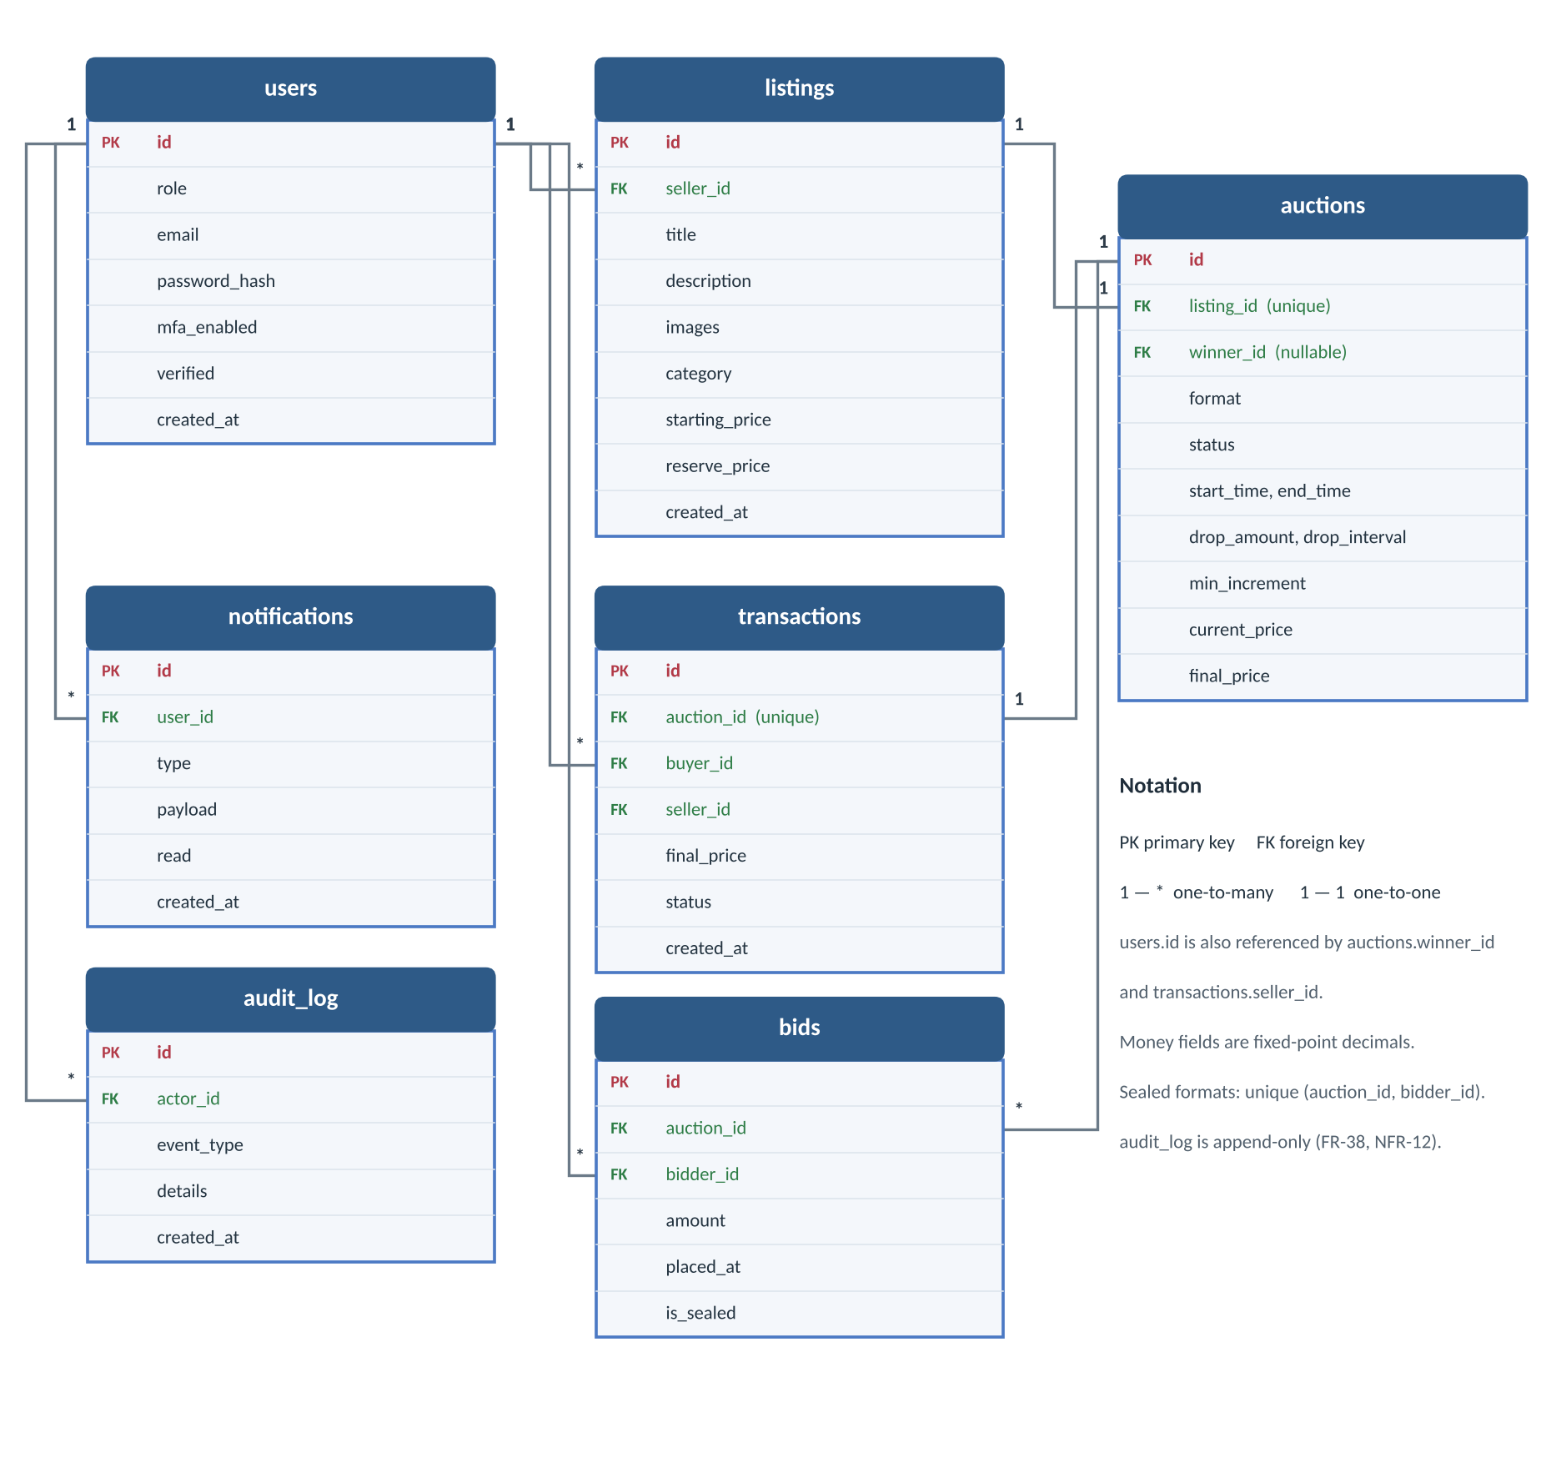
Figure 8. Database schema. Key constraints: unique transactions.auction_id; unique (auction_id, bidder_id) for sealed bids; index on bids (auction_id, amount, placed_at, id); index on auctions (status, end_time).
Technology decisions: requirement, options, justification
Concern | Requirement | Options considered | Decision and reason
Frontend | Responsive views; a page that updates continuously over a live channel. | React, Vue, Angular, server-rendered templates | React: component model suits frequent re-rendering; team knows it. Templates rejected: live updates are awkward.
Backend | REST endpoints, admin interface, transactional data access. | Django + DRF, Node + Express, FastAPI, Rails | Django + DRF: built-in admin covers much of the dashboard; the ORM gives transactions and row locking.
Real-time | Low-latency push of bids, price drops, notifications. | Django Channels, Node + Socket.IO, server-sent events, polling | Django Channels: WebSockets in the same framework. Polling rejected as too slow and wasteful.
Database | Durable storage, reliable transactions, row-level locking. | PostgreSQL, MySQL/MariaDB, SQLite | PostgreSQL; SQLite for local development only.
Concurrency | One winner and price under simultaneous bids. | Row locks, optimistic version + retry, bid queue | Row locks (see above); measured fallback.
Authentication and MFA | Three roles, login protection, extra check at purchase. | Cookies or JWT; TOTP or email/SMS codes; MFA at login only or also at finalization | Django auth + JWT (SimpleJWT), email verification, TOTP (django-otp) at login and as step-up at finalization. TOTP needs no SMS cost and works offline.
A documented fallback stack is Node.js + Express + Socket.IO; PostgreSQL locking and WebSockets carry over unchanged. [TBD: advisor's view.]
API, real-time and security design (summary)
Area | Design
REST API (proposed) | Accounts: POST /api/auth/register, /verify-email, /login, /mfa/setup, /mfa/verify, /token/refresh. Listings: GET/POST /api/listings, GET/PATCH/DELETE /api/listings/{id}, POST .../flag. Auctions: POST /api/listings/{id}/auction, GET /api/auctions/{id}. Bidding: POST /api/auctions/{id}/bids (bid, or accept Dutch price). Orders: GET /api/transactions, POST /api/transactions/{id}/confirm (step-up MFA). Notifications and /api/admin/....
Real-time | Each auction has a Channels group at /ws/auctions/{id}/ delivering bid_placed, price_changed, time_extended, auction_closed. After a bid commits the server sends one event to the group. The Dutch price is computed on the server and broadcast at each drop. Sealed auctions send counts and status only. A Redis channel layer works across processes.
Authentication | Argon2 or PBKDF2 password hashes; short-lived JWT access token plus refresh token; roles re-checked against the database for sensitive actions; email verification before bidding or selling; TOTP MFA at login; step-up TOTP code valid only for the one transaction being confirmed.
OWASP controls | A01 server-side role and object checks; A02 TLS, hashed passwords, secrets in environment variables; A03 serializer validation and parameterized ORM queries; A05 DEBUG off, restricted CORS, secure headers; A07 rate limiting, lockout, MFA; A09 append-only audit log. Stretch: hash-chain the audit log so tampering is detectable (could later move to a permissioned ledger).
User interface
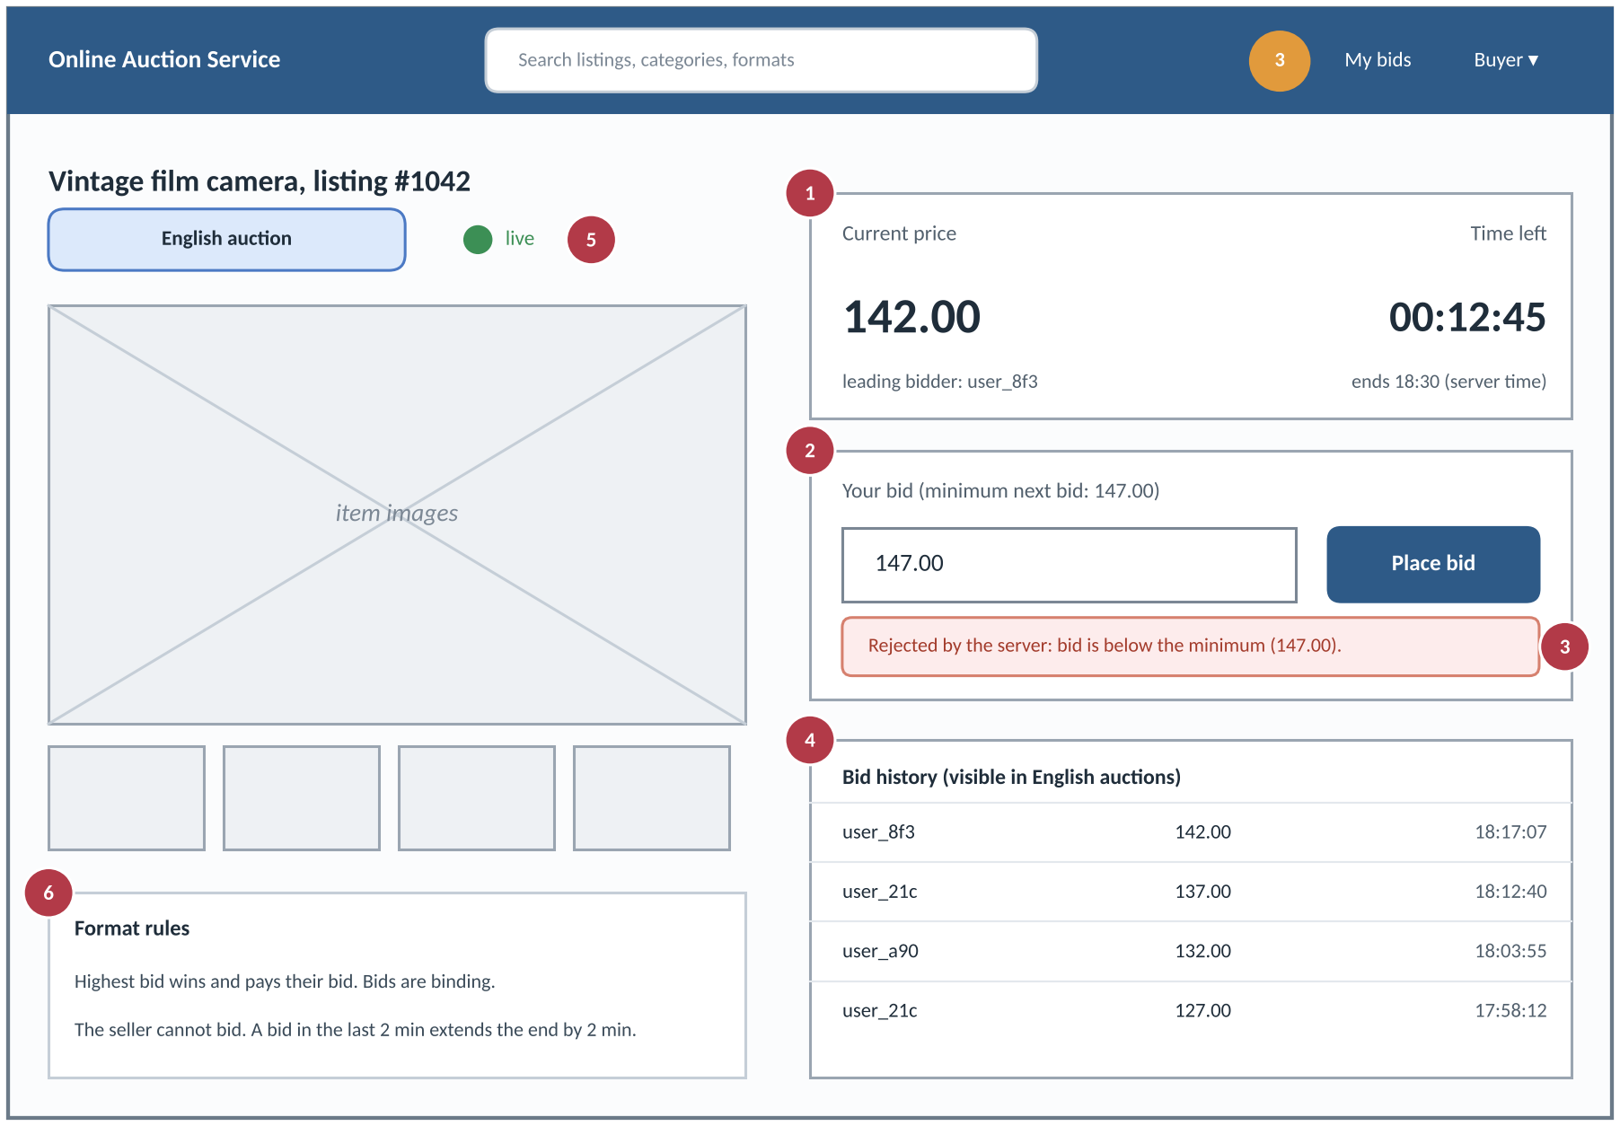
Figure 9. Buyer auction page (wireframe). 1 current price, 2 countdown, 3 live status, 4 bid form with rejection messages, 5 bid history, 6 navigation. Seller and admin views follow the same layout.
Views: buyer (browse and search, auction page, my bids, notifications, checkout), seller (create or edit a listing, configure an auction, my listings and results), admin (flagged listings, users, audit log). The auction page opens a WebSocket on load and falls back to a REST refresh if the connection drops.
Verification and traceability
Tests: one suite per format (winner and price, ties, no bids, reserve not met, bid at close, sniping, Vickrey single bid); concurrency and load tests with Locust or k6 (no lost or duplicate winners, latency per NFR-3 and NFR-4, lock contention); OWASP checklist tests for A01, A02, A03, A05, A07, A09; a usability test of the bidding flow.
Requirements | Design | Verified by
FR-14, FR-15, NFR-7 | Engine and strategy design | Test that registers a dummy format without touching the engine
FR-16, FR-19 to FR-21, NFR-1, NFR-2 | Concurrency design; SD-1, SD-2 | Per-format edge-case suites; concurrent-bid tests
FR-23, FR-24, FR-29 | English and sealed first-price strategies | Per-format winner and price tests
FR-25 to FR-27 | Dutch strategy; SD-4 | Timing and double-acceptance tests
FR-30, FR-31 | Vickrey strategy | Second-price tests incl. single bid and reserve
FR-32, NFR-3 | Real-time design | Load tests measuring delivery latency
FR-2 to FR-6, FR-38, NFR-5, NFR-6 | Authentication and OWASP design | OWASP-based test cases
FR-34 to FR-36 | Transaction states; SD-3 | Flow tests including step-up MFA
NFR-8 | User interface | Usability testing

High-level tasking plans (20%)
4.1 Project management tools and ways of working
- GitHub Projects board: every task has one owner, one reviewer, a due week and a link to the requirement IDs it covers (FR/NFR).
- Git with feature branches and pull requests: at least one reviewer per merge (NFR-10); the main branch always runs.
- Team chat (Slack or Discord, [TBD]) for daily questions; a weekly team sync [TBD: day and time] to update the board and the Gantt chart; regular meetings with the advisor.
- Shared document for this requirements and design document, with section owners as below; open questions are collected in the table in the Conclusion.
4.2 Work packages and responsible members
Weeks refer to the course schedule (week 6 is the current week; weeks 6 and 7 are the Requirements and Design weeks, weeks 13 and 14 are final report and presentations). Ayan and Sultanbek share the database and backend package; they divide its tasks between themselves at the first weekly sync.
Work package | Owner(s) | Tasks | Weeks
Feature comparison | Daniel | Compare existing auction platforms and formats; extend the table in Section 1.4; feed findings into priorities. | W6–8
Front end | Daniel, Magzhan | Wireframes (W6–7). React scaffold, API client, login and MFA screens (W8–10). Listing, browse and search (W9–11). Live auction page (W11–13). Checkout screens (W12–13). Usability test (W13–14). | W6–14
Design | Zhibek | Architecture, sequence diagrams, state machine (W6–7). Integrate this document (W8–9). Interface contracts between front end and API (W8–10). Design reviews and system test scenarios (W10–13). Design chapter and demo script (W13–14). | W6–14
Database and backend | Ayan, Sultanbek | Schema (W6–8). Accounts, email verification, TOTP (W8–10). Engine core and English strategy (W8–11). Locking, closing, sniping (W10–12). Real-time, transactions and step-up API (W11–13). Concurrency and load tests (W12–14). | W6–14
Whole team | All five | MVP integration, final report and presentation. | W13–14

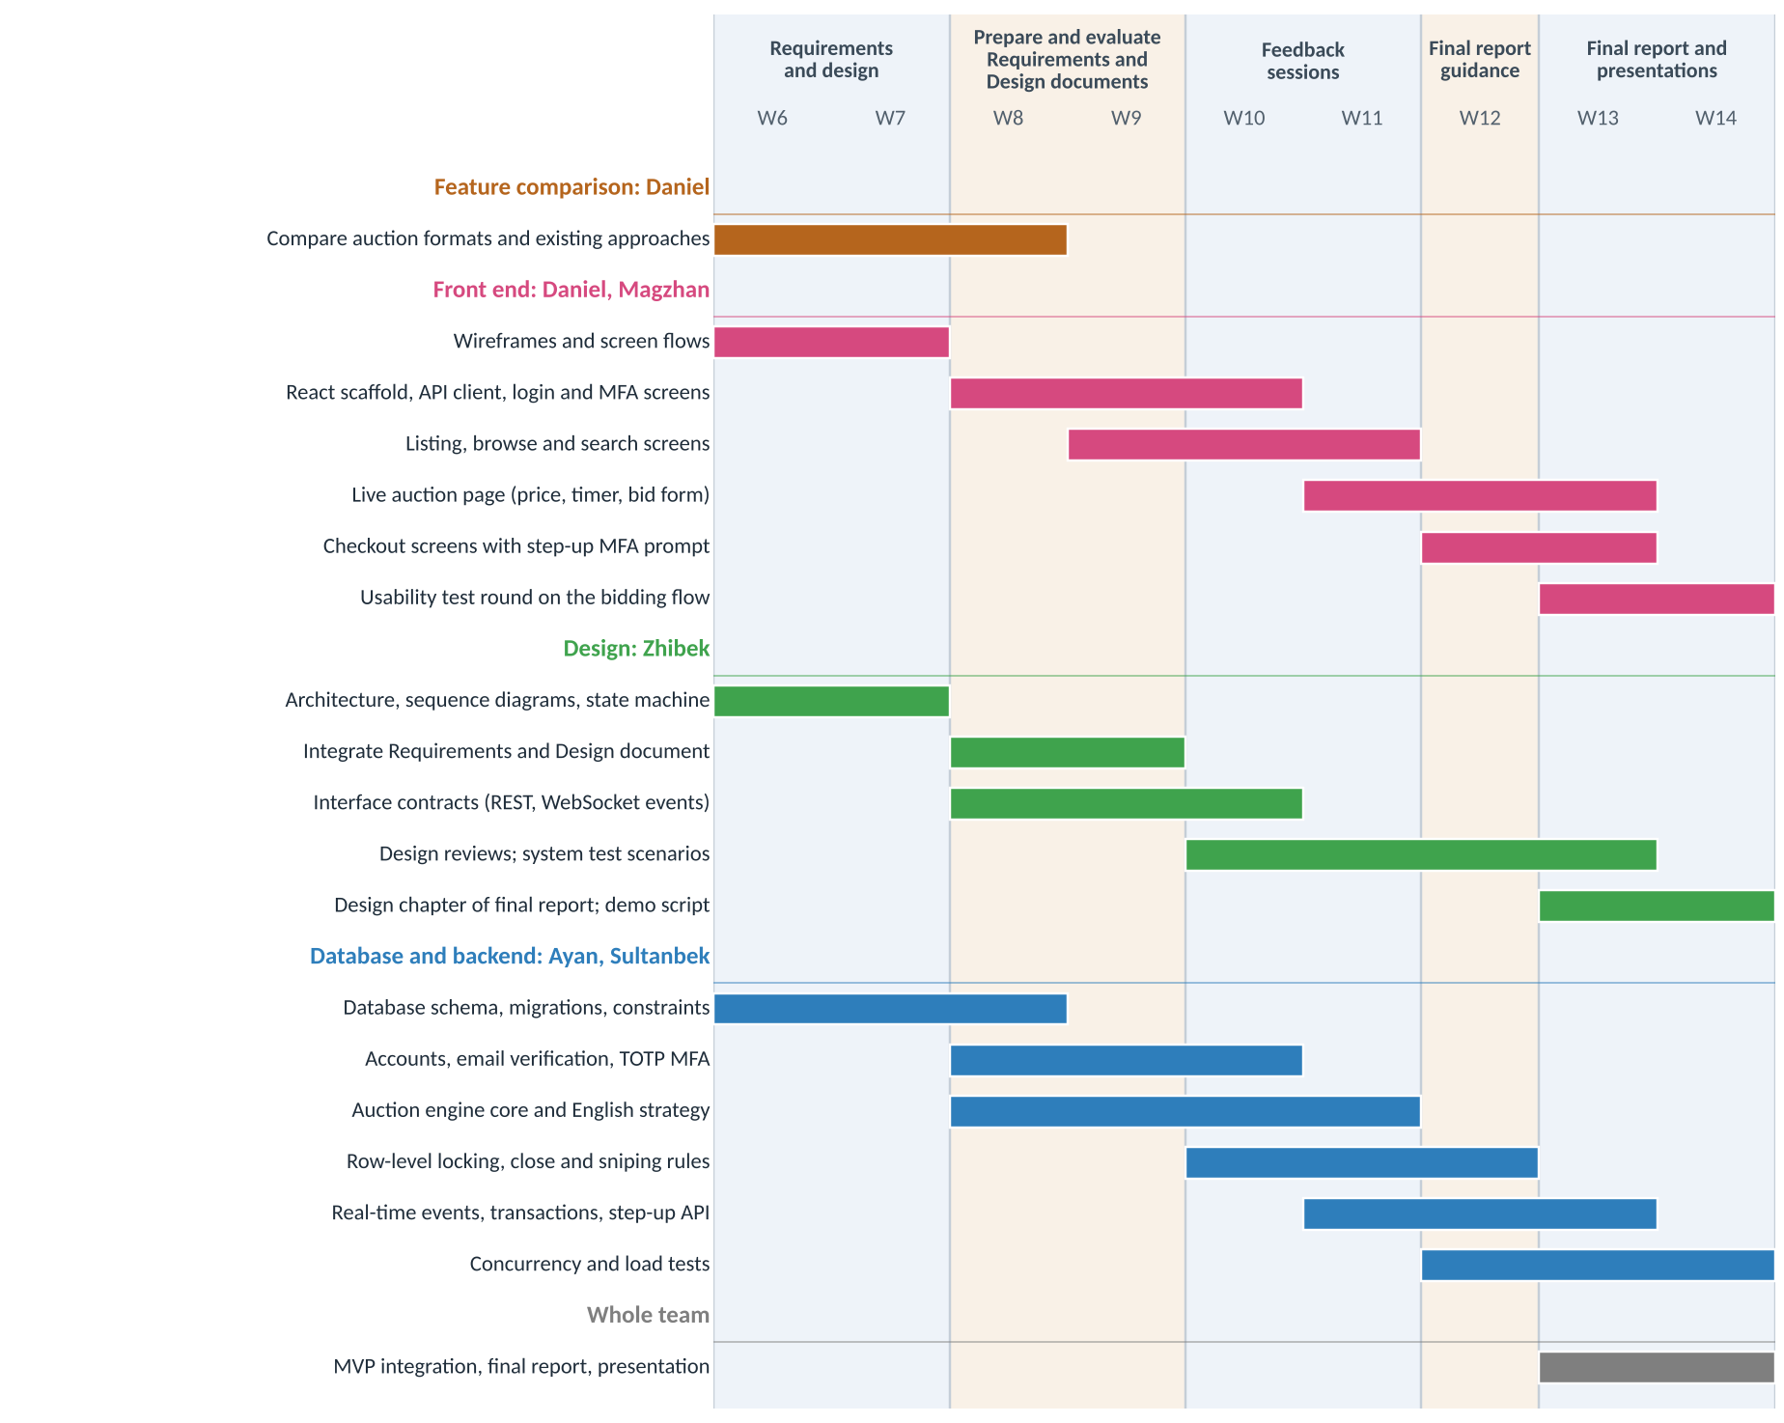
Figure 10. Task timeline, weeks 6 to 14. Every member has work in every week; there is no idle time.
4.3 Risks to the plan
Risk | Mitigation
The backend pair carries the heaviest load (engine, locking, real-time, security). | Fall scope is English auctions only; the other three strategies wait for spring. Zhibek's interface contracts (W8–10) let front end and backend work in parallel; the front end uses mock responses until the API is ready.
Concurrency bugs found late. | Concurrent-bid tests start in W10, at the same time as locking; they are not left to the end.
Open values (increment, sniping, floor, expiry) block implementation. | Each has a proposed default in this document; we confirm or change them with the advisor in the review sessions (W10–11).

Conclusion (10%)
What to expect at the end of this semester
- Documents: this requirements and design document, reviewed and updated after the advisor's feedback; the final report and presentation (W13–14).
- Working MVP: register, verify email and enable TOTP MFA; create listings and run English auctions with sniping protection; browse and search; live price updates for all watchers; automatic closing with one correct winner; transaction and checkout with step-up MFA; audit log.
- Evidence: concurrent-bid tests showing no lost or duplicate winners; a first load measurement against NFR-3 and NFR-4; a usability test of the bidding flow.
- Not yet (spring): Dutch, sealed first-price and Vickrey strategies, notifications, admin dashboard, full security and load evaluation.
Decisions to confirm with the advisor
# | Open issue | Proposed default
1 | Stack: Django with DRF and Channels, or Node. | Django with DRF and Channels.
2 | English minimum increment: fixed amount or percentage. | Fixed amount set by the seller.
3 | Sniping rule: window and extension. | 2 minutes and 2 minutes.
4 | Dutch auction floor and allowed drop-interval range. | Floor equals the reserve.
5 | Sealed bids: may a buyer revise before close? | No.
6 | Vickrey with one bid, and reserve higher than the second bid. | Winner pays the higher of second-highest bid and reserve.
7 | Reserve price confidentiality. | Hidden; English shows "reserve met" only.
8 | Performance targets NFR-3 and NFR-4 (sourced from Nielsen and RAIL; load figures are our assumption). | Confirm after the first load tests.
9 | Transaction expiry period and what happens to the item afterwards. | 48 hours; relist or offer to the next bidder.
10 | Email notifications in scope, or in-app only; time zone and currency. | In-app only; UTC; single currency.

