‘Provinces’ table of the attached ‘travelexperts’ database:

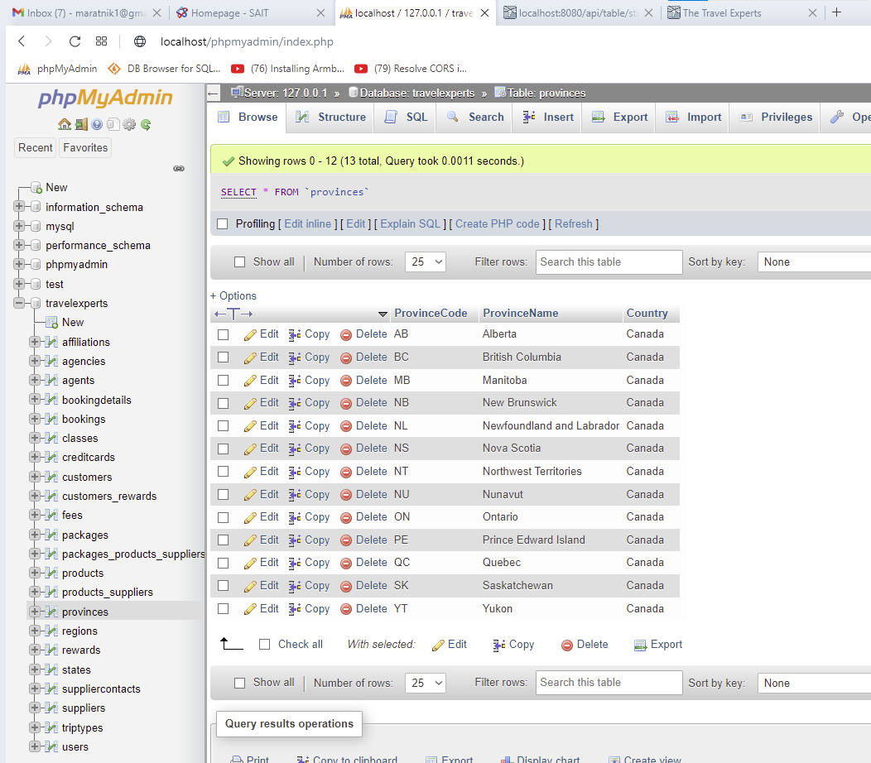

‘States’ table of the DB:

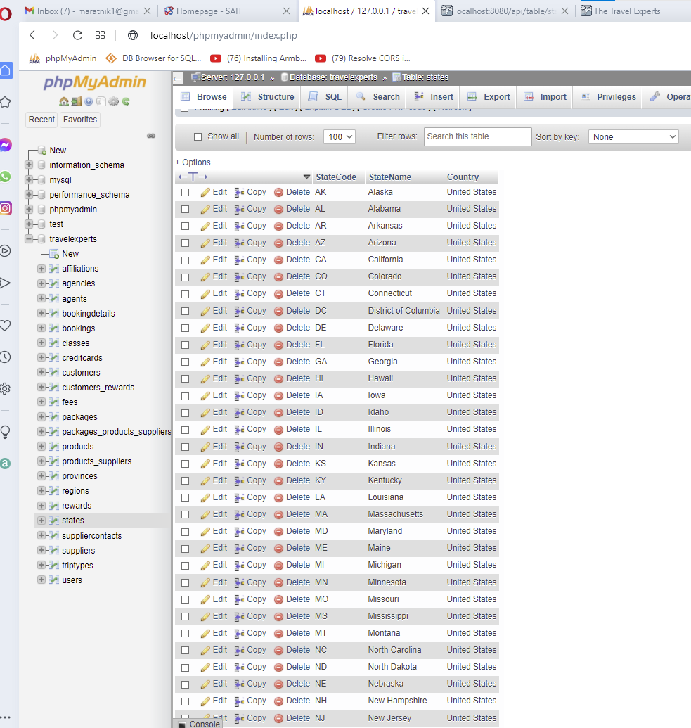

Content of the States DB table as a JSON:

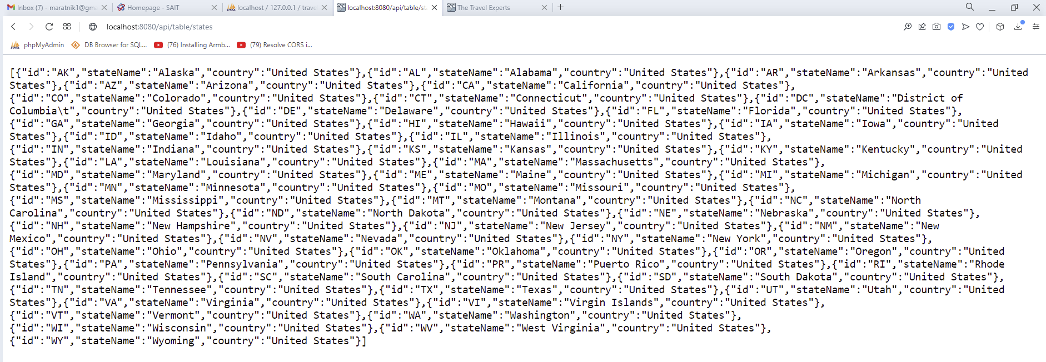

Content of the Provinces DB table as a JSON:

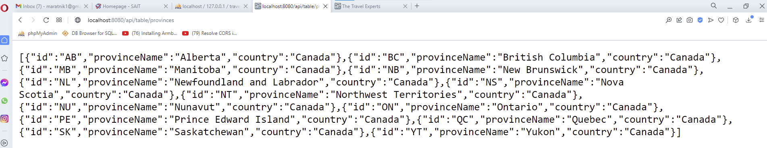

Nothing in the ‘Province/State’ dropdown list to select unless a country is selected:

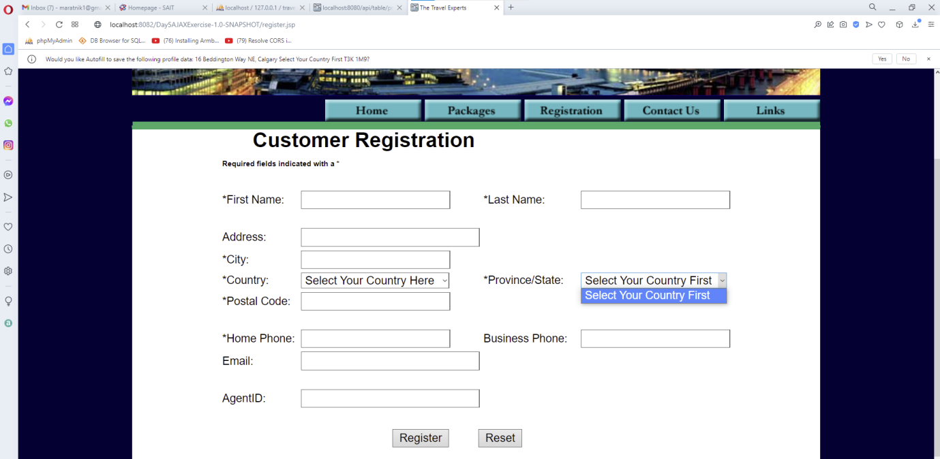

If Canada is selected, then Canadian provinces are displayed as option to select from in the ‘Province/State’ dropdown list:

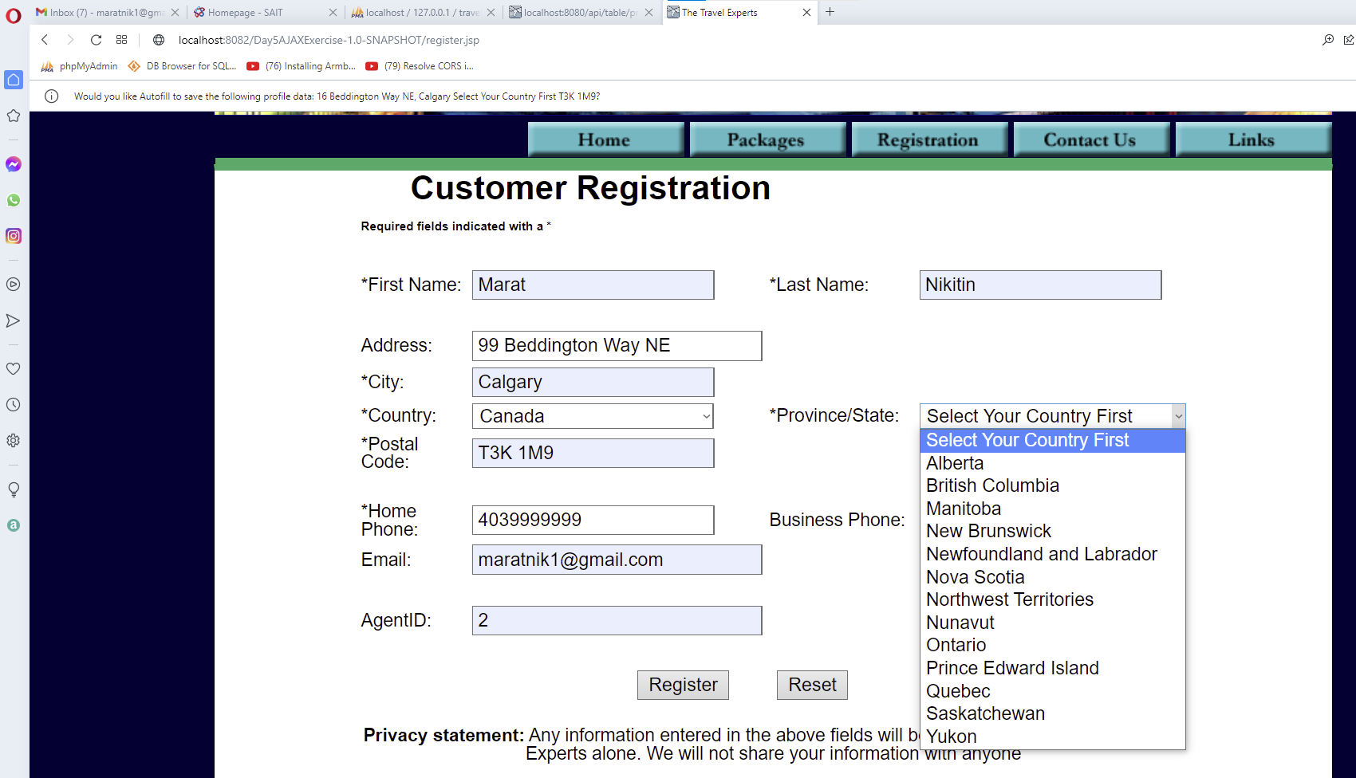

If US is selected, then US states are displayed as option to select from in the ‘Province/State’ dropdown list:

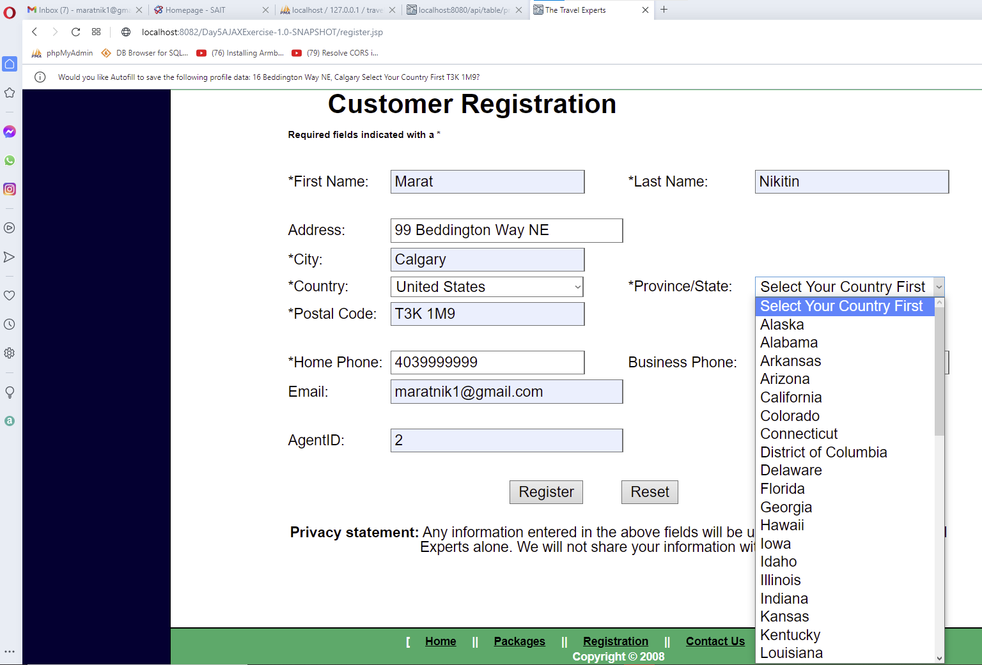

Having the uppermost line in the dropdown lists gives user instructions and helps with data validation (enforcing that Country and Province/State are consciously selected):

