Mokhotlong

Marata T.I

Monday, August 18, 2014

New Bacteriologically Confirmed TB patients 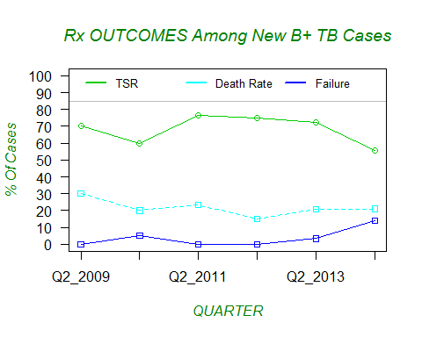 All New cases 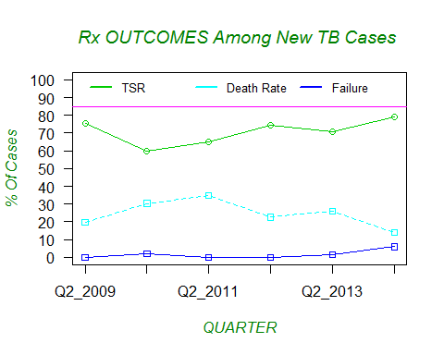 Retreatment cases 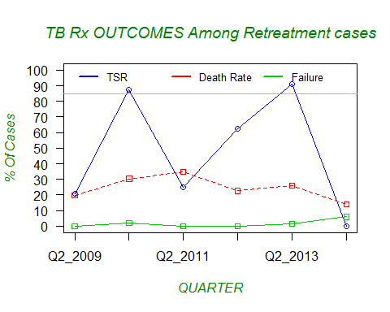

# Hiv Pos

