**SUPER RESOLUTION ENHANCEMENT WITH CONVOLUTIONAL NEURAL NETWORK AND**

**GENERATIVE ADVERSARIAL NETWORK**

**B.Ravinder Reddy**

Assistant Professor

Dept. of CSE

Anurag University

Hyderabad, India

[ravinderreddycse@anurag.edu.in](mailto:ravinderreddycse@anurag.edu.inm)

**Jagannath Rao Are**

Computer Science and Engineering,

Anurag University, Hyderabad, India.

[jagannathrao06@gmail.com](mailto:jagannathrao06@gmail.com)

**ABSTRACT**

**In this study, i compare and contrast mathematical CNN-based interpolation with generative adversarial network super-resolution. Making high-quality images from low-quality input photos is the main objective of dimension upscaling. Since VGG19 is more accurate than MSE in measuring loss, it is what is used. Conventional wisdom held that convolution neural networks (CNN) were the way to go for higher image resolution. In terms of Mean-Opinion-Score, GANs have recently surpassed CNN as the top model for producing high-quality images. Superior than SR-GAN in every way, the finished model was called enhanced Super Resolution GAN (ESR-GAN). The ESR-GAN is widely utilized in both the premastering of movies and the production of games.**

***Keywords—Generative Adversarial Networks, GAN, Deep Learning.***

**1. INTRODUCTION**

Images have a wealth of personal history for all of us. However, these photographs have low resolution. Several elements are missing, and it can't be seen on a large screen. Consequently, "premastering" is a procedure that attempts to recover as many details from hazy pictures as feasible. On top of that, it gives the greatest boost when the image is enlarged to fit greater proportions. As mentioned in [1, 2, 3], the Generative Adversarial Network (GAN) has been used to improve these tasks. The effort is based on the following: [3]. A GAN network's principal objective is to generate misleading images that seem as realistic as possible. Consequently, it may generate ultra-high-resolution pictures that, in principle, should render their creation undetectable. Several methods, including bicubic interpolation, can achieve the same result [4]. This study covers the architecture of GAN, SR-GAN, and conditional GAN. It also includes a literature review on GANs and other designs developed for use in super-resolution settings. Uncomplicated Design The term "generative adversarial network" describes a combination of two networks used in deep learning models. included in the 2014 presentation by Ian and colleague [5] The generative network is represented by GAN. We all have our own unique objectives. A generative network's end result should be very similar to the input data. When comparing real and fake photos, the Discriminator looks for discrepancies. The discriminator and generator are often trained in tandem in each batch and epoch, as is the case with us. At least from a distance, it looks like they're practicing to fight each other. Plus, they aren't working toward the same objectives. Upon further examination, however, this perspective can be perceived as very cooperative [6]. On top of that, the generator gets smarter with each false positive, so it may adapt to the discriminator input and get better outcomes overall. But the generator gets more powerful and more convincing as it tricks the discriminator. Once training is complete, the discriminator network is disabled and new examples are generated by means of the generator network. To feed the generative adversarial network, just send it random noise. But that's not the case with the high-resolution task. F1 and its objective function define GAN training.

GANs, comprising a generative and a discriminative network, operate in tandem, with the generator aiming to mimic input data and the discriminator detecting discrepancies between real and generated images. Despite their apparent adversarial relationship, this cooperation enhances the generator's ability to produce convincing images by learning from false positives. Post-training, the discriminator is bypassed, allowing the generator to autonomously generate new examples from random noise, a departure from its initial training method.

**2. LITERATURE SURVEY**

**chenyu, et al** **[1]** Then we detail a semi-supervised deep learning approach that successfully separates high-resolution (HR) CTfilm land from their low-resolution (LR) cousins. Specifically, we use the generative inimical network (GAN) as its foundation to produce a nonlinear end-to-end mapping that uses the Wasserstein distance to enforce cycle consistency, going from noisy LR input photos to de-noised and de-blurred HR labors.we also include the common limitations in the loss function to help with structural preservation. For point birth and restoration, we employ network-in-network ways, deep convolutional neural networks (CNNs), and residual literacy. In discrepancy to the current trend of adding network depth and complexity to increase imaging performance, we optimize the number of layers and filters for each convolutional subcaste and compress the affair of the retired subcaste using a resemblance 1 × 1 CNN.

**Ledig, Christian, Et Al** **[2]**

Despite significant advancements in the realm of single-image super-resolution achieved through the adoption of deeper and faster convolutional neural networks, a critical question remains unanswered: how can we effectively recover fine texture details when dealing with considerable upscaling factors? The efficacy of optimization-based super-resolution approaches hinges on the careful selection of the objective function. While recent endeavors have primarily aimed at minimizing mean squared reconstruction errors, resulting outputs often exhibit high peak signal-to-noise ratios but fall short of delivering the perceptual fidelity expected at higher resolutions, lacking in high-frequency characteristics. Our research introduces SRGAN, a generative adversarial network (GAN) tailored specifically for super-resolution (SR) tasks. To our knowledge, this stands as the sole system capable of upscaling images by a factor of 4 without compromising the ability to generate photorealistic natural images. This achievement is made possible through the integration of a perceptual loss function that amalgamates adversarial and content losses. The adversarial loss drives the model towards the natural image manifold by leveraging a discriminator network trained to distinguish between original photorealistic images and their super-resolved counterparts. Additionally, we adopt a perceptual similarity-driven content loss, departing from the conventional pixel-space similarity-driven approach.

**Brunet, Dominique, Edward R** **[3]** Since the introduction in the year 2004, the structural similarity index (SSIM) has become an indispensable tool for assessing the efficacy of algorithms and systems of image processing, as well as the quality of individual photographs. The usage of SSIM as a goal function for optimization problems is investigated with increased number of image processing applications. A major roadblock that can impede these efforts' progress is due to not being able to understand the mathematical properties of SSIM measure. For instance, it's possible that desirable properties, like convexity and triangular inequality, which are lacking in the mean squared error. First, we build a set of generalized and normalized (vector-valued) metrics in this work using the essential components of SSIM as a basis.

**Wang, Zhou, Et Al** **[4]** The appearance of defects, or differences, from a base image to a distorted counterpart. has traditionally been measured using a variety of well-established visual system features as the basis for objective methods for assessing perceptual picture quality. Assuming that visual perception is a strong fit for extracting structural information from scenes, we offer an alternative additional paradigm for quality evaluation that relies on the degradation of structural information. To demonstrate the concept in action, we construct a structural similarity index and provide many illustrative examples that highlight its promise.

**Jia, Kui, And Shaogang Gong** **[5]** Present day learning-based face super-resolution (hallucination) approaches create high-resolution images from a single face modality through training. ( in a specific location, with a fixed expression, and with lighting) by utilizing one or more low-resolution shots of the face as a probe. In this paper, we detail an enhanced approach to hallucinating multi-modal high-resolution face images using a way of organizing data in layers using multidimensional structures called tensors. Extensions to expression and location alterations are made possible by this. Specifically, we create combined tensor that will split into double: one for model mappings between different modalities of face, and another that includes high-resolution picture data into patch-based multiresolution tensor. By continually matching a face being examined to its likeness among a collection of training face images., we construct an automated alignment of face system able to do alignment pixel-wise. This allows for practical hallucinations of low-resolution faces present in original photos.

**3. SYSTEM ANALYSIS**

**3.1 EXISTING SYSTEM**

Utilizing GANs for super-resolution involves a systematic approach encompassing data preparation, architectural selection, and GAN training with adversarial and perceptual loss functions. Performance evaluation and application in real-world settings play crucial roles in refining these methods and assessing their practical utility. The ongoing emphasis in research is on enhancing the quality and efficiency of super-resolution enhancement techniques. Researchers are exploring various avenues to optimize data processing, fine-tune network architectures, and devise innovative training strategies. Additionally, advancements in performance evaluation metrics contribute to a deeper understanding of the capabilities and limitations of GAN-based super-resolution methods. Ultimately, the aim is to develop robust and versatile techniques that can seamlessly integrate into diverse real-world applications across domains such as healthcare, surveillance, and entertainment

**3.2 PROPOSED SYSTEM**

Employing GANs for super-resolution involves several key steps, including data preparation, architecture selection, and training with adversarial and perceptual loss functions. Performance evaluation and consideration of real-world applicability further refine these methods, guiding their development. Ongoing research endeavors are dedicated to enhancing the efficacy and quality of super-resolution techniques, aiming to push the boundaries of visual enhancement. These efforts encompass refining data processing techniques, optimizing network architectures, and devising novel training strategies. Moreover, advancements in performance evaluation metrics contribute to a deeper understanding of model capabilities and limitations. Ultimately, the goal is to develop robust and versatile super-resolution methods that can be seamlessly integrated into various real-world applications, spanning diverse domains from healthcare to surveillance.

**4. ARCHITECTURE**

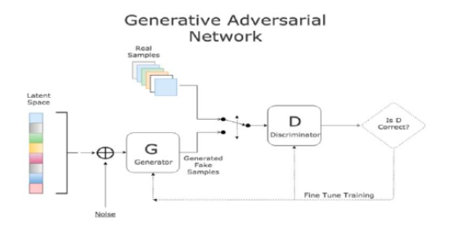

Fig.1.architecture

**5. ALGORITHAMS**

**5.1 SUPER RESOLUTION GAN**

The super-resolution GAN gets around the information inequality principle by filling in the gaps with learned data from the dataset source.

To predict and interpolate the missing features for the unseen photographs, it is required to generalize the dataset's data. The SR-GAN makes use of two optimization functions: the VGG19 loss and the MSE. However, the VGG19 is given far greater weight, and the MSE error is almost disregarded.

With AN (C-GAN), the problem of GAN control may be solved. Just as in plain old GAN, the output image is completely out of your hands. In order to train the GAN's latent space to output images with certain attributes, the conditional GAN is used. In the case of super-resolution, the generative adversarial network relies on the original image. The source picture, which is low-resolution, needs an upgrade [6, 7]. The Subjective GAN was first proposed by Mirza et al.

**5.2 SUPER RESOLUTION CNN**

When it comes to super-resolution imaging, SRCNN recommends a three-layer CNN. When it comes to super-resolution photo problems, this article is one of the first to apply deep neural networks. Extraction of feature, mapping non-linearly and rebuilding are three components that comprise the SRCNN architecture. Reducing MSE with original picture And reconstructed pictures is the primary objective of the model training process. The research swaps out several model topologies and hyperparameters for better performance and speed. Extraction of feature, Mapping non-linearly and rebuilding are three conceptual components that comprise the proposed architecture. It is within their domain to extract low-resolution data, transform it into high-resolution features, and then recreate it. The low-resolution image is bicubic interpolated into Y such that its dimensions match those of the high-resolution picture, X. A mapping is what the model aims to learn.

**6. RESULTS**



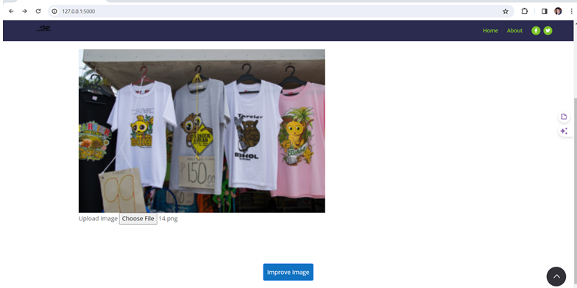

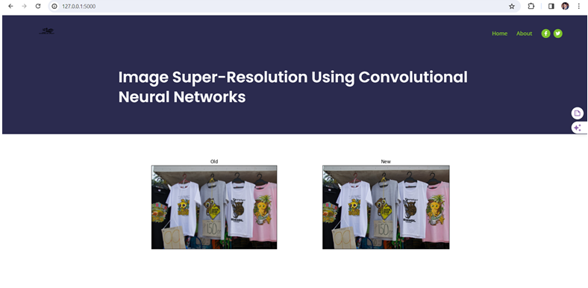









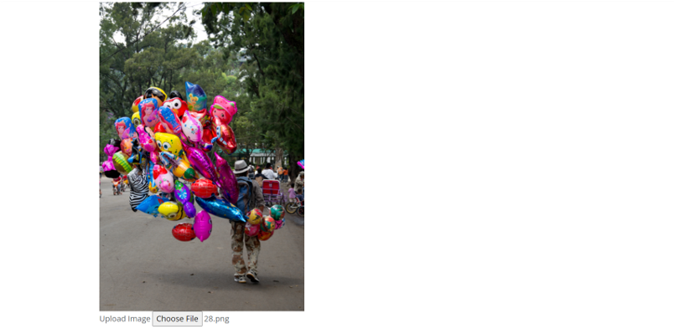

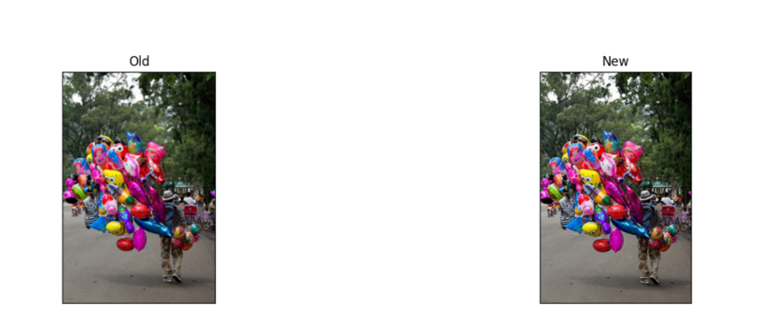

**7. CONCLUSION**

Thanks to the super-resolution challenge, we can see that the GAN is working. As far as research is concerned, it remains an active and unexplored area. When handling sensitive data, the results of any learning base, including GANs, cannot be trusted due to the data processing inequality principle. When pitted against the SR-CNN, the generative adversarial networks performed better on the Mean Opinion Score measure. Reason being, the mean squared error loss forms the basis of SR-CNN's architecture. It became discovered that compared to the MSE loss, the VGG loss was better. The SR-GAN, which borrows heavily from ResNet, makes use of loss VGG. To enhance the design, ESR-GAN later employed pre-activation VGG-loss with a weighted average with MSE loss, additional layers, and a relativistic discriminator. So, it combined the two metrics that worked best by using the idea of deep network interpolation. One type of super-resolution that was considered was single-source super-resolution, as opposed to multiple-frame super-resolution. They also proved that a super-resolution architecture should be approved if it has a specific main purpose. Video games and movie remasters are only two of many applications for the versatile super-resolution. Lastly, it's said to be used in RTX GPUs today for improved performance and higher frame rates.

**REFERENCES**

[1] Bulat, Adrian, Jing Yang, and Georgios Tzimiropoulos. "To Learn Image Super-Resolution, Use a GAN to Learn How to Do Image Degradation First." *Proceedings of the European Conference on Computer Vision (ECCV),* 2018.

[2] You, Chenyu, et al. "CT Super-Resolution GAN Constrained by the Identical, Residual, and Cycle Learning Ensemble (GAN-CIRCLE*)." IEEE Transactions on Medical Imaging* 39, no. 1 (2019): 188-203.

[3] Ledig, Christian, et al. "Photo-Realistic Single Image Super-Resolution Using a Generative Adversarial Network*." Proceedings of the IEEE Conference on Computer Vision and Pattern Recognition,* 2017.

[4] Jing, Liu, Gan Zongliang, and Zhu Xiuchang. "Directional Bicubic Interpolation-A New Method of Image Super-Resolution*." Proceedings of ICMT, Atlantis Press* (2013): 470-477.

[5] Goodfellow, Ian, et al. "Generative Adversarial Nets." *Advances in Neural Information Processing Systems 27* (2014): 2672-2680.

[6] Brownlee, Jason. *Generative Adversarial Networks with Python: Deep Learning Generative Models for Image Synthesis and Image Translation*. Machine Learning Mastery, 2019.

[7] Mirza, Mehdi, and Simon Osindero. "Conditional Generative Adversarial Nets." *arXiv Preprint arXiv:1411.1784* (2014).

[8] Tian, Chunwei, et al. "Lightweight Image Super-Resolution with MEnhanced CNN." *Knowledge-Based Systems* 205 (2020): 106235.

[9] Brunet, Dominique, Edward R. Vrscay, and Zhou Wang. "On the Mathematical Properties of the Structural Similarity Index." *IEEE Transactions on Image Processing* 21, no. 4 (2011): 1488-1499.

[10] Wang, Zhou, et al. "Image Quality Assessment: From Error Visibility to Structural Similarity*.*" *IEEE Transactions on Image Processing* 13, no. 4 (2004): 600-612.

[11] Wang, Xintao, et al. "ESRGAN: Enhanced Super-Resolution Generative Adversarial Networks." *Proceedings of the European Conference on Computer Vision (ECCV) Workshops,* 2018.

[12] Simon, Marcel, Erik Rodner, and Joachim Denzler. "ImageNet Pre-Trained Models with Batch Normalization*.*" *arXiv Preprint arXiv:1612.01452* (2016).