

**JSC “Kazakh British Technical University”**

**School of Mathematic and Cybernetics**

    Analysis of Data Bases

**Laboratory Work #1**

**Prepared by: Maratuly Temirbolat**

**Almaty 2020**

**Main Content:**

**Exercise**

Create Three Tables as it shown below and insert the corresponded rows

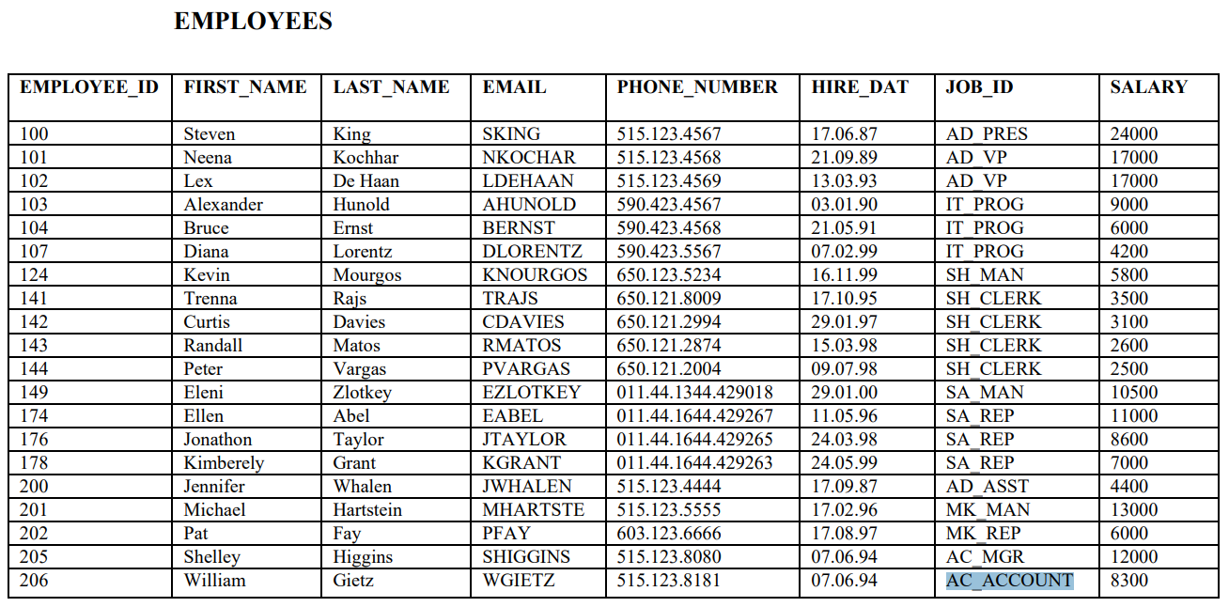

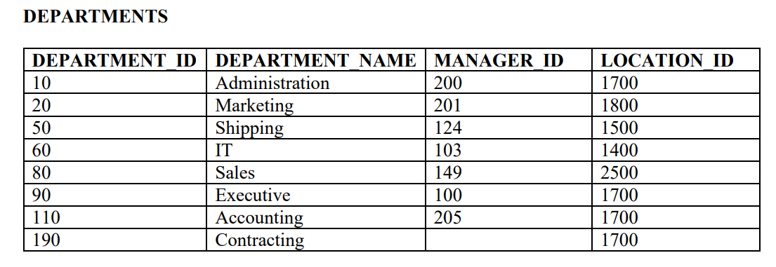

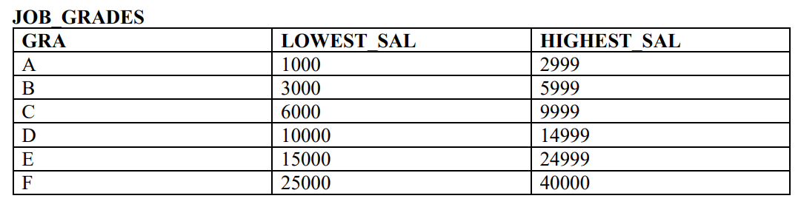

**Solution:**

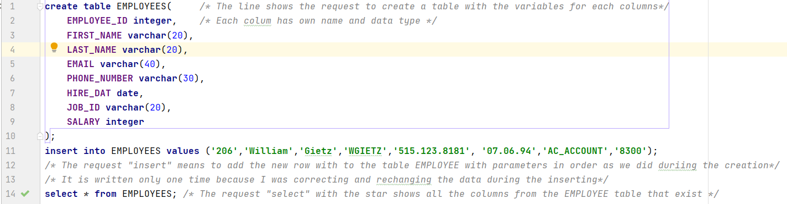For the first Table:

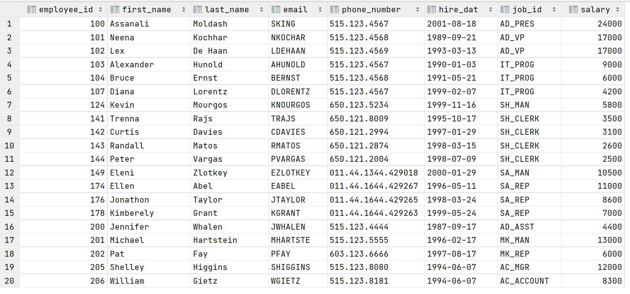Result:

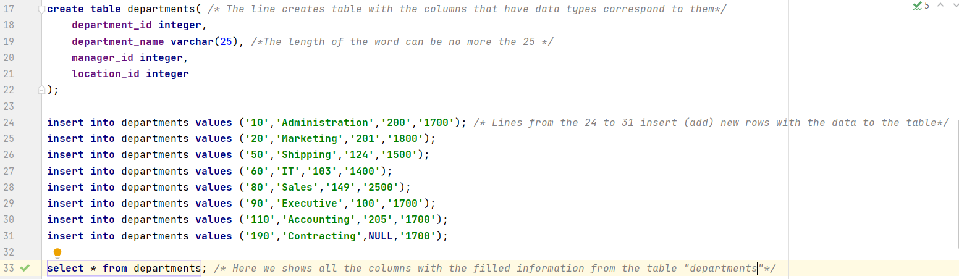For the Second:

The Resulted Table:

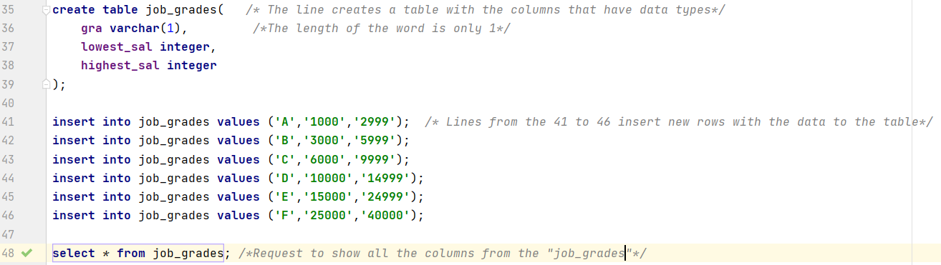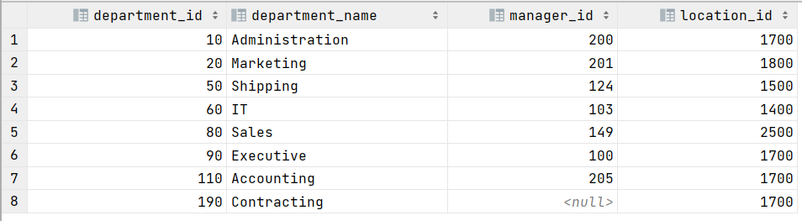For the Third Table:

The resulted table is:

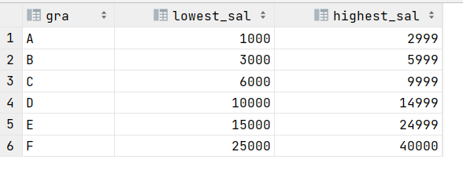

**Exercises:**

**1.** The Human Resources (HR) department needs data including id, first name, last name, hiring date and salaries of all employees

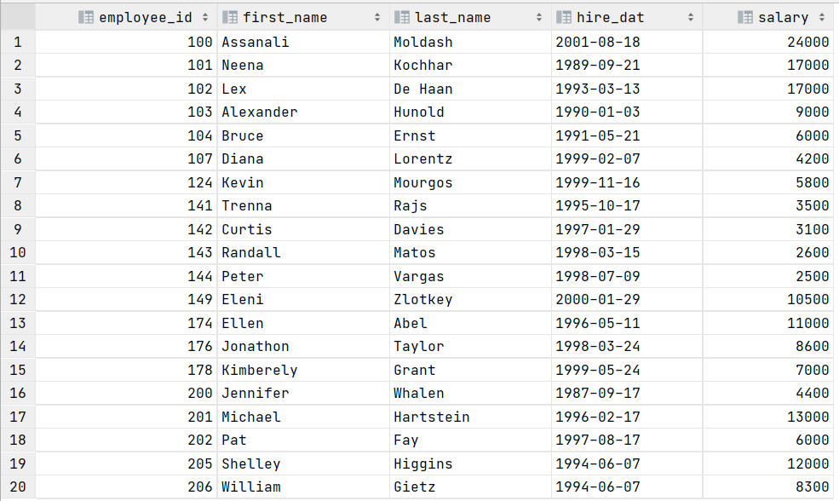

**2.** Write a query to display id, first names, last names, email, annual salaries of all empl

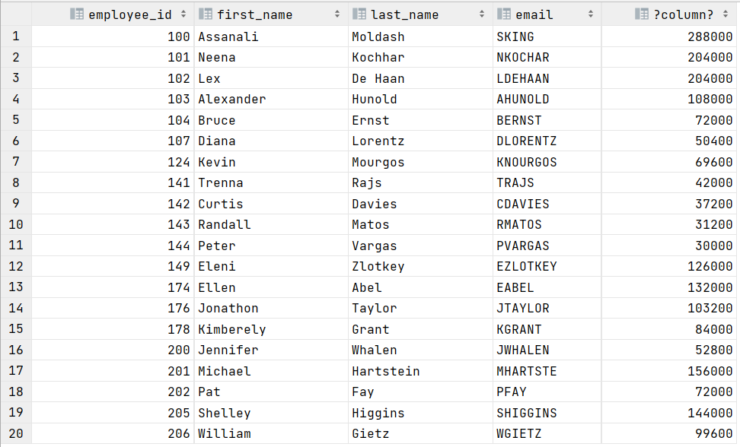

**3.** The Human Resources (HR) department requests data for all unique jobs from the EMPLOYEES table. Job IDs should not be repeated in the output.

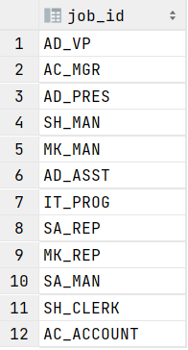

**4.** Due to funding problems, the HR department needs a report that provides all the information about the programmers whose salaries are over 5000

**5.** Generate a report to display the id, last name, first name, and job title of all employees whose salaries range from 4000 to 7000.

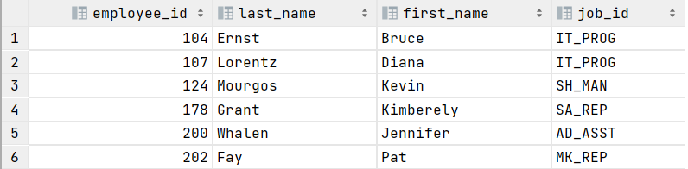

**6.** The HR department needs data on high-paid and low-paid employees. Write a query to display the last names, first names, and salaries of all employees whose salaries are outside the range from 3000 to 9000.

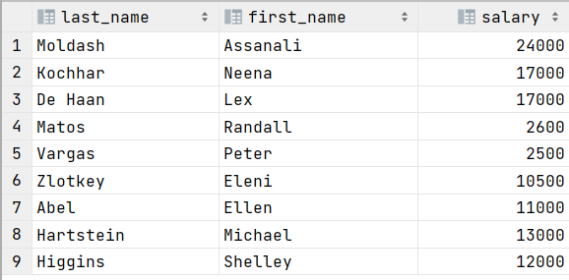

**7.** Write a query to display id, last names, first names, annual salaries of those employees whose salaries are below 10000.

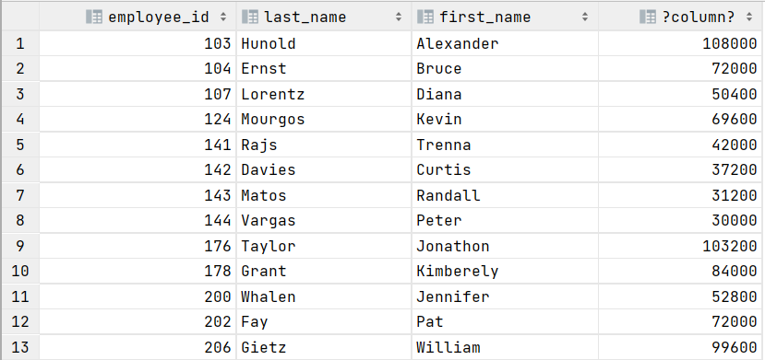

**8.** Write a query to display id, last names, salaries of those employees whose salaries are in the range from 4000 to 7000 using the BETWEEN ... AND command and explain the difference between this task and task #5.

The Difference between these two tasks is that in 5-th we used typical conditions (>= ,<=) with the binary statement as (AND) to determine the range using mathematical point of view, but in 8-th exercise we used “Between… AND… ” command to determine the range having the correspondent function. This is also suitable for texts, dates.

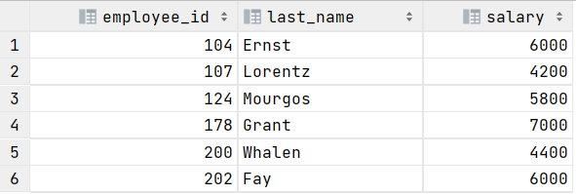

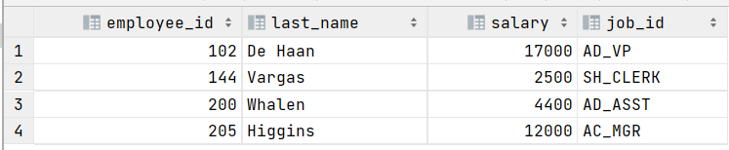**9.** Write a query to display id, last names, salaries, job title from the list of id «144, 102, 200, 205».

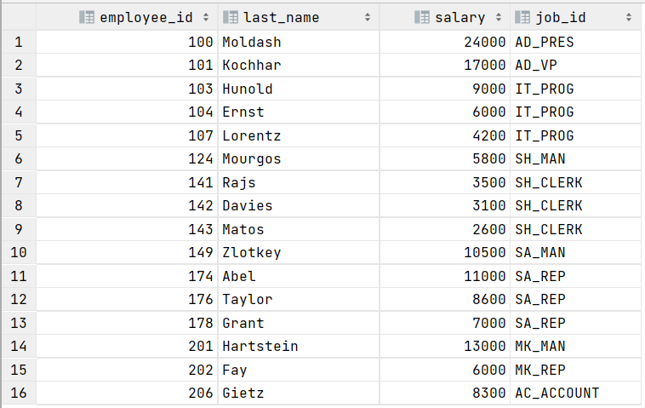**10**.Write a query to display id, last names, salaries, job title not from the list of id «144, 102, 200, 205».

**11.** Write a query to display id, last names, first names, salaries of those employees whose names begin with the letter D.

**12.** Write a query to display all the names of employees in which the third letter is A.

For ‘A’ (Capital A)

No correspondent data in the table

For ‘a’ (small a):

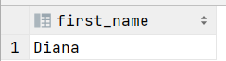

**13.** . Write a query to display id, last names, names, email, salaries of those employees whose names end with a letter N.

For Capital ‘N’. We get Empty Table



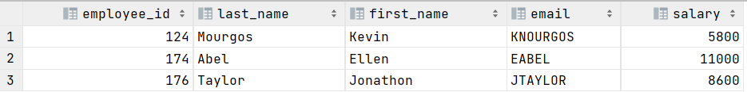For small ‘n’.

**14.** Write a query to display id, last names, email, salaries of all employees, sorting their salaries in ascending order

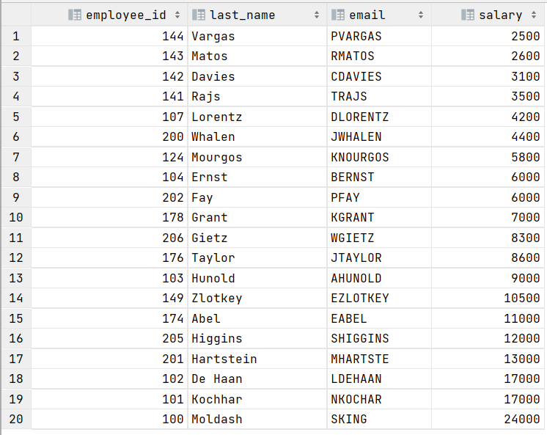

**15.** Write a query to display id, last names, names, salaries of all employees, sorting their id in descending order

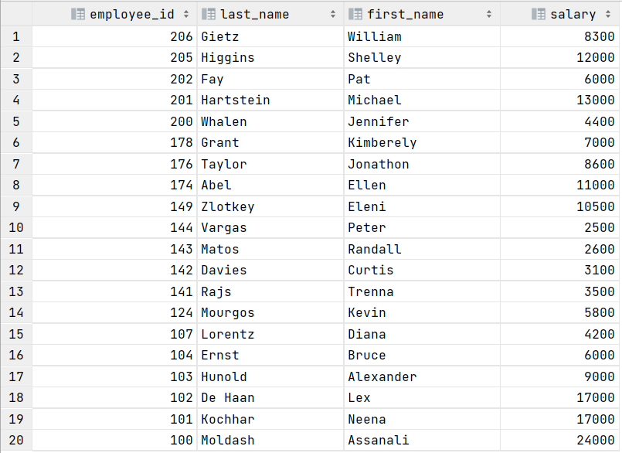

**16.** Write a query to display the average, maximum, minimum and the sum of all programmers' salaries.



**17.** Write a query to display the number of programmers.

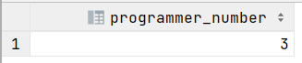

**18.** Write a query to display the number of unique professions.

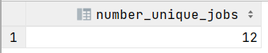

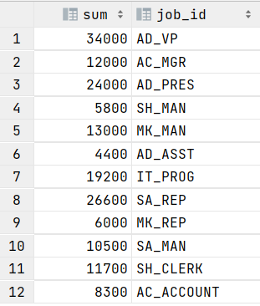**19.** Sum the salaries in the EMPLOYEES table for each job title.

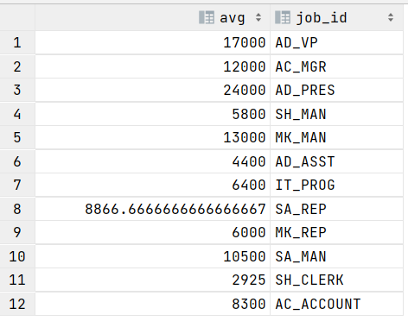**20.** Find the average salaries in the EMPLOYEES table for each job title.

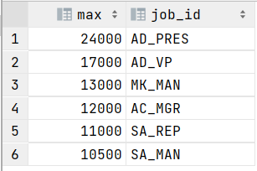**21.** Find the maximum salaries in the EMPLOYEES table for each job title that exceed 10,000 and sort them in descending order.

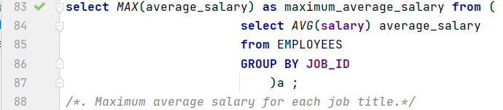**22.** Find the maximum average salary for each job title.



**23.** Receive a report for each employee in the following form: “last name” earns “salary” per month, but wants “triple salary”. Name the column Dream Salaries.

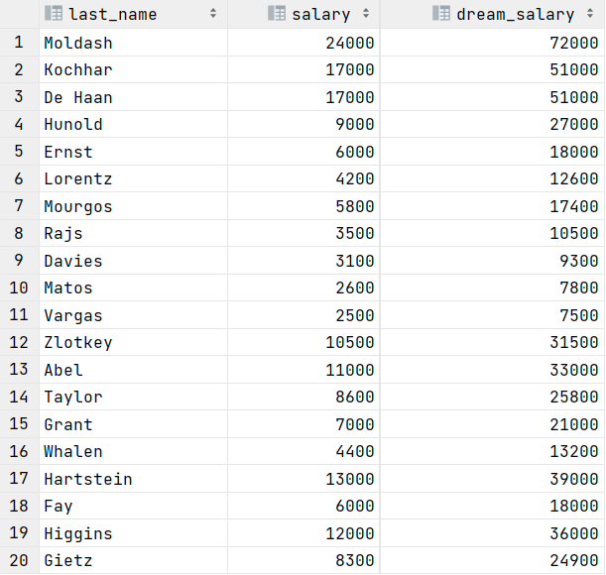

**24.** Write a query to display the last name, first name and the number of letters in the first name of employees.

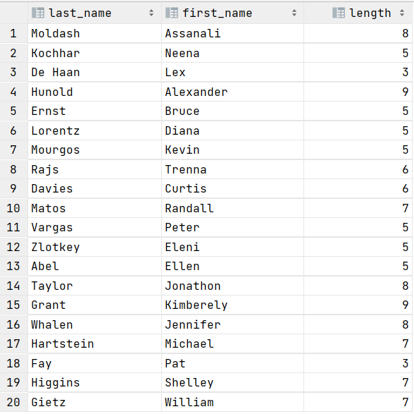

**25.** Write a query to display the full names of employees (last name + first name), separated by only one space, into a common column and name it "Employee_name".

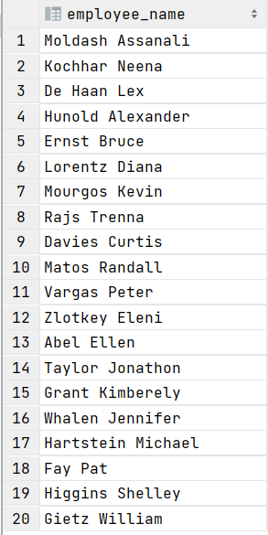

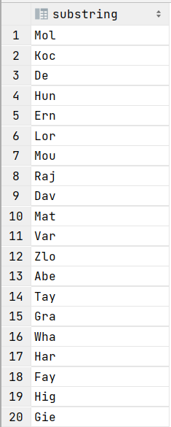**26.** Write a query to display the first three letters in the last names of employees.

**27.** Write a query to display the letters in the first names of employees in reverse order.

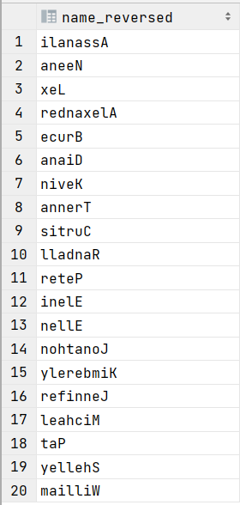

**28.** Replace "en" characters in the first names of employees with "yu" characters.

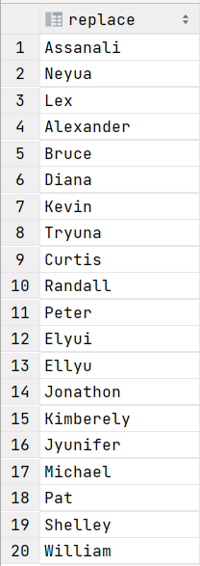

**29.** Convert all letters in the last names of employees to uppercase.

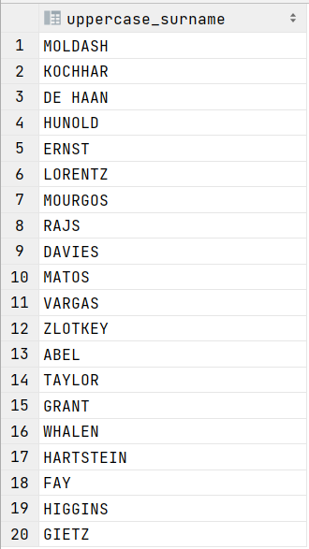

**30.** Make 23 Exercise more complicated with Adding new Column “dream_salary” into your table and then Update this table assigning to the column triple salary of each employee.

