

**JSC “Kazakh British Technical University”**

**School of Mathematic and Cybernetics**

    Analysis of Data Bases

**Laboratory Work #12**

**(Python)**

**Prepared by: Maratuly Temirbolat**

**Almaty 2021**

**Short Description:**

The main task of this Laboratory work is to investigate the interface with the connection of Database and opportunities to do defined activities for determined users.

The Laboratory work was done using OOP(Object Oriented Programming) principle. It means that we used classes (University System, Admin including User), methods (check password, create user, find user and so on) along with corresponded attributes (number id, name, surname, login, password etc.)

The program has to distinguish users and admins providing appropriate list of all possible activities respectively.

There must be appeared Errors if something was typed wrong (login of the user, password etc.) or requirements for the password or user may not exist.

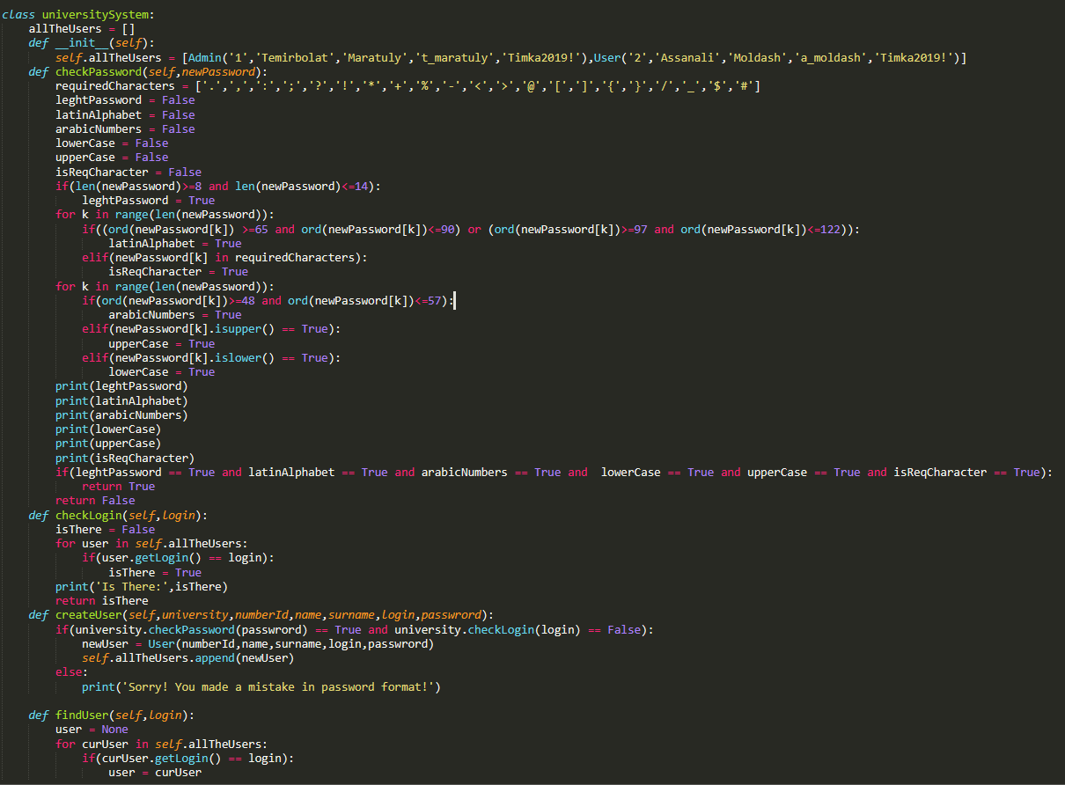**The code of the Classes:**

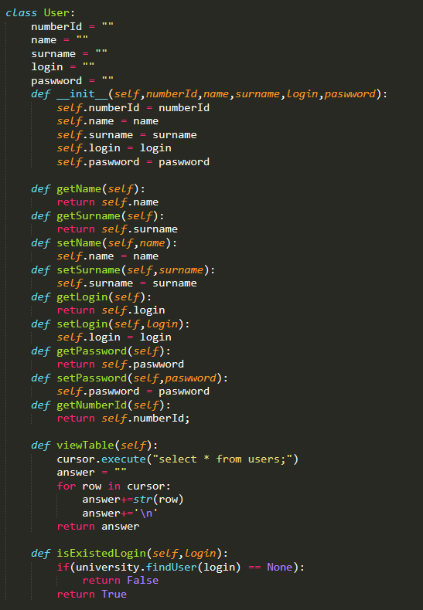**The code for User Class:**

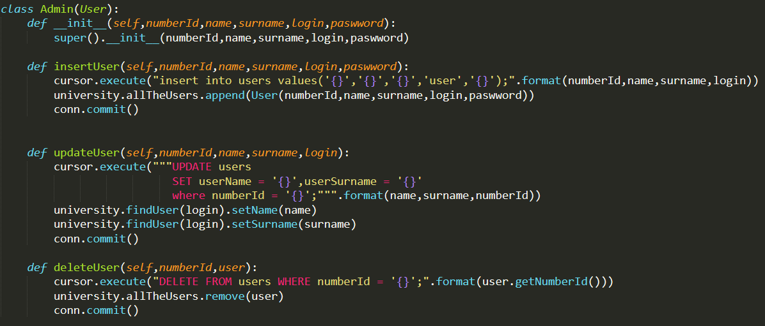**The code for Admin class that has inheritance from User:**

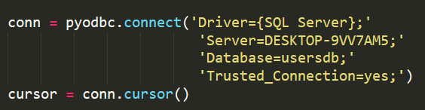**The code for connection with Microsoft Server DBMS:**

**Some methods(functions) for interface realization:**

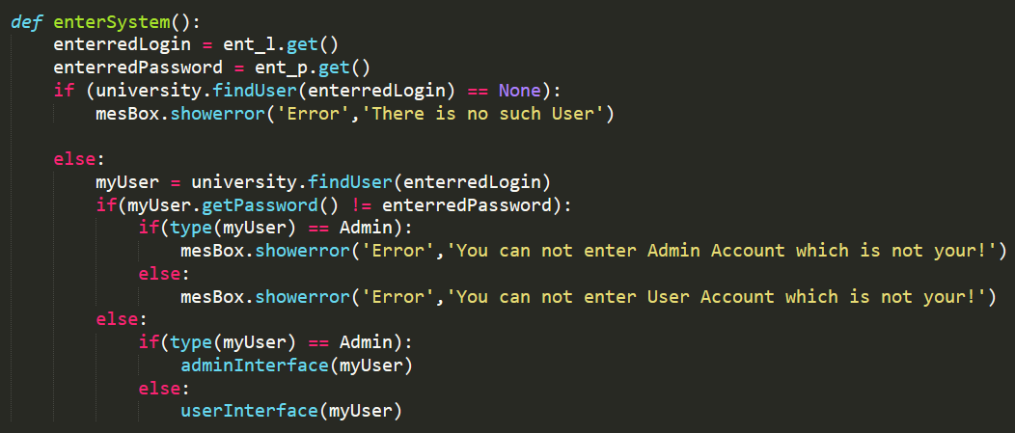 **To Enter the System:**

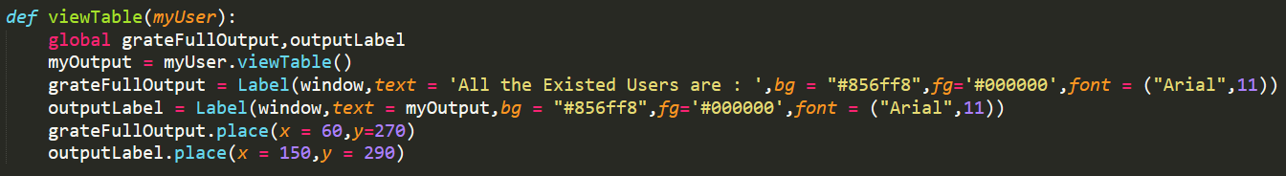 **To view all the existed Users:**

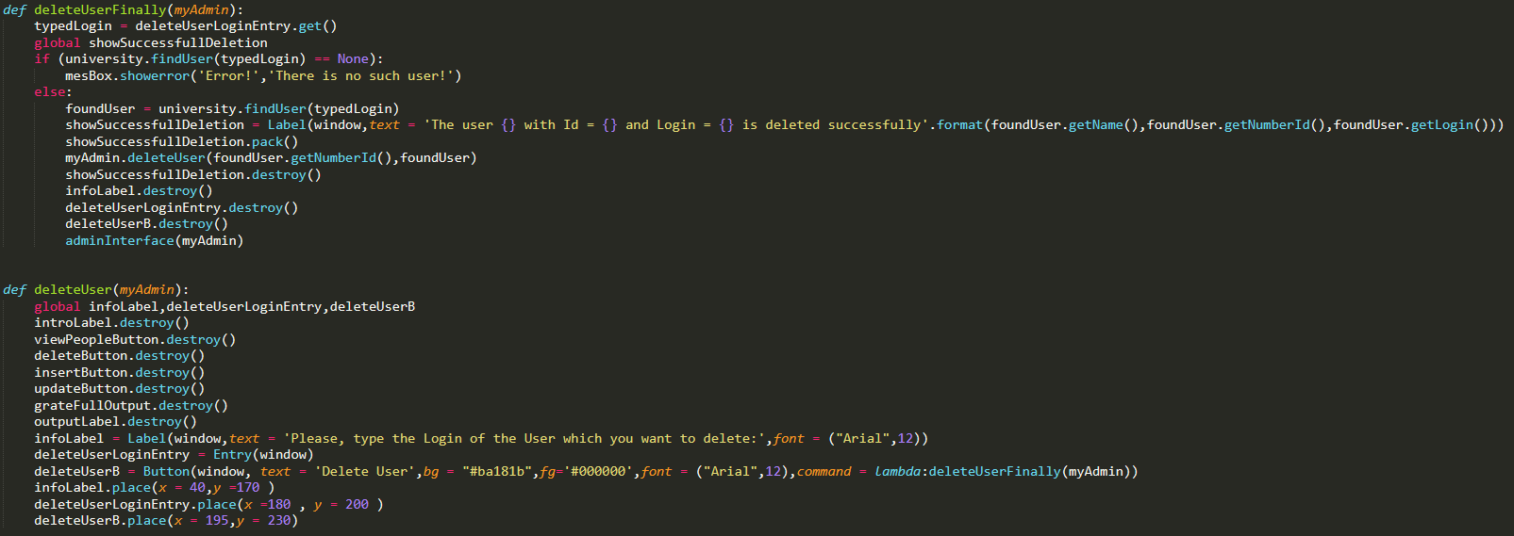 **To Delete any Existed User:**

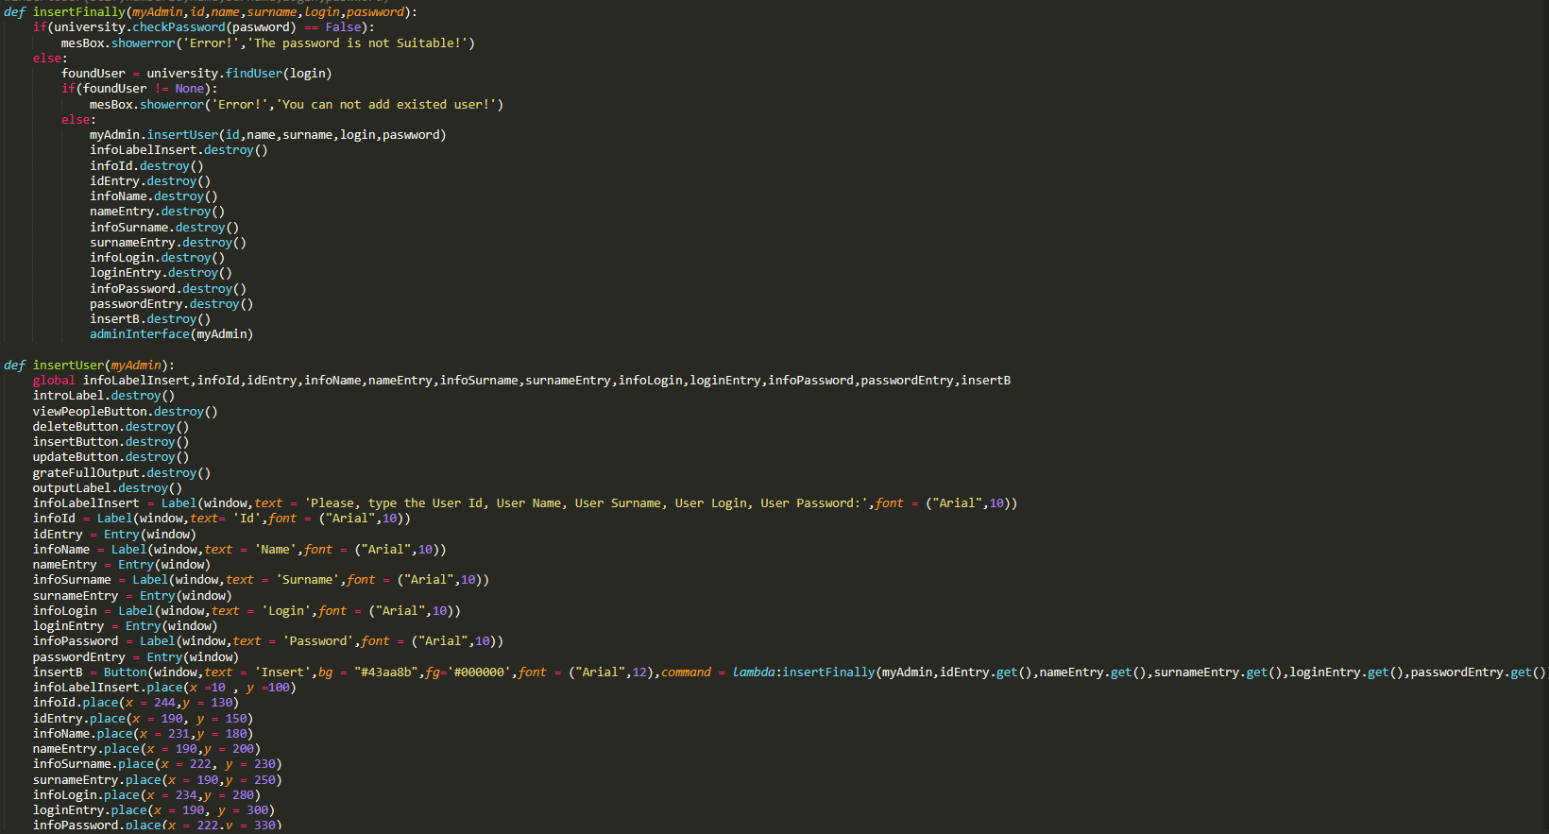 **To insert a user into the System By Admin:**

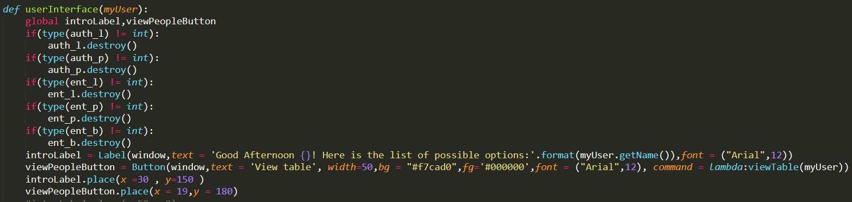 **The view for User’s interface:**

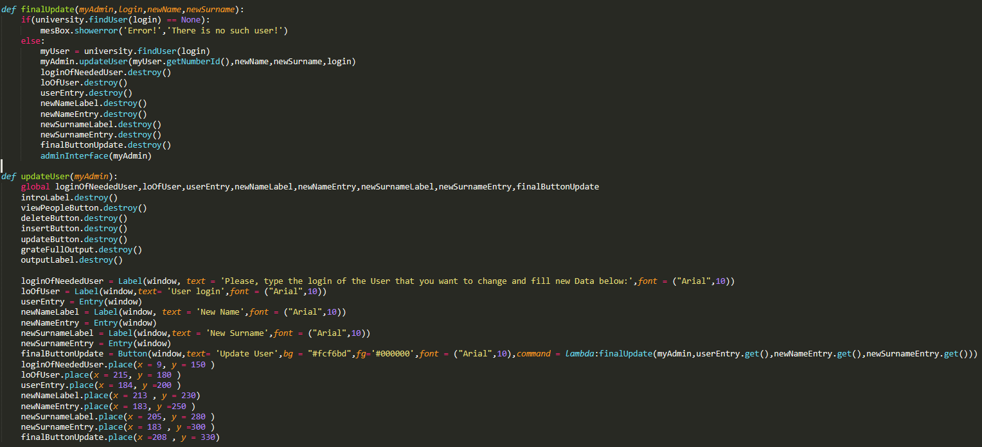 **To Update information about User:**

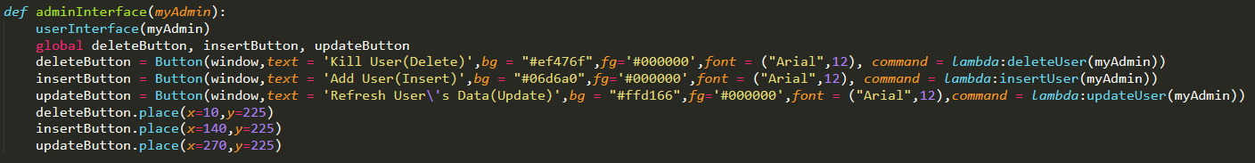 **Admin’s Interface:**

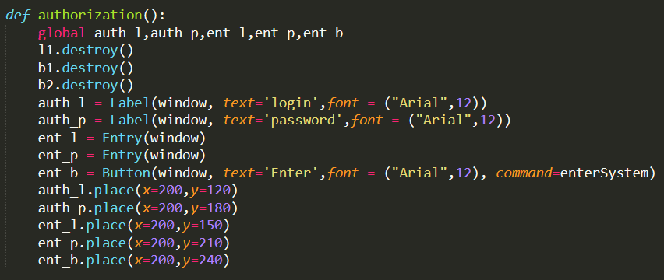**To log in the System:**

**Working Principle of the program:**

**There are 2 included users(Admin- Temirbolat, User – Asanali) in advanced**

1. **Main Menu:**

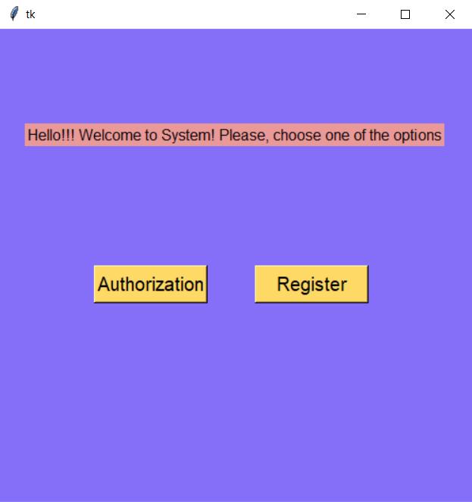

**Here we can choose one of 2 options:**

**1) Autorization 2) Registration**

**Let’s firstly Try to register a new User:**

1. 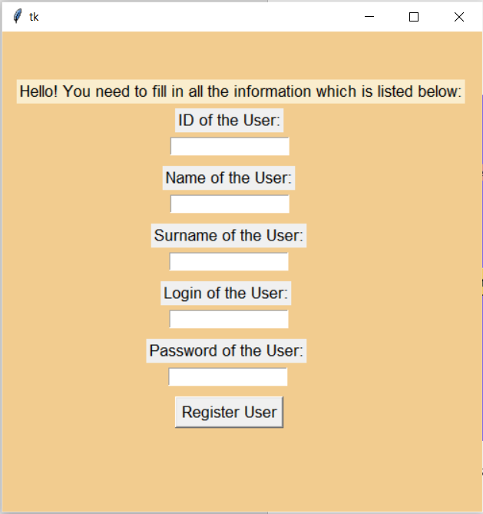**User’s Registration by himself:**

Here we see another opened window which meets us with message and asks to fill the gaps with required information. Let’s type the information for new User but instead of new Login we write already existed. The corresponded Error must appear.

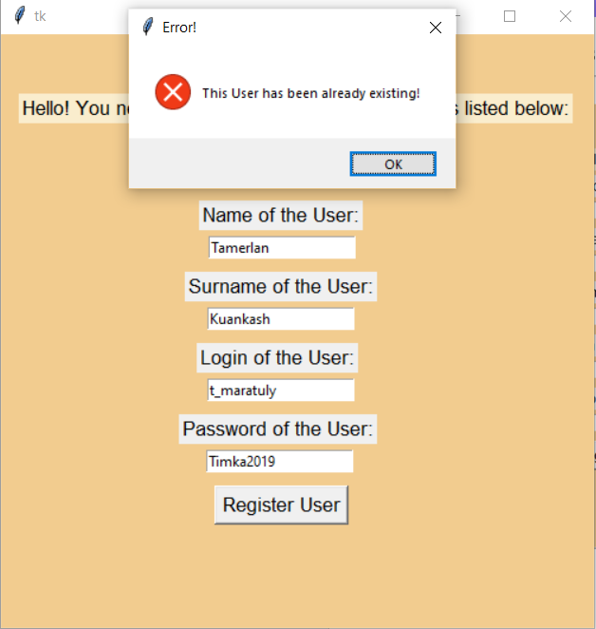

**Attempt to register with existed user’s login:**

The login ‘t_maratuly’ belongs to Admin Temirbolat 🡪 we can not add a new user taking the same unique part.

Let’s try to type a good login, but with not appropriate password(Password requirements were provided in the task)

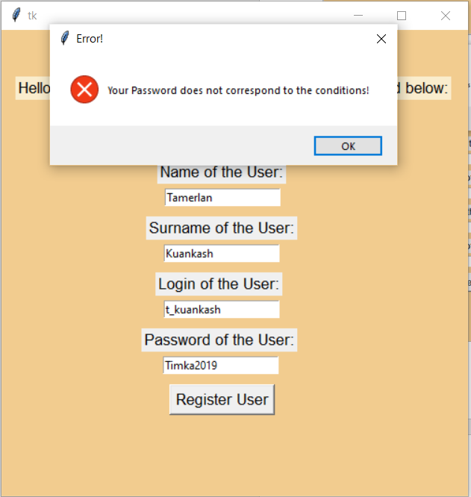**Attempt to register with not suitable password:**

Here we can see appeared Error because the password is wrong. It contains the Capital letter as well as small ones, numbers, good length, however, it doesn’t have a specific sign(symbol) that doesn’t allow to continue. Let’s type a good password by adding ‘!’ in the end.

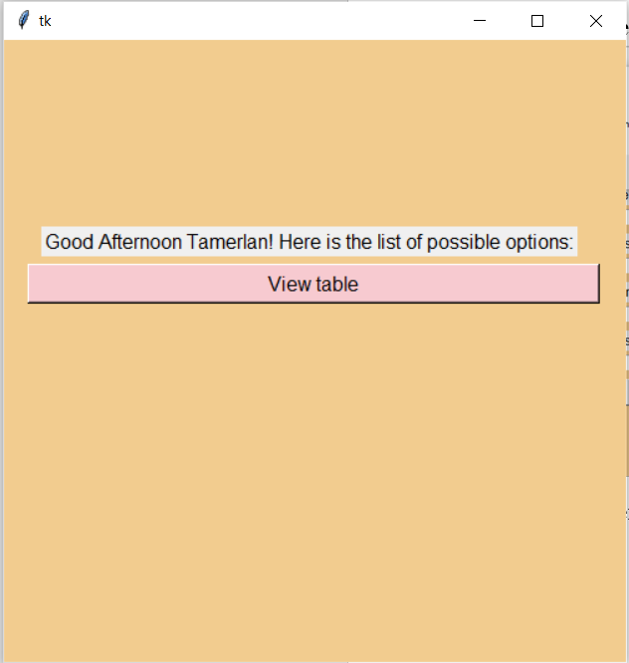**Good Register Example:**

When data were provided correctly, new user is entered to the system automatically and he/she sees all the possible buttons which he/she can use.

1. 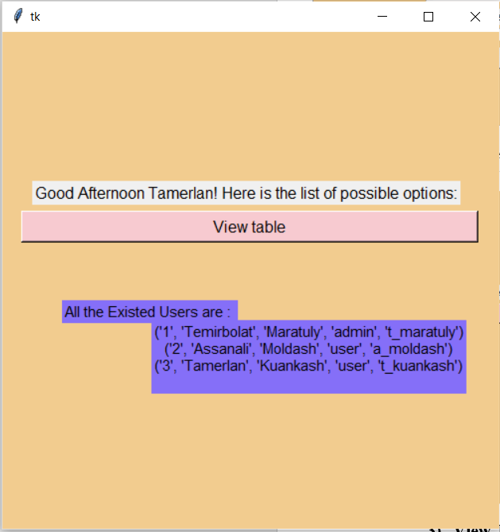**View Table Option for All the Users:**

If we type the button “View table” we can see all the existed users in our database from Microsoft Server DBMS. It can be clearly seen that our created user Tamerlan is already here😊

1. 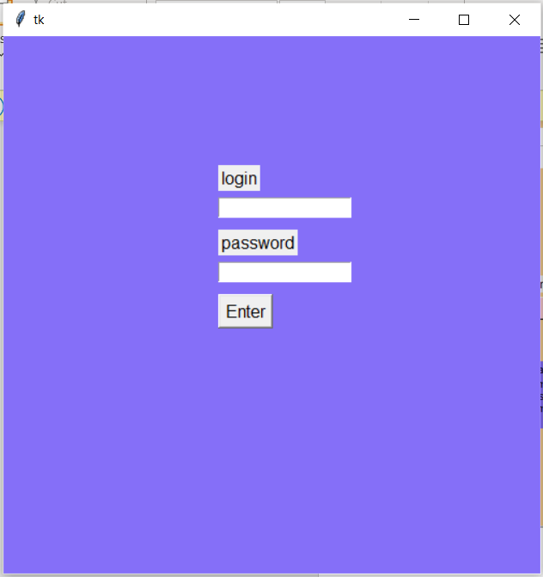**Autorization part:**

If we choose Aurization button in the beginning, we come to the page with filling Login and Password.

Let’s try to fill in wrong login.

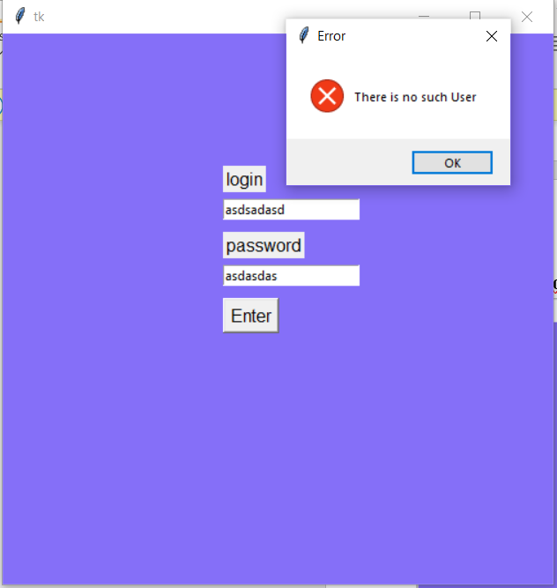

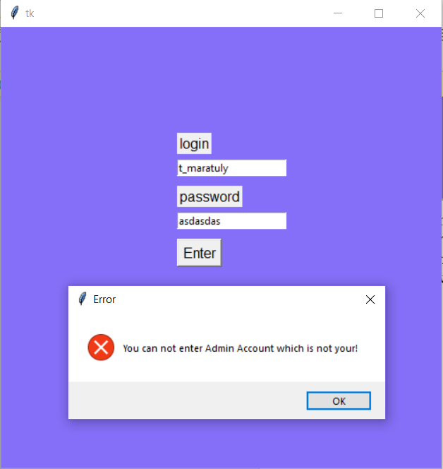Here we can see that there is no such user in system with this Login. Therefore, we obtain an error. Let’s write an existed login but among with wrong password.

Here a person tries to login in Admin’s account without password knowledge. He obtains the corresponded error. DO the same for User.

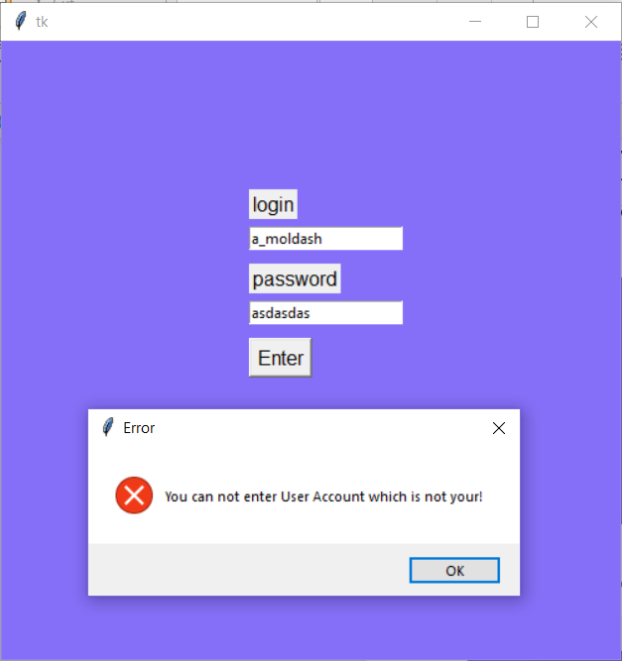

Here we see the same problem but here the person tries to enter a user account without correct password. He gets about the same Error, although there is written User Account.

1. 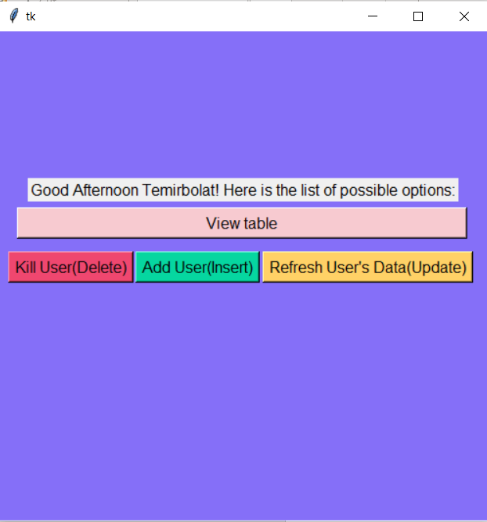**Entering the System By Admin:**

If we type the correct Admin’s login and password correctly we come to this page and see all the available options for Temirbolat (Admin)

1. 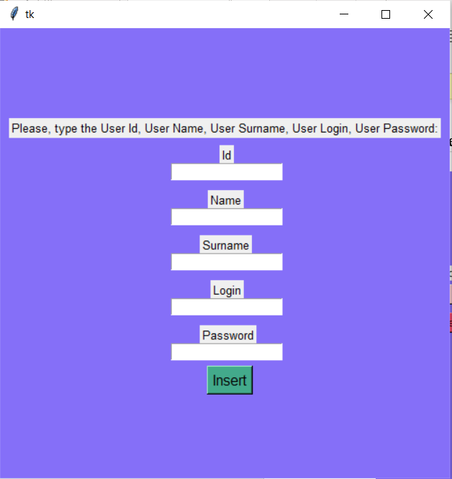**Add New User**

If we decide to press the button ‘Add User(Insert)’ we see this page 🡪

Here we are asked to write all the required data to add new User into the system

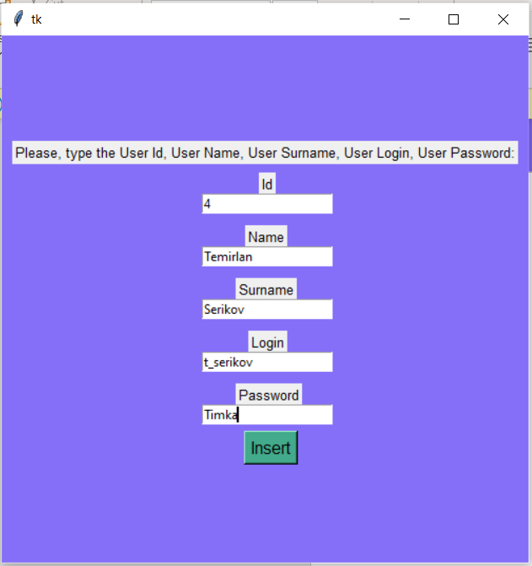

Here we typed the data for new User. Id = 4, Name = Temirlan, Surname = Serikov,Login = t_serikov, Password = Timka. (Which is not suitable)

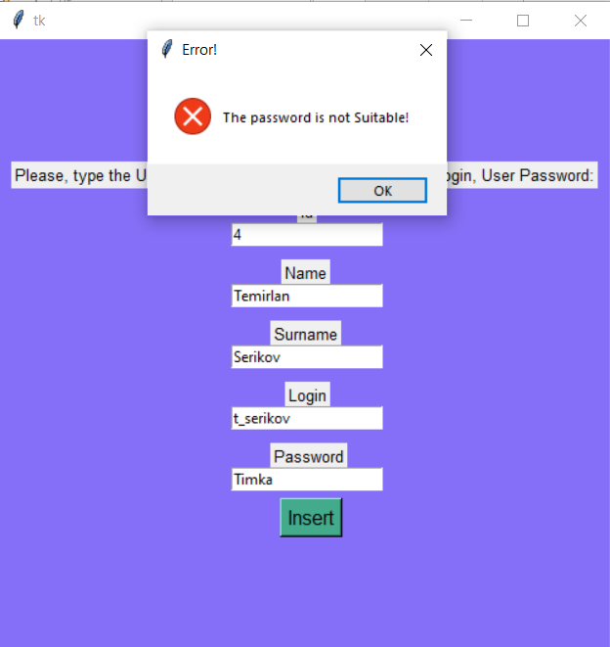Here the Admins obtains the Error, since the typed password doesn’t fit the requirements of the password. Here it doesn’t have any number and specific sign.

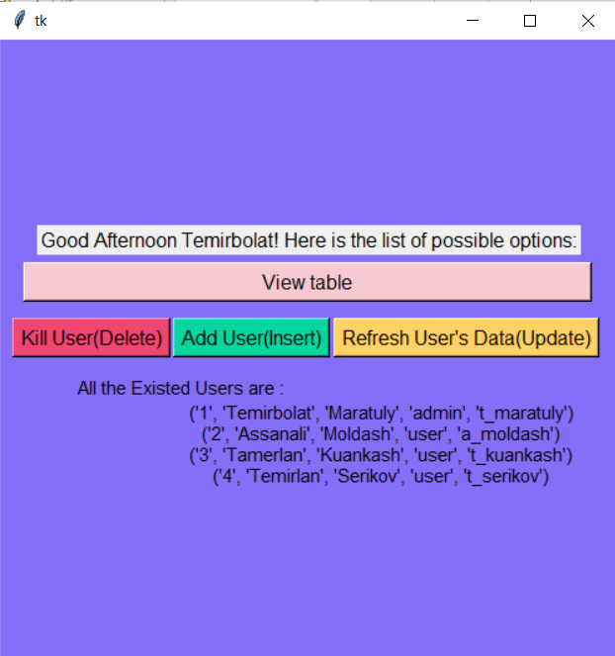

Now, when we typed the suitable password, the user is instantly created and added to the system. Here we can 🡨 see it

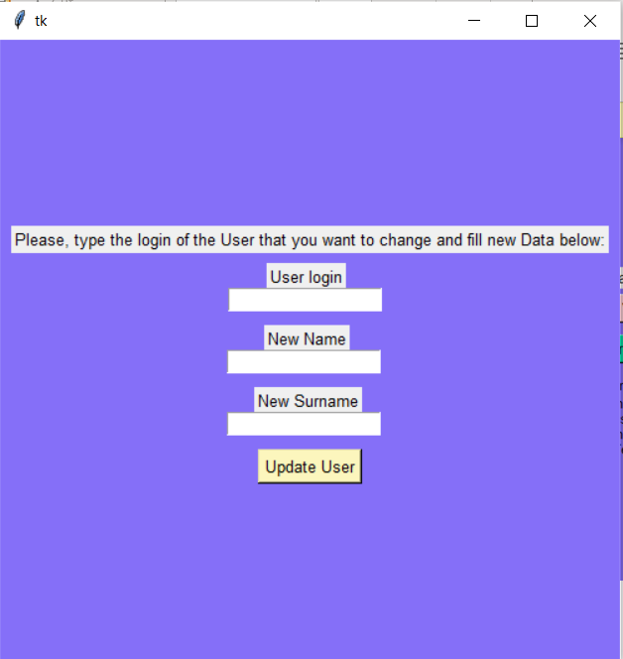

1. **Updating User’s Information:**

If a Admin desires to Update User’s Information and press the button ‘Refresh User’s Data (Update)’. He finds out the window (where he needs to fill the corresponded login as well as new Name including Surname of the User) 🡪

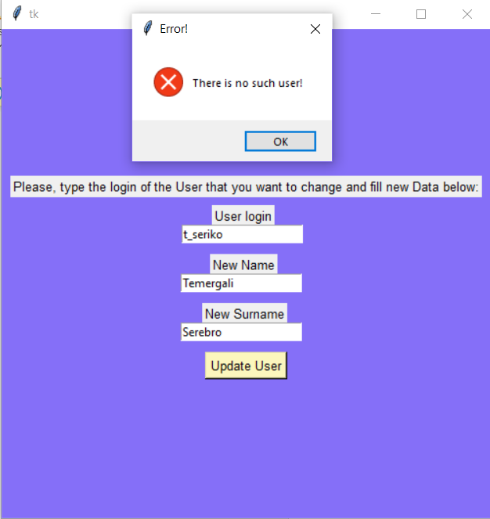If we type wrong login we get an error since the existed user doesn’t have this written unexisted login.

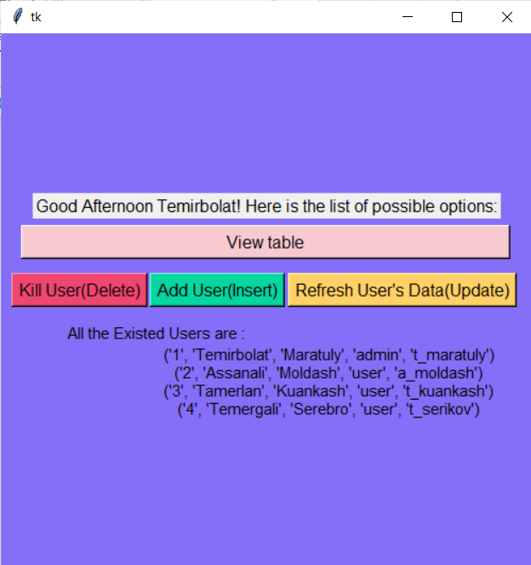

When we typed the login correctly (t_serikov) and click on ‘Update User’ we get to the initial page where we see that this user is successfully changed.

1. **Delete the User**

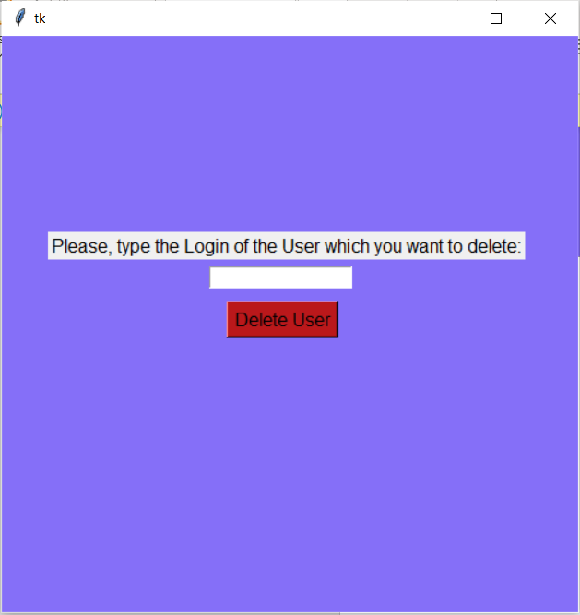

If we click on ‘Kill User(Delete)’ we get to another page which asks us to type user’s login which we want to delete (Since it is unique)

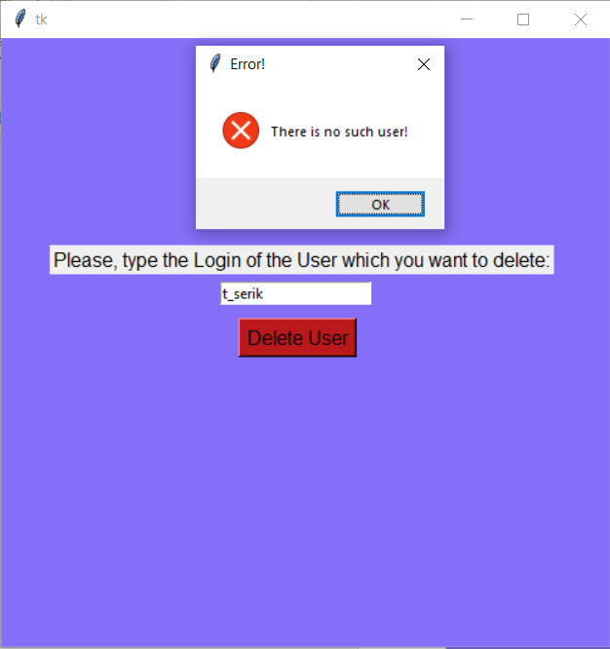If we remain the login incorrectly we get the Error message that says ‘You made a mistake’.

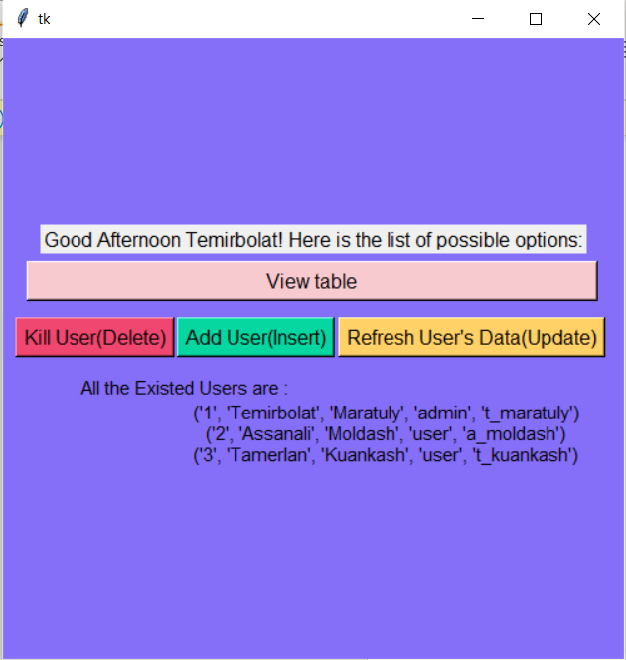

When you finished the previous step with correct login you can find out that this user is successfully deleted and now it is not listed below.

**Final Result:**

**Table in SQL:**

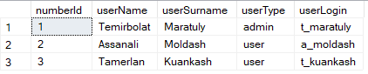

**We see that the result is exactly the same as it was given above.It means that our Program works correctly and it is connected to our DBMS.**