

**JSC “Kazakh British Technical University”**

**School of Mathematic and Cybernetics**

    Analysis of Data Bases

**Laboratory Work #2**

**Prepared by: Maratuly Temirbolat**

**Almaty 2021**

To perform the following tasks, you need to supplement the EMPLOYEES table with new data: add a department_id column with data type integer. For each department that is present on employees, assign the following numeric values:

AD – ‘10’;

MK – ‘20’;

SH – ‘50’;

IT – ‘60’;

SA – ‘80’;

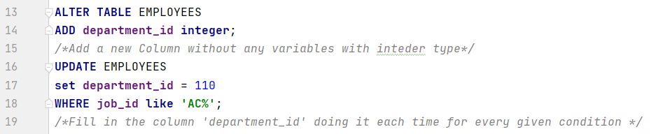AC – ‘110’.

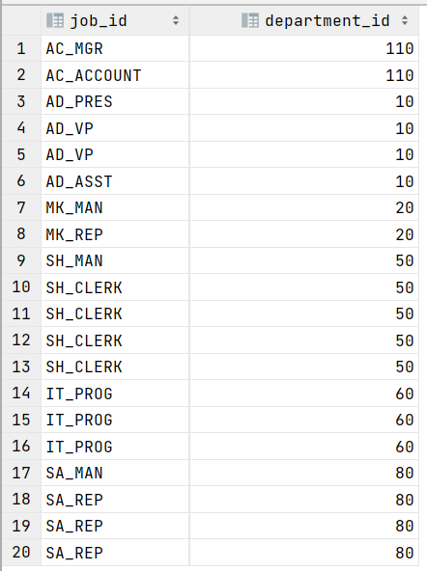

**Exercises:**

**1.** Write a query to display all the information about employees whose salaries are higher than the average salary of programmers

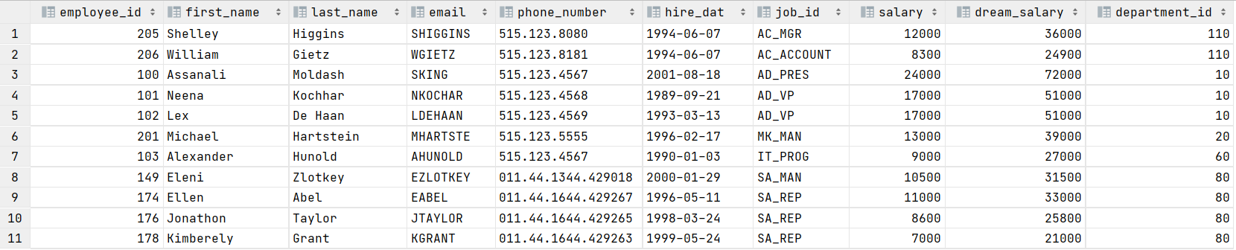**2.** Write a query to display the list of employees with the longest name

**3.** Write a query to display the id, first name, last name and salary of the employee with the maximum salary

**4.** Write a query to display the information of department managed by Jennifer.

**5.** Write a query to display the average salary for the most numerous department.

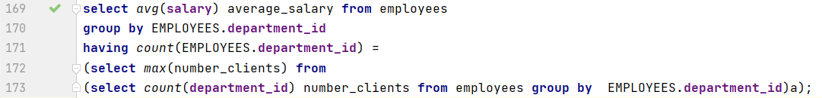



**6.** Write a query to display in which departments the minimum salary is greater than the minimum salary in the 50th department.

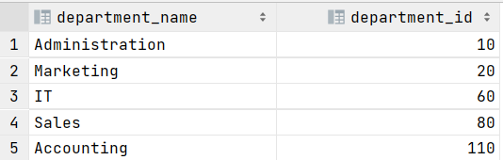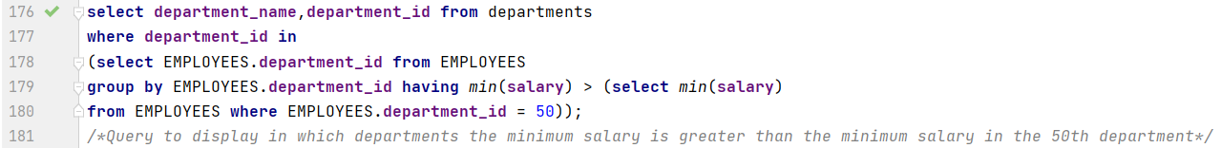

**7.** Write a query to display the maximum average salary by department

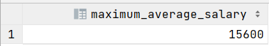

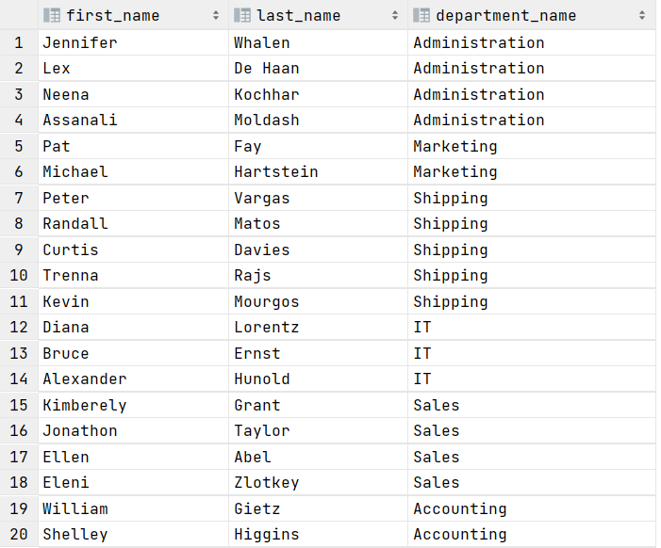**8.** Write a query to display the department names for each employee 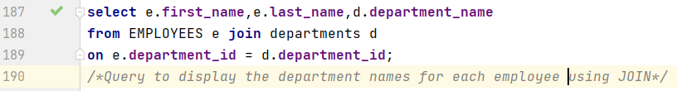using JOIN

**9.** Write a query to display all departments in which there is no employee.

**10.** Write a query to display the JOB_Grade for each employee.

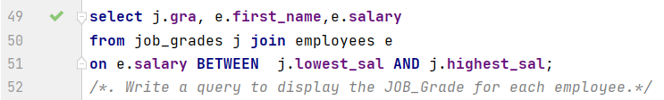

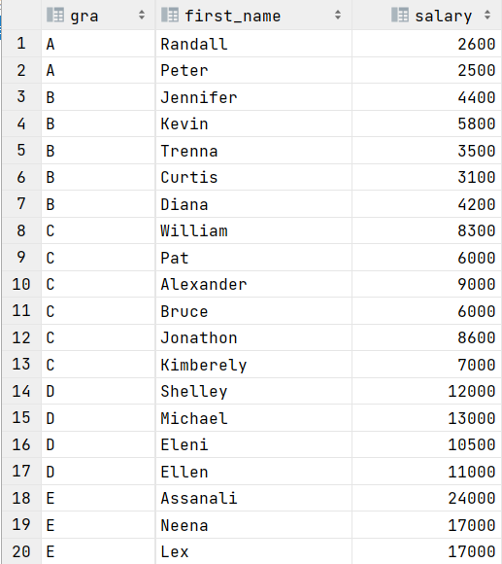

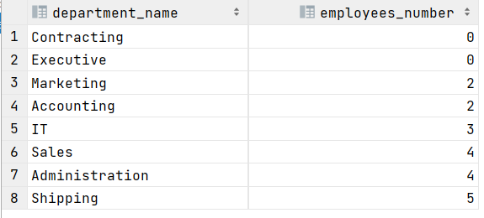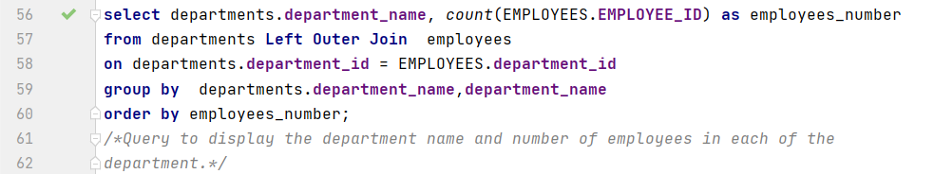**11.** Write a query to display the department name and number of employees in each of the department.

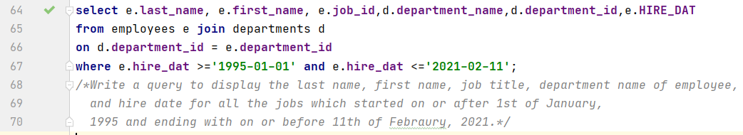**12.** Write a query to display the last name, first name, job title, department name of employee, and hire date for all the jobs which started on or after 1st of January, 1995 and ending with on or before 11th of February, 2021.

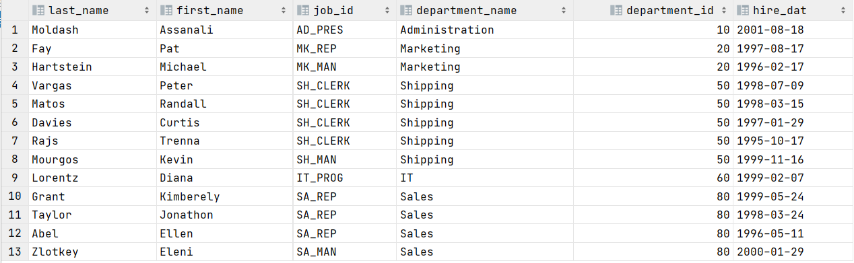

**Create a table LOCATIONS and Fill the information**

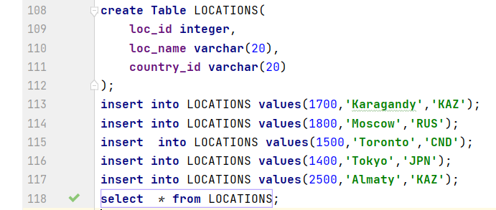

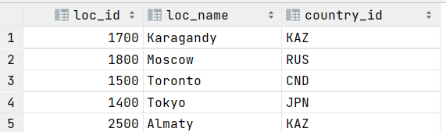

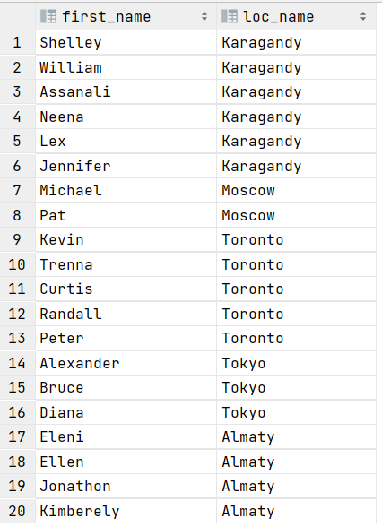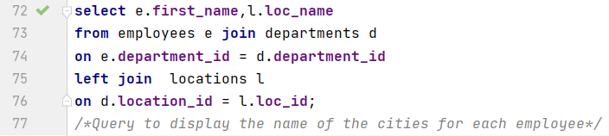**13.** Write a query to display the name of the cities for each employee

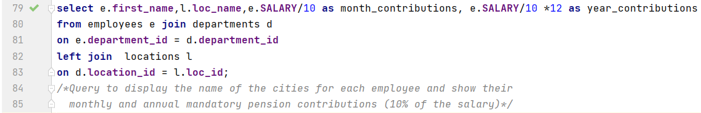**14.** Write a query to display the name of the cities for each employee and show their monthly and annual mandatory pension contributions (10% of the salary).

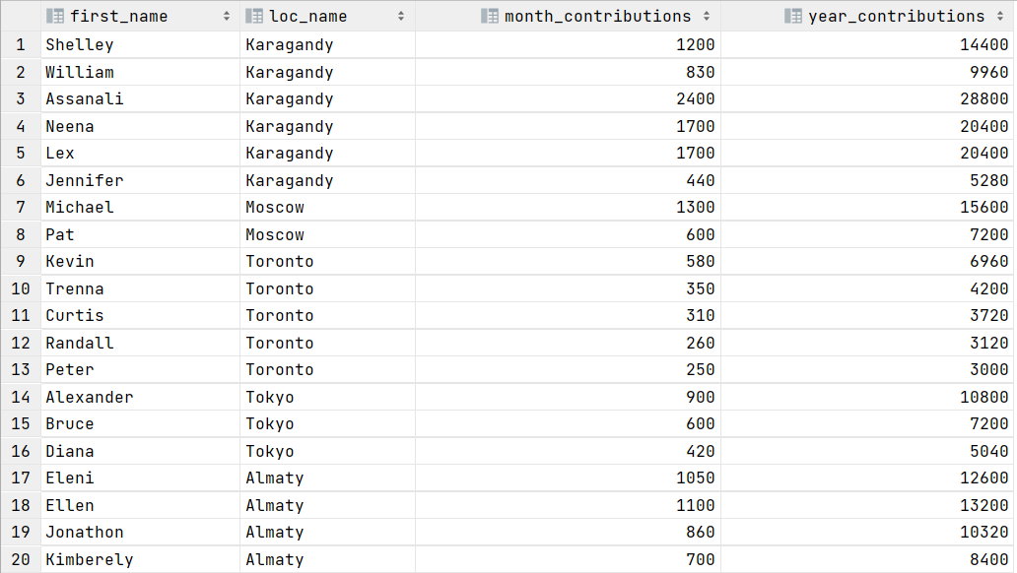

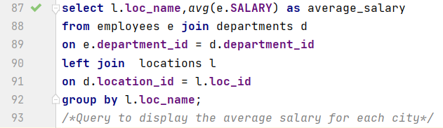**15**. Write a query to display the average salary for each city

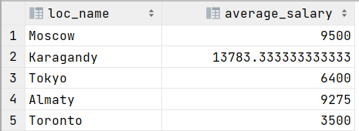

**16.** Write a query to display all the information about the manager with the highest salary.

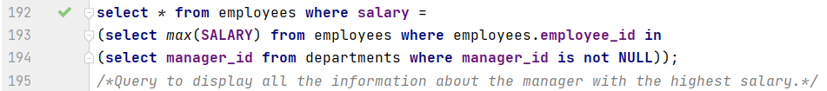

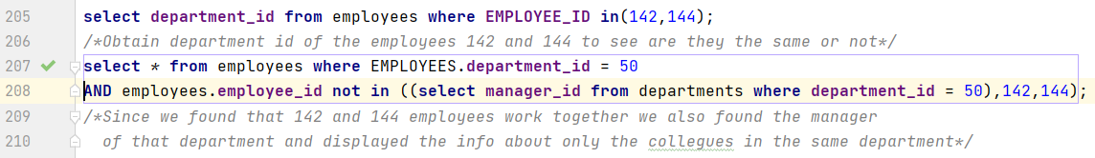 **17.** If the 142nd and 144th employees work in the same department, then write a query to display only their colleagues, without a manager.

**18.** Write a query to display data about the employee who has the third maximum salary.

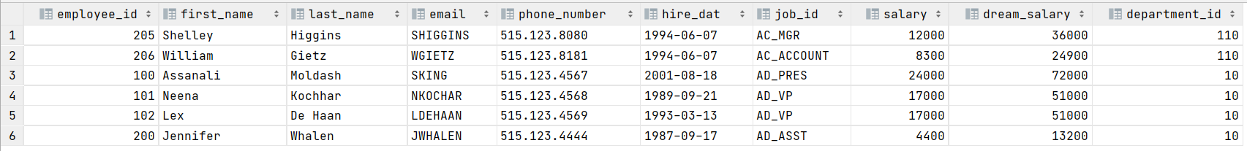**19.** Write a query to display all the information about the employees whose department location is <select any city from the table LOCATIONS at your direction>

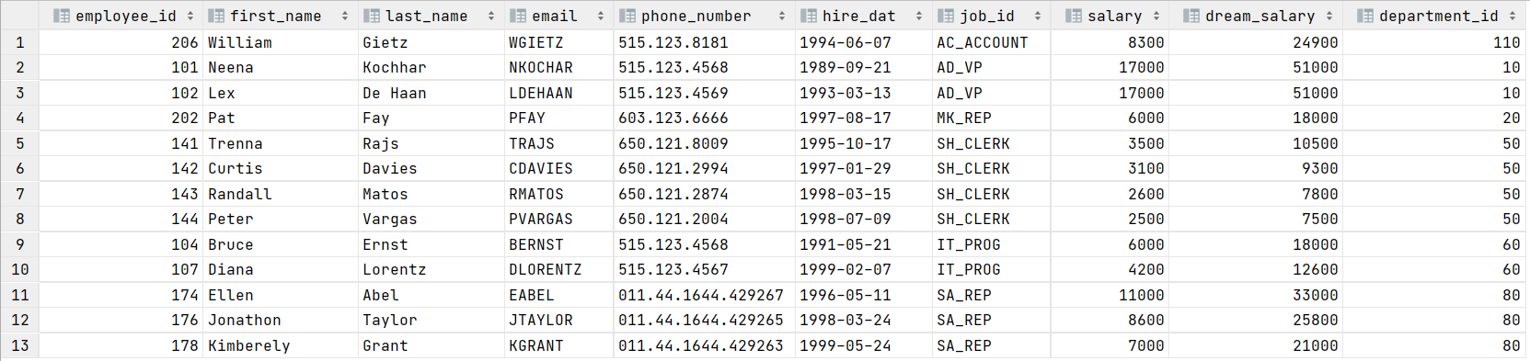**20.** Write a query to display all employees who are not managers.

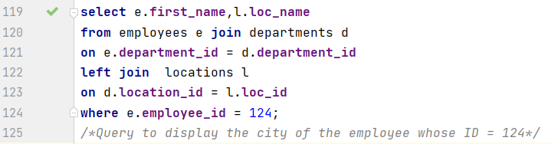**21.** Write a query to display the city of the employee whose ID <select ID>



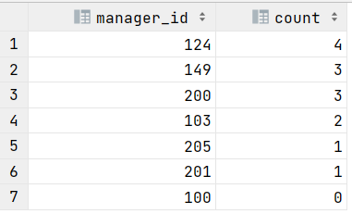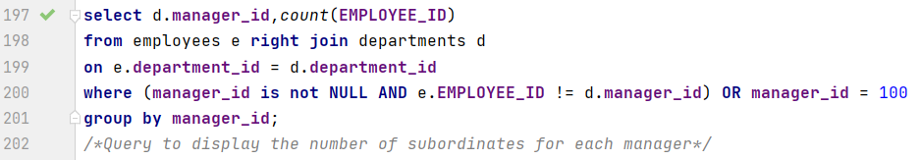**22.** Write a query to display the number of subordinates for each manager

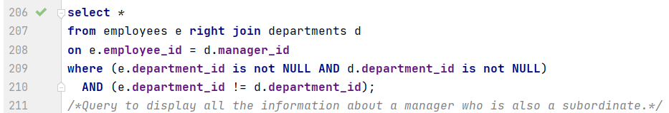**23.** Write a query to display all the information about a manager who is also a subordinate.



**Countries Table creation and insertion of variables:**

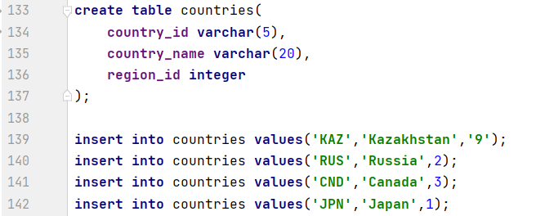

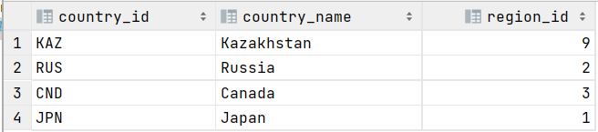

**24.** Write a query to display the full names of employees (last name + first name), separated by only one space, into a common column, with ID and name of the country presently where (s)he is working

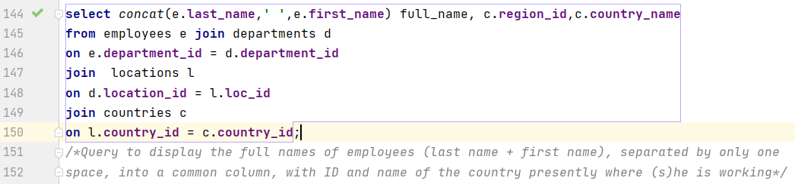

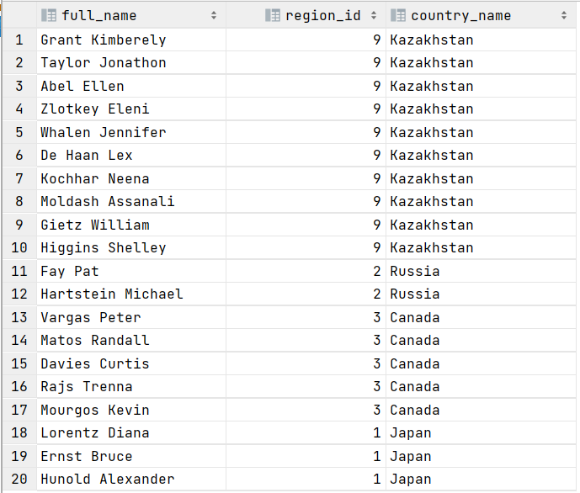

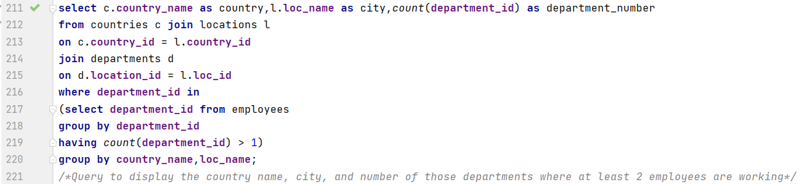**25.** Write a query to display the country name, city, and number of those departments where at least 2 employees are working

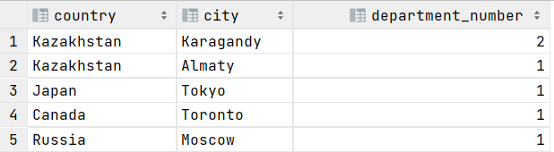

**26.** Write a query to display the name ( first name and last name ) for those employees who gets more salary than the employee whose id is 124.

