

**JSC “Kazakh British Technical University”**

**School of Mathematic and Cybernetics**

    Analysis of Data Bases

**Laboratory Work #3**

**Prepared by: Maratuly Temirbolat**

**Almaty 2021**

**1.1 Add constraint Primary key – for new column EMP_ID**

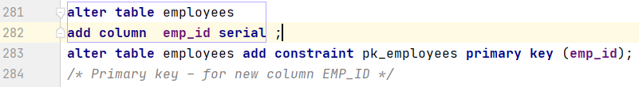

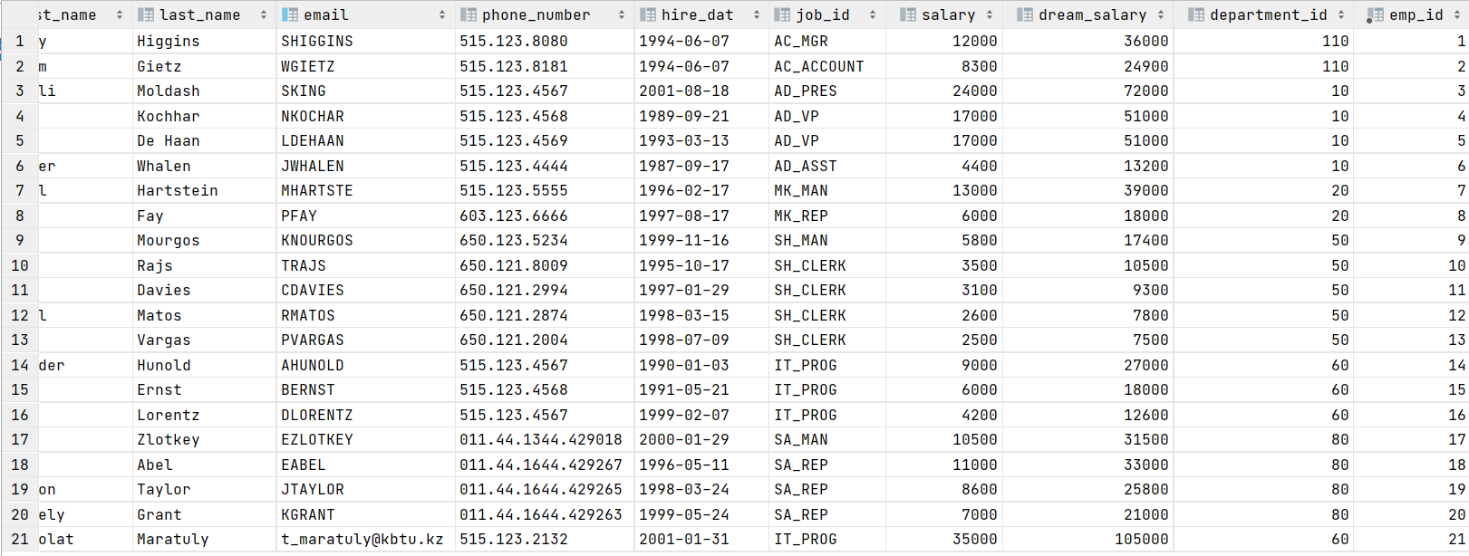

**1.2 Add constraint unique – for Email**



**1.3 Add constraint not null – for First_Name**



**1.4 Add constraint Check >1000 – for Salary**



**1.5 Add constraint Check where the last name’s length < 15**



**1.6 Add new Employee taking into account all constraints**

**1.7 Create queries that would give errors for each constraint**









 



**2.1 Add constraint primary key – for new column DEP_ID**

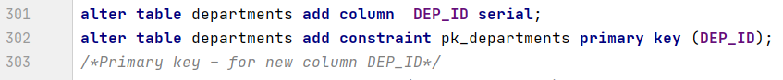

**2.2 Add constraint unique – for the Department_Name** 

**2.3 Add constraint NOT NULL – for Location_Id**



**2.4 Add foreign key – for Manager_ID with reference to Employee_ID from Employees**

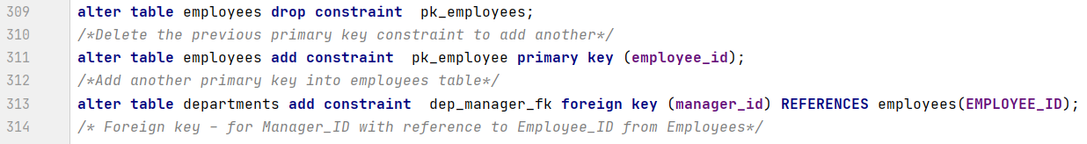

**2.5 Add Foreign key – for Department_ID (Employees table) with reference to Department_ID from Departments table**



**2.6 Create queries that would give errors for each constraint**



 



**3.1 Add constraint primary key – for GRA**



**3.2 Add constraint Not Null – for Lowest_Sal and Highest_Sal**

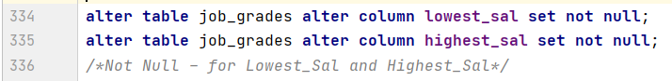

**3.3 Add constraint Check to avoid letter with sign**



**3.4 Add a new Grade taking into account all constraints**

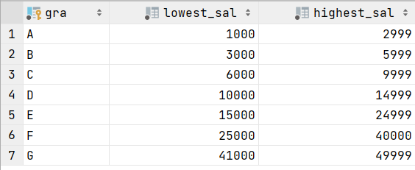

**4.1 Add constraint Primary key – for Location_ID**



**4.2 Add constraint Unique - for Location_Name**



**4.3 Add Foreign key – for Location_ID (Departments table) with reference to Location_ID from Locations**



**5. Create a table films, add all the constraints during the creation and write the queries to catch all the errors for each constraint.**

