

**JSC “Kazakh British Technical University”**

**School of Mathematic and Cybernetics**

    Analysis of Data Bases

**Laboratory Work #4**

**Prepared by: Maratuly Temirbolat**

**Almaty 2021**

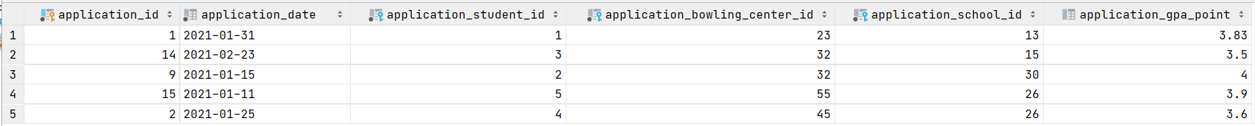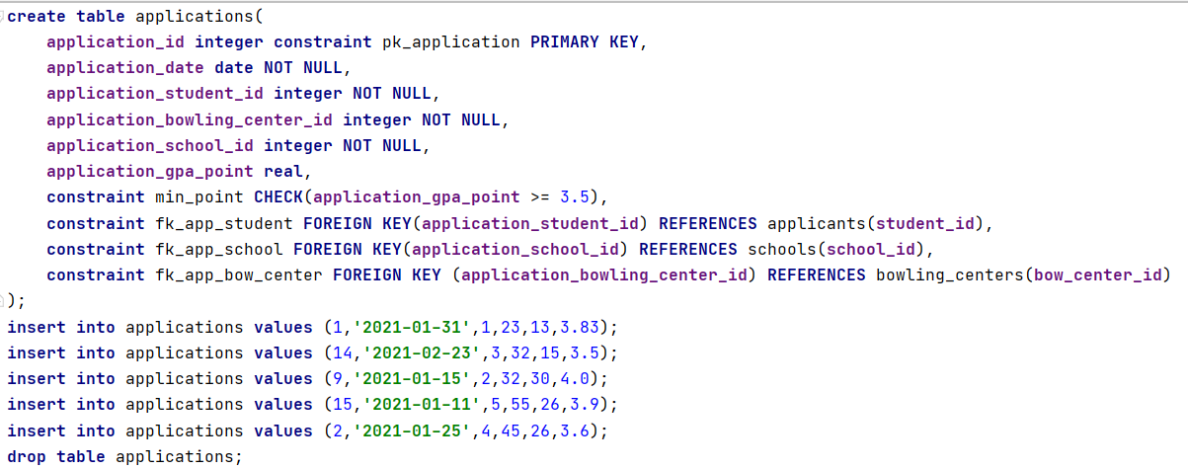**As for the Applications table:**

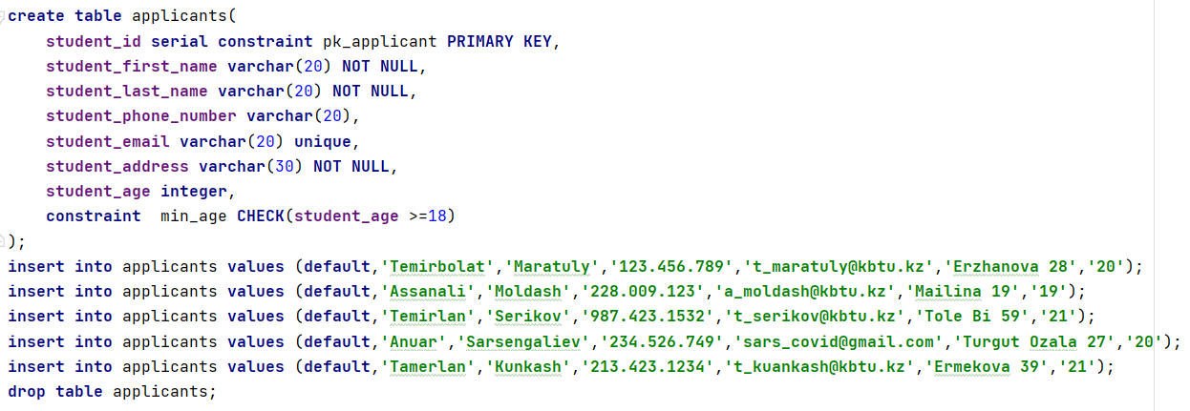**As for the Applicants table:**

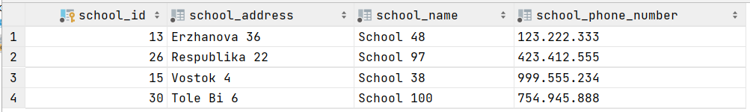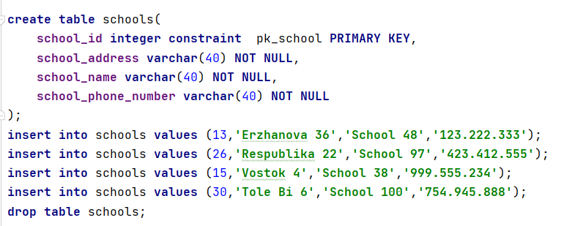**As for the Schools table:**

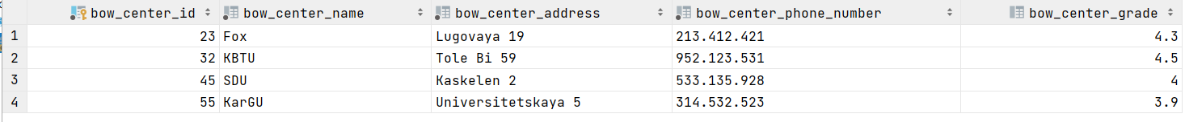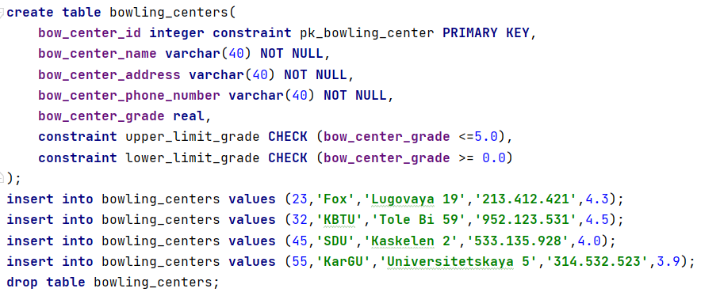**As for the Bowling Centers table:**

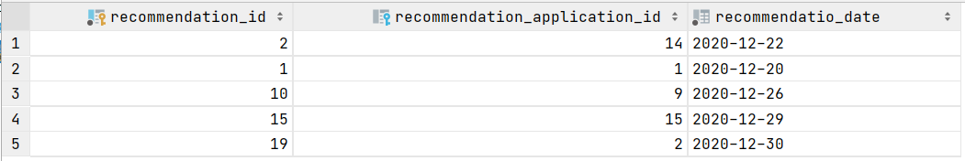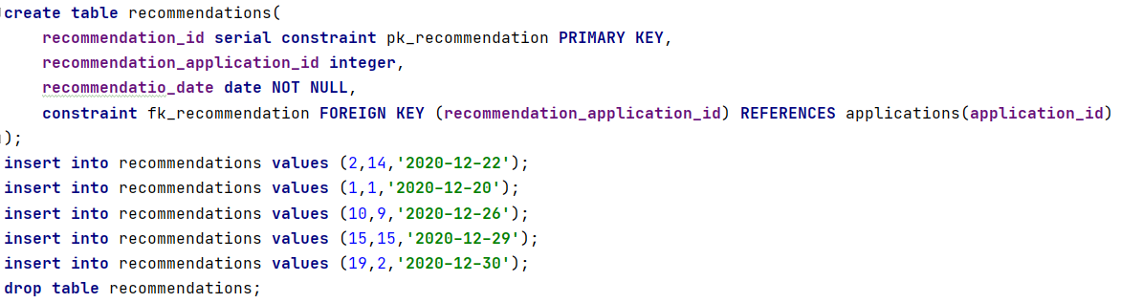**As for the Recommendations table:**

**Some request exercises:**

1. Make join of ‘Applications’ table and ‘Bowling_centers’ by bowling center id.

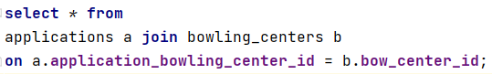

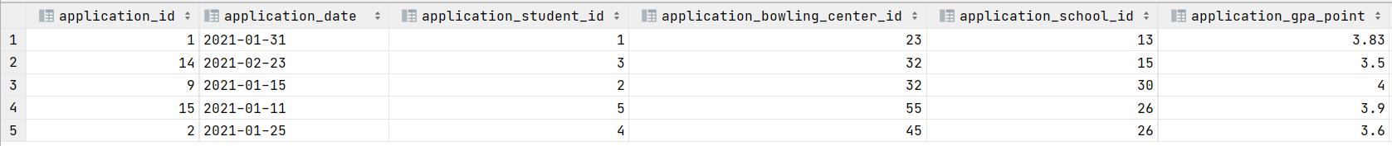

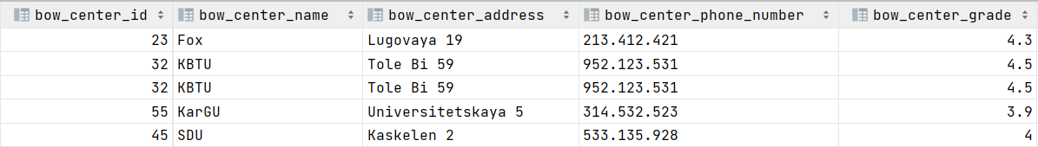

1. Show student’s first name and last name where the length of the name is less than 10 and order by the age (default).



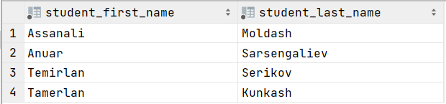

1. Show all the information of the applicants whose first name starts with ‘Temir’.





1. Show all the information of the applicants whose GPA is Between 3.5 and 3.8.





1. Show application date, gpa, first name and last name of the students using the join. Also condition that the application date can be only January.

