

**JSC “Kazakh British Technical University”**

**School of Mathematic and Cybernetics**

    Analysis of Data Bases

**Laboratory Work #6**

**Prepared by: Maratuly Temirbolat**

**Almaty 2021**

**Exercises:**

1. Import train.xls into your DBMS

Looking at the database train (that was created) going though the tables folder we can see ‘dbo.train’ file that appeared only after taking the imported file from xls format into sql.

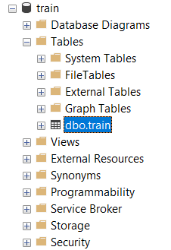

The first possible 1000 rows from the gotten table can be seen below:

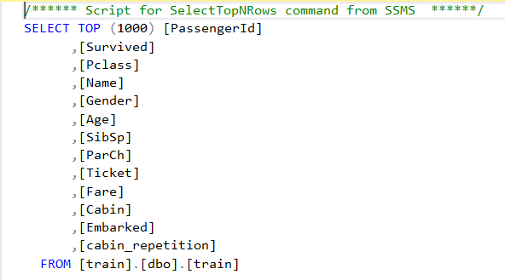

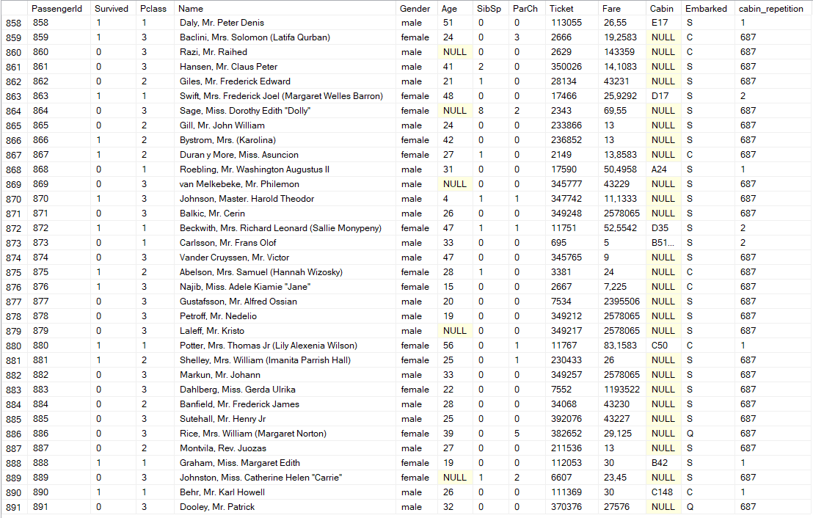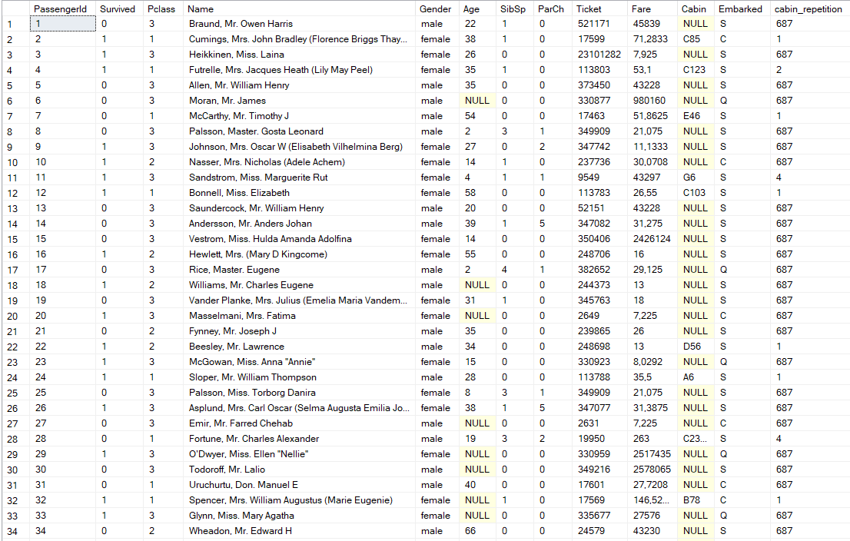….

1. 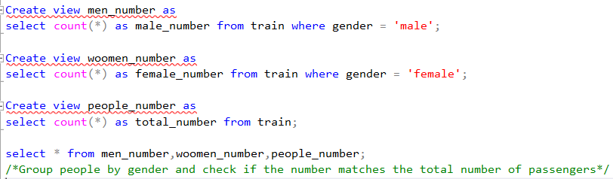Group people by gender and check if the number matches the total number of passengers.



1. 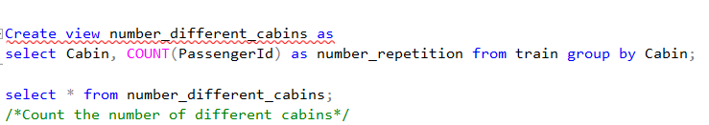Count the number of different cabins.

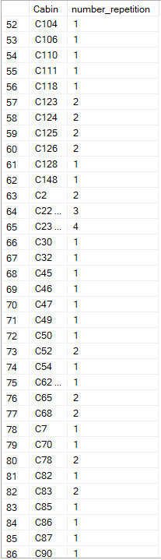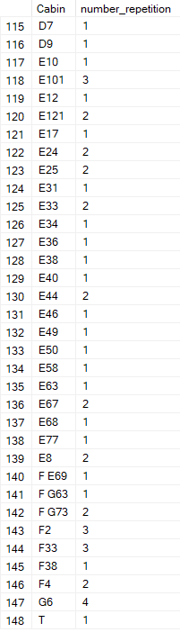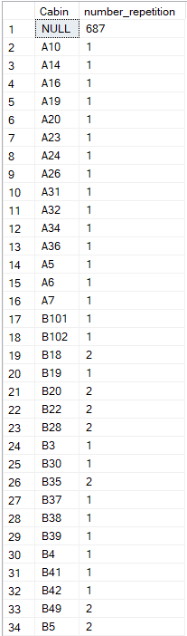

**…**

1. 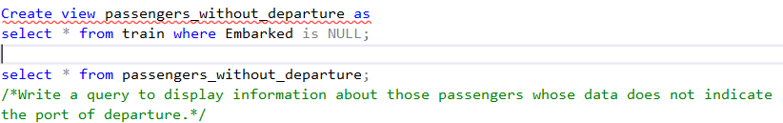Write a query to display information about those passengers whose data does not indicate the port of departure.
2. 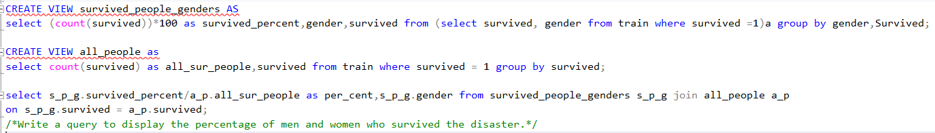Write a query to display the percentage of men and women who survived the disaster.
3. 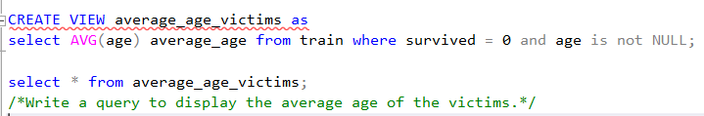Write a query to display the average age of the victims.



1. Add a column indicating the number of repetitions for each cabin. The absence of a cabin number should also be taken into account.

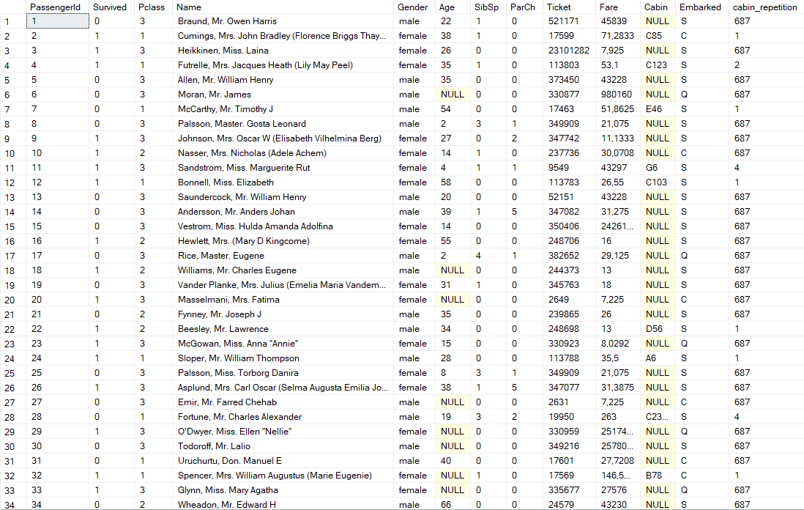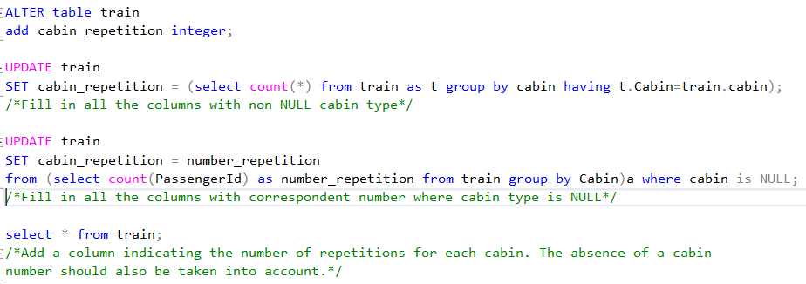

.

.

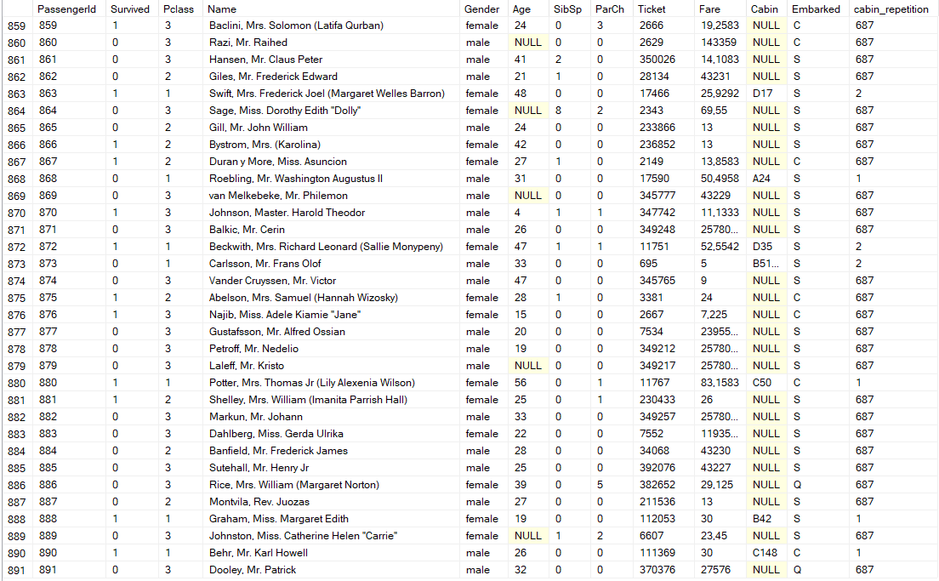

1. 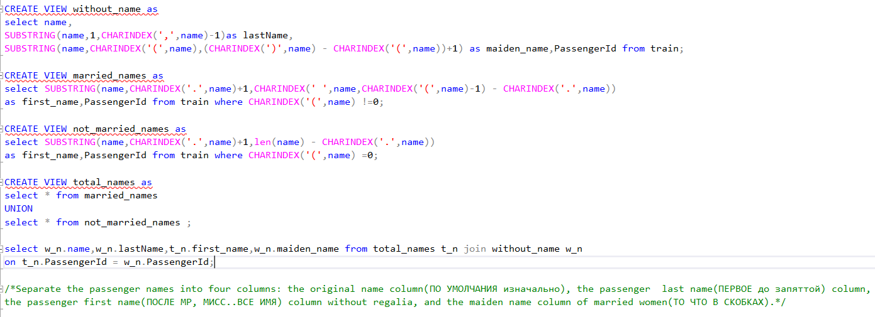Separate the passenger names into four columns: the original name column, the passenger last name column, the passenger first name column without regalia, and the maiden name column of married women.

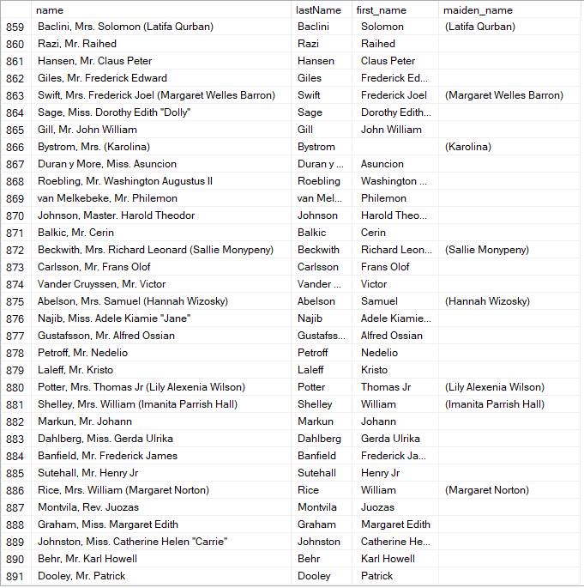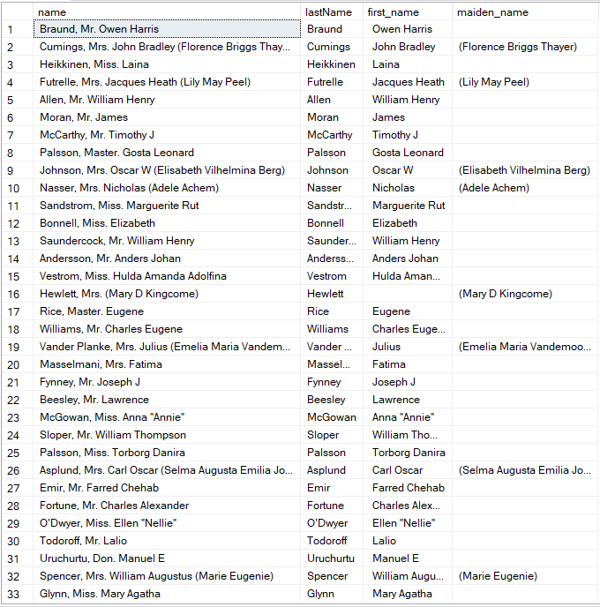

🡪

🡪

1. 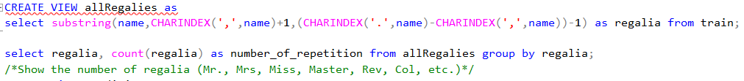Show the number of regalia (Mr., Mrs, Miss, Master, Rev, Col, etc.)

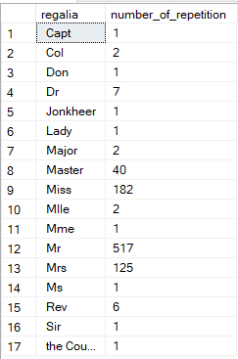

1. Divide people into families. More than one select may be needed to complete the task.

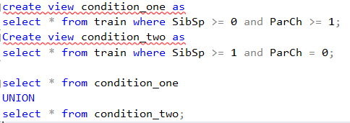

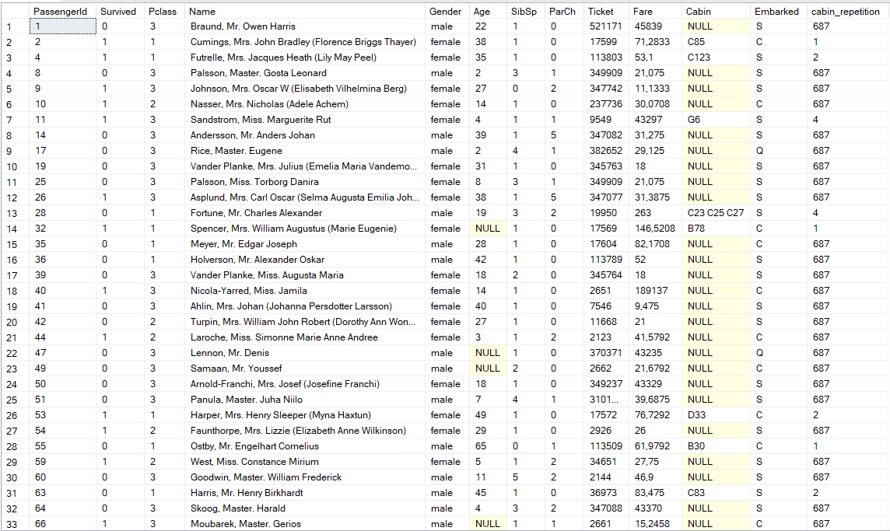

…

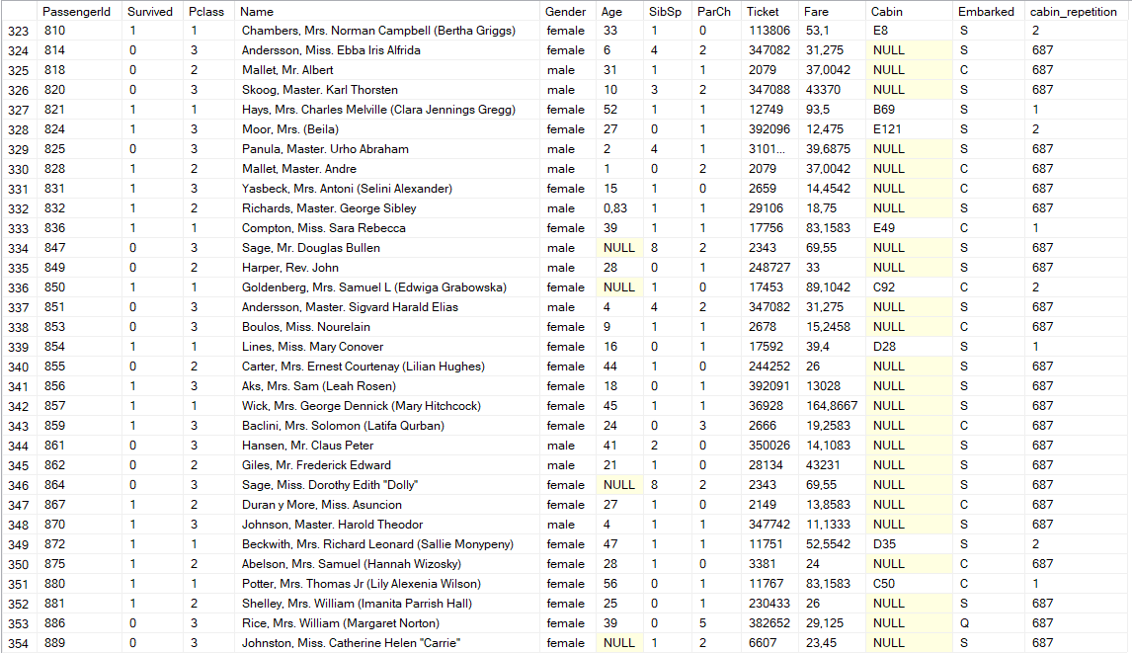

1. 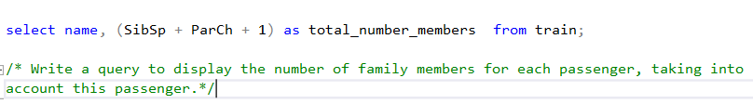Write a query to display the number of family members for each passenger, taking into account this passenger.

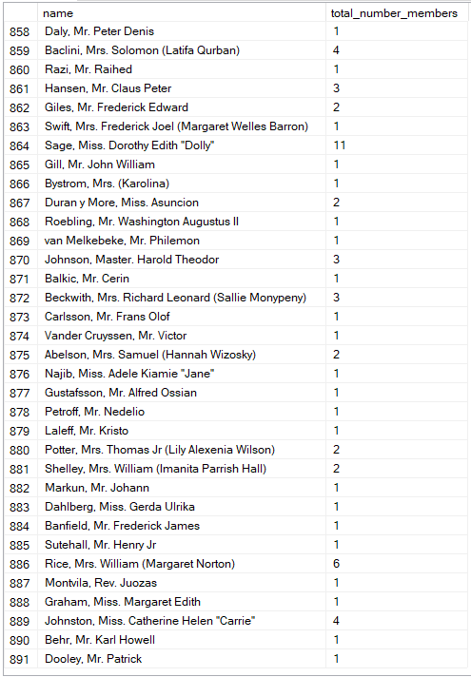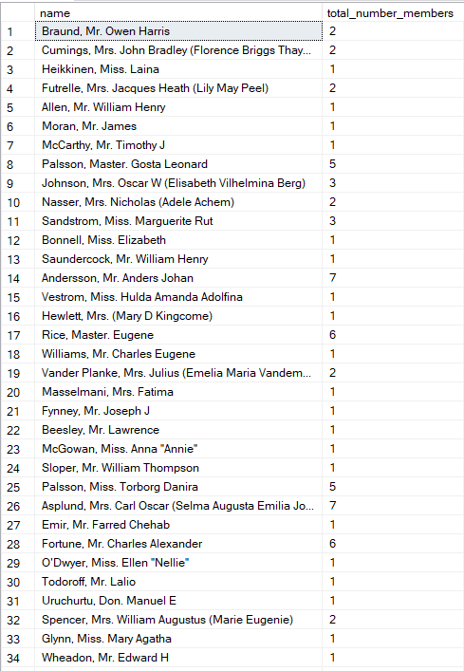

…

1. **GENERAL PREVIEW:** Separate children and parents. Create views for each of the below queries. The last names and first names of passengers should be in different columns.

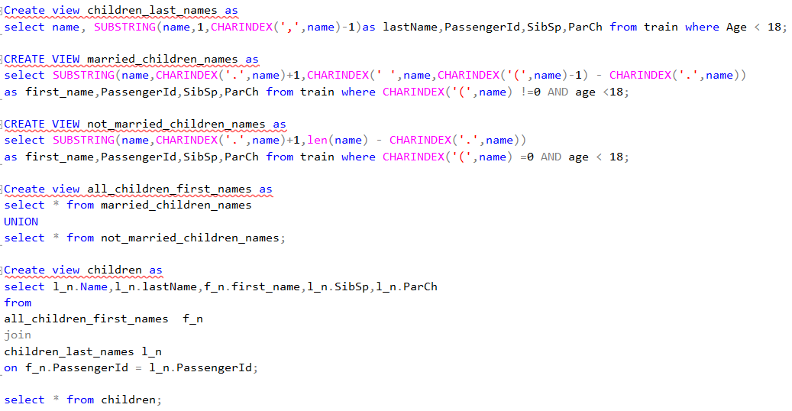**Part for the Children view:**

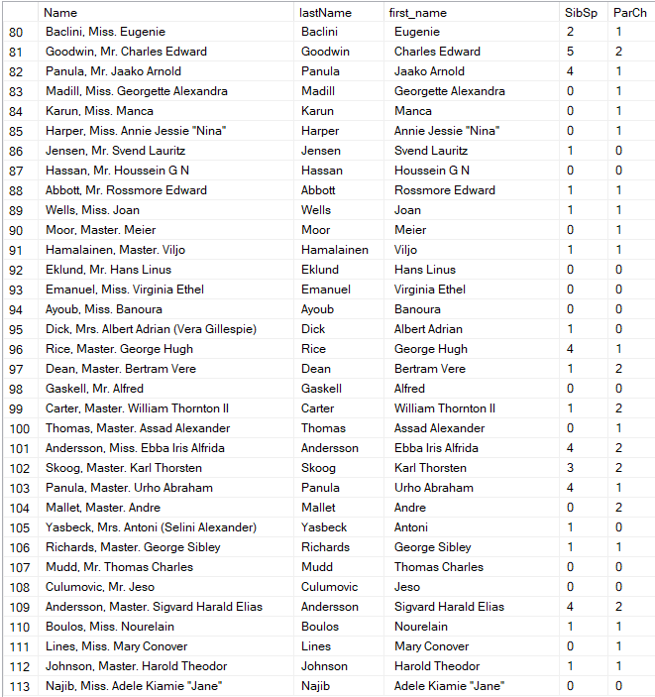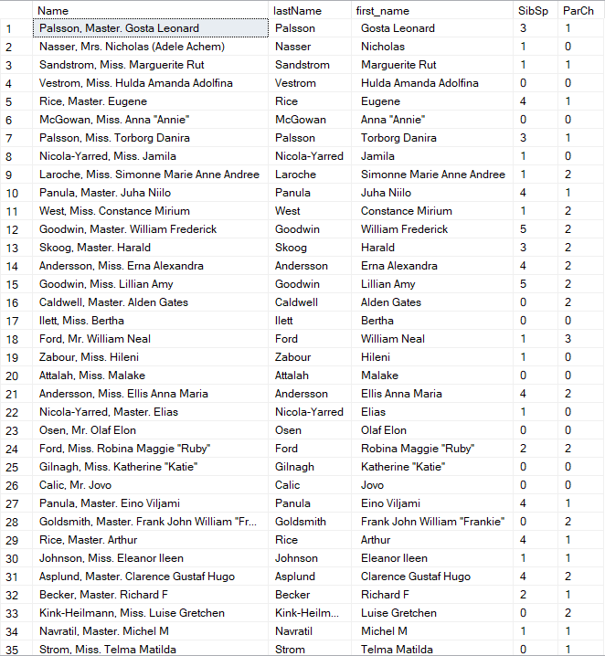

**🡪**

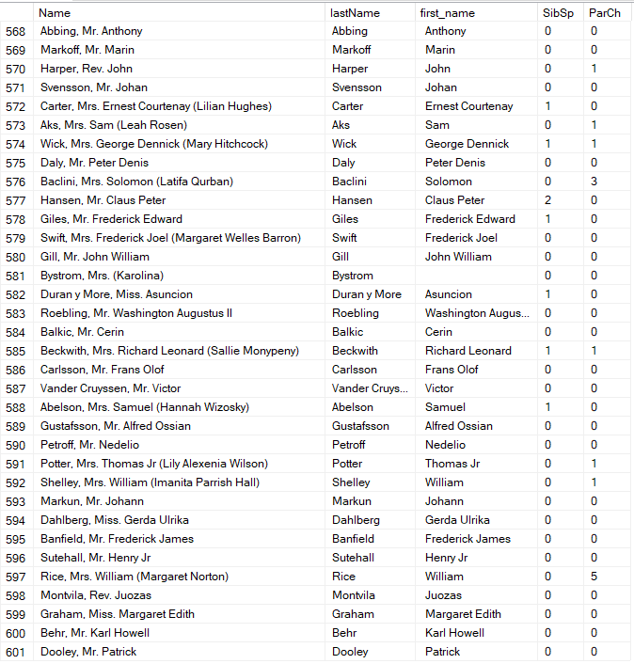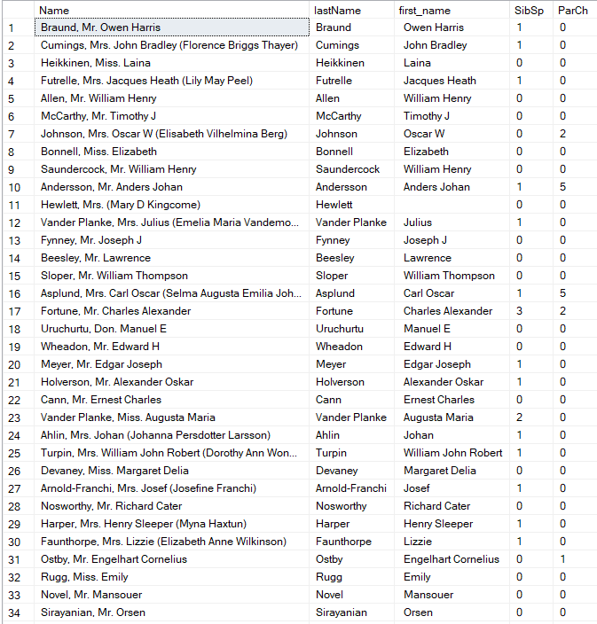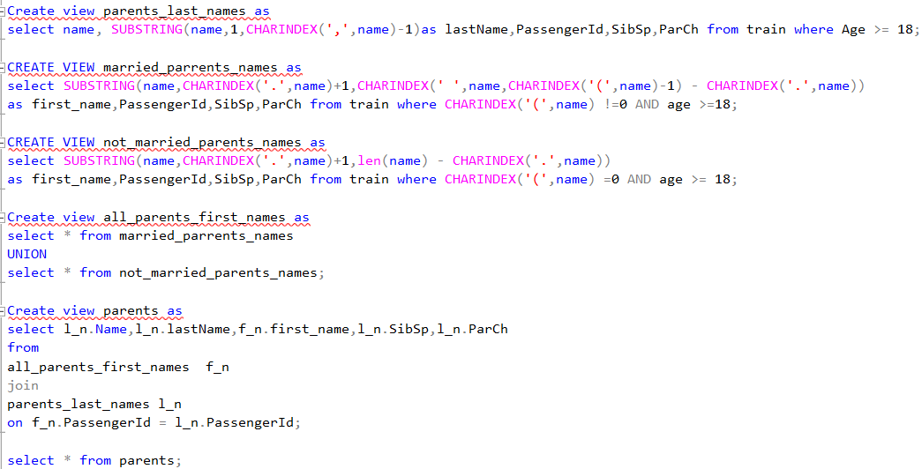**Part for the Parents view:**

**12.A)** Write a query to display the children traveling without their parents.



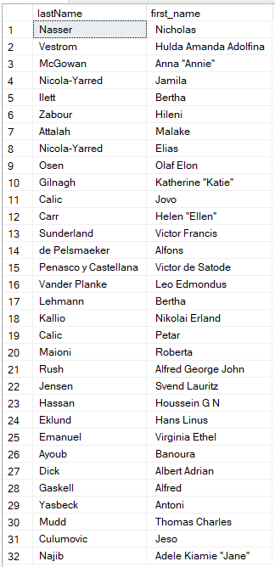

**12 B)** Write a query to display the children traveling with their parents.

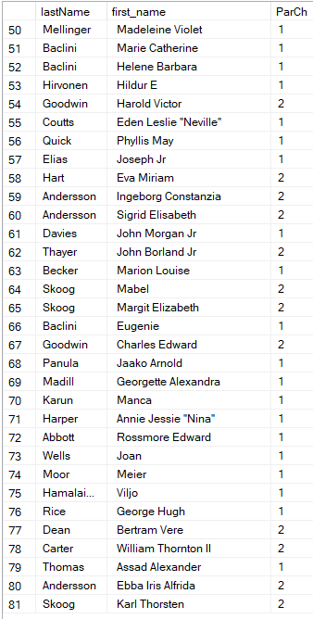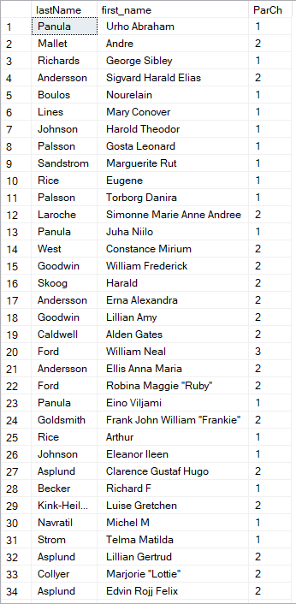

🡪

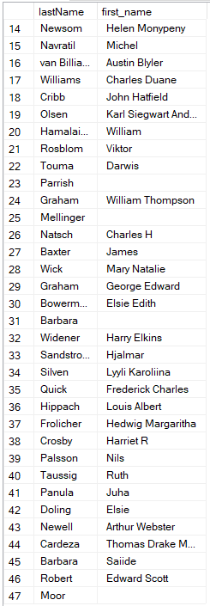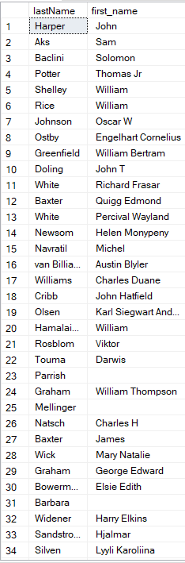 **12 C)** Write a query to display the single parents (without SibSp).

**🡪**

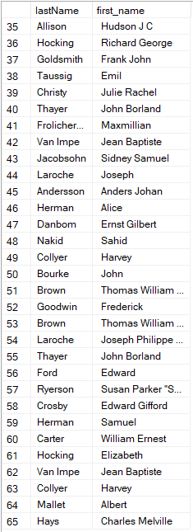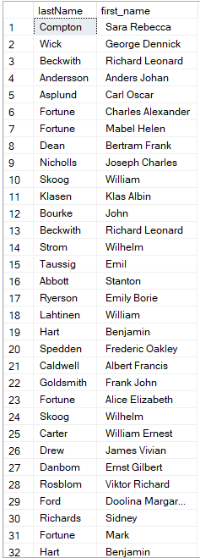 **12 D)** Write a query to display the parents who have SibSp.

**🡪**

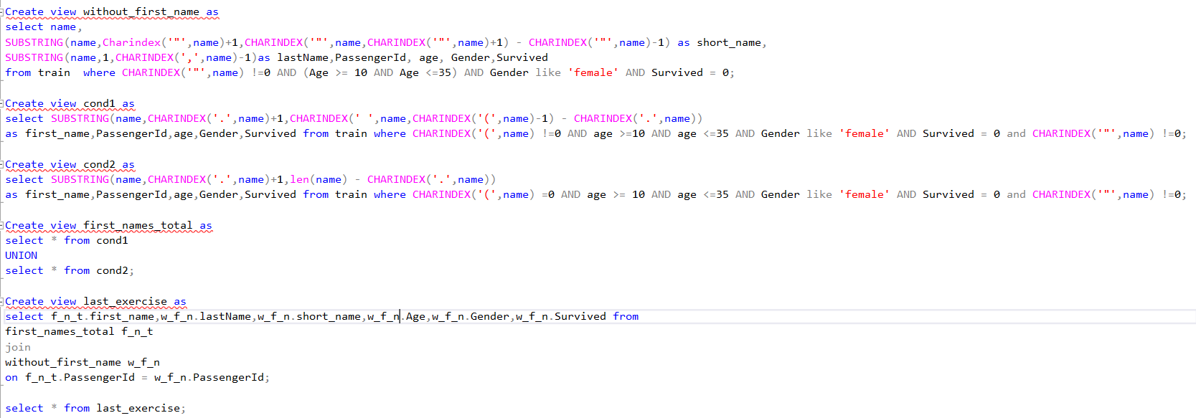**13) Own query:** Write a query to display the first_names(can be together with short_names because can organize first name if not in brackets), short_names, last_names of the victims' full names with the ages from 10 to 35 and they must be females. Short names are said to be names in form "Name". For example, "Daisy". Use views if it is necessary with joins or unions and so on.

