

**JSC “Kazakh British Technical University”**

**School of Mathematic and Cybernetics**

    Analysis of Data Bases

**Laboratory Work #8**

**Prepared by: Maratuly Temirbolat**

**Almaty 2021**

The requirement of this Laboratory is to create 20 queries for the given sql file. There was a need to create 20 queries where: 5 easy, 5 subqueries, 5 join as well as 5 interesting functions queries. Also, we needed to show the usage of Views, Indexes and Transactions.

5 Easy Tasks:

1. 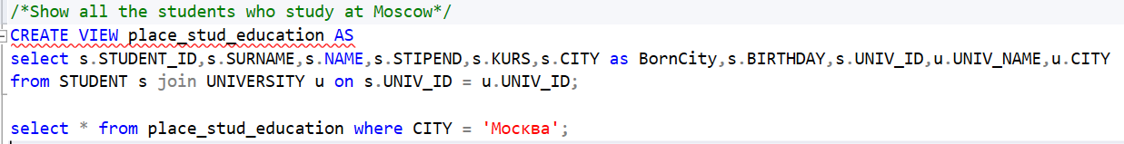Write a query to show all the students who study at Moscow University.

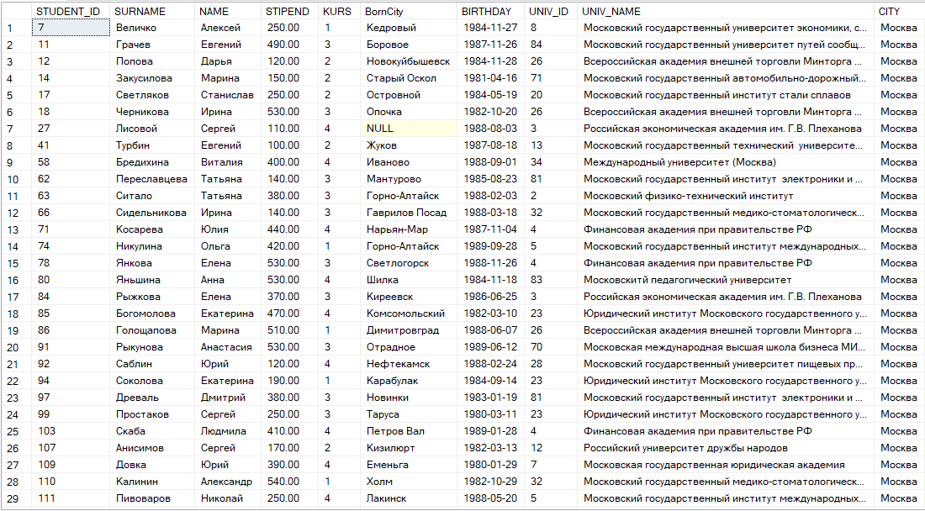

.

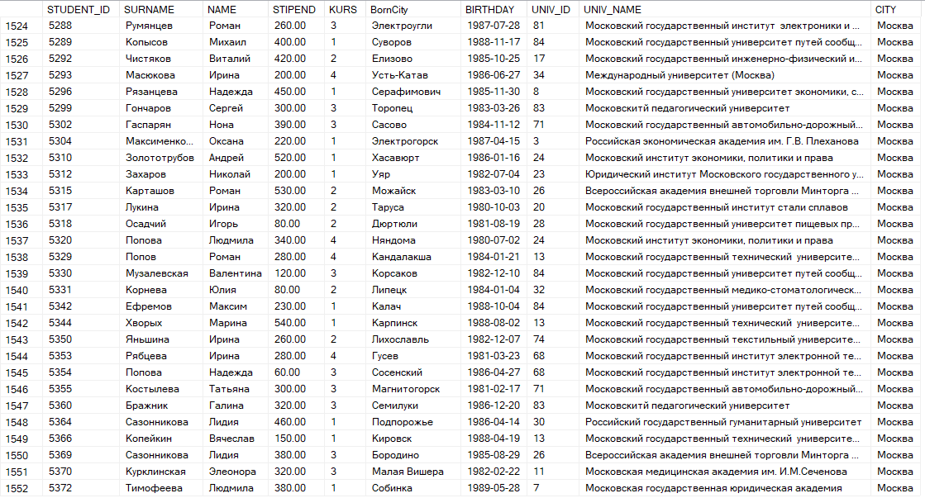.

1. 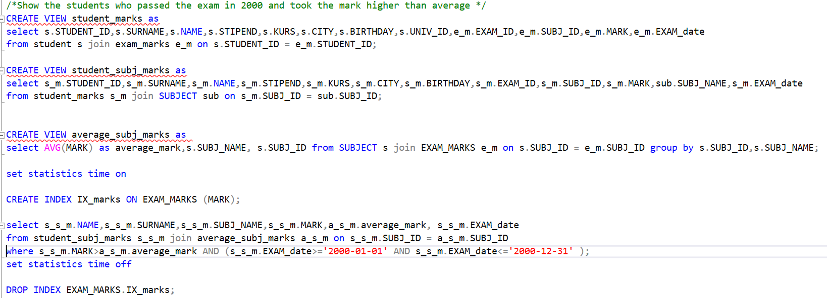Write a query to display all the students who passed the exam in 2000 and took the mark higher than average one.

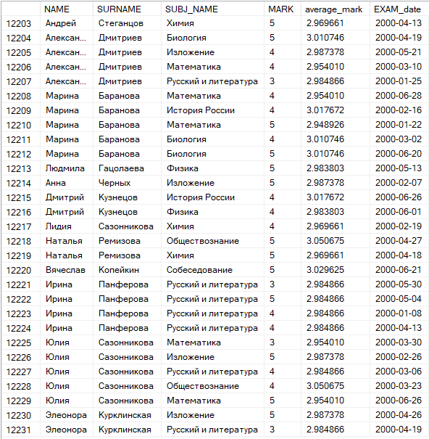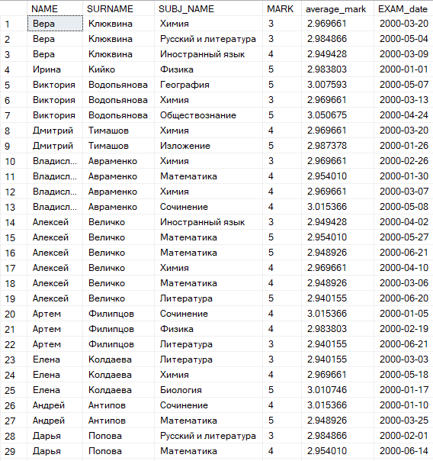

🡪

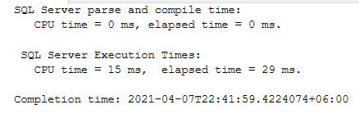Considering saved time using INDEX on MARK column we can see below:

1. Write a query to demonstrate the opportunity of working with transactions. Increase the scholarships of students who are the second year by 20% and by 25 % for students who are the third years ones UPDATING the table STUDENT.

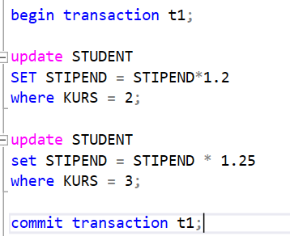

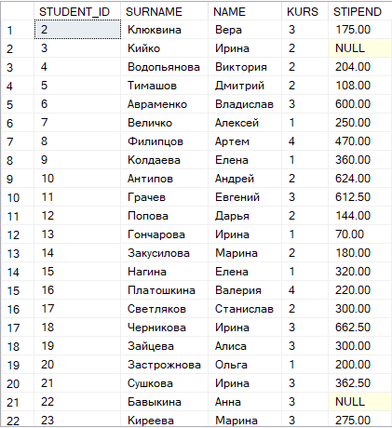

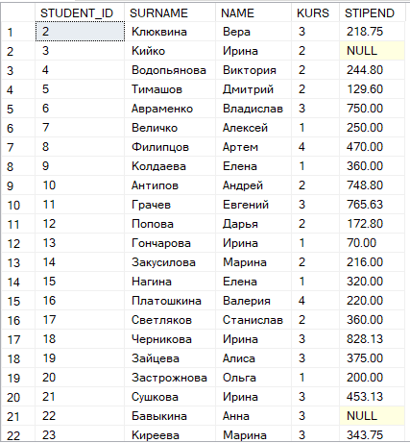

🡪

🡪

🡪

1. Try to show all the best 3 Universities in the RUSSIA.

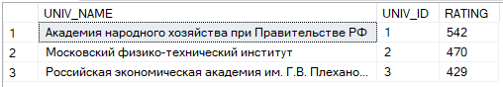

1. 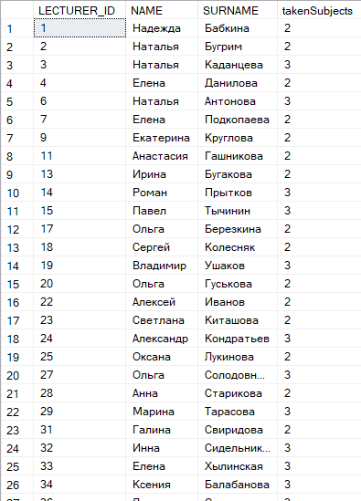Make a request to illustrate all the Lectures who teach more than 1 subject.

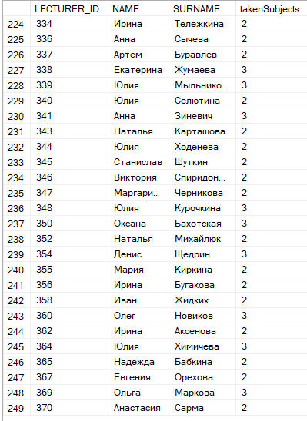

🡪

**5 Join Requests:**

1. Show all the information of the universities where the majority of the students survived at least before the fourth year of study.

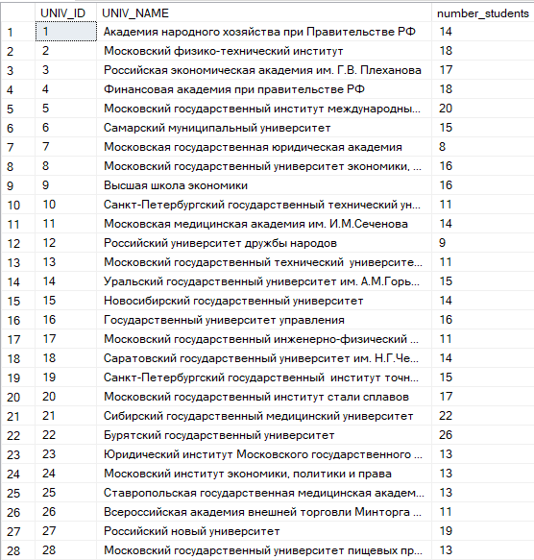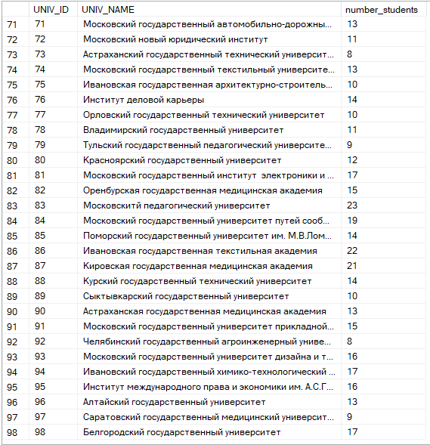

…

1. 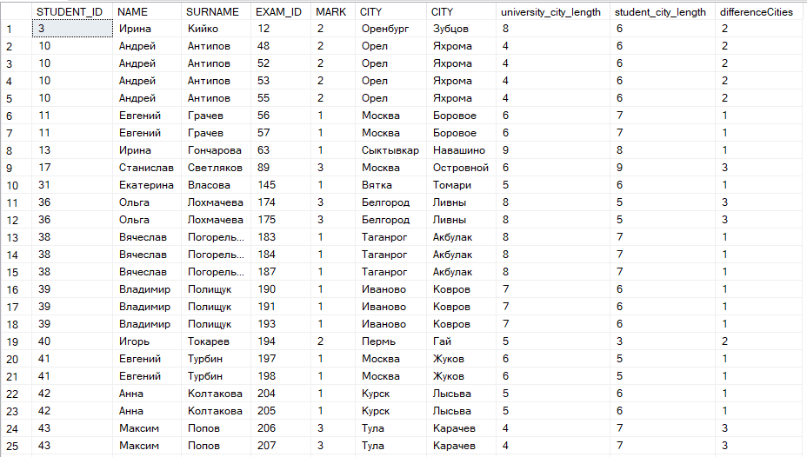 Show all the students whose absolute difference between length of the city where they live and length of city where they study is equal to the mark of the exam of any subject.

.

.

1. 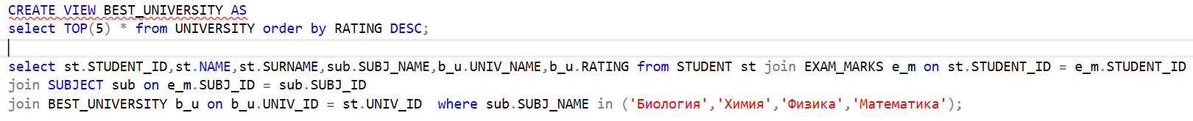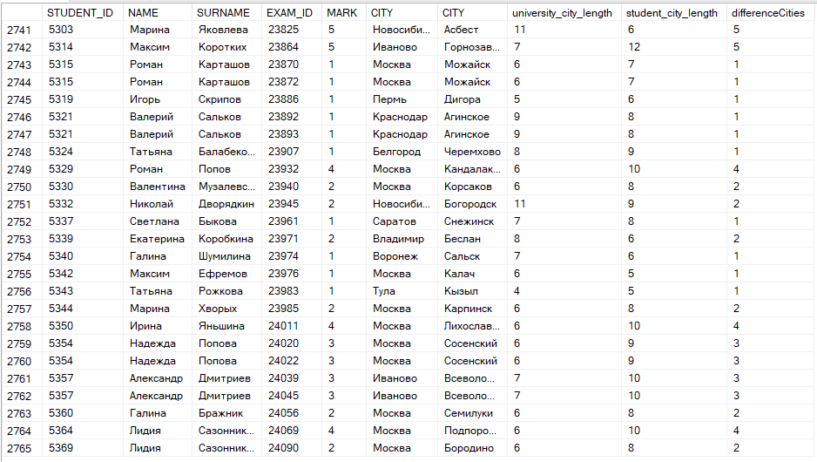 Show all the universities as well as students who study one of the Technical courses in the best TOP 5 Universities.

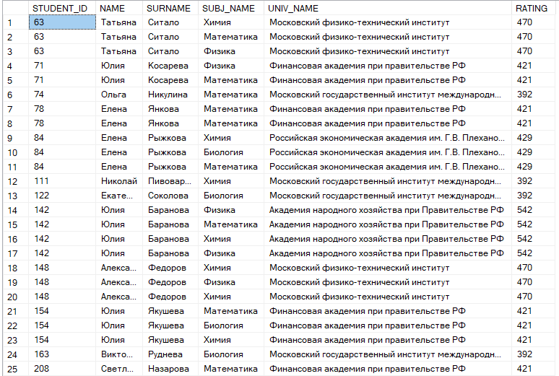

.

.

.

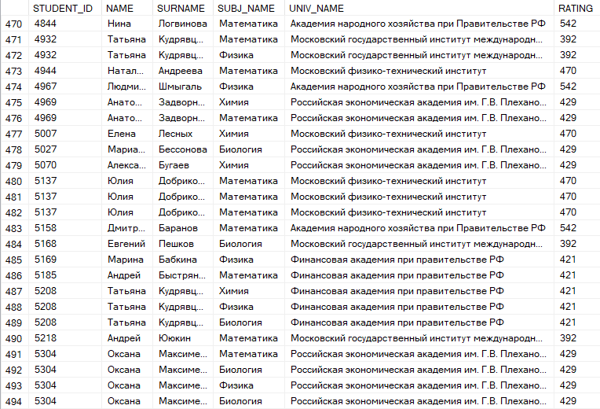

1. 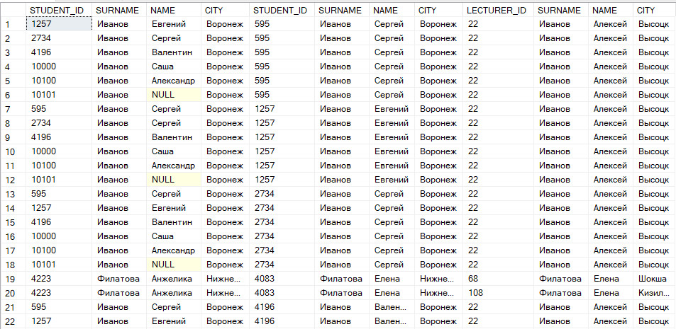Show all the possible RELATIVES among Students who could live together and corresponsible Lecturers who could also be their far RELATIVE and could live in Another city
2. Represent TOP 3 cities where all the students and lecturers live in the same city as University

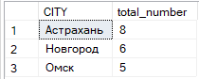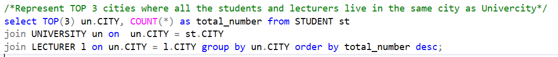

1. 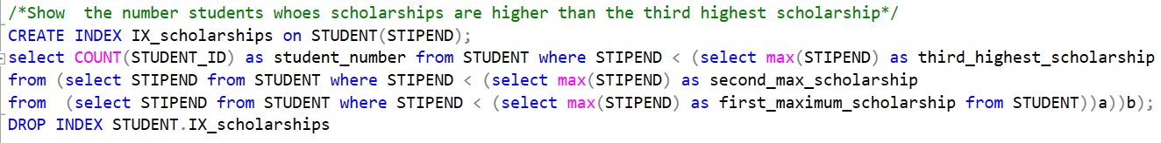**5 SUBQUERY REQUESTS.** Show the number students whose scholarships are higher than the third highest scholarship
2. Make a request to illustrate all the universities’ info where average scholarship of each university is higher than the average scholarship of the university with ID = 58

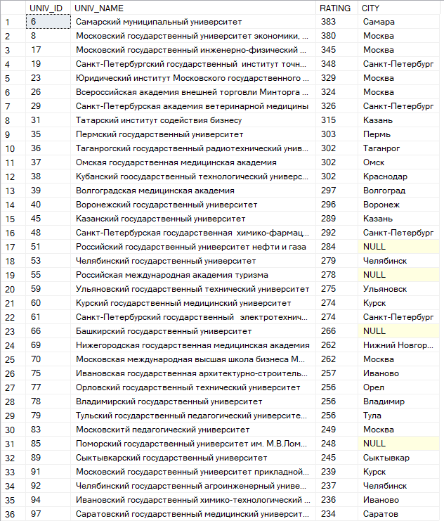

1. 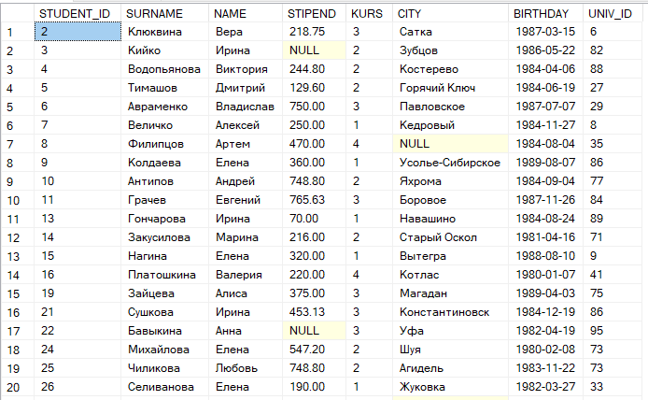Show all the possible students that Lecturer with Name 'Надежда' and Surname 'Бабкина' would teach any lesson.

.

.

.

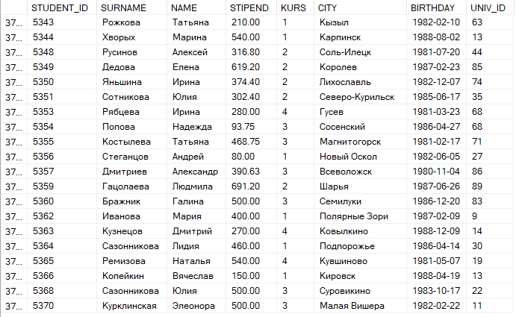

1. 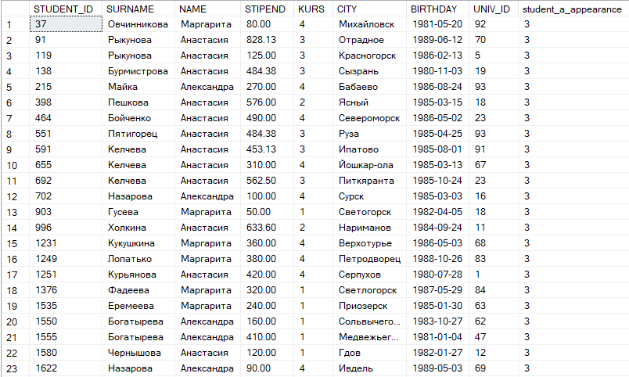Show all the Students whose Name contains the exact MAX appearance all 'a' letter - 1 in ANY Register of the SURNAME of the Lectures.

.

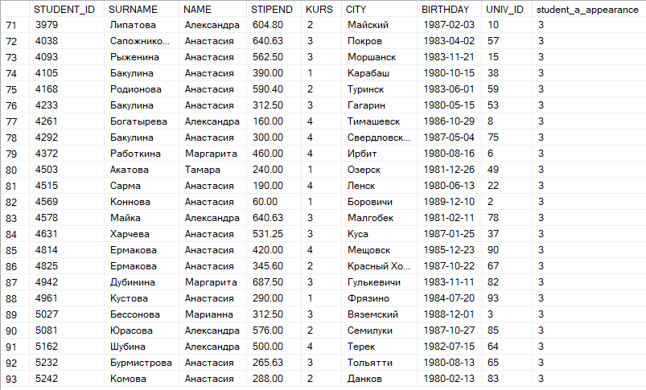 .

1. 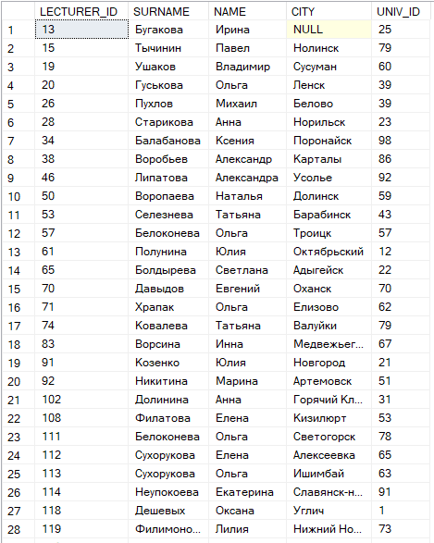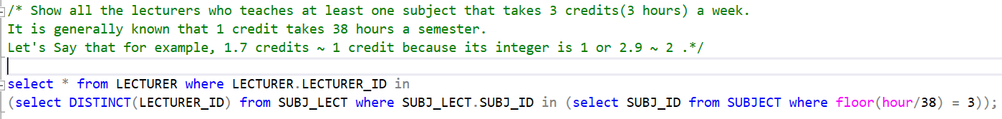Show all the lecturers who teaches at least one subject that takes 3 credits(3 hours) a week. It is generally known that 1 credit takes 38 hours a semester. Let's Say that for example, 1.7 credits ~ 1 credit because its integer is 1 or 2.9 ~ 2.

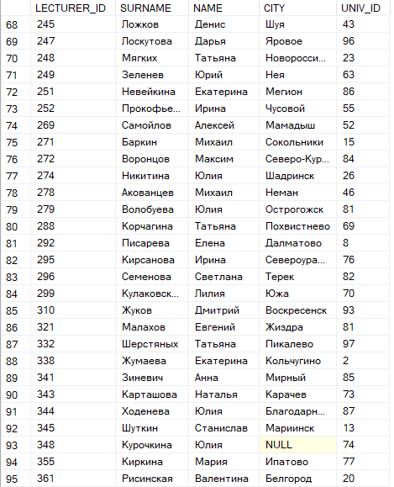

🡪

🡪

**5 FUNCTIONS REQUEST**

1. Show all the students whose age is at least 18 years old. Consider Leap Years as normal Years.

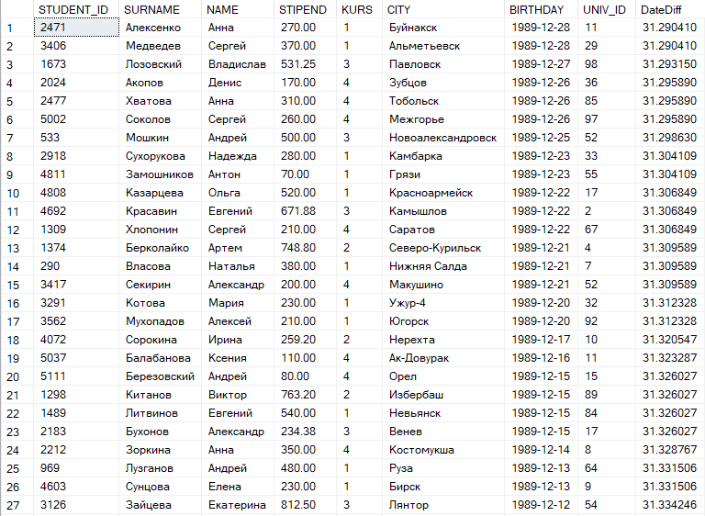

.

.

.

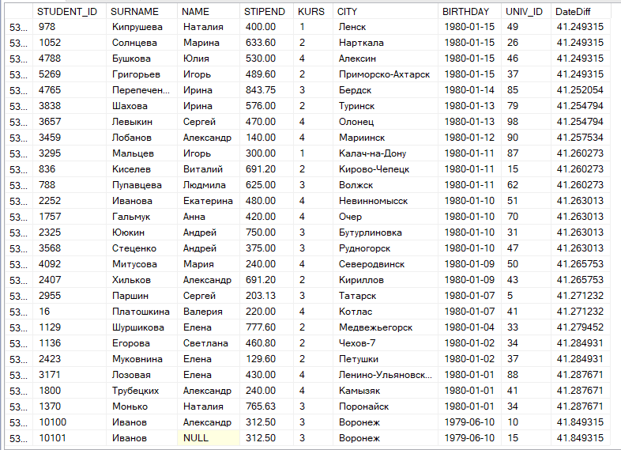

1. Show the students with their appropriate Lecturers and subjects that they teach making the Surname and Name of the Student and Lecturer together by different functions.

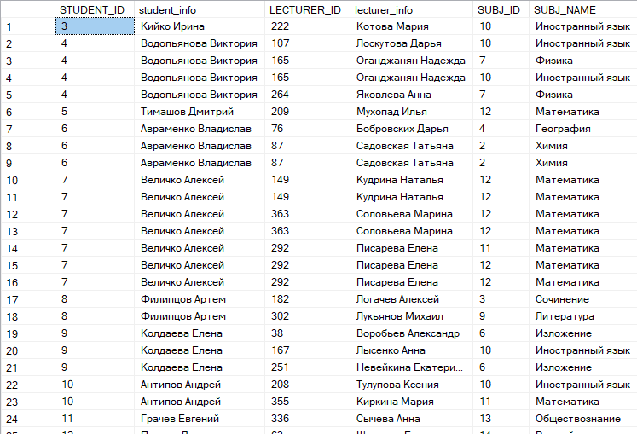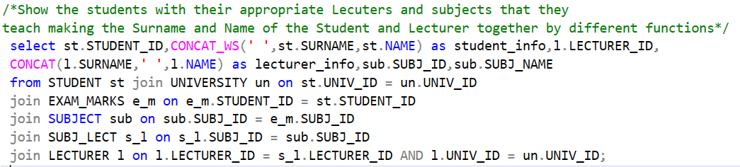

.

.

.

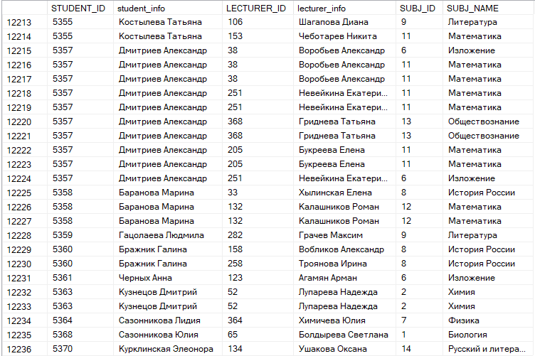

1. 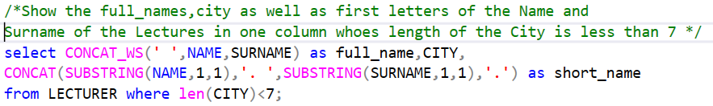Show the full_names,city as well as first letters of the Name and Surname of the Lectures in one column whoes length of the City is less than 7.

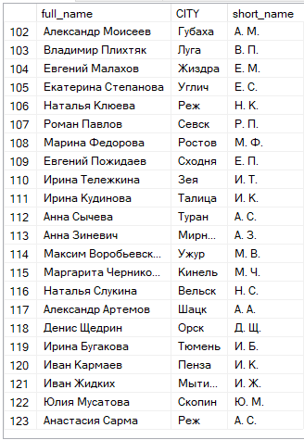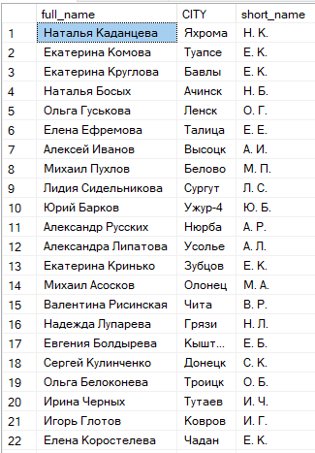

🡪

🡪

🡪

1.  Show all the students whose zodiac sign is Cancer.

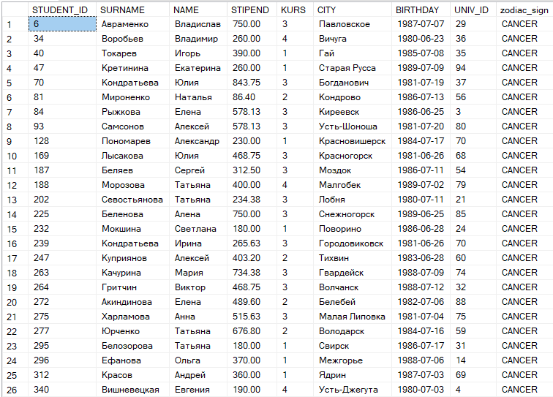

.

.

.

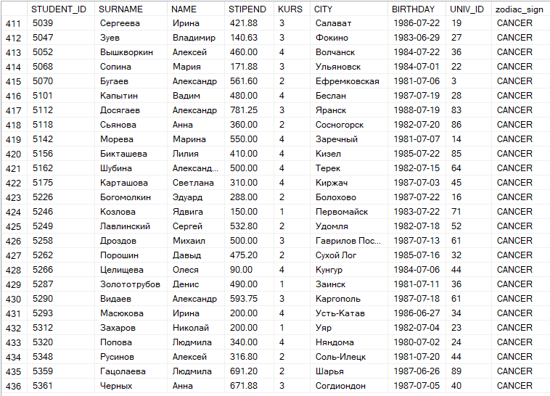

1. Show all the subjects which square root of id is a good number. Good number can be a figure square root of which is a beautiful quantity. For ex.: 1,4,9,16,25 etc.

