

**JSC “Kazakh British Technical University”**

**School of Mathematic and Cybernetics**

    Analysis of Data Bases

**Laboratory Work #9**

**Prepared by: Maratuly Temirbolat**

**Almaty 2021**

1. **Create a stored procedure that adds the missing data to the “Bank scheme” database.**

This time in order to demonstrate the above statement I used the loop and filled in the SUPERIOR_EMP_ID column with Random numbers in range from 1 to 18 in EMPLOYEE TABLE.

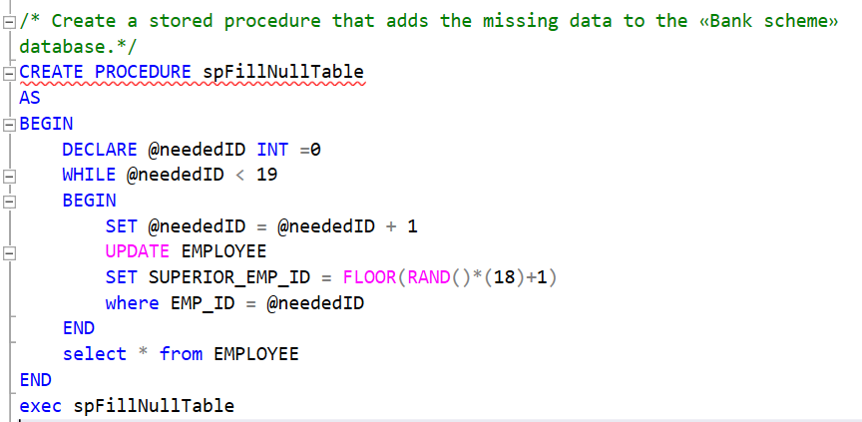

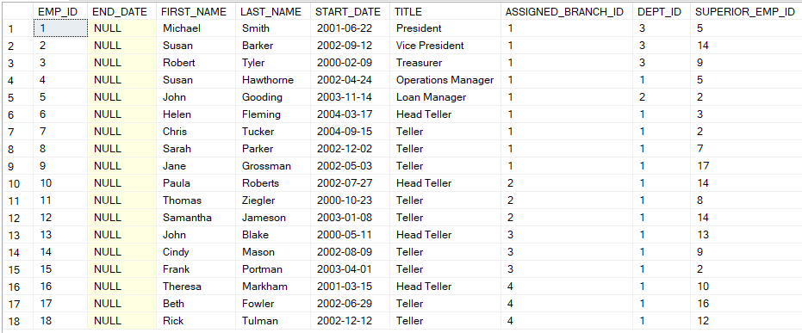

1. **Create a stored procedure that changes the datetime data type to date for all the corresponding columns of the «Bank scheme».**

**Remark:** I have changed the datatype from datetime to date only for NONNULL columns. Demonstrate the result illustrating the columns from ACCOUNT table.

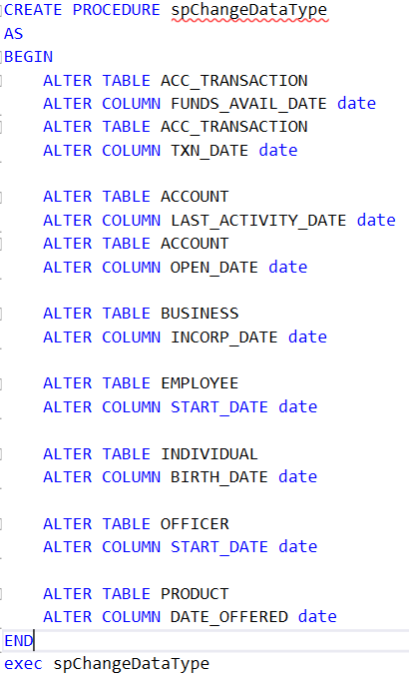

1. 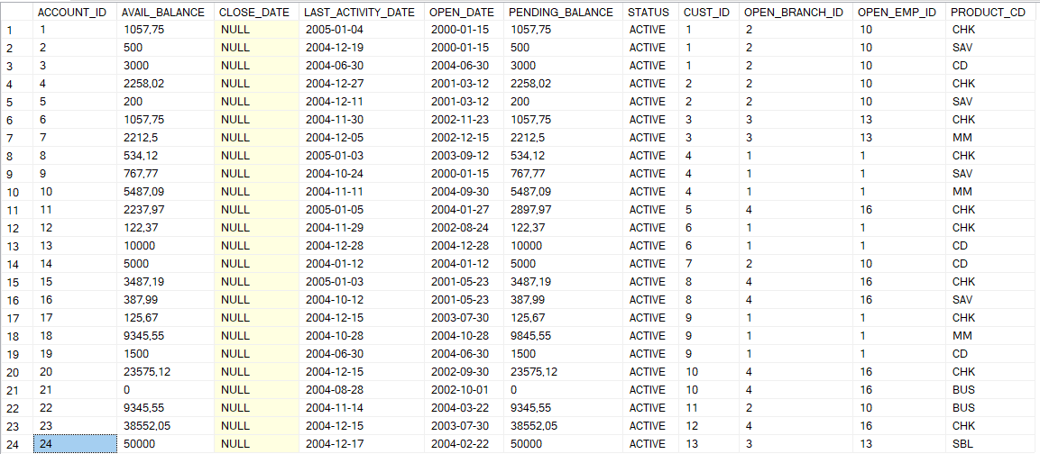**Create a stored procedure that counts the number of accounts for each bank customer and returns either ‘None’, ‘1’, ‘2’ or ‘3+’. The result set should include the customer identification number, the customer type and the number of accounts.**

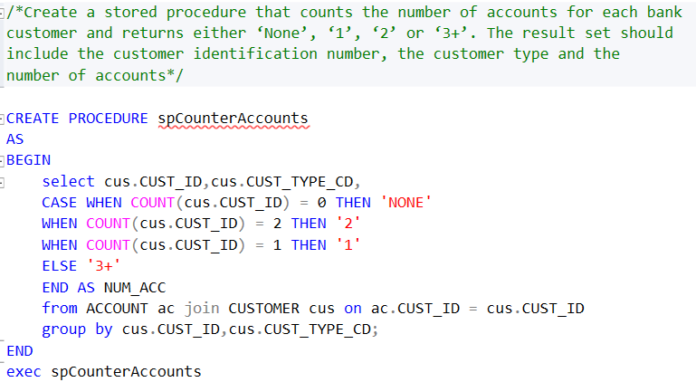

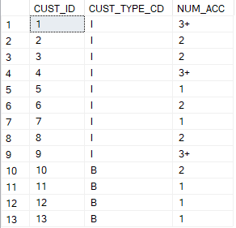

1. **Create a stored procedure that uses two CASE expressions to generate two output columns, one to show whether the customer has any checking accounts and the other to show whether the customer has any savings accounts. If the customer has the account, print ‘Y’, otherwise print ‘N’. The result set should include the following information: the customer ID, their home address, the existence of checking accounts and the existence of savings accounts.**

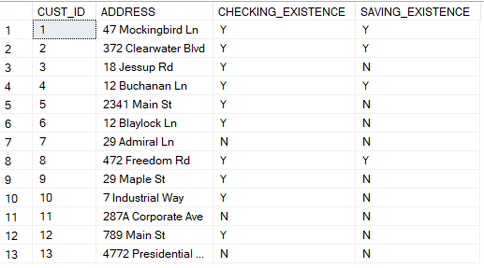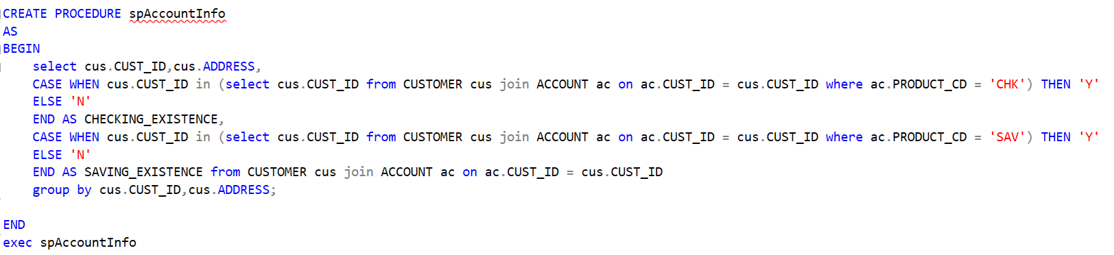

1. 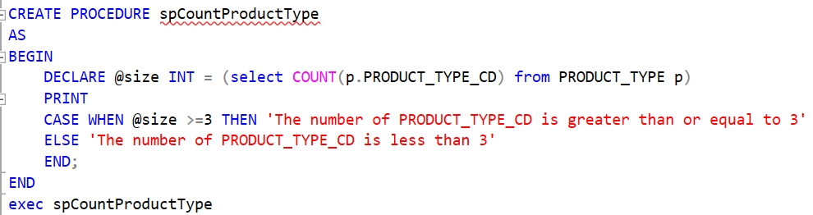**Create a stored procedure that declares a variable and set it to the count of all PRODUCT_TYPE_CD in the Product_Type table. If the count is greater than or equal to 3, the stored procedure should display a message that says, “The number of PRODUCT_TYPE_CD is greater than or equal to 3”. Otherwise, it should say, “The number of PRODUCT_TYPE_CD is less than 3”.**



1. **Create a stored procedure that uses two variables to store:**

**a) the count of all of the customers in the Customer table;**

**b) the average avail balance for each customer. If the customers count is greater than or equal to 13, the stored procedure should display a result set that displays the values of both variables. Otherwise, the procedure should display a result set that displays a message that says, “The number of customers is less than 13”.**

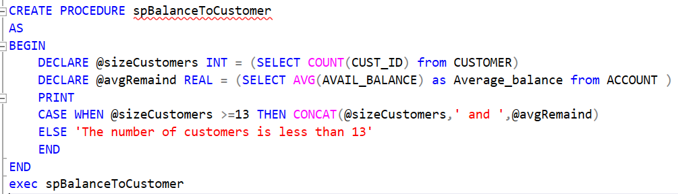



1. **Create a stored procedure that calculates the common factors between 15 and 30. This procedure should display a string that displays the common factors in this form: Common factors of 15 and 30: 1 3 5 15**

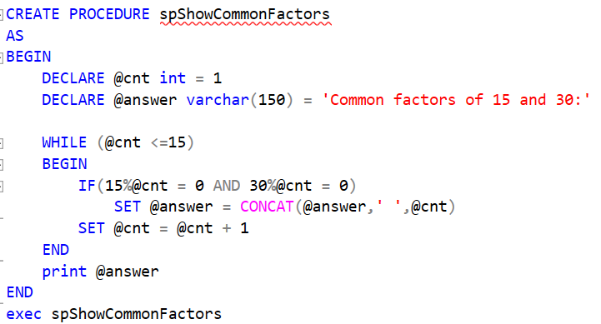



1. 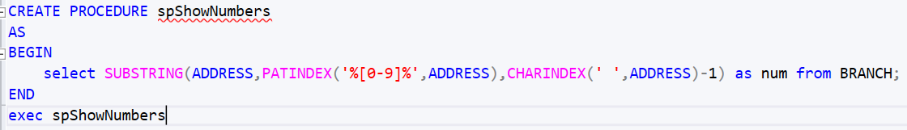**Create a stored procedure that shows all numeric characters from the entire string. You can use the ADDRESS columns in the «Bank scheme» database or any row of your choice.**

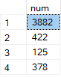

1. **Create a stored procedure for the «Bank scheme» database of your choice. Condition: the procedure must be encrypted.**

**Description of the Task:** Create a stored procedure which is encrypted and shows the First names, last names, description of their full names and maximum appearance of the ‘a’ letter of the OFFICER Table. Take the max possible appearance of the ‘a’ letter from the CONCATINATION of the FIRST_NAME and Last_NAME from INDIVIDUAL table. If the appearance of the ‘a’ exceeds of equal the quantity that is considered as random number from 0 to amount of maximum appearance from the INDIVIDUALS then it shows ‘Enough amount of repetitions’ otherwise 'tiny amount of (a) letter appearances'. Floor the random number.

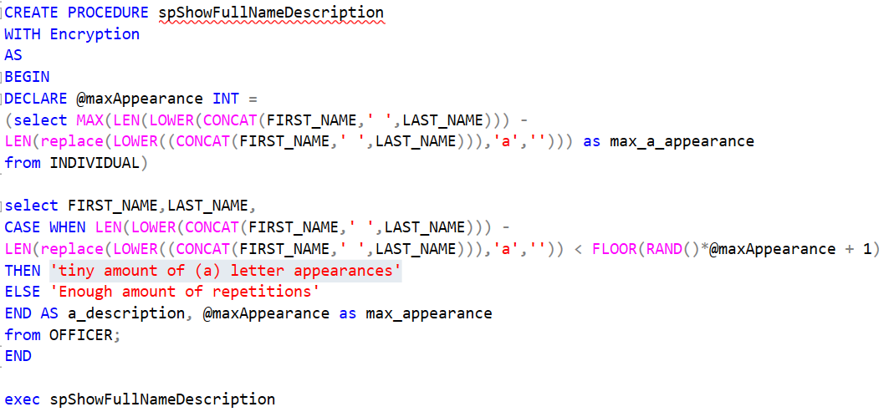

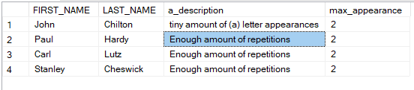

1. **Create two stored procedures for the «Bank scheme» database. Condition: one procedure must call another.**

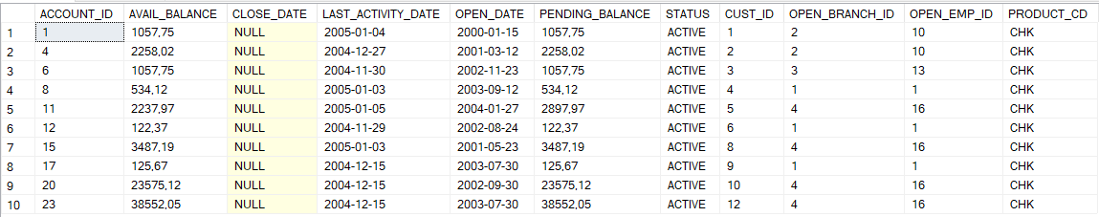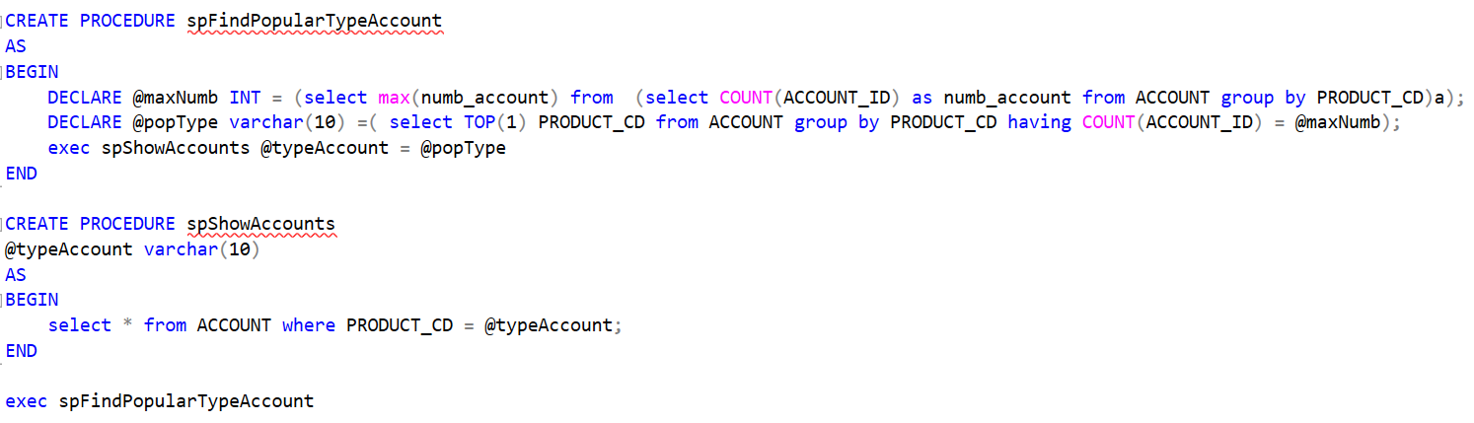**Description of the own exercise:** Create two stored procedures where one DECLARES 2 variables (First variable is responsible to keep the maximum number of the most popular account and Second to store the type(short description) of the most popular account) then this procedure calls another one to show all the accounts with the appropriate type of the account that was sent from the last procedure.