INTRODUCTION

This project is aimed to implement a TODO list for handling events such as posting new tasks, fetching own tasks, logging into the system, registering new users, and deleting own tasks. The Django was used because of its simplicity, quick realization of the tasks (since it used commonly used for MVP products), and just personal passion to this framework. Containerization via Docker is assumed to quickly developed product transfer into isolated virtual environment, and easily deploy it on a server or connect unused packages (modules) which are used in the current project with no need to manually install them (here PostgreSQL). It ensures that what works on the developer’s machine will also work in production, minimizing conflicts caused by dependencies or system configurations. Docker is used to containerize both the Django task management application and the PostgreSQL database. It combines the following motivation: consistent development environment (both the application and database run identically on local machines and in production), multi-container setup with docker compose (Django web service, here, back-end, and the PostgreSQL database service, named “db”, are defined and managed together using Docker Compose. This makes it easy to orchestrate and maintain both services). The usage of volumes for docker is a simple way to store database results, even, if we stop and restart the container. Django is chosen for its high-level abstractions (class based approach), built-in admin panel (to manage models data), and robust ORM (Object-Relational Mapping) that easily integrated with PostgreSQL.
Executive summary. The project combines the most popular technologies such as DRF (Django Rest Framework) for back-end development, PostgreSQL as a relation database, JWT (JSON Web Tokens) for user’s authentication, Debug Tool Bar for processing database queries, connection for further optimization, Docker to build and launch the project without any forced requirements for packages, technologies or even an operational system. Docker compose is applied to connect both back-end (DRF) and database (PostgreSQL) into one network without manual way doing it separately for each of them.
Project goal. The project is aimed to create a high loaded, quickly implemented simple back-end application using REST (Representational State Transfer) architecture style to divide the Web application into separate responsible sides.
Project outcome. The project contains several outcomes such as the possibility to create, delete, view and partially update tasks through a simple application (each user has own tasks, so, they separated). Another outcome is that the application is based on the latest technologies such as containerization to quickly build and run a project in a several system (Docker networking ensures that Django can communicate securely with the PostgreSQL database).

1. Project setup

The section is responsible to describe the project’s configuration, settings, created applications, approach, used package manager, etc. Before the beginning of the own representation of a done work, we need to setup the initial project using python. Here “python3”, especially, “python3.12” version applied for the whole work. We need to create a virtual environment to store all the required packages along with their specific version to be used especially in the current version. To achieve this role the command “python3 -m venv venv” was executed to create a folder “venv” that contains all the information about interpreter. Now, all the packages can be installed directly to the virtual environment. To run a virtual environment, run the command: “source venv/bin/activate” (for linux based systems). Then install django using the command “pip3 install django” (latest django version) and run the command “django-admin startproject <project-name>”. Figure 1.1 illustrates customized django’s project configuration.
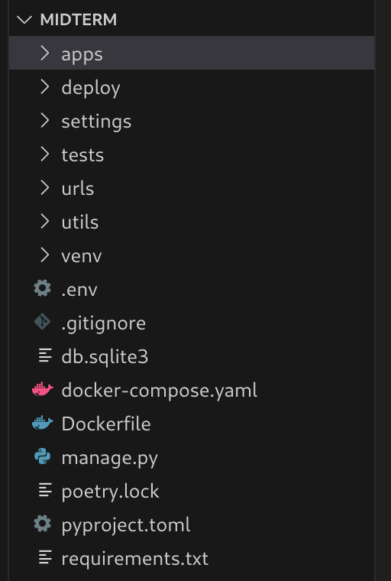
Figure 1.1 – Project’s files tree

The project’s default configuration of the project has been changed for a custom one. The project’s configuration has been changed because of the personal experience as well as native understanding of files locations as the project would get bigger. Inside the "apps/" folder, you’ll find all the project’s applications separated by its names. The "settings/" folder stores the project's configuration files, such as separate settings for development and production. There’s also a "tests/" folder, which contains tests to make sure everything in the project works as expected. The "urls/" folder manages the links in the app and tells the system which page to load for each URL.
The "venv/" folder holds the virtual environment, which helps keep all the project's dependencies separate from other projects on your computer. The "utils/" folder contains reusable helper functions used across the project. Files like ".env" store private settings (like passwords) safely, and ".gitignore" ensures unnecessary files are not tracked by Git (such as the virtual environment or temporary files). For deployment, there are Docker tools available: "docker-compose.yaml" helps run multiple services (like databases and the Django app) together, and the "Dockerfile" explains how to build the app inside a container. Finally, the "manage.py" file helps you interact with Django from the command line (e.g., running the server or making database changes). "requirements.txt" lists the libraries the app needs, while "pyproject.toml" and "poetry.lock" help manage these dependencies using Poetry, a modern tool for handling project libraries. This structure ensures everything is well-organized, easy to develop, and ready for deployment. The project by itself includes DRF (Django Rest Framework), it also uses JWT (JavaScript Web Tokens) for authentication. Let’s now examine project’s settings (“settings” folder). Figure 1.2 shows the files under the “settings” folder.

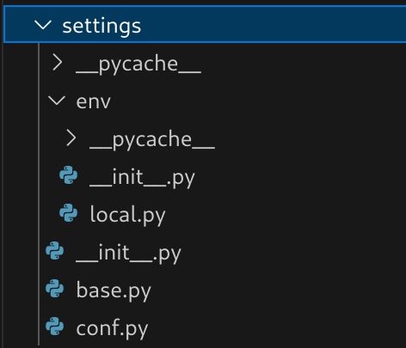
Figure 1.2 – Structure of the project settings

The project’s settings divided into 2 groups: environmental and common ones. Environmental settings are located into “env” folder, here, especially, “local.py” file which contains such parameters like (debug mode, database configuration, wsgi and asgi paths) for the local machine running. Moreover, another group contains the same files configuration for all the projects modes (production or test, does not matter). It contains 2 files: “base.py” and “conf.py”. The former has only base configuration for the project such as “INSTALLED_APPS”, “MIDDLEWARE” and other main variables, while the latter is about third party libraries configuration such as “DJANGO_DEBUG_TOOLBAR”, JWT configuration, etc. The “base.py” file just exports everything from the “conf.py” file. Let’s examine “local.py” file to see more details (Figure 1.3).

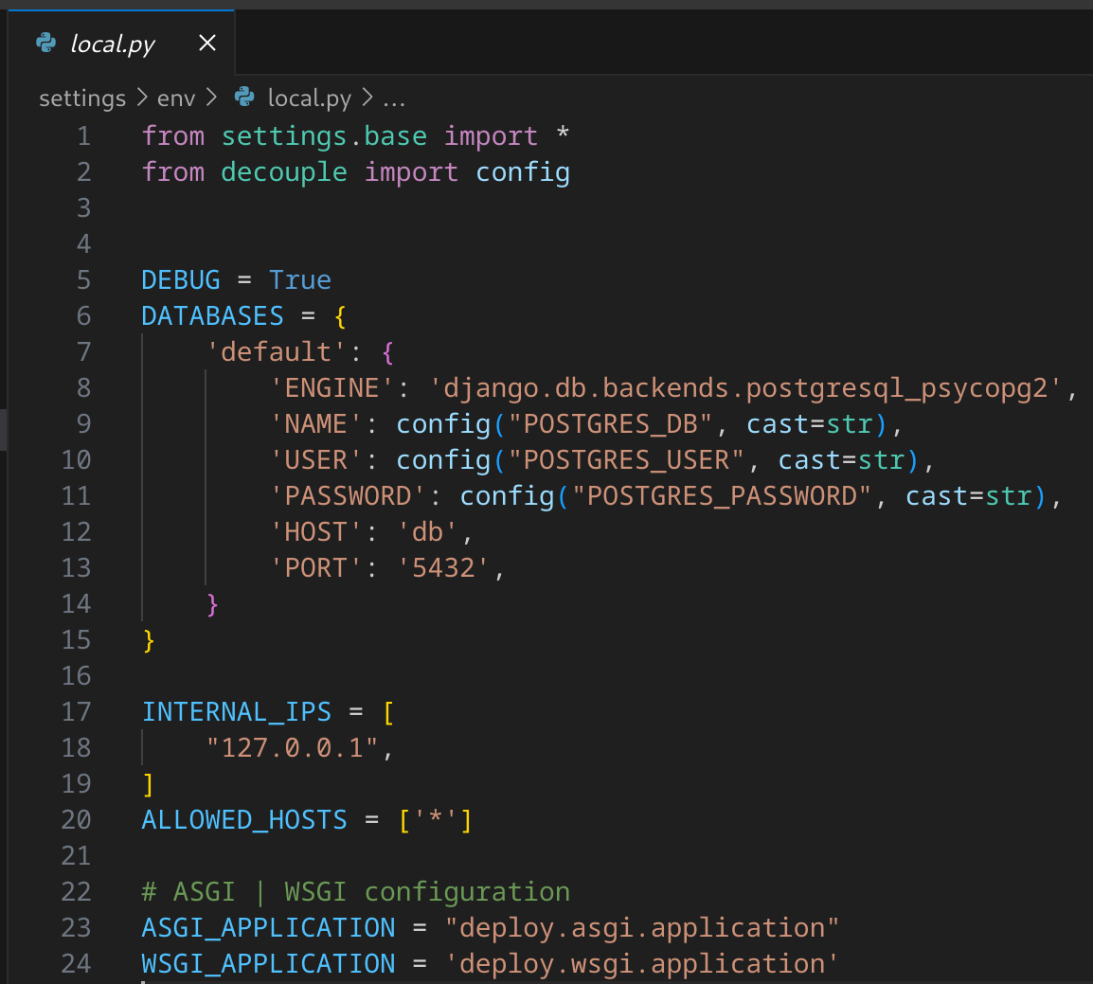
Figure 1.3 – Local file configuration

It can be clearly seen that file contains specific configuration related to the current environment which is set, e.g. for the local machine we use postgres as a database, debug mode is enabled to see the trace back of the code as an error appears. It could be noticed that we just extend the “base.py” file which also include “conf.py” inside, and the required variables such as database name, user’s name in a database or password are set “.env” (located in the root project folder) file for managing some hidden variables from the developer. Figure 1.4 contains all the environmental variables which are used for the both database and back-end parts.

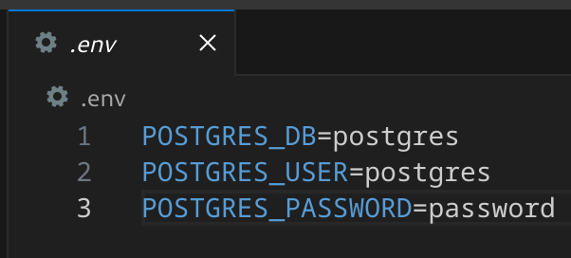
Figure 1.4 – Database and back-end environment variables

The naming for variables would be described in project’s launching section. It is left to explain what “deploy” folder contains. Figure 1.5 demonstrates the explorer of the files of a “deploy” folder.
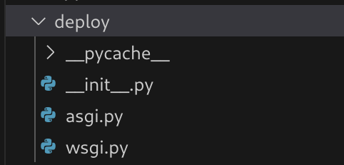
Figure 1.5 – Deployment files

So, there are 2 main files and empty “__init__.py” file for the Django to see the files. There are 2 files “asgi.py” and “wsgi.py” which are named as Asynchronous Server Gateway (ASGI) Interface and Web Server Gateway Interface (WSGI) respectively. Figure 1.6 represents the customization for the ASGI.
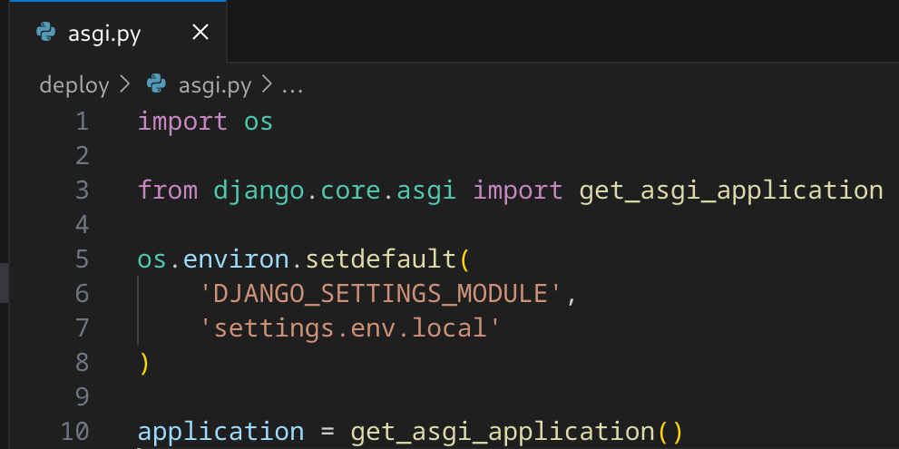
Figure 1.6 – ASGI file settings
ASGI file allows Django to communicate with asynchronous web servers, supporting features like WebSockets and background tasks. It's used if you plan to run Django with an asynchronous server like Daphne. Figure 1.7 demonstrates the code of the WSGI file.

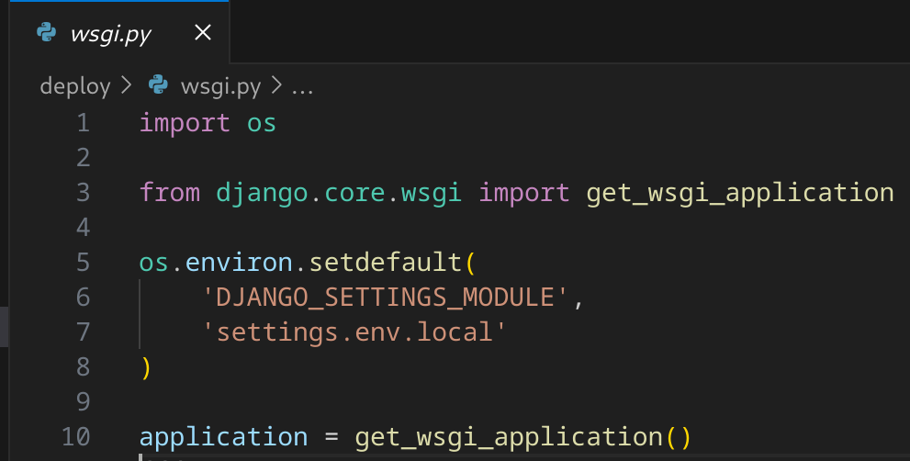
Figure 1.7 – WSGI file configuration

WSGI file is an entry point for synchronous web servers like Gunicorn or uWSGI to communicate with your Django app. It’s used when you are deploying Django in a production environment. By default, all the synchronous operations of the Django goes through the Web Server Gateway Interface.
Let’s discuss the the URL paths which direct our queries to our logic processing. The is a single file “urls.py” which is used to collect all the paths and redirect them to a set view (here ViewSet). The file “urls.py” is located in the “urls” folder (Figure 1.8).

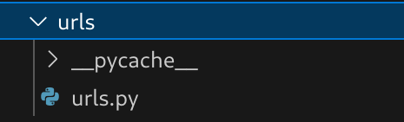
Figure 1.8 – Location of the URL file

Generally, it plays a role in routing web requests to the appropriate views (functions or classes that generate a response). It defines the URL patterns that your application will respond to. Figure 1.9 shows the code of the “urls.py” file.

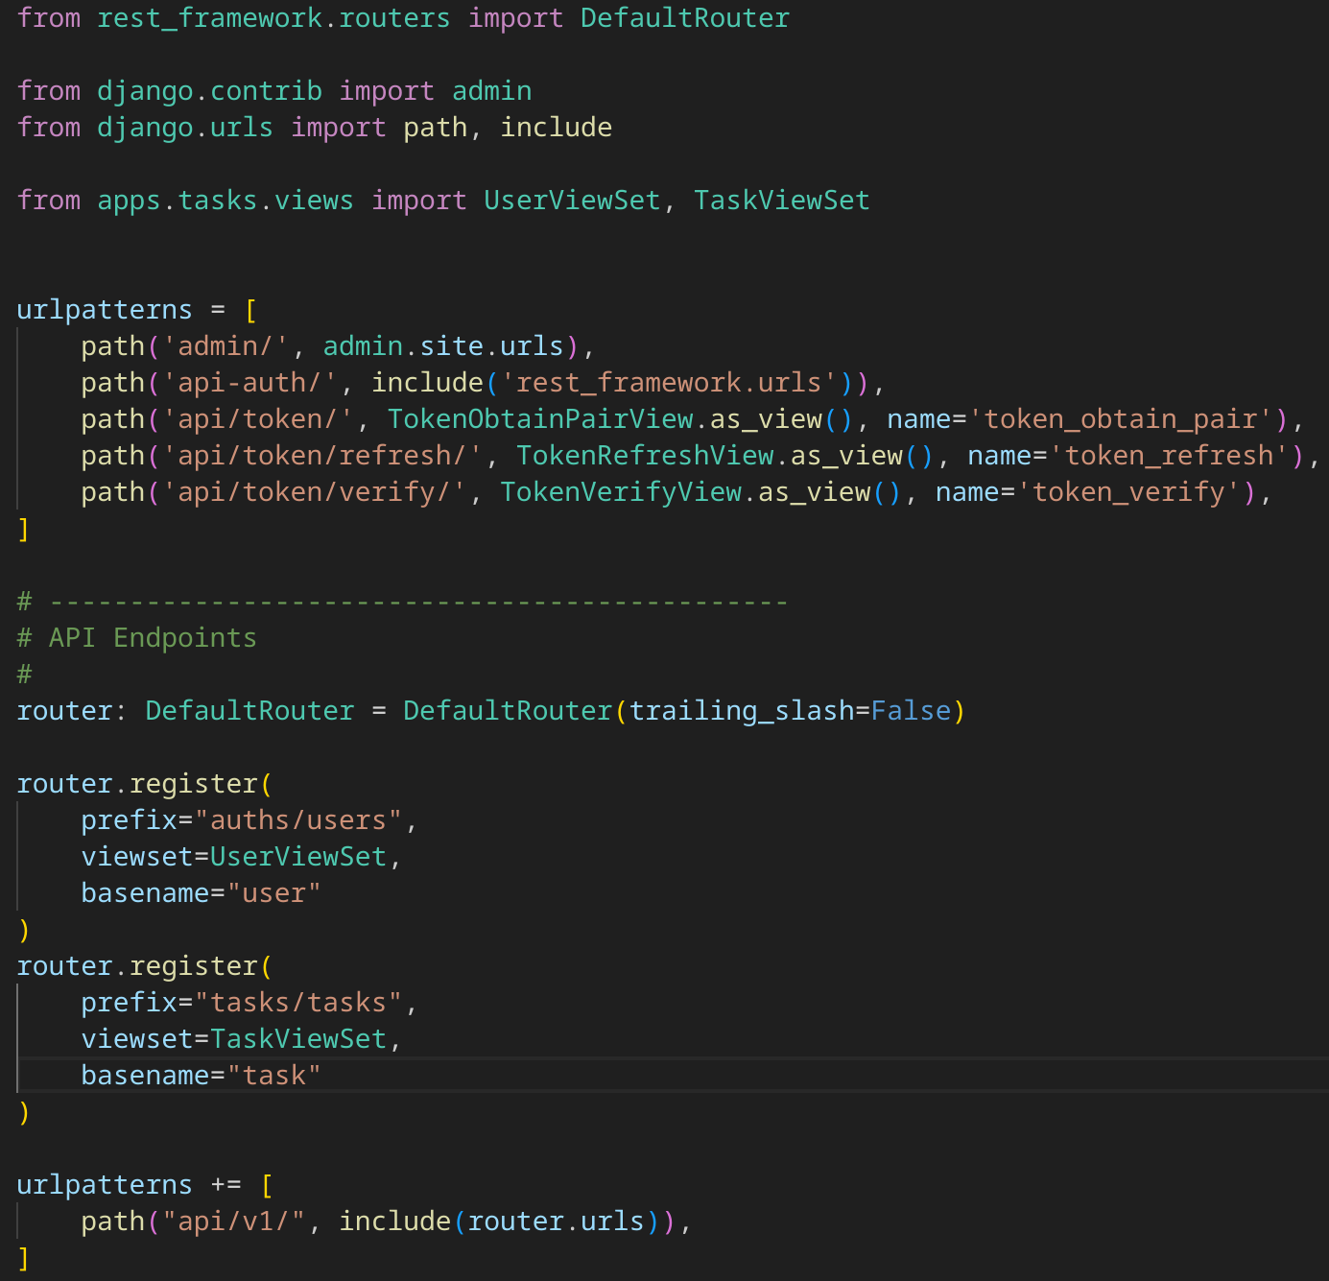
Figure 1.9 – Code for the URL routing

Initially, it is necessary to import all the packages, such as, router, path, and include in order to register all the endpoints’ paths. It creates several paths: one for the Django admin interface, another for authentication-related endpoints, and specific JWT token management endpoints. The code then uses a “DefaultRouter” to automatically generate RESTful API routes. It registers two “viewsets”: one for user-related operations under the path "auths/users" and one for task-related operations under "tasks/tasks". Finally, it includes the router’s URLs under the API version (here “v1”). So, if a user decides to register, or login, he/she will follow “http://host-name/api/v1/auths/users” and then an appropriate name like “login” and “register” as a suffix of a route.

2. Introduction to Containerization: Docker

This section is responsible for getting familiar with containerization, docker, its installation and benefits of the usage. Containerization is an approach where you wrap you application, program or any utility into an isolated environment, own operational system, with a separated networking. One of the best offers is to use Docker containerization. Docker is an open source product which is used for developing and wrapping application into images, then run these images in containers. Docker has several components (Docker engine, Docker CLI, Docker image, Docker container, Docker registry, Docker hub, Docker network, etc.). Docker Engine is a core part that is responsible for running and managing containers. 5It consists of 2 parts: Docker daemon (docker’s server side) and Docker API (interface that communicates between Docker Daemon and other Docker components). Docker CLI or Docker Client or Docker Command-Line-Interface is used to work with Docker, for example, run containers, stop them, etc. Docker Image is a read-only template (e.g., template of ubuntu os, or python interpretator, etc.) with instructions to create a docker container. Dockerfile is your own image. Docker Container is a runnable instance of an image. By default, these containers are isolated from each other. Docker Registry is a place where you host/store different images or group os images. Docker Hub is a registry to store and share images. Docker Network is a way to provide isolation for docker containers. It is possible to set containers to see each other or be in the same network.
Docker installation depends on what operation system (OS) you use (Linux, MacOS or Windows). Here we introduce installation only for Linux (Fedora distributor) since this OS was used. Firstly install the docker using the command in a terminal “sudo dnf install docker-ce docker-ce-cli containerd.io docker-buildx-plugin docker-compose-plugin”, then you need to start a docker as a process using the command “sudo systemctl start docker”, add your user to a docker group in order to run the commands with no admin privileges. That’s it, the installation is over.
As we installed docker via official documentation, we need to make sure that it works. The best way to use ‘docker --version’ which must show the installed version of a docker. The information about docker’s version is illustrated in Figure 1.10.

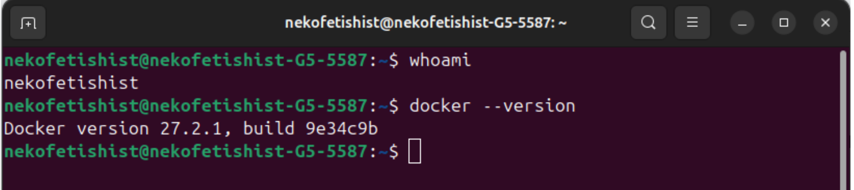
Figure 1.10 - Docker’s installed version information

As we installed the docker, we can run ‘hello-world’ container to see that docker works properly with no issues and errors. Figure # demonstrates the results of this command. Docker will download ‘hello-world’ image if you do not have it.

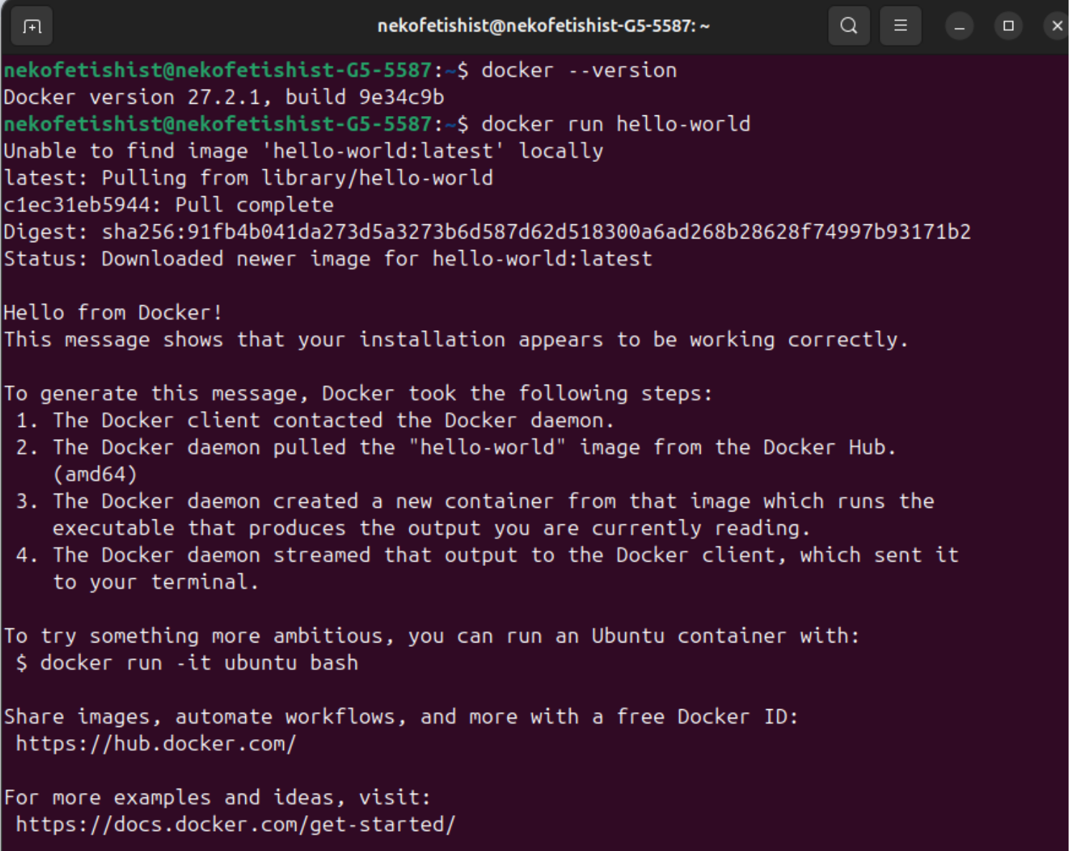
Figure # - Logs after running ‘hello-world’ container

The output of the docker run hello-world command was that there was no hello-world image, and it started downloading it. After that it showed the message that docker is installed correctly and ready to work.

2. Creating a Dockerfile

As we know that docker works perfectly, we can create a Dockerfile for our backend application. Let’s now look at “Dockerfile” to understand the project’s building approach. Dockerfile is located in root of the project as it is our entry point to build an image from it and run. Figure 1.11 contains information about django’s docker file.

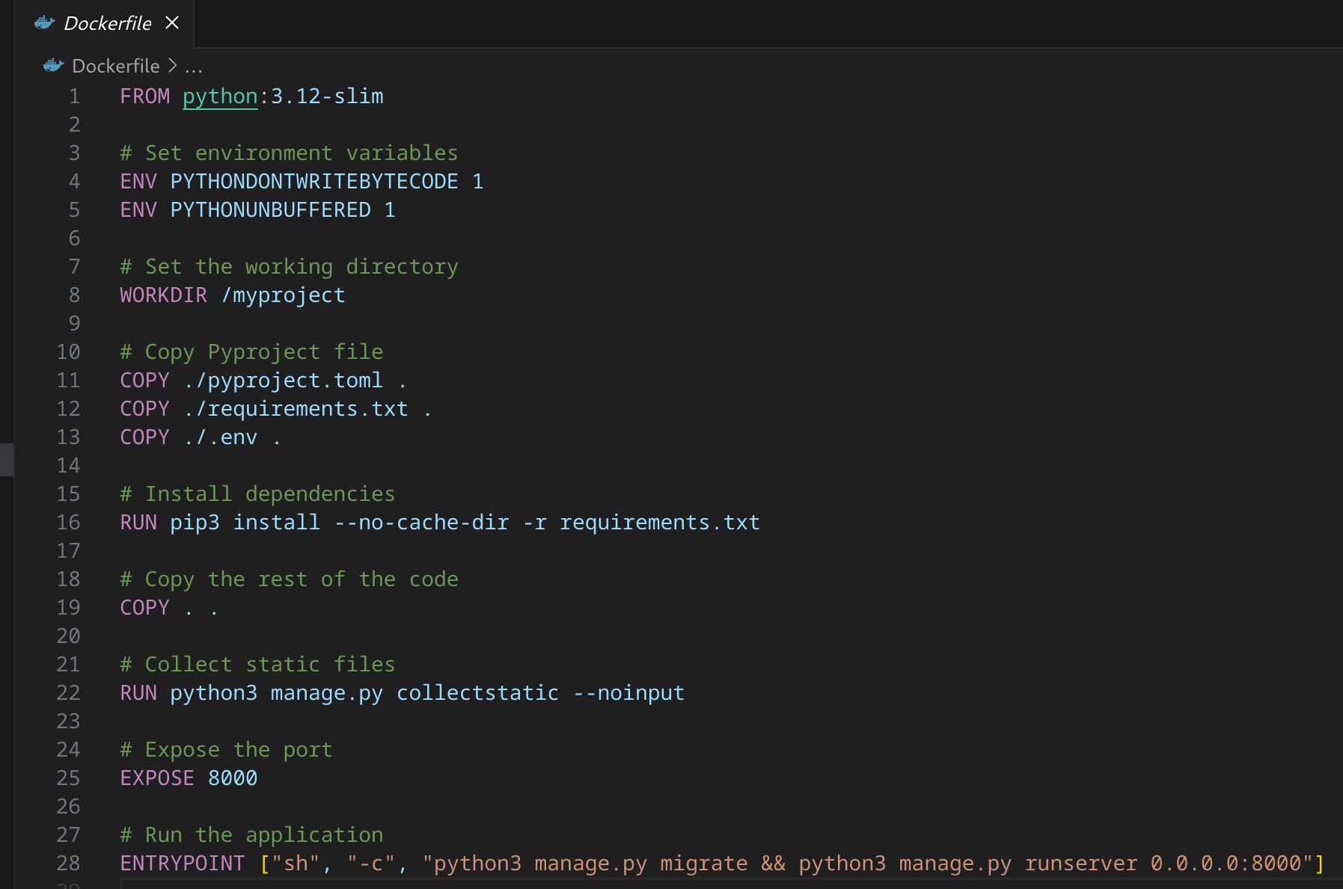
Figure 1.11 - Dockerfile’s details for project building

The file contains all the comments about each command but emphasizing some notes it can be added that we use python 3.12 slim version and run the application using guvicorn to bind a specified url. Initially, we copy only “pyproject.toml”, “requirements.txt” and “.env” files because we want to cache these steps as we contain there all necessary dependencies. Moreover, we set environment variables “PYTHONDONTWRITEBYTECODE” to 1 or True as well as “PYTHONUNBUFFERED” to 1 or True in order to not to save the cache into the buffer. Then, we copy all the files from the project root folder and transfer then to a “myproject” directory, collect static files, make migrations to apply the rules for a database and run the application. The description of the “Dockerfile” is now over.

3. Using Docker compose

Now we can start with “docker-compose.yaml” file. It is used locally to manage all the containers which are described there to make the project work correctly using all the services. For our case, we need to include images of “postgresql” (here it was decided to use 15th version) and locally built “Dockerfile” of the project. The information about “docker-compose” file data is shown in Figure 1.12.

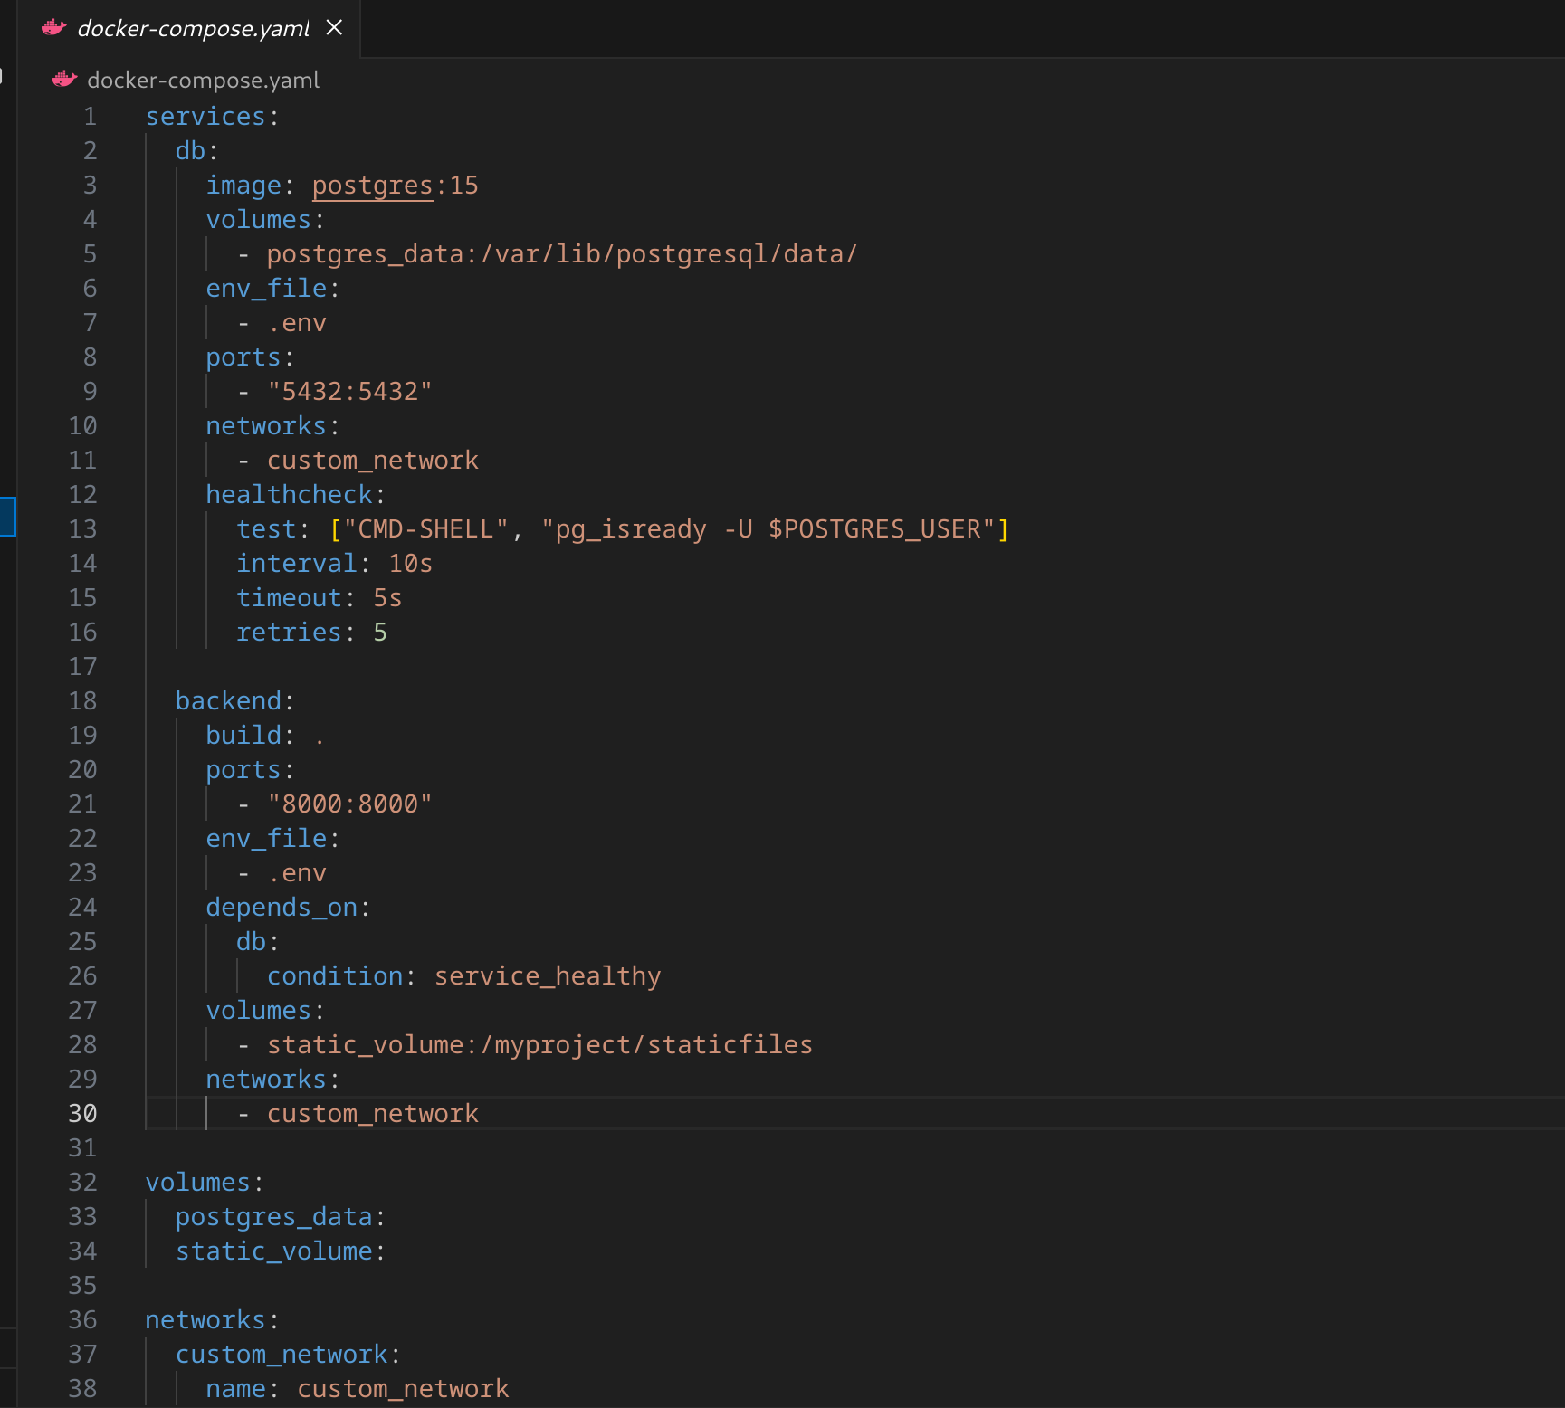
Figure 1.12 - Docker compose file’s configuration

This file defines a multi-service setup with Docker for a project using the latest version (not specified at the top). It contains two services: "db" and "backend". The "db" service uses the “postgres:15 image”, its data stored in a volume called "postgres_data". It also uses an environment file named ".env" for configuration and exposes port "5432" to communicate with other services or the host. Additionally, before the database service is launched it passes the health check to be sure that database works with not problems.
The "backend" service is set to build from the current directory where the “docker-compose” is located, and it also references the ".env" file for its configuration. It depends on the "db" service, ensuring that the database is ready before the backend starts. The "backend" service is exposed on port "8000" and uses a volume named "static_volume" to store static files at the specified path in the container.

