- Model Architectures
- Production code flow
  - Data acquisition (Fathomnet, Deepfish, Marauder datasets) sort data into specific sections for different layers of training pre-processing SSL Baseline Yolo Active learning Annotations (performed by Mindy Services, no code needed here) Critical species specialization Ensemble, multi-scale, TTA, calibration, export
- Nvidia Jetson Nano-based architecture
  - Pre-processed data, 3x YOLO ensemble (YOLOv8 with high precision, balanced, and high recall variants), multi-scaling, TTA, calibration
    - Optimized for energy efficiency, counting accuracy, and MAP
    - ~5 FPS from 4x barlus cameras processed
    - 30 seconds every 30 minutes processed
  - To be used to sort through video data and find only important parts of video to send back to shore. This will reduce energy consumption on slow and costly connections
- Shoreside architecture
  - Use same code base and general architecture but with most accurate models from nano training (IE best version of YOLOv8) + add 3 more YOLO models to the ensemble (best version of YOLOv11)
  - Based in Google Cloud Platform
    - Vertex AI and workbench, or similar base don cost and speed efficiency
    - Optimized for cost and speed efficiency, it needs to push results in near real time as the video feed is received from offshore system.
    - Can parallelize processing as needed, if cost does not become excessive
  - To be used for more accurate inference where power and computing restraints are not an issue

- Training Labels
- Categories (common name and scientific name provided)
  - Critical: Notify user immediately
    - Lionfish (Pterois)
    - Sea urchin:
      - Purple sea urchin (Strongylocentrotus purpuratus)
      - Green Sea Urchin (Strongylocentrotus droebachiensis)
      - Red sea urchin (Mesocentrotus franciscanus)
      - Long-spined Sea urchin (Diadema Antillarum)
    - Abalone:
      - White abalone (Haliotis sorenseni)
      - Red abalone (Haliotis rufescens)
      - Pinto abalone (Haliotis kamtschatkana)
    - Sheepshead
    - Kelp Crab (Pugettia Gracilis)
    - Help Crab (Pugettia Producta)
    - Giant pacific octopus (Enteroctopus dofleini)
    - Trout (Oncorhynchus mykiss)
    - Sunflower sea star (Pycnopodia helianthoides)
    - Wrasse (Labridae)
    - Oyster Drills (Urosalpinx cinerea)
    - Red Snapper (Lutjanus campechanus)
    - Eel Grass (Zostera Marina)
    - Rock fish (Sebastes)
  - Important: species important enough to track separately from general categories
    - Grouper (Epinephelidae)
    - Oyster (Ostreidae)
    - Salmon (Oncorhynchus)
    - Sea star (Asteroidea)
    - Sea slug (Nudibranchia)
    - Eel (Anguilliformes)
    - Shrimp (Caridea)
    - Jellyfish (Scyphozoa)
    - Seahorse (Hippocampus)
  - General categories: for general less important species or general labels if inference is unsure
    - Less important species:
      - Shark (Selachimorpha)
      - Sea turtle (Chelonioidea)
      - Sea lion (Otariinae)
      - Sea otter (Enhydra lutris)
      - Swordfish (Xiphias gladius)
      - Whale (Cetacea)
    - General categories:
      - Reef Fish
      - Undefined
- General Overview/ To Do
- Pretraining- Gather and sort datasets
  - Create: image, metadata, yolo files
  - Sort into specific training segments in file structure
  - Develop pre-processing hybrid algorithm for input to model training and prediction steps
- Week 1- Self-supervised pretraining (SSL)
  - MoCo V3
  - Unlabeled ocean (underwater) data at least 50,000 images (other datasets)
  - Purpose: train the model to recognize underwater features without labels
- Week 1- Train baseline YOLO model
  - version TBD (v8l, why?)
  - High confidence, verified labels at least 10,000 images (Fathomnet?)
  - Uses SSL backbone as initial input for increased accuracy
  - Analysis at end of training provides report on critical issues in ID
- Week 2- Active Learning
  - Run inference on unlabeled dataset at least 2,000 images (Marauder unlabeled + Fathomnet critical species)
  - Score results of inference to identify issue images
  - Result will be additional images to send for annotation based on clear issues found in prediction
- Week 3- Have all images annotated
  - Mindy Services
- Week 4- Critical Species Specialization
  - Create oversampling set of images for critical species ID
  - Train specialized YOLO
    - Baseline YOLO model used as input
  - Hard negative mining for false positive re-training
    - Specialized model as input
  - Result: specialized model w/ false positive optimization
- Week 5- Ensemble & Multi-scale
  - Dynamic resolution training
    - Specialized models as input
  - Ensemble training
    - Multi-scale model as inputs
    - Includes weighted NMS for bounding box optimization
- Week 6- Test time augmentation (TTA), Calibration & Export
  - TTA uses ensemble prediction as input
  - Calibration for confidence scores on critical species
  - Optimize thresholds for critical species detection
  - Export to TensorRT for deployment on nano
- Overall Design Considerations
- Nano-based model faster, less accurate
  - Maybe only necessary over Bluetooth or Iridium, wifi could send all data
- Shore-based similar setup, slower, more accurate (not resource constrained)
  - Use dual ensemble 3x YOLOv8x (report from Nano code) + 3x YOLOv11x (SOTA) recall, balanced, precision for each on voting system
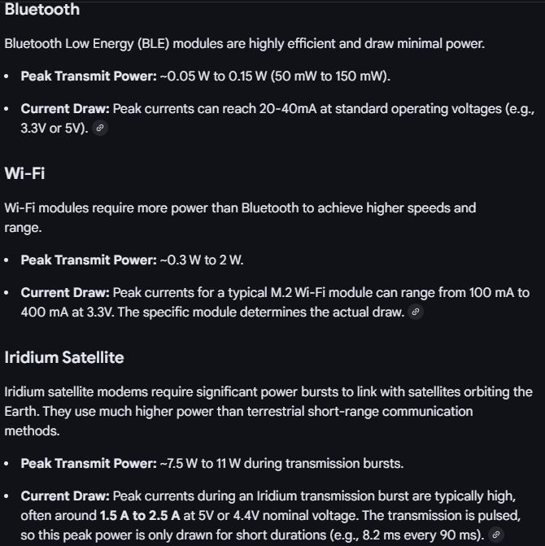
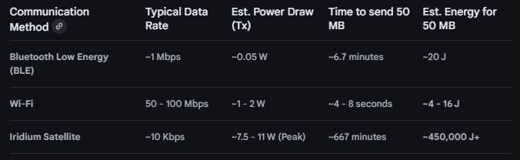
- General Notes / Questions
  - Counting architecture tradeoffs
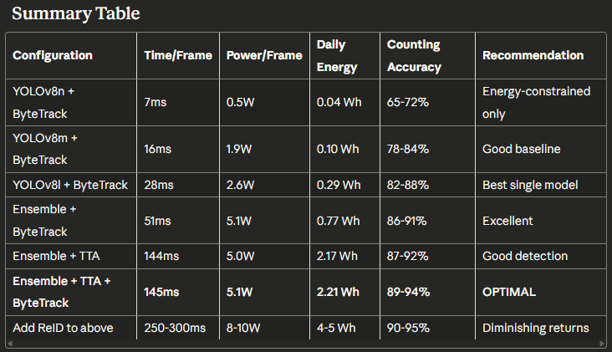
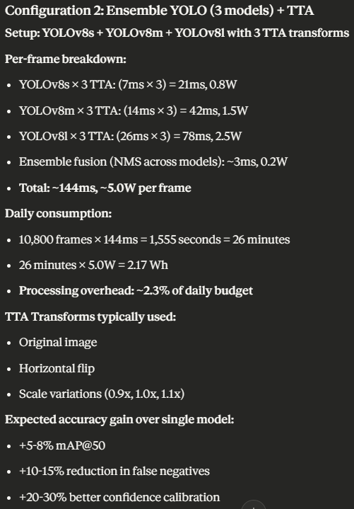
  - YOLO version notes
    - Best current community support for nano implementation- V8
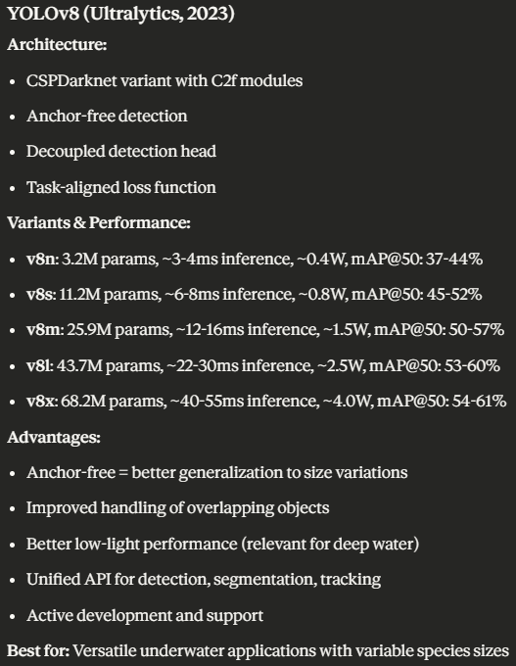
  - YOLO ensemble- versions vs recall/ precision optimization
    - Ensemble of versions increases complexity and training time significantly, ensemble of recall/precision might limit possible improvement
  - Pre-processing
    - Use either adaptive or TTA based pre-processing
    - Options
      - CLAHE, color correction (white contrasting), dehazing, gaussian blur, frame differencing
    - Optimal solution
      - Hybrid- preprocessing approach before ensemble
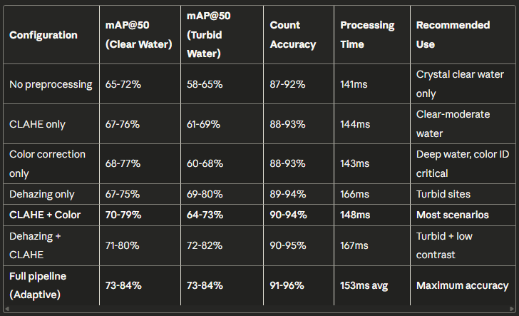
  - Energy budget
    - ~40 Wh per day max for all inference, less would give more room for energy error
    - With 4 cameras @ 90 seconds per hour @ 5 FPS with 3 model ensemble
      - 4*90*24*5*3 129600 inferences/day
    - Estimated power consumption YOLO v8 models on nano @ 15W power mode, excluding pre and post processing consumption
      - V8n ~0.185 J/inference ~6.66 Wh
      - V8s ~0.302 J/inference ~10.9 Wh
      - V8m ~0.4 J/inference ~14.4 Wh
      - V8l ~0.5 J/inference ~18 Wh
      - V8x ~0.675 J/inference ~24.3 Wh
    - All versions of model can run at 5 FPS on nano
      - Inference time limits options down to v8l or v8m options
        - TBD between l and m on Nano (performance gain vs latency tradeoff)
        - Will use x on shoreside
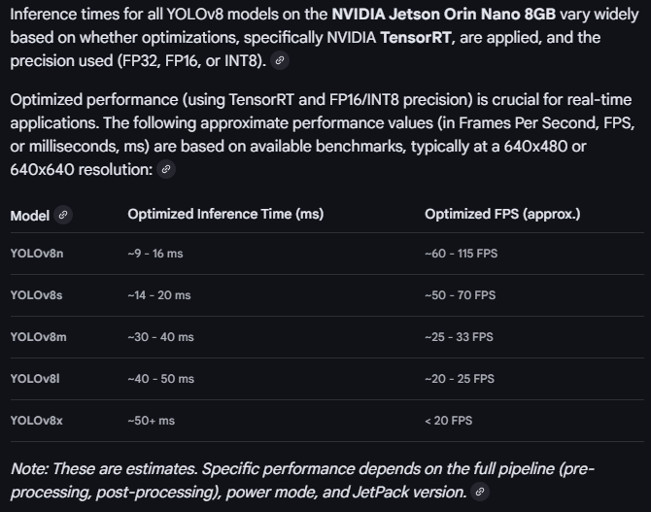
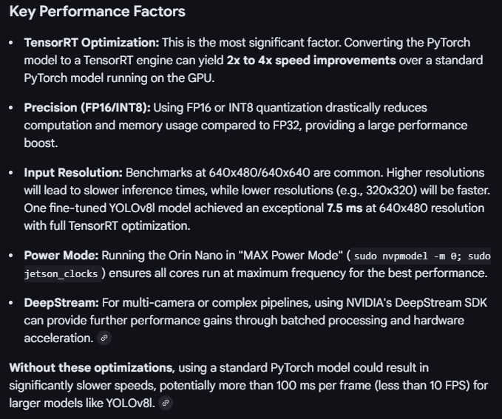
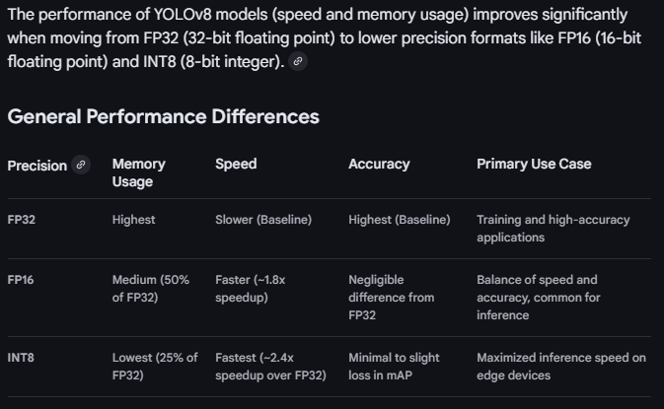
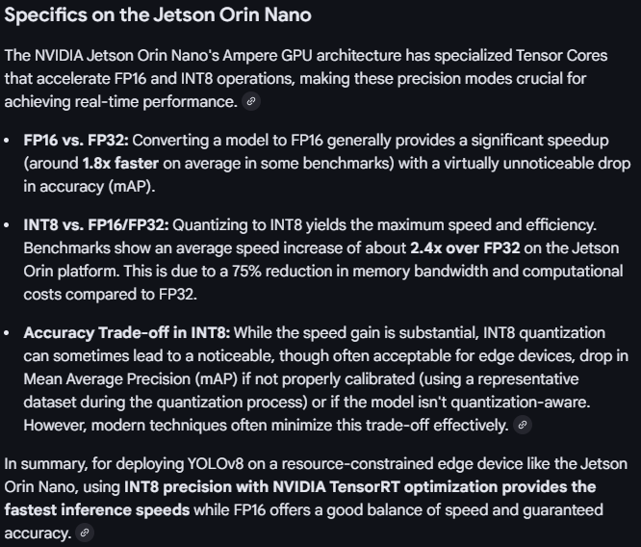
- Image Data Use Cases
- General Dataset notes
  - Marauder: ~850 images, unlabeled but will be labeled high priority
  - Fathomnet: ~280,000 images, high confidence labeled
  - Deepfish: TBD, supposedly ~40,000 images over ~20 different terrains
    - Will not be labeled unless marked as critical species or part of active learning images
- Initial SSL at least 50,000 unlabeled images
  - Mix of deepfish and less useful Fathomnet images
  - Will not use Marauder images
  - Use all deepfish images here not from critical species list

- Resources
- https://www.jetson-ai-lab.com/tutorial_ultralytics.html#__tabbed_1_3
- https://developer.nvidia.com/embedded/learn/jetson-orin-nano-devkit-user-guide/index.html
- https://docs.ultralytics.com/models/yolo11/
- https://docs.ultralytics.com/models/yolov8/

- YOLO Overview
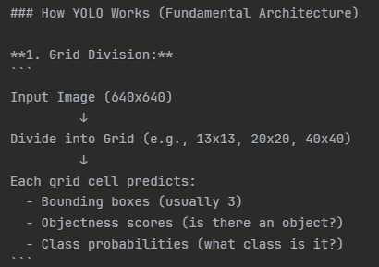
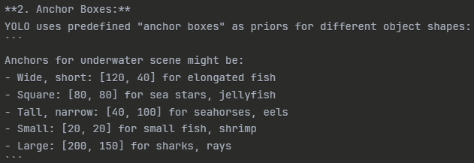
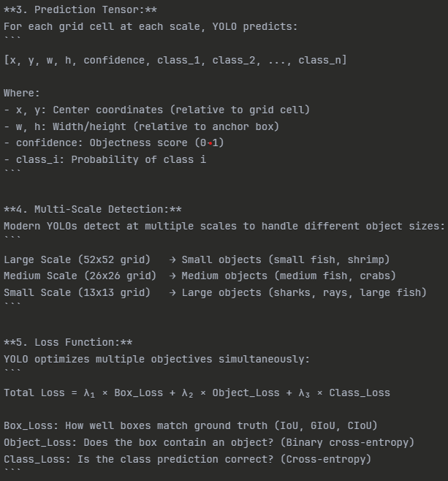
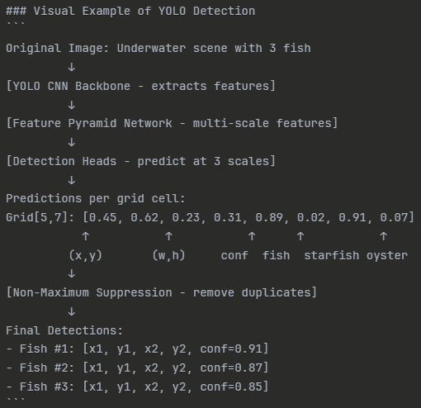
- Yolo Version History
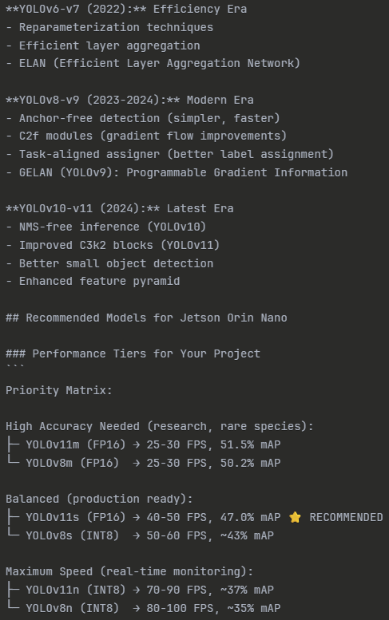

- Potential Datasets
  - https://homepages.inf.ed.ac.uk/rbf/Fish4Knowledge/GROUNDTRUTH/RECOG/
    - Terrible quality
  - Fathomnet
  - https://alzayats.github.io/DeepFish/
    - ~40,000 images over ~20 different terrains
  - Marauder data

- Labeling Format
  - Separate YOLO labelling file and metadata file
  - Guidelines
    - Tight boxes
    - Only label >25% visibility
    - Only annotate visible portion
    - Handle uncertainty:
      - Most certain: give species
      - Uncertain: genus or family
      - Very uncertain: broad category (fish unidentified, etc)
Labeling checklist:
✓ DATASET STRUCTURE
□ Organized in images/ and labels/ folders
□ Separate train/, val/, test/ splits
□ data.yaml file created
□ All paths correct

✓ LABEL FILE FORMAT
□ One .txt file per image (matching names)
□ Format: class_id x_center y_center width height
□ Coordinates normalized (0.0 to 1.0)
□ Center-based (not corners)
□ 4-6 decimal places
□ Space-separated values
□ One bounding box per line

✓ BOUNDING BOXES
□ Tight boxes around organisms
□ Include partial visibility (>30%)
□ Handle occlusion appropriately
□ Each individual labeled separately
□ No boxes extending beyond image

✓ CLASS IDs
□ Start from 0
□ Match data.yaml order exactly
□ Critical species prioritized (IDs 0-3)
□ Consistent across all files

✓ QUALITY
□ All critical species double-checked
□ Ambiguous cases handled appropriately
□ No duplicate annotations
□ Metadata documented (if applicable)
□ Dataset validated with scripts

✓ ANNOTATION TEAM
□ Guidelines distributed
□ Inter-annotator agreement checked
□ Regular quality reviews
□ Clear communication channel
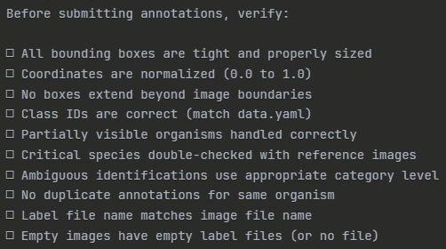

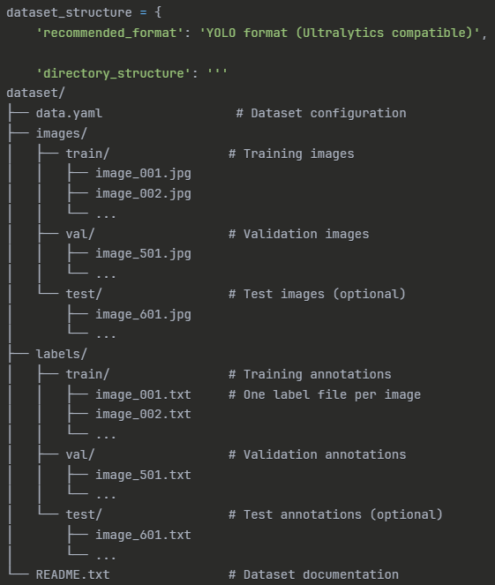
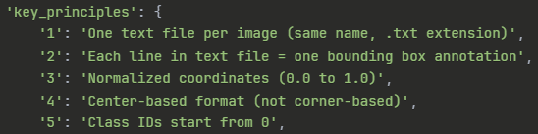
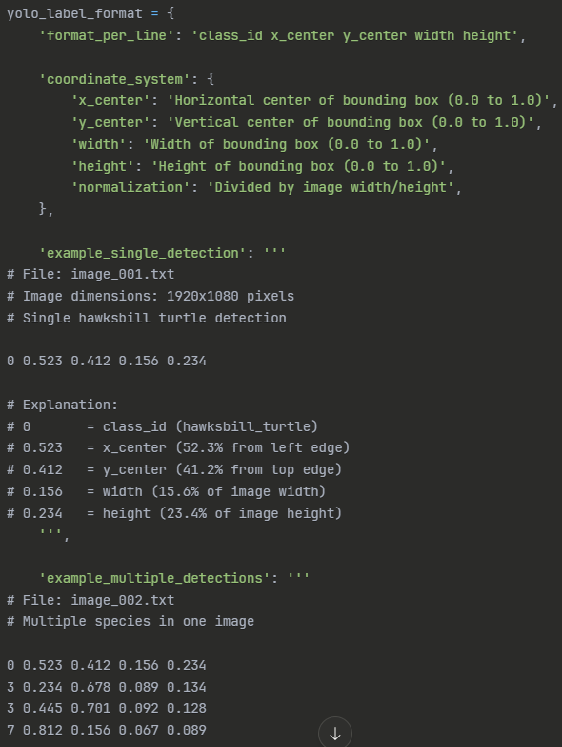
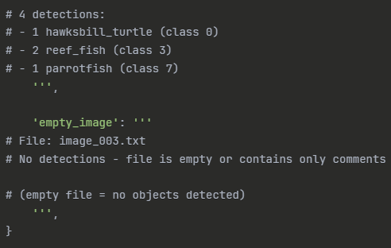
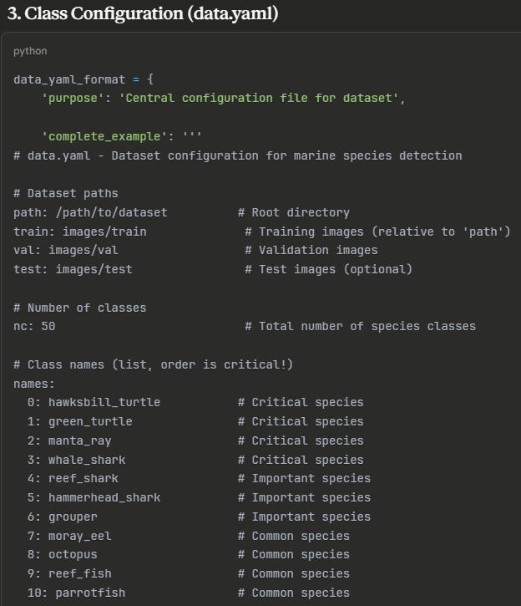
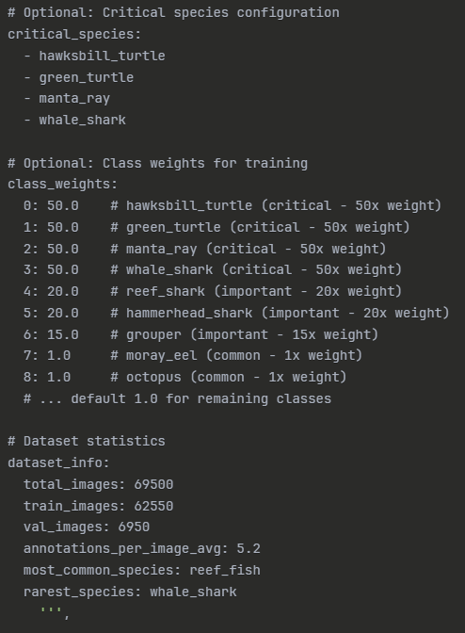
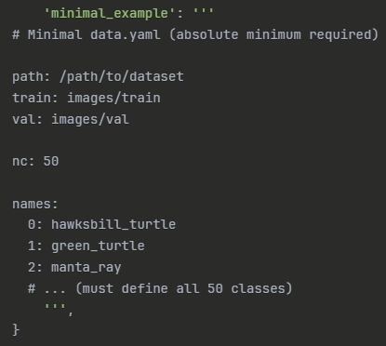
- CV Architectural Overview/ Implementation Steps
  - Architecture
    - Overview
      - 3 model ensemble + TTA + ByteTrack (w/ counting)
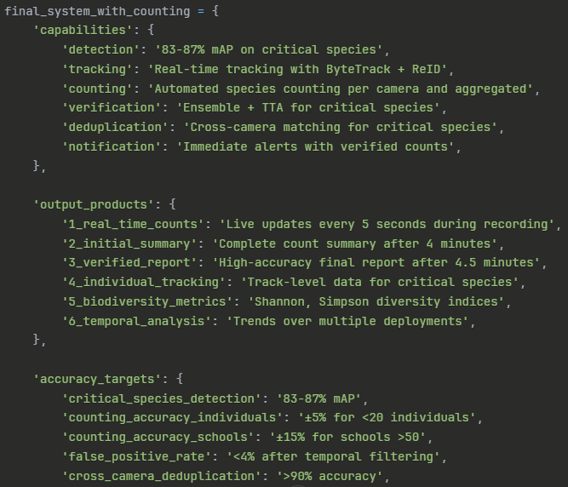
    - Ensemble
      - High recall
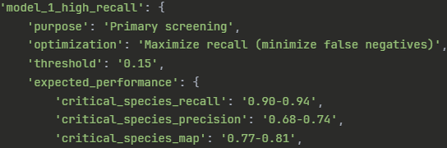
      - Balanced
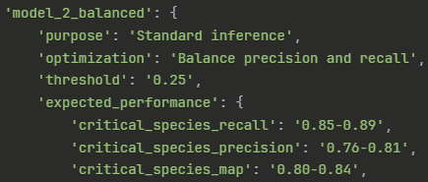
      - High Precision
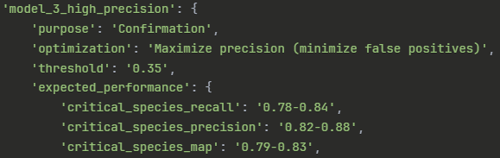
      - Expected performance
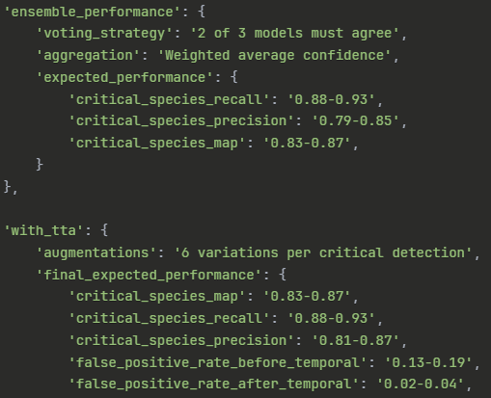

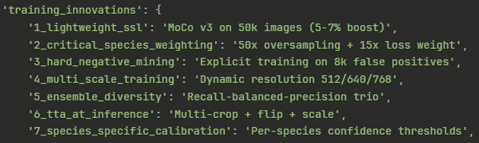
    - Counting
      - Issues to handle
        - Occlusion & Reappearance tracking
        - Deal with schooling fish via density
        - Cross-camera de-duplication
        - Partial visibility
    - Bio-diversity metrics?
      - 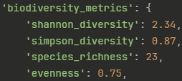
  - General Overview
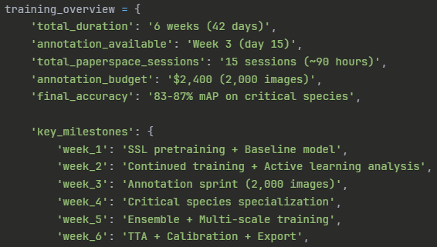
  - Detailed Overview
