TRAVEL COMMUNITY PLATFORM
A MERN Stack Community-Based Travel Management System

MINI PROJECT REPORT

Submitted by
Marc Rohan
[ROLL NUMBER]

[DEPARTMENT NAME]
[COLLEGE / UNIVERSITY NAME]
[ACADEMIC YEAR]

Technology: MongoDB • Express.js • React • Node.js

CERTIFICATE
This is to certify that the project entitled “Travel Community Platform” is a bonafide mini project work carried out by Marc Rohan under the guidance of the faculty concerned. The work presented in this report describes the design and implementation of a community-oriented travel platform developed using the MERN technology stack.
Guide: ______________________________
Head of Department: __________________
Date: _________________________________

DECLARATION
I hereby declare that the project report entitled “Travel Community Platform” is prepared for academic submission and represents the implementation work carried out for the stated project requirements. The application demonstrates MERN stack concepts including React components, REST APIs, MongoDB, Mongoose, JWT authentication, bcrypt password hashing and CRUD operations.
Signature: _____________________________
Name: Marc Rohan
Date: _________________________________

ACKNOWLEDGEMENT
I express my sincere gratitude to the institution, department and faculty members who provided the guidance and resources required to complete this mini project. I also thank my project guide for the technical direction provided during system analysis, design, implementation and testing.
I acknowledge the open-source technologies used in this work, particularly MongoDB, Express.js, React, Node.js, Mongoose, Axios, Bootstrap, JSON Web Token and bcryptjs. Their documentation and development ecosystems supported the implementation of the application.

ABSTRACT
Travel planning is increasingly influenced by online communities, digital booking services and social recommendations. However, travelers may need to use multiple platforms to discover destinations, find organized trips, maintain travel plans and track bookings. The Travel Community Platform addresses this problem by combining these activities in a single web application.
The system is implemented using the MERN stack. React provides the interactive client interface, while Node.js and Express.js provide RESTful backend services. MongoDB stores users, destinations, trip plans, trips, bookings and notifications, with Mongoose providing schema-based data access. JWT is used for session authentication and bcryptjs is used to securely hash passwords.
The platform supports three roles: Traveler, Agent and Admin. Travelers can explore destinations, filter trips by category, create trip plans and book trips. Agents can create and manage destinations and trips and process booking requests. Administrators have management-level visibility. The distinctive feature is category-based feed filtering, allowing users to quickly view Beach, Mountain, Adventure, Historical, Wildlife and Cultural trips.

TABLE OF CONTENTS
1. Introduction
2. System Analysis
3. System Requirements
4. System Design
5. Implementation and Testing
6. Conclusion and Future Work
7. Appendices
References
Note: Update page numbers after final formatting if your institution requires numbered contents.

LIST OF TABLES AND FIGURES
Item | Description
Table 1 | Functional requirements
Table 2 | Non-functional requirements
Table 3 | MongoDB collections
Table 4 | API endpoints
Table 5 | Test cases
Figure 1 | System architecture
Figure 2 | Use case diagram
Figure 3 | Entity relationship overview

ABBREVIATIONS
Abbreviation | Meaning
MERN | MongoDB, Express.js, React, Node.js
API | Application Programming Interface
REST | Representational State Transfer
JWT | JSON Web Token
CRUD | Create, Read, Update, Delete
UI | User Interface
UX | User Experience
HTTP | Hypertext Transfer Protocol
DB | Database
ODM | Object Document Mapper

CHAPTER 1 — INTRODUCTION

1.1 Overview
The Travel Community Platform is a web-based application designed to connect travelers, travel agents and administrators in a common digital environment. The platform provides destination discovery, trip management, personal trip planning and booking workflows. It is designed as a modular MERN application so that the front end, server and database responsibilities remain clearly separated.

1.2 Problem Statement
Travelers frequently collect information from social networks, destination websites, booking portals and messaging applications. This fragmented process makes it difficult to maintain a consistent travel plan and track bookings. Agents also require a simple mechanism to publish trips and respond to booking requests. The proposed system consolidates these activities.

1.3 Objectives
- Provide secure registration and login for different user roles.
- Allow travelers to explore destinations and community trips.
- Implement category-based feed filtering for faster discovery.
- Allow travelers to create and maintain trip plans.
- Provide trip booking and booking-status workflows.
- Allow agents and administrators to perform destination and trip CRUD operations.
- Store application data using MongoDB and Mongoose.
- Expose modular REST APIs through Node.js and Express.js.

1.4 Scope of the System
The project scope covers the core community and management workflow required for an academic MERN application. Authentication, role handling, destination records, trip records, trip planning, booking records and notifications are included. Payment gateway integration, live GPS tracking and external supplier synchronization are outside the current implementation scope.

1.5 Advanced Technologies Used
React JSX and component-based development are used for reusable interfaces. React Router provides single-page navigation. Axios communicates with the REST API. Express.js organizes backend routes and middleware. Mongoose defines MongoDB document structures. JWT provides stateless authentication and bcryptjs protects stored passwords through hashing.

1.6 Global Perspective
Community-oriented travel applications can support local tourism by making smaller destinations and agent-created experiences easier to discover. A future production system could extend the platform with multilingual content, accessibility features, sustainability information, recommendation systems and integration with external booking providers.

1.7 Sustainable Development Perspective
The application has a potential relationship with SDG 11 (Sustainable Cities and Communities) through community-based discovery and local destination visibility. It can also support economic participation for travel agents and local tourism businesses, aligning conceptually with SDG 8 (Decent Work and Economic Growth). These are potential social benefits rather than measured outcomes of the prototype.

CHAPTER 2 — SYSTEM ANALYSIS

2.1 Existing System
In a typical fragmented travel workflow, destination discovery, trip planning, communication and booking may be handled through different services. A traveler may save destination information in one place, communicate with an agent in another and maintain a personal itinerary separately.

2.1.1 Drawbacks
- Information is distributed across multiple services.
- Trip discovery may not be organized according to user interests.
- Manual communication can make booking status difficult to track.
- Agents may need separate tools to publish and manage trip information.
- Personal travel plans are not directly connected to destination and booking records.

2.2 Proposed System
The proposed Travel Community Platform combines the main activities into one web application. A user first creates an account and authenticates using JWT. Travelers can then browse destinations and trips, use category filtering, create plans and submit bookings. Agents manage trip and destination records, while administrators have broader platform management access.

2.2.1 Advantages
- Centralized travel community workflow.
- Role-based access control.
- Reusable React components.
- RESTful CRUD APIs.
- Structured MongoDB collections.
- Fast category-based filtering using JavaScript array methods.
- Notification support for booking events.

CHAPTER 3 — SYSTEM REQUIREMENTS

3.1 Hardware Requirements
Component | Minimum Recommendation
Processor | Dual-core 2 GHz or better
RAM | 4 GB minimum; 8 GB recommended
Storage | 2 GB free for source code and dependencies
Network | Internet connection for package installation / Atlas
Display | 1366 × 768 or higher

3.2 Software Requirements
Software | Purpose
VS Code | Source-code editing and terminal
Node.js | JavaScript runtime
npm | Dependency management
MongoDB / MongoDB Atlas | Database
Google Chrome / Edge | Application testing
Postman (optional) | REST API testing

3.3 Functional Requirements
ID | Requirement
FR1 | User registration and login
FR2 | Role selection for traveler or agent
FR3 | Destination listing and details
FR4 | Destination CRUD for authorized roles
FR5 | Trip listing and details
FR6 | Trip CRUD for authorized roles
FR7 | Category-based trip feed filtering
FR8 | Personal trip planning
FR9 | Booking creation and cancellation
FR10 | Booking confirmation/rejection by authorized roles
FR11 | Notification generation
FR12 | Role-based dashboard statistics

3.4 Non-Functional Requirements
Category | Requirement
Security | Passwords are hashed and API access uses JWT.
Performance | Filtering and navigation should respond quickly for prototype-sized data.
Usability | Forms provide labels, validation and clear status messages.
Maintainability | Frontend and backend are separated into reusable modules.
Scalability | MongoDB and REST architecture can be extended with more modules.
Reliability | API errors are returned with HTTP status codes and messages.

CHAPTER 4 — SYSTEM DESIGN

4.1 System Architecture
The system follows a three-layer web architecture. The React client is responsible for presentation and user interaction. The Express server exposes REST endpoints, performs authentication and business rules. MongoDB stores persistent documents. Axios connects the client to the API and the JWT token is sent in the Authorization header for protected requests.
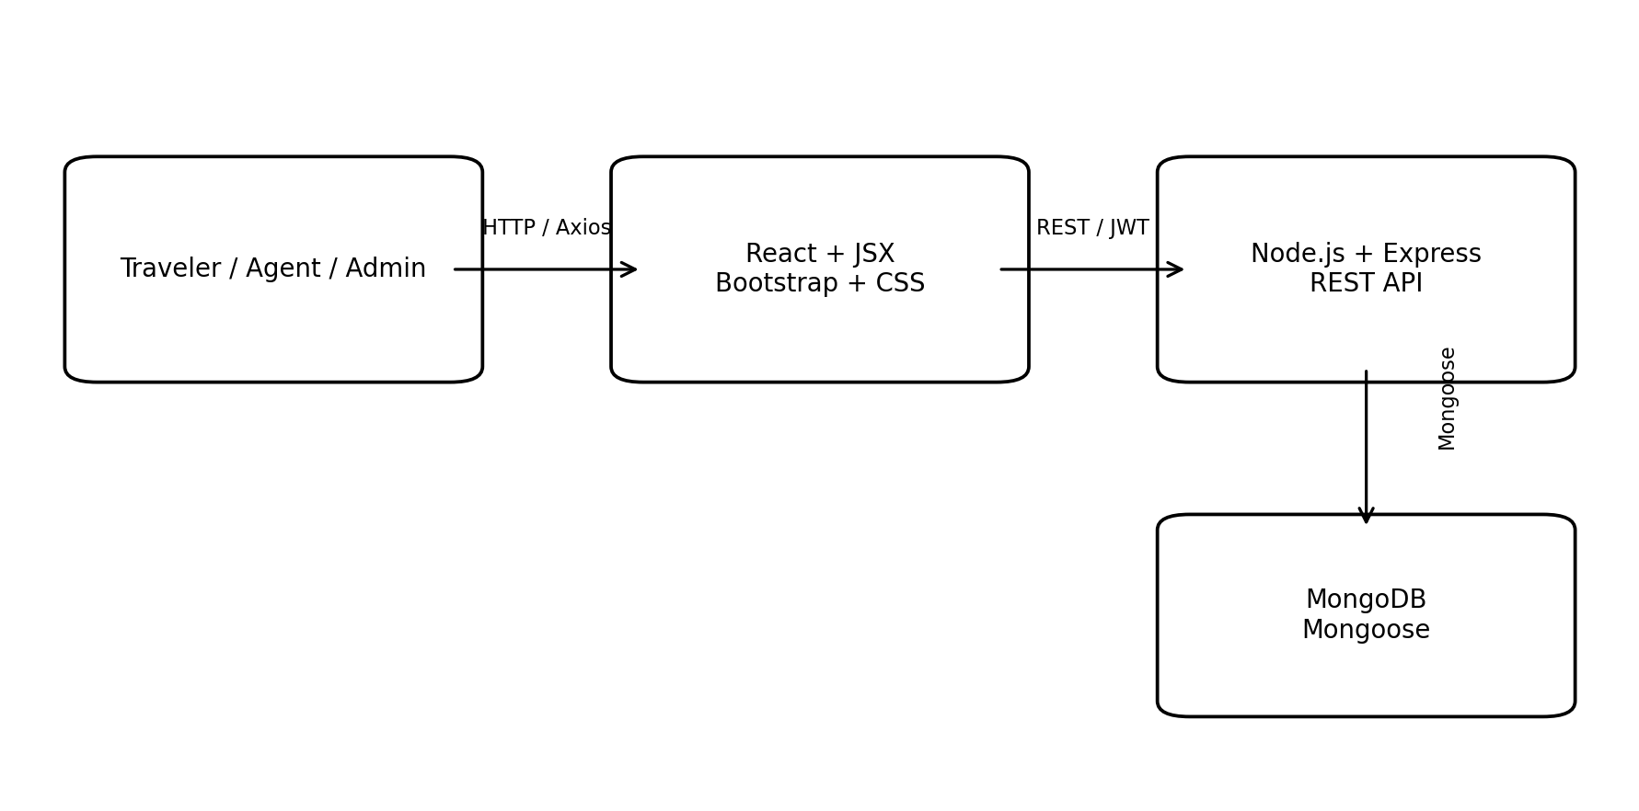
Figure 1 — System Architecture

4.2 User Roles
Role | Main Responsibilities
Traveler | Browse destinations, filter trips, plan travel, create bookings, cancel bookings and view notifications.
Agent | Create and manage destinations/trips and process booking requests related to managed trips.
Admin | Platform-level management and access to aggregate dashboard information.

4.3 Core Modules

User Management
Registration, login, password hashing, JWT creation and role-based access.

Destination Management
Create, read, update and delete destination records.

Trip Management
Publish, update, view and remove trips linked to destinations and agents.

Trip Planning
Store a traveler's intended destination, dates, traveler count, budget and notes.

Booking Management
Create bookings, reserve seats, update status and cancel bookings.

Notification
Generate user notifications for important booking events.

Category Feed
Filter trips by Beach, Mountain, Adventure, Historical, Wildlife and Cultural categories.

Dashboard
Show role-specific counts and quick actions.

4.4 Use Case Diagram
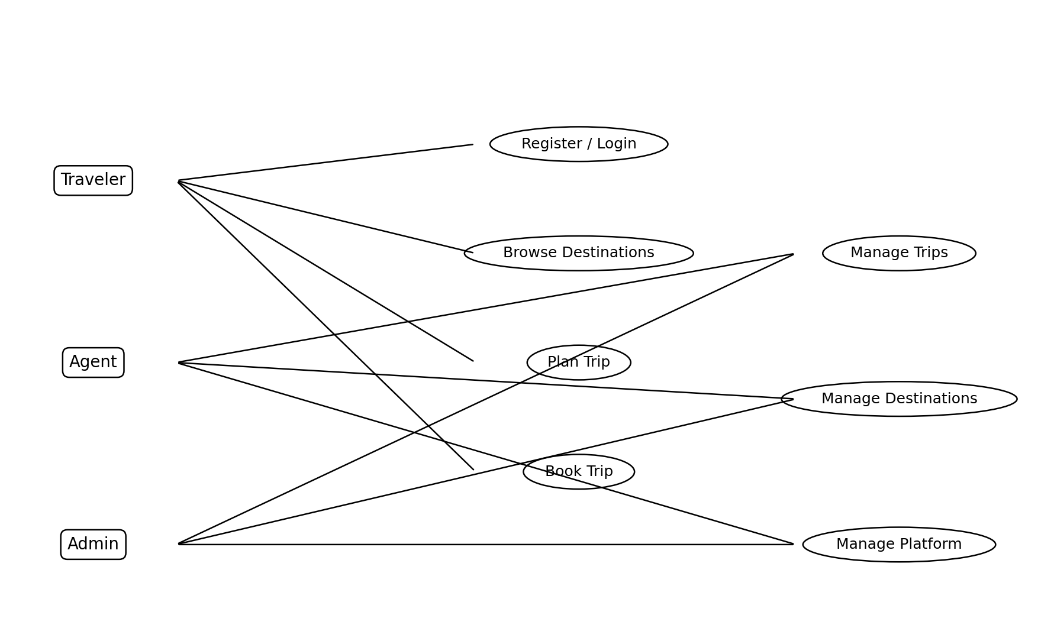
Figure 2 — Use Case Diagram
The use case view shows the three roles and their major interactions. Travelers focus on discovery, planning and booking. Agents manage travel content and booking requests. Administrators have platform-level management capabilities.

4.5 Database Design
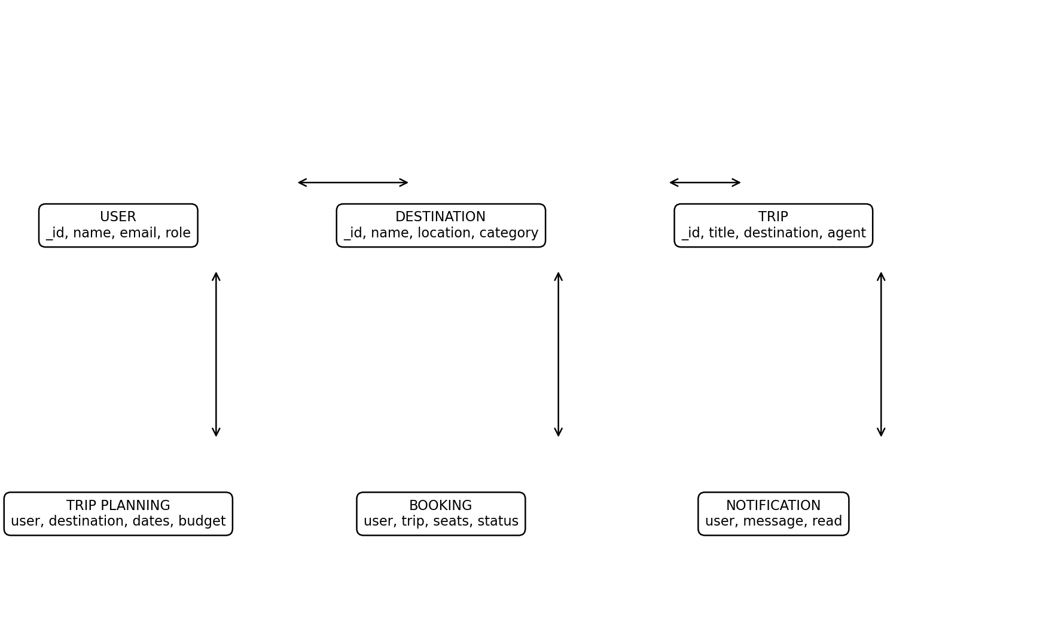
Figure 3 — Entity Relationship Overview
MongoDB stores each domain object as a document collection. ObjectId references connect users with destinations, trips, planning records, bookings and notifications. Mongoose populate operations are used where related information is required by the API response.
Collection | Important Fields
User | name, email, password, role, location, bio
Destination | name, location, description, category, bestTime, createdBy
Trip | title, destination, description, startDate, endDate, price, availableSeats, agent, category
TripPlanning | user, destination, startDate, endDate, travelers, budget, notes
Booking | user, trip, seats, totalAmount, status, bookingDate
Notification | user, message, type, read, timestamps

4.6 REST API Design
Method | Endpoint | Purpose
POST | /api/auth/register | Register a traveler or agent
POST | /api/auth/login | Authenticate user and return JWT
GET | /api/destination | List destinations
POST | /api/destination | Create destination
PUT | /api/destination/:id | Update destination
DELETE | /api/destination/:id | Delete destination
GET | /api/trip | List trips
POST | /api/trip | Create trip
PUT | /api/trip/:id | Update trip
DELETE | /api/trip/:id | Delete trip
GET/POST/PUT/DELETE | /api/tripplanning | Trip planning CRUD
GET/POST/PUT/DELETE | /api/booking | Booking operations
GET | /api/dashboard | Dashboard statistics
GET/PUT | /api/notification | Notification operations

4.7 Security Design
Passwords are not stored as plain text. During registration, bcryptjs creates a password hash. During login, bcrypt compares the submitted password with the stored hash. JWT tokens contain the authenticated user identifier, display name and role. Protected routes verify the token before allowing access. Role middleware prevents unauthorized roles from reaching management endpoints.

CHAPTER 5 — IMPLEMENTATION AND TESTING

5.1 Frontend Implementation
The frontend uses functional React components and React Hooks. useState manages form values, category selection and UI messages. useEffect loads data from REST endpoints. Props pass trip and destination objects into reusable cards. React Router handles navigation between public and protected pages.

5.2 Category-Based Feed Filtering
The unique feature is implemented with JavaScript filter(). The selected category is stored in React state. When the value is not “All”, the application keeps only trip objects whose category matches the selected category. Search text is also applied using string matching. This makes the feed easy to understand and demonstrates JavaScript array methods required by the project.

5.3 Backend Implementation
The backend is divided into models, controllers, routes and middleware. This structure keeps database definitions separate from business logic and HTTP routing. Express middleware parses JSON, enables CORS and validates JWTs for protected resources.

5.4 Booking Workflow
- Traveler opens a trip details page.
- Traveler selects the number of seats.
- The client sends a POST request to /api/booking.
- The server verifies the trip and available seats.
- Available seats are reduced and a booking record is created.
- A notification is generated for the traveler.
- An agent or administrator can confirm or cancel a pending booking.
- If a booking is cancelled, reserved seats are returned.

5.5 Test Cases
TC | Test | Expected Result
TC01 | Register with valid data | Account is created and JWT is returned.
TC02 | Register with duplicate email | API returns an error and no duplicate user is created.
TC03 | Login with correct credentials | User is authenticated and dashboard opens.
TC04 | Login with wrong password | API rejects the login.
TC05 | Open trip list | Trips are displayed from MongoDB.
TC06 | Select Mountain category | Only Mountain trips are displayed.
TC07 | Create trip as traveler | Request is blocked by role authorization.
TC08 | Create trip as agent | Trip is created and linked to the agent.
TC09 | Create booking with enough seats | Booking is created and seats decrease.
TC10 | Book more seats than available | Booking is rejected.
TC11 | Cancel booking | Booking becomes Cancelled and seats are restored.
TC12 | Access management route without login | User is redirected to login / API returns 401.

5.6 Error and Empty States
The frontend includes empty-state messages for missing trips, destinations, bookings and notifications. API failures are displayed as warning or error messages. Forms use required fields and numeric constraints where appropriate. The backend also validates authentication, role access and booking seat availability.

CHAPTER 6 — CONCLUSION AND FUTURE WORK

6.1 Conclusion
The Travel Community Platform demonstrates how the MERN stack can be used to build a modular community application. The project integrates authentication, role-based access, MongoDB persistence, REST CRUD operations, React routing, Axios communication and a category-based travel feed. The resulting architecture is suitable as an undergraduate mini project because each module has a clear responsibility and can be demonstrated independently during evaluation.

6.2 Future Enhancements
- Online payment gateway integration.
- Real-time chat between travelers and agents.
- Reviews and ratings for destinations and trips.
- Google Maps or other map-based location services.
- Email/SMS/push notifications.
- AI-assisted personalized trip recommendations.
- Multi-language support.
- Image upload and cloud storage.
- Advanced analytics for agents and administrators.
- Deployment using a cloud hosting platform.

CHAPTER 7 — APPENDICES

Appendix A — Project Folder Structure
Travel-Community-Platform/
├── client/
│ └── travel-community-frontend/
│ └── src/
│ ├── components/
│ ├── pages/
│ ├── services/
│ ├── App.jsx
│ ├── main.jsx
│ └── index.css
├── server/
│ ├── controllers/
│ ├── middleware/
│ ├── models/
│ ├── routes/
│ ├── .env.example
│ ├── seed.js
│ ├── server.js
│ └── package.json
├── report/
└── README.md

Appendix B — Important Code Concepts
JWT authentication is created on successful login and sent to protected API requests as a Bearer token.
bcryptjs is used to hash passwords during registration and compare them during login.
React useState and useEffect are used for UI state and API data loading.
Axios provides a reusable API client with a request interceptor for the JWT.
MongoDB collections are modeled through Mongoose schemas and ObjectId references.

Appendix C — Running the Project
- Install Node.js and MongoDB or create a MongoDB Atlas database.
- Open the project folder in VS Code.
- Open a terminal in server and run npm install.
- Create .env from .env.example and set MONGO_URI and JWT_SECRET.
- Run npm run seed and then npm run dev.
- Open a second terminal in client/travel-community-frontend.
- Run npm install and npm run dev.
- Open the Vite URL shown in the terminal, normally http://localhost:5173.
- Login using one of the demo accounts in README.md.

REFERENCES
- MongoDB Documentation — MongoDB database concepts and operations.
- Mongoose Documentation — Schema modeling and MongoDB access from Node.js.
- React Documentation — Components, JSX and Hooks.
- React Router Documentation — Client-side routing.
- Express.js Documentation — REST API and middleware development.
- Node.js Documentation — JavaScript runtime and server-side development.
- Axios Documentation — HTTP client for browser and Node.js.
- Bootstrap Documentation — Responsive UI components and layout.
- JSON Web Token (JWT) documentation — Token-based authentication concepts.
- bcryptjs package documentation — Password hashing and verification.

SOURCE CODE AVAILABILITY
The complete VS Code-ready source code is supplied with this report in the project ZIP archive. The archive contains the React frontend, Node/Express backend, Mongoose models, REST routes, controllers, JWT middleware, seed data, styling and setup instructions. This report intentionally summarizes the code architecture so that the document remains readable; the ZIP is the authoritative implementation package.
Before submission, replace the bracketed institution, department, roll-number, guide and academic-year placeholders.
Recommended submission package: project ZIP + this report DOCX/PDF + screenshots of the running application.

